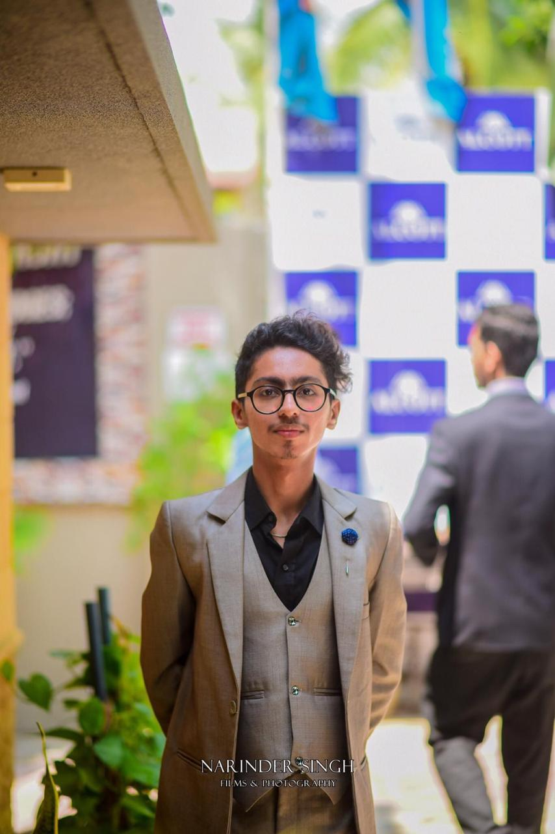

**Interpersonal Skills:**

* **English Language**
* **Management Skills**
* **Software Skill**
* **Good Communication Skill**
* **Leadership Skills**

**Hobbies:**

* **Photography**
* **Debating**
* **Socializing**
* **Exploring ideas**

**Projects:**

* [**https://zubair-aahmed.github.io/tic-tac-toe/**](https://zubair-aahmed.github.io/tic-tac-toe/)
* [**https://zubair-aahmed.github.io/clock/**](https://zubair-aahmed.github.io/clock/)
* [**https://zubair-aahmed.github.io/Calculator/**](https://zubair-aahmed.github.io/Calculator/)
* [**https://zubair-aahmed.github.io/texteditor/**](https://zubair-aahmed.github.io/texteditor/)
* **MS PowerPoint**
* **Bootstrap**
* **JavaScript**
* **jQuery**
* **Blockchain**

**Contact:**

**Phone:** 03360440200

**Email:** [zubair2209e@aptechgdn.net](mailto:zubair2209e@aptechgdn.net)

[Jigarzubair95@gmail.com](mailto:Jigarzubair95@gmail.com)

**LinkedIn:**

**www.linkedin.com/in/zubair-ahmed-63803a262**

**GitHub:** [**https://github.com/Zubair-Aahmed**](https://github.com/Zubair-Aahmed)

**Technical Skills:**

* **Html**
* **CSS**
* **Figma**
* **MS Word**
* **MS Excel**

**About me:**

I am ZUBAIR AHMED and I’m a commerce student, recently did intermediate in commerce, and currently doing diploma from Aptech learning I want to become a good web developer also gaining Experience and skills as much as I can, and my goal is to Seeks an entry level position to begin My Career in a High-Level Professional Environment. I am very passionate for my career

**Education:**

* Diploma in DISM from Aptech Learning (in process)
* Block Chain from PIAIC (in process)
* Intermediate in Commerce from S.M Commerce and Arts College no.1
* Matriculation in Bio Science from Nasra School main campus

**ZUBAIR AHMED**

**Web Designer**