Agentic AI Product Design Requirements (PDR)
Implementation blueprint for the Company AP Automation human + AI agent workflow
Generated: 21 May 2026 | Project: Company AP Automation

1. Executive Summary
This PDR defines the next implementation scope for adding Agentic AI capabilities to the AP Automation system. The objective is to reduce manual finance operations while keeping department head approval, CFO payment sign-off, vendor bank-account changes, tax overrides and high-value payment release under mandatory human control.
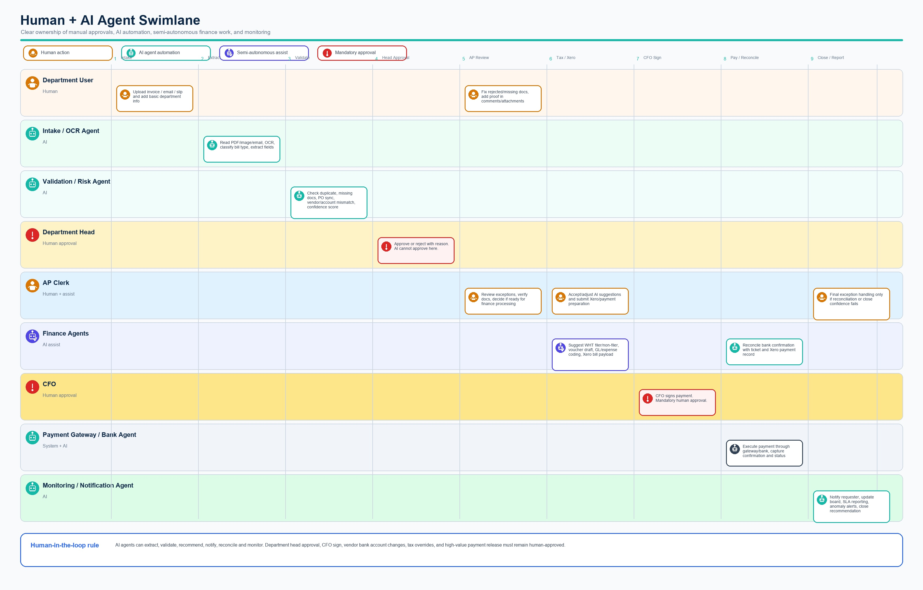
Target human + AI agent swimlane

2. Current System Baseline
- Frontend: React screens for login/register, upload, invoice detail, AP/head board, ticket detail, operations and dashboard.
- Backend: NestJS modules for auth, invoices, approvals, tickets, vendors, departments, payments and full-scope operations.
- Workflow: invoice/PO creation, department head approval, AP document review, vendor/PO/account verification, WHT, voucher, Xero, payment gateway/bank execution and close.
- Data model: Prisma models for Invoice, PurchaseOrder, PaymentTicket, SupportingDocument, TicketActivity, PaymentBatch, PaymentRecord, Notification and XeroConnection.
- Controls: role-based transitions, field-level edit restrictions, comments, attachments, downloadable documents and locked payment-complete tickets.

3. Target Agentic Operating Model
The workflow should evolve from a manually operated Kanban board into an event-driven agentic operating layer. Agents listen to workflow events, perform bounded analysis or automation, write recommendations and low-risk updates through the existing API, and escalate high-risk decisions to humans.
Layer | Responsibility | Implementation Direction
Workflow engine | Keeps ticket status, permissions and audit trail authoritative. | Existing NestJS ticket/invoice services remain source of truth.
Agent orchestrator | Runs agents when invoice/ticket/payment events occur. | Add background worker with event queue, idempotent job table and retry policy.
AI agents | Extract, validate, recommend, notify, reconcile and monitor. | Agents call approved tools/APIs; outputs stored as recommendations and activity records.
Human approvals | Approve/reject department requests and authorize payment. | Department Head and CFO actions stay manual with explicit UI gates.

4. AI Agent Roles and Responsibilities
Agent | Trigger | Responsibilities | Output
Document Intake Agent | Invoice upload or email import | Classify file, OCR PDF/image/slip, extract vendor, amount, invoice date, account, PO and bill type. | Extracted fields, confidence score, document classification.
Validation/Risk Agent | Invoice draft created or edited | Check duplicate invoice, missing docs, PO sync, vendor match, account mismatch and old sheet references. | Validation checklist, risk score, missing-doc list.
Approval Routing Agent | Ready for head approval | Route to correct department head, calculate SLA, remind/escalate overdue approvals. | Approval task, reminders, escalation activity.
AP Finance Copilot | Ticket enters AP review | Recommend next status, highlight blockers, summarize invoice/PO/vendor context. | AP recommendation panel and suggested action.
WHT/Voucher Agent | Ticket enters WHT/voucher stage | Suggest filer/non-filer rate, WHT amount, net payable, voucher draft and GL/expense mapping. | Tax/voucher draft requiring AP confirmation.
Xero Sync Agent | Ready for Xero bill or paid marking | Prepare bill payload, detect sync errors, refresh token, retry safe failures. | Xero bill/payment status and error resolution guidance.
Payment Gateway Agent | Payment prepared or bank confirmation received | Validate payment batch data, capture payment confirmation, reconcile with ticket and Xero status. | Payment execution status and reconciliation result.
Notification Agent | Missing docs, approval pending, overdue, close | Send requester/head/AP/CFO notifications, write comments, summarize blockers. | Notifications and audit activity.
QA/Workflow Agent | Scheduled or after deployment | Run end-to-end test scenarios and validate role permissions/status transitions. | Test report and failed workflow alerts.

5. Human-in-the-Loop Rules
Decision | Automation Level | Reason
Department head approval/rejection | Human mandatory | Business owner must approve budget/department request.
CFO payment sign | Human mandatory | Financial authorization and fraud control.
Vendor bank account creation/change | Human mandatory with dual control | High fraud risk; AI can flag mismatch but not approve.
WHT/tax override | Human mandatory | Compliance and tax liability risk.
High-value payment release | Human mandatory | Payment risk threshold requires explicit sign-off.
OCR/extraction correction | Semi-autonomous | AI can prefill; user confirms low-confidence fields.
Missing-doc reminders | Autonomous | Low-risk operational communication.
Status close after confirmed reconciliation | Semi-autonomous | Agent can recommend close; auto-close only when confidence and rules pass.

6. Functional Requirements for Implementation
ID | Requirement | Acceptance Criteria
AG-01 | Agent job orchestration | System creates idempotent background jobs for upload, validation, notification, Xero and payment events.
AG-02 | AI extraction panel | Invoice detail shows extracted fields, confidence, source document and user-confirmed corrections.
AG-03 | Validation checklist | Ticket shows required docs, duplicate risk, vendor/account match, PO sync and readiness status.
AG-04 | Recommendation actions | AP sees suggested next action but final status move follows role permissions.
AG-05 | Approval reminders | Head/CFO pending tasks trigger reminders and escalation based on SLA.
AG-06 | WHT/voucher draft | Agent calculates draft WHT/net payable and AP must confirm before voucher is finalized.
AG-07 | Xero assistant | Agent prepares bill/payment payload, stores sync error explanations and prevents duplicate bill creation.
AG-08 | Payment gateway reconciliation | Agent matches gateway/bank confirmation to ticket, amount, vendor and Xero payment status.
AG-09 | Conversation assistant | Users can ask ticket-specific questions and receive answers grounded in ticket, invoice, PO and activity data.
AG-10 | Workflow QA agent | Automated tests verify critical role/status paths before release.

7. Data Model Additions
Entity / Field | Purpose
AgentJob | Track queued/running/completed/failed agent jobs with idempotency key and retry count.
AgentRun | Store model/tool used, prompt version, input references, output summary, confidence and cost metadata.
AgentRecommendation | Store suggested field updates, next status, risk flags and human acceptance/rejection.
Invoice.extractionConfidence | Field-level confidence for extracted values.
PaymentTicket.riskScore | Aggregated duplicate/vendor/account/payment risk score.
PaymentTicket.agentReadiness | READY, NEEDS_REVIEW, BLOCKED or FAILED state for agent checks.
TicketActivity.actorType | Differentiate human, system and AI agent actions in audit history.

8. APIs and Tools Required
- LLM with vision/OCR capability for invoice and slip extraction.
- Embedding/fuzzy-match service for duplicate detection and vendor matching.
- Xero Accounting API with idempotency protection for bill/payment creation.
- Payment gateway or bank file/API response integration for payment execution status.
- Email ingestion API for invoices arriving by email.
- Notification channels: in-app first; optional email, Slack, Teams or WhatsApp later.
- Policy/rules engine for mandatory fields, approval thresholds, WHT rates and risk gates.

9. User Experience Changes
- Invoice Detail: add AI extraction review card with confidence indicators and confirm/correct buttons.
- Ticket Detail: add AI validation checklist, recommendation summary and risk reasons.
- AP Board: add agent-ready, blocked-by-docs and high-risk badges.
- Department Head Board: show AI summary but keep approve/reject buttons human-only.
- CFO View: show payment risk summary, vendor/account confirmation and payment gateway status.
- Operations: add Agent Jobs, failed runs, prompt/version settings and audit export.

10. Notifications, Reporting and Monitoring
- Daily AP digest: pending approvals, missing docs, high-risk tickets, Xero failures and payment queue.
- Overdue workflow monitor: alerts when due date or SLA is near breach.
- Self-healing monitor: retry safe Xero token refresh, stuck agent jobs and transient gateway failures.
- Exception report: duplicate risk, account mismatch, low confidence OCR, payment confirmation mismatch.
- Performance dashboard: manual touches removed, average cycle time, first-pass approval rate, agent confidence and override rate.

11. Security, Compliance and Governance
- Agents must call existing APIs and respect RBAC; no direct database mutation for critical status/payment actions.
- Use prompt-injection defenses: document text is untrusted input and cannot instruct agents to bypass workflow rules.
- Encrypt uploaded documents and store least-privilege credentials for Xero/payment gateway.
- Mask sensitive bank account data in prompts where full value is not required.
- Log all agent actions with input reference, model/tool version, confidence and human acceptance.
- Require dual control for vendor bank account changes and payment release above threshold.

12. Testing Strategy
Test Area | Coverage
Unit tests | Due-date cutoff, WHT calculation, validation rules, idempotency and risk scoring.
API tests | Agent job creation, recommendation acceptance/rejection, RBAC and audit records.
Workflow tests | Department upload to head approval, AP review, Xero, payment gateway and close.
AI evaluation tests | OCR accuracy, duplicate detection, vendor/account matching and missing-doc classification.
Security tests | Prompt injection documents, unauthorized role transitions, payment duplication and data leakage.
Regression tests | Existing invoice/PO/ticket workflows continue working without agents enabled.

13. Phased Implementation Plan
Phase | Scope | Business Value
Phase 1: Assistive AI | Document extraction, validation checklist, missing-doc suggestions, AP summary. | Reduces data entry and review time quickly.
Phase 2: Semi-autonomous workflow | Agent jobs, recommendations, reminders, duplicate risk, WHT/voucher draft. | Cuts repetitive AP work while humans approve key decisions.
Phase 3: Integration agents | Xero assistant, payment gateway reconciliation, notification automation. | Reduces finance close and reconciliation effort.
Phase 4: Predictive operations | SLA prediction, anomaly detection, self-healing jobs, conversational assistant. | Improves control, forecasting and exception handling.

14. Immediate Implementation Backlog
- Create AgentJob, AgentRun and AgentRecommendation tables with audit-friendly metadata.
- Add background worker/orchestrator service and event triggers for invoice upload, approval, AP stage, Xero and payment events.
- Build Document Intake Agent for OCR/extraction with confidence fields.
- Build Validation/Risk Agent for duplicate, missing docs, PO sync and vendor account checks.
- Add AI extraction and validation UI cards to Invoice Detail and Ticket Detail.
- Add agent badges to AP Board and Head Board.
- Add Notification Agent for reminders and missing-doc follow-ups.
- Add QA/Workflow Agent with Playwright/API scenario tests.

15. Success Metrics
- Reduce clean invoice processing from roughly 3 days toward 1 day.
- Reduce manual data entry by 70-85%.
- Reduce missing-doc follow-up effort by 60-80%.
- Reduce daily reporting/follow-up effort by 80-90%.
- Maintain zero unauthorized payment release and zero duplicate Xero bill creation.
- Track AI override rate and keep high-risk auto-actions at 0 without human approval.

