Application Design
Functional, UX and technical design for the AP automation platform
Generated: 21 May 2026 | Project: Company AP Automation

Design Summary
The app is a React and NestJS AP workflow system with role-based screens, status-scoped editing, a Kanban ticket board, invoice/PO detail pages, AP operations controls and external-system adapters.
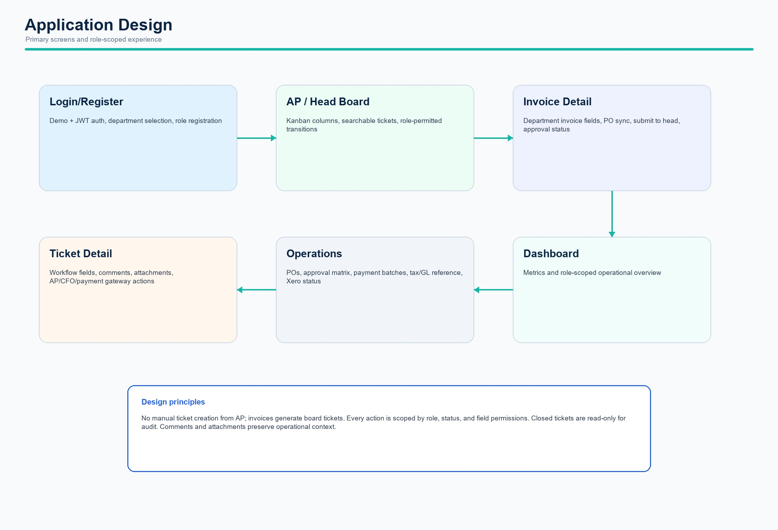
Application design overview

Role-Based Experience
Role | Primary Experience
DEPT_USER | Create invoice/PO, complete department fields, respond to rejection or missing docs.
DEPT_ADMIN | View department head board, read ticket, approve or reject with reason.
AP_CLERK | Run finance workflow, assign AP/CFO, verify docs/data, WHT, Xero, bank and close.
CFO | Open CFO sign pending tickets and record bank authorization.
COMPANY_ADMIN | Full administrative scope across departments, operations, Xero setup and rules.

Core Screens
Screen | Purpose
Login/Register | Authenticate users and bind department and role.
AP Board / Head Board | Track tickets by status; department head sees only approval board.
Invoice Detail | Complete invoice/PO fields, submit to head and show approval status.
Ticket Detail | Run AP actions, comments, attachments, CFO sign, payment gateway close, Xero close.
Operations | Purchase orders, queries, approval matrix, Meezan batches, tax/GL references and Xero status.
Dashboard | Role-scoped metrics and workload summary.

Data Design
- Invoice and PurchaseOrder records are created/synced from department submission.
- PaymentTicket is the operational tracking record and carries status, assignment, vendor, PO, WHT, bank and Xero fields.
- SupportingDocument enables invoice scans, PO copies, vouchers and bank confirmations.
- TicketActivity records comments, status changes, attachments and payment gateway actions.
- PaymentBatch and PaymentRecord support Meezan export and bank response/reconciliation scope.

Controls
- Role permissions restrict which statuses each user can move.
- Field-level edit rules prevent AP, CFO, department and head users from changing out-of-scope data.
- Payment complete tickets are locked for audit.
- Due date is 3 days from the current day if created before the configured cutoff time, otherwise 3 days from the next day.
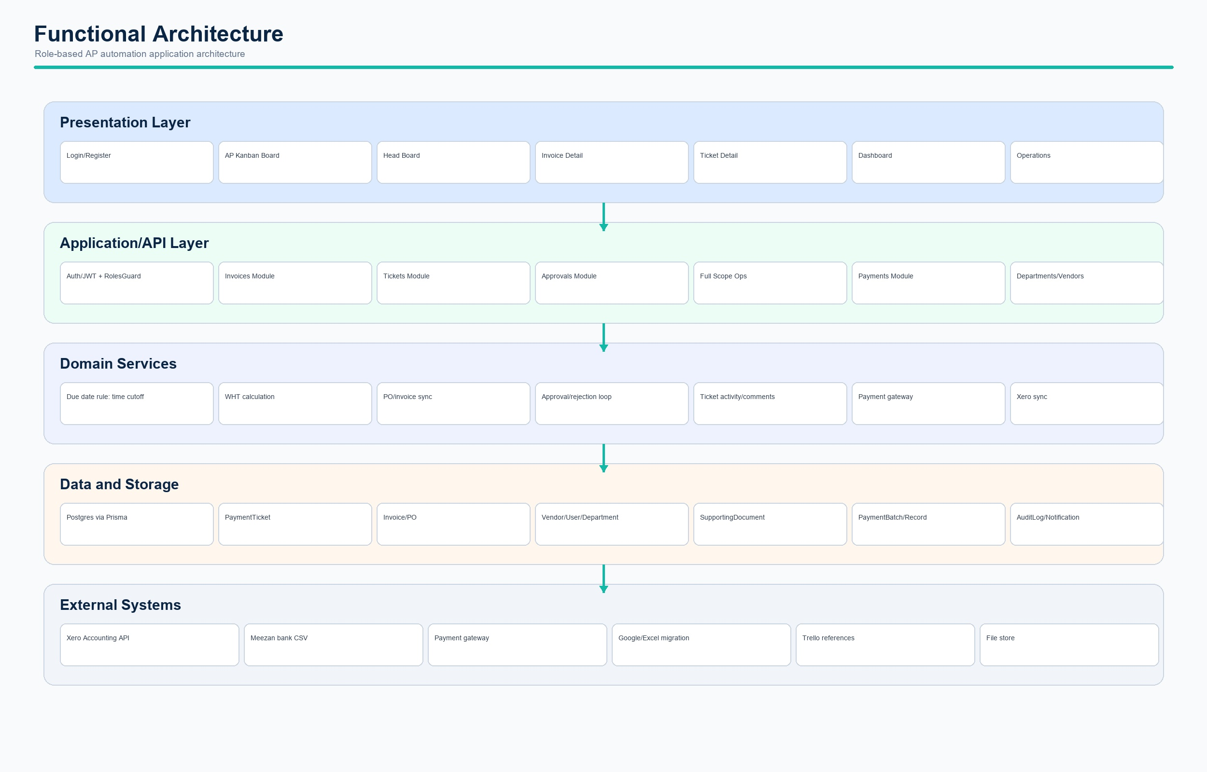
Functional architecture diagram

