Business Canvas
AP automation value model and operating case
Generated: 21 May 2026 | Project: Company AP Automation

Executive View
The platform replaces a fragmented Trello, Google Sheets, Excel and manual bank/Xero process with a role-scoped AP workflow. It centralizes invoice creation, PO sync, department head approval, AP verification, CFO bank authorization, bank execution, Xero bookkeeping and payment closeout.
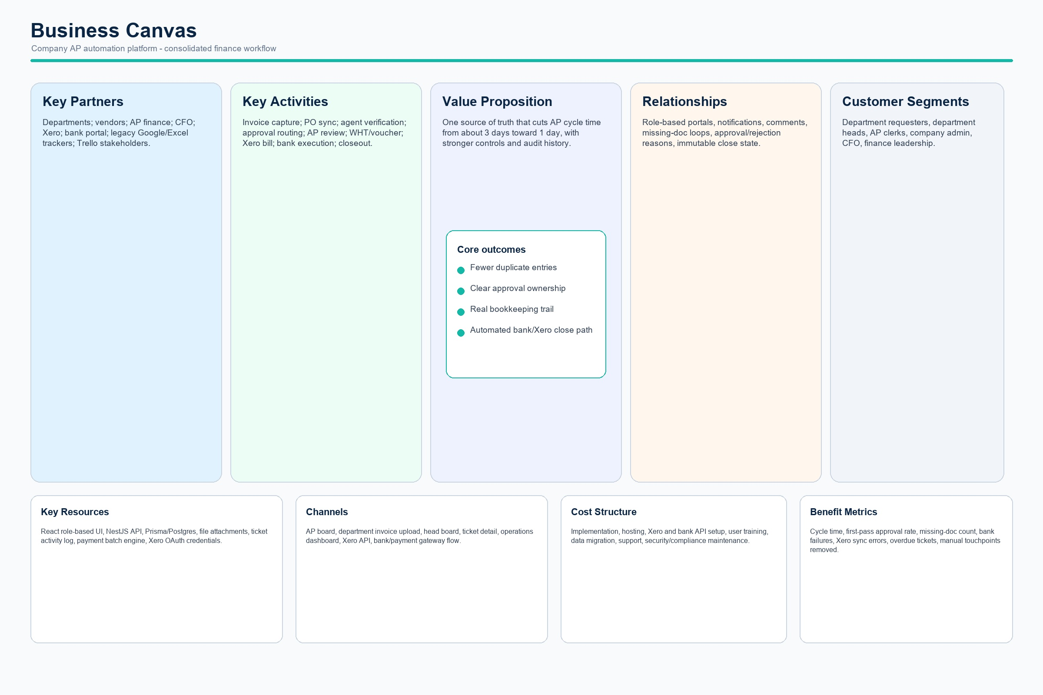
Business canvas for Company AP Automation

Canvas Detail
Area | Project Interpretation
Customer segments | Departments, department heads, AP finance, CFO, company admin and finance leadership.
Value proposition | Reduce duplicate entry and compress AP processing from roughly 3 days toward 1 day with better controls.
Channels | Kanban board, invoice pages, head board, operations dashboard, Xero and bank/payment gateway flows.
Key activities | Invoice capture, agent verification, approvals, document review, WHT, voucher, payment and reconciliation.
Key resources | React UI, NestJS API, Prisma/Postgres schema, file attachments, role permissions and integrations.
Partners | Xero, bank portal, vendors, Trello/legacy references and Google/Excel migration sources.
Metrics | Cycle time, overdue tickets, first pass approval, missing-doc loop count, bank failures, Xero errors.

