Company AP Automation Documentation Pack
Business canvas, process flow, architecture, integrations, swimlane, application design and PRD
Generated: 21 May 2026 | Project: Company AP Automation

Executive Summary
This documentation pack reflects the current project implementation in the local repository. The solution consolidates department invoice creation, PO synchronization, department head approval, AP finance processing, Xero bookkeeping, bank execution and requester closeout into one role-based AP automation application.

Implemented Scope Snapshot
- React frontend with login, AP/head board, dashboard, operations, invoice detail and ticket detail screens.
- NestJS API with auth, invoices, approvals, tickets, payment operations, Xero and reference modules.
- Prisma/Postgres domain model covering invoices, POs, tickets, activities, attachments, vendors, payments, approvals and notifications.
- Department head approval column and read-only decision portal.
- Comments, downloadable attachments and closed-ticket audit locking.
- Payment gateway flow for bank execution, Xero paid marking, requester notification and ticket close.

1. Business Canvas
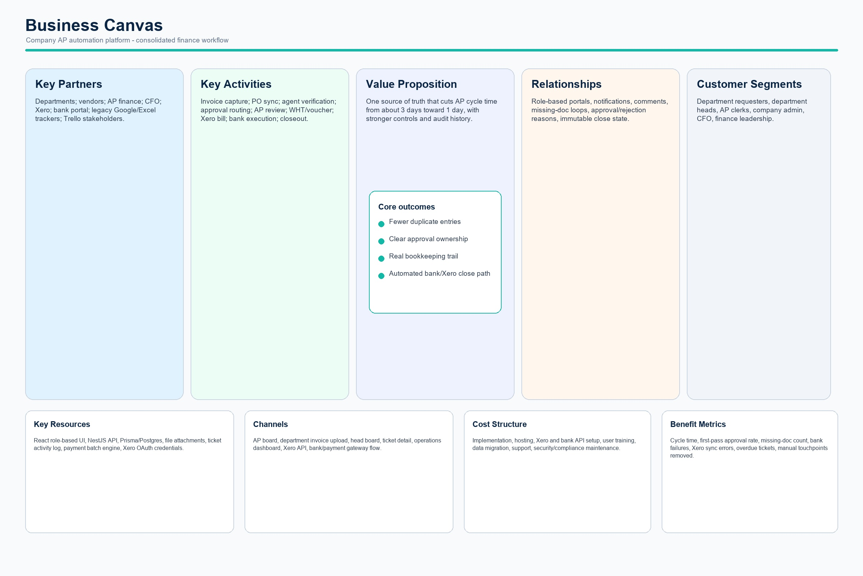
Business canvas

2. Process Flow
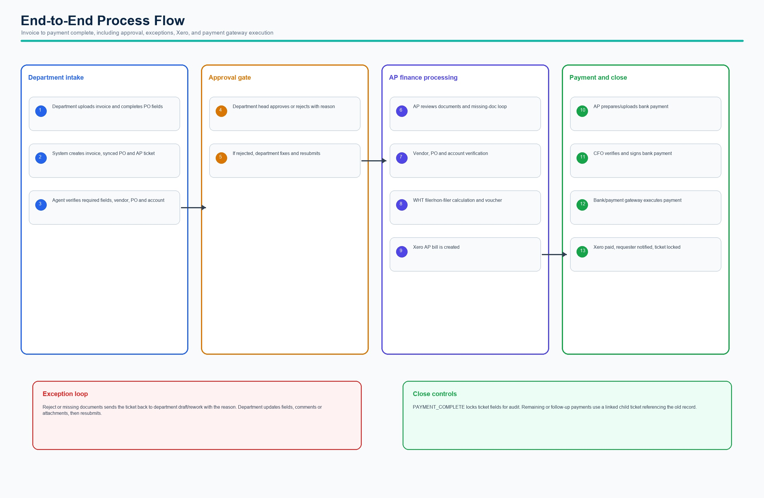
Process flow

3. Functional Architecture Diagram
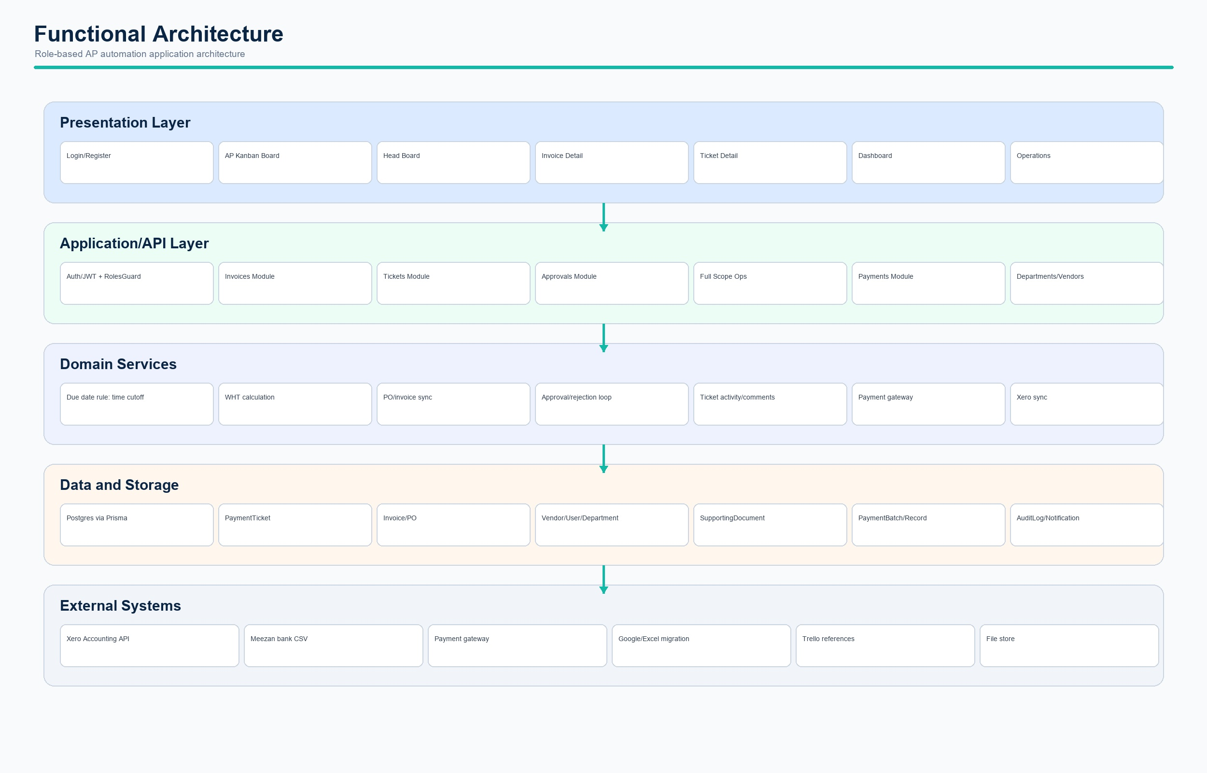
Functional architecture

4. Integration Diagram
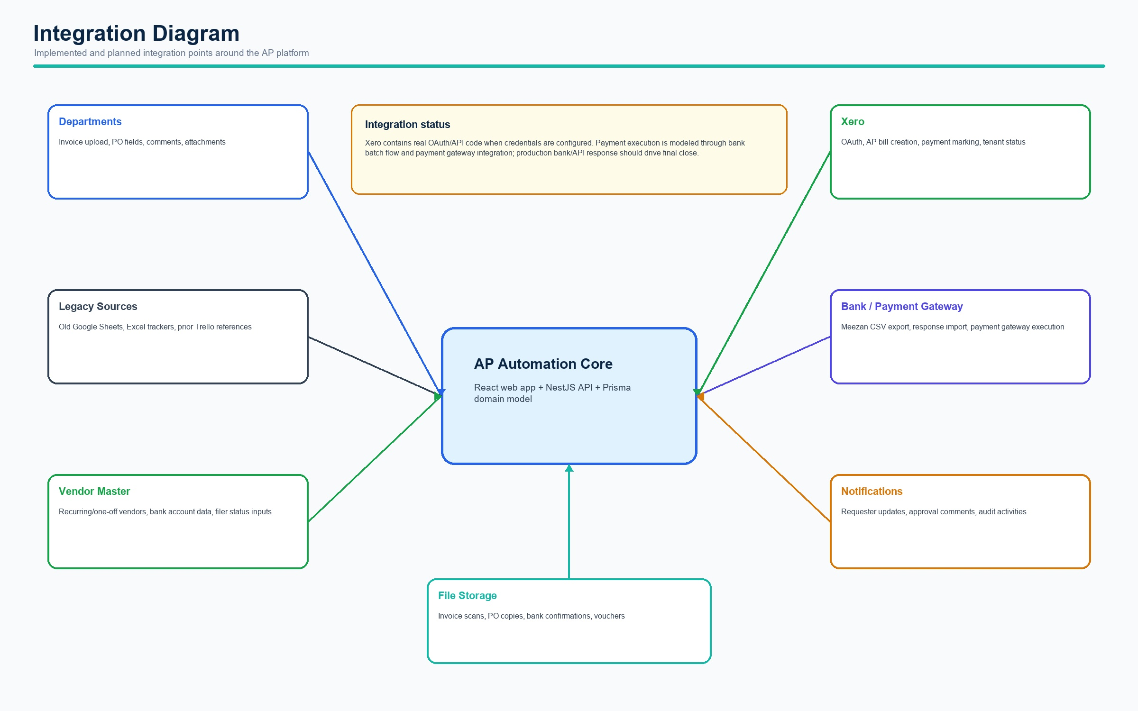
Integration diagram

5. Swimlane Diagram
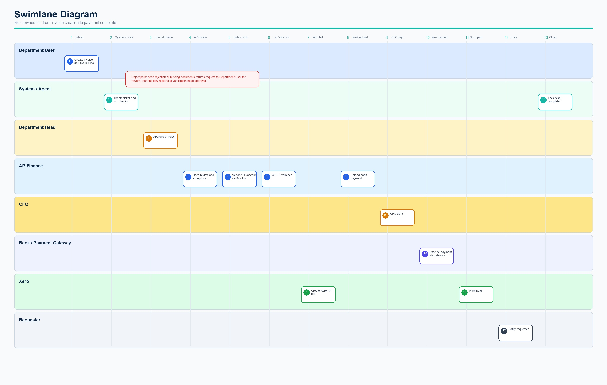
Swimlane diagram

6. Application Design
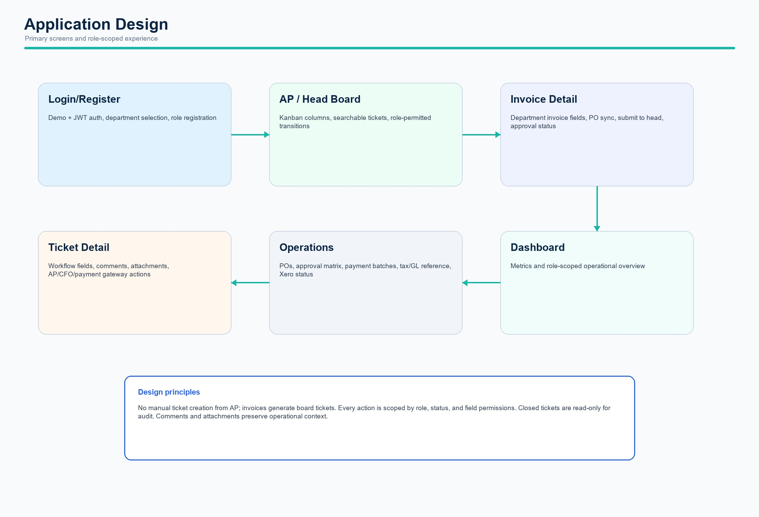
Application design
Role | Responsibility
DEPT_USER | Create invoice/PO, complete department fields, respond to rejection or missing docs.
DEPT_ADMIN | View department head board, read ticket, approve or reject with reason.
AP_CLERK | Run finance workflow, assign AP/CFO, verify docs/data, WHT, Xero, bank and close.
CFO | Open CFO sign pending tickets and record bank authorization.
COMPANY_ADMIN | Full administrative scope across departments, operations, Xero setup and rules.

7. Product Requirements Document
The PRD defines the product goal as replacing fragmented AP tracking with a governed, role-scoped workflow that reduces cycle time and manual entry while preserving finance controls.
Step | Stage | Owner | Output
1 | Department creates invoice | DEPT_USER / COMPANY_ADMIN | Invoice + synced PO draft, AP ticket NEW_REQUEST
2 | Agent verification | System | Required fields, vendor, account, PO and amount checks
3 | Department head decision | DEPT_ADMIN | Approve to finance or reject with reason
4 | AP document review | AP_CLERK | Complete docs or missing-doc loop to requester
5 | Data verification | AP_CLERK | Vendor, PO, invoice account, old sheet/reference validation
6 | WHT and voucher | AP_CLERK | Filer/non-filer rate, WHT amount, net payable, voucher
7 | Xero bill | AP_CLERK / COMPANY_ADMIN | AP bill sync and Xero bill identifiers
8 | Payment preparation | AP_CLERK | Payment file/batch and bank portal reference
9 | CFO sign | CFO | CFO authorizes bank portal payment
10 | Bank execution | AP / Payment Gateway | Executed status or payment gateway confirmation
11 | Xero paid and close | AP / System | Mark paid, notify requester, lock ticket

Integration Notes
- Xero: real OAuth and Accounting API code exists for bill creation and payment marking when tenant credentials are configured.
- Bank/payment gateway: current implementation supports Meezan-style CSV export/import concepts and payment gateway execution flow. Production should use bank API/file response integration.
- Legacy data: schema and operations include old sheet references and Google CSV import/migration support.
- Trello: ticket fields store Trello card IDs/URLs for continuity; full Trello API sync is future scope.

Traceability
Area | Current Implementation
Workflow status engine | api/src/tickets/tickets.service.ts
Approval logic | api/src/approvals and api/src/invoices
Xero integration | api/src/full-scope/full-scope.service.ts
Payment gateway flow | api/src/tickets/tickets.service.ts and dev-mock-api.cjs
Role UI | web/src/pages and web/src/components/Layout.tsx

