Product Requirements Document (PRD)
Company AP Automation
Generated: 21 May 2026 | Project: Company AP Automation

Problem Statement
The current AP process uses Trello, Google Sheets, Excel sheets, email invoices, bank portal activity and Xero bookkeeping separately. This creates duplicate entry, missing status visibility, slower approvals, higher error risk and unclear ownership.

Goals
- Centralize AP requests into one workflow and board.
- Reduce manual touchpoints and target a one-day processing cycle where documents are complete.
- Make department head approval explicit before AP finance processing.
- Integrate bookkeeping through Xero and payment execution through bank/payment gateway workflow.
- Preserve audit trail through comments, attachments and locked completed tickets.

Out of Scope / Future Production Hardening
- Production bank API credentials and payment gateway callback/response handling.
- Full Trello API synchronization beyond reference fields.
- Automated OCR quality guarantees for every invoice format.

Personas
Persona | Need
DEPT_USER | Create invoice/PO, complete department fields, respond to rejection or missing docs.
DEPT_ADMIN | View department head board, read ticket, approve or reject with reason.
AP_CLERK | Run finance workflow, assign AP/CFO, verify docs/data, WHT, Xero, bank and close.
CFO | Open CFO sign pending tickets and record bank authorization.
COMPANY_ADMIN | Full administrative scope across departments, operations, Xero setup and rules.

Functional Requirements
ID | Requirement | Acceptance Criteria
FR-01 | Department invoice creation | Department user can create/upload invoice; system creates linked PO and AP ticket.
FR-02 | Agent verification | Request cannot move to head until key invoice, PO, vendor and amount checks pass.
FR-03 | Head approval/rejection | Head sees read-only request, can approve or reject with reason; buttons hide after decision.
FR-04 | AP workflow board | AP sees finance statuses and can move only permitted transitions.
FR-05 | Missing document loop | AP can mark incomplete, requester can fix and resubmit.
FR-06 | WHT and voucher | Filer/non-filer rate calculates WHT and net payable; voucher number stored.
FR-07 | Xero bill and paid marking | Xero bill and payment IDs are stored; failures are visible.
FR-08 | Bank execution | CFO signs; AP can execute manually or receive payment gateway confirmation.
FR-09 | Attachments/comments | Users can add/download allowed attachments and comments by role/stage.
FR-10 | Audit lock | PAYMENT_COMPLETE ticket cannot be edited.

Workflow
Step | Stage | Owner | Output
1 | Department creates invoice | DEPT_USER / COMPANY_ADMIN | Invoice + synced PO draft, AP ticket NEW_REQUEST
2 | Agent verification | System | Required fields, vendor, account, PO and amount checks
3 | Department head decision | DEPT_ADMIN | Approve to finance or reject with reason
4 | AP document review | AP_CLERK | Complete docs or missing-doc loop to requester
5 | Data verification | AP_CLERK | Vendor, PO, invoice account, old sheet/reference validation
6 | WHT and voucher | AP_CLERK | Filer/non-filer rate, WHT amount, net payable, voucher
7 | Xero bill | AP_CLERK / COMPANY_ADMIN | AP bill sync and Xero bill identifiers
8 | Payment preparation | AP_CLERK | Payment file/batch and bank portal reference
9 | CFO sign | CFO | CFO authorizes bank portal payment
10 | Bank execution | AP / Payment Gateway | Executed status or payment gateway confirmation
11 | Xero paid and close | AP / System | Mark paid, notify requester, lock ticket

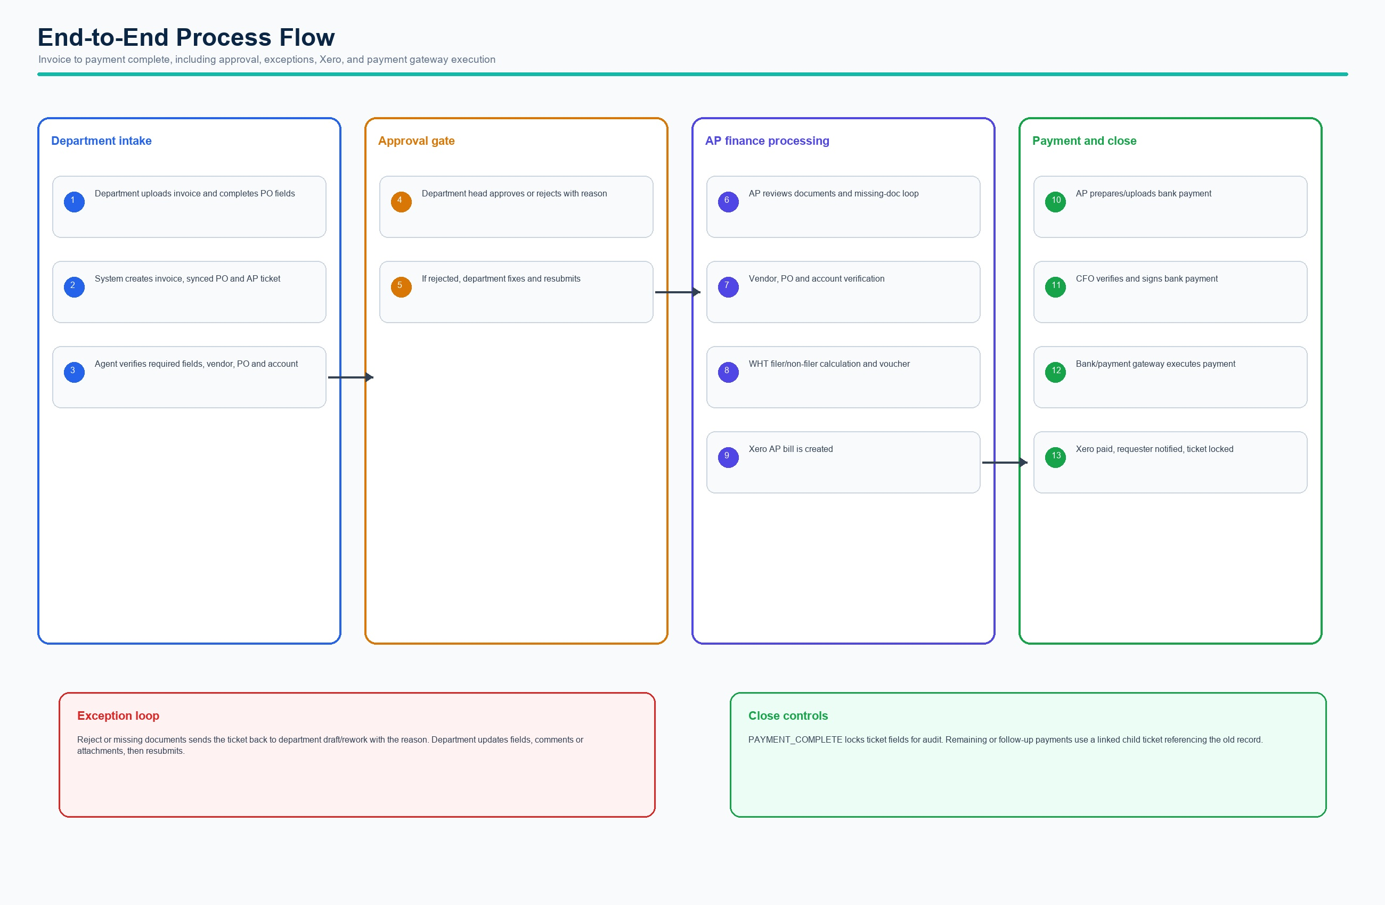
End-to-end process flow
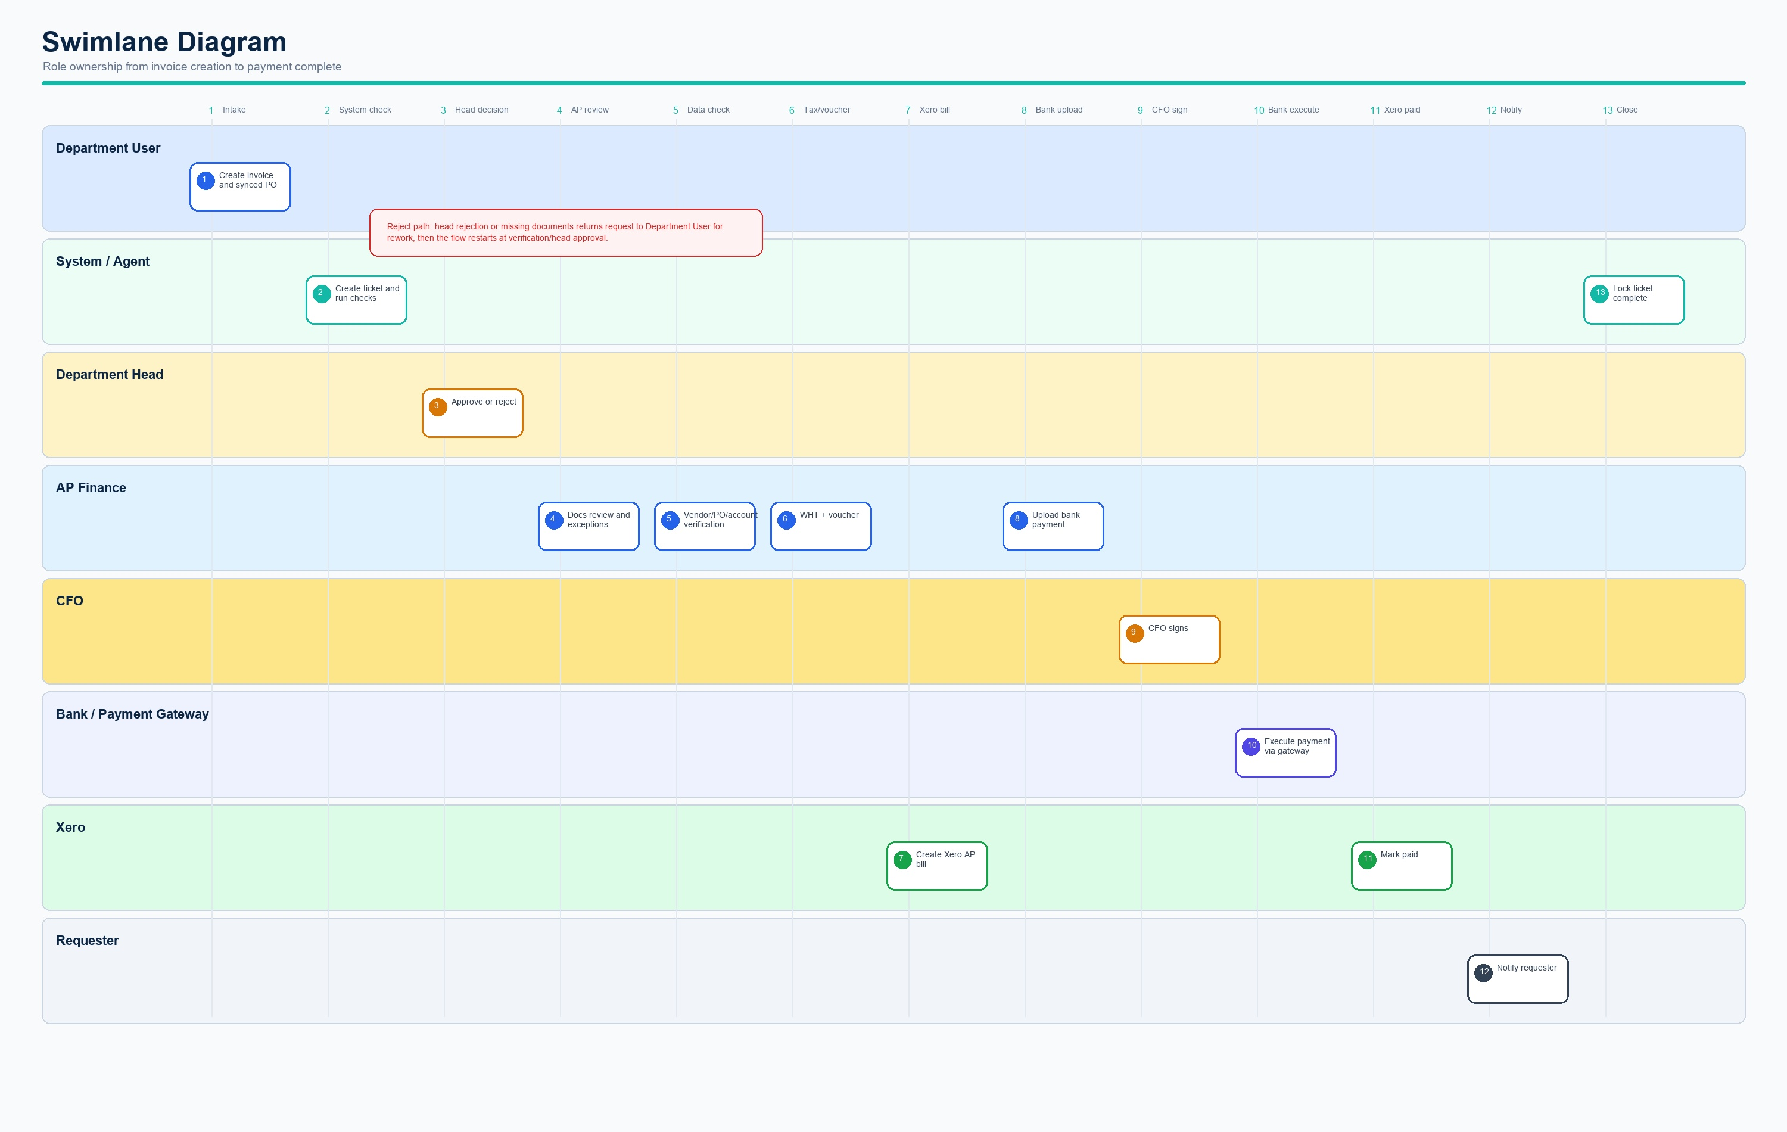
Swimlane role ownership

Success Metrics
- Average invoice-to-paid cycle time.
- Percentage of tickets completed within due date.
- First pass department head approval rate.
- Missing-doc loop count by department/vendor.
- Xero sync error rate and bank execution failure rate.

