LAB 3 QUERIES

Query 1: Write a query to report orders which were delayed shipped?

SELECT \* FROM Orders WHERE RequiredDate < ShippedDate;

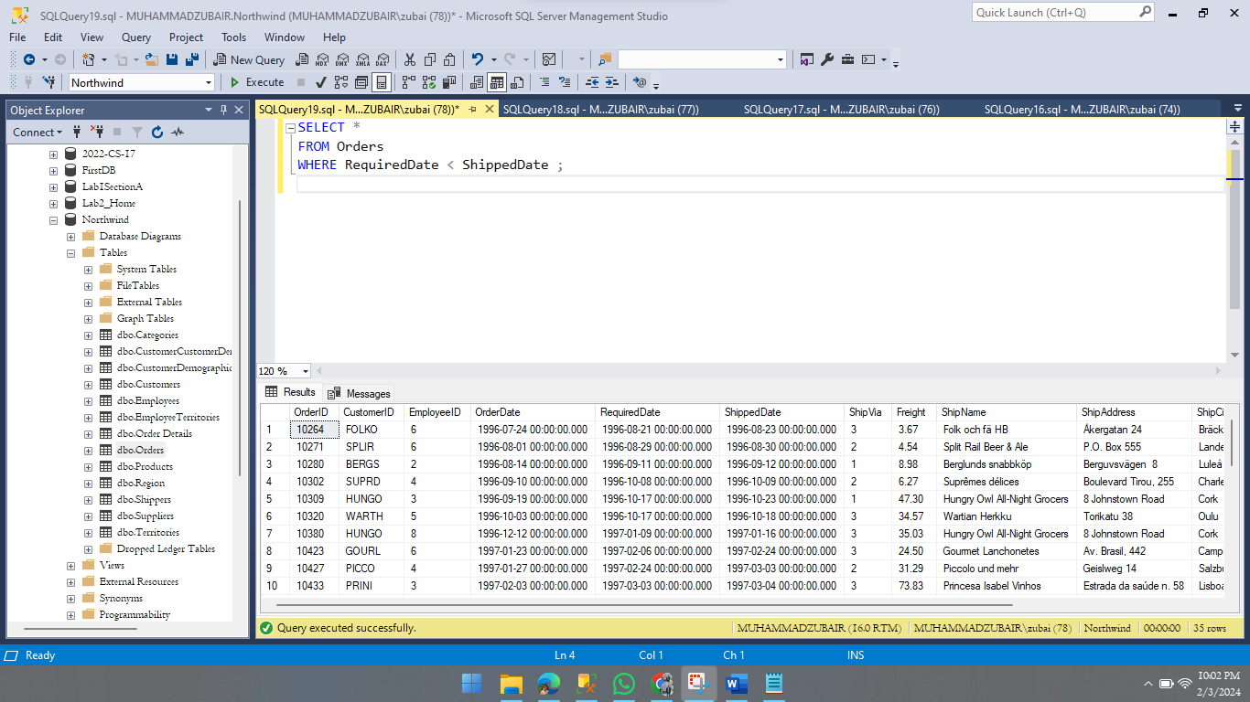

Query 2: Our employees belong to how many countries. List the names?

SELECT DISTINCT(Country) FROM Employees;

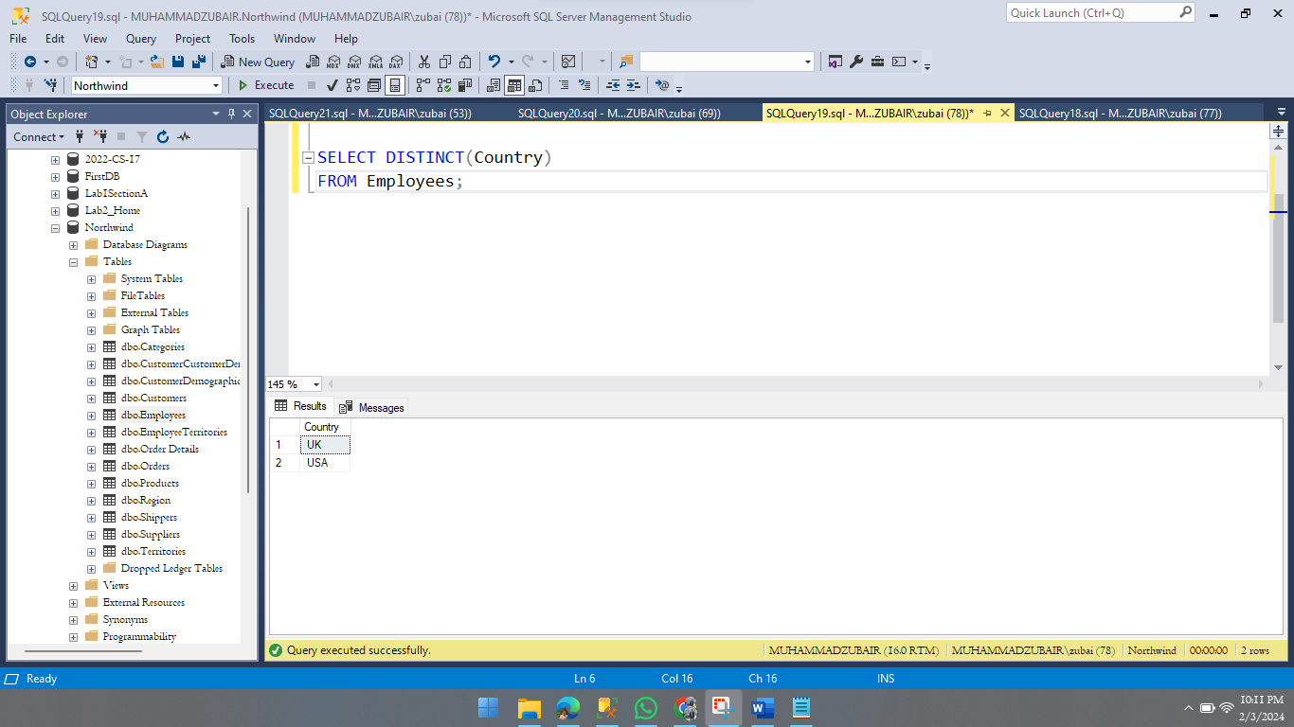

Query 3: Is there any employee who is not accountable?

SELECT \* FROM Employees WHERE ReportsTo IS Null;

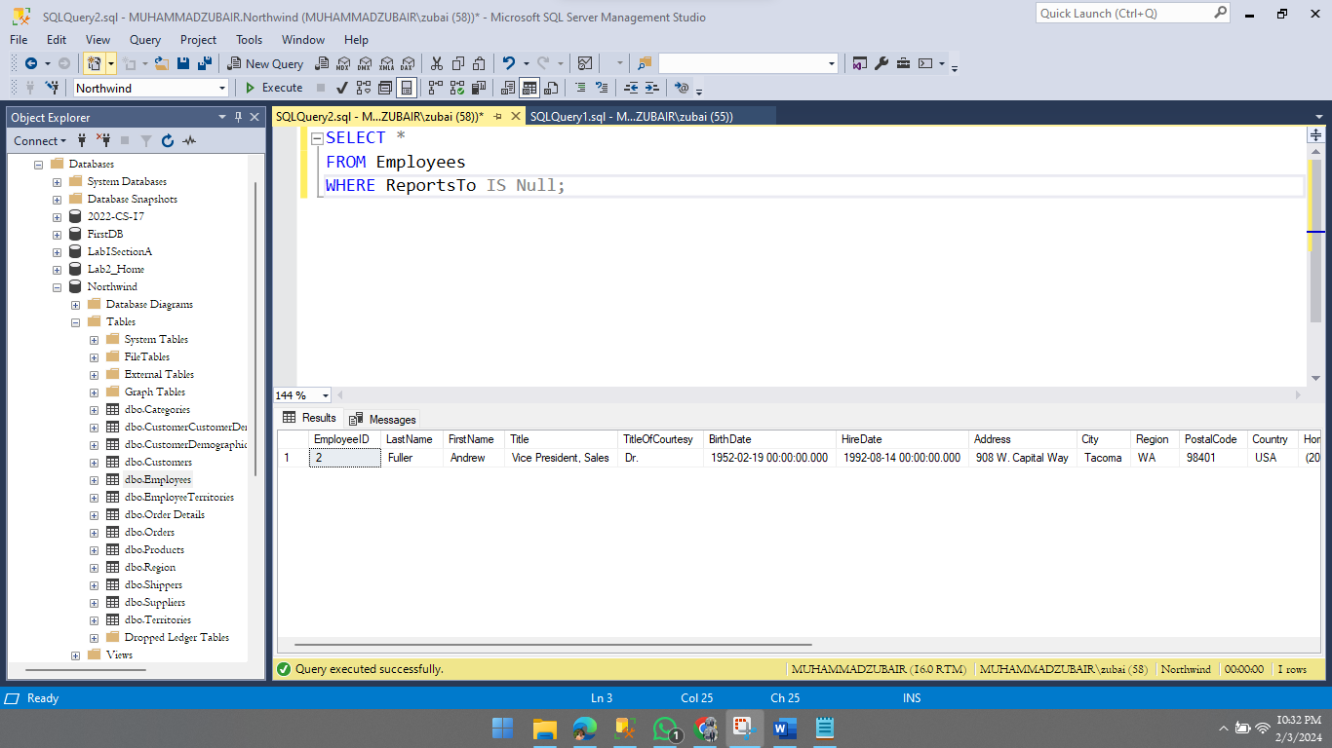

Query 4: List the names of products which have been discontinued?

SELECT ProductName FROM Products WHERE Discontinued=1;

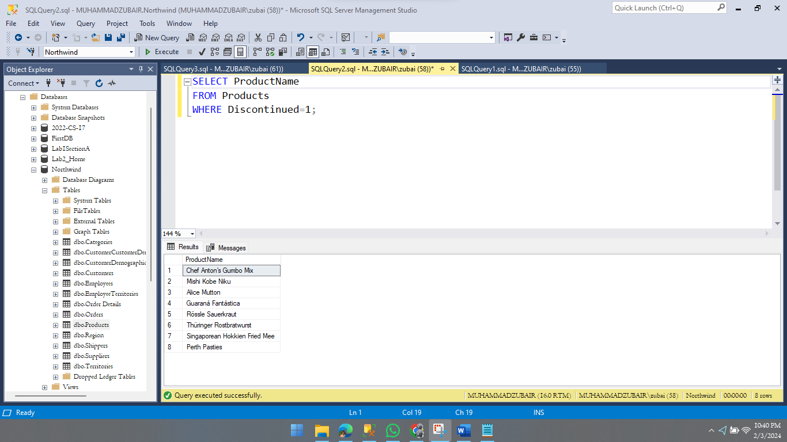

Query 5: List the IDs the orders on which discount was not provided?

SELECT \* FROM [Order Details] Where Discount=0 AND Discount Not Like '0.%';

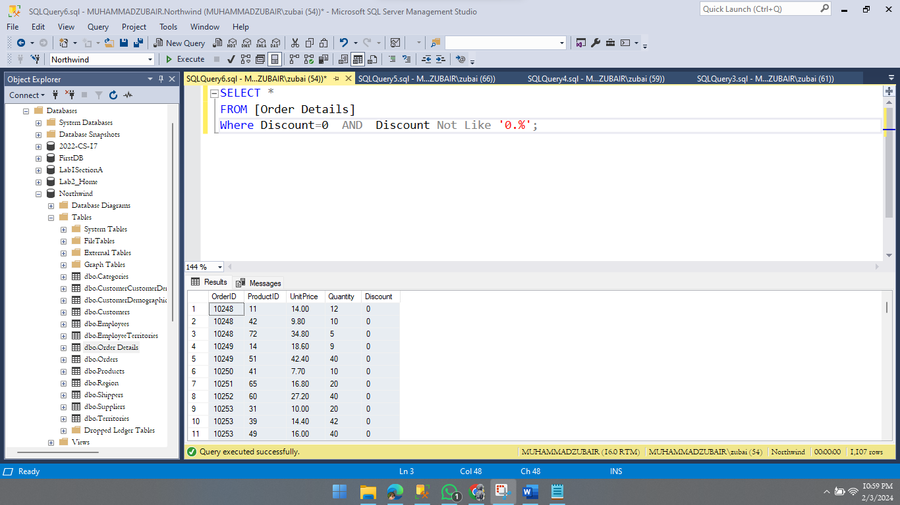

Query 6: Enlist the names of customers who have not specified their region?

SELECT ContactName FROM Customers WHERE Region is Null;

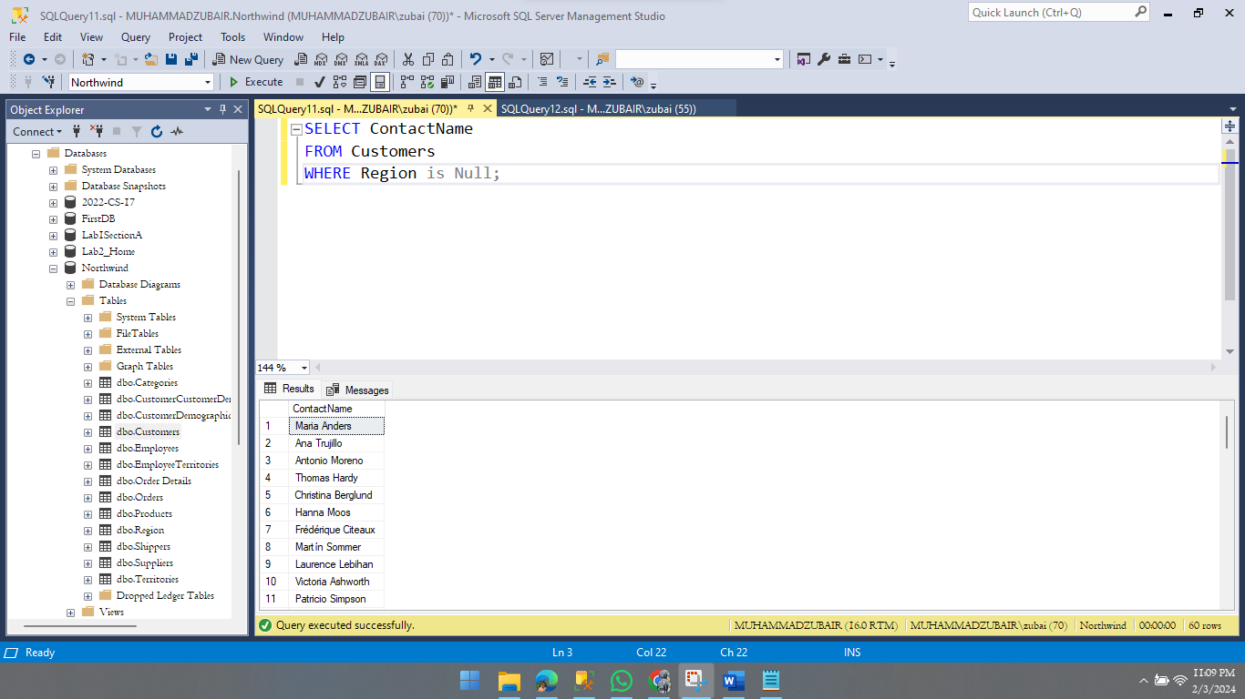

Query 7: Enlist the names of customers along with contact number who either belongs to UK or USA?

SELECT ContactName,Phone FROM Customers WHERE Country='UK' OR Country='USA';

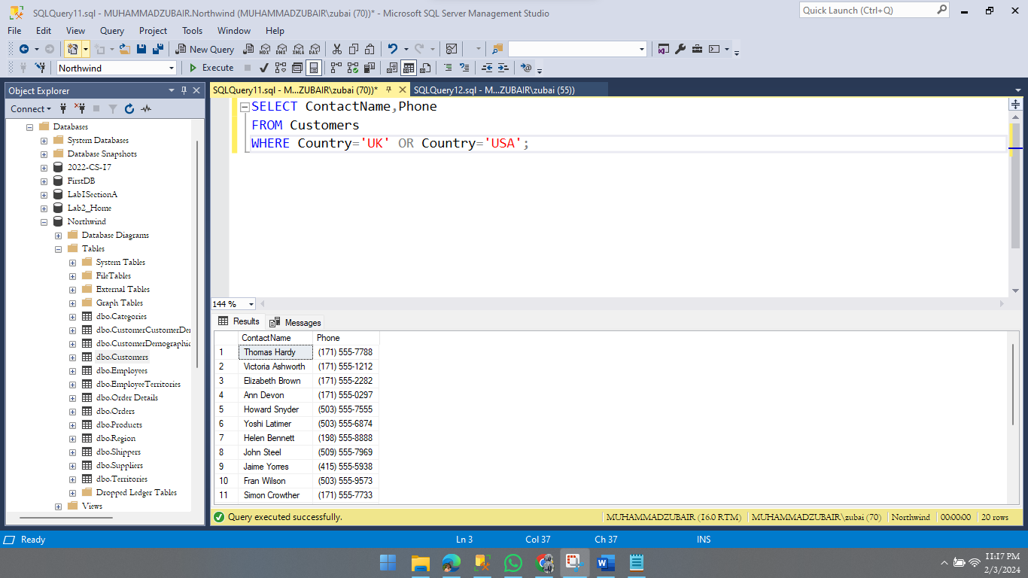Query 8: Report the names of companies who have provided their web page?

SELECT CompanyName FROM Suppliers WHERE HomePage is Not Null;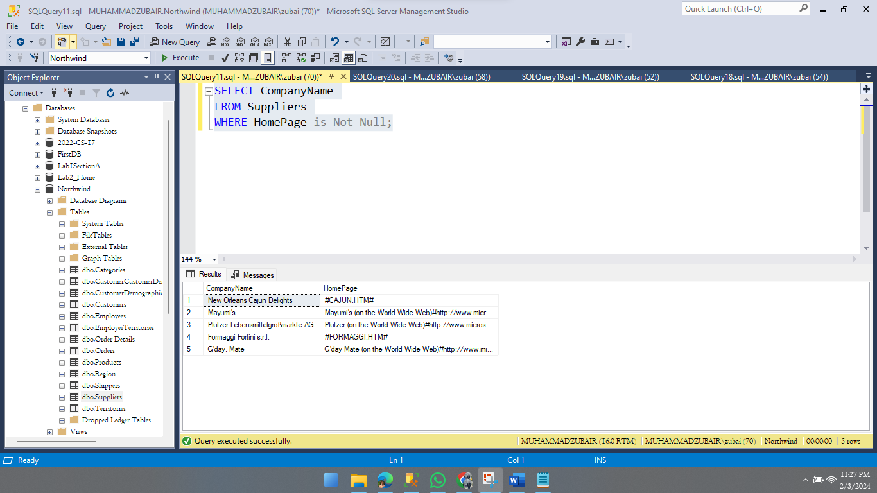

Query 9: In which countries, products were sold in year 1997?

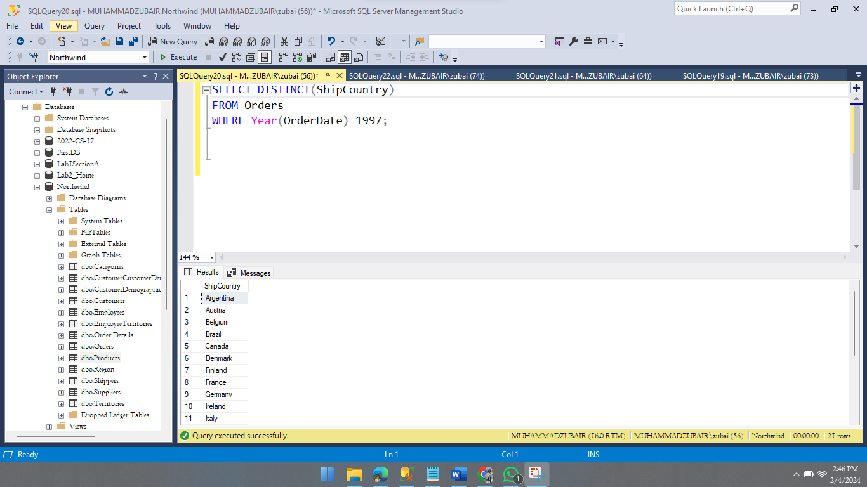 SELECT DISTINCT(ShipCountry) FROM Orders WHERE Year(OrderDate)=1997;

Query 10: List the ids of customers whose orders were never shipped?

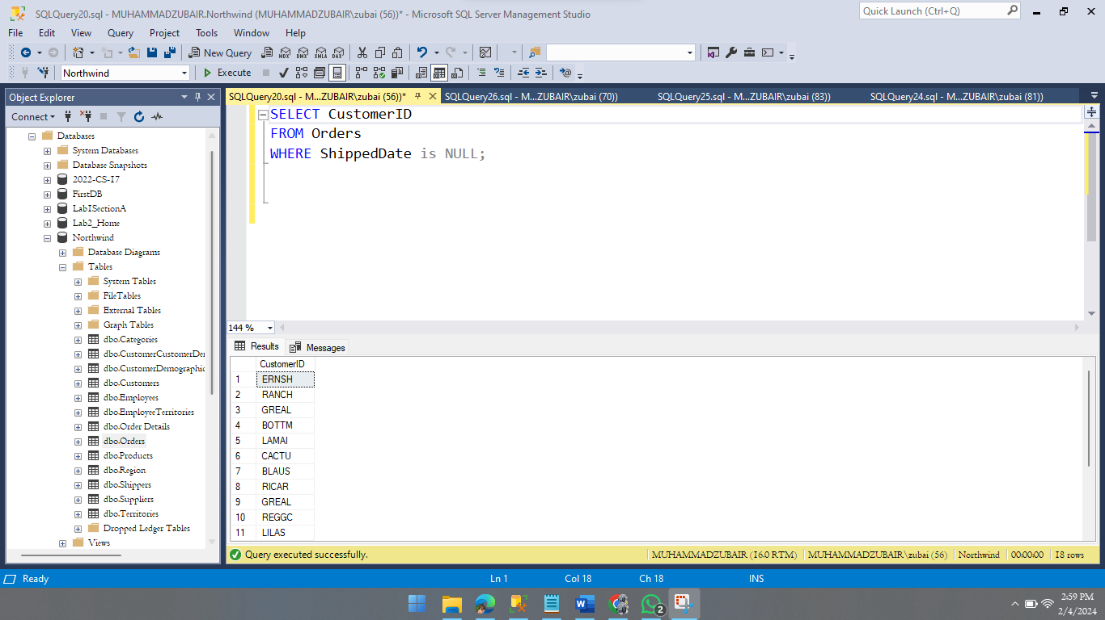 SELECT CustomerID FROM Orders WHERE ShippedDate is Null;

Query 11: Write a query to report suppliers with their id, company name and city?

SELECT SupplierID,CompanyName,City From Suppliers;

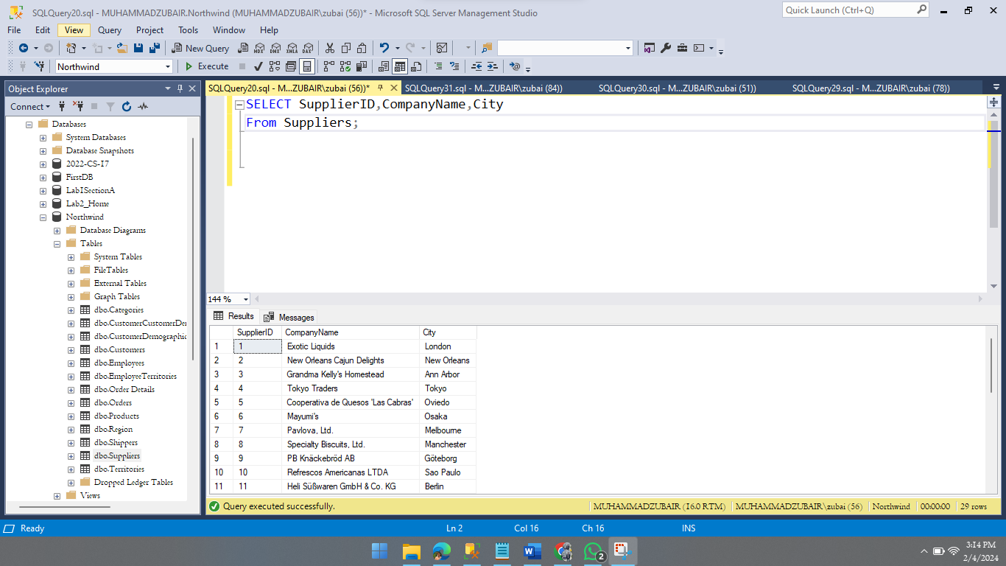

Query 12: Our employees belong to how many countries. List them who are used to live in London?

SELECT \* FROM Employees WHERE City='London';

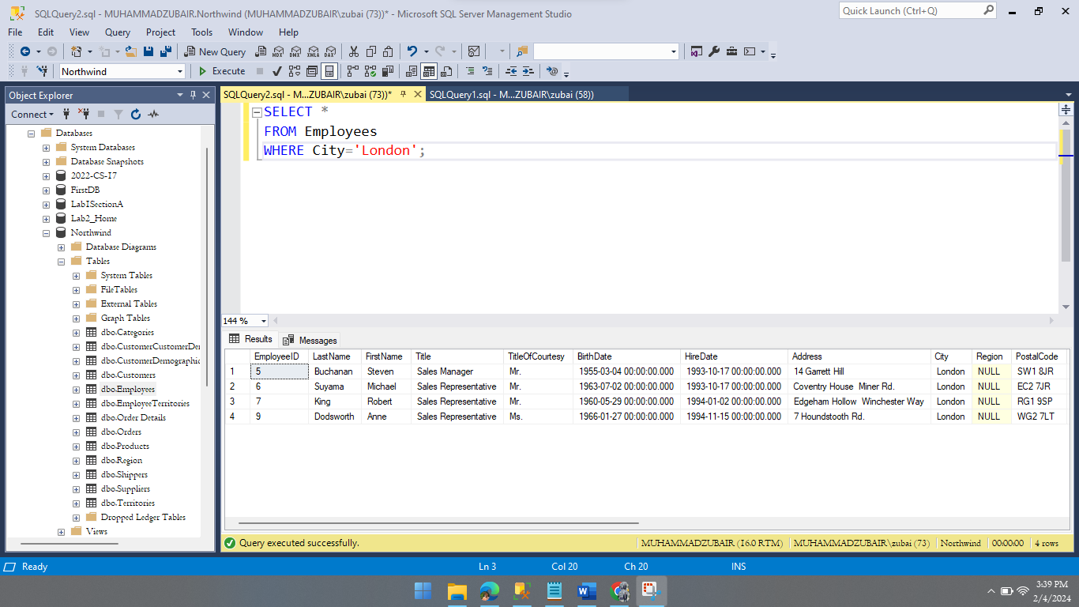

Query 13: List the names of products which have not been discontinued?

SELECT ProductName FROM Products WHERE Discontinued=0;

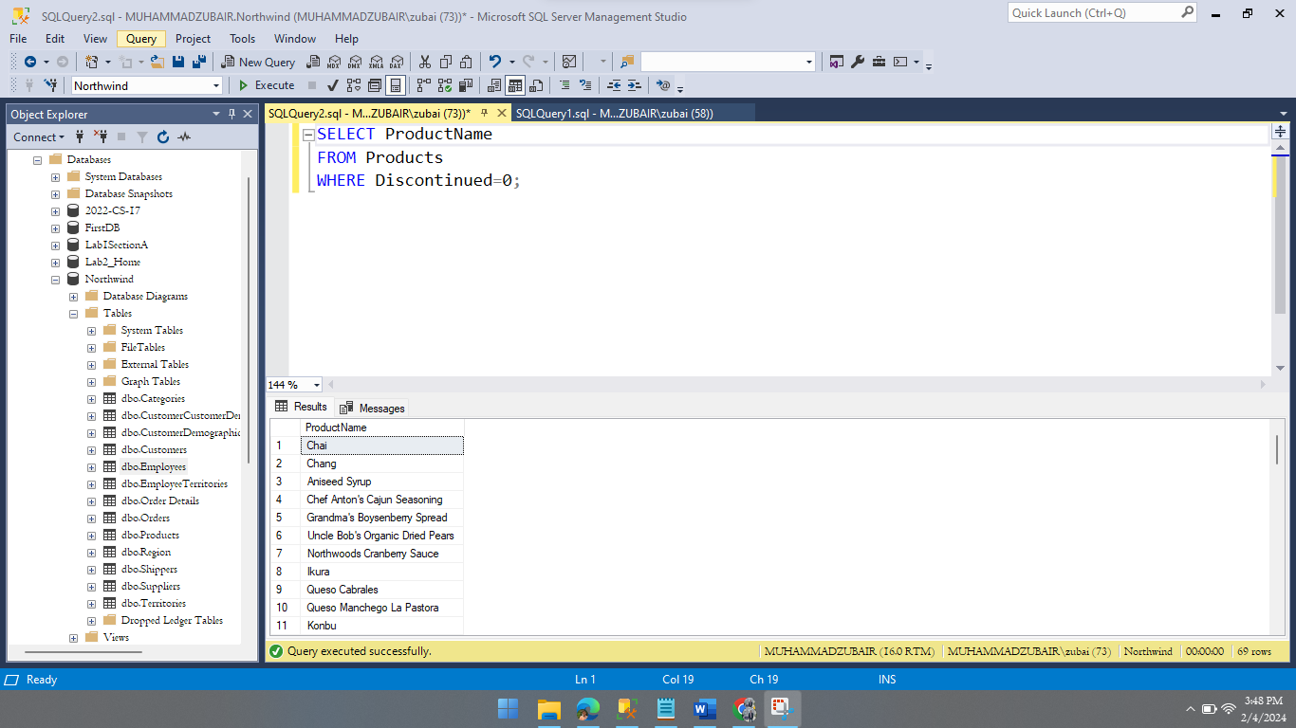

Query 14: List the IDs the orders on which discount was 0.1 or less?

SELECT OrderID FROM [Order Details] WHERE Discount<=0.1;

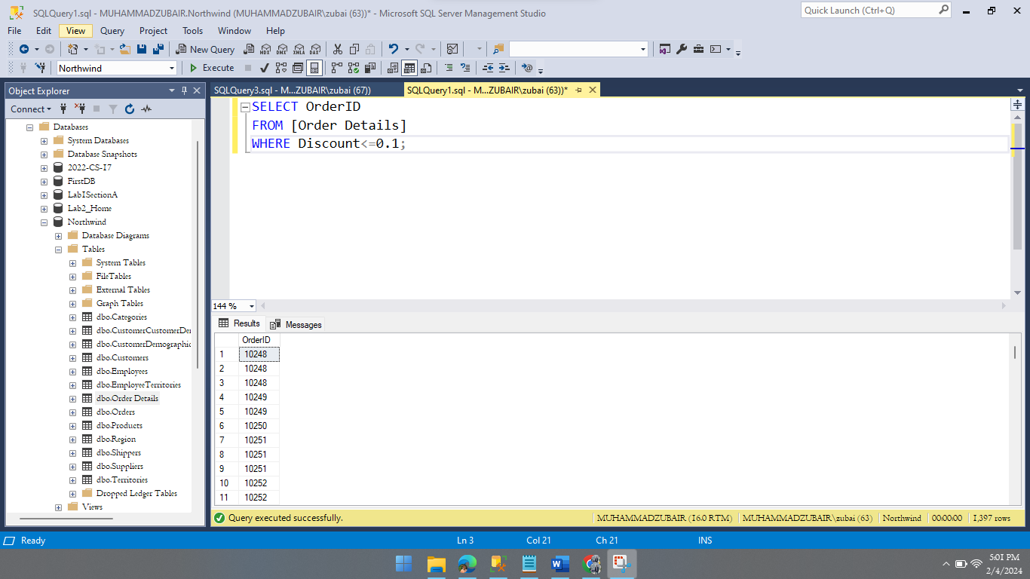

Query 15: Enlist the IDS, names of employees and their contact number with extensions who have not specified their region?

SELECT EmployeeID,LastName,FirstName,HomePhone,Extension FROM Employees WHERE Region is Null;

