COMPUTER NETWORKS PROJECT

Name: Muhammad Zubair Tariq
Roll no: 24i-2095
Section: Cyber-B
Submission Date: May 6, 2026

Project Objective & Given Parameters:

VLSM Calculations & IP Addressing Scheme:

Network | Required  Hosts | Allocated  Subnet (CIDR | Subnet Mask | Default  Gateway
Network I | 99,002 | 10.8.0.0 /15 | 255.254.0.0 | 10.8.0.1
Network B | 99,001 | 10.2.0.0 /15 | 255.254.0.0 | 10.2.0.1
Network E | 88,990 | 10.13.0.0/15 | 255.254.0.0 | 10.13.0.1
Network H | 77,889 | 10.10.0.0 /15 | 255.254.0.0 | 10.10.0.1
Network A | 66,778 | 10.0.0.0 /15 | 255.254.0.0 | 10.0.0.1
Network D | 55,667 | 10.12.0.0 /16 | 255.255.0.0 | 10.12.0.1
Network K | 55,667 | 10.1.0.0 /16 | 255.255.0.0 | 10.1.0.1

Network G | 44,556 | 10.11.0.0 /16 | 255.255.0.0 | 10.11.0.1
Network C | 22,345 | 10.14.0.0 /16 | 255.255.128.0 | 10.14.0.1
Network J | 22,334 | 10.54.0.0 /17 | 255.255.128.0 | 10.54.0.1
Network F | 11,234 | 10.16.0.0 /18 | 255.255.192.0 | 10.16.0.1

Network Topology Design:

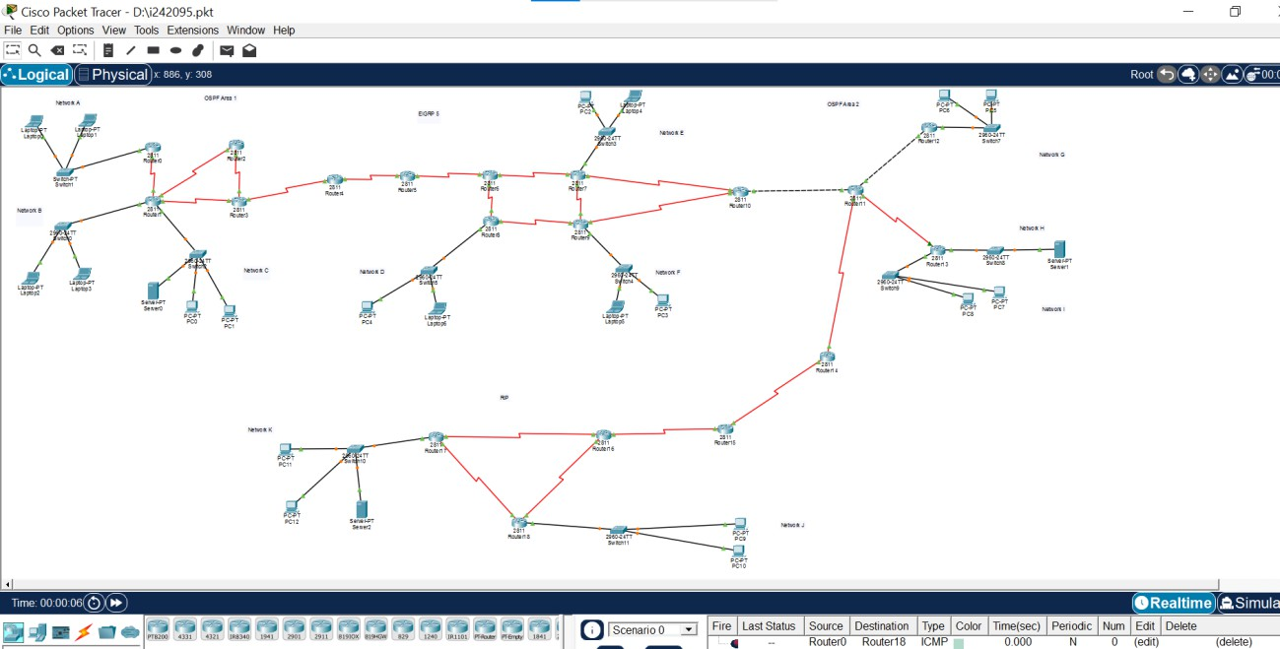

Access Control Lists (ACLs):
On Router 8 (To block all of Network D):
enable

configure terminal
! Corrected Target IP to 10.11.0.2
access-list 101 deny tcp 10.10.0.0 0.0.255.255 host 10.11.0.2 eq 80 access-list 101 permit ip any any
interface FastEthernet0/0 ip access-group 101 in
exit

On Router 0 (To block Laptop 0 from Network A):
enable
configure terminal
! Corrected Target IP to 10.11.0.2
access-list 101 deny tcp host 10.8.0.2 host 10.11.0.2 eq 80[cite: 1] access-list 101 permit ip any any[cite: 1]
interface FastEthernet0/0
ip access-group 101 in[cite: 1] exit

Testing & Verification:

End-to-End Routing & DHCP Verification:
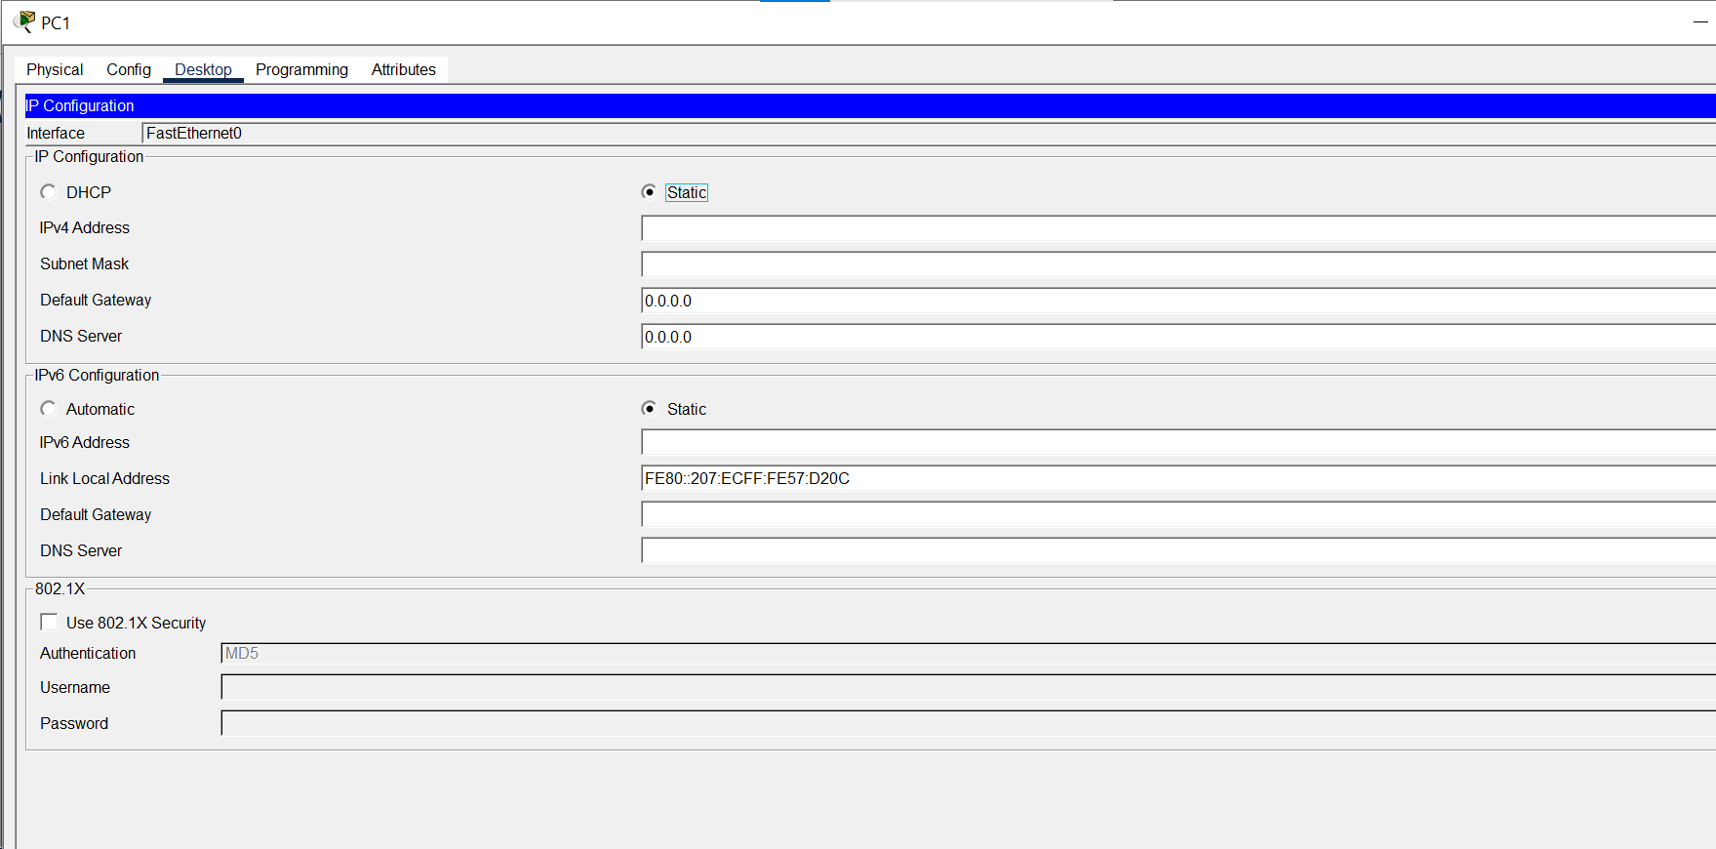

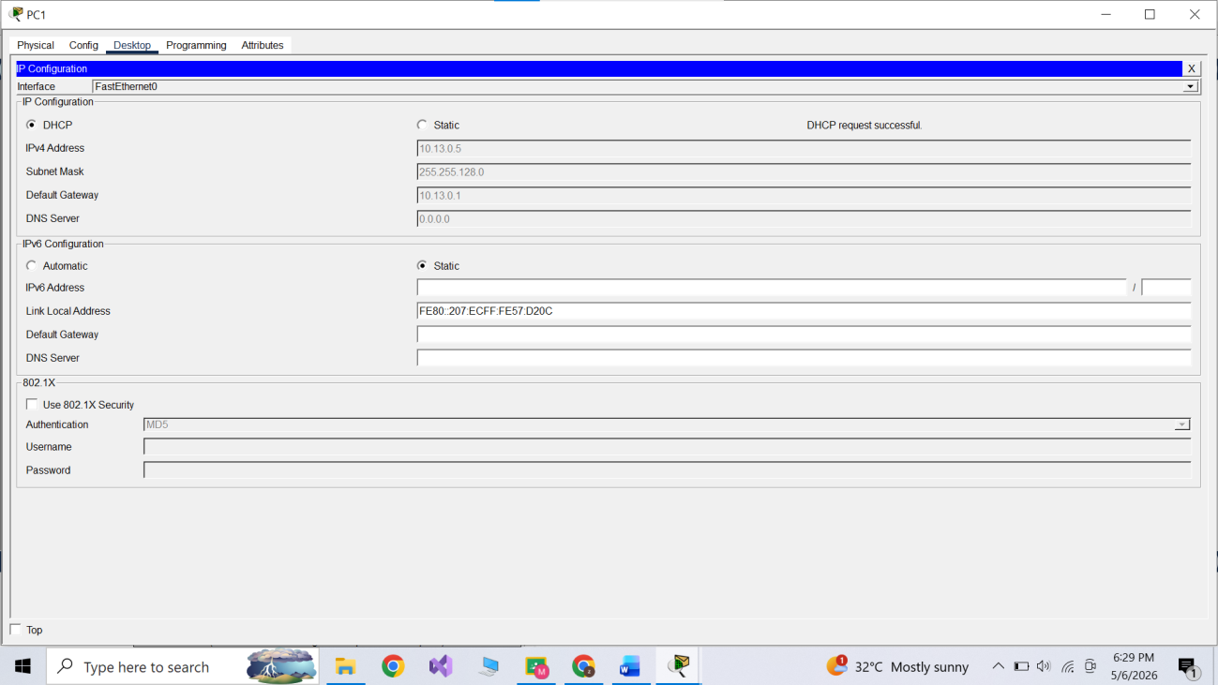

NAT Translation Verification:

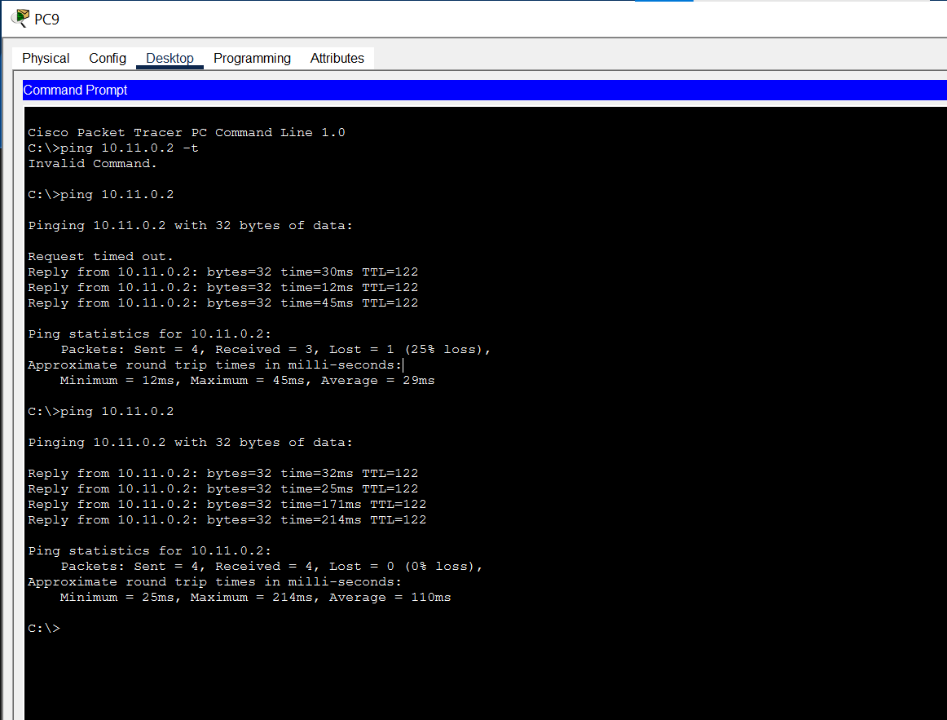

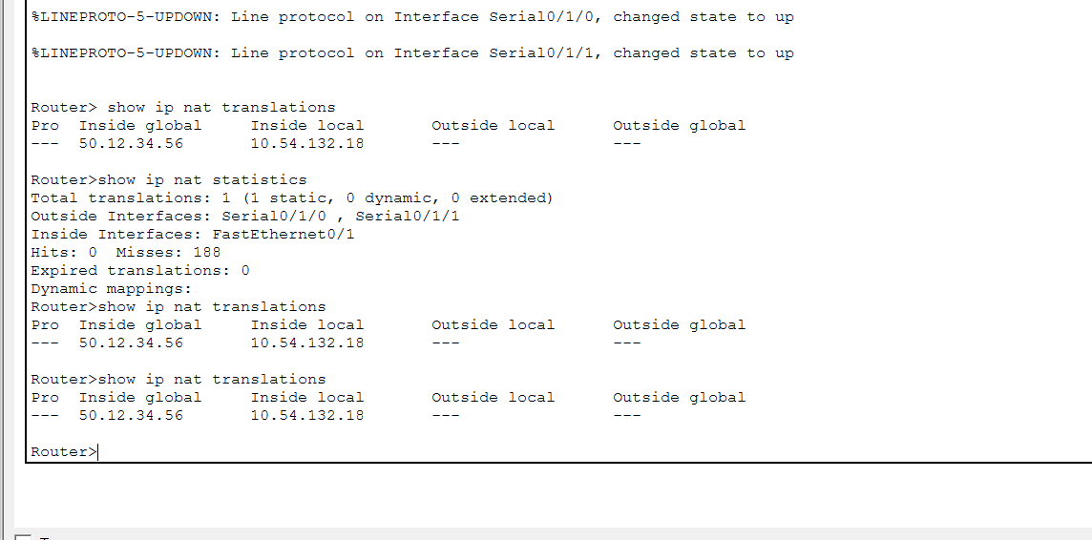

ACL Functionality Verification:
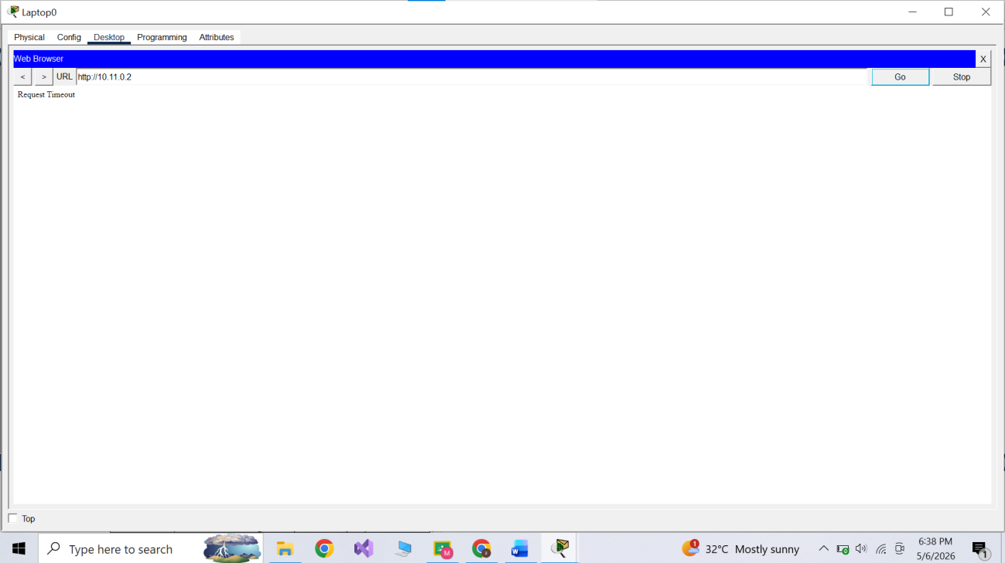

Mail Server Verification:
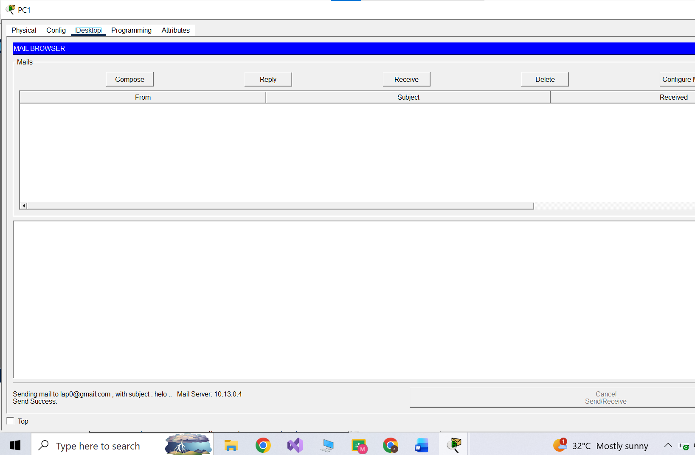

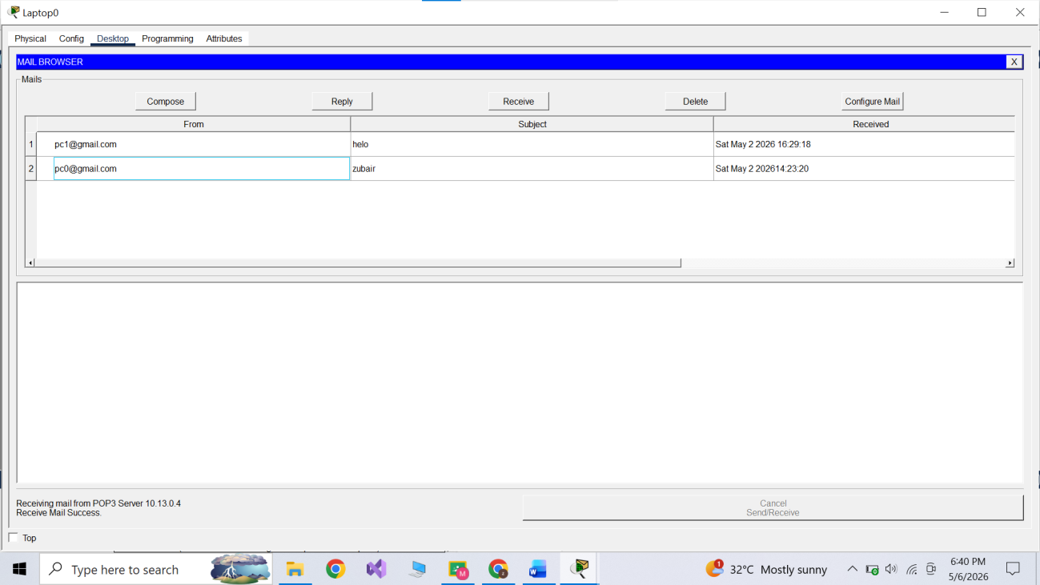

Screen shots:
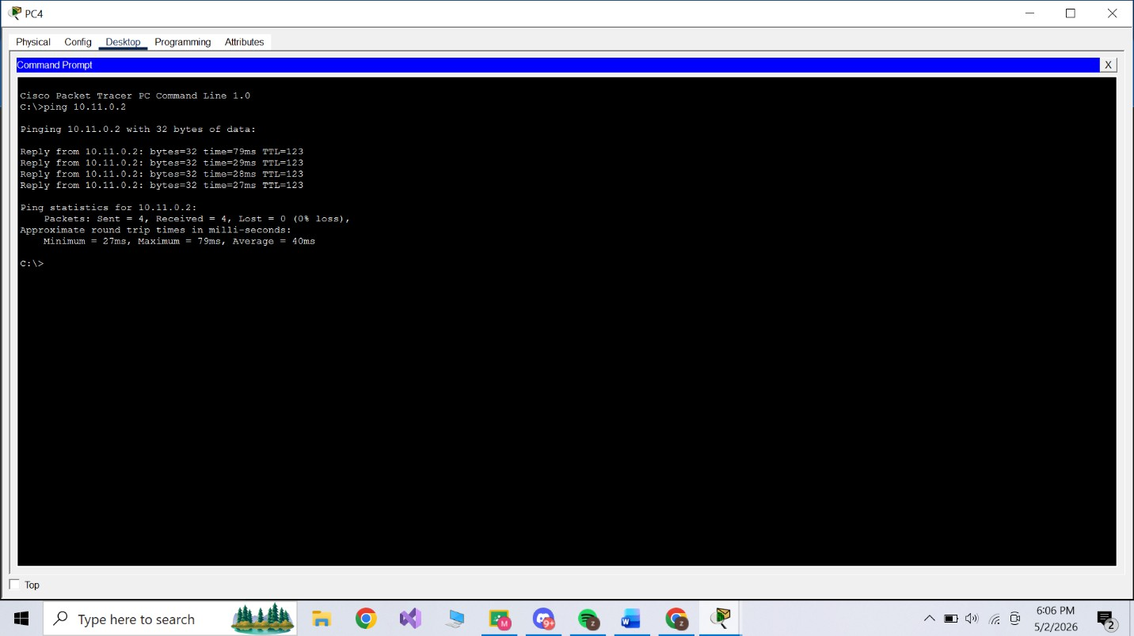

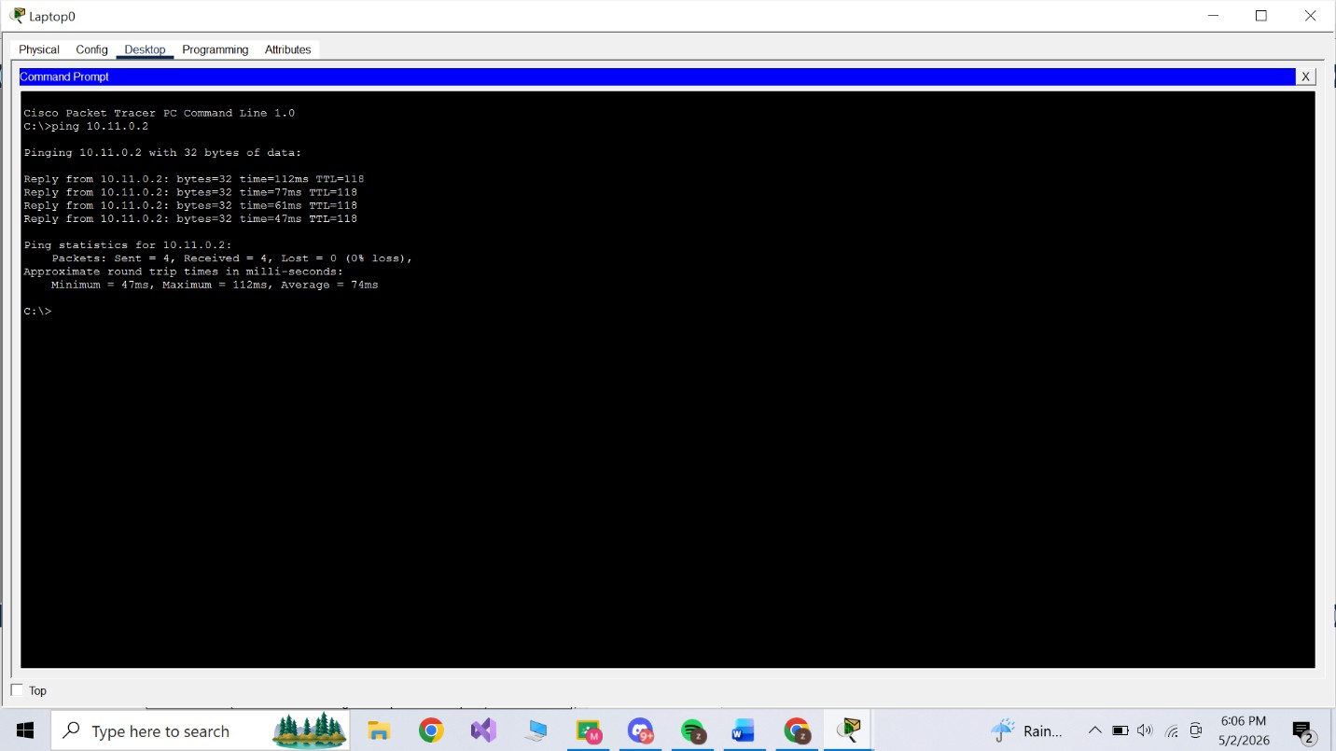

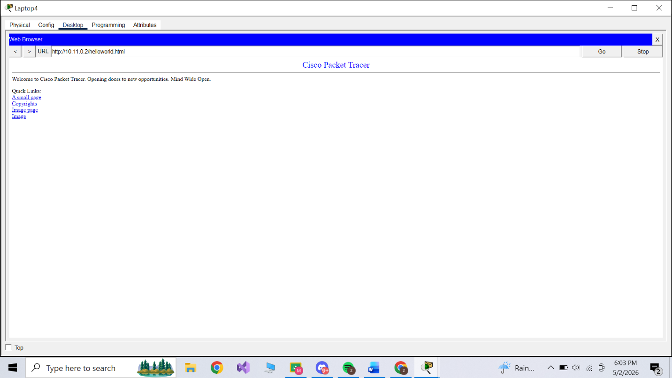

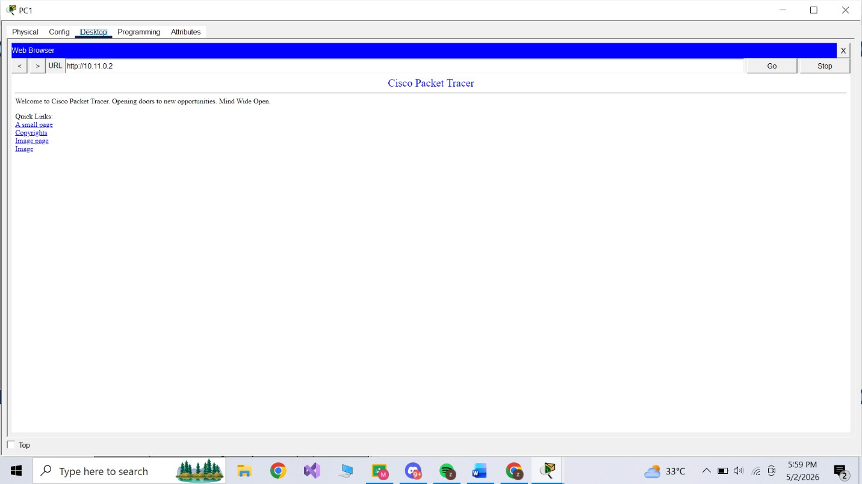
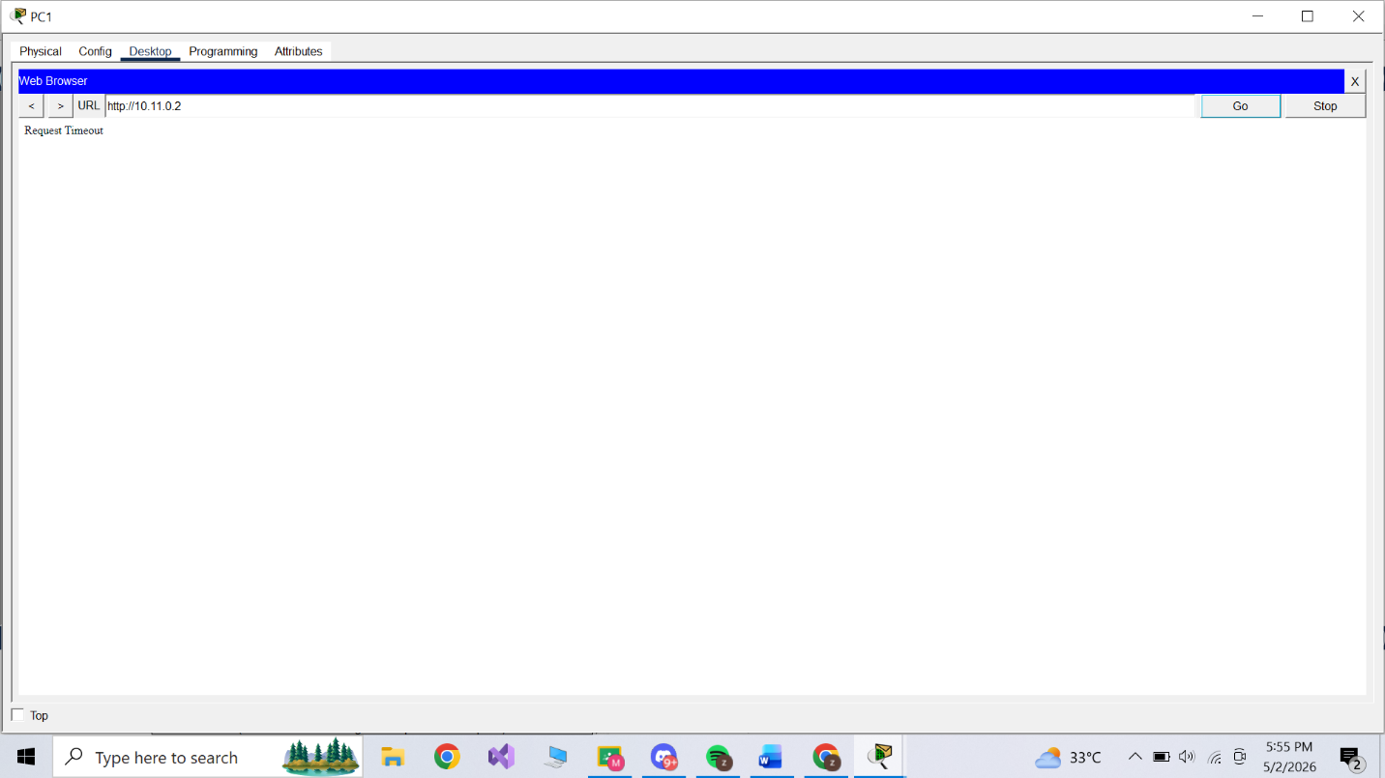

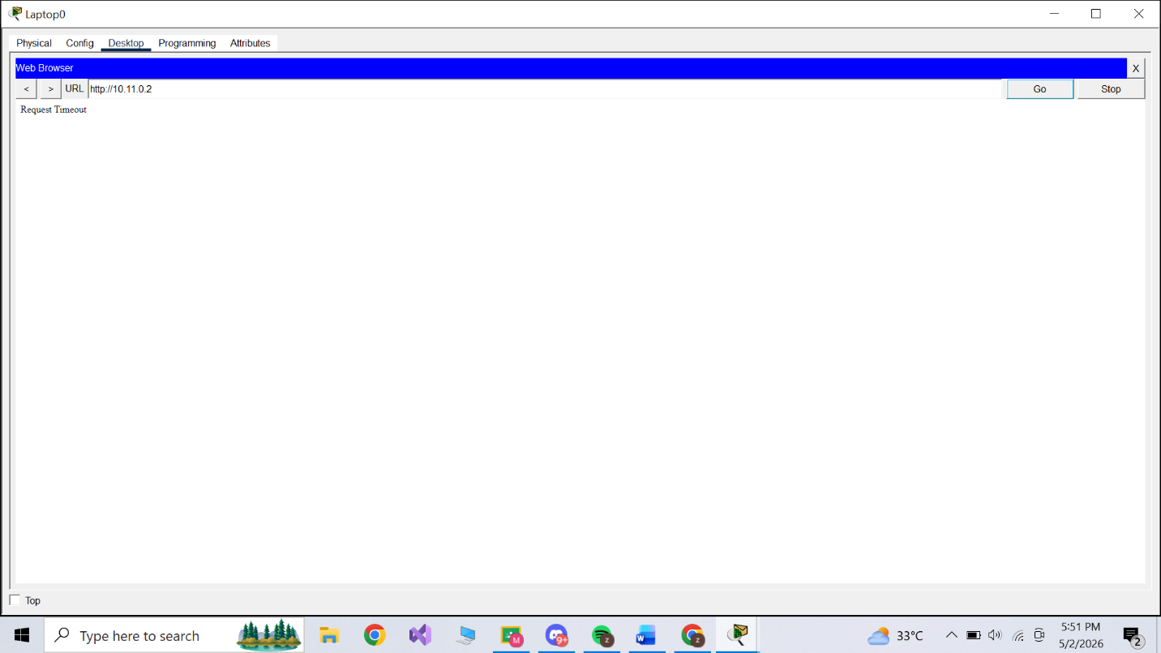
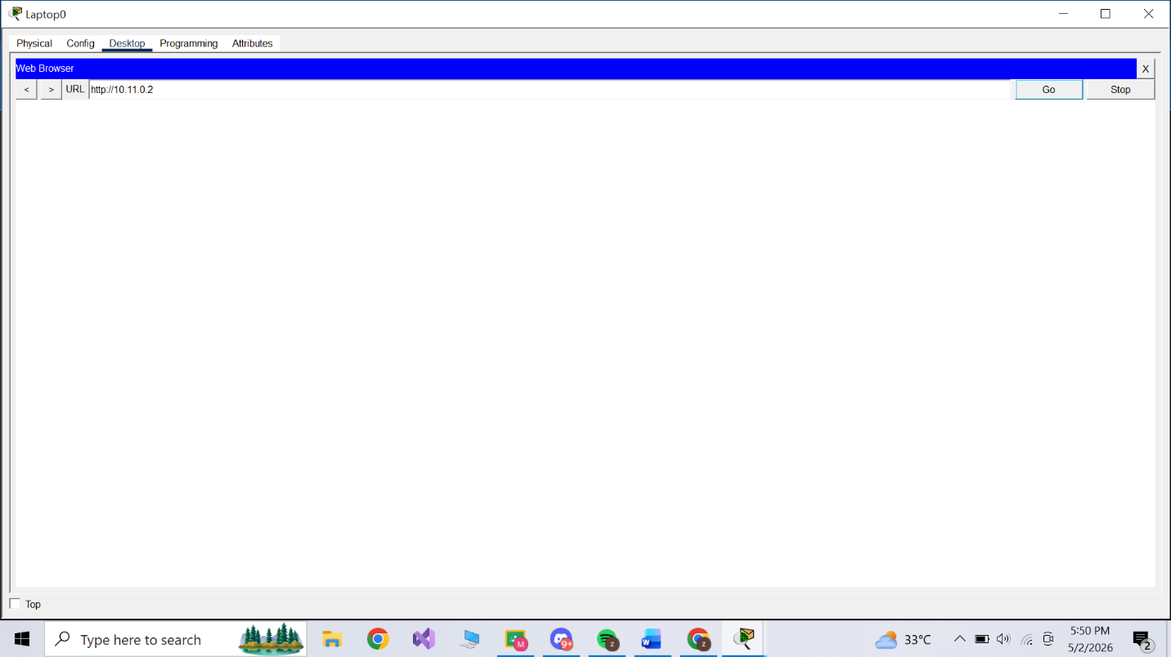

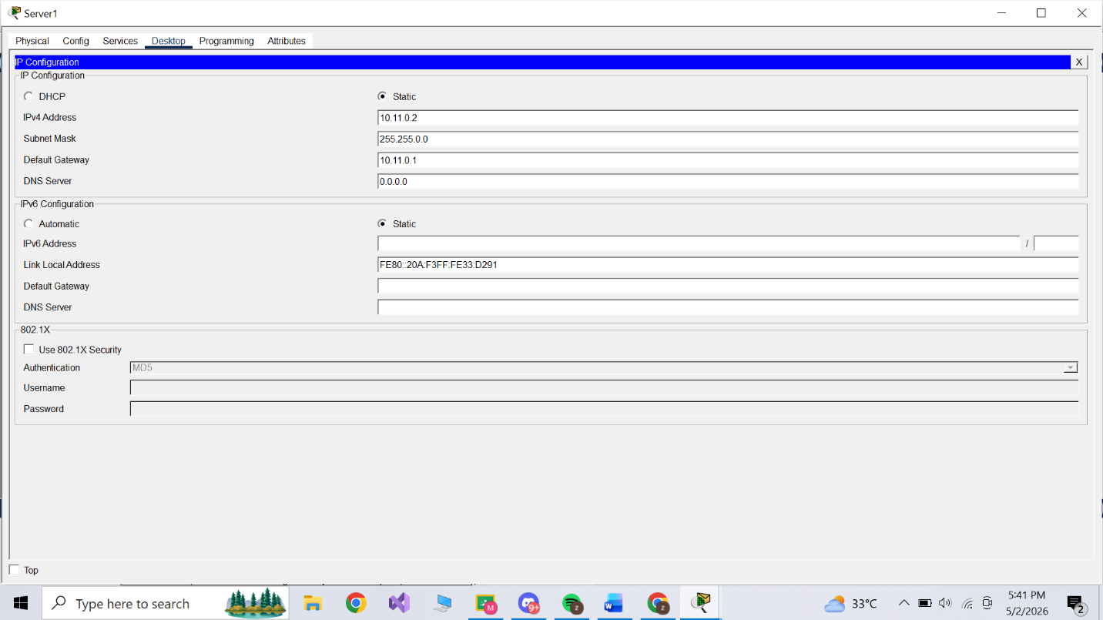

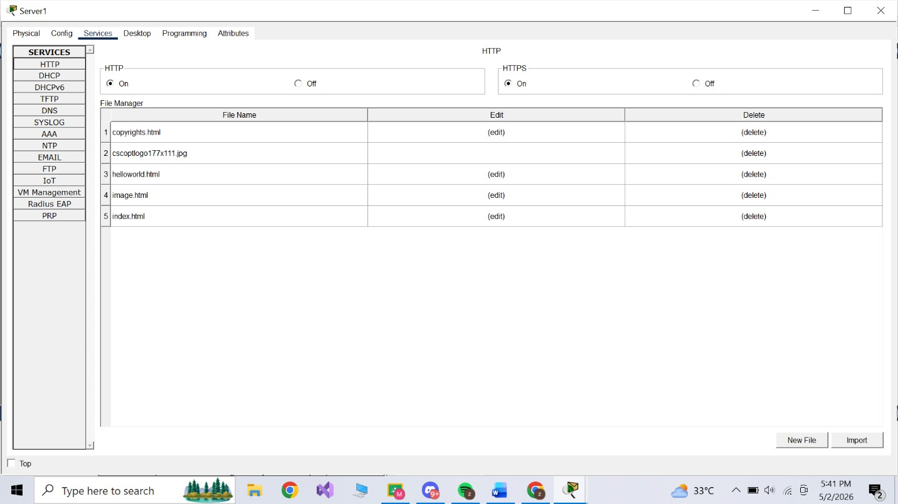

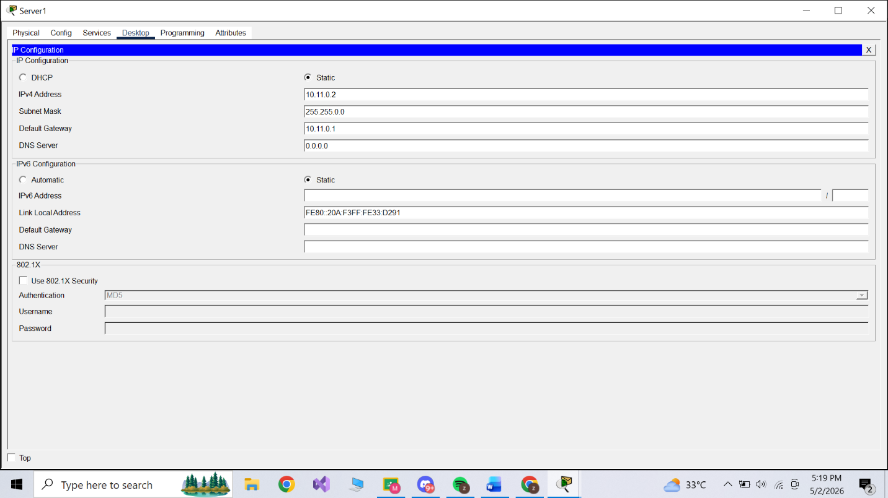

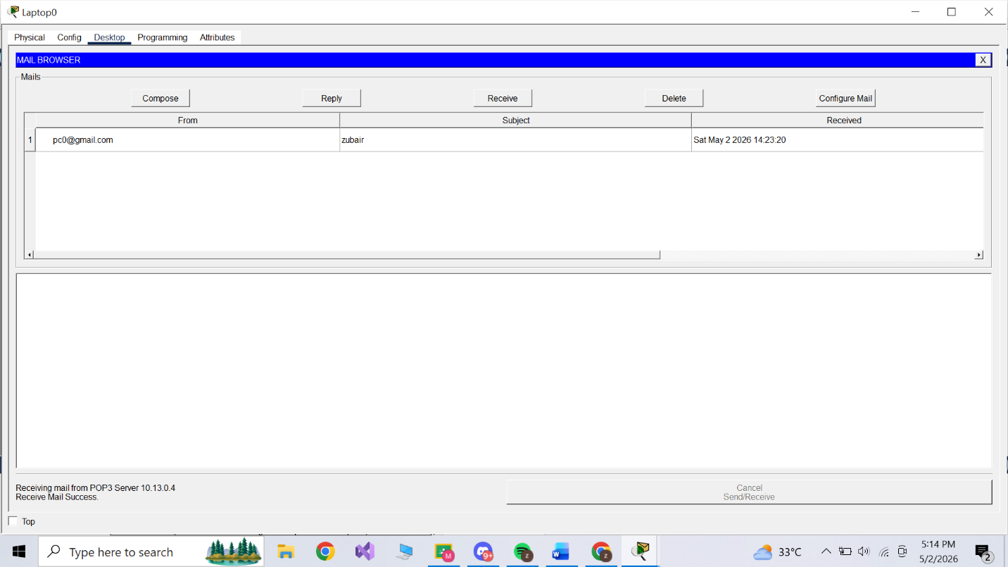

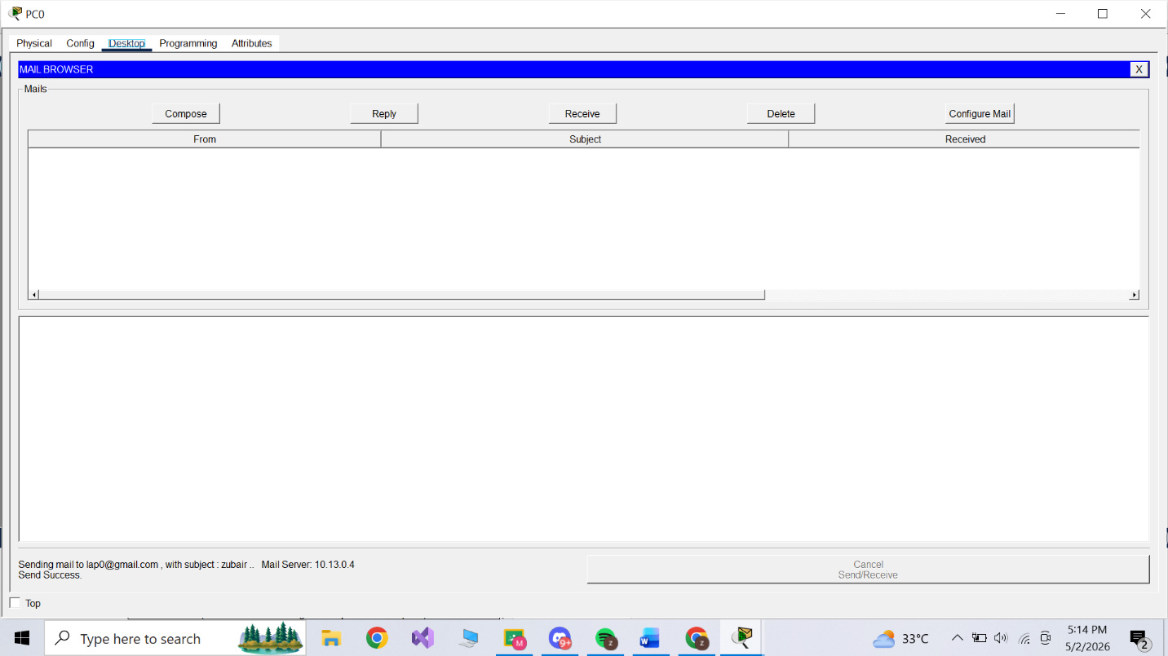

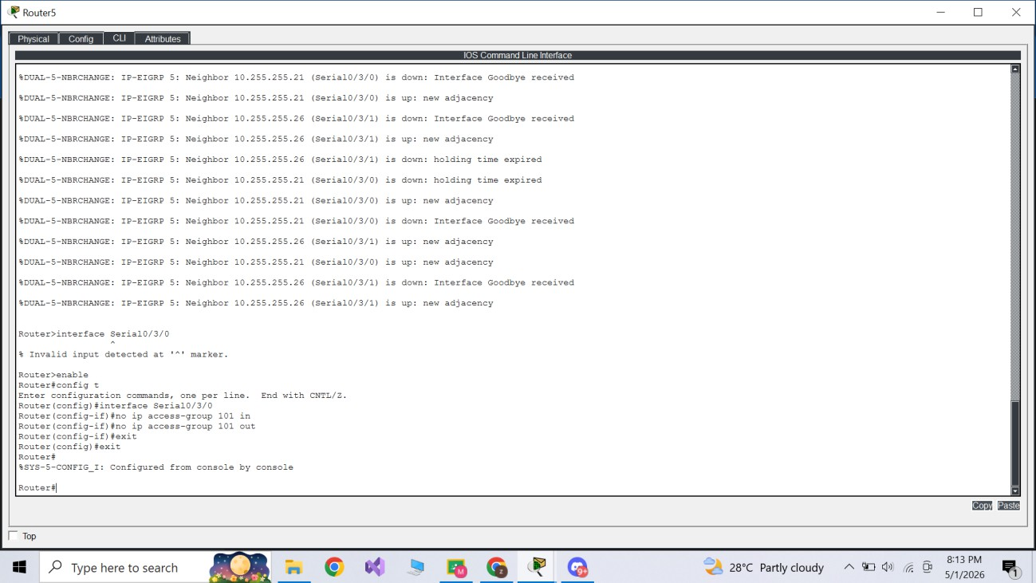

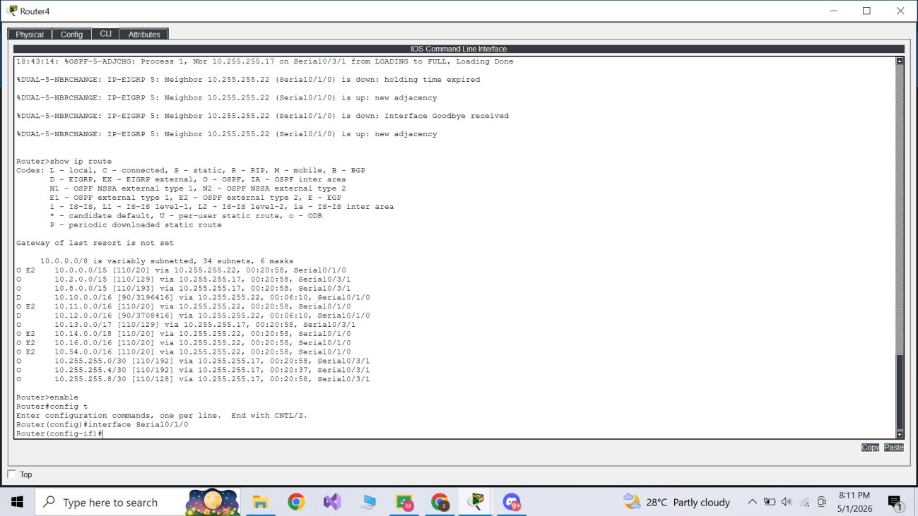

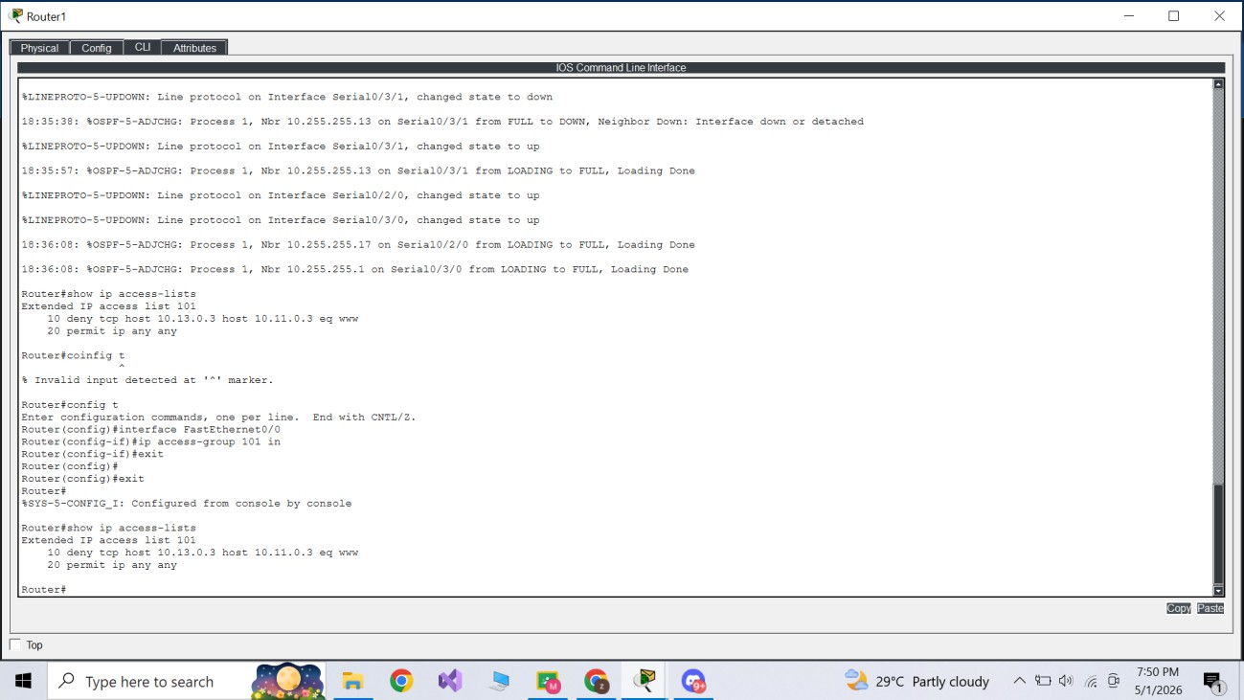

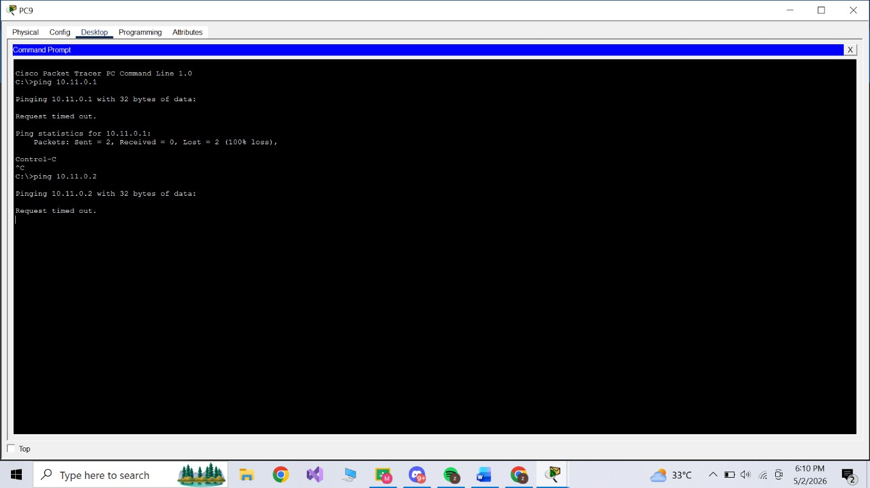

Conclusion:
The network topology was successfully implemented, addressing all host requirements via VLSM, establishing
seamless multi-protocol routing through redistribution, and securing network perimeters using standard ACLs and NAT protocols.

