**COCOMO (Constructive Cost Model)**

Based on the **Source Line Of Code** **(SLOC)** characteristicandoperatesaccording to the followingequations:

* Effort = PM = Coefficient<Effort Factor>*(SLOC/1000)^P

= 2.4 * (7500 /1000)^1.05

= 19.9 ≈ 20 person-months

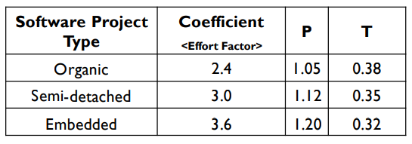

* Development time = DM = 2.50*(PM)^T

= 2.50 * 20^0.38

= 7.80 ≈ 8

Development time is 8 months=176 days=(176*8)hrs=1408hrs

[8hours per working day]

* Required number of people = ST = PM/DM

= 20/8

= 2.5 ≈ 3

Required number of people is 3

**Budgeting:**

Number of people = 3

Working hours per month = (5*8*4)hours = 160 hours

[1 week = 5 working days; 1 day = 8 working hours; 1 month = 4 weeks]

Salary per month is 200000tk

Salary per hour is (200000/160)tk = 1250tk

|  |  |
| --- | --- |
| **Costs** | **Amount** |
| Human Resource Salary | (200000*8*3)tk = 4800000 tk |
| Rent Fee | (30000*8)tk = 240000tk |
| Hardware Fee | (100000*8)tk = 800000tk |
| Maintenance | (2500*8*8)tk = 160000tk  [8 hours service per month;  4 months advance] |
| Electricity bill | (60000*8)tk = 480000tk |
| Transport cost | (12000*8)tk = 96000tk |
| Profit (25%) | 1644000tk |
| Others | 50000tk |
| **Total** | 5114000tk |