



*January 17, 2025*

***Presented By:***

**Zubair Ahmed Balouch**

*[Roll No: 00375285 - Day/Time: Wednesday 7-10pm]*

**Planing The Technical Foundation**

**[E-Commerce Website]**

**HACKATHON-3 (DAY-02)**

**Table of Contents**

* Introduction
* Core Technologies
* System Design
* Key Features and Workflow
* Sanity Schema
* System Architecture Overview
* API Endpoints
* Conclusion

**INTRODUCTION:**

This document presents a comprehensive technical framework for the development of **Bandage**, a modern e-commerce platform designed to revolutionize the online shopping experience. Bandage is not just a clothing brand—it is a lifestyle choice that merges style with comfort, offering versatile, dynamic, and functional pieces to suit diverse needs. Our platform is dedicated to individuals who prioritize premium quality, cutting-edge designs, and trending fashion.

The website features an extensive collection of high-quality clothing tailored for men, women, children, and professionals, ensuring that every customer finds something that resonates with their personal style. By supporting small businesses and entrepreneurs, this marketplace provides an opportunity for showcasing and selling products, with a particular focus on clothing and other lifestyle essentials.

This plan draws on innovative ideas from Hackathon Day 1 and incorporates thoughtful feedback from Day 2, ensuring that the project aligns with its goals of delivering an exceptional user experience and promoting sustainable growth for businesses.

**BUSINESS GOAL:**

“The primary objective of this e-commerce platform is to serve as a comprehensive one-stop shop, offering users a seamless experience to browse, explore, and purchase high-quality clothing for men, women, and children. Our goal is to create a reliable, fast, and accessible fashion environment that meets the diverse needs of our customers, ensuring they have access to the latest trends with ease and efficiency”.

1. **CORE TECHNOLOGIES:**

* **Frontend Framework:** Next.js .
* **Content Management System (CMS):** Sanity
* **Order and Shipping Solution**: ShipEngine
* **Database**: MongoDB (for managing user authentication)
* **Hosting and Deployment**: Vercel (frontend) and AWS (backend)
* **Payment Integration:** Stripe.

**2. SYSTEM DESIGN:**

**2.1. Frontend (Next.js):**

* Optimized for client-side rendering to enhance speed and user experience.
* Implements server-side rendering to boost SEO and enable preloading for product pages.
* Seamlessly integrates with Sanity CMS for managing and displaying dynamic content.
* **Product Browsing:**
* User can view product categories.
* Categories and products are fetched from Sanity CMS using an API.
* Fetched data is displayed dynamically on the frontend.
* **Checkout and Order Placement:**
* User fill in billing and shipping information
* Order details are validated and sent to saniyt CMS via APIs.
* Order Summary displayed to the User.

**2.2 Sanity CMS (Backend):**

* **Centralized Data Management:**
* **User Data:** Stores User registration details.
* **Product Data:** Stores product categories and product details.
* **Order Data:** Stores all order-related details, including billing, shipping, and payment status.
* **API Integration:**
* Handles incoming requests from the frontend to fetch or update data.
* Serves as the bridge between frontend and third-party APIs.

**2.3 Third Party APIs:**

* **Payment Processing:**
* Payment details are securely sent to the third-party payment gateway.
* Payment confirmation or error response in returned.
* Confirmation details are saved in Sanity CMS.
* **Shipment Tracking:**
* Shipment details are fetched from the third-party logistics API.
* Real-time tracking updates are displayed to the user.

**2.4 Order Management (ShipEngine):**

* Provides real-time order tracking.
* Manages shipping and delivery status updates.

**2.5 Deployment:**

* Frontend hosted on Vercel for seamless delivers

1. **Key Feactures & Workflow**

**Feactures:**

* **Product Listing Page:** Display products availaible for purchasse.
* **Cart Page:** Allow users to add products to their card and view the total.
* **Checkout Page**: Complete the purchase securely using stripe.
* **Payment Integration with Stripe**: Secure Payment processing for orders.
* **Shipping Label Generation & Order Tracking via ShipEngine**: Generate shipping labels and track orders.
* **Product & Order Management cia Sanity CMS:** Easily manage products and orders.
* **Main Pages of Website:**
* **Home**
* **About**
* **Contact**
* **Products**
* **Product Details**
* **Add to Cart**
* **Login/SignUp**
* **Checkout and Payment**

1. **Sanity Schema**

**Product Schema Example::**

* **Product Schema:** (For Sanity CMS):

export const product = defineType({

name: "product",

title: "Product",

type: "document",

fields: [ {

name: "title",

title: "Title",

validation: (rule) => rule.required(),

type: "string” },

{

name:"description",

type:"text",

validation: (rule) => rule.required(),

title:"Description",

},

{

name: "productImage",

type: "image",

validation: (rule) => rule.required(),

title: "Product Image"

},

{name: "price",

type: "number",

validation: (rule) => rule.required(),

title: "Price", },

{name: "tags",

type: "array",

title: "Tags",

of: [{ type: "string" }]

},

{ name:"dicountPercentage",

type:"number",

title:"Discount Percentage",

},

{ name:"isNew",

type:"boolean",

title:"New Badge",

}

]

})

1. **Marketplace E-Commerce Website Workflow**

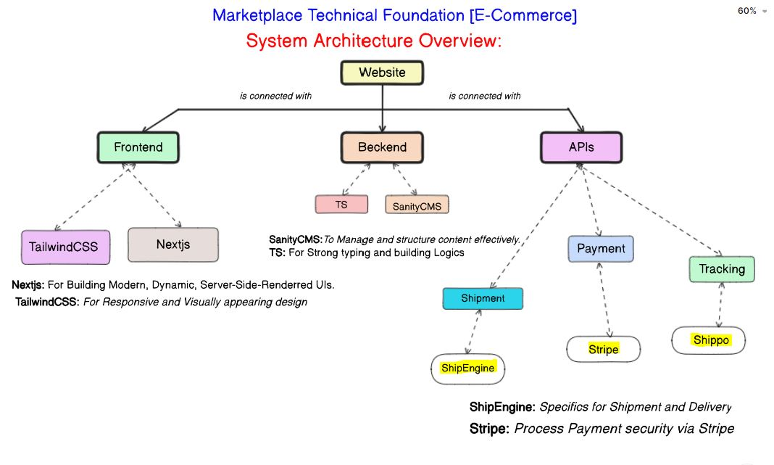

1. **API Endpoints:**

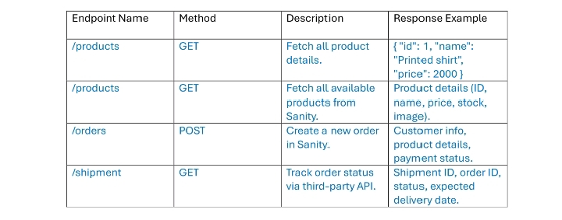

**7. CONCLUSION**

Our modern e-commerce website offers a fast, secure, and scalable platform designed to enhance the online shopping experience. Leveraging a robust tech stack, including Next.js, Sanity CMS, and Stripe, the platform ensures efficient product management, seamless payment processing, and real-time order tracking.

With features like server-side rendering for SEO optimization, dynamic product listings, and real-time shipping updates, the platform prioritizes user experience while offering small businesses and entrepreneurs an intuitive solution for managing products and orders. Hosted on Vercel, the website guarantees high availability and scalability.

This platform is poised to deliver exceptional value, offering quality and innovation to customers and businesses alike.

*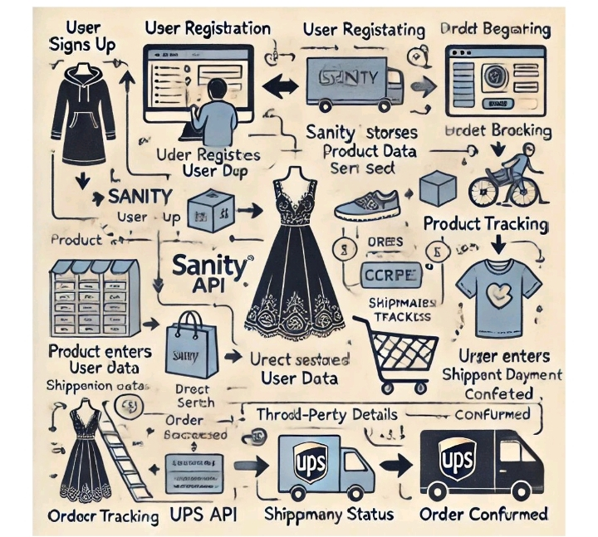Figure 7.1: it shows complete workflow of E-commerce web.*