**API Integration and fetching data from sanity- Bandage**

**How I Connect API to Sanity**

1. ***API Overview:***APIs provide data like products or categories that can be used in Sanity.
2. ***Provided APIs:***  
   Select an API from the provided list (e.g., Product API).
3. ***Steps to Connect API to Sanity:***
   * Step 1: Check the API's data fields (e.g., product_name, price).
   * Step 2: Update your Sanity schema to match these fields.
   * Step 3: Use migration scripts or manually import data (JSON/CSV).

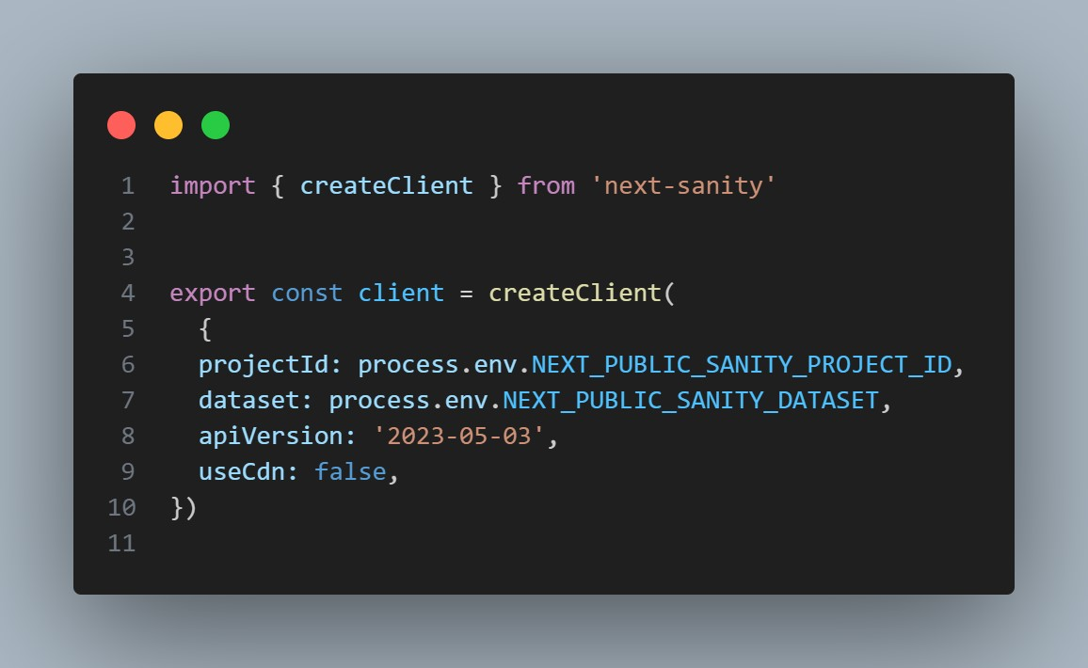

* **Steps:**

**Install Sanity Client:**

I installed the Sanity client for Next.js:

bash CopyEdit npm install @sanity/client

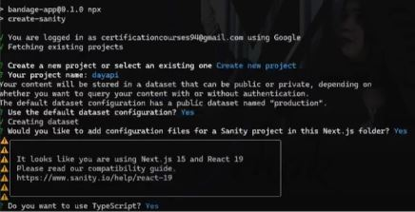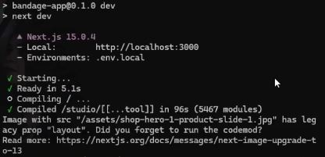

1. **Create API Utility File:**

I created a utility file (sanityClient.ts) for Sanity configuration:

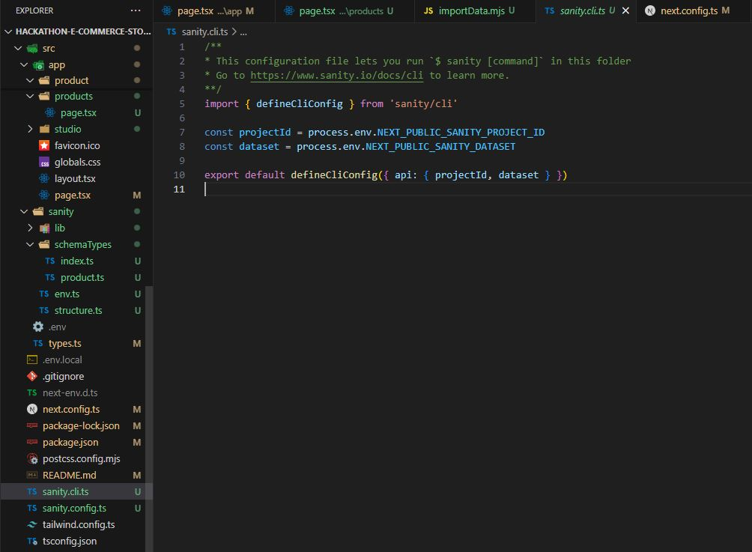

**Then Created API URL and Token and paste into importData.mjs file.**

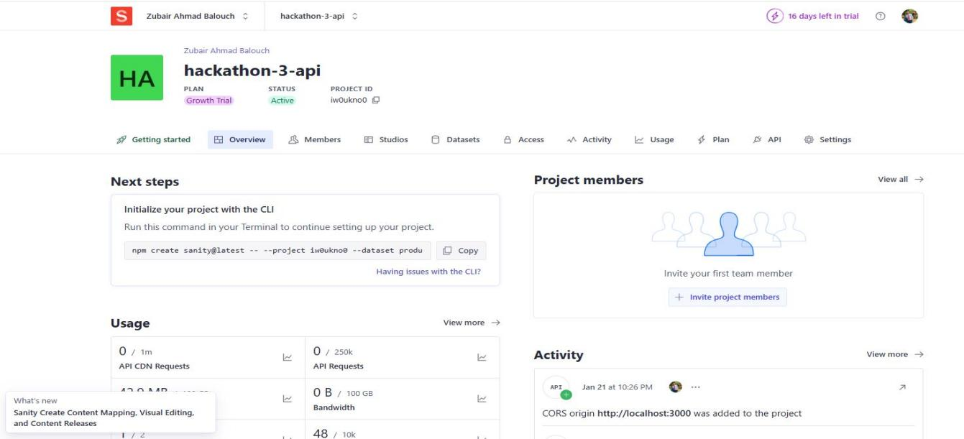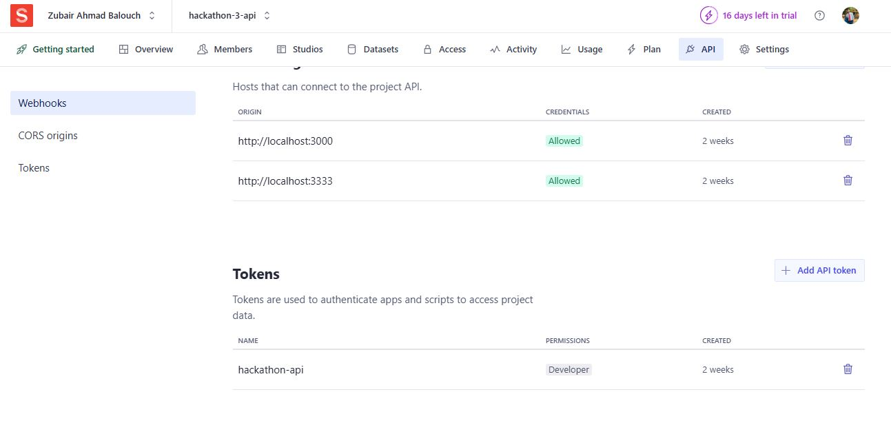

1. **Schema Adjustment in Sanity CMS:**

* I adjusted the schema in Sanity Studio to ensure compatibility with the API data. ● Key fields include:

○ name: String

○ description: Text

○ price: Number

○ image: Image type

○ category, colors, and sizes: Array

**3:Make file Importdata.mjs**

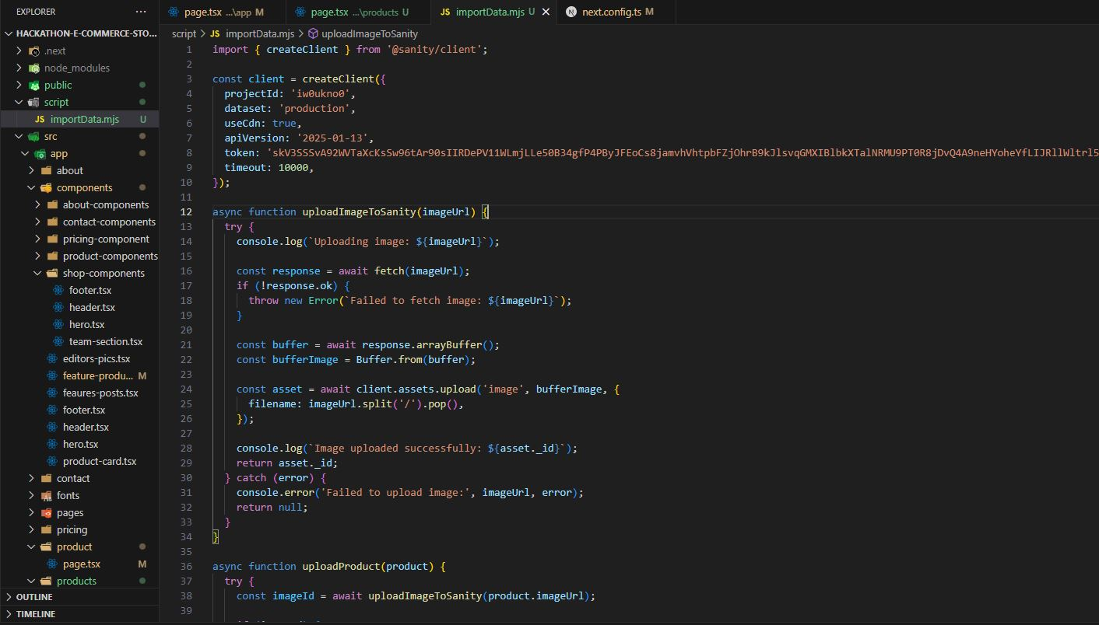

**4:**Run command

**Node run importdata.**mjs

5:Data migrate in to sanity studio

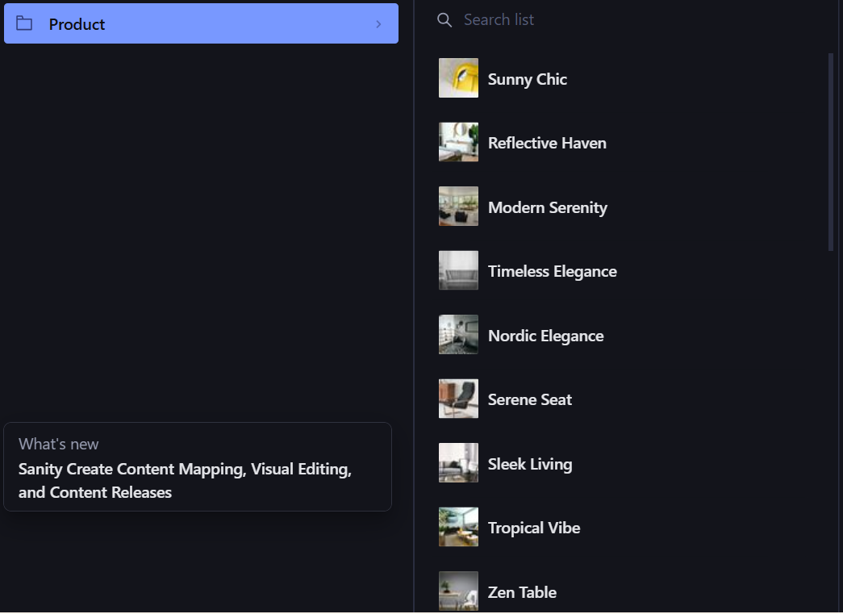

**Achievements:**

This task helped me gain hands-on experience in API integration and data migration into Sanity CMS.

* Configuring and using Sanity CMS with Next.js.
* Creating dynamic and scalable data pipelines for modern web applications.

**Skills Gained:**

* Configuring and integrating Sanity CMS with Next.js.
* Creating dynamic data pipelines for web applications.
* Hands-on experience with schema adjustments and data migration using scripts.