



*January 17, 2025*

***Presented By:***

**Faizan Sajid**

*[Roll No: 00261796 - Day/shift : Friday:Morning]*

**Planning The Technical Foundation**

**[E-Commerce Website]**

**HACKATHON-3 (DAY-02)**

**Table of Contents**

* Introduction
* Business Goal
* Core Technologies
* System Design
* Key Features and Workflow
* Sanity Schema
* System Architecture Overview
* API Endpoints
* Conclusion

**INTRODUCTION:**

Welcome to our furniture marketplace! This website is designed to make buying and selling furniture easier and more convenient. Our goal is to connect customers with a wide range of quality furniture from trusted sellers.

Whether you're looking for modern designs, classic pieces, or affordable options, our platform will provide a user-friendly experience for browsing, comparing, and purchasing furniture.

This document will explain the technical foundation of the website, including the technologies we will use, system design, and key features that will ensure the platform is efficient, scalable, and easy to use for everyone.

**BUSINESS GOAL:**

Our goal is to create a trusted online marketplace for buying and selling furniture. We want to make it easy for customers to find quality furniture and for sellers to reach a wide audience.

**Short-Term Goals:**

* Launch the website with basic features like product listings and a secure checkout.
* Attract users through marketing and build trust.

**Long-Term Goals:**

* Add more features like seller dashboards and personalized recommendations.
* Partner with top furniture brands and local sellers.
* Create a steady income through commissions and premium services.

Our aim is to become a top choice for furniture shopping online.

1. **CORE TECHNOLOGIES:**

**2. SYSTEM DESIGN:**

**2.1. Frontend (Next.js):**

* Optimized for client-side rendering to enhance speed and user experience.
* Implements server-side rendering to boost SEO and enable preloading for product pages.
* Seamlessly integrates with Sanity CMS for managing and displaying dynamic content.
* **Product Browsing:**
* User can view product categories.
* Categories and products are fetched from Sanity CMS using an API.
* Fetched data is displayed dynamically on the frontend.
* **Checkout and Order Placement:**
* User fill in billing and shipping information
* Order details are validated and sent to saniyt CMS via APIs.
* Order Summary displayed to the User.

**2.2 Sanity CMS (Backend):**

* **Centralized Data Management:**
* **User Data:** Stores User registration details.
* **Product Data:** Stores product categories and product details.
* **Order Data:** Stores all order-related details, including billing, shipping, and payment status.
* **API Integration:**
* Handles incoming requests from the frontend to fetch or update data.
* Serves as the bridge between frontend and third-party APIs.

**2.3 Third Party APIs:**

* **Payment Processing:**
* Payment details are securely sent to the third-party payment gateway.
* Payment confirmation or error response in returned.
* Confirmation details are saved in Sanity CMS.
* **Shipment Tracking:**
* Shipment details are fetched from the third-party logistics API.
* Real-time tracking updates are displayed to the user.

**2.4 Order Management (ShipEngine):**

* Provides real-time order tracking.
* Manages shipping and delivery status updates.

**2.5 Deployment:**

* Frontend hosted on Vercel for seamless delivers

1. **Key Feactures & Workflow**

**Feactures:**

* **Product Listing Page:** Display products availaible for purchasse.
* **Cart Page:** Allow users to add products to their card and view the total.
* **Checkout Page**: Complete the purchase securely using stripe.
* **Payment Integration with Stripe**: Secure Payment processing for orders.
* **Shipping Label Generation & Order Tracking via ShipEngine**: Generate shipping labels and track orders.
* **Product & Order Management cia Sanity CMS:** Easily manage products and orders.
* **Main Pages of Website:**
* **Home**
* **About**
* **Contact**
* **Products**
* **Product Details**
* **Add to Cart**
* **Login/SignUp**
* **Checkout and Payment**

1. **Sanity Schema**

**Product Schema Example::**

* **Product Schema:** (For Sanity CMS):

export const product = defineType({

name: "product",

title: "Product",

type: "document",

fields: [ {

name: "title",

title: "Title",

validation: (rule) => rule.required(),

type: "string” },

{

name:"description",

type:"text",

validation: (rule) => rule.required(),

title:"Description",

},

{

name: "productImage",

type: "image",

validation: (rule) => rule.required(),

title: "Product Image"

},

{name: "price",

type: "number",

validation: (rule) => rule.required(),

title: "Price", },

{name: "tags",

type: "array",

title: "Tags",

of: [{ type: "string" }]

},

{ name:"dicountPercentage",

type:"number",

title:"Discount Percentage",

},

{ name:"isNew",

type:"boolean",

title:"New Badge",

}

]

})

1. **Marketplace E-Commerce Website Workflow**

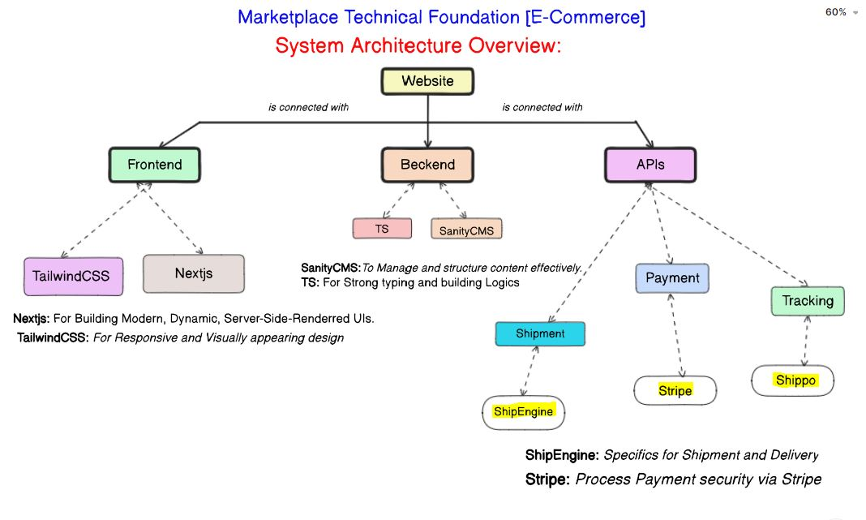

**7. CONCLUSION**

Our modern e-commerce website offers a fast, secure, and scalable platform designed to enhance the online shopping experience. Leveraging a robust tech stack, including Next.js, Sanity CMS, and Stripe, the platform ensures efficient product management, seamless payment processing, and real-time order tracking.

With features like server-side rendering for SEO optimization, dynamic product listings, and real-time shipping updates, the platform prioritizes user experience while offering small businesses and entrepreneurs an intuitive solution for managing products and orders. Hosted on Vercel, the website guarantees high availability and scalability.

This platform is poised to deliver exceptional value, offering quality and innovation to customers and businesses alike.

*Figure 7.1: it shows complete workflow of E-commerce web.*

