**University of Engineering and Technology, Peshawar**

Department of Computer Systems Engineering.

*Course Lab: CSE-308 Digital System Design*



**Zubair Khan 19** PWCSE **1797**

Section A

Batch 21 (Spring_2022)

**Submitted to** Engr. Madiha Sher

**LAB 06 Title**

***4-Digit BCD Counter on Multiplexed Seven Segment Display***

***Objectives(s):***

This lab will enable students to:

* Learn top down and bottom up design methodologies
* Learn to use time multiplexed 4-digit Seven Segment display

**Theory**

**Block Diagram:** The S6 board has four seven-segment LED displays, each containing seven bars and one small round dot. To reduce the use of FPGA's I/0 pins, the S6 board uses a time-multiplexing sharing scheme. In this scheme, the three displays have their individual enable signals but share eight common signals to light the segments. All signals are active low (i.e., enabled when a signal is 0). The schematic of displaying a "2" on the leftmost LED is shown in Figure.

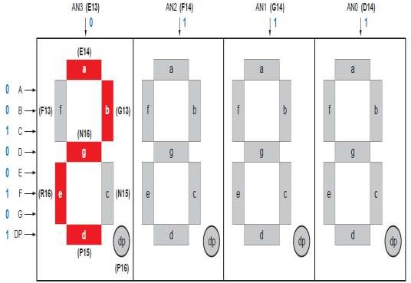Note that the enable signal (i.e., an) is "011". This configuration clearly can enable only one display at a time. We can time-multiplex the four LED patterns by enabling the four displays in turn, as shown in the simplified timing diagram. If the refreshing rate of the enable signal is fast enough, the human eye cannot distinguish the on and off intervals of the LEDs and perceives that all four displays are lit simultaneously. This scheme reduces the number of I/O pins from 32 to 11 (i.e., eight LED segments plus three enable signals) but requires a time-multiplexing circuit.

**3 Digit BCD Counter and timing diagram of LED multiplexing**

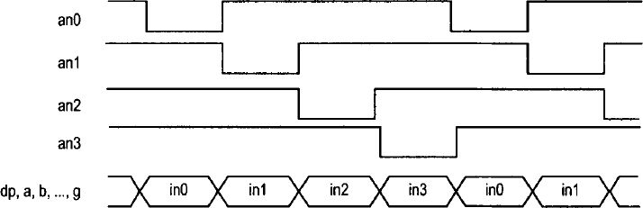

**LED time Multiplexing**

The refresh rate of the enable signal has to be fast enough to fool our eyes but should be slow enough so that the LEDs can be turned on and off completely. The rate around the range 1000 Hz should work properly. In our design, we use an 18-bit binary counter for this purpose. The two MSBs are decoded to generate the enable signal and are used as the selection signal for multiplexing

**LAB TASK**

**Implement a BCD counter that runs from 000 to 999 and shows each BCD digit on the seven-segment display.**

**Explanation:**

**In this LAB we have don two tasks 6a and 6b**

* **6a:** Implementation of BCD counter that runs from 0 to 9 and shows each BCD digit on the seven-segment display
* **6b:** Implementation of BCD counter that runs from 000 to 999 and shows each BCD digit on the seven-segment display

**6a:** Implementation of BCD counter that runs from 0 to 9 and shows each BCD digit on the seven-segment display

**Source Code**

**For [ *. v] file (Verilog)**

module counter(

    input clk, rst,

    output [2:0]en,

    output [6:0] counter7seg

    );

    reg [3:0] counter;

    assign en = 3'b011;

    seven_seg seg(counter, counter7seg);

    clk_divider Div_Clock(clk, clk1, rst);

    always @ (posedge clk1)

    begin

        if(rst)

            counter = 0;

        else

            begin

                counter = counter + 1'b1;

                if(counter == 10)

                    counter = 0;

            end

    end

endmodule

module seven_seg(

    input [3:0] in,

    output [6:0] out

);

    assign out = (in == 0) ? 7'd0:

                 (in == 1) ? 7'b1111001:

                 (in == 2) ? 7'b0100100:

                 (in == 3) ? 7'b0110000:

                 (in == 4) ? 7'b0011001:

                 (in == 5) ? 7'b0010010:

                 (in == 6) ? 7'b0000010:

                 (in == 7) ? 7'b1111000:

                 (in == 8) ? 7'b0000000:

                 (in == 9) ? 7'b0011000: 7'b1111111;

endmodule

module clk_divider(clk, clk1, rst);

    integer cnt;

    input clk, rst;

    output reg clk1;

    always @(posedge clk)

        begin

            if(rst)

                begin

                    cnt = 0;

                    clk1 = 0;

                end

            else

                begin

                    cnt = cnt + 1;

                    if(cnt == 10000000)

                        begin

                            clk1 = ~clk1;

                            cnt = 0;

                        end

                end

        end

endmodule

**6b:** Implementation of BCD counter that runs from 000 to 999 and shows each BCD digit on the seven-segment display

**Source Code**

**For [*.v] file (verilog)**

module counter(

    input clk, rst,

    output [2:0]en,

    output [6:0] counter7seg

    );

    reg [3:0] U,T,H;

    seven_seg seg_7(U,T,H, en, clk, rst, counter7seg);

    clk_divider Div_Clock(clk, clk1, rst);

    always @ (posedge clk1)

    if(rst)

    begin

            U = 0;

            T = 0;

            H = 0;

   end

    else

    begin

        U = U + 1'b1;

        if(U == 10)

        begin

            U = 0;

            T = T + 1'b1;

            if(T == 10)

            begin

                T = 0;

                H = H + 1'b1;

                if(H==10)

                    H = 0;

            end

        end

  end

endmodule

module seven_seg(U,T,H, en, clk, rst, out);

input [3:0]U,T,H;

output reg [2:0]en;

input clk,rst;

output [6:0]out;

reg[3:0]in;

    assign out = (in == 0) ? 7'd0:

                 (in == 1) ? 7'b1111001:

                 (in == 2) ? 7'b0100100:

                 (in == 3) ? 7'b0110000:

                 (in == 4) ? 7'b0011001:

                 (in == 5) ? 7'b0010010:

                 (in == 6) ? 7'b0000010:

                 (in == 7) ? 7'b1111000:

                 (in == 8) ? 7'b0000000:

                 (in == 9) ? 7'b0011000: 7'b1111111;

  always @(posedge clk)

  begin

      if(rst)

          in = U;

      else begin

          if(en == 3'b110) begin

              en = 3'b101;

              in = T;

          end

          else begin

              if(en == 3'b101)begin

                  en = 3'b 011;

                  in = H;

              end

          end

      end

  end

endmodule

module clk_divider(clk, clk1, rst);

    integer cnt;

    input clk, rst;

    output reg clk1;

    always @(posedge clk)

        begin

            if(rst)

                begin

                    cnt = 0;

                    clk1 = 0;

                end

            else

                begin

                    cnt = cnt + 1;

                    if(cnt == 100000000)

                        begin

                            clk1 = ~clk1;

                            cnt = 0;

                        end

                end

        end

endmodule

**For [*.ucf] file (verilog)**

NET "clk" LOC = V10;

NET "rst" LOC = F17;

NET "en[2]" LOC = B3;

NET "en[1]" LOC = A2;

NET "en[0]" LOC = B2;

NET "counter7seg[6]" LOC = A3;

NET "counter7seg[5]" LOC = B4;

NET "counter7seg[4]" LOC = A4;

NET "counter7seg[3]" LOC = C4;

NET "counter7seg[2]" LOC = C5;

NET "counter7seg[1]" LOC = D6;

NET "counter7seg[0]" LOC = A5;

NET "counter7seg[6]" SLEW = FAST;

NET "counter7seg[5]" SLEW = FAST;

NET "counter7seg[4]" SLEW = FAST;

NET "counter7seg[3]" SLEW = FAST;

NET "counter7seg[2]" SLEW = FAST;

NET "counter7seg[1]" SLEW = FAST;

NET "counter7seg[0]" SLEW = FAST;

# PlanAhead Generated IO constraints

NET "en[2]" SLEW = FAST;

NET "en[1]" SLEW = FAST;

NET "en[0]" SLEW = FAST;