

|  |  |  |  |  |  |  |  |  |
| --- | --- | --- | --- | --- | --- | --- | --- | --- |
|  | | | | | | | | |
|  | | DB Assignment No 2 | | | | |  | |
|  |  | | | | | | |  |
|  | | | |  |  | | | |
|  | | | | Zubair Ali |  | | | |
|  | | | | 28-03-2024—Roll no: 22i-2591—Zeeshan Khan |  | | | |
|  | | |  | | |  | | |

### Query 1-4:

### 

### Query 5-10:

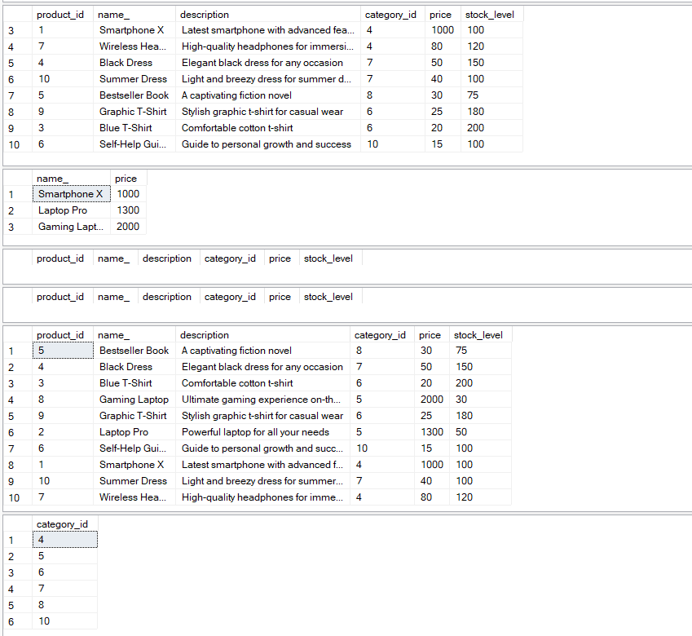

### Query 11-18:

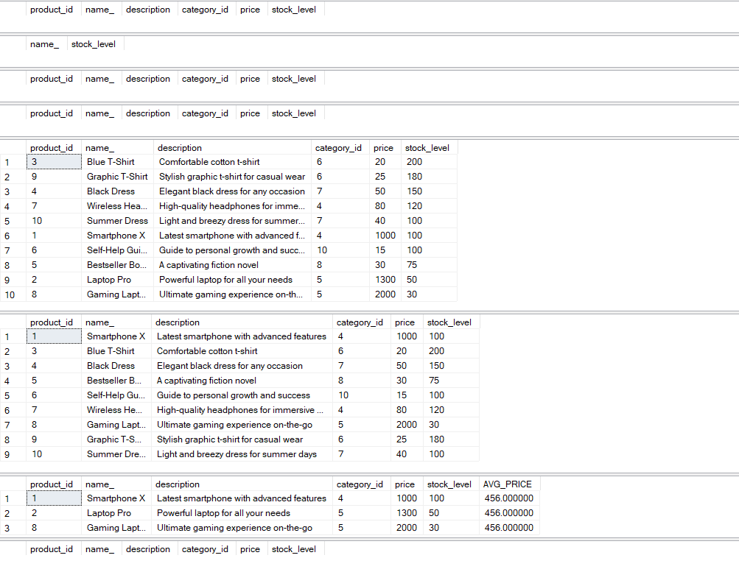

### Query 19-30:

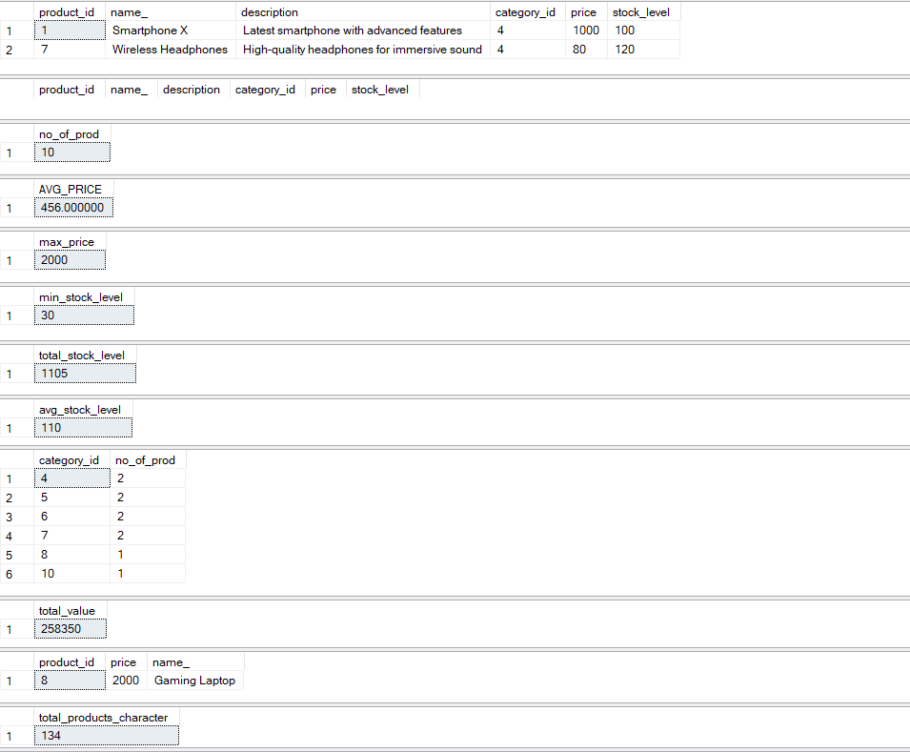

### Query 31-39:

### Query 40-44:

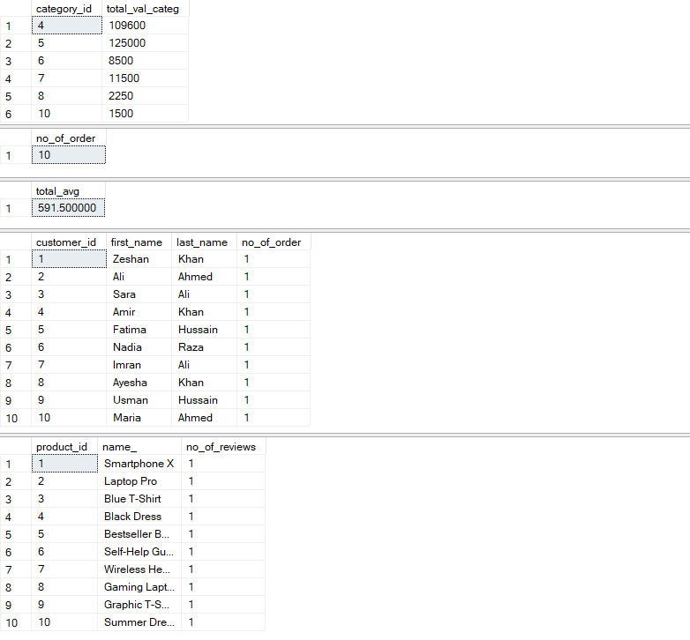

### Query 45-47:

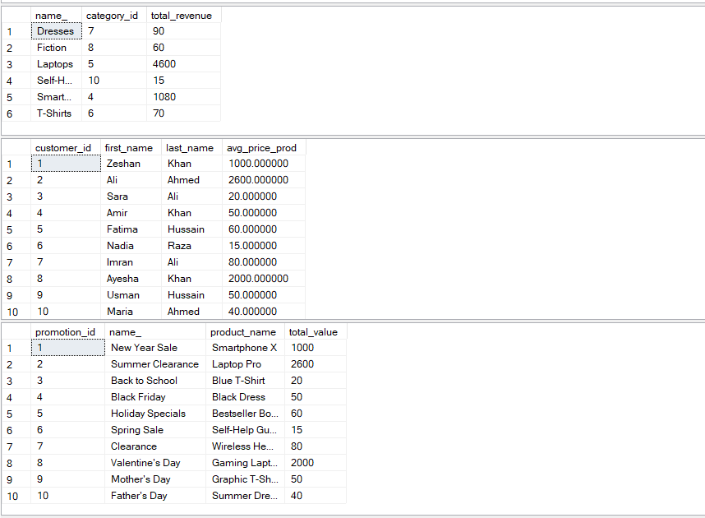

### Query 48-50:

### 

### Query 51-55:

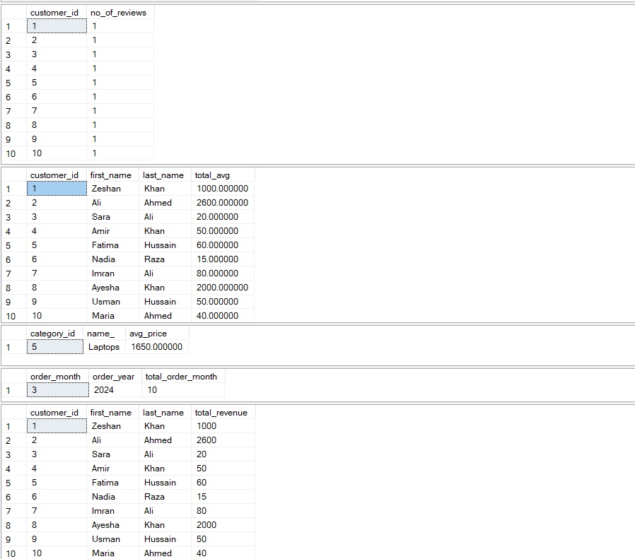

### Query 56-61:

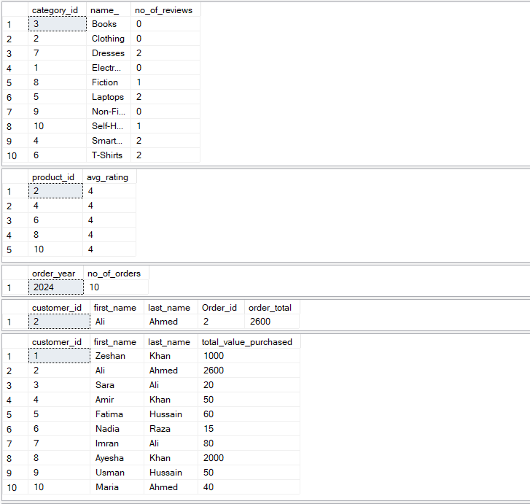

### Query 62-63:

### 

### Query 64-70:

### 

### Query 71-73:

### 

### Query 74-80:

