**

*Database Management System*

*Final-Project*

***GROUP MEMBERS:*** *ZUBAIR ALI.*

***ROLL NUMBERS:*** *22I-2591.*

***DEGREE PROGRAM:*** *BS SOFTWARE ENGINEERING (BATCH 2022).*

***SECTION:*** *G.*

***SUBMITTED TO:*** *Sir Zeeshan Khan*

***Software Design & Architecture***

***FAST-NUCES Islamabad Campus***

***SUBMISSION DATE: 6 April 2024.***

*Contents*

***1. Project Scope Document (1-2 Pages) Deadline April 22, 2024 2***

***Scope/List of Features: 3***

***2- Functional Requirements/Features for Every User: 3***

***Detailed Functional Requirements of Each Module*** *3*

***1. Order Management:*** *3*

***2. Inventory Management:*** *3*

***3. User Profile Management:*** *4*

***4. Billing and Payment:*** *5*

***5. Reporting and Analytics:*** *5*

***Planning Approach:*** *6*

***3- Entity-Relationship Diagram (ERD):*** *7*

***4- Enhanced Entity-Relationship Diagram (EERD)*** *8*

***5- Relational Schema/Logical Schema:*** *9*

***6- Relational Schema/Logical Schema with Normalization:*** *10*

***7- User Documentation and Help*** *12*

***1. Introduction to the Cafe Management System:*** *12*

***2. Getting Started:*** *12*

***3. Menu Management:*** *13*

***4. Order Management:*** *13*

***5. Inventory Management:*** *13*

***6. User Management:*** *13*

***7. Reporting and Analytics:*** *14*

***8. Support and Assistance:*** *14*

***Conclusion:*** *14*

***8- Screen Shots OF implemented Project*** *15*

***1-Login Page:*** *15*

***2-Registration Page:*** *15*

***3- Customer-Page*** *16*

***4- menu-Page*** *16*

***5-Cashier-Page*** *17*

***6- Cashier-Record-Page*** *17*

***7- Order-Payment-Page*** *18*

***8- Add-Order-Page*** *18*

***9- Remove-Order-Page*** *19*

***10- Admin-Dashboard-Page*** *19*

***11- Admin-Add-User-Page*** *20*

***12- Admin-Add-Product-Page*** *20*

***13- Admin-menu-product-Page:*** *21*

***14- Order-Manage-Page*** *21*

***15- Order-Pending-Page*** *22*

***16- Order-in Progress -Page*** *22*

***17- Order Tracking Page*** *23*

# 

# *1. Project Scope Document (1-2 Pages) Deadline April 22, 2024*

***Project Description:***

*The Cafe Management System is an innovative software solution designed to transform and optimize the operations of cafes by integrating and automating various critical processes such as order management, inventory tracking, customer engagement, billing, and analytics. This system aims to provide cafes with a robust, efficient, and user-friendly platform that addresses their unique operational challenges, enhances customer satisfaction, and drives business growth.*

***Problem Statement:***

*The cafe industry faces numerous challenges due to manual and disjointed processes, including order processing delays, inventory inaccuracies, inconsistent customer experiences, and limited visibility into business performance and customer behavior. These challenges hinder operational efficiency, affect customer satisfaction, and impede business growth. Therefore, there is a pressing need for a modern, integrated, and automated Cafe Management System to streamline operations, improve accuracy, enhance customer service, and enable data-driven decision-making in cafes.*

***Problem Solution:***

*We are developing a Cafe Management System that will revolutionize cafe operations by providing a unified, streamlined, and automated platform for managing all key aspects of cafe management. This system will automate order processing, inventory management, customer engagement, and billing processes, while offering real-time data, analytics, and insights to support informed decision-making, optimize resource utilization, and drive business success in cafes.*

***Advantages/Benefits of Proposed System:***

***Operational Efficiency:*** *Streamlines and automates cafe operations, reducing manual tasks, minimizing errors, and enhancing productivity.*

***Data Accuracy and Insights:*** *Ensures accurate and consistent data across all processes, provides actionable insights, trends, and analytics to identify opportunities, optimize performance, and make informed decisions.*

***Customer Satisfaction and Engagement****: Improves customer service, loyalty, and engagement by offering personalized experiences, efficient order processing, timely communication, and responsive support.*

***Scalability and Adaptability:*** *Offers a scalable, customizable, and flexible solution that can adapt to the evolving needs, growth, and diversification of cafes, while supporting integration with other systems and technologies.*

***Compliance and Security****: Ensures compliance with industry standards, regulations, and data protection laws, and applies robust security measures to protect sensitive data, transactions, and operations.*

## *Scope/List of Features:*

***Users:***

***Managers:***

*Real-time dashboard, analytics*

*Employee scheduling, performance evaluation, task assignment*

*System configuration, customization, monitoring*

***Customers:***

*Menu browsing, item selection, customization*

*Order placement, tracking, history viewing*

*Loyalty program enrollment, points accumulation, rewards redemption, membership management*

***Cashiers:***

*Process payments, issue receipts*

*Manage cash register, handle transactions*

*Assist customers with billing queries, refunds, and exchanges*

***Modules of the Project:***

* *Order Management*
* *Inventory Management*
* *User Profile Management*
* *Billing and Payment*
* *Reporting and Analytics*

# *2- Functional Requirements/Features for Every User:*

***Managers:***

*Real-time dashboard, analytics*

*Employee scheduling, performance evaluation, task assignment*

*System configuration, customization, user management*

***Customers:***

*Menu browsing, item selection, customization*

*Order placement, tracking, history viewing*

*Loyalty program enrollment, points accumulation, rewards redemption, membership management*

***Cashiers:***

*Process payments, issue receipts*

*Manage cash register, handle transactions*

*Assist customers with billing queries, refunds, and exchanges*

## ***Detailed Functional Requirements of Each Module***

### ***1. Order Management:***

* ***Order Creation:***

***Description:*** *A feature allowing cafe staff to create, modify, and cancel orders efficiently.*

***Functionality:***

*Create new orders by selecting items from the menu.*

*Modify existing orders by adding or removing items.*

*Cancel orders that are not yet processed or delivered.*

* ***Order Fulfillment:***

***Description****: A comprehensive toolset to manage and fulfill customer orders effectively.*

***Functionality:***

*Prioritize and schedule order preparation based on demand and kitchen capacity.*

*Notify staff about new orders and update order status in real-time.*

*Ensure timely preparation, packaging, and dispatch of orders to customers.*

* ***Order Tracking:***

***Description:*** *A feature allowing customers to track the status of their orders in real-time.*

***Functionality:***

*Provide customers with real-time updates on order preparation, dispatch, and delivery.*

*Enable customers to view order status, estimated delivery time, and delivery person's location.*

*Send notifications to customers upon order dispatch, arrival, and completion.*

### ***2. Inventory Management:***

* ***Inventory Monitoring:***

***Description:*** *A feature enabling cafe staff to monitor inventory levels in real-time.*

***Functionality:***

*Display current inventory levels, stock counts, and item details.*

*Set up low-stock alerts and notifications for timely restocking.*

*Monitor inventory turnover, wastage, and expiry dates to optimize inventory management.*

* ***Inventory Restocking:***

***Description:*** *An automated process to restock inventory based on predefined thresholds.*

***Functionality:***

*Automatically generate restocking orders based on inventory levels and reorder points.*

*Notify suppliers and staff about restocking requirements and delivery schedules.*

*Update inventory records upon receipt of new stock and quality checks.*

* ***Inventory Updates:***

***Description:*** *A feature allowing staff to update inventory counts and details as needed.*

***Functionality:***

*Manually update inventory counts, item details, and storage locations.*

*Record inventory adjustments, transfers, and wastage accurately.*

*Sync inventory updates across all locations and devices in real-time.*

### ***3. User Profile Management:***

* ***Profile Creation and Management:***

***Description:*** *A feature allowing cafe staff, managers, customers, and cashiers to create, edit, and manage their profiles.*

***Functionality:***

*Create new user profiles with personal details, contact information, and preferences.*

*Edit and update existing profiles, including contact details, profile pictures, and preferences.*

*Manage multiple profiles (e.g., staff, managers, customers, cashiers) with role-specific settings and access permissions.*

* ***Role-based Access Control:***

***Description****: A feature assigning roles, responsibilities, and access permissions based on user roles and responsibilities.*

***Functionality:***

*Define user roles (e.g., admin, manager, cashier, staff, customer) with specific permissions and access levels.*

*Assign roles to new and existing users based on their job roles, responsibilities, and experience.*

*Monitor and manage user access, permissions, and roles to ensure compliance and security.*

* ***Profile Monitoring:***

***Description:*** *A feature enabling monitoring and management of user profiles, interactions, preferences, and activities.*

***Functionality:***

*Monitor user interactions, preferences, and activities across the platform.*

*Analyze user behavior, preferences, and feedback to improve services and user experience.*

*Generate reports and insights on user profiles, interactions, preferences, and activities for analysis and decision-making.*

### ***4. Billing and Payment:***

* ***Payment Processing:***

***Description:*** *A feature enabling cashiers to process payments, issue receipts, and handle transactions securely.*

***Functionality:***

*Process payments using various methods (e.g., cash, credit/debit cards, mobile payments).*

*Issue electronic or printed receipts to customers upon successful payment.*

*Handle split payments, discounts, promotions, and loyalty points seamlessly.*

* ***Billing Queries and Refunds:***

***Description:*** *A feature assisting cashiers in managing billing queries, refunds, exchanges, and other related tasks.*

***Functionality:***

*Assist customers with billing queries, discrepancies, and clarification.*

*Process refunds, exchanges, and adjustments as per company policies and procedures.*

*Maintain accurate records of all billing transactions, adjustments, and refunds for audit and reconciliation.*

* ***Payment Gateway Integration:***

***Description****: A feature integrating with payment gateways to facilitate seamless and secure online payments.*

***Functionality:***

*Integrate with popular payment gateways to support online and mobile payments.*

*Ensure secure, encrypted, and PCI-compliant payment processing.*

*Handle payment gateway configurations, settings, and updates as per requirements.*

### ***5. Reporting and Analytics:***

* ***Real-time Dashboard:***

***Description:*** *A feature providing managers with a real-time dashboard displaying key metrics, analytics, and insights.*

***Functionality:***

*Display real-time metrics, KPIs, and performance indicators on a customizable dashboard.*

*Provide interactive charts, graphs, and visualizations for better understanding and decision-making.*

*Enable managers to drill down into data, filter results, and customize views based on preferences.*

* ***Custom Reports:***

***Description:*** *A feature generating custom reports, summaries, and insights based on user-defined criteria and requirements.*

***Functionality:***

*Generate custom reports on sales, inventory, customer behavior, and other key metrics.*

*Customize report parameters, filters, and formats based on specific requirements.*

*Schedule, export, and share reports with stakeholders, team members, and external partners as needed.*

* ***Data Visualization:***

***Description:*** *A feature presenting data and insights through interactive charts, graphs, and visualizations to facilitate better understanding and decision-making.*

***Functionality:***

*Transform raw data into interactive and visually appealing charts, graphs, and dashboards.*

*Provide drill-down, zoom-in, and filter options to explore data in detail.*

*Enable users to customize visualization settings, layouts, and designs based on preferences.*

## ***Planning Approach:***

***Structured Methodology****: Adopted a structured approach to guide the development and implementation of the Cafe Management System.*

***Stakeholder Engagement:*** *Conducted comprehensive interviews, surveys, focus group discussions, and workshops with cafe owners, managers, staff, and customers to understand their specific needs, challenges, expectations, and preferences.*

***Requirement Analysis****: Analyzed, prioritized, and validated the gathered requirements to define the scope, objectives, and deliverables of the project.*

***Project Planning:*** *Developed a detailed project plan, timeline, and budget based on the analyzed requirements and defined objectives.*

***Techniques and Tools:*** *Utilized various tools and techniques such as questionnaires, observation, record review, brainstorming sessions, prototyping, and user feedback to gather, validate, and refine requirements, and identify key functionalities.*

***Collaborative Approach****: Fostered a collaborative environment with continuous collaboration, communication, and feedback among team members, stakeholders, and end-users throughout the project lifecycle.*

***Agile Development****: Adopted agile development methodologies to ensure flexibility, adaptability, and responsiveness to changing requirements, priorities, and feedback during the development process.*

***Compliance and Standards:*** *Ensured compliance with industry standards, regulations, and best practices, and applied robust security measures to protect sensitive data, transactions, and operations.*

***Quality Assurance:*** *Implemented rigorous quality assurance and testing processes to identify and rectify issues, ensure system reliability, performance, usability, and user satisfaction, and deliver a high-quality, user-friendly, and efficient Cafe Management System.*

***Continuous Improvement****: Emphasized continuous improvement, innovation, and learning to enhance the system, optimize performance, address emerging needs, and support cafes in achieving operational excellence, customer satisfaction, and business success.*

# ***3- Entity-Relationship Diagram (ERD):***

# ***A diagram of a computer network Description automatically generated4- Enhanced Entity-Relationship Diagram (EERD)***

# ***5- Relational Schema/Logical Schema:***

# ***6- Relational Schema/Logical Schema with Normalization:***

*The relational schema of the Coffee Management System has been designed to ensure data integrity and minimize redundancy. To verify that all relations are in the Third Normal Form (3NF), each table and its attributes were analyzed for compliance with normalization principles.*

***OrderDetails Table:***

*No multi-valued attributes.*

*Attributes dependent only on the primary key.*

*No transitive dependencies.*

***Result:*** *Appears to be in 3NF.*

***Order Table:***

*No multi-valued attributes.*

*Attributes dependent only on the primary key.*

*No transitive dependencies.*

***Result****: Appears to be in 3NF.*

***MenuItem Table:***

*No multi-valued attributes.*

*Attributes dependent only on the primary key.*

*No transitive dependencies.*

***Result:*** *Appears to be in 3NF.*

***InventoryItem Table:***

*No multi-valued attributes.*

*Attributes dependent only on the primary key.*

*No transitive dependencies.*

***Result:*** *Appears to be in 3NF.*

***User Table:***

*No multi-valued attributes.*

*Attributes dependent only on the primary key.*

*No transitive dependencies.*

***Result:*** *Appears to be in 3NF.*

***Customer, Manager, CafeStaff, Cashier Tables:***

*No apparent violations of normalization principles.*

***Result:*** *Each table appears to be in 3NF.*

***Payment, Debit, Credit, Cash Tables:***

*Payment table needs further analysis due to the foreign key reference to PaymentMethod.*

*Debit, Credit, and Cash tables appear to be in 3NF.*

***Feedback Table:***

*No apparent violations of normalization principles.*

***Result:*** *Appears to be in 3NF.*

***Report Table:***

*No apparent violations of normalization principles.*

***Result****: Appears to be in 3NF.*

***InventoryRestock Table:***

*No apparent violations of normalization principles.*

***Result:*** *Appears to be in 3NF.*

***MenuCategory, PaymentMethod, Discount, Notification Tables:***

*Each table appears to be in 3NF based on the provided attributes.*

***Summary****: Most tables in the relational schema of the Coffee Management System appear to be in the Third Normal Form (3NF). However, further examination may be required for the Payment table to ensure full compliance with normalization principles.*

# ***7- User Documentation and Help***

*Welcome to the Cafe Management System!*

*Thank you for choosing our state-of-the-art Cafe Management System to optimize your cafe's operations. This comprehensive user documentation is designed to provide you with a thorough understanding of the system's features and functionalities, ensuring a seamless experience as you manage your cafe.*

### ***1. Introduction to the Cafe Management System:***

*The Cafe Management System is a powerful tool designed to streamline all aspects of cafe management, including order processing, inventory management, user management, reporting, and analytics. By centralizing critical tasks and providing real-time insights, our system empowers cafe owners and managers to enhance efficiency, improve customer service, and drive business growth.*

### ***2. Getting Started:***

*Upon logging in, you'll be greeted by the intuitive dashboard, your command center for monitoring key metrics and managing your cafe's operations. Here's a quick overview of what you'll find:*

***Dashboard:*** *A centralized hub displaying vital information such as sales trends, inventory levels, and order status, allowing you to make informed decisions at a glance.*

***Menu Management:*** *Easily add, edit, and organize menu items and categories to tailor your offerings to your customers' preferences.*

***Order Management****: Efficiently process orders from creation to fulfillment, with features like real-time order tracking ensuring a seamless experience for your customers.*

***Inventory Management****: Stay on top of inventory levels, receive alerts for low-stock items, and manage restocks effortlessly to keep your operations running smoothly.*

***User Management:*** *Seamlessly manage user accounts, assign roles and permissions, and ensure secure access to the system for your team members.*

### ***3. Menu Management:***

***Adding Menu Items:*** *Simply navigate to the Menu Management section, click "Add Item," and fill in the required details, including item name, description, price, and category.*

***Editing Menu Items:*** *Easily update existing menu items by selecting the item, making the necessary changes, and saving your edits with a click.*

***Managing Categories:*** *Organize your menu items efficiently by creating, editing, and deleting menu categories as needed.*

### ***4. Order Management:***

***Creating Orders:*** *Quickly create new orders by selecting items from the menu, specifying quantities, and proceeding to checkout in just a few clicks.*

***Processing Orders:*** *Cashiers can efficiently process orders, apply discounts, and confirm payments, ensuring a smooth and hassle-free experience for your customers.*

***Tracking Orders:*** *Keep your customers informed with real-time order tracking, allowing them to follow the progress of their orders from preparation to delivery.*

### ***5. Inventory Management:***

***Monitoring Inventory Levels:*** *Keep a close eye on inventory levels, receive timely alerts for low-stock items, and manage restocks effortlessly to maintain smooth operations.*

***Updating Inventory****: Easily update inventory counts, item details, and expiry dates to ensure accuracy and prevent any discrepancies.*

### ***6. User Management:***

***Adding Users:*** *Administrators can effortlessly add new users, assign roles, and manage permissions to ensure secure access and efficient collaboration among team members.*

***Managing Permissions:*** *Define user roles and permissions to control access to specific features and functionalities, maintaining security and confidentiality within the system.*

### ***7. Reporting and Analytics:***

***Accessing Reports:*** *Gain valuable insights into your cafe's performance by generating reports on sales, inventory, and user activity, empowering you to make informed decisions and drive business growth.*

***Analyzing Data:*** *Utilize the built-in analytics tools to analyze trends, identify opportunities, and optimize your cafe's operations for maximum efficiency and profitability.*

### ***8. Support and Assistance:***

*For additional assistance, our dedicated customer support team is available to provide guidance and address any questions or concerns you may have. You can also explore the Help section within the system for access to additional resources and tutorials.*

### ***Conclusion:***

*We are confident that this user documentation will serve as a valuable resource as you navigate the Cafe Management System. By leveraging its robust features and functionalities, you'll be well-equipped to streamline your cafe operations, enhance customer satisfaction, and achieve your business goals. Thank you for choosing our system, and we look forward to supporting you on your journey to success!*

# ***8- Screen Shots OF implemented Project***

### ***1-Login Page:***

### ***2-Registration Page:***

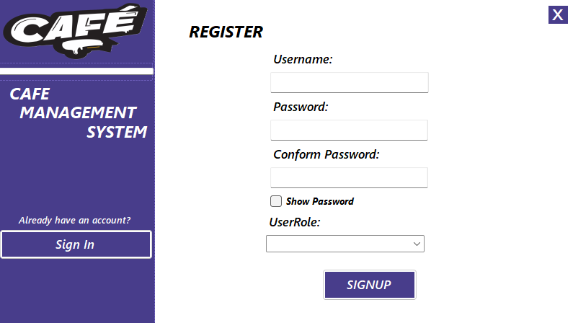

### ***3- Customer-Page***

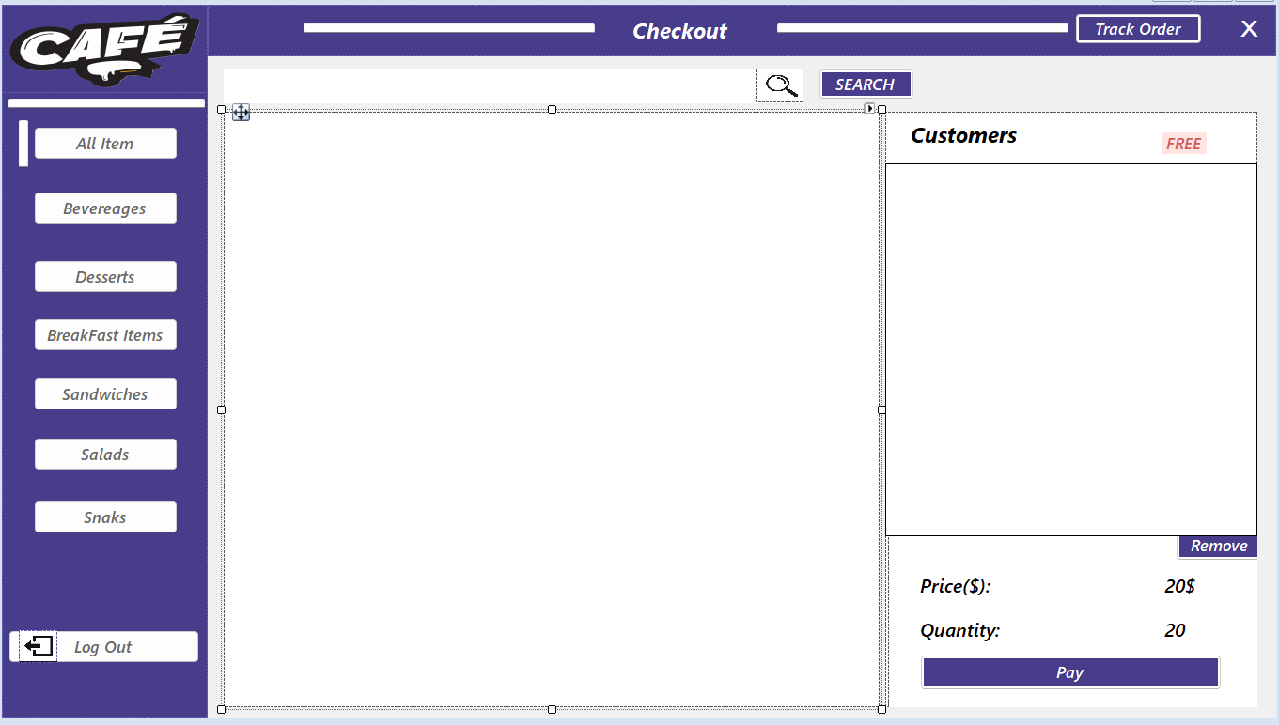

### ***4- menu-Page***

***

### ***5-Cashier-Page***

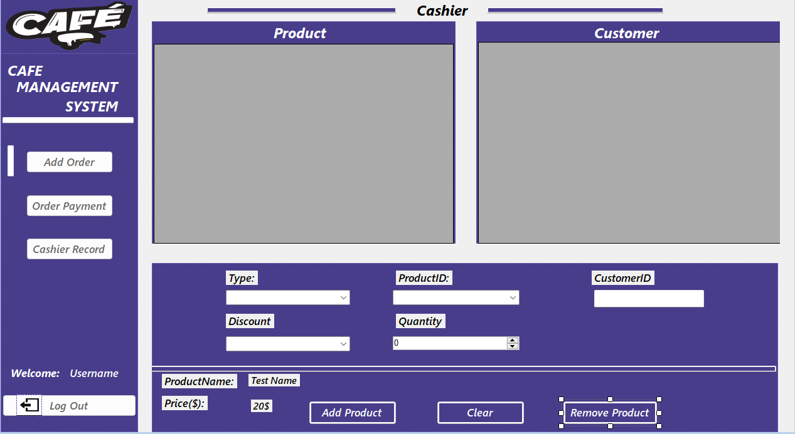

### ***6- Cashier-Record-Page***

### ***7- Order-Payment-Page***

### ***A screenshot of a computer Description automatically generated8- Add-Order-Page***

### ***9- Remove-Order-Page***

### ***10- Admin-Dashboard-Page***

### ***11- Admin-Add-User-Page***

### ***12- Admin-Add-Product-Page***

### ***13- Admin-menu-product-Page:***

### ***14- Order-Manage-Page***

### ***15- Order-Pending-Page***

### ***16- Order-in Progress -Page***

### ***17- Order Tracking Page***

