**Криштапович Іван ТМ-42**

Текст HelloJava1, 1 вариант

public class HelloJava1 {

public static void main(String[] args) {

System.out.println("Hello, Java!")

}

}

Вывод :

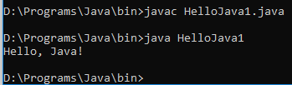

Текст HelloJava1, 2 вариант

1)Main.java

**package** tef.tm42.khrishpatovich;  
  
**public class** Main {  
 **public static void** main(String[] args) {  
 *// Initialization* Model model = **new** Model();  
 View view = **new** View();  
 Controller controller = **new** Controller(model, view);  
 *//Run* controller.sayHello();  
 }  
}

2)Controller

**package** tef.tm42.khrishpatovich;  
  
**import** java.util.Scanner;  
  
**public class** Controller {  
 **private** Model **model**;  
 **private** View **view**;  
  
 **public** Controller(Model model, View view) {  
 **this**.**model** = model;  
 **this**.**view** = view;  
 }  
  
 *// The Work method* **public void** sayHello() {  
 Scanner sc = **new** Scanner(System.***in***);  
 **model**.setValue(inputStringValueWithScanner(sc));  
 **view**.printMessage(**model**.getValue());  
  
 }  
  
 *// The Utility methods* **private** String inputStringValueWithScanner(Scanner sc) {  
 **view**.printMessage(View.***INPUT_STRING_DATA***);  
 **while** (!sc.nextLine().equals(**"Hello Java!"**)) {  
 **view**.printMessage(View.***WRONG_INPUT_STRING_DATA*** + View.***INPUT_STRING_DATA***);  
 }  
 **return view**.***OUTPUT_STRING_DATA***;  
 }  
}

3)Model

**package** tef.tm42.khrishpatovich;  
  
**public class** Model {  
  
 **private** String **text**;  
  
 **public** String getValue() {  
 **return text**;  
 }  
  
 **public void** setValue(String text) {  
 **this**.**text** = text;  
 }  
}

4)View  
**package** tef.tm42.khrishpatovich;  
  
**public class** View {  
 *// Text's constants* **public static final** String ***INPUT_STRING_DATA*** = **"Say Hello Java!"**;  
 **public static final** String ***WRONG_INPUT_STRING_DATA*** = **"Wrong input! How impolite! "**;  
 **public static final** String ***OUTPUT_STRING_DATA*** = **"Hi!"**;  
  
 **void** printMessage(String text) {  
 System.***out***.println(text);  
 }  
}

Вывод :

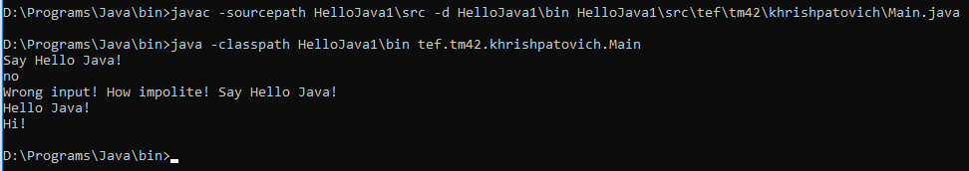

javac -sourcepath HelloJava1\src -d HelloJava1\bin HelloJava1\src\tef\tm42\khrishpatovich\Main.java

java -classpath HelloJava1\bin tef.tm42.khrishpatovich.Main