COSC 341: Human Computer Interaction

Instructor: A. K. M. Amanat Ullah

Assignment 2: Fitts’ Law Selection

Group #7

Adam Zabenskie 87191003

Solana Hendrick 87015947

Due Date: July 30, 2024

# 1.0 Background

For this assignment we were asked to apply Fitts Law to analyze an experiment comparing input from a mouse and a touchpad. Fitts Law is used to calculate a difficulty (Fitts ID) based on the amplitude (distance) and width of a target for a user to point to. In Fitts Law, the time required to move a target is a function of the distance to the target and its size [1]. A movement's difficulty can be quantified by finding the index of difficulty (ID), which can be calculated using Equation 1 below.

$ID=\log_{2}\left(A / W + 1\right)$*.*

Where *A* is the amplitude and *W* is the width of the target.

*Equation 1: Fitts Law calculation for index of difficulty.*

# 2.0 Test Methodology

To perform the testing, nine different scenes were created in Unity (see Figure 1 for an example of three scenes). Each scene was a combination of three amplitudes (5cm, 10cm and 15cm) and three circle sizes (0.5cm, 1cm and 1.5cm). A color changing script was used to make the circle that was clicked on gray again and write out the data to a csv file by using a data logging script. It also colored the next circle to be clicked as red by skipping to the fourth circle from the current one (the circle that is “across” from the current one). An input handling script was used to get the information such as time for example when the circle is clicked on. A scene changing script was used in order to switch scenes at random after the first one. This was done by keeping a list of the completed scenes and getting random numbers between 0 and 9 and checking if they have already been done, then once all the scenes have been completed and added to the list, the game stops. The test was performed with three different subjects to get average results and compares the Fitts Law results of using a mouse versus a touchpad.

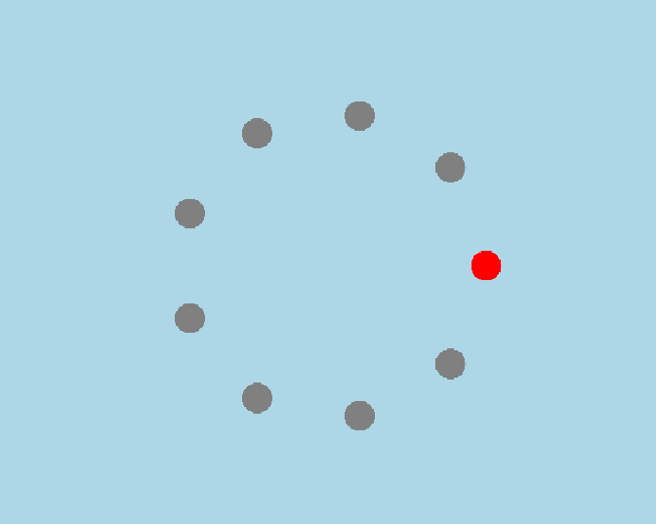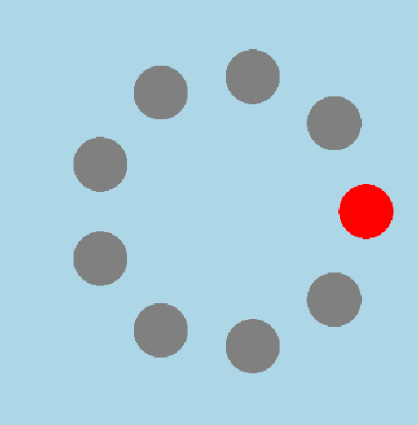

*Figure 1: Three scenes of 5v cm amplitude and 0.5, 1 and 1.5 cm circles.*

# 3.0 Results

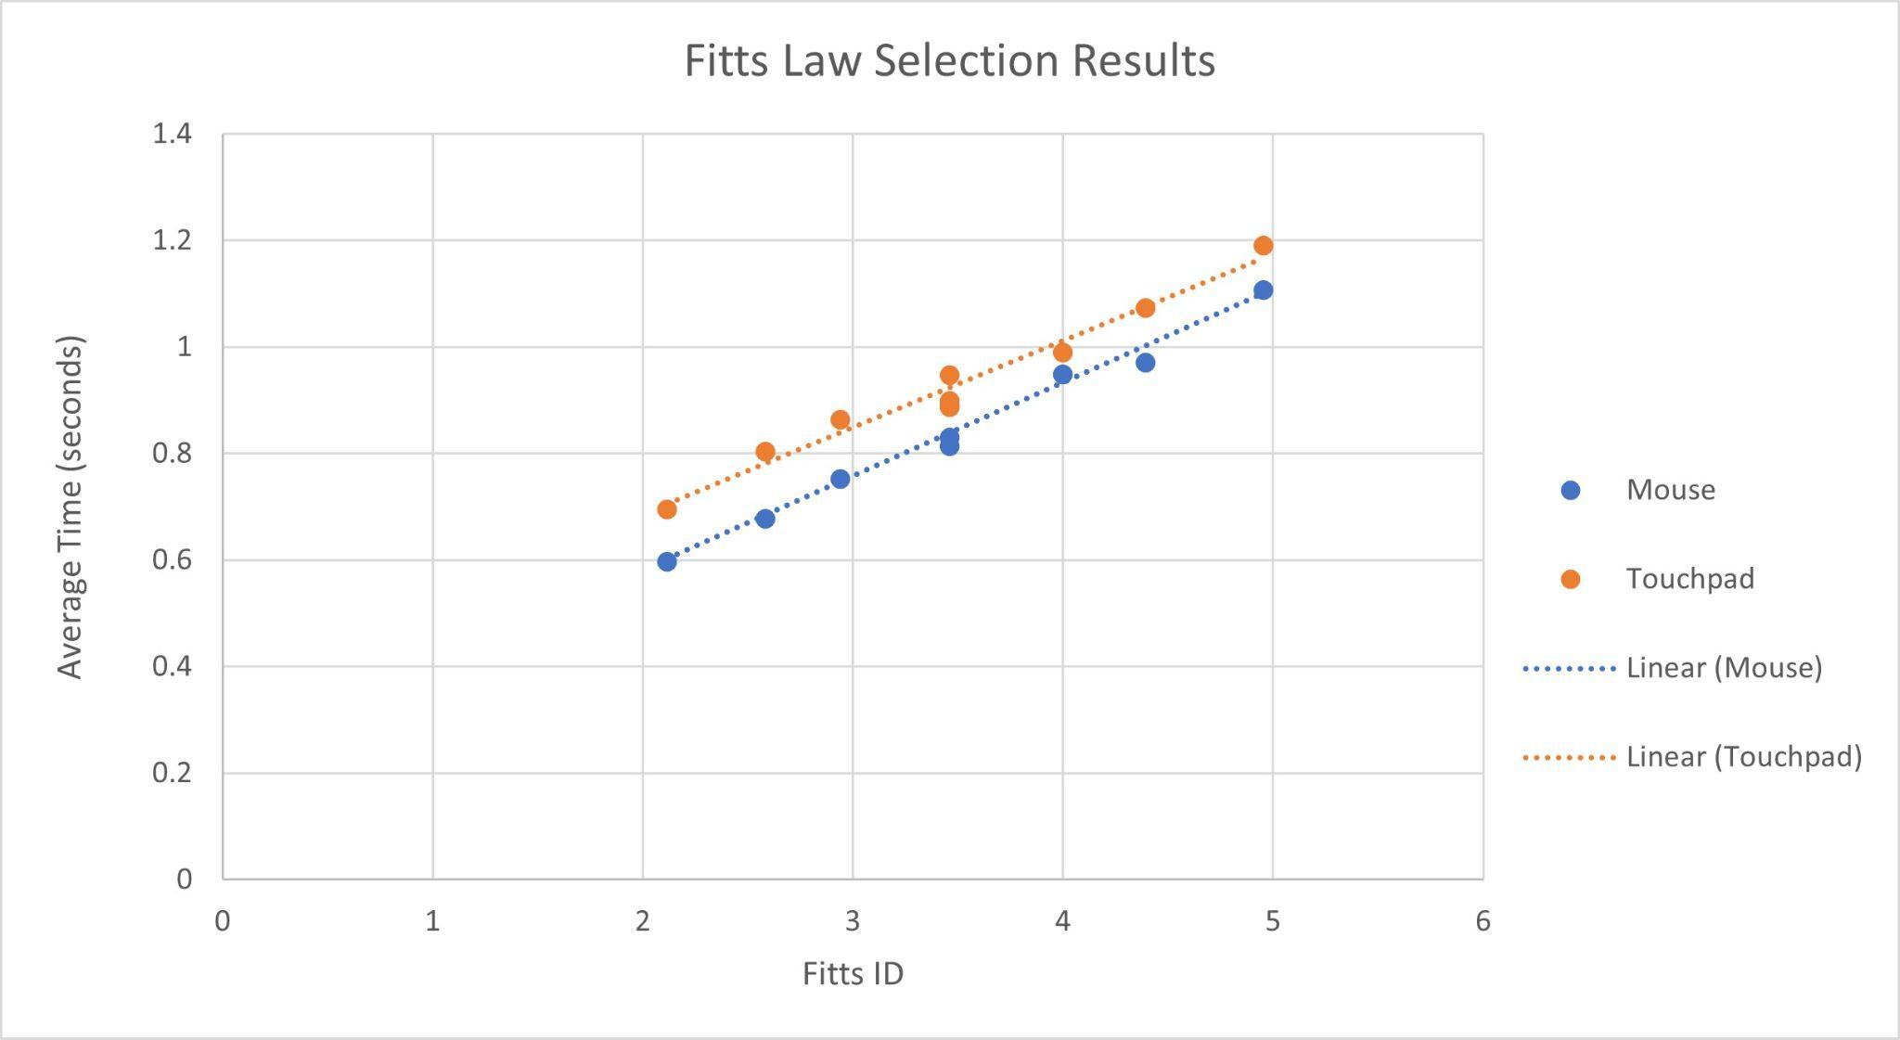

*Figure 2: Results of mouse versus touchpad test.*

# 4.0 Conclusion

Looking to figure 2 we can see a linear relationship where the increasing difficulty (Fitts ID) leads to a higher time value. We amalgamated our data from the 3 participants to get an average for each of the different tasks. The mouse shows a consistently lower time required to acquire the targets than the touchpad. A possible source of error in our experiment could have been introduced by collecting data using different devices, the mice and touchpads used were not identical. If we were to improve things in the future we could use more participants and ensure all equipment used was identical or only use one laptop and mouse.

# References

[1] Interaction Design Foundation - IxDF. “What is Fitts’ Law?” Interaction Design Foundation - IxDF. https://www.interaction-design.org/literature/topics/fitts-law (accessed Jul. 30, 2024).