
Adendorff Machinery Mart

Job title | Sales
Reports to | Branch Manager

Position overview

The role of an Internal/Counter Salesman at Adendorff Machinery Mart is to provide excellent customer service and generate sales by assisting customers with their inquiries, recommending the appropriate products, and ensuring a smooth and efficient sales process. The role encompasses a variety of responsibilities, including product knowledge, customer service, sales performance, stock management, administrave duties and adherence to company policies.

Key Responsibilities

Sales Performance
- Sales against Targets: Meet or exceed monthly and quarterly sales targets as set by management. Sales performance is measured against the tier-level average.
- Invoice Count & Basket Size: Achieve the expected number of invoices processed daily and ensure the average basket size meets company standards.
- Turnover Generated: Contribute to the company’s revenue by generating sales turnover that aligns with set targets.
- Upselling: Identify opportunities to upsell and cross-sell products by combining complementary items from various categories to increase the value of each transaction.
- Credit notes: minimizing credit notes by ensuring the correct info is given to customers and they buy the correct items first time around.

Customer Service & Communication
- Emails: Respond promptly to customer queries received via email, including providing accurate quotes, stock updates, and price details within the same day.
- Phone Calls: Maintain a branch answer rate of over 80%, ensuring that incoming calls are answered promptly and messages are accurately relayed if needed.
- Customer Queries: Effectively address customer questions, providing expert advice, and ensuring customers receive accurate technical specifications on the most popular product categories.
- Customer Solutions: Understand customer requirements thoroughly and suggest the correct product or solution that best suits their needs.

Product Knowledge
- Technical Expertise: Have in-depth knowledge of the company's full product range, including the ability to provide expert advice and technical specifications for popular products and machinery.
- Knowledge Growth: Continually expand product knowledge through training and research, sharing valuable insights with team members to maintain collective expertise.
- Code Identification: Accurately identify product codes, minimizing errors on invoices and ensuring seamless stock control.

Collections Management
- Follow-Up on Collections: Ensure all collections are picked, followed up, and the customer is contacted when ready. Follow proper collection procedures.
- Customer Communication: Coordinate with customers to arrange collection times and manage any related inquiries promptly. Finalize collection screens to complete the transaction.
- Collections: Ensure timely follow-up with customers on collections, communicating any delays or issues promptly.
- Collection Procedures: Verify that collections are prepared and controlled properly, with adherence to company procedures for finalizing collection screens.

Stock & Inventory Control
- Generate & Assign Stock Counts: Generate rolling stock counts, assign count sheets, and ensure the timely completion of stock-taking tasks.
- Perform Accurate Counts: Conduct precise counts and recounts of stock items, paying attention to discrepancies and investigating stock movement to resolve variances.
- Discrepancy Resolution: Use stock movement records to identify and address variances effectively, ensuring an accurate and up-to-date inventory.
- In & Out Transfers: Manage the efficient transfer of incoming and outgoing stock, ensuring no unresolved transfers.
- Spares Stock Control: Ensure responsible employees perform monthly stock takes on spare parts and ensure stock levels are maintained.
- Shop Soiled & Damaged Items: Tag damaged or shop-soiled goods correctly, manage returns with every truckload, and conduct regular stocktakes of these items.
- Discounted items: Tag discounted items with discount price tag correctly, manage discount section efficiently by ensuring discount balances with discount teams' sheet and doing regular stocktakes on this section)
- Sub locations: Effectively manage IBT & VAR sublocations, able to balance sublocations and do necessary transfers.

Repairs & Job Management
- Repairs Management: Log repairs into Syspro, ensure stickers and tags are added, and keep job cards up to date, adding spares as needed.
- Technician Management: Assign repairs on a First In, First Out (FIFO) basis, hold technicians accountable for performance, and order necessary spares.
- Customer Communication on Repairs: Provide customers with repair quotes, update them on repair progress, and respond to their queries within the same day by updating all info onto the job card in the allocated fields
- Stock Control on Repairs: Follow the correct transferring procedure when sending and receiving machines to and from Head Office or branches. By doing bi-weekly rolling stock on all repairs in the branch.
- Repair Collections: Ensure timely follow-up with customers on repair collections, communicating any delays or issues promptly.
- Repairs & Collections: Ensure timely follow-up with customers on both repairs and collections, communicating any delays or issues promptly.
- Collection Procedures: Verify that collections are prepared and controlled properly, with adherence to company procedures for finalizing collection screens.

Daily Operations & Administrative Duties
- Till Float & Daily Banking: Maintain the daily cash float, perform daily banking, and ensure accurate records are kept for proper reconciliation and bank filing.
- Discount Locations: Manage shop-soiled and recon machines, ensuring correct transfers and adherence to discount procedures, including Area Manager approvals.
- IBT Management: Resolve IBT (Inter-Branch Transfers) discrepancies and direct merchandising efforts in line with company standards.
- Facility Management: Assist in maintaining the cleanliness and functionality of the office, restrooms, kitchen, and staff areas, adhering to the cleaning register policy.

Health & Safety Compliance
- Safety Procedures: Follow all health and safety procedures, including using the proper PPE (Personal Protective Equipment) and attending all required safety meetings.
- Safety Checks: Complete safety checklists assigned to you and report any safety hazards to management immediately.

Time Management & Personal Growth
- Productive Time Management: Ensure working time is spent effectively, avoiding personal matters during work hours.
- Task Completion: Complete assigned tasks with eagerness and dedication, displaying a proactive approach to all responsibilities.
- Personal Development: Actively seek opportunities to grow your competencies and knowledge, demonstrating a continual desire to improve your performance.
- Teamwork: Work cohesively with your colleagues, contributing to a positive team environment and shared success.

Disciplinary Record & Attendance
- Timekeeping & Attendance: Maintain consistent punctuality, avoid extending breaks, and follow the appropriate procedures for leave and absenteeism.
- Disciplinary Record: Uphold a clean disciplinary record by adhering to company policies and procedures at all times.

Additional Duties
- Petty Cash & EFT Checks: Accurately manage petty cash and conduct EFT payment checks, ensuring that all misrouted payments are correctly handled.
- Weekly Meetings: Attend weekly product and safety meetings, providing valuable input and suggestions for continuous improvement.

Product knowledge requirements

- Knowledge Level: Maintain a display code knowledge of 95% (tests will be given).
- Knowledge Sources: Build product knowledge through brochures, the website, and videos available on the company’s TEAMS and YOUTUBE channels.

Standard Operating Procedures (SOPs)

- Familiarization: Regularly update yourself with the standard branch operating procedures (SOPs) available from your branch and area managers.
- Updates: Attend weekly meetings where changes to SOPs will be communicated.

Stock Control

Responsibility: Protect company stock and follow relevant processes and procedures as per your contract. Report any unauthorized handling of stock immediately to senior management.

Performance Appriasal

Attached below is an image of your performance contract, which outlines the specific sections and key performance areas you will be assessed against. Please note that this contract will be updated periodically as the role evolves and in alignment with business and company changes, to ensure we remain competitive and focused on delivering excellent customer service

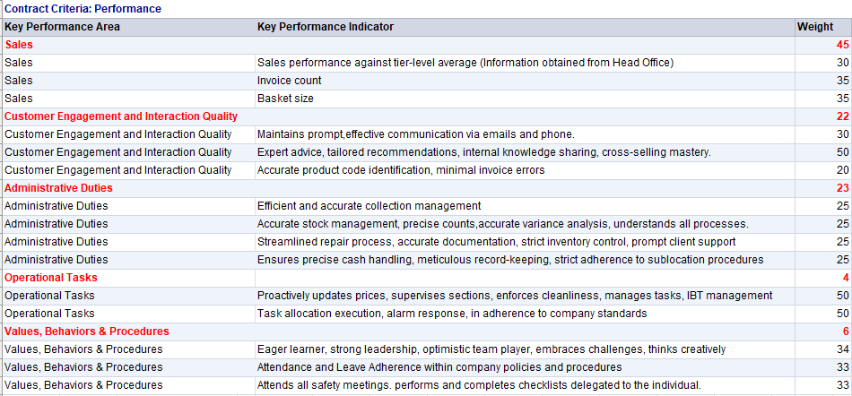

Signed by:

Signature:
Date:

