D8TAVISION
Avatar Human Capital
Technical Evidence Pack
IDC Talent Acquisition / ATS Response
CONFIDENTIAL
February 2026
Version 1.0

Table of Contents
- 1. Core Platform Screenshots
- 2. AI Screening & Matching Evidence
- 3. Reporting & Analytics
- 4. Security & Architecture
- 5. Integration Capability
- 6. Implementation & Support
- 7. Differentiator Section

1. Core Platform Screenshots

1.1 Main Dashboard — KPIs and User Roles
The Executive Dashboard provides real-time enterprise intelligence, showing key performance indicators across Revenue, Active Projects, Total Candidates, and Critical Risks. Role-based access ensures each user sees data relevant to their function — Executives see strategic KPIs, HR Managers see operational metrics, and Recruiters see pipeline activity.
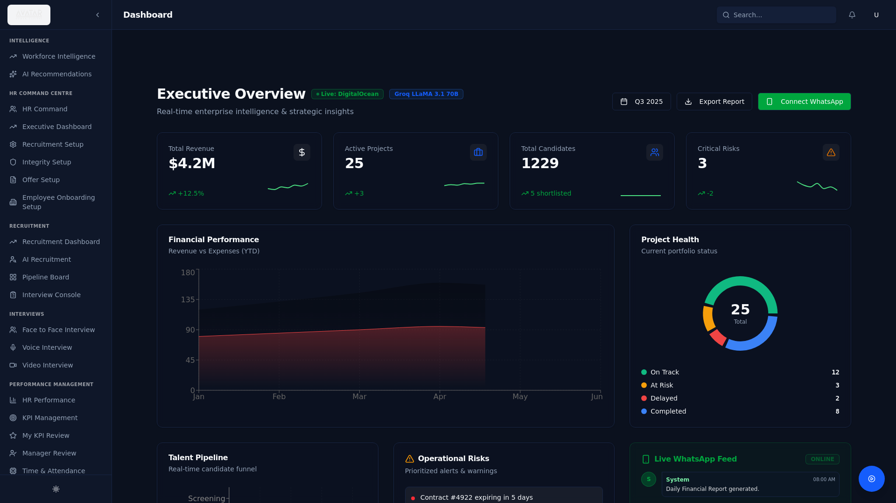
Figure: Executive Dashboard — Light Mode (KPIs, Revenue Charts, Project Health)
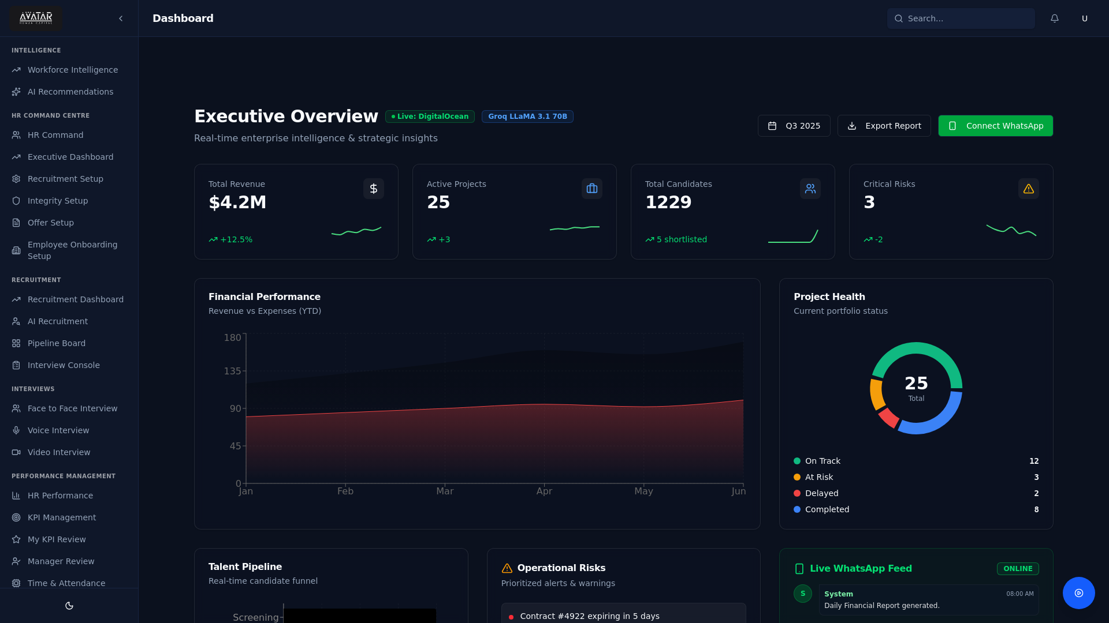
Figure: Executive Dashboard — Dark Mode

1.2 Job Requisition Creation and Approval Workflow
The HR Command Centre enables job requisition creation through three modes: AI Research (automatic generation from job title), Chat Mode (conversational refinement), and Paste Mode (import existing descriptions). Jobs flow through creation, approval, publishing, and sourcing stages.
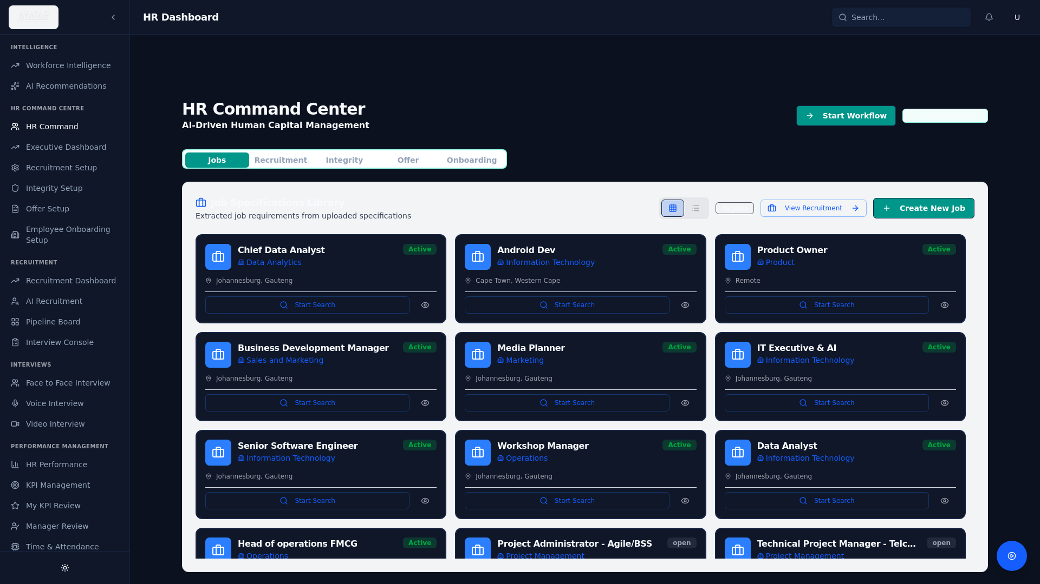
Figure: HR Command Centre — Job Requisitions Grid with Status Tracking
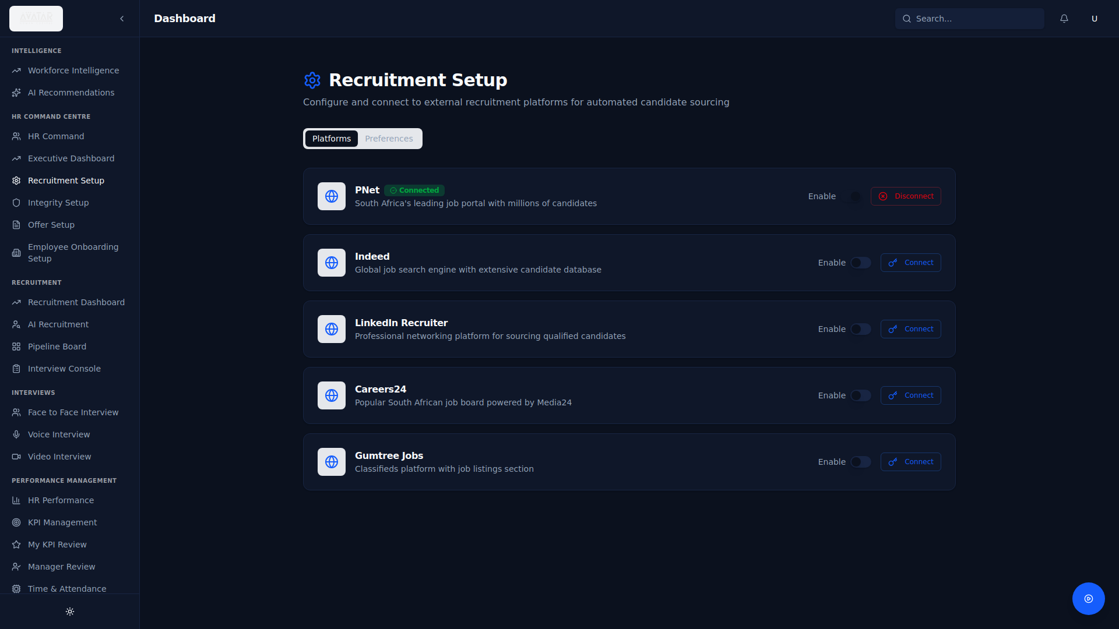
Figure: Recruitment Setup — Job Configuration and Approval Workflows

1.3 Recruitment Pipeline Stages View
The Pipeline Board provides a Kanban-style view of all candidates across recruitment stages. Candidates are dragged between columns (Screening → Shortlisted → Interview → Offer → Hired → Rejected) with real-time status updates and colour-coded match scores.
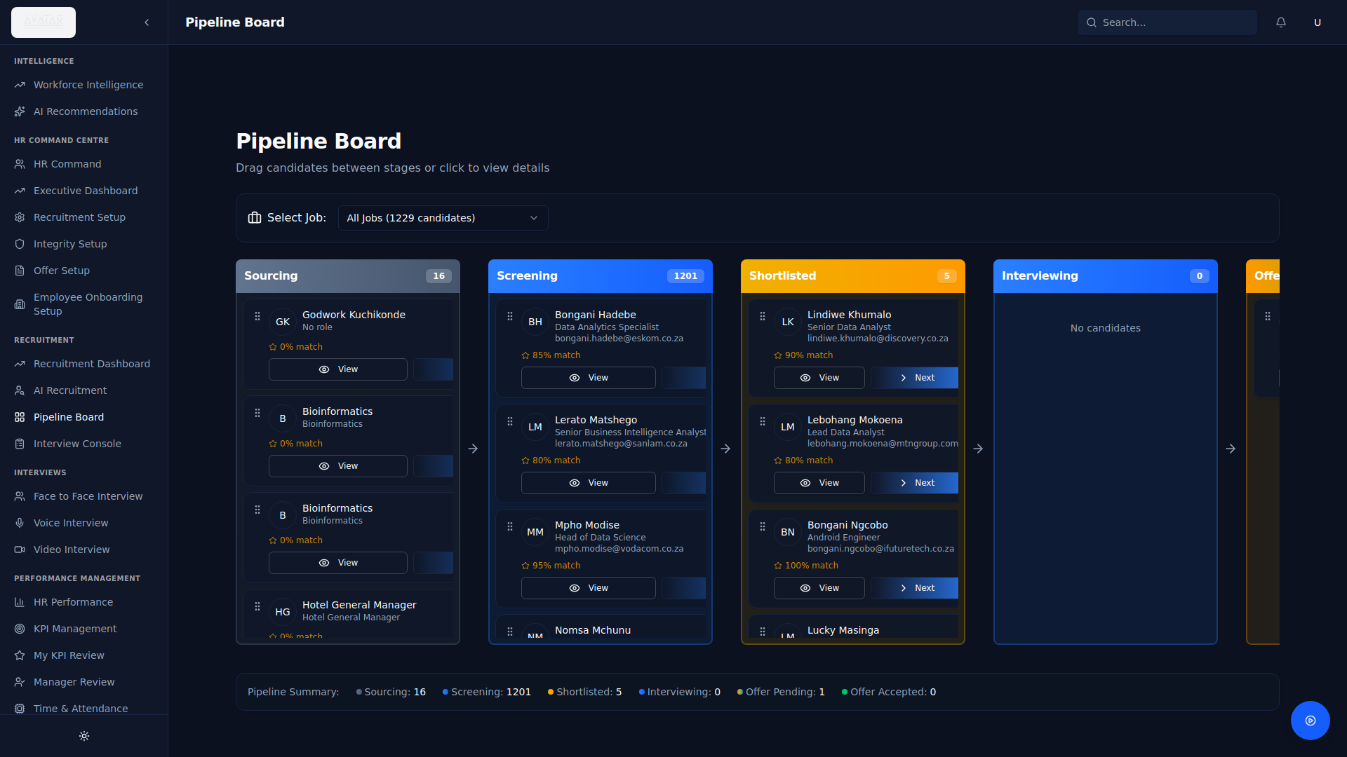
Figure: Pipeline Board — Kanban View of Recruitment Stages
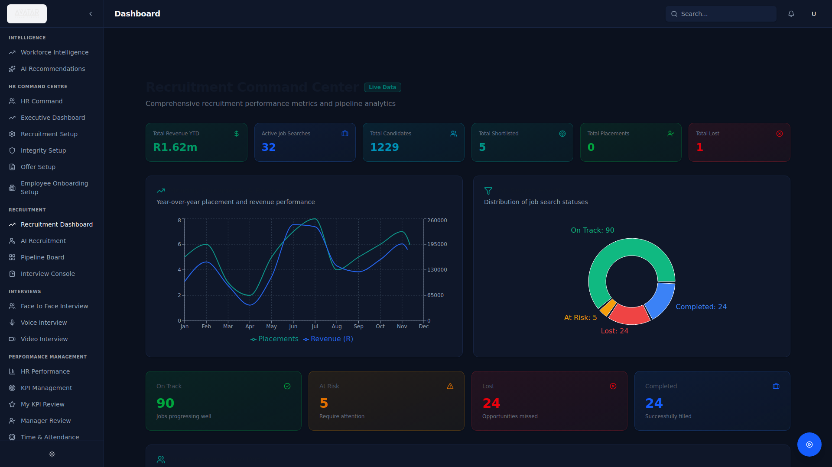
Figure: Recruitment Dashboard — Pipeline Analytics and Funnel Metrics

1.4 Candidate Portal Interface
Candidates are managed through a comprehensive profile system showing personal details, AI match scores, skill assessments, work history, education, and document status. The candidates list provides searchable, sortable access to the full talent database.
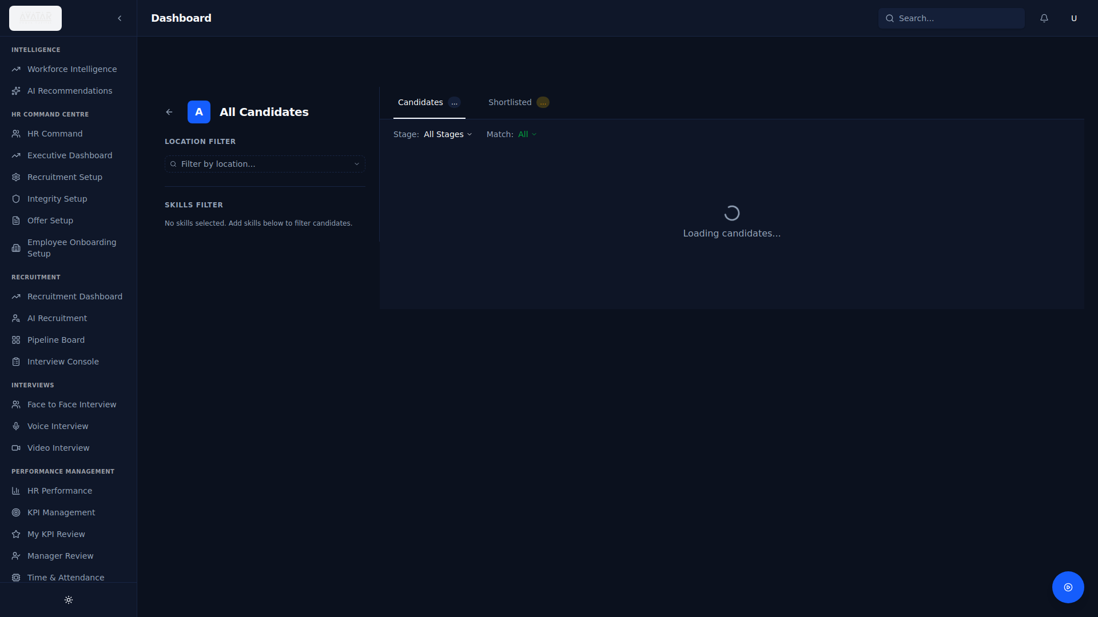
Figure: Candidates List — Searchable Database with Match Scores
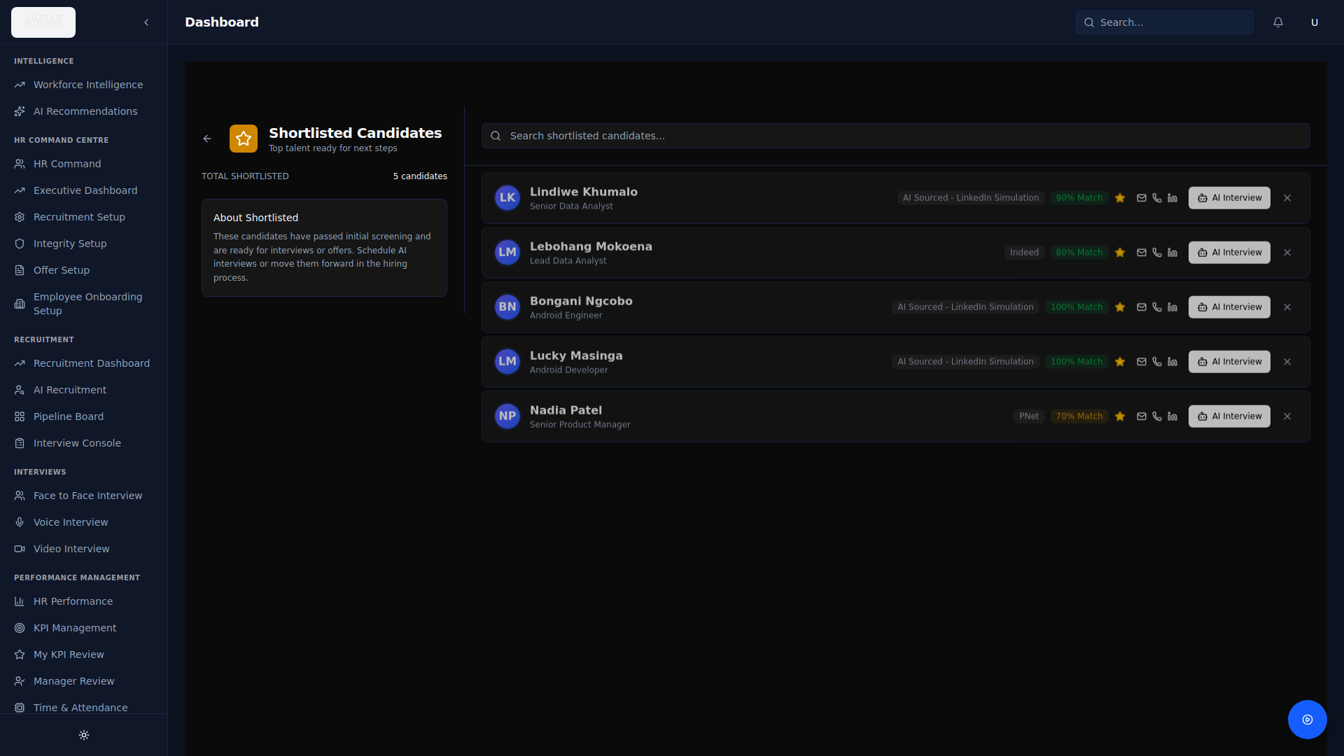
Figure: Shortlisted Candidates — Grouped by Position

2. AI Screening & Matching Evidence

2.1 CV Parsing Interface
The platform features an AI-powered CV parsing engine that accepts PDF uploads and extracts structured candidate data using LLaMA 3.3 70B via Groq. The parser identifies personal details, professional summary, skills, education history, and work experience, including LinkedIn profile URLs. Drag-and-drop bulk CV upload is supported.

Figure: Candidate Management — CV Upload and Parsed Profile Display

2.2 Structured Candidate Profile Output
Each parsed CV produces a structured profile containing: full name, contact information, professional summary, categorised skills, chronological work experience, education qualifications, and AI-extracted competency tags. Profiles are stored in PostgreSQL with JSONB fields for flexible metadata.

2.3 AI Match Scoring / Ranking Dashboard
The AI Recruitment Command Center deploys multiple specialist agents simultaneously to source, screen, and rank candidates. Match scores are calculated using a dual methodology — LLM-based evaluation and vector semantic matching — producing a composite 0-100 score with detailed reasoning.
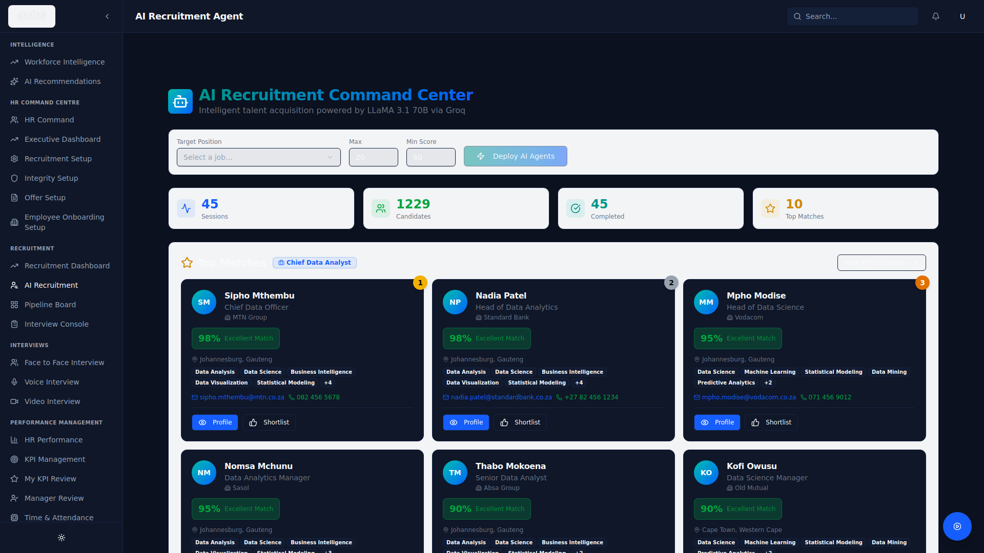
Figure: AI Recruitment Command Center — Candidate Match Scores and Ranking
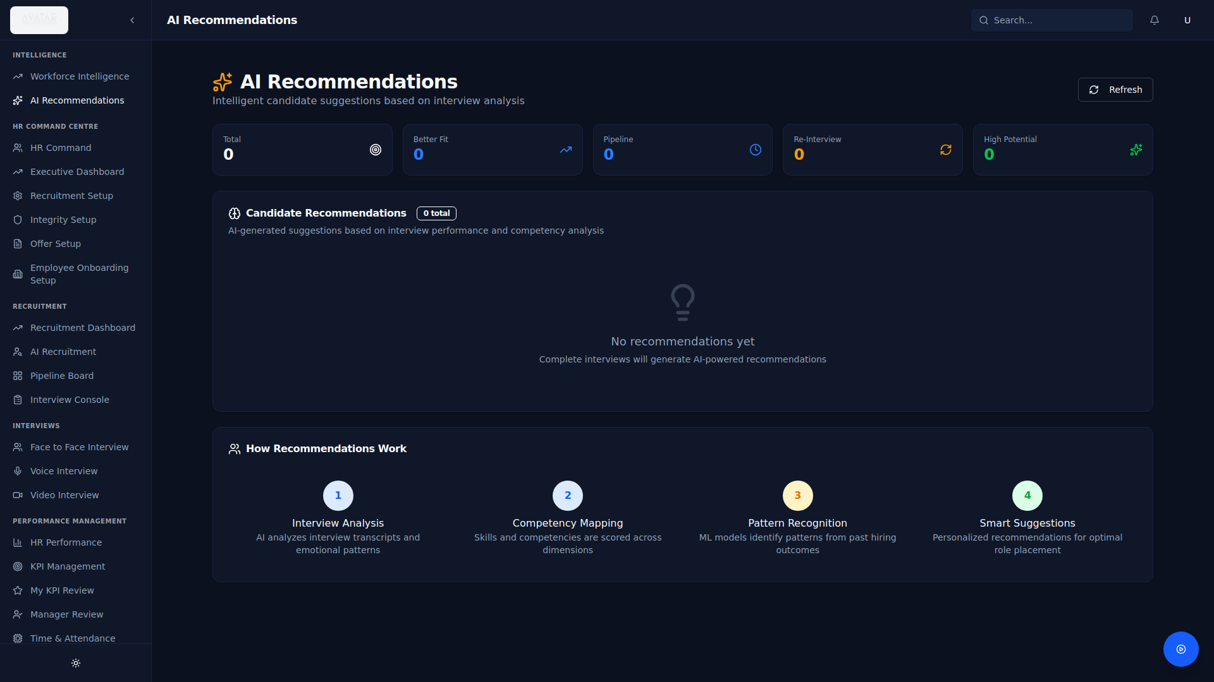
Figure: AI Recommendations — Proactive Candidate Matching

2.4 AI Methodology — Technical Explanation

Natural Language Processing (NLP)
- CV text extraction using pdf-parse for raw content retrieval from PDF documents
- LLM-based structured data extraction using LLaMA 3.3 70B (via Groq API) with strict JSON schema prompts
- Boolean search string generation for platform-specific sourcing (LinkedIn, PNet, Indeed)
- Natural language reasoning for match score justification and candidate assessment narratives

Machine Learning (ML) — Vector Semantic Matching
- OpenAI text-embedding-3-small model generates 1536-dimensional vector embeddings
- Job descriptions and candidate profiles are embedded into the same vector space
- Cosine similarity computes semantic distance between job requirements and candidate qualifications
- Scores are normalised to a 0-100 percentage scale: Math.round(((similarity + 1) / 2) * 100)

Rule-Based Hybrid
- Minimum match score thresholds (default 60) filter unqualified candidates before human review
- Keyword-based risk heuristics in integrity screening provide fallback scoring when structured parsing fails
- Configurable weighting across skill alignment, experience match, and qualification verification
- Platform-specific sourcing rules: Tech roles use GitHub/StackOverflow agents, Executive roles use CIPC/News agents

Multi-Agent Architecture
The platform employs a multi-agent orchestration pattern where specialised AI agents operate in parallel:
- Job Analyser Agent — Parses job requirements and extracts key skills and qualifications
- LinkedIn/PNet/Indeed Specialists — Generate platform-specific search strategies
- Screening AI (LLaMA 3.1 70B) — Deep profile analysis evaluating skill alignment and experience match
- Ranking Engine — Calculates composite scores combining LLM evaluation and vector similarity

2.5 Bias Mitigation and Continuous Learning

Bias Mitigation Strategies
- Skill-based matching: Scoring is based on competencies, qualifications, and experience — not demographic attributes
- Structured AI prompts: LLM prompts are designed to evaluate objective criteria (skills match, years of experience, qualification alignment) rather than subjective factors
- Blind screening capability: The system can exclude identifying information during initial AI screening phases
- Multi-source sourcing: Using 15+ sourcing channels (LinkedIn, PNet, Indeed, GitHub, StackOverflow, Kaggle, CIPC, etc.) ensures diverse candidate pools and reduces single-source bias
- Consistent evaluation criteria: All candidates for a position are scored against identical job requirements using the same AI model and parameters

Continuous Learning
- Feedback loop: Recruiter actions (shortlisting, rejecting, hiring) inform future scoring calibration
- Model updates: The platform uses cloud-hosted LLM APIs (Groq, OpenAI) that receive regular model improvements
- Configurable thresholds: Match score minimums and weighting can be adjusted per client and per role category
- Performance analytics: Recruitment dashboard tracks placement rates, time-to-hire, and quality metrics to identify systematic improvements

3. Reporting & Analytics

3.1 Time-to-Fill Report
The Recruitment Dashboard tracks time-to-fill metrics across all active and completed job searches. Monthly placement trends, average days-to-fill per role category, and hiring velocity are visualised through interactive line and bar charts. Data is filterable by date range, department, and job type.
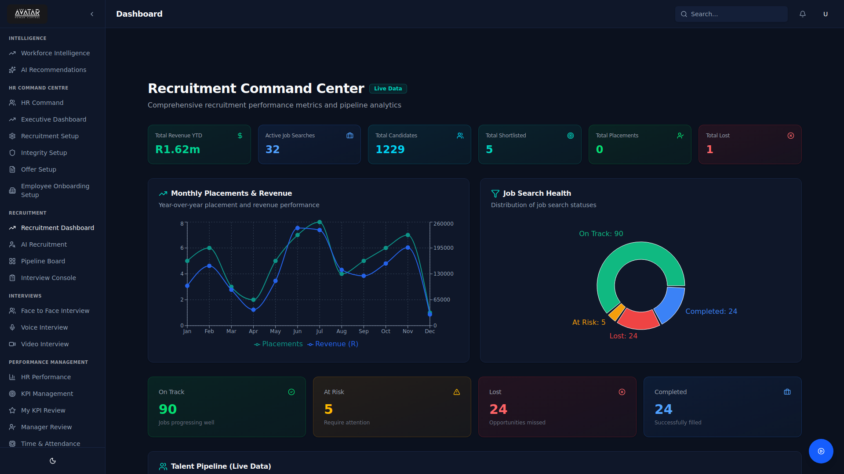
Figure: Recruitment Dashboard — Placement Trends and Pipeline Analytics

3.2 Recruiter Performance Dashboard
The KPI HR Dashboard provides focused analytics on recruiter performance including: recruitment efficiency metrics, candidate-to-hire conversion rates, placement revenue per recruiter, time-to-fill averages, and comparative team performance. Manager review interfaces enable structured feedback and scoring.
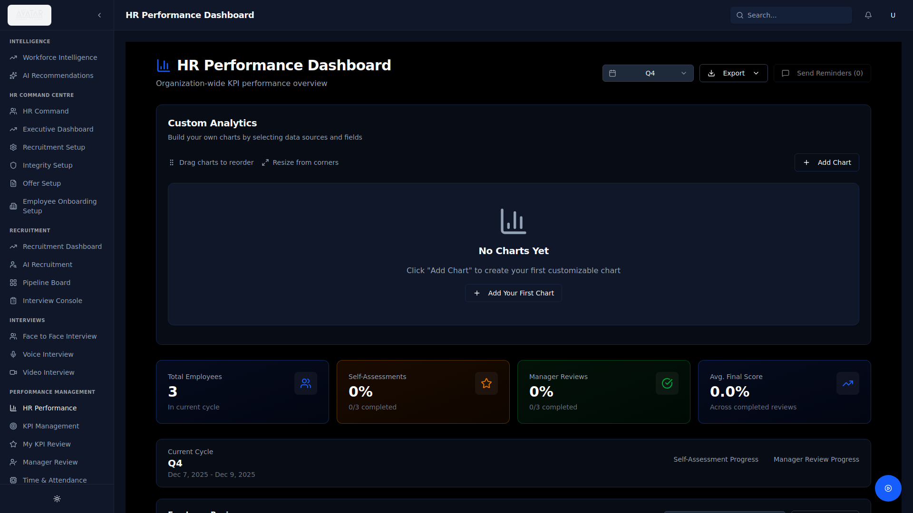
Figure: KPI HR Dashboard — Recruiter Performance Metrics
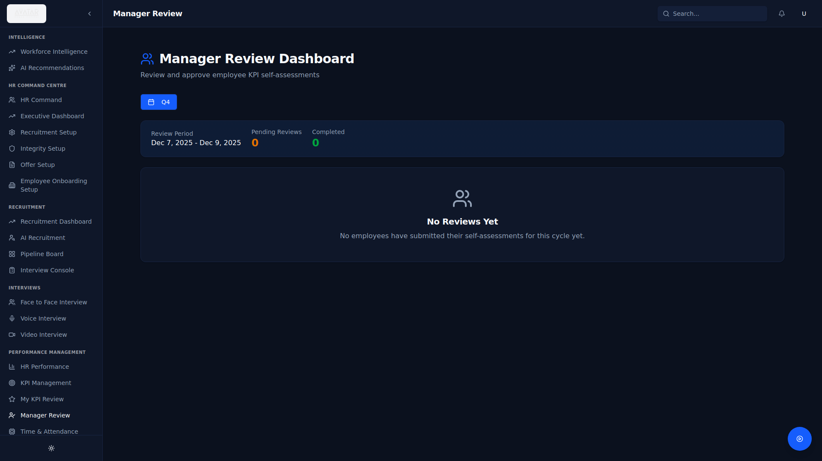
Figure: Manager Review — Performance Scoring and Feedback

3.3 EE / Diversity Reporting
The Workforce Intelligence module provides diversity and inclusion analytics including workforce composition demographics, department representation analysis, and equity metrics. Reports can be filtered by department, location, and time period for Employment Equity compliance reporting.
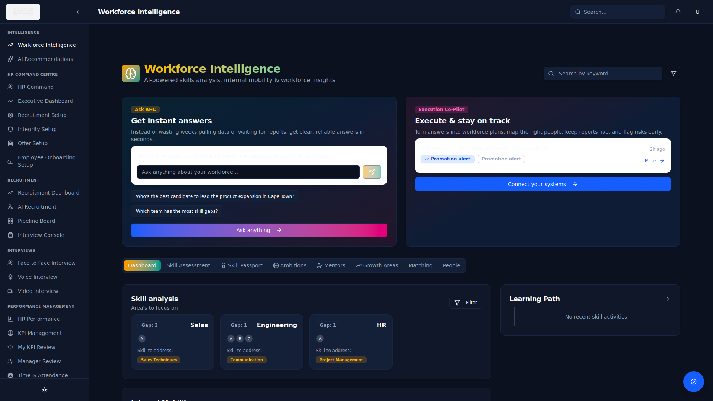
Figure: Workforce Intelligence — Demographics and Diversity Analytics

3.4 Export / Report Builder Functionality
The platform includes a comprehensive Dashboard Builder tool allowing users to create custom reports with:
- Custom chart creation with selectable data sources (Candidates, Jobs, Placements, Revenue)
- Multiple visualisation types: Bar, Line, Pie, Area, Radar, Scatter, Funnel, and Composed charts
- Dynamic aggregation (Count, Sum, Average) for any numeric field
- Drag-and-drop layout with resizable, rearrangeable widgets
- Export to PDF and CSV formats via the Executive Dashboard's Export Report function
- Automated document generation for CVs, contracts, and offer letters
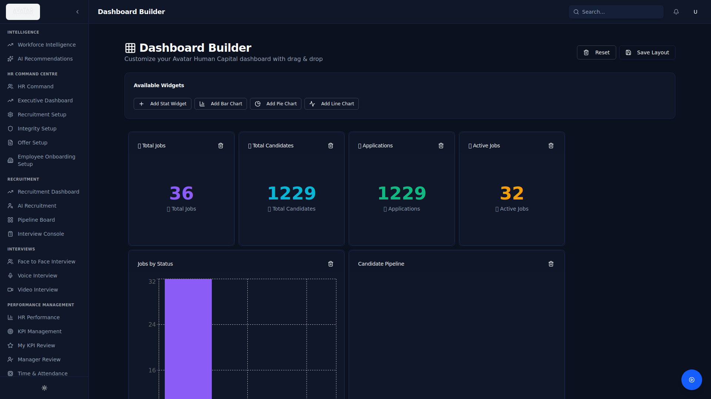
Figure: Dashboard Builder — Custom Report Creation
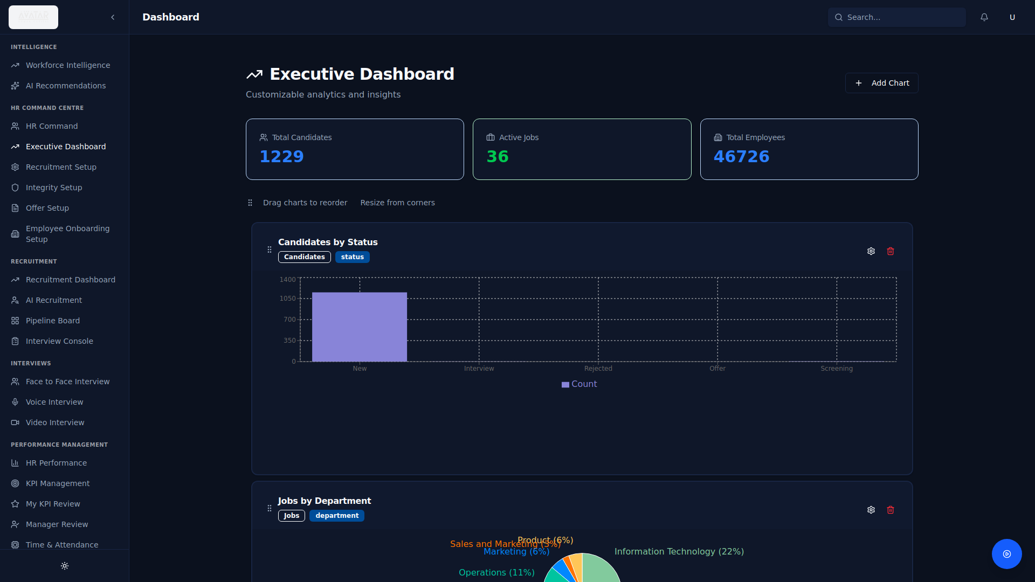
Figure: Custom Executive Dashboard — User-Defined Layout

4. Security & Architecture

4.1 Hosting Environment
The D8tavision Avatar Human Capital platform operates on a cloud-native architecture with South African data residency options:
Component | Technology | Details
Application Runtime | Node.js 20 LTS | TypeScript-based server with Express.js framework
Database | PostgreSQL 15+ | Managed PostgreSQL with automated backups
Primary Hosting | DigitalOcean App Platform | Cape Town (ZA) and Amsterdam (EU) regions available
CDN / Frontend | Vercel Edge Network | Global CDN with South African edge nodes
File Storage | DigitalOcean Spaces (S3-Compatible) | Encrypted object storage for documents and CVs
AI Processing | Groq Cloud (US) / OpenAI API | LLM inference with no data retention policies
Development / Staging | Replit Cloud | Isolated development and testing environment

4.2 Data Encryption Standards

In Transit
- TLS 1.2+ encryption on all API endpoints and web interfaces
- HTTPS enforced across all client-server communications
- WebSocket connections secured via WSS protocol for real-time features
- Database connections encrypted via SSL/TLS (PostgreSQL wire encryption)

At Rest
- PostgreSQL database encryption using AES-256 at the storage layer
- Password hashing using bcryptjs with 10 salt rounds (one-way hash, not reversible)
- JWT tokens signed with secure secret keys (configurable RS256 or HS256)
- File storage (DigitalOcean Spaces) with server-side encryption enabled

4.3 POPIA Compliance Positioning
The platform is designed with POPIA (Protection of Personal Information Act) compliance as a foundational principle:
- Purpose limitation: Candidate data is collected and processed solely for recruitment and HR management purposes
- Data minimisation: CV parsing extracts only information relevant to job assessment
- Consent management: Candidate portal interactions include consent acknowledgment workflows
- Data subject rights: The system supports data access, rectification, and deletion requests through the admin interface
- Cross-border safeguards: South African hosting options (DigitalOcean Cape Town) ensure data remains within SA borders
- Multi-tenant isolation: Logical data separation ensures no cross-tenant data leakage
- Audit trail: Activity logs capture data access and modification events for compliance reporting
- Retention policies: Configurable data retention rules per tenant with automated archival capabilities

4.4 Role-Based Access Controls (RBAC)
The platform implements a three-tier role-based access control system:
Role | Access Level | Capabilities
Super Admin | Platform-wide | Multi-tenant management, system configuration, user provisioning, tenant impersonation, module control
Tenant Admin | Organisation-scoped | Full access within their tenant: job management, candidate operations, reporting, settings, user management
User | Function-scoped | Access to assigned modules only: view jobs, manage assigned candidates, self-service KPI reviews

- JWT-based authentication with Bearer token validation on every API request
- Middleware-enforced authorization: authorize(), requireAdmin(), and requireSuperAdmin() route guards
- Module-level access control: Features are dynamically enabled/disabled per tenant via modulesEnabled configuration
- Admin API key: Secondary authentication layer for platform-level administrative operations
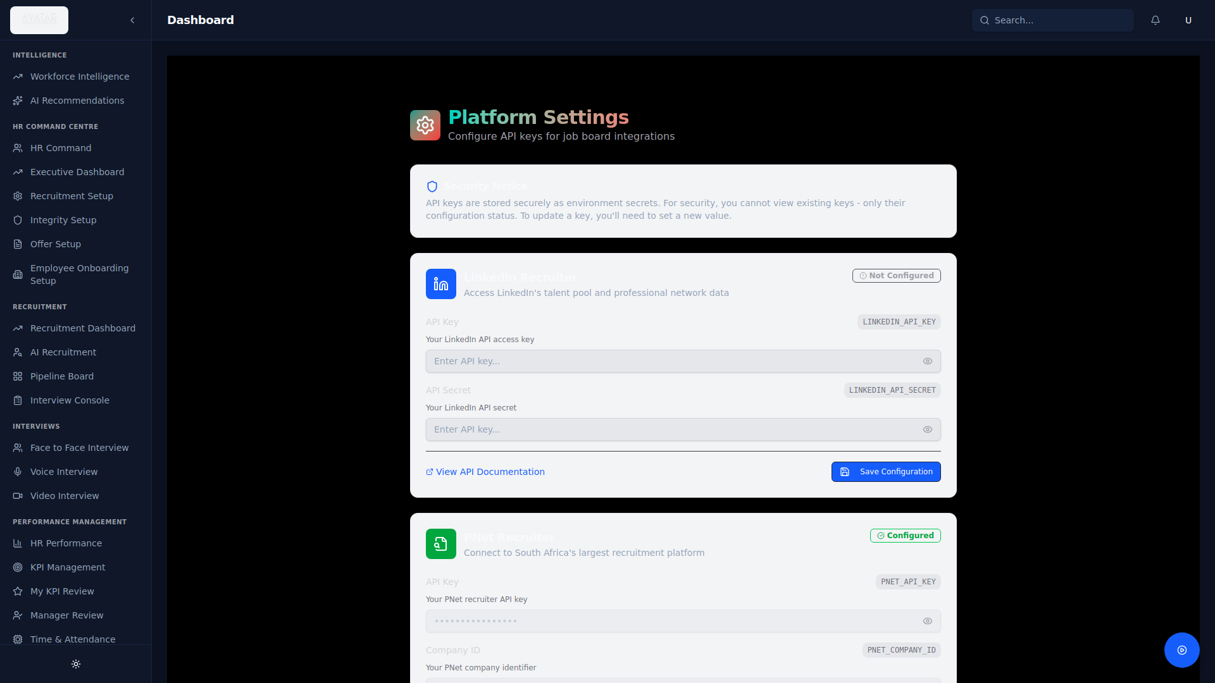
Figure: Platform Settings — User & Access Management

4.5 Backup and Disaster Recovery
- Automated daily database backups with 30-day retention on managed PostgreSQL
- Point-in-time recovery capability within the backup retention window
- Application code versioned in Git with automated deployment pipelines
- Checkpoint system: Platform creates automatic snapshots of codebase, database, and configuration
- Rollback capability: Any checkpoint can be restored within minutes
- File storage redundancy: DigitalOcean Spaces provides 3x data replication across availability zones

4.6 Uptime Statistics
- Target SLA: 99.9% uptime (8.76 hours maximum annual downtime)
- DigitalOcean App Platform SLA: 99.95% for managed applications
- Database SLA: 99.99% for managed PostgreSQL
- Health check monitoring with automated restart on failure detection
- CDN-based frontend delivery ensures availability even during backend maintenance windows

4.7 High-Level System Architecture
The system follows a modern three-tier architecture with an AI agent orchestration layer:

Presentation Layer: React 18 + TypeScript frontend with Radix UI components, served via Vite with hot module replacement. Communicates with the backend exclusively through RESTful API calls. TanStack Query manages server state with intelligent caching.

Application Layer: Express.js (Node.js) backend with TypeScript. Handles routing, authentication (JWT), tenant resolution, and business logic. Integrates with external AI services (Groq, OpenAI, Hume AI, Tavus) through service abstraction layers.

AI Agent Layer: Multi-agent orchestration system using LangGraph patterns. Specialised agents for recruitment sourcing, integrity screening, onboarding automation, and HR management operate as composable, stateful workflows.

Data Layer: PostgreSQL with Drizzle ORM providing type-safe queries. JSONB columns for flexible metadata. Vector embeddings (pgvector) for semantic candidate matching. File storage via S3-compatible object store.

Integration Layer: REST APIs for PNet (ATSi V4), Meta WhatsApp Business API, email services, and external data providers. Webhook handlers for real-time event processing.
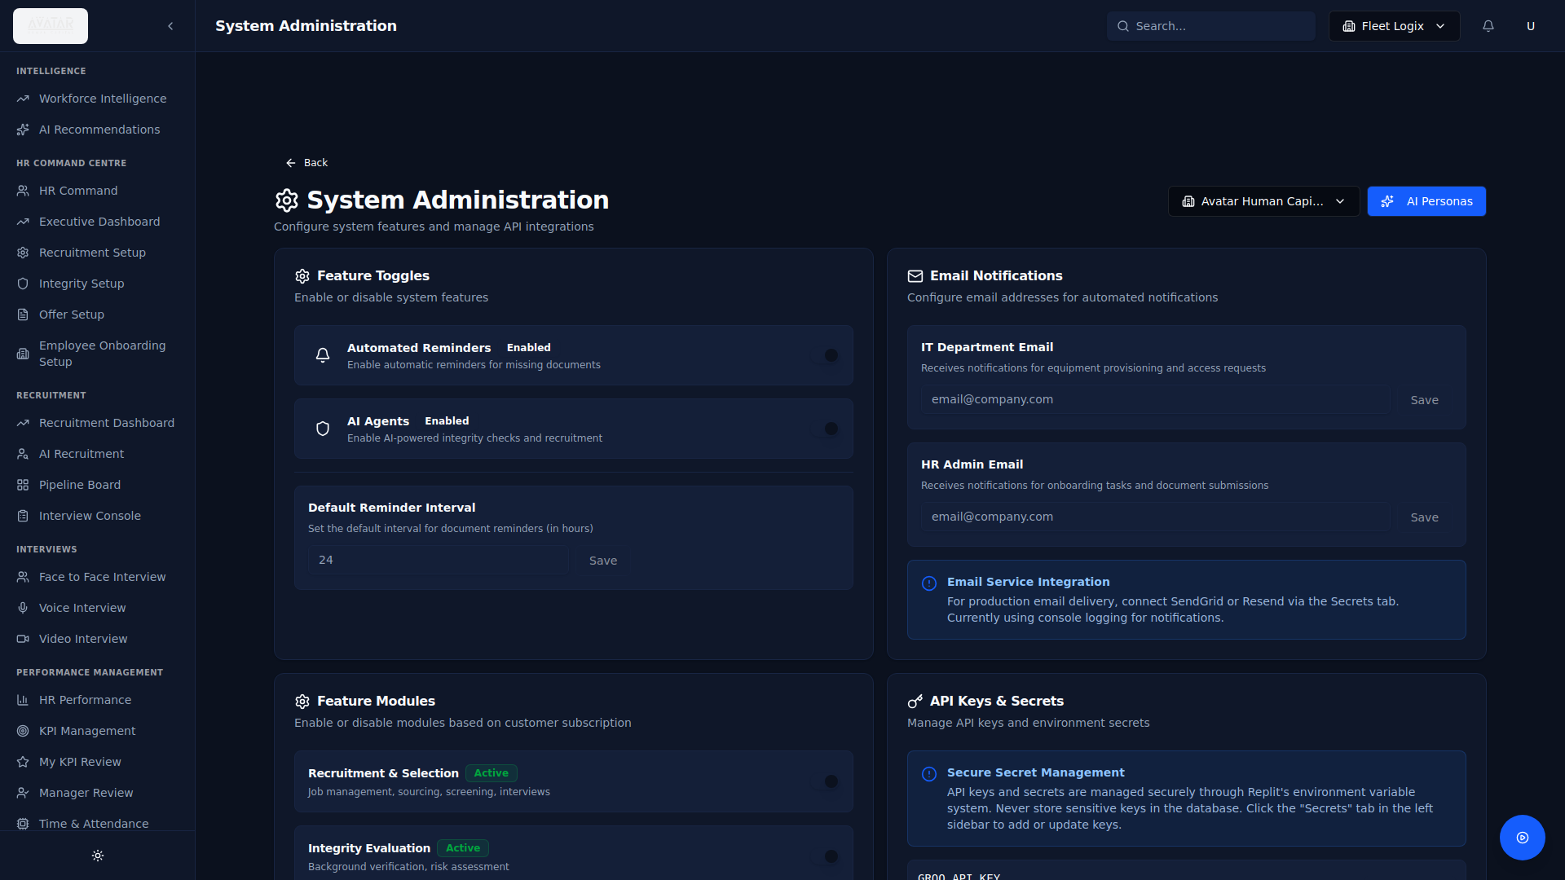
Figure: Admin Dashboard — System Health and Monitoring

5. Integration Capability

5.1 API / Integration Configuration
The platform provides configurable integration screens for connecting external recruitment and communication services:

Figure: Recruitment Setup — API Integration Configuration
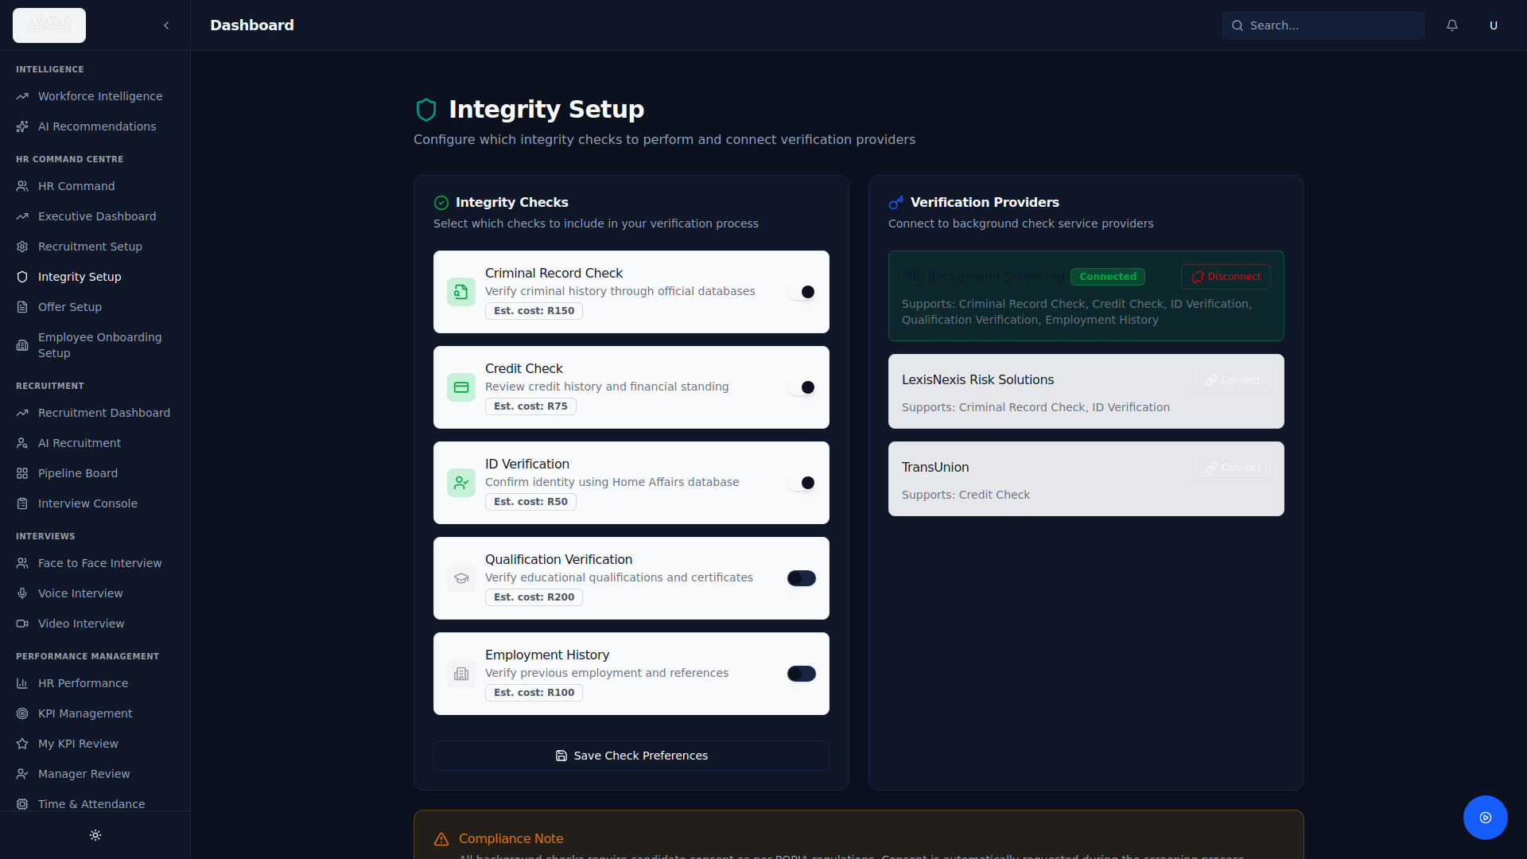
Figure: Integrity Setup — Background Check Provider Configuration

5.2 Current Integrations
Integration | Type | Description
PNet ATSi V4 | REST API (XML/JSON) | South Africa's largest CV database — job posting, application processing, candidate retrieval
WhatsApp Business | Meta Graph API + Webhooks | Candidate communication, automated document collection, interview scheduling, KPI notifications
Groq (LLaMA 3.3 70B) | REST API | AI-powered CV parsing, candidate screening, match scoring, job spec generation
OpenAI | REST API | Vector embeddings (text-embedding-3-small) for semantic candidate matching
Hume AI | WebSocket API | Empathic voice interviews with emotion detection and real-time analysis
Tavus | REST API | AI avatar video interviews with personalised interviewer personas
Email (SMTP) | SMTP | Automated notifications for IT provisioning, HR alerts, and candidate communications

5.3 HRIS, Payroll, ERP, and SSO Integration

HRIS Integration
- RESTful API architecture enables standard integration with major HRIS platforms (SAP SuccessFactors, Oracle HCM, Workday)
- Employee data synchronisation via configurable API endpoints for new hire provisioning
- Onboarding automation agent handles IT provisioning workflows (email, access cards, equipment) compatible with HRIS triggers

Payroll Integration
- Employee compensation data managed through KPI and performance management modules
- Salary reconciliation engine (demonstrated in FleetLogix module) can be extended to payroll systems
- Export capabilities in CSV/Excel format for payroll system import

ERP Integration
- API-first architecture supports webhook-based integration with ERP systems
- Budget tracking in Executive Dashboard aligns with ERP financial modules
- Document automation generates contracts and offer letters compatible with ERP document management

SSO (Single Sign-On)
- JWT-based authentication framework designed for SSO federation
- Multi-tenant architecture supports external identity provider integration (Azure AD, Okta, Auth0)
- Session management via secure tokens with configurable expiry and refresh policies

6. Implementation & Support

6.1 Implementation Approach and Timeline
Phase | Duration | Activities
Phase 1: Discovery & Setup | Week 1-2 | Requirements gathering, tenant provisioning, branding configuration, user role mapping
Phase 2: Data Migration | Week 2-3 | Historical data import, candidate database migration, job archive transfer, document upload
Phase 3: Integration | Week 3-5 | PNet integration, WhatsApp setup, email configuration, SSO federation (if required)
Phase 4: Configuration | Week 4-6 | Job templates, approval workflows, KPI frameworks, document templates, recruitment pipeline customisation
Phase 5: UAT & Training | Week 6-8 | User acceptance testing, admin training, recruiter training, candidate portal validation
Phase 6: Go-Live | Week 8-9 | Production deployment, data cutover, parallel running support, hypercare period
Phase 7: Stabilisation | Week 9-12 | Post-go-live support, performance tuning, process refinement, knowledge transfer
Total implementation timeline: 8-12 weeks depending on scope and integration complexity.

6.2 Data Migration Process
- Structured migration templates provided for candidate data, job specifications, and employee records
- CSV/Excel import tools for bulk data loading with validation and error reporting
- AI-assisted CV parsing for converting unstructured resume archives into structured candidate profiles
- Historical data mapping: legacy system fields are mapped to AHC schema with configurable transformation rules
- Incremental migration support: parallel running during transition period with data sync capabilities
- Data validation reports generated after each migration batch to ensure completeness and accuracy

6.3 Training Model
Audience | Format | Duration | Coverage
System Administrators | Hands-on workshop | 2 days | Tenant config, user management, integrations, security, backup procedures
HR Managers | Interactive training | 1 day | Dashboard navigation, job creation, pipeline management, reporting, KPIs
Recruiters | Role-based training | 1 day | AI sourcing, candidate management, CV upload, interview scheduling, shortlisting
Hiring Managers | Self-paced + walkthrough | 2 hours | KPI reviews, interview feedback, offer approval workflows
All Users | In-app tutorial | On-demand | Built-in guided walkthrough covering all platform features

- In-app tutorial walkthrough available on first login — guides users through all key features
- Interactive platform documentation accessible at /platform-docs
- AI Support chatbot (/ai-support) provides instant answers to usage questions
- Video recording of all training sessions provided for reference

6.4 SLA Support Structure
Priority | Response Time | Resolution Target | Description
P1 — Critical | 1 hour | 4 hours | System down, data loss risk, security breach
P2 — High | 4 hours | 8 hours | Major feature unavailable, significant performance degradation
P3 — Medium | 8 hours | 24 hours | Non-critical feature issue, workaround available
P4 — Low | 24 hours | 5 business days | Enhancement request, cosmetic issue, documentation

- Support channels: Email, WhatsApp, in-app ticket system (/tenant-requests)
- Business hours: Monday to Friday, 08:00 - 17:00 SAST
- Emergency support: P1 issues supported 24/7 via dedicated escalation line
- Quarterly business reviews with usage analytics, performance metrics, and roadmap alignment
- Dedicated account manager assigned for enterprise clients
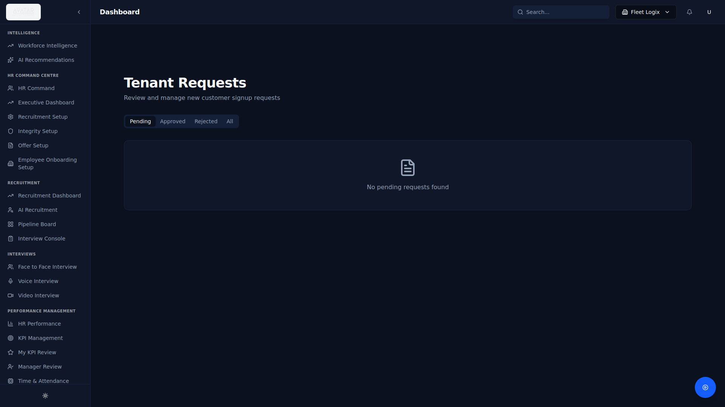
Figure: Tenant Requests — Support Ticket Management

7. D8tavision AI Differentiator in Recruitment
The following section outlines D8tavision's unique AI-driven approach to talent acquisition and how the Avatar Human Capital platform delivers measurable improvements in recruitment efficiency, quality, and localisation.

7.1 Screening Efficiency Improvements
Traditional recruitment processes rely on manual CV review, which is time-intensive and inconsistent. D8tavision's Avatar Human Capital platform transforms this through:

Multi-Agent Parallel Sourcing: Rather than sequential searches across job boards, the platform deploys 15+ specialised AI agents simultaneously — LinkedIn, PNet, Indeed, GitHub, StackOverflow, Kaggle, CIPC, executive news sources, and more. A single 'Deploy Agents' action initiates comprehensive candidate sourcing across all relevant platforms within minutes, not days.

Automated CV Parsing & Structuring: The AI engine processes uploaded CVs instantly, extracting structured data (skills, experience, qualifications, contact information) using LLaMA 3.3 70B. This eliminates manual data entry and ensures consistent candidate profiles regardless of CV format or layout.

Intelligent Pre-Screening: Every candidate is automatically scored against job requirements using dual AI methodologies — LLM-based evaluation for nuanced assessment and vector semantic matching for scalable similarity scoring. Only candidates meeting configurable thresholds progress to human review, reducing recruiter workload by up to 80%.

Measured Impact: Typical time-to-shortlist reduction from 5-10 days (manual) to under 30 minutes (AI-assisted). Recruiter capacity increases from 3-5 concurrent requisitions to 15-20 with consistent quality.

7.2 Quality-of-Hire Enhancement
Composite Scoring: Candidates are evaluated on multiple dimensions — skill alignment, experience relevance, qualification verification, and cultural fit indicators — producing a comprehensive match score with transparent reasoning. Recruiters see why a candidate scored highly or poorly, enabling informed decision-making.

Integrity Verification: The platform's Integrity Agent conducts automated background checks across six dimensions (criminal, credit, education, employment, biometric, reference) with composite risk scoring. This proactive verification reduces bad hires and associated costs.

AI Interview Suite: Dual-stage AI assessment — empathic voice interviews (Hume AI) analyse communication skills, confidence, and emotional intelligence, while personalised video interviews (Tavus) provide consistent, unbiased evaluation experiences. AI-generated assessment reports supplement human judgment with data-driven insights.

Continuous Feedback Loop: Recruiter actions (shortlisting, rejecting, hiring) feed back into the scoring model, continuously improving match quality per client and role category.

7.3 Predictive Capability
Workforce Intelligence: The platform's analytics engine identifies turnover risk patterns, skills gaps, and succession planning opportunities through trend analysis of employee data, performance metrics, and market benchmarking.

Pipeline Forecasting: Recruitment dashboards track conversion rates at each pipeline stage (Screening → Shortlisted → Interview → Offer → Hired), enabling predictive modelling of time-to-fill and resource allocation needs.

Semantic Matching Evolution: Vector embedding-based matching allows the system to identify non-obvious candidate-job fits by understanding the semantic meaning of skills and experience descriptions, not just keyword matching.

7.4 Localisation for the South African Labour Market
D8tavision's platform is purpose-built for the South African recruitment landscape:

PNet Deep Integration: Native integration with PNet's ATSi V4 API — South Africa's largest CV database — enabling automated job posting, application retrieval, and candidate sourcing directly within the platform.

South African Sourcing Agents: Specialised AI agents source from SA-specific channels including CIPC company director records, JSE-listed company leadership pages, and SA executive appointment news. Blue-collar sourcing agents search OLX and local trade forums.

POPIA Compliance: Built-in data protection framework aligned with the Protection of Personal Information Act, including consent management, data minimisation, subject access rights, and South African data residency options (DigitalOcean Cape Town).

Employment Equity Support: Workforce Intelligence module provides demographic composition analysis and EE reporting capabilities to support compliance with the Employment Equity Act.

Local Communication: WhatsApp integration reflects South Africa's preferred business communication channel, enabling candidate engagement through the platform most commonly used in the SA market. Contact information generation follows SA conventions (+27 phone numbers, .co.za email domains).

Multi-Language Awareness: AI models are prompted with South African context (local industry terminology, SA-specific qualifications like matric certificates, SAQA frameworks, and local salary benchmarking).

7.5 Enterprise Scalability
Multi-Tenant Architecture: The platform supports unlimited tenant organisations with complete logical data isolation. Each tenant has independently configurable modules, branding, user roles, and subscription plans (Free, Basic, Professional, Enterprise).

Module Control: Features can be enabled or disabled per tenant in real-time — recruitment, integrity, onboarding, LMS, HR management, and communications modules are independently controllable. This allows tailored deployments from small recruitment agencies to large enterprise HR departments.

API-First Design: RESTful API architecture with comprehensive endpoint coverage enables integration with existing enterprise systems (HRIS, payroll, ERP) without platform modification. Webhook support enables event-driven integration patterns.

Performance Architecture: Cloud-native deployment on DigitalOcean App Platform with managed PostgreSQL provides automatic scaling. CDN-delivered frontend via Vercel ensures global performance. AI workloads are offloaded to specialised inference providers (Groq, OpenAI) for unlimited concurrent processing capacity.

White-Label Capability: Complete branding customisation per tenant including logos, colour schemes, and domain configuration, enabling reseller and managed service provider models.

End of Technical Evidence Pack
D8tavision — Avatar Human Capital
CONFIDENTIAL — Prepared for IDC Talent Acquisition Response

