AMBASSADORC v5
Insurance Management Platform
ILLUSTRATED USER MANUAL

Step-by-Step Guide with Screenshots
Version 5.0 | April 2026

CONFIDENTIAL — Internal Use Only

1. Introduction
AmbassadorC v5 is a unified, web-based insurance management platform for South African operations. It replaces three legacy systems with a single modern interface accessible from any web browser.

1.1 The Home Screen

Figure 1.1 — AmbassadorC v5 landing page
The public landing page shows platform statistics and two entry buttons: Start for free (Register) and Sign in to your account (Login).

1.2 User Roles
Role | Description
Ambassador | Field representatives — submit leads, track referrals, view commissions.
Agent | Sales agents — work the dialler queue, record call outcomes.
Admin | Back-office staff — full platform access and management.
QA Officer | Quality assurance — review and approve/reject sales.

2. Logging In
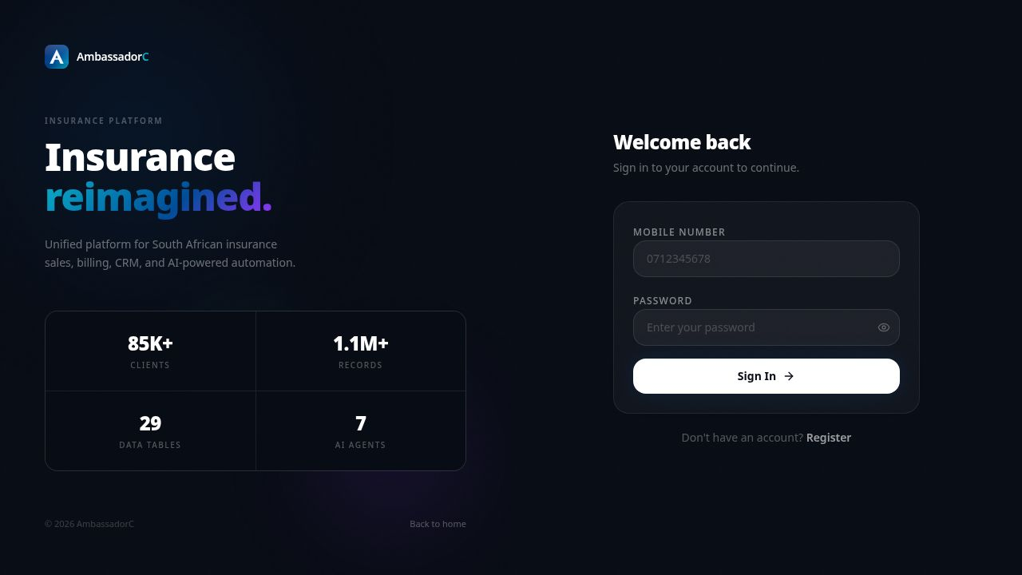
Figure 2.1 — Login page

2.1 How to Log In
Step 1: Open your web browser and navigate to the AmbassadorC v5 URL.
Step 2: You will see the "Welcome back" screen shown above.
Step 3: Enter your Mobile Number (e.g. 0821234567) in the MOBILE NUMBER field.
Step 4: Enter your Password.
Step 5: Click the blue Sign In button.
Step 6: You will be taken to your role-appropriate dashboard automatically.
NOTE: Ambassadors are taken to the Ambassador Dashboard. Admins, Agents, and QA Officers are taken to the Admin Operations Centre.

2.2 Registering as a New Ambassador
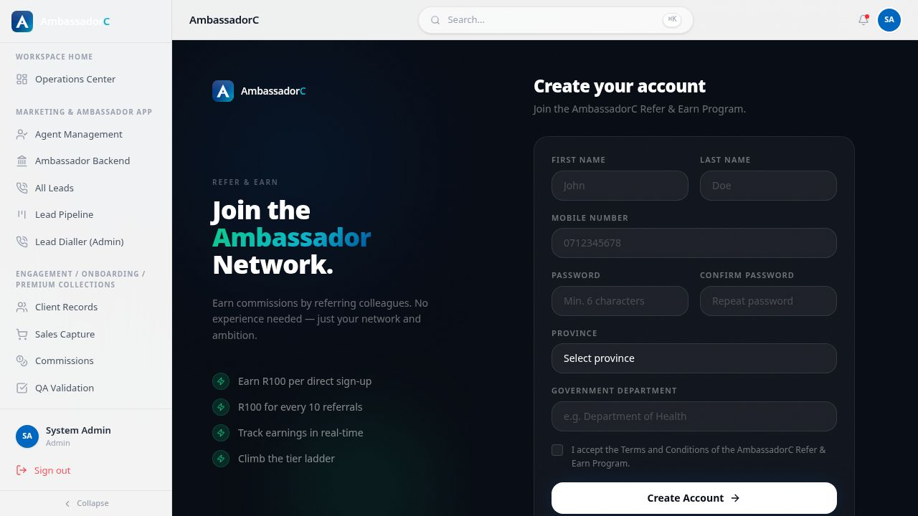
Figure 2.2 — Ambassador registration page
Step 1: On the login page, click Register (bottom right) or navigate to /register.
Step 2: Enter your First Name, Last Name, Mobile Number, Province, Government Department, and Password.
Step 3: Tick the Terms & Conditions checkbox.
Step 4: Click Create Account.
Step 5: Once an admin approves your account, you can log in.
TIP: Your mobile number is your username — use the same number every time you log in.

3. Admin Dashboard (Operations Centre)
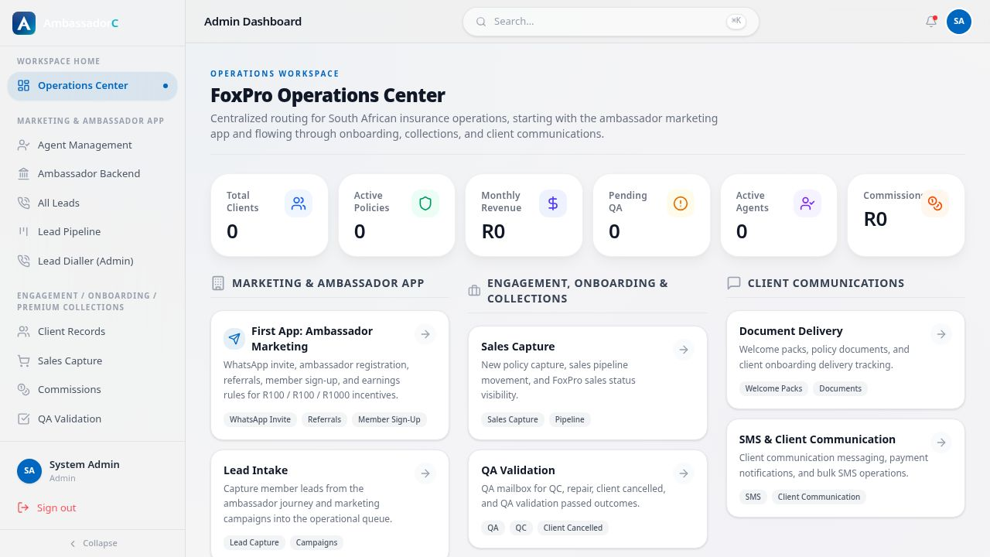
Figure 3.1 — Admin Dashboard / Operations Centre

3.1 What You See
The Admin Dashboard is the central hub for administrators. It shows:
- KPI Cards (top row): Total Clients, Active Policies, Monthly Revenue, Pending QA, Active Agents, Commissions.
- Module tiles: Quick links to every section — Ambassador Marketing, Sales Capture, QA Validation, Document Delivery, SMS & Client Communication, Lead Intake.
- Sidebar (left): Navigation menu with all modules grouped by function.
- Header (top): Search bar and your user avatar (SA for System Admin).

3.2 Navigation Sidebar
The sidebar groups all modules into three sections:
Section | Modules Available
Marketing & Ambassador App | Agent Management, Ambassador Backend, All Leads, Lead Pipeline, Lead Dialler (Admin)
Engagement / Onboarding / Premium Collections | Client Records, Sales Capture, Commissions, QA Validation
Bottom | Sign out, Collapse sidebar

4. Lead Management

4.1 All Leads List
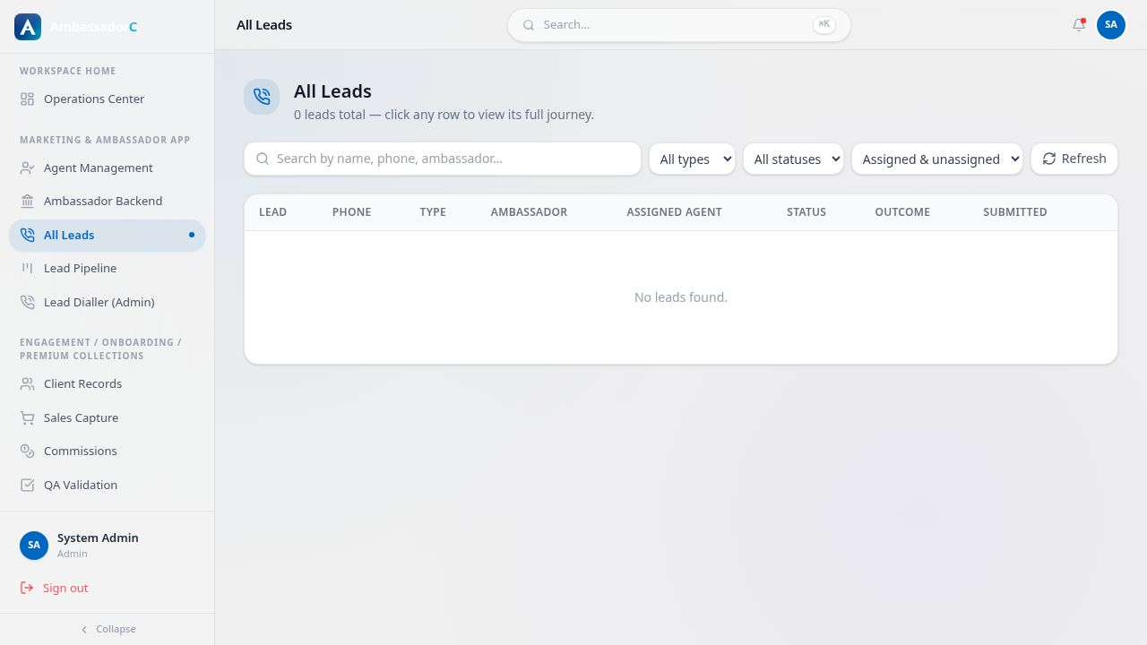
Figure 4.1 — All Leads list with search and filters
The All Leads page shows every lead in the system in a searchable, sortable table.
Step 1: In the sidebar, click All Leads.
Step 2: Use the search bar to find a lead by name, phone number, or ambassador name.
Step 3: Use the filter dropdowns to narrow by Type, Status, or Assignment.
Step 4: Click any row to open the full Lead Detail page.
Step 5: Click the Refresh button to reload the list.

4.2 Lead Pipeline (Kanban View)
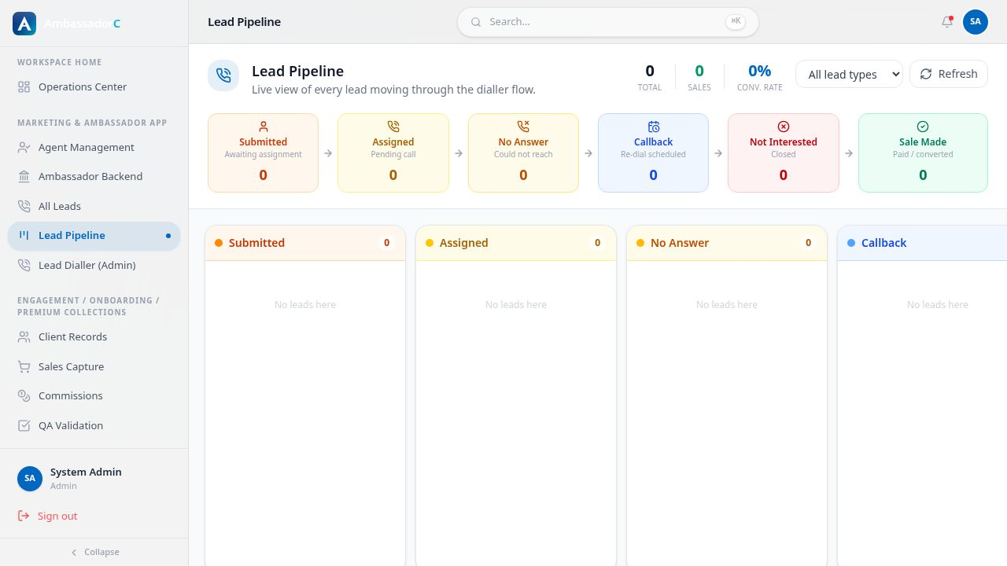
Figure 4.2 — Lead Pipeline Kanban board
The Lead Pipeline shows all leads as cards in columns, one column per stage of the sales journey.
Column | Meaning
Submitted | Lead just submitted by an ambassador. Awaiting agent assignment.
Assigned | Lead assigned to an agent. Pending first call.
No Answer | Agent called — no answer. Scheduled for callback.
Callback | Client requested a specific callback time.
Not Interested | Client not interested. Archived.
Sale Made | Lead converted — client paid. Commission triggered.

4.3 Lead Dialler Management
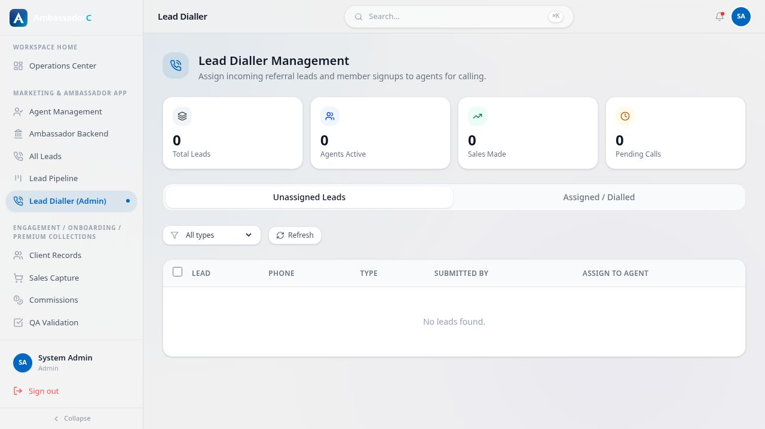
Figure 4.3 — Lead Dialler Management page
Admins use the Dialler Management page to assign leads to agents and monitor the call queue.
Step 1: Click Lead Dialler (Admin) in the sidebar.
Step 2: The top row shows KPIs: Total Leads, Agents Active, Sales Made, Pending Calls.
Step 3: The Unassigned Leads tab shows all leads waiting for an agent.
Step 4: Tick one or more lead checkboxes, then select an agent from the ASSIGN TO AGENT dropdown.
Step 5: Click Assign to transfer the leads to that agent.
Step 6: Click Assigned / Dialled tab to see leads already in agents queues.

5. Client Records
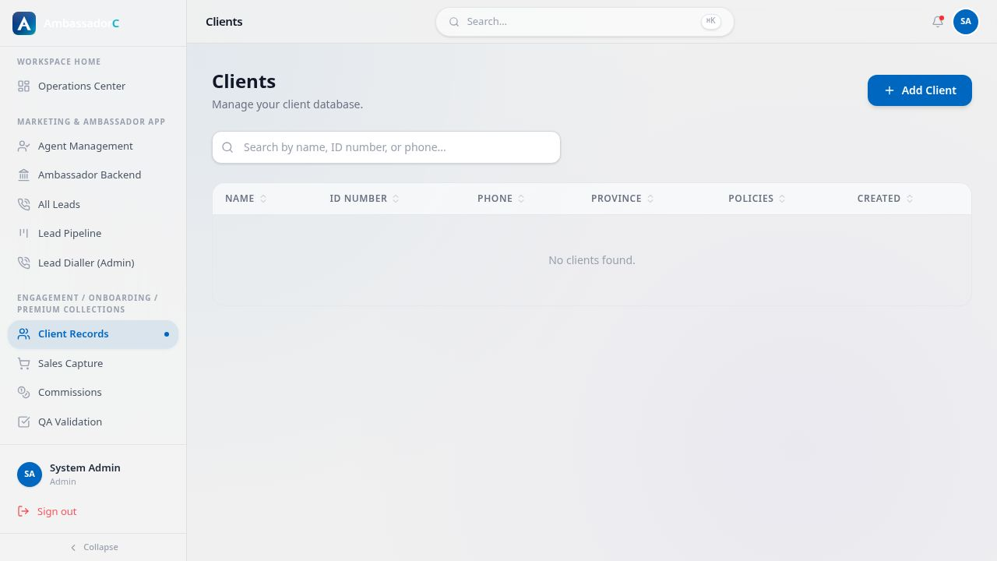
Figure 5.1 — Client Records list

5.1 Viewing All Clients
Step 1: In the sidebar, click Client Records.
Step 2: A table shows all clients: Name, ID Number, Phone, Province, Policies, Created Date.
Step 3: Use the search bar to find a client by name, ID number, or phone.
Step 4: Click any row to open the full Client Detail page.

5.2 Adding a New Client
Step 1: Click the blue + Add Client button (top right).
Step 2: Fill in: First Name, Last Name, ID Number, Cell Number, Address, Province.
Step 3: Click Save Client.
WARNING: South African ID numbers are validated. Ensure the ID is correct before saving.

6. Policies
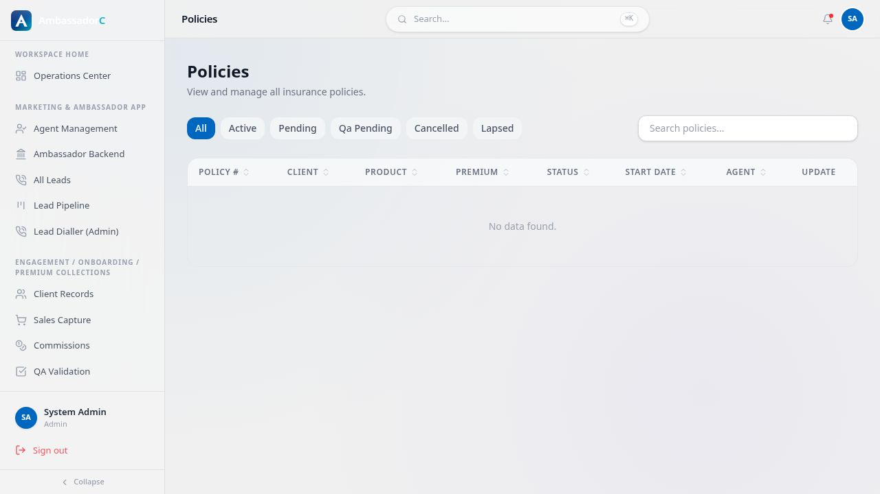
Figure 6.1 — Policies list with status filter tabs

6.1 Viewing Policies
Step 1: In the sidebar, click under Sales Capture (or navigate to Policies).
Step 2: Use the filter tabs — All, Active, Pending, Qa Pending, Cancelled, Lapsed — to narrow results.
Step 3: Use the search bar to find a specific policy by number, client, or product.
Step 4: Each row shows: Policy #, Client, Product, Premium, Status, Start Date, Agent.

6.2 Policy Status Guide
Status Tab | Meaning
Pending | Policy created but first payment not yet collected.
Qa Pending | Awaiting QA officer review before activation.
Active | Policy in force — client is paying monthly.
Lapsed | Missed payments — policy inactive but recoverable.
Cancelled | Policy permanently closed.

7. Sales Capture (Sales Pipeline)
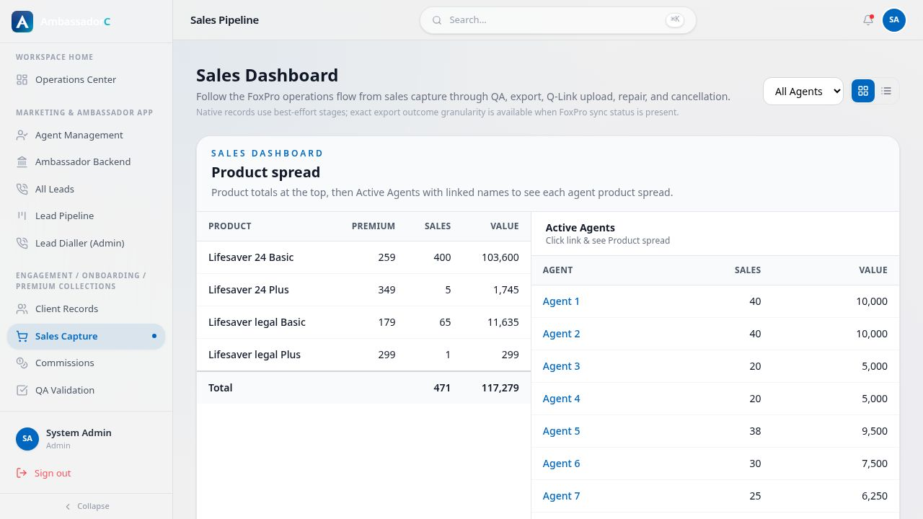
Figure 7.1 — Sales Dashboard showing product spread and active agents

7.1 What the Sales Dashboard Shows
The Sales Dashboard gives a product-by-product breakdown of all sales, and lists all active agents with their individual sales counts and values.
- Product Spread table: rows per product — Premium, Sales count, Total Value.
- Active Agents list: click an agent name to drill into their individual product spread.
- Toggle between grid view (tiles) and list view (table) using the icons top-right.

7.2 Sale Status Flow
Status | Meaning | Next Action
NEW | Sale just recorded. | Submit for QA review.
QA_PENDING | Awaiting QA officer. | QA officer reviews.
QA_APPROVED | QA passed. | Admin activates.
QA_REJECTED | QA failed. | Agent corrects and resubmits.
ACTIVE | Sale live, policy in force. | Monthly premium collection.
CANCELLED | Sale cancelled. | No further action.

8. Commissions
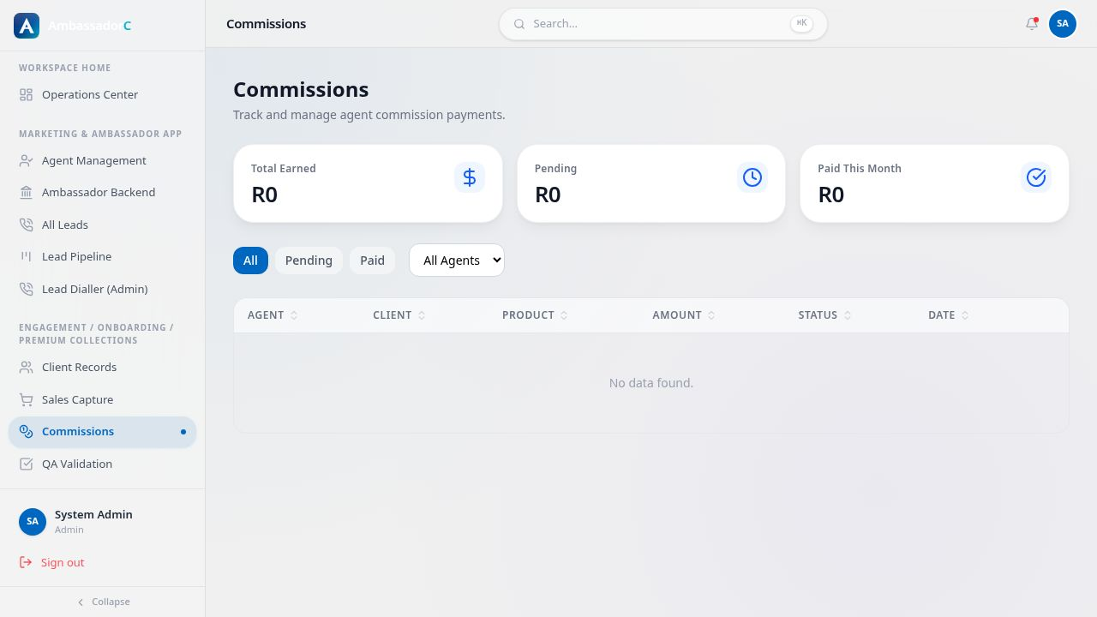
Figure 8.1 — Commissions page with KPI cards and agent filter

8.1 Viewing Commissions
Step 1: In the sidebar, click Commissions.
Step 2: The three KPI cards show: Total Earned, Pending, and Paid This Month.
Step 3: Use the tabs — All, Pending, Paid — to filter the table below.
Step 4: Use the All Agents dropdown to filter by a specific ambassador.
Step 5: Each row shows: Agent, Client, Product, Amount, Status, Date.

8.2 How Commissions Are Calculated
Commissions are automatically generated when a sale reaches QA_APPROVED or ACTIVE status. Each product has a pre-configured commission percentage. The ambassador who submitted the original lead receives the commission.
TIP: Use the All Agents dropdown to generate a commission statement for a specific ambassador, then export to CSV for payroll.

9. Quality Assurance (QA Validation)
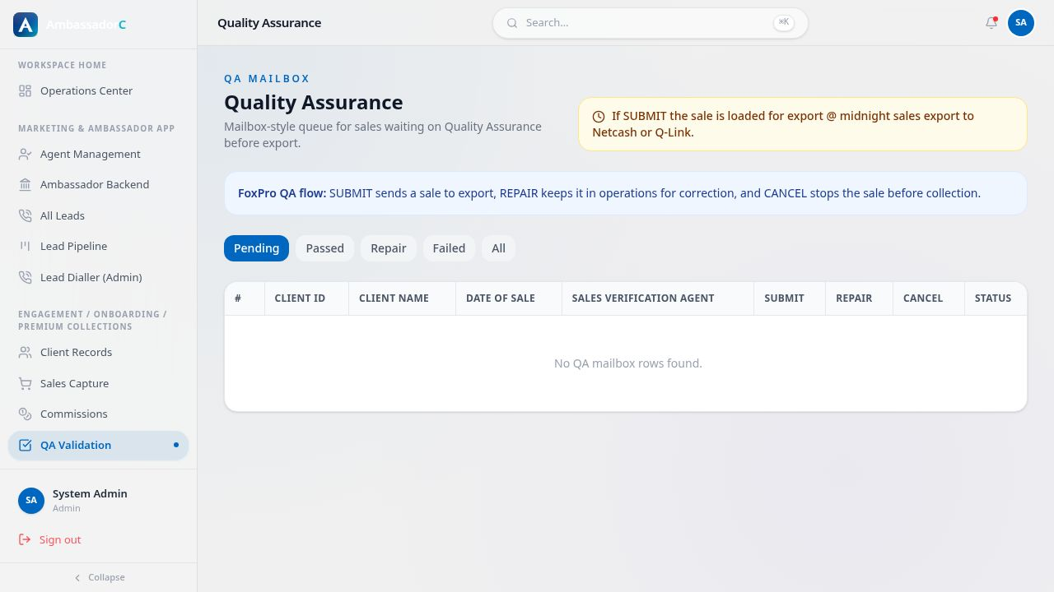
Figure 9.1 — QA Mailbox with Pending, Passed, Repair, Failed tabs

9.1 The QA Mailbox
The QA Mailbox is a queue of all sales waiting for quality review before export to NetCash or QLink. Each sale must be reviewed by a QA officer before the policy can go live.

9.2 Reviewing a Sale (QA Officer)
Step 1: In the sidebar, click QA Validation.
Step 2: The Pending tab is selected by default — these are sales awaiting review.
Step 3: Click a sale row to open its detail view.
Step 4: Verify: client consent, correct premium, valid ID number, welcome pack sent, e-signature obtained.
Step 5: Click SUBMIT to pass the sale to export. Click REPAIR to send it back for correction. Click CANCEL to stop the sale.

9.3 QA Flow Summary
FoxPro QA flow: SUBMIT sends a sale to export, REPAIR keeps it in operations for correction, CANCEL stops the sale before collection.
Tab | What It Shows
Pending | Sales waiting for QA review.
Passed | Sales that passed QA — exported or queued for export.
Repair | Sales sent back to agent for correction.
Failed | Sales that failed QA and were cancelled.
All | Every sale regardless of QA status.

10. Messaging Centre (SMS & WhatsApp)
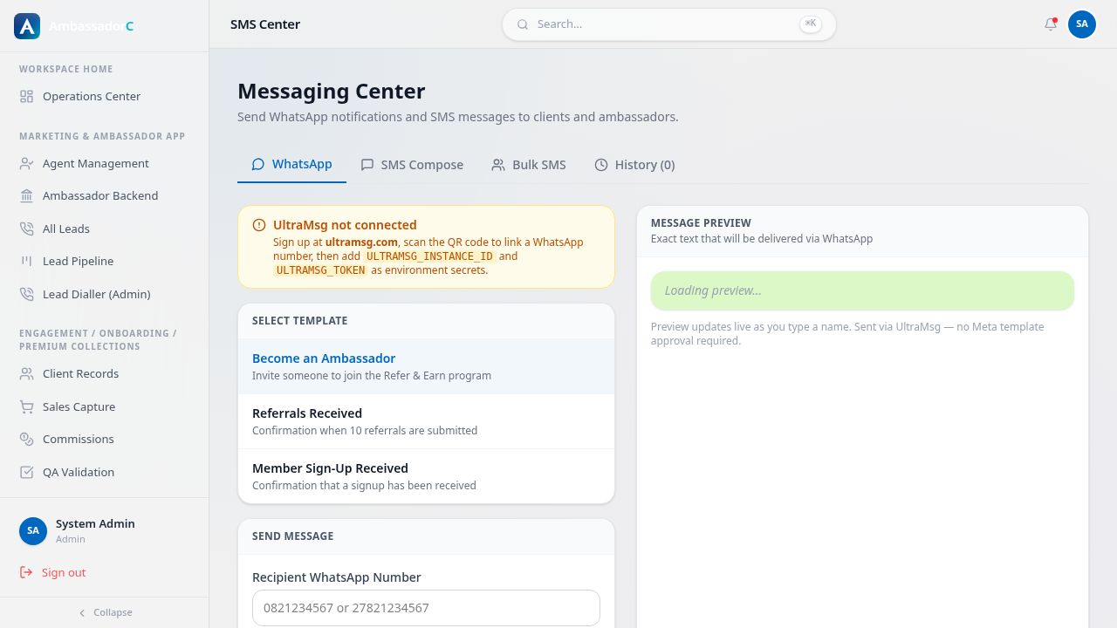
Figure 10.1 — Messaging Centre with WhatsApp, SMS Compose, Bulk SMS, and History tabs

10.1 Overview
The Messaging Centre has four tabs: WhatsApp, SMS Compose, Bulk SMS, and History. It handles both WhatsApp messages (via UltraMsg) and standard SMS (via SMS Portal).

10.2 Sending a WhatsApp Message
Step 1: Click SMS Centre in the sidebar.
Step 2: The WhatsApp tab is selected by default.
Step 3: Click a message template from the list (e.g. Become an Ambassador).
Step 4: Enter the recipient WhatsApp number in the field at the bottom.
Step 5: The MESSAGE PREVIEW panel on the right shows exactly what will be sent.
Step 6: Click Send.
NOTE: If you see 'UltraMsg not connected', the WhatsApp integration needs to be configured in Integrations. See Chapter 14.

10.3 Sending an SMS
Step 1: Click the SMS Compose tab.
Step 2: Enter or search for the recipient (client or ambassador).
Step 3: Type your message (160 characters per SMS segment).
Step 4: Click Send SMS.

10.4 Bulk SMS
Step 1: Click the Bulk SMS tab.
Step 2: Choose the recipient group: All Active Clients, Lapsed Clients, All Ambassadors, or Custom CSV.
Step 3: Type your message template. Use {firstName} to personalise.
Step 4: Click Send Bulk SMS. Monitor progress in the History tab.

11. Products Catalogue
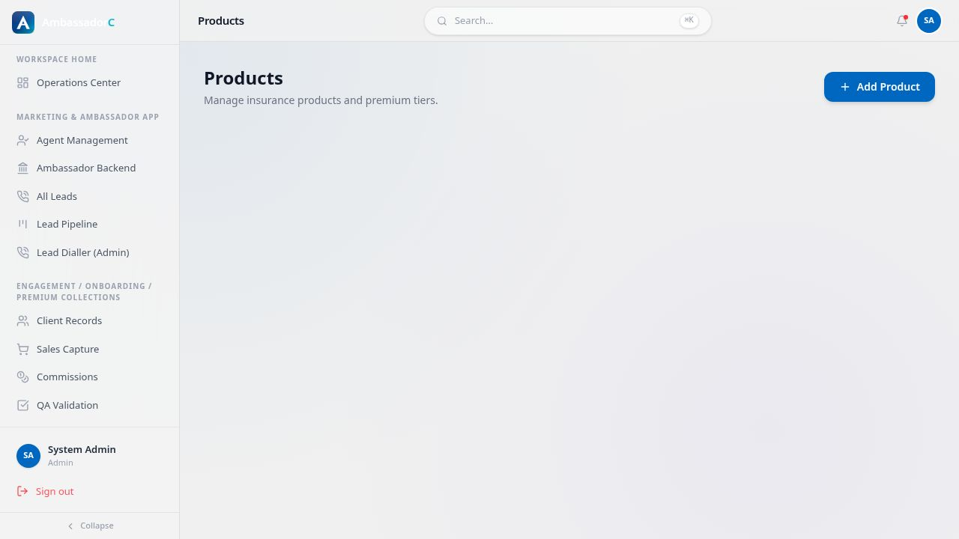
Figure 11.1 — Products page with Add Product button

11.1 Viewing Products
Step 1: In the sidebar, navigate to Products.
Step 2: The table lists all available insurance products with type, premium amount, and status.

11.2 Adding a New Product
Step 1: Click + Add Product (top right).
Step 2: Enter: Name, Type (Life Cover, Legal, SOS, Five-in-One, Short Term, Consult), Description, Base Premium.
Step 3: Add premium tiers if the product has multiple levels (Bronze/Silver/Gold).
Step 4: Click Save Product.
WARNING: Changing a product's premium does NOT update existing active policies. Use the Premium Changes function for each affected policy.

12. AI Agents
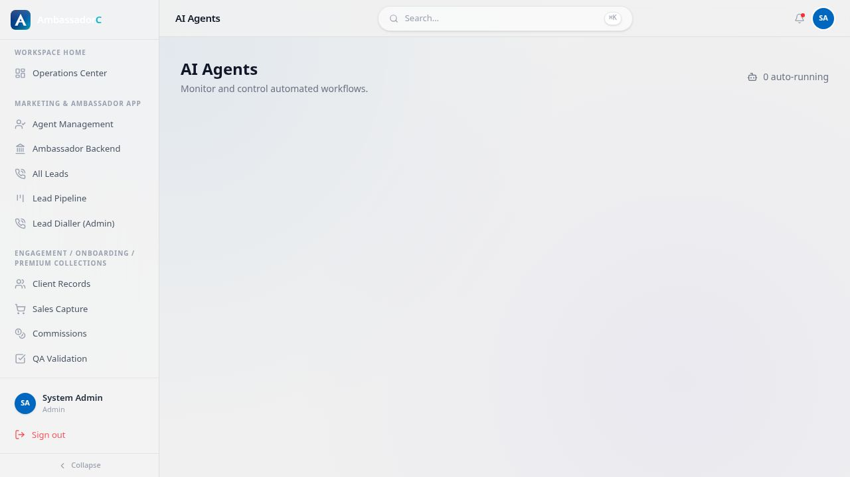
Figure 12.1 — AI Agents page showing all automation agents

12.1 What Are AI Agents?
AI Agents are automated processes that run routine tasks without human input. They can be triggered manually or scheduled to run at set times.

12.2 Available Agents
Agent | What It Does
Lead Scorer | Scores each lead 1–100 based on province, product match, and contact quality.
QA Auto Checker | Pre-screens sales for data completeness before the human QA review.
Commission Calculator | Recalculates all pending commissions in bulk.
SMS Dispatcher | Sends queued bulk SMS batches.
Welcome Pack Sender | Sends welcome packs to newly activated clients.
Debit Order Reconciler | Matches NetCash payment returns to client policy records.

12.3 Running an Agent Manually
Step 1: In the sidebar, click AI Agents.
Step 2: Find the agent you want to run.
Step 3: Click the Run button next to it.
Step 4: A progress indicator appears. When done, the Last Run timestamp updates and a summary is shown.

13. Workflow Management
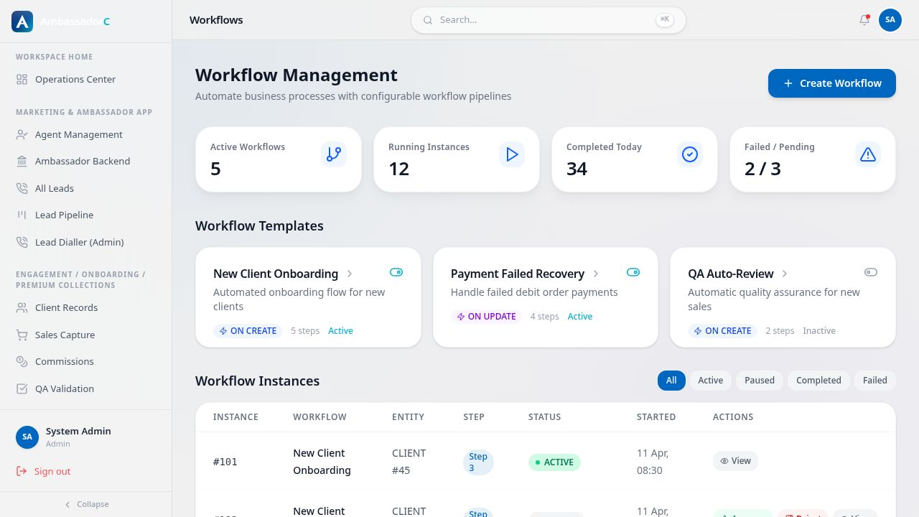
Figure 13.1 — Workflows page showing templates and running instances

13.1 Overview
The Workflow Engine lets admins build automated multi-step processes without writing code. The page shows KPI cards at the top (Active Workflows, Running Instances, Completed Today, Failed/Pending), followed by Workflow Templates and a live Instances table.

13.2 Pre-Built Templates
Template | Trigger | Steps
New Client Onboarding | ON CREATE | 5 steps — Active
Payment Failed Recovery | ON UPDATE | 4 steps — Active
QA Auto-Review | ON CREATE | 2 steps — Inactive

13.3 Creating a Workflow
Step 1: Click + Create Workflow (top right).
Step 2: Enter a name and description.
Step 3: Add steps using + Add Step.
Step 4: For each step, set the Step Type (SMS, API call, Manual review) and conditions.
Step 5: Save as Draft, then click Activate to go live.

13.4 Monitoring Running Instances
The Workflow Instances table (bottom of the page) shows every active run: Instance #, Workflow name, Entity, current Step, Status, Started time, and action buttons (View, Retry). Click View to see the full step-by-step execution log.

14. Integrations
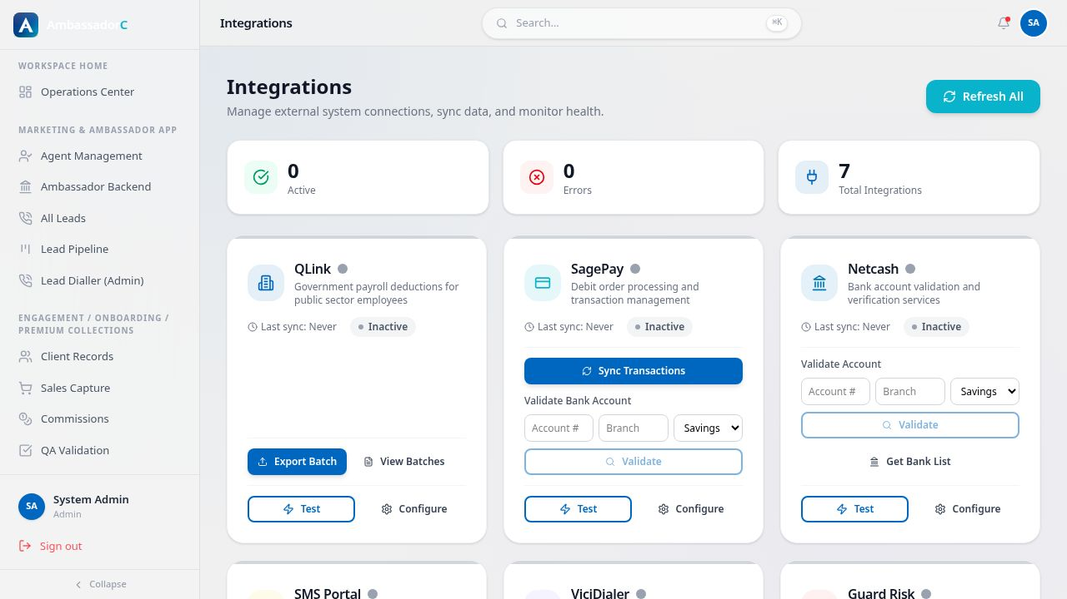
Figure 14.1 — Integrations page showing QLink, SagePay, NetCash, SMS Portal, ViciDialer, Guard Risk

14.1 Overview
The Integrations page connects AmbassadorC v5 to third-party payment, communication, and underwriting services. Each integration card shows its current status (Active / Inactive) and the last sync time.

14.2 Configured Integrations
Service | Purpose | Actions Available
QLink | Government payroll deductions (public sector clients). | Export Batch, View Batches, Test, Configure
SagePay | Card payment processing. | Sync Transactions, Validate Bank Account, Test, Configure
Netcash | Debit order collection. | Validate Account, Get Bank List, Test, Configure
SMS Portal | Bulk SMS messaging. | Test, Configure
ViciDialer | Outbound call centre campaigns. | Test, Configure
Guard Risk | Insurance underwriting. | Test, Configure

14.3 Configuring an Integration
Step 1: Find the integration card.
Step 2: Click Configure.
Step 3: Enter the required API credentials (keys, passwords, merchant IDs).
Step 4: Click Save.
Step 5: Click Test to verify the connection is working.
WARNING: Never share API keys or credentials. All credentials are stored encrypted.

15. Quick Reference & Tips

15.1 Global Search
Press Ctrl+K (Windows) or Cmd+K (Mac) anywhere in the app to open the global search bar. Type a client name, policy number, or lead name to jump directly to that record.

15.2 Status Colour Guide
Colour / Badge | Meaning
Blue dot (sidebar) | New item — requires attention.
Green — ACTIVE / PASSED | Record is live and in good standing.
Orange — PENDING / ASSIGNED | Action required — in progress.
Red — FAILED / CANCELLED / REJECTED | Issue — needs investigation or write-off.
Grey — INACTIVE / CLOSED | Record archived or deactivated.

15.3 Common Tasks — Quick Steps
Task | Where to Go | Key Button
Assign a lead to an agent | Lead Dialler (Admin) → Unassigned Leads | Assign
Approve a QA check | QA Validation → Pending tab → click sale | SUBMIT
Send a WhatsApp to an agent | SMS Centre → WhatsApp tab | Send
Run commission recalculation | AI Agents → Commission Calculator | Run
Export client list to CSV | Client Records → Export button | Export
Check workflow run history | Workflows → Instances table | View
Test an integration connection | Integrations → card → Test | Test
Add a new insurance product | Products → + Add Product | Save Product

15.4 Frequently Asked Questions

Q: I cannot log in — what do I do?
Check that you are using your mobile number (not email) as your username. Contact your administrator to reset your password.

Q: Why did my commission not appear?
Commissions only appear after a sale reaches QA_APPROVED or ACTIVE status — not just when a lead is marked as a sale. Wait for the QA step to be completed.

Q: A client did not receive their welcome pack — what do I do?
Go to AI Agents and manually run the Welcome Pack Sender agent for that client.

Q: WhatsApp messages are not being sent — what should I check?
Go to Integrations → UltraMsg. Check that the Instance ID and Token are saved and click Test. If it fails, contact UltraMsg support.

Q: How do I generate a month-end commission report?
Go to Commissions, filter by month using the date range, select All Agents or a specific ambassador, then click Export.

