单元测试
—SE2018—G04简易查



小组：G04
骆佳俊 徐双铅 吕迪

修订表
编号 | 生成版本 | 修订人 | 修订章节与内容 | 修订日期
1 | 1 | 骆佳俊 | 编写内容 | 2018.6.25

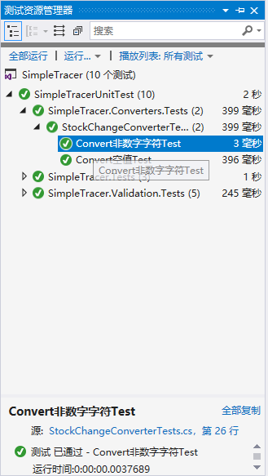usi

ng Microsoft.VisualStudio.TestTools.UnitTesting;
using SimpleTracer.Converters;
using System;
using System.Collections.Generic;
using System.Linq;
using System.Text;
using System.Threading.Tasks;

namespace SimpleTracer.Converters.Tests
{
[TestClass()]
public class StockChangeConverterTests
{
[TestMethod()]
public void Convert空值Test()
{
//如果传入null，正常应该主动引发InvalidCastException异常
StockChangeConverter converter = new StockChangeConverter();
Assert.ThrowsException<InvalidCastException>(() =>
{
converter.Convert(null, typeof(string), null, null);
});
}

[TestMethod()]
public void Convert非数字字符Test()
{
//如果传入非数字字符串，正常应该主动引发InvalidCastException异常
StockChangeConverter converter = new StockChangeConverter();
Assert.ThrowsException<InvalidCastException>(() =>
{
converter.Convert("jhsd465454vd6v", typeof(string), null, null);
});
}
}
}

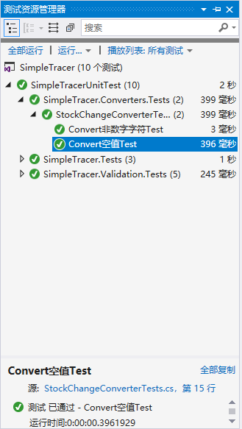using Microsoft.VisualStudio.TestTools.UnitTesting;
using SimpleTracer.Converters;
using System;
using System.Collections.Generic;
using System.Linq;
using System.Text;
using System.Threading.Tasks;

namespace SimpleTracer.Converters.Tests
{
[TestClass()]
public class StockChangeConverterTests
{
[TestMethod()]
public void Convert空值Test()
{
//如果传入null，正常应该主动引发InvalidCastException异常
StockChangeConverter converter = new StockChangeConverter();
Assert.ThrowsException<InvalidCastException>(() =>
{
converter.Convert(null, typeof(string), null, null);
});
}

[TestMethod()]
public void Convert非数字字符Test()
{
//如果传入非数字字符串，正常应该主动引发InvalidCastException异常
StockChangeConverter converter = new StockChangeConverter();
Assert.ThrowsException<InvalidCastException>(() =>
{
converter.Convert("jhsd465454vd6v", typeof(string), null, null);
});
}
}
}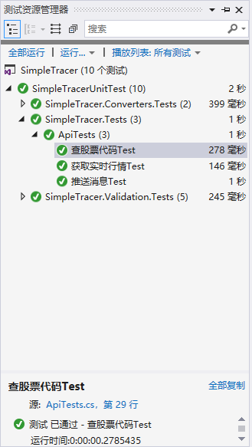using Microsoft.VisualStudio.TestTools.UnitTesting;
using SimpleTracer;
using System;
using System.Collections.Generic;
using System.Diagnostics;
using System.Linq;
using System.Text;
using System.Threading.Tasks;

namespace SimpleTracer.Tests
{
[TestClass()]
public class ApiTests
{
[TestMethod()]
public void 推送消息Test()
{
try
{
Api.PushMessageAsync("测试" + DateTime.Now, ".....").Wait();
}
catch (Exception e)
{
Assert.Fail(e.ToString());
}
}

[TestMethod()]
public void 查股票代码Test()
{
try
{
var s = Api.GetStockQueryAsync("000").Result;

}
catch (Exception e)
{
Assert.Fail(e.ToString());
}
}

[TestMethod()]
public void 获取实时行情Test()
{
try
{
var model = Api.GetRealTimeQuotationAsync("000001.SS", new[]
{
"data_timestamp",
"shares_per_hand",
"open_px",
"high_px",
"low_px",
"last_px",
"preclose_px",
"business_amount",
"business_balance",
"offer_grp",
"bid_grp",
"px_change_rate",
"px_change",
"turnover_ratio",
"vol_ratio",
"prod_name",
"min5_chgpct"
}).Result;
Debug.Print(Newtonsoft.Json.JsonConvert.SerializeObject(model));
}
catch (Exception e)
{
Assert.Fail(e.ToString());
}
}
}
}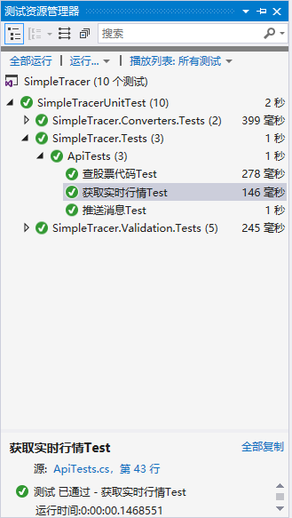using Microsoft.VisualStudio.TestTools.UnitTesting;
using SimpleTracer;
using System;
using System.Collections.Generic;
using System.Diagnostics;
using System.Linq;
using System.Text;
using System.Threading.Tasks;

namespace SimpleTracer.Tests
{
[TestClass()]
public class ApiTests
{
[TestMethod()]
public void 推送消息Test()
{
try
{
Api.PushMessageAsync("测试" + DateTime.Now, ".....").Wait();
}
catch (Exception e)
{
Assert.Fail(e.ToString());
}
}

[TestMethod()]
public void 查股票代码Test()
{
try
{
var s = Api.GetStockQueryAsync("000").Result;

}
catch (Exception e)
{
Assert.Fail(e.ToString());
}
}

[TestMethod()]
public void 获取实时行情Test()
{
try
{
var model = Api.GetRealTimeQuotationAsync("000001.SS", new[]
{
"data_timestamp",
"shares_per_hand",
"open_px",
"high_px",
"low_px",
"last_px",
"preclose_px",
"business_amount",
"business_balance",
"offer_grp",
"bid_grp",
"px_change_rate",
"px_change",
"turnover_ratio",
"vol_ratio",
"prod_name",
"min5_chgpct"
}).Result;
Debug.Print(Newtonsoft.Json.JsonConvert.SerializeObject(model));
}
catch (Exception e)
{
Assert.Fail(e.ToString());
}
}
}
}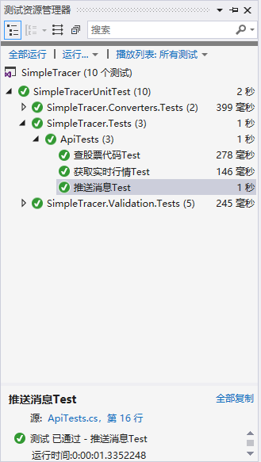using Microsoft.VisualStudio.TestTools.UnitTesting;
using SimpleTracer;
using System;
using System.Collections.Generic;
using System.Diagnostics;
using System.Linq;
using System.Text;
using System.Threading.Tasks;

namespace SimpleTracer.Tests
{
[TestClass()]
public class ApiTests
{
[TestMethod()]
public void 推送消息Test()
{
try
{
Api.PushMessageAsync("测试" + DateTime.Now, ".....").Wait();
}
catch (Exception e)
{
Assert.Fail(e.ToString());
}
}

[TestMethod()]
public void 查股票代码Test()
{
try
{
var s = Api.GetStockQueryAsync("000").Result;

}
catch (Exception e)
{
Assert.Fail(e.ToString());
}
}

[TestMethod()]
public void 获取实时行情Test()
{
try
{
var model = Api.GetRealTimeQuotationAsync("000001.SS", new[]
{
"data_timestamp",
"shares_per_hand",
"open_px",
"high_px",
"low_px",
"last_px",
"preclose_px",
"business_amount",
"business_balance",
"offer_grp",
"bid_grp",
"px_change_rate",
"px_change",
"turnover_ratio",
"vol_ratio",
"prod_name",
"min5_chgpct"
}).Result;
Debug.Print(Newtonsoft.Json.JsonConvert.SerializeObject(model));
}
catch (Exception e)
{
Assert.Fail(e.ToString());
}
}
}
}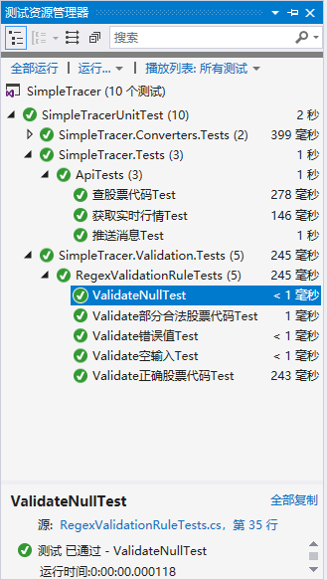using Microsoft.VisualStudio.TestTools.UnitTesting;
using SimpleTracer.Validation;
using System;
using System.Collections.Generic;
using System.Linq;
using System.Text;
using System.Threading.Tasks;

namespace SimpleTracer.Validation.Tests
{
[TestClass()]
public class RegexValidationRuleTests
{
private static string pattern = @"^[0-9]{1,6}(\.[A-Za-z]{2})?$";
private RegexValidationRule v = new RegexValidationRule
{
RegexPattern = pattern
};
[TestMethod()]
public void Validate正确股票代码Test()
{
Assert.AreEqual(v.Validate("114514.SS", null).IsValid, true);
}
[TestMethod()]
public void Validate部分合法股票代码Test()
{
Assert.AreEqual(v.Validate("666", null).IsValid, true);
}
[TestMethod()]
public void Validate空输入Test()
{
Assert.AreEqual(v.Validate("", null).IsValid, false);
}
[TestMethod()]
public void ValidateNullTest()
{
Assert.AreEqual(v.Validate(null, null).IsValid, false);
}
[TestMethod()]
public void Validate错误值Test()
{
Assert.AreEqual(v.Validate("nmsl沃日", null).IsValid, false);
}
}
}

