


COURSE TITLE (i.e., EE809 Analog IC Design)
MSEE (ICS) 2026
Tutorial # 2
DC I/V characteristics of MOS Transistors
Name | Zuha Fatima
Reg # | 582671
Instructor | Dr. Saman Fatima
Date | 20th September, 2026

Table of Contents
1. Overview 2
2. Tutorial: NMOS characterization 2
3. Activities (DC I/V Characterization of a PMOS Transistor) 4
3.1 PMOS Testbench and sign convention 4
3.2 Activity 2.1: I_{D} versus V_{SG} at constant V_{SD} 5
3.3 Activity 2.2: I_{D} versus V_{SD} 6
3.3.1 Single V_{SG} 6
3.3.2 Parametric sweep over V_{SG} 6
3.3.3 Why the saturation region is not flat, and how to flatten it 7
3.4 Activity 2.3: subthreshold conduction in the PMOS 7
3.5 Activity 2.4: threshold voltage versus body bias and temperature 8
4. Conclusion 9

- Overview
The tutorial itself walked through the DC characterization of an NMOS (nch_mac, W = 200 nm, L = 60 nm) in ADE Explorer. A dc sweep of V_{GS} at fixed V_{DS} gave the transfer curve and g_{m} was extracted from it with the Calculator deriv function; a parametric sweep of V_{GS} over a V_{DS} sweep gave the family of output curves; the saved operating-point code M0:region exposed the subthreshold window below V_{TH}; and a body-bias sweep showed V_{TH} rising as the bulk was pulled below the source.
The exercise activities repeat that whole flow on a PMOS, and everything below was run on the pch_mac testbench rebuilt from the NMOS one. Activities 2.1 and 2.2 reproduce the transfer and output characteristics and ask why the current keeps rising after saturation, 2.3 locates the subthreshold region for the PMOS, and 2.4 measures how the threshold voltage moves with body bias and with temperature. Each section below states the analysis setup, shows the resulting plot and reads the physics off it.
- Tutorial: NMOS characterization
The walkthrough uses an nch_mac (W = 200 nm, L = 60 nm) with source and bulk at VSS = 0 V, at nominal V_{GS} = 1 V and V_{DS} = 2 V.
- Testbench and operating point
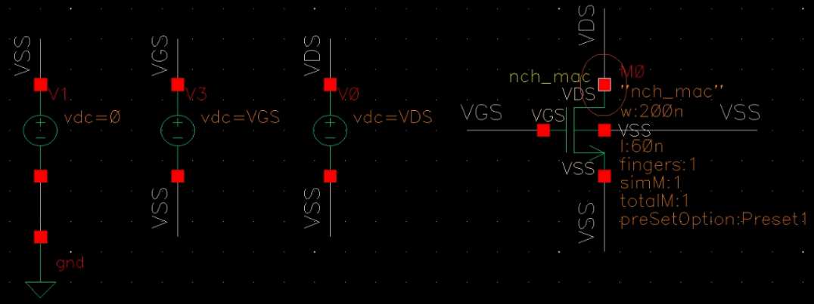
Figure 1. NMOS testbench. V3 sets V_{GS} and V0 sets V_{DS} against VSS, which V1 ties to ground. The circled drain terminal is the plotted output.
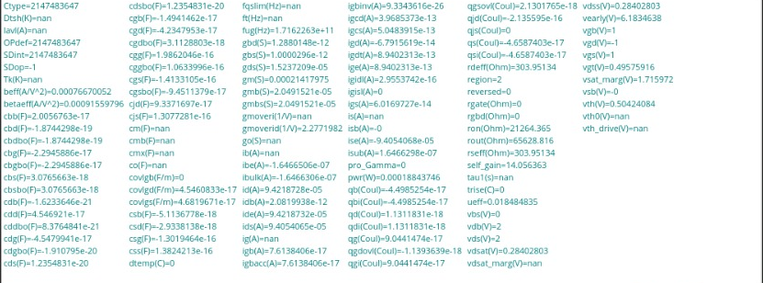
Figure 2. Results Browser, dcOpInfo of M0 at V_{GS} = 1 V, V_{DS} = 2 V.
Key values: V_{TH} = 504 mV, I_{D} = 94.2 µA, g_{m} = 214 µS, V_{DS,sat} = 284 mV, V_{A} = 6.18 V and region = 2 (saturation).
- Transfer characteristic and g_{m}
VGS swept from 0 to 1 V at VDS = 2 V; gm taken with the Calculator deriv function.
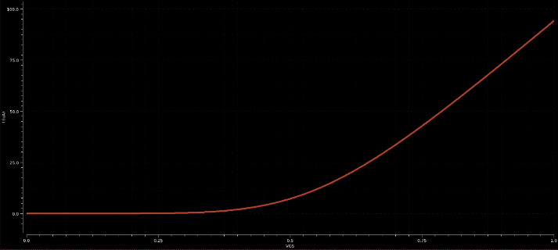  Figure 3. ID against VGS at VDS = 2 V. | 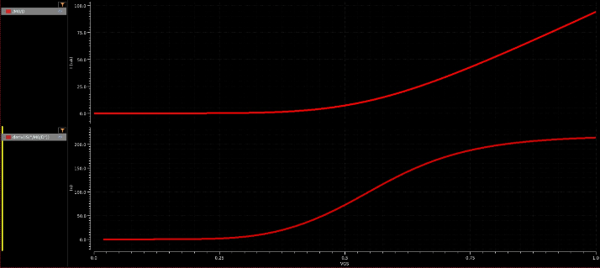  Figure 4. ID (upper) and its derivative gm (lower).
The device turns on near VTH ≈ 0.5 V and reaches about 94 µA at VGS = 1 V. gm = ∂ID/∂VGS rises through turn-on and flattens near 210 µS, because velocity saturation makes ID almost linear in VGS at high overdrive.
- Output characteristics
VDS swept from 0 to 2 V at VGS = 1 V, then VGS stepped from 0 to 1 V in 0.1 V steps over a 0 to 1 V sweep of VDS.
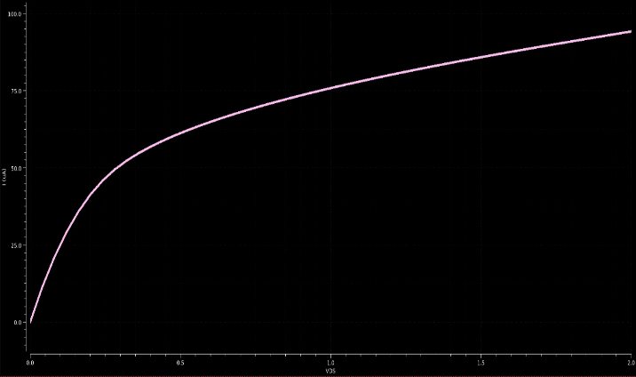  Figure 5. ID against VDS at VGS = 1 V. | 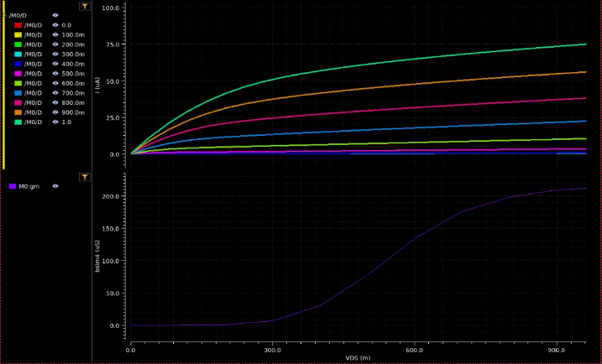  Figure 6. Output family for each VGS step (upper) and M0:gm at each step (lower).
Triode up to VDS,sat = 0.28 V, then saturation, where the current still climbs from about 61 µA at 0.5 V to 94 µA at 2 V because of channel-length modulation. In the family, curves at VGS ≤ 0.4 V stay near zero and the 1 V curve reaches about 75 µA. The lower strip of Fig. 6 is M0:gm at each VGS step, so it runs against VGS although its axis label comes from the upper strip.
- Subthreshold region and body effect
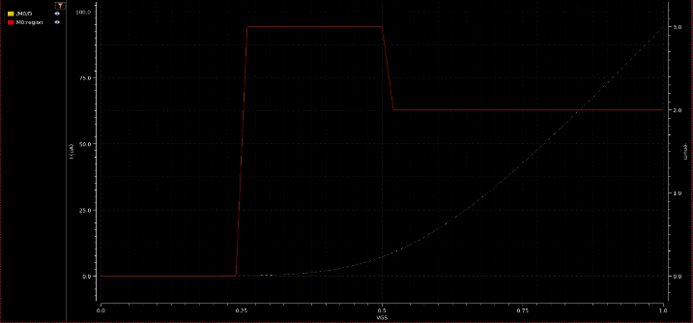  Figure 7. I_{D} (dotted) and M0:region (solid) against V_{GS}. | 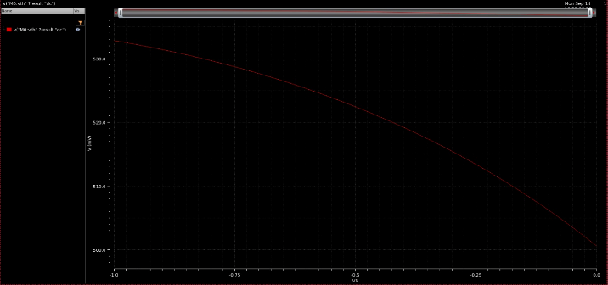  Figure 8. M0:vth against body voltage VB, -1 to 0 V.
The region code steps from 0 (cut-off) to 3 (subthreshold) at V_{GS} ≈ 0.25 V and to 2 (saturation) at about 0.51 V, so the device already conducts weakly over the 0.26 V below threshold. With the bulk moved off VSS onto a separate source V_{B}, the threshold follows
V_{TH} = V_{TH0} + γ [ (|2φ_{F}| + V_{SB})^{1/2} − (|2φ_{F}|)^{1/2} ]
where V_{TH0} is the threshold at V_{SB} = 0. Pulling the bulk below the source raises V_{TH} from about 500 mV at V_{B} = 0 to 533 mV at V_{B} = -1 V.
- Activities (DC I/V Characterization of a PMOS Transistor)
- PMOS Testbench and sign convention
Source and bulk (n-well) of the pch_mac sit at VDD = 1.8 V, and both characterization sources are referenced to VDD rather than ground, so that:

V(gate) = VDD − V_{SG} V(drain) = VDD − V_{SD}
The design variables V_{SG} and V_{SD} are therefore the source-to-gate and source-to-drain voltages directly. ADE plots the current into the drain terminal, which a PMOS pushes outward, so every trace is negative and magnitudes are quoted below.
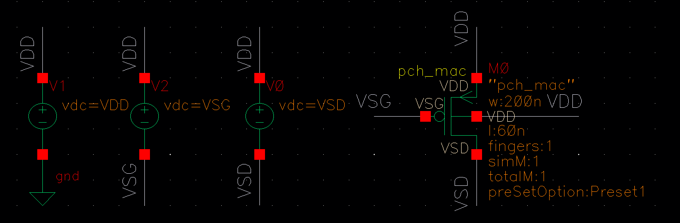
Figure 1: PMOS characterization testbench. V1 sets the rail, V2 and V0 sit between VDD and the gate and drain nodes so that their values are V_{SG} and V_{SD} directly

Table 1 Operating point of M0 at VSG = 0.8 V, VSD = 0.5 V, VDD = 1.8 V, 27 °C
Quantity | Symbol | Value | Quantity | Symbol
Threshold voltage | V_{TH} | -537 mV | Threshold voltage | V_{TH}
Saturation voltage | |V_{SD,sat}| | 209 mV | Saturation voltage | |V_{SD,sat}|
Early voltage | V_{A} | 1.28 V | Early voltage | V_{A}

Table 1 is the operating point from Results Browser, dcOp, at V_{SG} = 0.8 V and V_{SD} = 0.5 V.
- Activity 2.1: I_{D} versus V_{SG} at constant V_{SD}
DC sweep of V_{SG} from 0 to 1 V with V_{SD} fixed at 0.5 V.

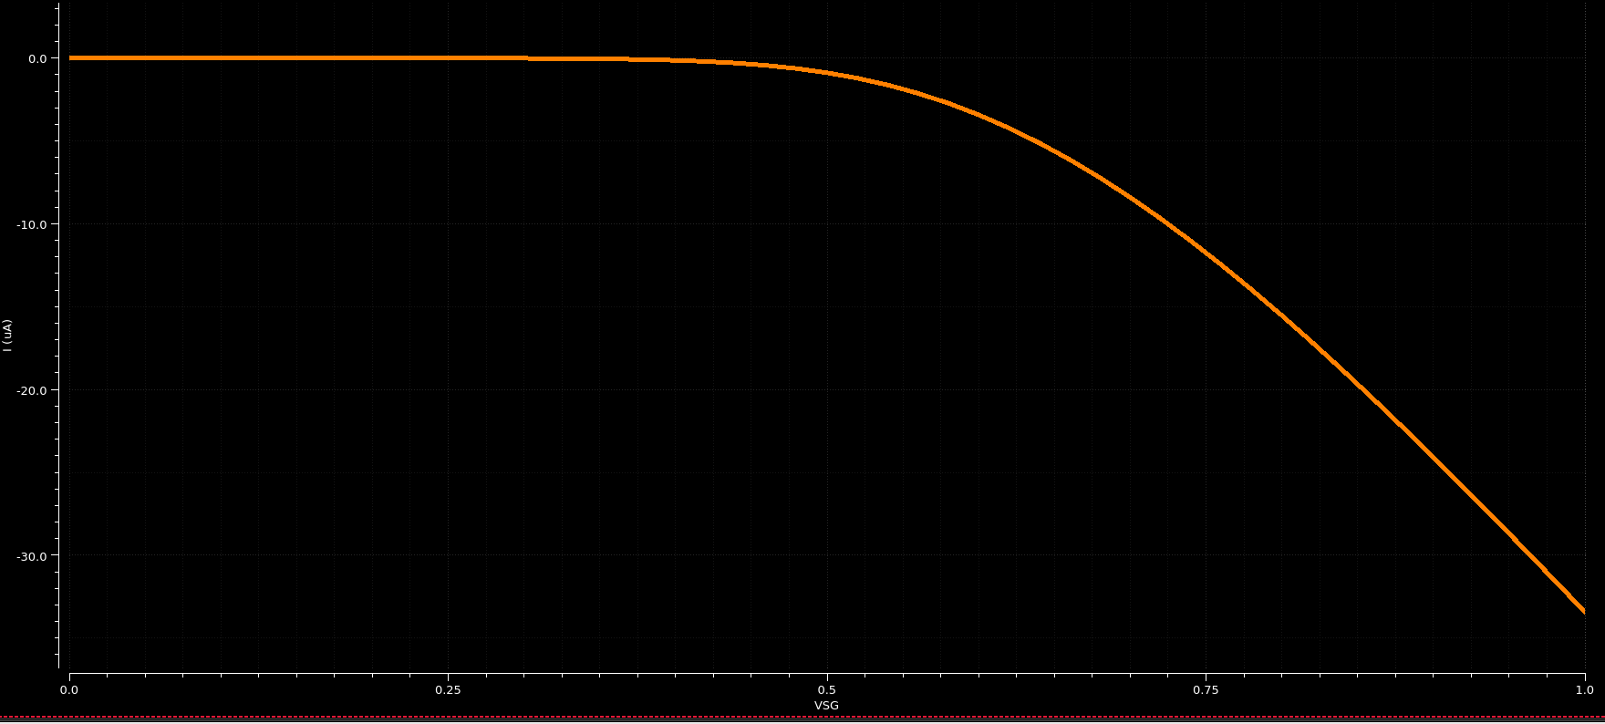
Figure 2. Transfer characteristic: drain current against V_{SG} at V_{SD} = 0.5 V.

Conduction starts at |V_{TH}| = 537 mV and reaches about 35 µA at V_{SG} = 1 V. The overdrive never exceeds V_{SD} = 0.5 V, so the device stays in saturation over the conducting part of the sweep (region = 2 in Fig. 5) and the trace is:

I_{D} = ½ μ_{p}C_{ox}(W/L)(V_{SG} − |V_{TH}|)²

The rise is sub-quadratic: doubling the overdrive from about 0.21 V to 0.46 V raises the current roughly three times instead of the 4.7 the square law predicts, which is velocity saturation again.
The transconductance is the slope of this curve,
g_{m} = ∂I_{D} / ∂V_{SG} at constant V_{SD}
taken with the Calculator deriv function or read as M0:gm: 81.1 µS at the same bias, where I_{D} = 15.53 µA, so g_{m}/I_{D} = 5.2 V⁻¹.
- Activity 2.2: I_{D} versus V_{SD}
- Single V_{SG}
V_{SD} swept from 0 to 1 V at V_{SG} = 0.8 V.
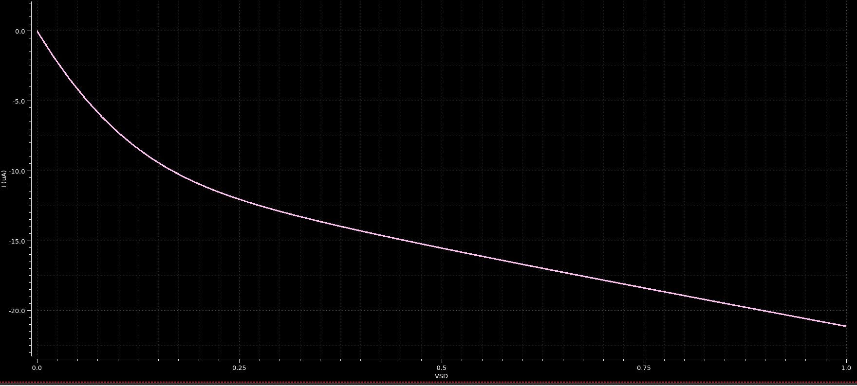
Figure 3. Output characteristic: drain current against V_{SD} at V_{SG} = 0.8 V.
Triode below |V_{SD,sat}| = 209 mV, where the channel is still continuous, then the knee into saturation as the channel pinches off near the drain.
- Parametric sweep over V_{SG}
V_{SG} parameterized from 0 to 0.8 V in 0.2 V linear steps over the same V_{SD} sweep.

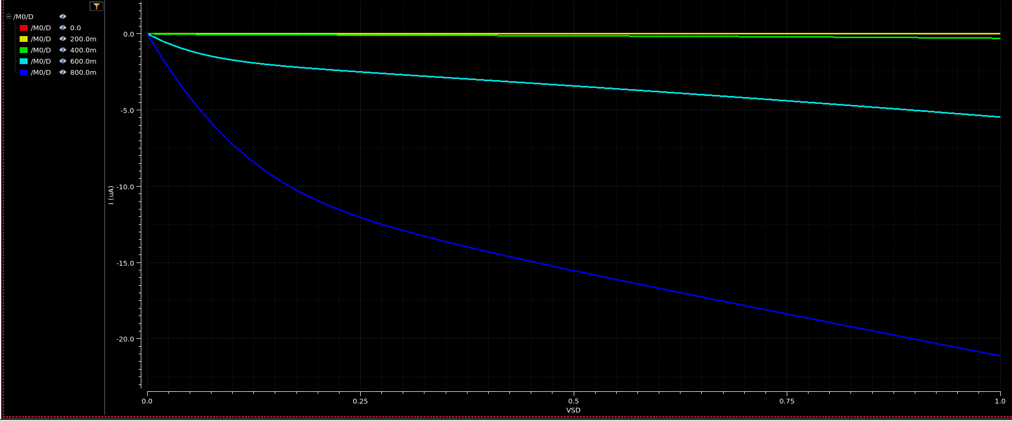
Figure 4. Output characteristics for V_{SG} stepped from 0 to 0.8 V in 0.2 V steps.

The 0, 0.2 and 0.4 V curves lie on the axis, all below |V_{TH}| = 0.54 V. The 0.6 V curve gives about 5.5 µA at V_{SD} = 1 V and the 0.8 V curve about 22 µA, matching Fig. 3.
- Why the saturation region is not flat, and how to flatten it
The current should be constant past |V_{SD,sat}| but climbs from about 11 µA at V_{SD} = 0.3 V to 22 µA at 1 V. Two short-channel effects cause it.
Channel-length modulation. Pinch-off moves towards the source, shortening the effective channel by ΔL, so
I_{D} = I_{D,sat}(1 + λV_{SD}) λ = 1 / V_{A} r_{o} = V_{A} / I_{D}
ΔL is set by the drain depletion region and hardly depends on L, so λ scales as 1/L. Here V_{A} = 1.28 V, λ = 0.78 V⁻¹ and the intrinsic gain is only 6.7.
Drain-induced barrier lowering. The drain field also lowers the source barrier, cutting |V_{TH}| as |V_{SD}| rises. Channel-length modulation alone would give a 1.4 times rise over this range against the 2 times measured, so DIBL supplies the rest.
Remedy. Lengthen the channel and scale W to hold W/L. At L = 240 nm, V_{A} should rise about fourfold to near 5 V, cutting λ to about 0.2 V⁻¹ and flattening the slope by the same factor. A cascode does the same at circuit level for the cost of one V_{SD,sat} of headroom.
- Activity 2.3: subthreshold conduction in the PMOS
A save_operating_points.scs file holding save M0:all was imported under Setup, Simulation Files, which makes M0:region plottable alongside I_{D}. The codes are 0 cut-off, 1 triode, 2 saturation, 3 subthreshold.
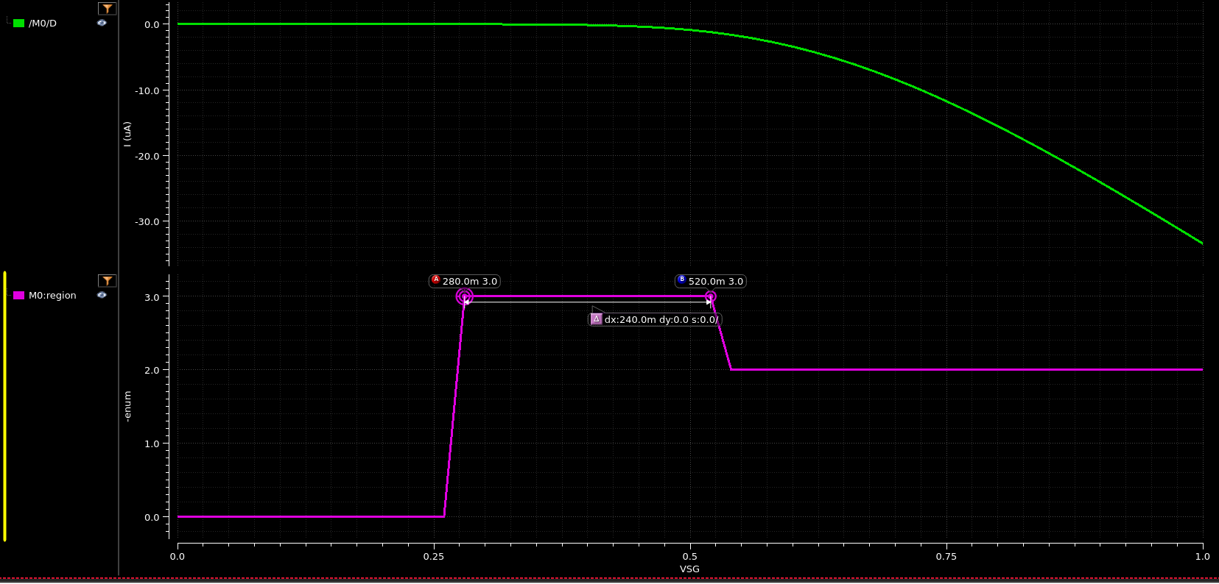
Figure 5. Drain current (upper strip) and operating-region code (lower strip) against V_{SG}. Markers A and B bracket the subthreshold window, 240 mV wide.
Region 3 runs from V_{SG} = 0.28 V to 0.52 V, a 240 mV window ending at |V_{TH}| = 537 mV. The surface is weakly inverted there and conduction is by diffusion, so the current is exponential:
I_{D} = I₀ exp[ (V_{SG} − |V_{TH}|) / (nV_{T}) ] S = nV_{T} ln10
with V_{T} = kT/q ≈ 25.9 mV, giving a decade of current every S ≈ 70 to 100 mV. These currents are invisible on the linear axis of Fig. 5, which is why the region code is needed; a log plot of |I_{D}| would give S from the slope. This is the leakage that sets standby current in a gate built from this device.
- Activity 2.4: threshold voltage versus body bias and temperature
- Body Effect
The bulk was taken off VDD and driven by a fourth source V3, so V(bulk) = VDD + V_{B}. Raising V_{B} from 0 to 1 V reverse-biases the source-bulk junction, and
|V_{TH}| = |V_{TH0}| + γ [ (|2φ_{F}| + V_{BS})^{1/2} − (|2φ_{F}|)^{1/2} ]
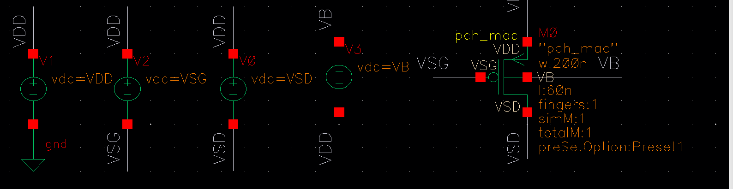
Figure 6. Testbench modified for the body-effect sweep: V3 lifts the n-well to VDD + V_{B}.
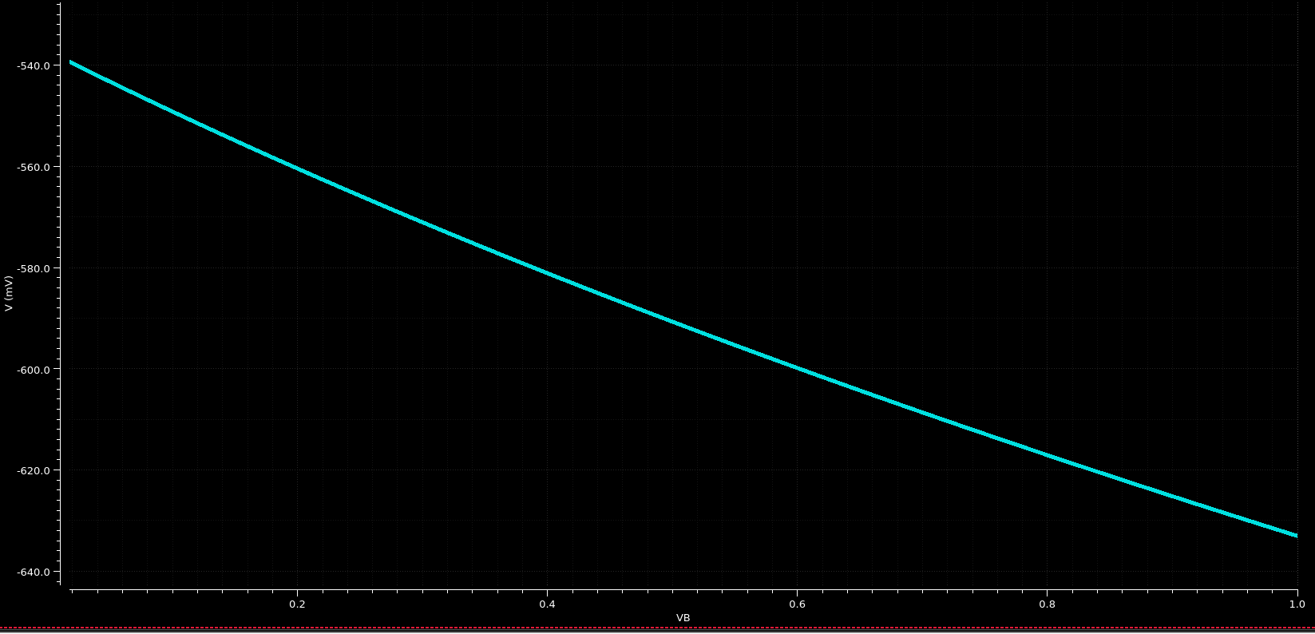
Figure 7. Threshold voltage M0:vth against body voltage V_{B}.
V_{TH} moves from -539 mV at V_{B} = 0 to -632 mV at V_{B} = 1 V, so |V_{TH}| grows 93 mV per volt of reverse bias; with 2φ_{F} ≈ 0.8 V that gives γ ≈ 0.21 V^{1/2}. The wider depletion region needs more charge from the gate before inversion, so a stacked PMOS whose source is off the well potential loses overdrive.
- Temperature
Same dc analysis with temperature as the sweep variable, -40 to 125 °C.
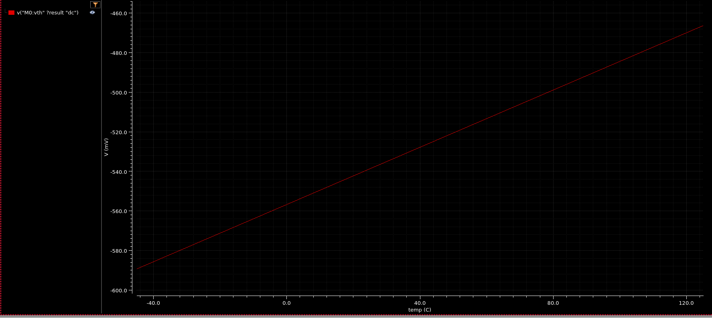
Figure 8. Threshold voltage M0:vth against temperature, -40 to 125 °C.
V_{TH} rises linearly from about -589 mV to -470 mV, roughly 0.74 mV per °C, and interpolates to -539 mV at 27 °C against the -537 mV of Table 1. φ_{F} shrinks as temperature rises, so less band bending is needed to invert the surface.
Mobility falls as roughly T^{-1.5} at the same time, so the two effects cancel at one bias, the zero-temperature-coefficient point: below it the drain current has a positive temperature coefficient, above it a negative one.
- Conclusion
The pch_mac gives |V_{TH}| = 537 mV at 27 °C and zero body bias, with |V_{SD,sat}| already below the overdrive from velocity saturation.
Saturation is far from flat: V_{A} = 1.28 V and g_{m}r_{o} = 6.7, with channel-length modulation and DIBL acting together. Longer L with W scaled to match is the device fix, a cascode the circuit one.
Below threshold the device still conducts over a 240 mV window, and the threshold itself moves: up 93 mV per volt of well bias (γ ≈ 0.21 V^{1/2}) and down 0.74 mV per °C of heating.

