


COURSE TITLE (i.e., EE809 Analog IC Design)
MSEE (ICS) 2026
Tutorial # 3
AC characteristics of MOS Transistors
Name | Zuha Fatima
Reg # | 582671
Instructor | Dr. Saman Fatima
Date | 26th September, 2026
Table of Contents
1. Introduction 2
2. Objectives 2
3. Guided tasks 2
3.1 Task A Transconductance and current efficiency 2
3.1.1 Drain current and small signal parameters 3
3.1.2 Transition frequency from operating point data 3
3.1.3 Speed versus current efficiency 4
3.1.4 Intrinsic gain 5
3.1.5 Gain versus current efficiency 7
3.2 Task B Transition frequency 7
3.2.1 AC verification 8
3.2.2 Channel length and width sweeps 8
3.2.3 Transition frequency versus overdrive 9
3.3 Task C Maximum oscillation frequency 10
3.3.1 Effect of increasing device dimensions 11
3.3.2 Effect of two gate fingers 12
3.3.3 RF NMOS and finger count 13
4. Exercise activities 13
4.1 Activity 3.1 PMOS characterization 13
4.2 Activity 3.2 PMOS dimension sweeps 18
4.3 Activity 3.3 Speed efficiency FOM 18
4.4 Activity 3.4 PMOS maximum frequency 21
1. Introduction
Tutorial 3 examines MOS gain, speed and current efficiency through NMOS and PMOS simulations. The results show the trade-off between high frequency performance and efficient biasing.
2. Objectives
Extract g_{m}/I_{D}, intrinsic gain, f_{T} and f_{max}; compare NMOS and PMOS behavior; study device dimensions and finger count; and identify the peak speed–efficiency FOM.
3. Guided tasks
3.1 Task A Transconductance and current efficiency
Sweep V_{GS} from 0 to 1 V with V_{DS} = 0.5 V and grounded source and bulk. The supplied schematic shows W = 120 nm and L = 60 nm.
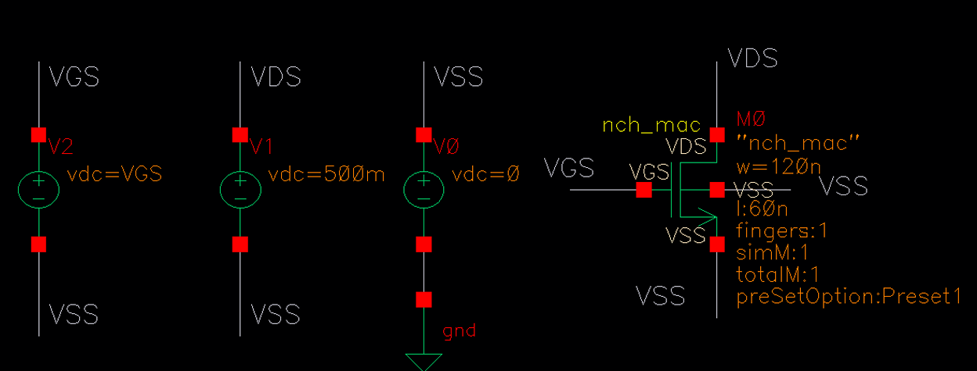
Figure 1. Guided Task A NMOS testbench with W = 120 nm and L = 60 nm.
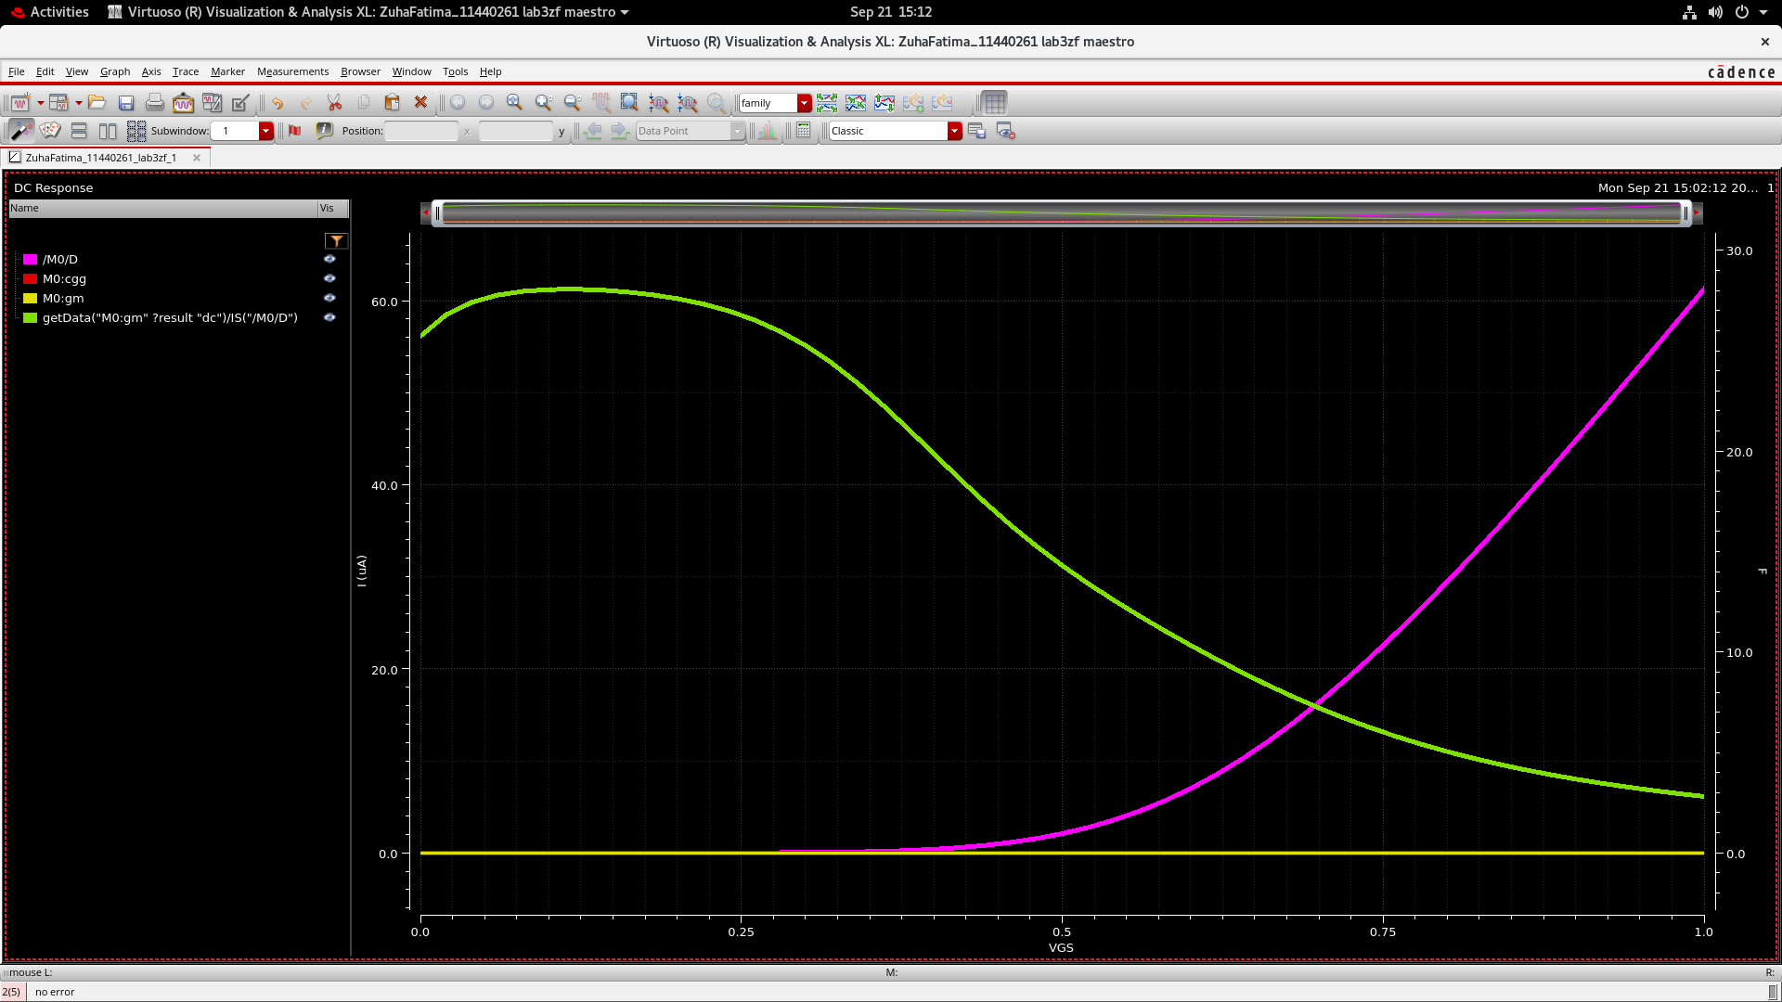
Figure 2. Combined DC sweep of I_{D}, g_{m}, C_{gg} and g_{m}/I_{D} against V_{GS}.
Separate plots clarify the traces because their units and scales differ.
3.1.1 Drain current and small signal parameters
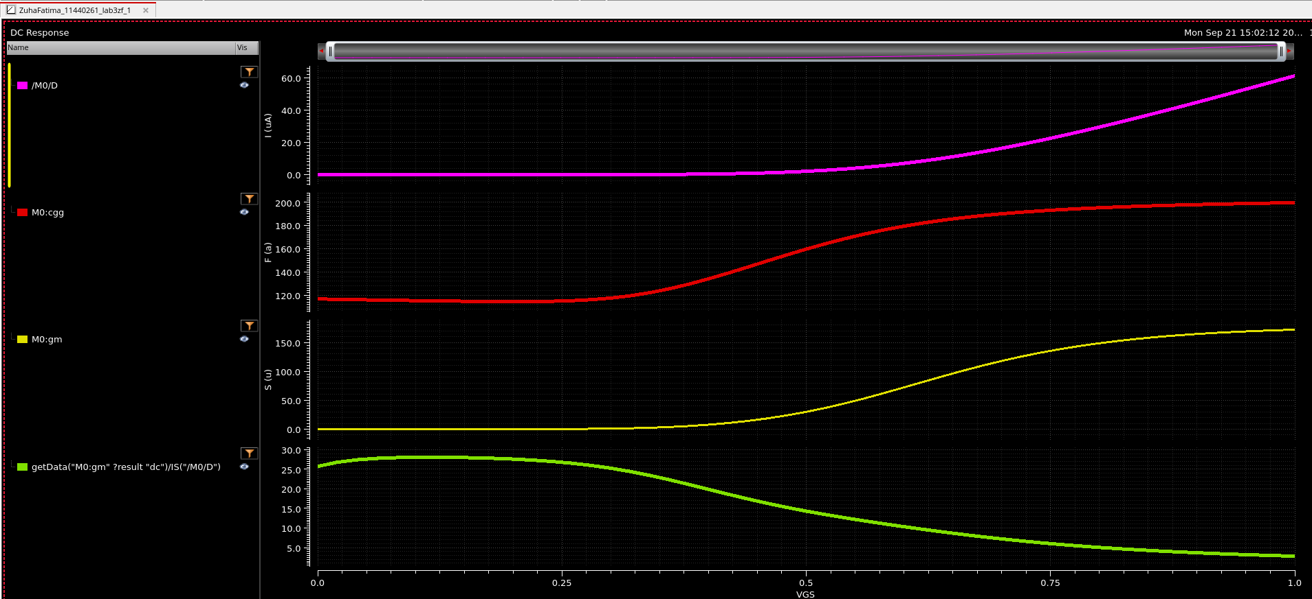
Figure 3. Separate plots of I_{D}, C_{gg}, g_{m} and g_{m}/I_{D} against V_{GS}.
At V_{GS} = 1 V, I_{D} ≈ 60 µA, g_{m} ≈ 170 µS and C_{gg} ≈ 200 aF. Meanwhile, g_{m}/I_{D} falls from about 28 to 3 V⁻¹ as gate bias increases.
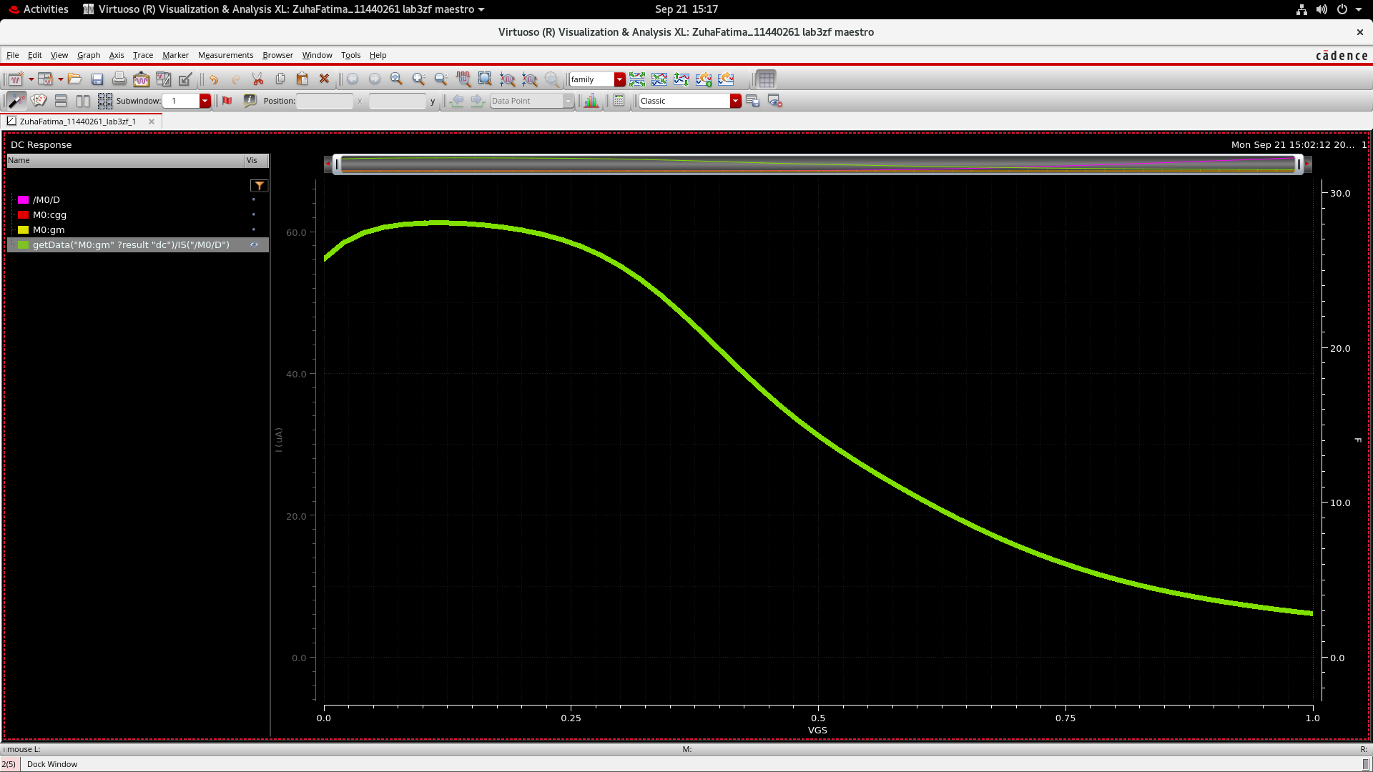
Figure 4. Isolated g_{m}/I_{D} curve showing the reduction in current efficiency as V_{GS} increases.
3.1.2 Transition frequency from operating point data
The f_{T} estimate rises with bias because g_{m} increases faster than C_{gg}.
$$f_{T} ≈ \frac{g_{m}}{2πC_{gg}}$$
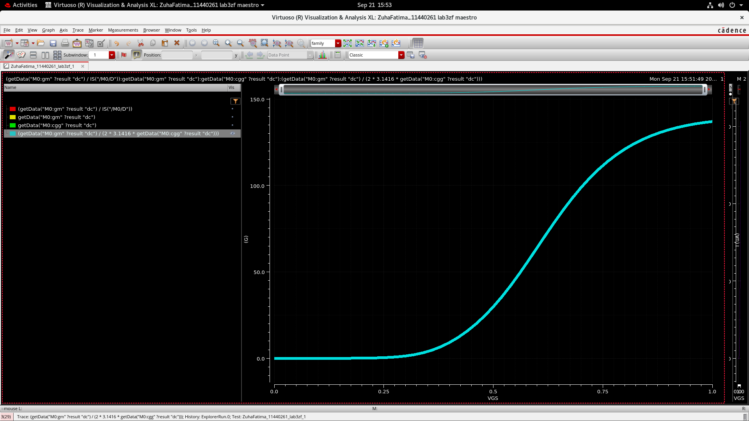
Figure 5. Calculated f_{T} against V_{GS}, reaching approximately 137 GHz at V_{GS} = 1 V.
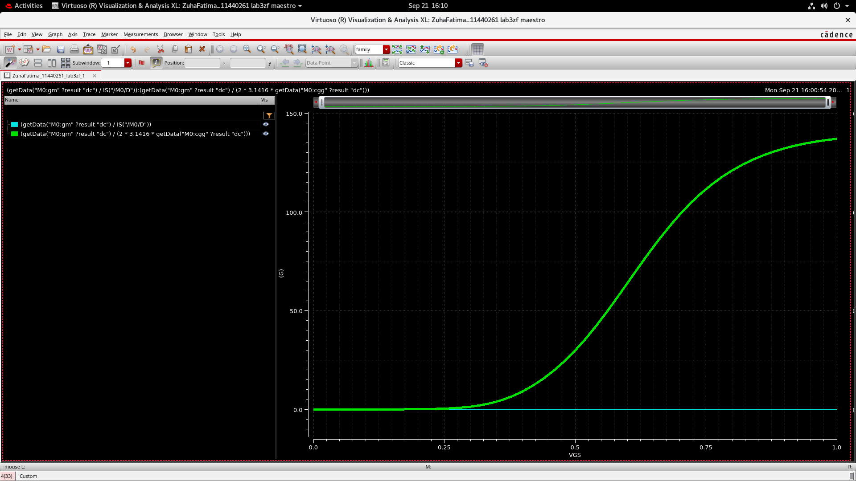
Figure 6. f_{T} and g_{m}/I_{D} overlaid against V_{GS} before constructing the wave-versus-wave plot.
The nearly flat g_{m}/I_{D} trace is caused by the shared scale, not constant efficiency.
3.1.3 Speed versus current efficiency
WaveVsWave plots f_{T} against g_{m}/I_{D} at corresponding bias points.
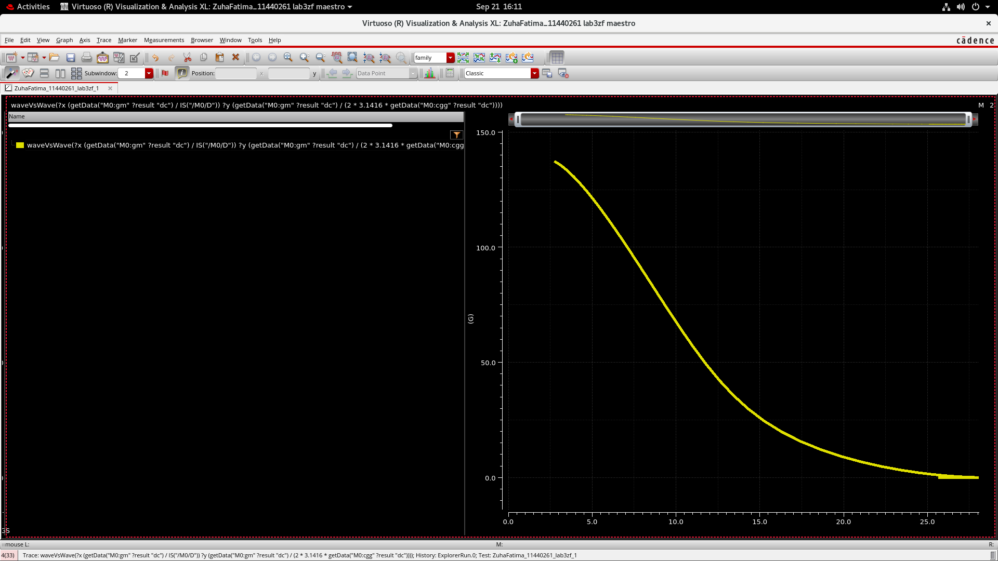
Figure 7. f_{T} versus g_{m}/I_{D}. Frequency decreases as transconductance efficiency increases.
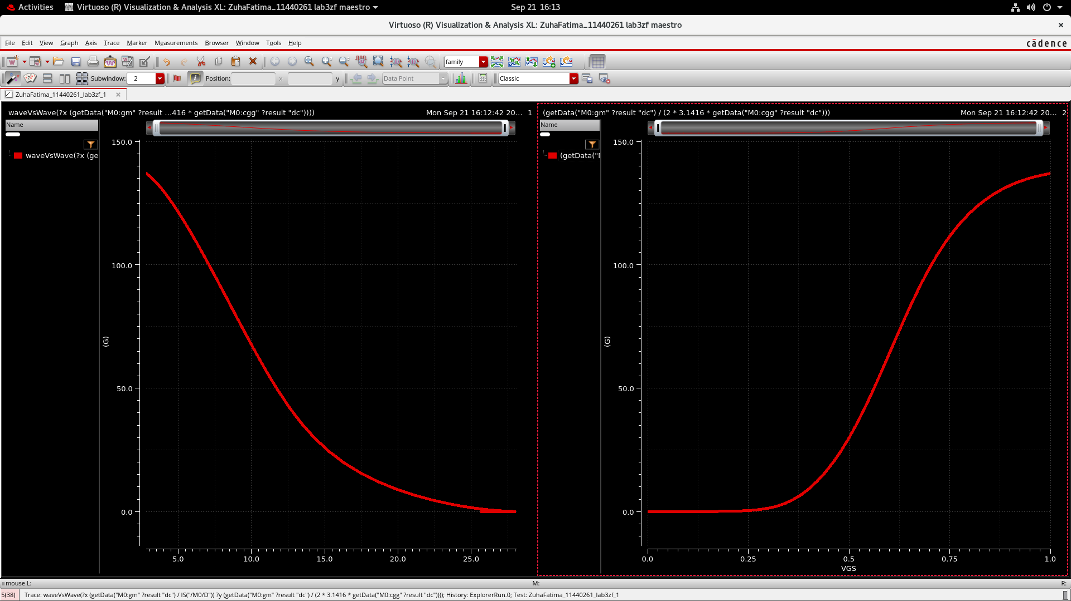
Figure 8. Side-by-side comparison of f_{T} versus g_{m}/I_{D} and f_{T} versus V_{GS}.
Higher g_{m}/I_{D} improves current efficiency but reduces f_{T}. Moderate inversion provides a compromise.
3.1.4 Intrinsic gain
Intrinsic gain is the unloaded small signal gain magnitude:
$$A_{v0} = g_{m}r_{o}$$
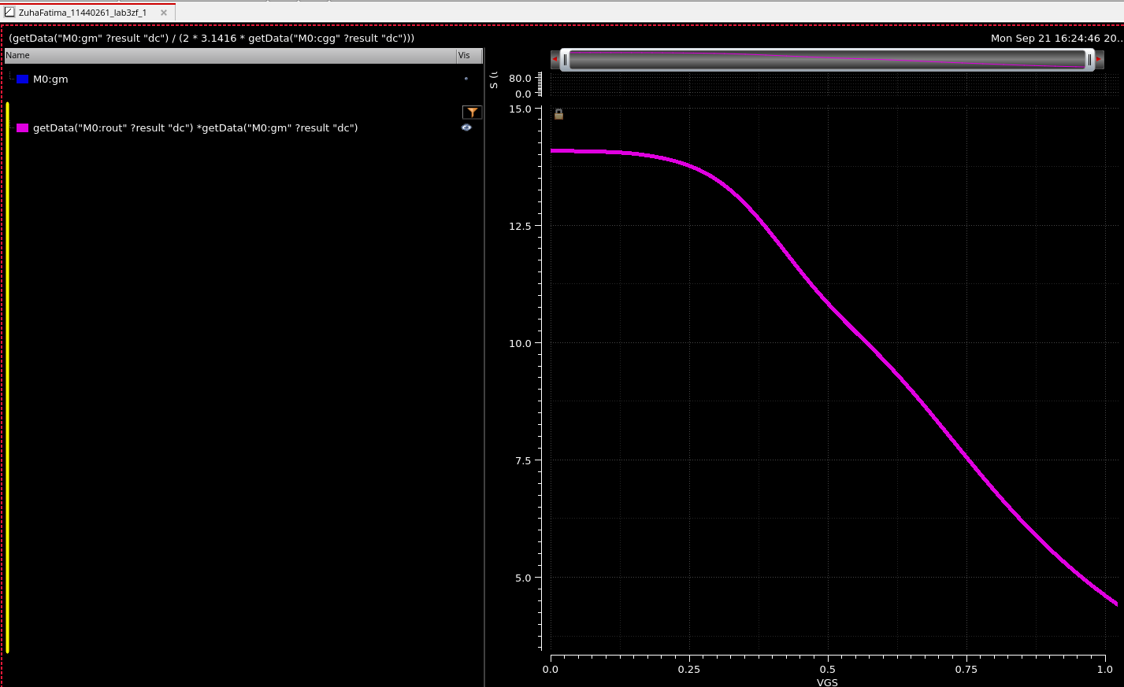
Figure 9. Intrinsic gain g_{m}r_{o} against V_{GS}, decreasing from approximately 14 to 4.4 V/V.
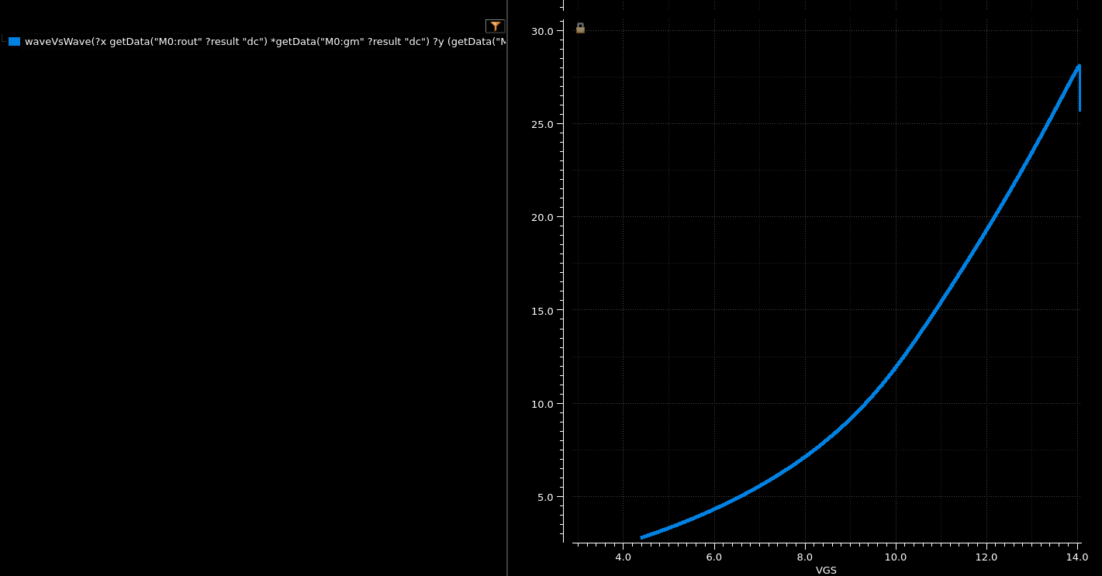
Figure 10. Initial wave-versus-wave result with intrinsic gain on the horizontal axis and g_{m}/I_{D} on the vertical axis.
Figure 10 has reversed axes: its horizontal quantity is gmro despite the V_{GS} label. Figure 11 shows the requested orientation.
3.1.5 Gain versus current efficiency
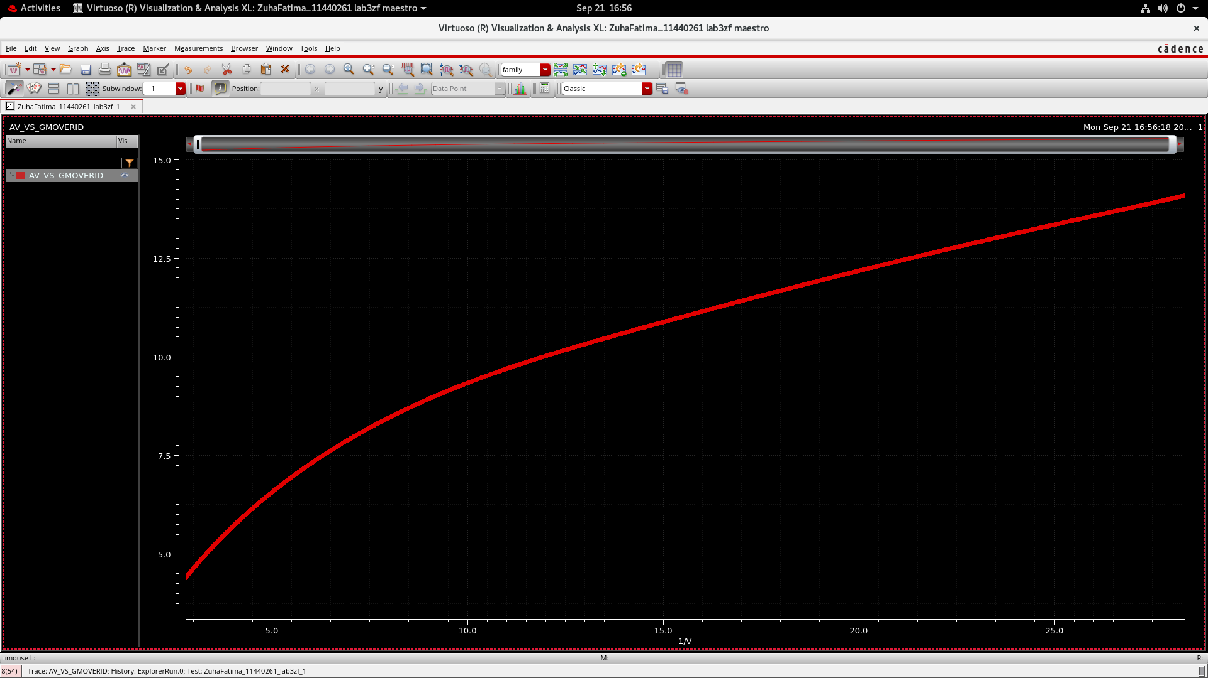
Figure 11. Intrinsic gain against g_{m}/I_{D}, with g_{m}/I_{D} on the horizontal axis in V⁻¹.
Gain rises from about 4.4 to 14 V/V as g_{m}/I_{D} increases from 3 to 28 V⁻¹. Higher efficiency therefore gives more intrinsic gain but less speed.
3.2 Task B Transition frequency
Compare the DC estimate and AC current-gain result near V_{GS} = 0.6 V, with V_{DS} = 0.5 V.
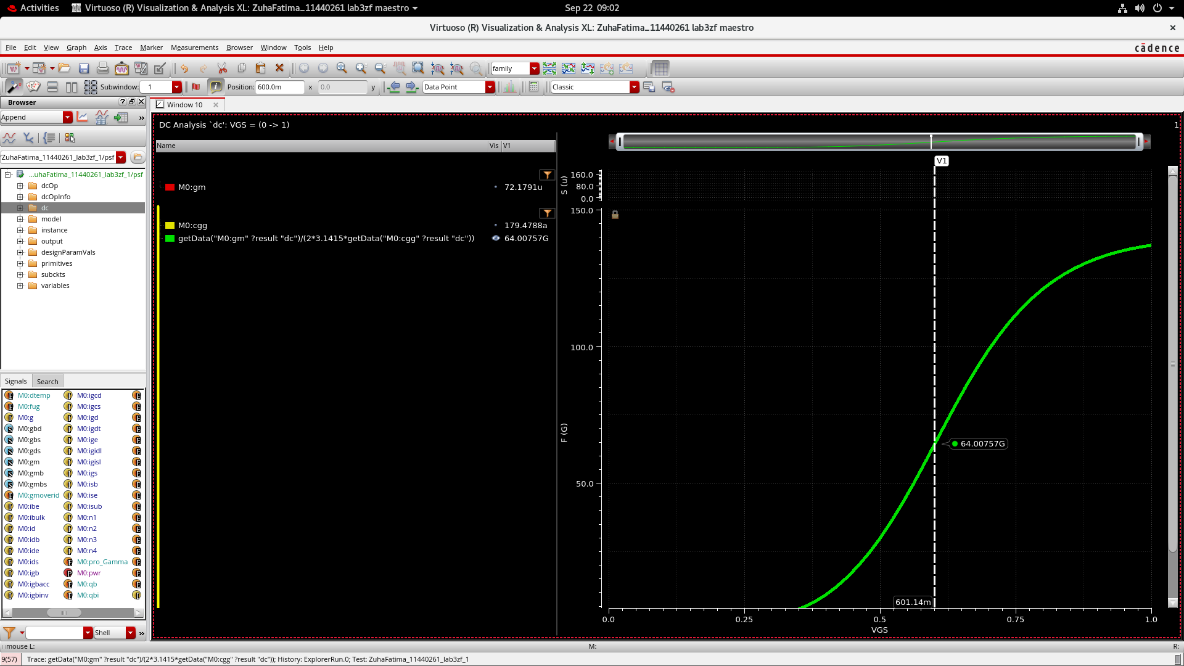
Figure 12. DC-derived f_{T} marker at V_{GS} = 601.14 mV: g_{m} = 72.1791 µS, C_{gg} = 179.4788 aF and f_{T} = 64.00757 GHz.
$$f_{T} ≈ \frac{72.1791 × 10⁻⁶}{2π × 179.4788 × 10⁻¹⁸} ≈ 64.0 GHz$$
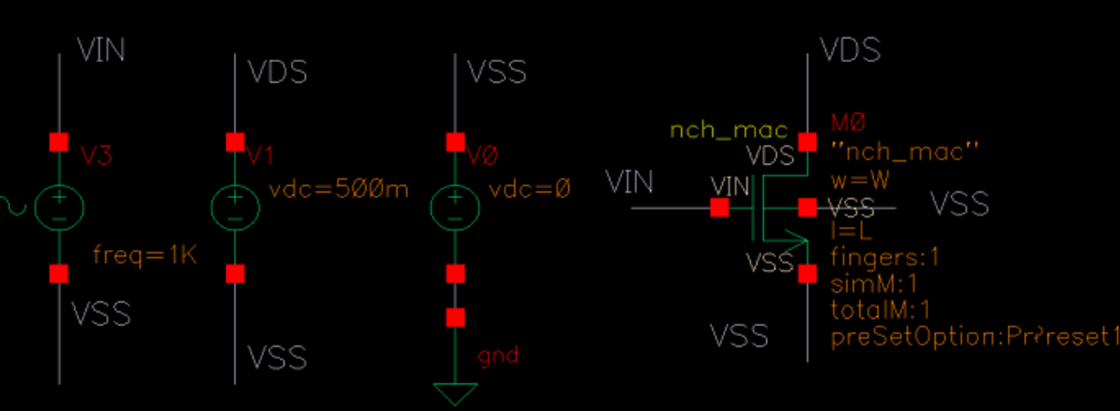
Figure 13. AC testbench. V3 drives the gate, V1 sets V_{DS} = 500 mV, and V0 ties V_{SS} to ground; device dimensions use variables W and L.
The ideal drain bias source holds the drain at AC ground for short-circuit current-gain extraction.
3.2.1 AC verification
The AC transition frequency is the unity-current-gain point, or 0 dB:
$$A_{i,dB} = 20 \log_{10}|\frac{i_{D}}{i_{G}}|$$
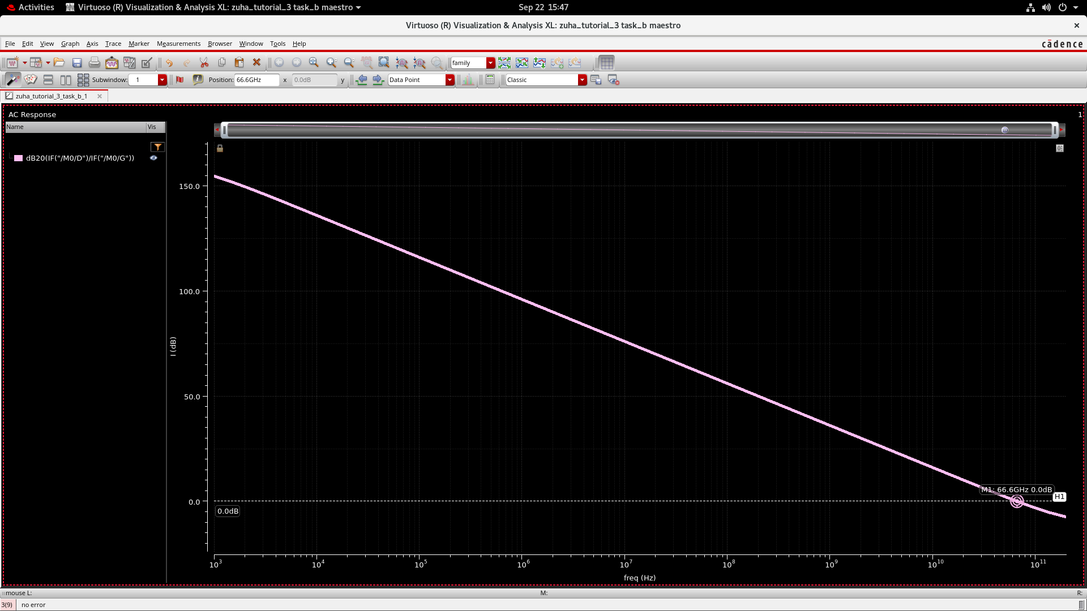
Figure 14. AC current-gain magnitude with the 0 dB crossing at 66.6 GHz.
The AC result is 66.6 GHz, about 4.1% above the 64.0 GHz DC estimate. Gain falls approximately 20 dB per decade.
The small difference reflects the DC approximation and AC terminal-current effects; the DC marker is also slightly offset at 601.14 mV.
3.2.2 Channel length and width sweeps
At V_{GS} = 0.6 V, sweep L from 60 nm toward 1 µm, then W from 0.2 to 1 µm at L = 60 nm.
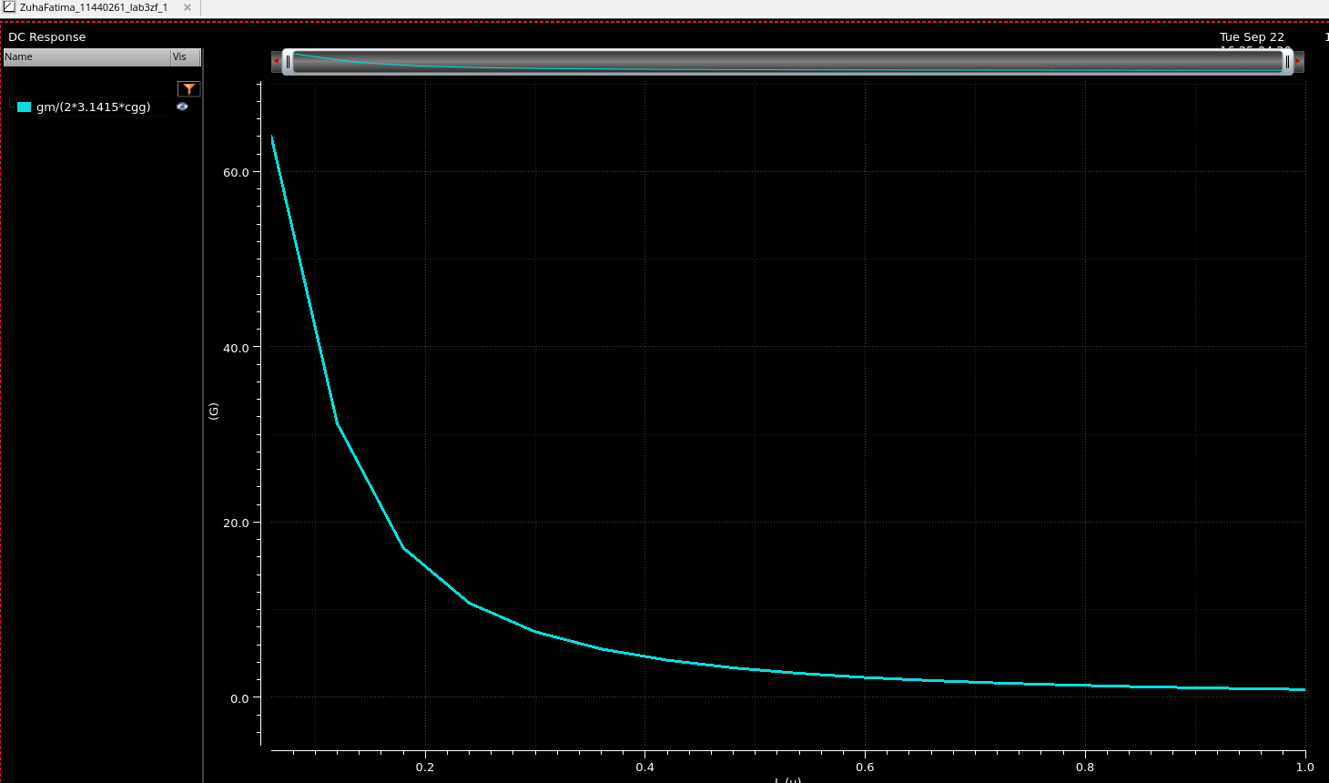
Figure 15. Calculated f_{T} versus channel length. Increasing L sharply reduces transition frequency.
Increasing L reduces f_{T} from about 64 GHz to roughly 1 GHz as channel transit time increases.
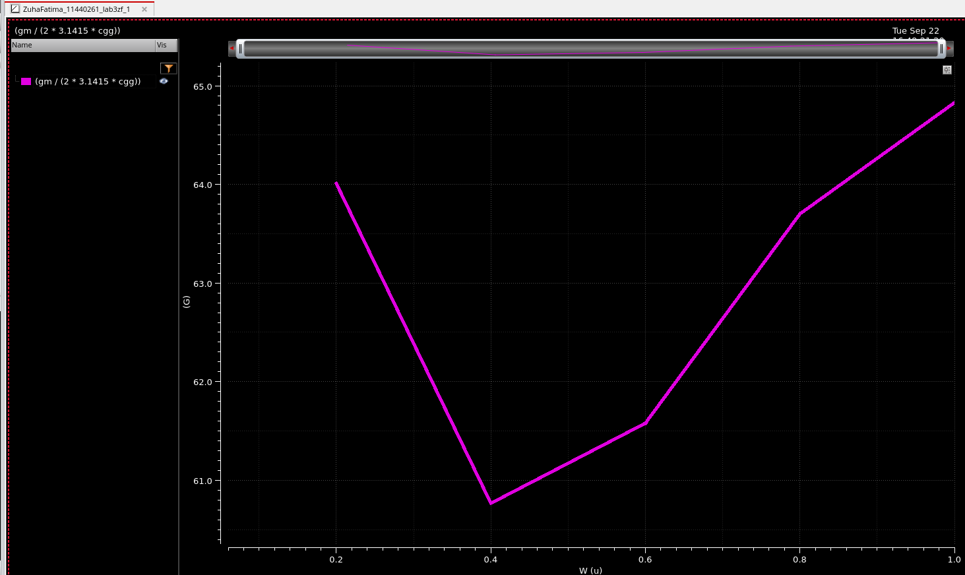
Figure 16. Calculated f_{T} versus width at fixed length, spanning approximately 60.8 to 64.8 GHz.
Width causes only a modest variation, about 60.8–64.8 GHz, because g_{m} and C_{gg} largely scale together.
3.2.3 Transition frequency versus overdrive
Overdrive is calculated from the gate and threshold voltages:
$$V_{ov} = V_{GS} - V_{TH}$$
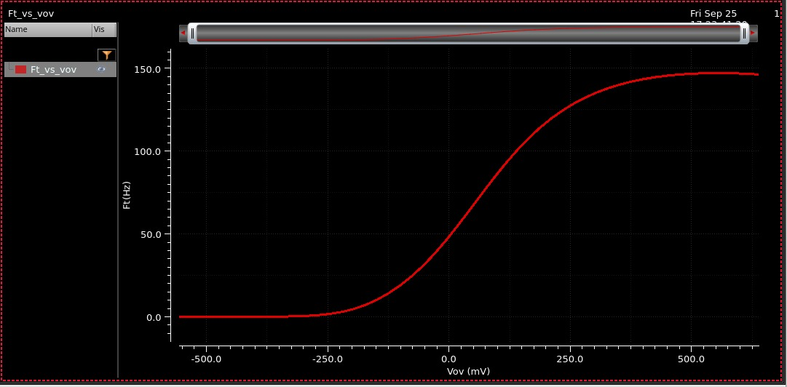
Figure 17. Transition frequency versus overdrive voltage. The frequency increases through turn-on and approaches a plateau at high overdrive.
The f_{T} curve rises through turn-on and flattens at high overdrive, where additional bias gives little speed improvement.
The screenshot omits the frequency multiplier, so an absolute peak cannot be confirmed from its axis alone.
3.3 Task C Maximum oscillation frequency
Use a two-port S-parameter sweep from 1 GHz to 2 THz at V_{GS} = 0.6 V and V_{DD} = 1 V. The near-zero G_{max} crossing estimates f_{max} here.
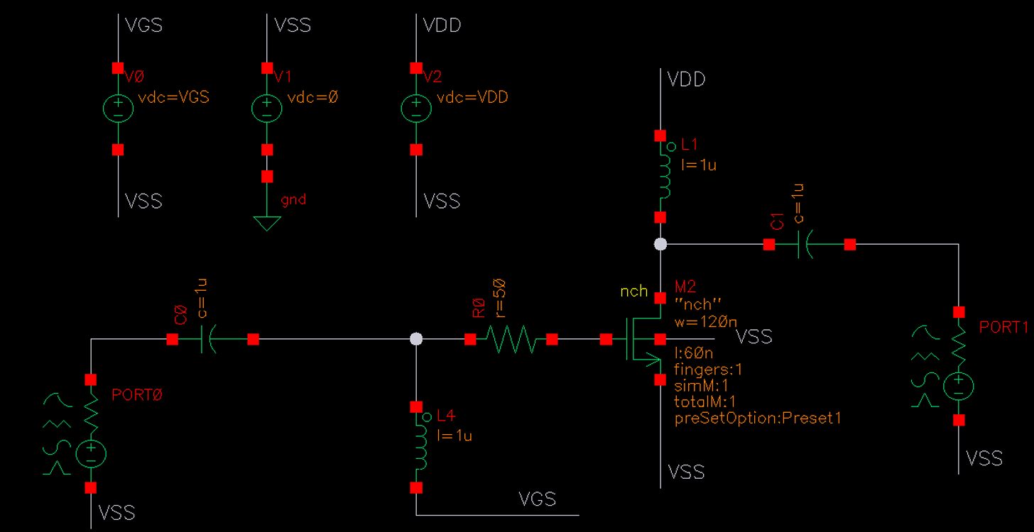
Figure 18. Two-port nch testbench: W = 120 nm, L = 60 nm, one finger, external gate resistance of 50 Ω, 1 µF coupling capacitors and 1 µH bias inductors.
Coupling capacitors block DC; inductors feed bias while impeding RF current. The external gate resistor adds loss.
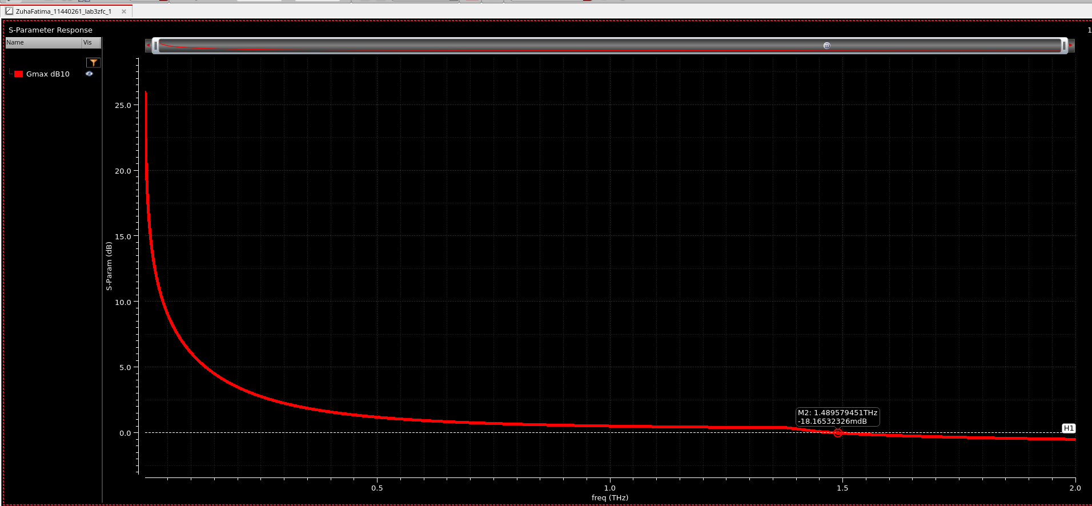
Figure 19. Minimum-size nch power-gain response. The marker is at 1.48958 THz and −18.17 mdB, close to the 0 dB crossing.
The initial crossing is approximately 1.49 THz and depends on the device model and parasitics.
3.3.1 Effect of increasing device dimensions
Increase W to 5 µm and L to 120 nm as specified in the tutorial.
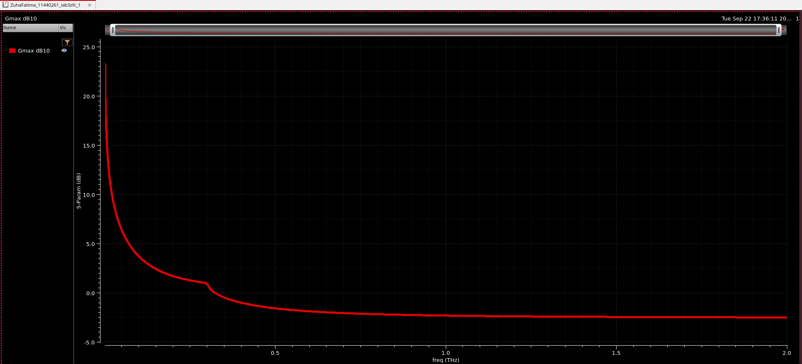
Figure 20. G_{max} versus frequency after increasing the device dimensions.
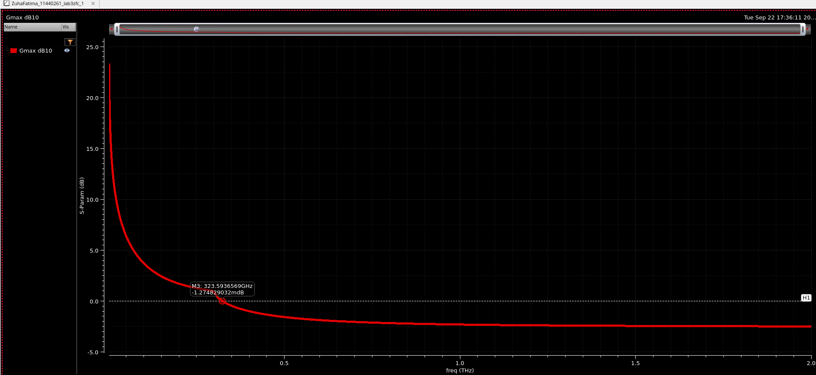
Figure 21. The same response with a marker at 323.593659 GHz and −1.275 mdB, essentially the unity-gain crossing.
The marked estimate falls to 323.6 GHz, about 78% below the initial value. Since both dimensions change, their individual effects are not isolated.
3.3.2 Effect of two gate fingers
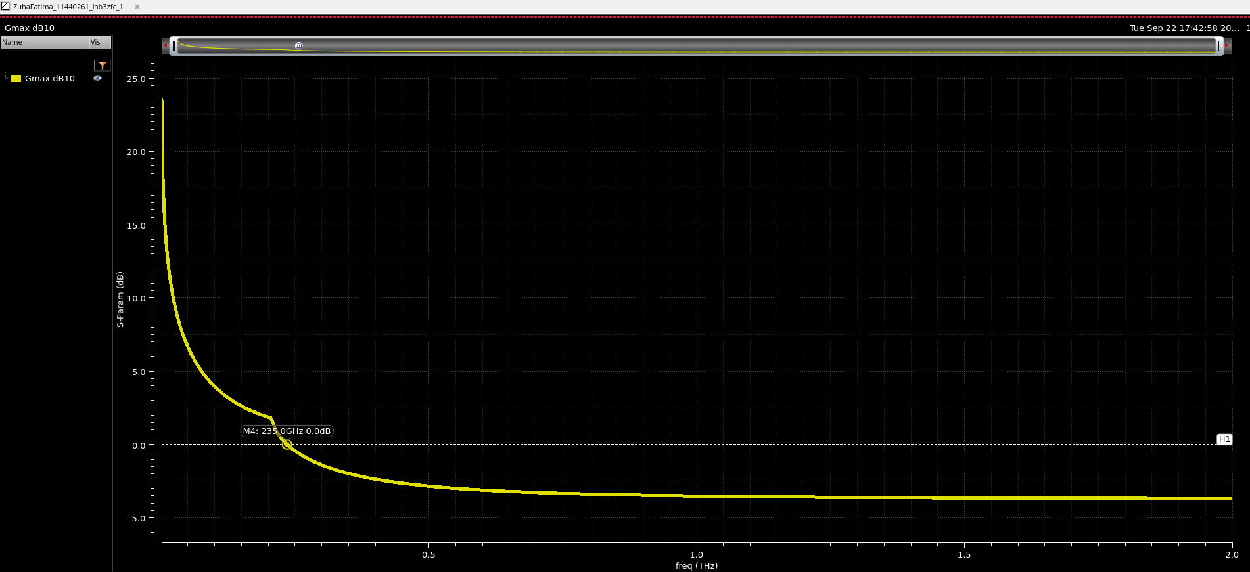
Figure 22. nch response with two fingers, giving a marked unity-power-gain frequency of 235.0 GHz.
Two fingers reduce the crossing from 323.6 to 235.0 GHz, a 27.4% decrease.
More fingers can reduce gate resistance, but total width and capacitance may also change. The external 50 Ω resistor remains fixed.
The tutorial approximation relates these competing effects:
$$f_{max} ≈ \sqrt{\frac{f_{T}}{8πR_{g}C_{gd}}}$$
Reported crossings use the displayed G_{max} traces, not a separate unilateral-gain plot.
3.3.3 RF NMOS and finger count
The nmos_rf runs compare 16 and 30 fingers. The tutorial removes the external gate resistor because the RF model includes gate resistance.
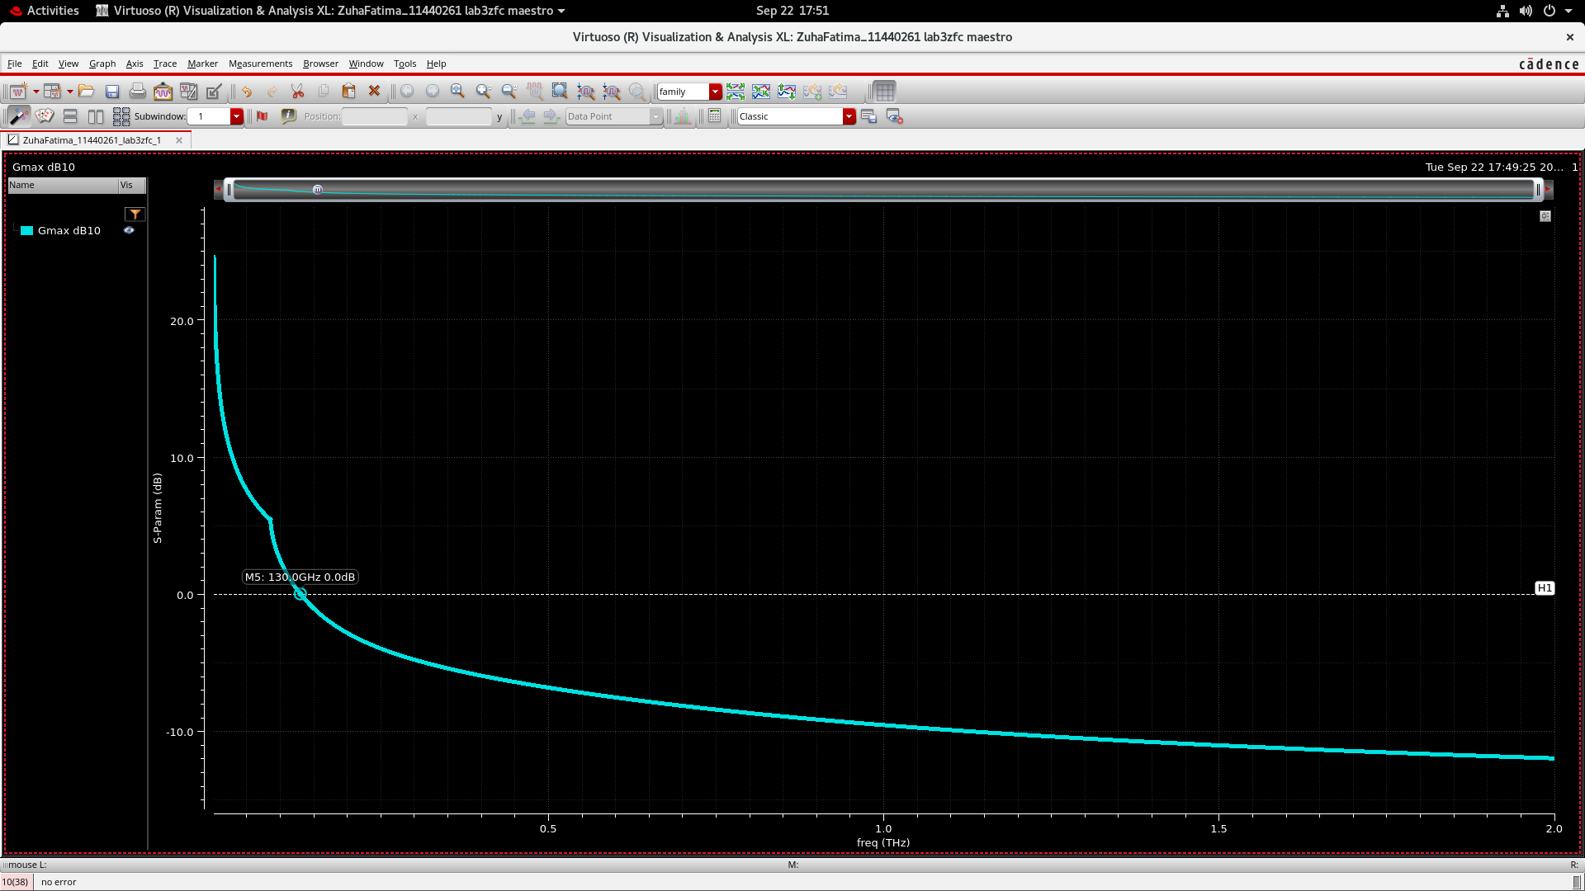
Figure 23. nmos_rf with 16 fingers: the marked 0 dB crossing is 130.0 GHz.
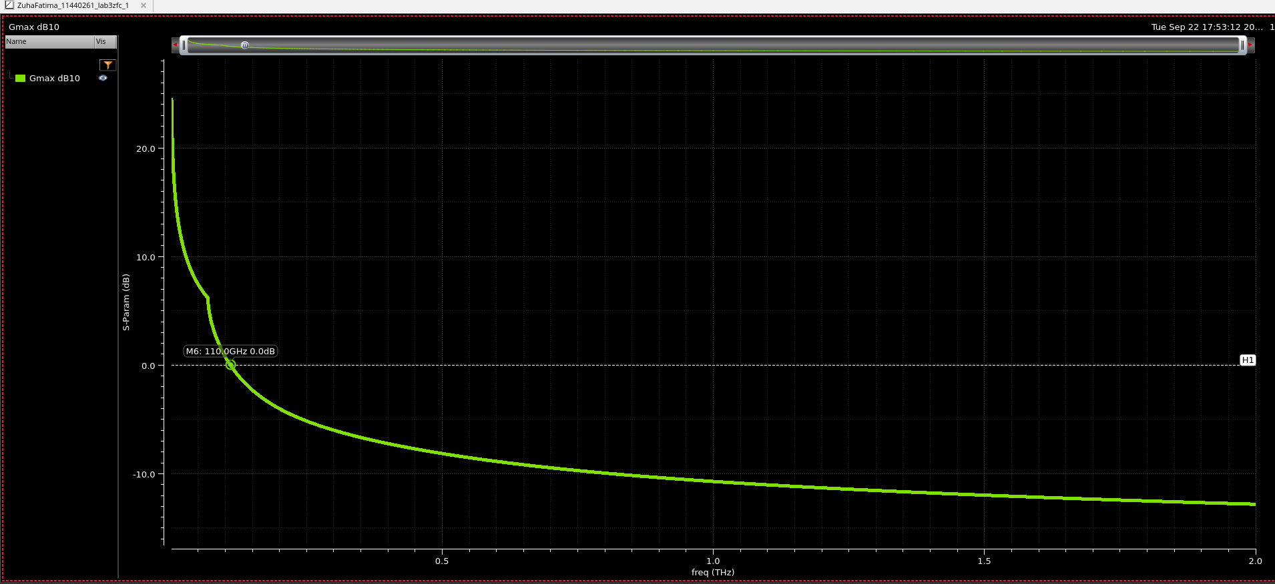
Figure 24. nmos_rf with 30 fingers: the marked 0 dB crossing is 110.0 GHz.
Increasing the count from 16 to 30 lowers f_{max} from 130 to 110 GHz, a 15.4% decrease. More fingers do not guarantee greater speed.
4. Exercise activities
4.1 Activity 3.1 PMOS characterization
Repeat Task A using pch_mac with W = 200 nm, L = 60 nm and V_{SD} = 0.5 V. Sweep V_{SG} from 0 to 1 V.
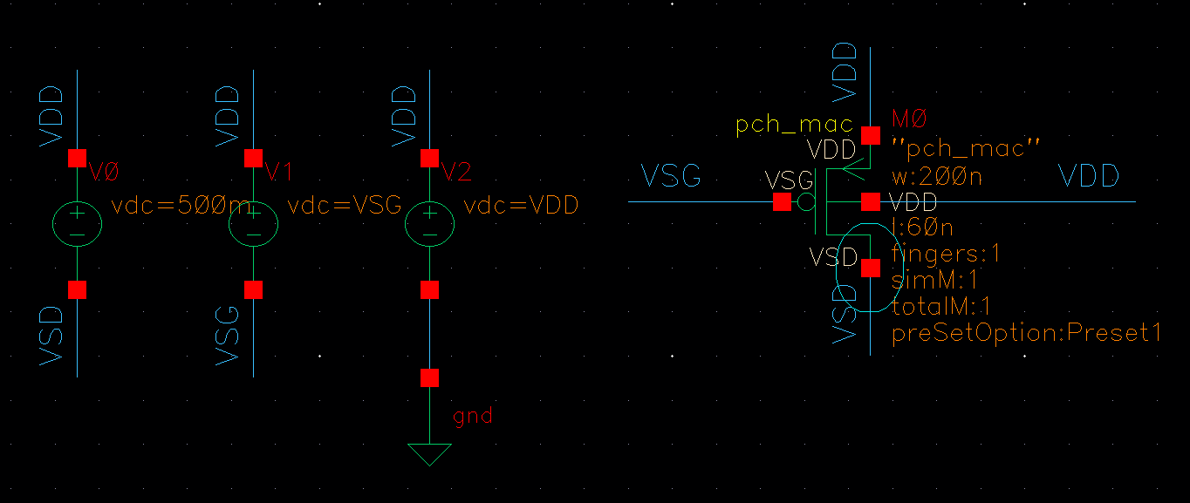
Figure 25. PMOS bias testbench with source and bulk tied to V_{DD}.
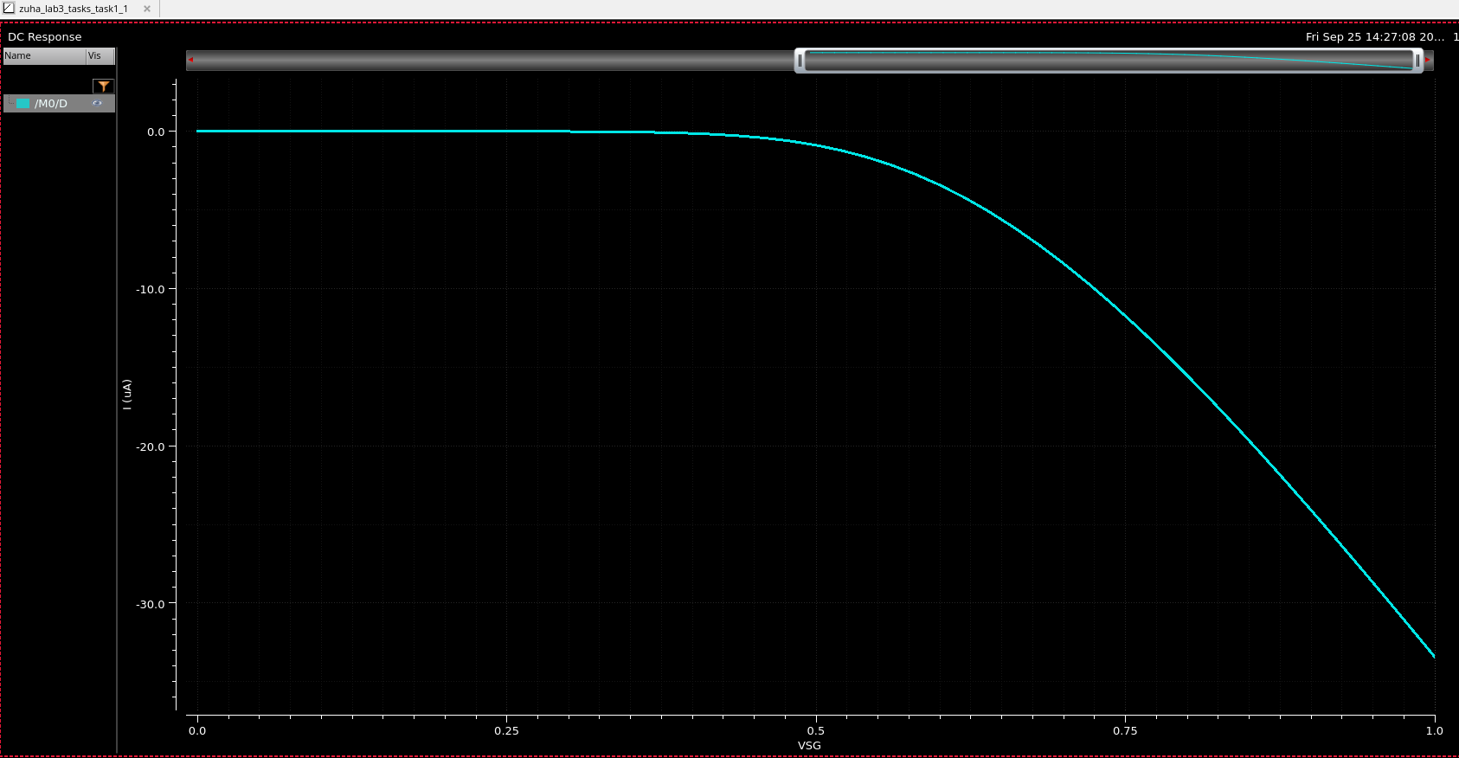
Figure 26. PMOS drain current versus V_{SG}.
The drain-current magnitude reaches approximately 33 µA at V_{SG} = 1 V. Its negative sign follows the terminal-current convention.
4.1.1 Transconductance and gate capacitance
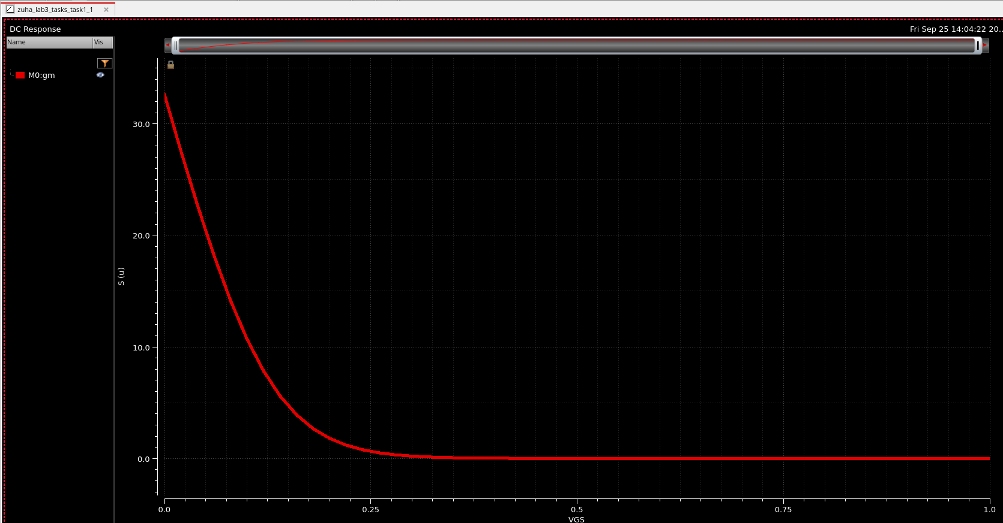
Figure 27. Supplied g_{m} trace versus the displayed V_{GS} sweep.
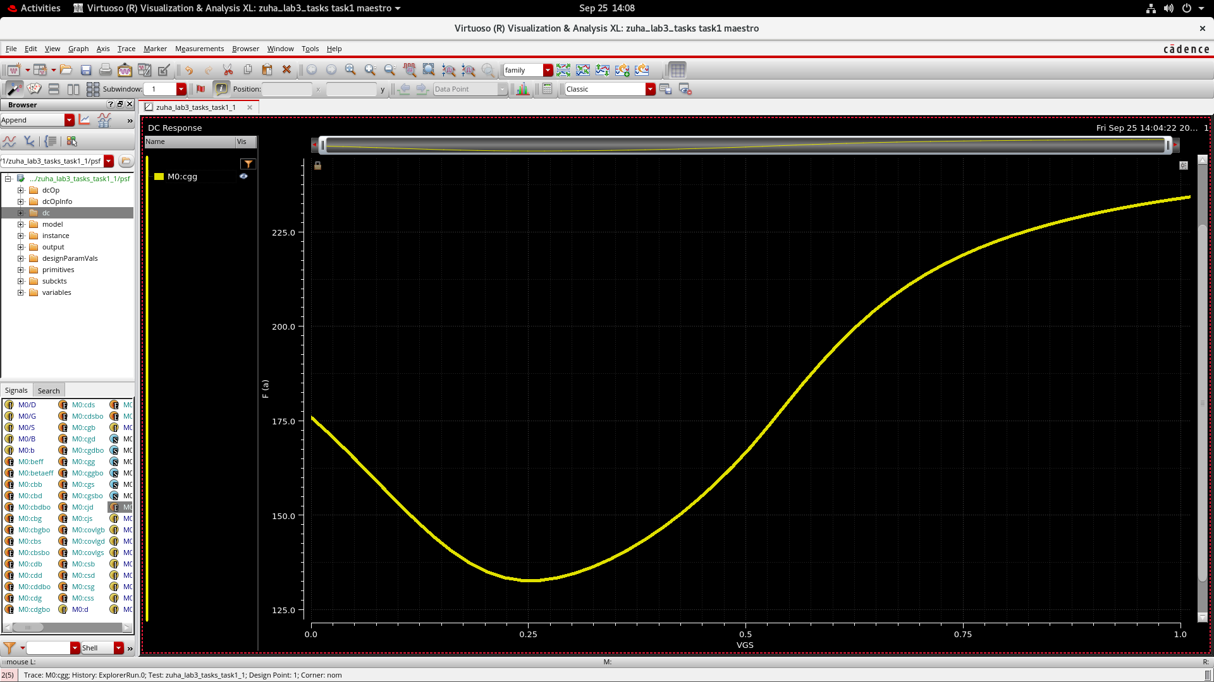
Figure 28. PMOS gate capacitance versus the displayed gate-bias sweep.
C_{gg} falls to about 133 aF before rising to roughly 235 aF. The decreasing g_{m} trace uses a V_{GS}-labelled sweep and does not match the later increasing-V_{SG} run; it should not be treated as the same bias sweep.
4.1.2 Current efficiency and inversion regions
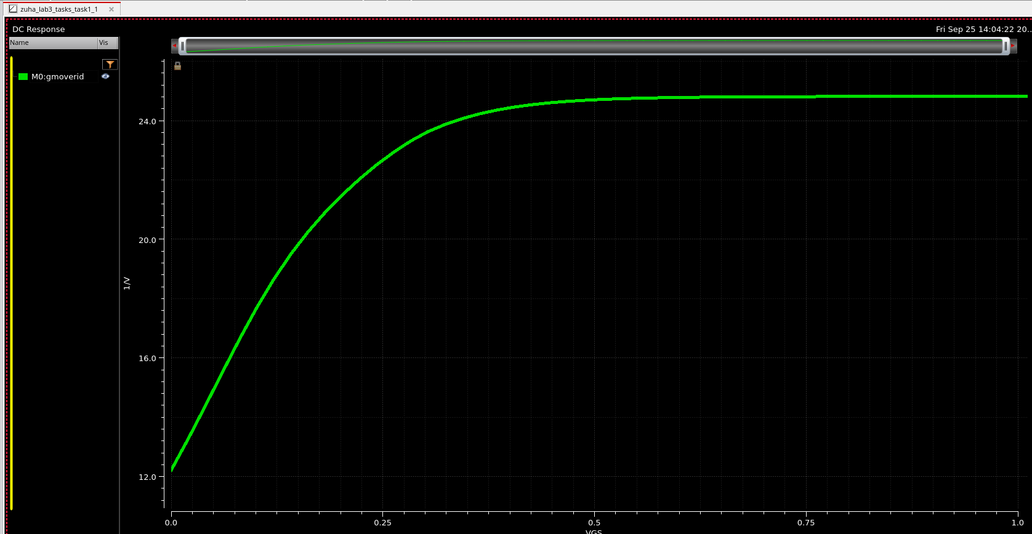
Figure 29. Initial g_{m}/I_{D} trace under the displayed V_{GS} sweep.
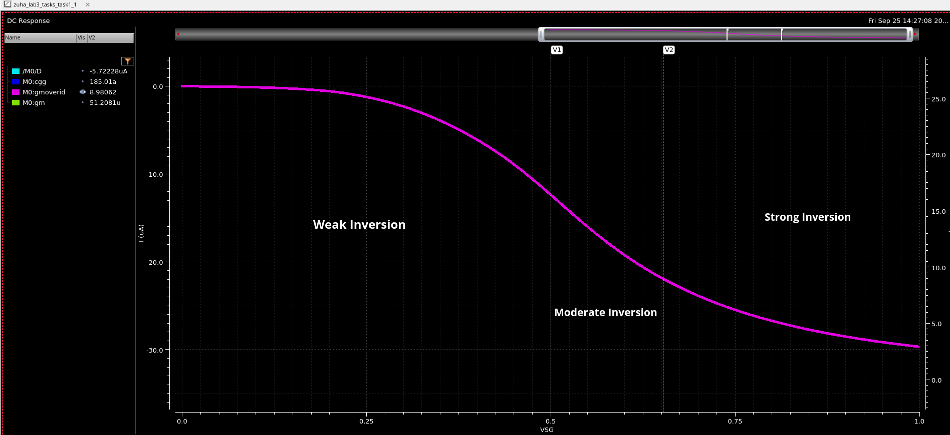
Figure 30. Labelled g_{m}/I_{D} versus V_{SG} with approximate inversion regions.
The labelled V_{SG} run shows g_{m}/I_{D} falling from about 28 to 3 V⁻¹, with moderate inversion around 0.5–0.65 V. The earlier V_{GS}-labelled trace rises instead, indicating a different bias convention or run.
4.1.3 Speed and intrinsic gain
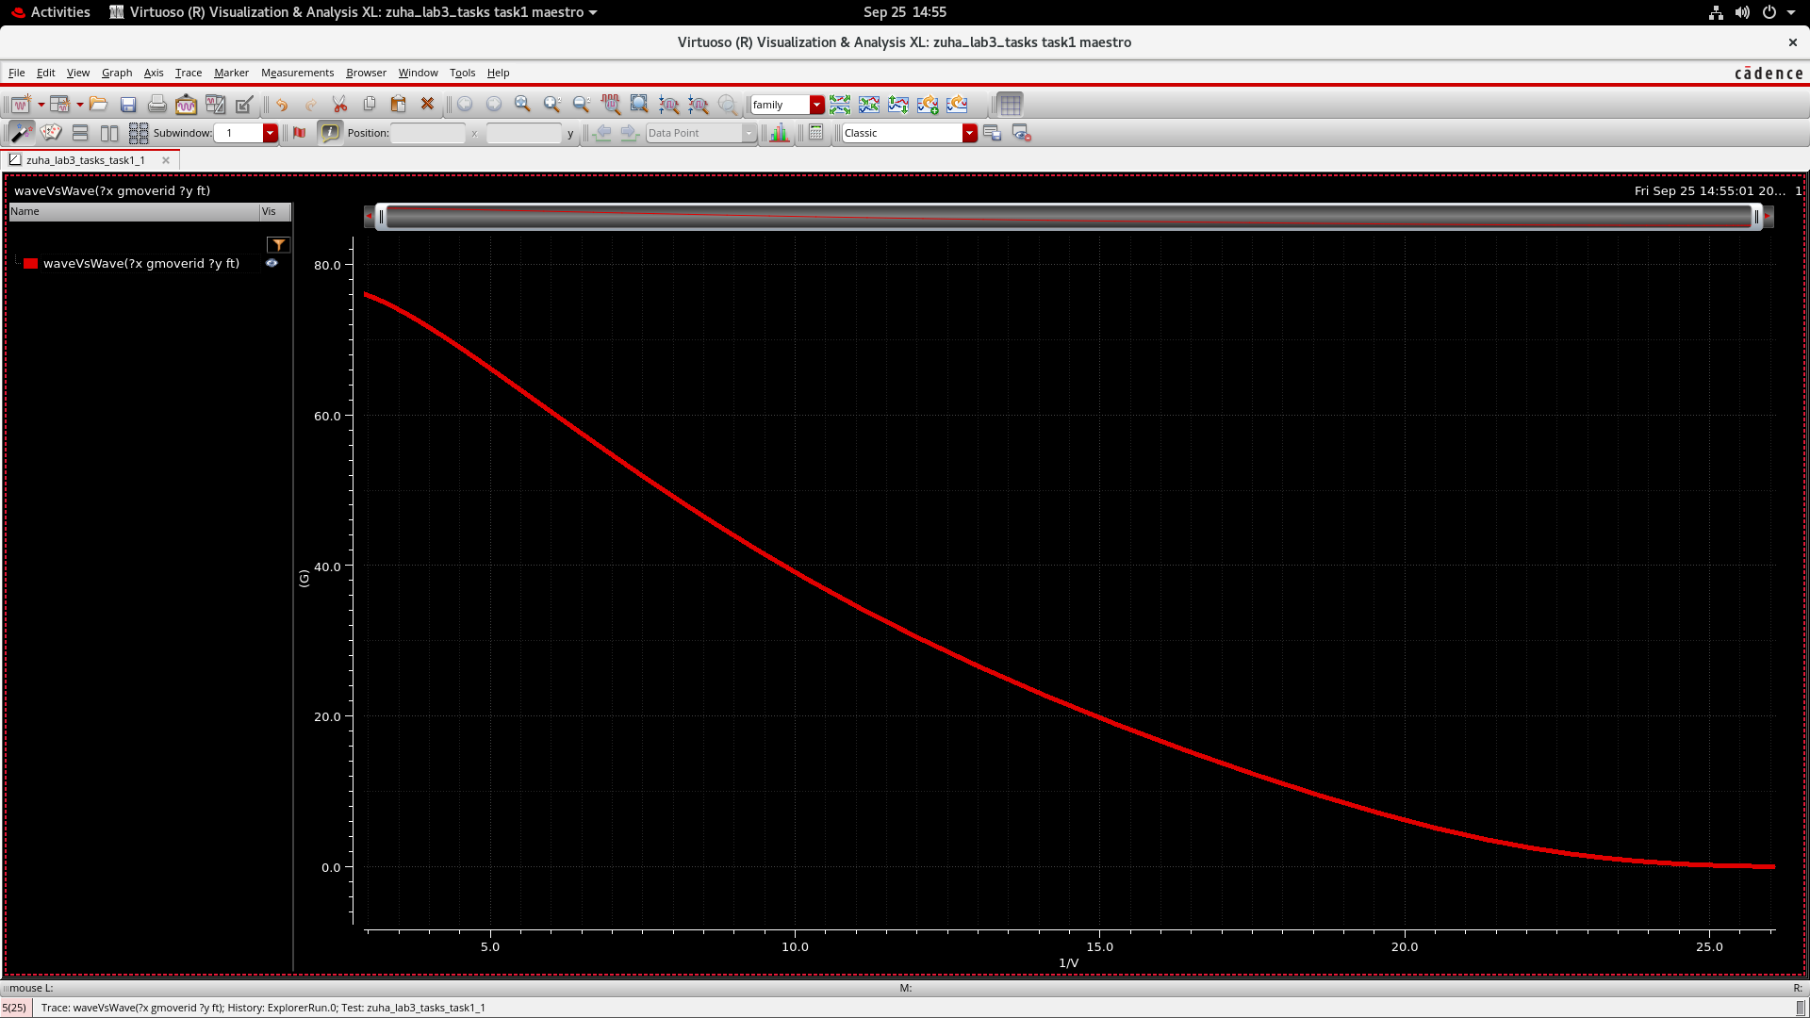
Figure 31. PMOS f_{T} versus g_{m}/I_{D}.
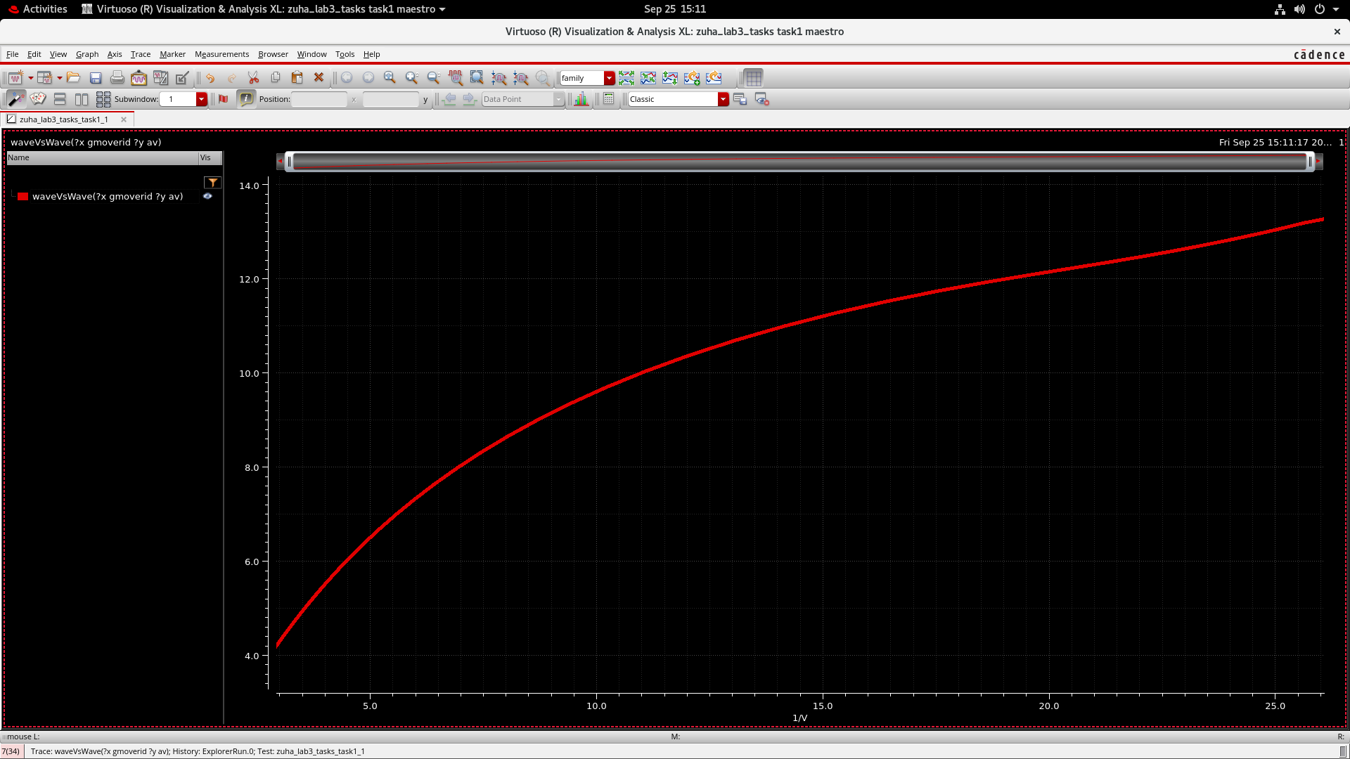
Figure 32. PMOS intrinsic gain versus g_{m}/I_{D}.
As g_{m}/I_{D} increases, f_{T} falls from about 76 GHz toward zero while intrinsic gain rises from roughly 4.2 to 13.3 V/V. Higher efficiency therefore trades speed for gain.
4.2 Activity 3.2 PMOS dimension sweeps
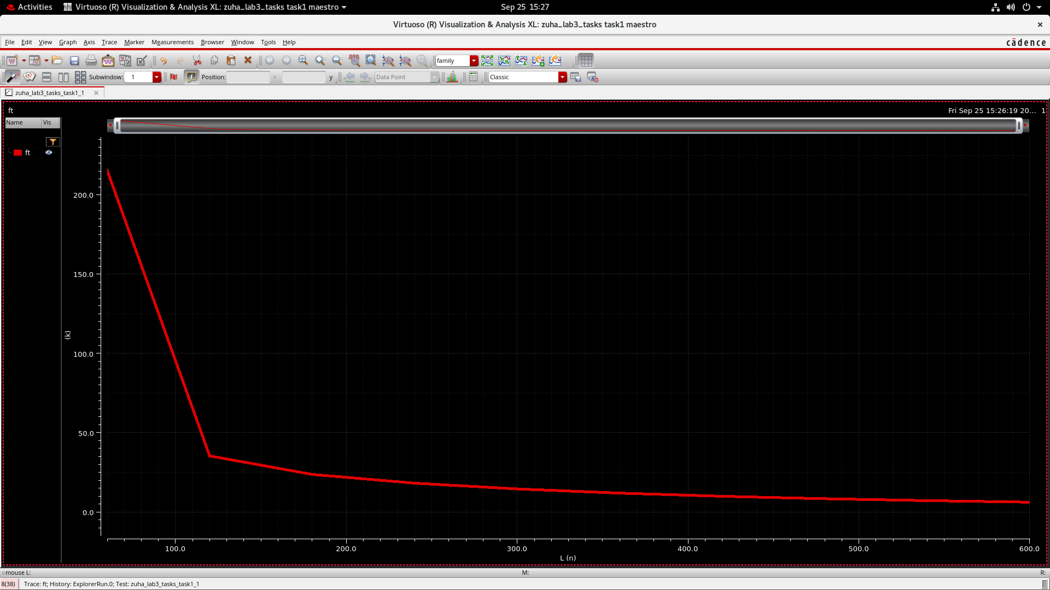
Figure 33. PMOS f_{T} for L = 60–600 nm in 60 nm steps.
Increasing L reduces the displayed f_{T} from about 215 GHz to roughly 6 GHz.
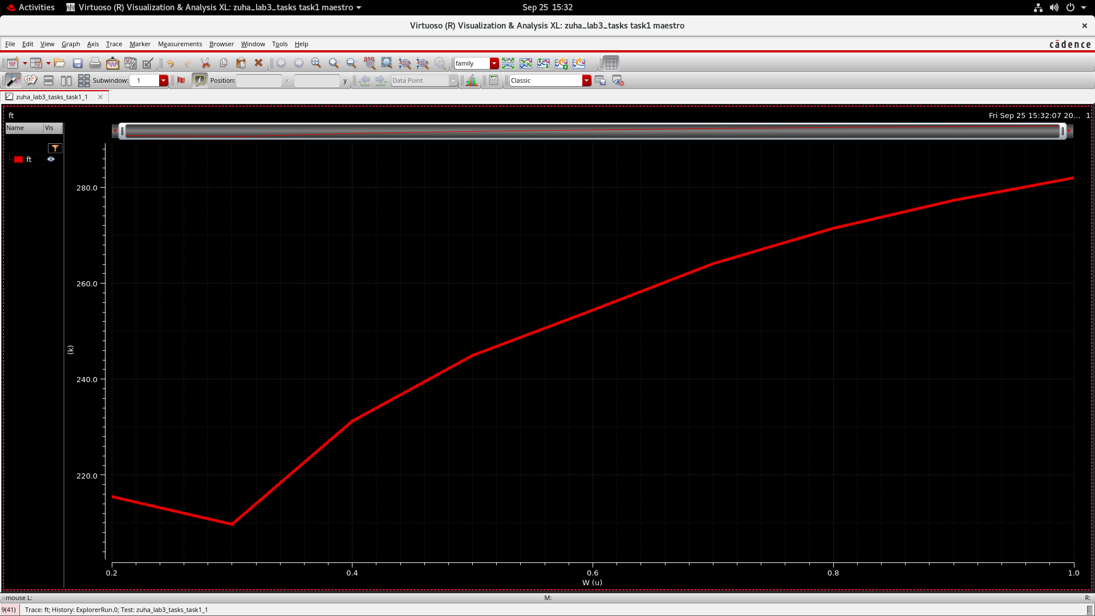
Figure 34. PMOS f_{T} for W = 0.2–1 µm.
The width sweep dips near 0.3 µm, then rises to about 282 GHz at 1 µm. These runs have a different frequency range from Activity 3.1; matching bias and saved expressions is necessary for a direct comparison.
4.3 Activity 3.3 Speed efficiency FOM
Calculate FOM = f_{T} × g_{m}/|I_{D}| while sweeping V_{GS} from 0 to 1 V at V_{DS} = 0.5 V.
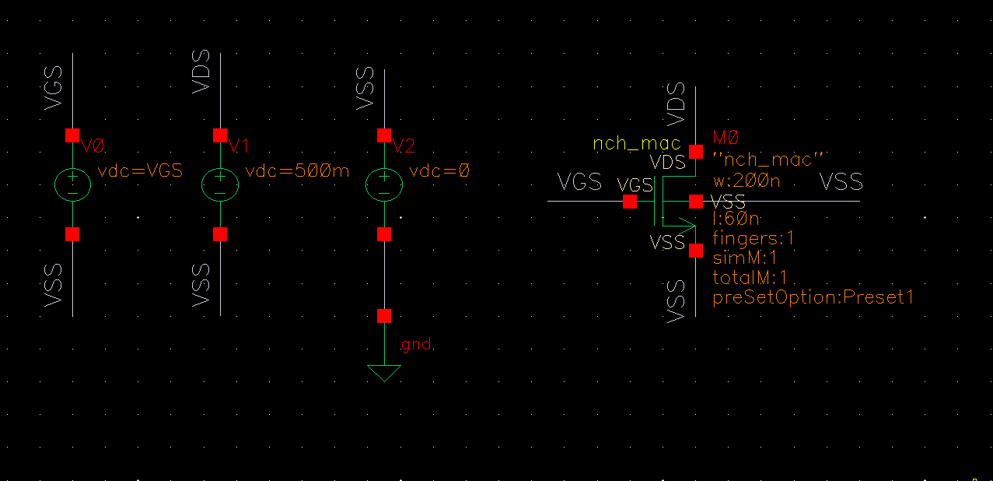
Figure 35. NMOS FOM testbench showing W = 200 nm and L = 60 nm.
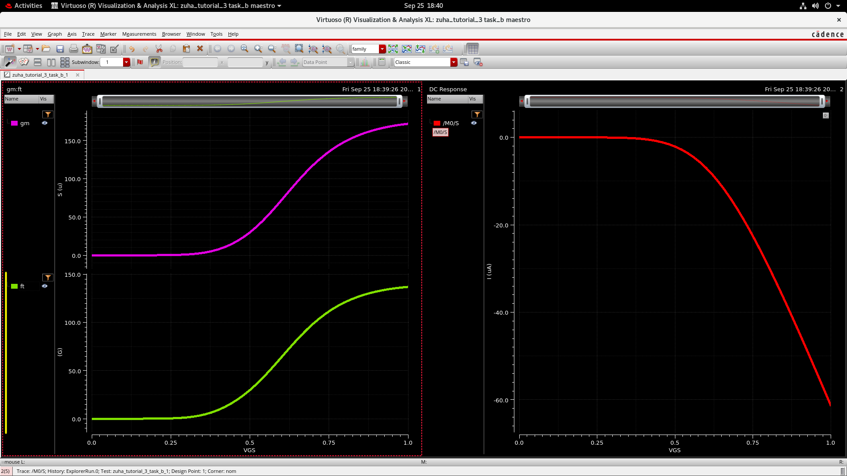
Figure 36. Saved g_{m}, f_{T} and signed source-current traces for the FOM calculation.
The supplied schematic uses W = 200 nm rather than the activity’s requested 120 nm. The source current is negative, so its magnitude is needed for a positive efficiency measure.
4.3.1 FOM peak
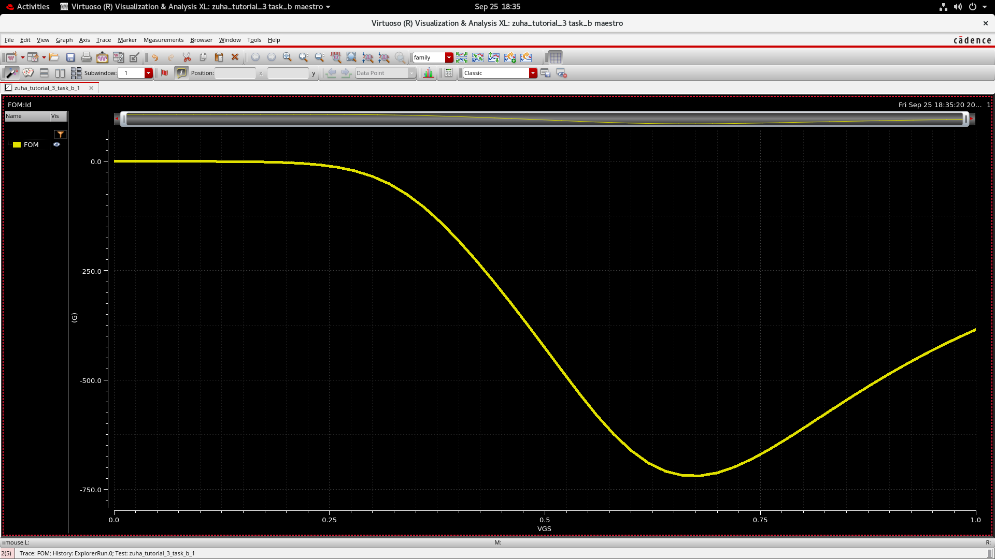
Figure 37. Signed FOM curve versus V_{GS}.
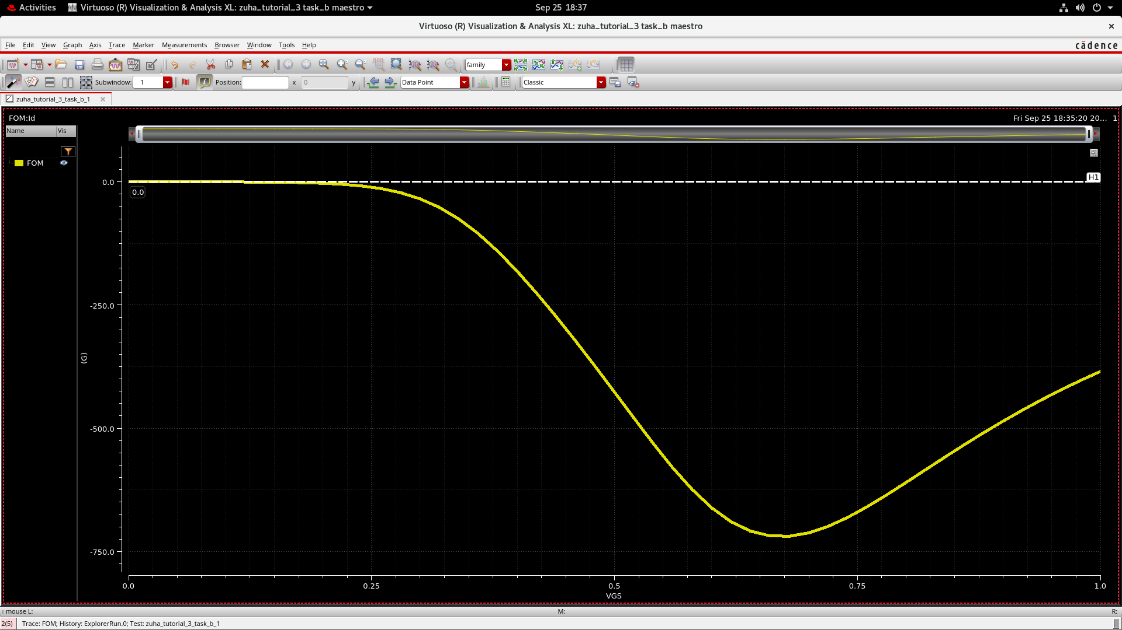
Figure 38. FOM plot with a zero reference line.
The curve reaches approximately −720 GHz/V near V_{GS} ≈ 0.67 V. Using current magnitude gives a peak FOM of about 720 GHz/V, showing the best speed–efficiency balance in this run. This is a visual estimate; the supplied marker does not identify the extremum.
4.4 Activity 3.4 PMOS maximum frequency
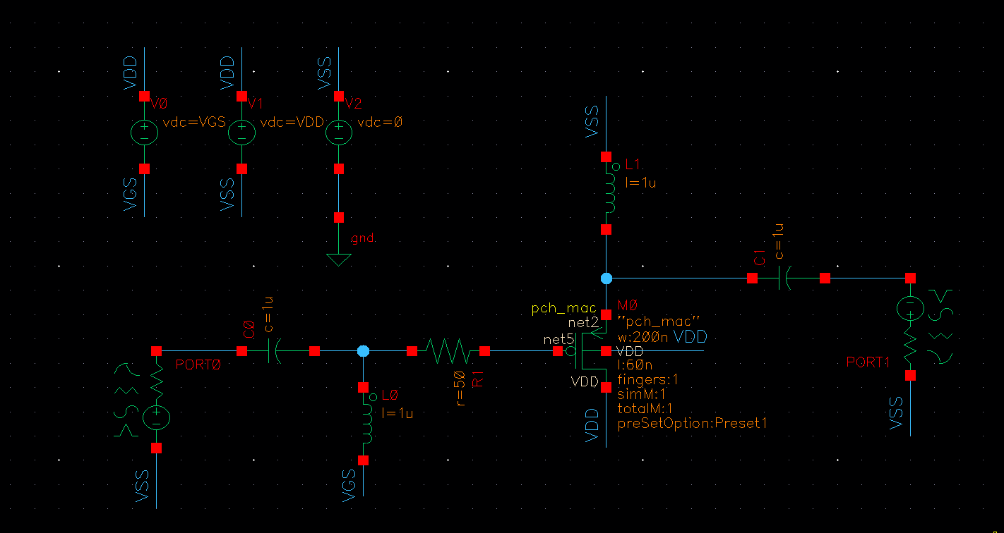
Figure 39. pch_mac two-port testbench with W = 200 nm, L = 60 nm and external R_{g} = 50 Ω.
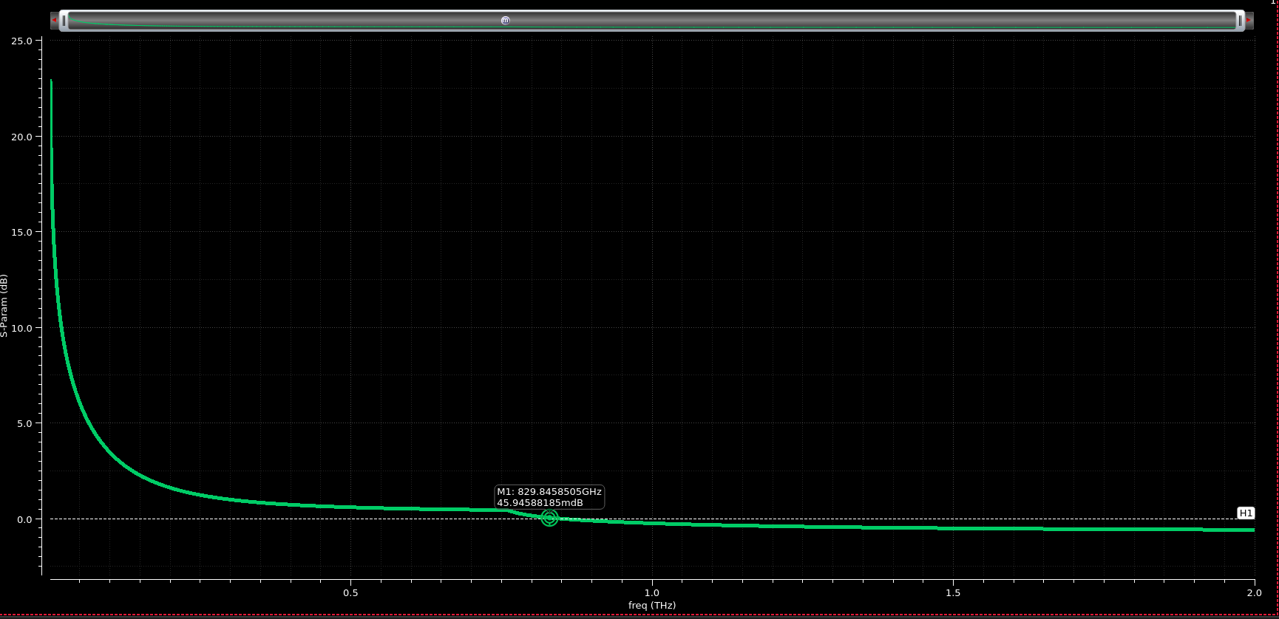
Figure 40. pch_mac marker at 829.85 GHz and +45.95 mdB, near unity power gain.
The PMOS estimate is about 0.83 THz, below the initial NMOS value of 1.49 THz in Part C. Different device widths and models prevent attributing the difference solely to transistor polarity.
4.4.1 RF PMOS comparison
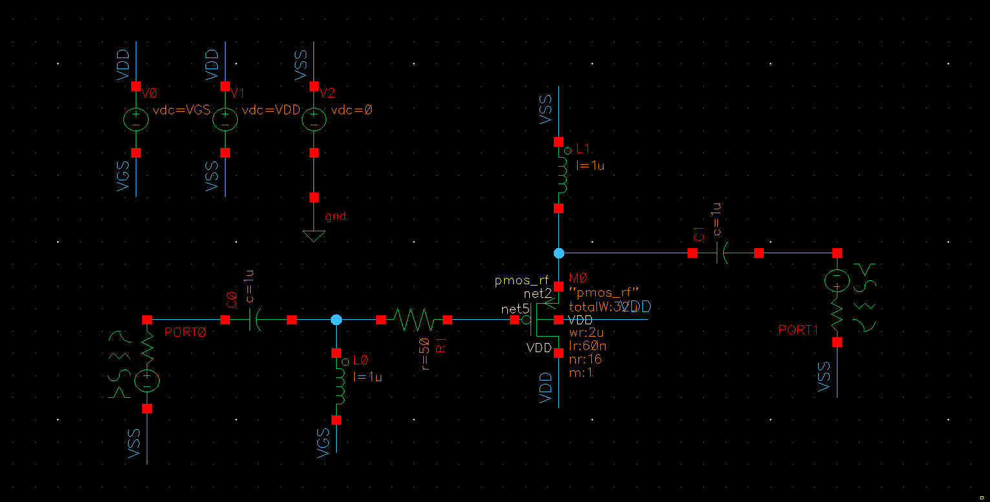
Figure 41. pmos_rf testbench with 16 fingers, 2 µm finger width and L = 60 nm.
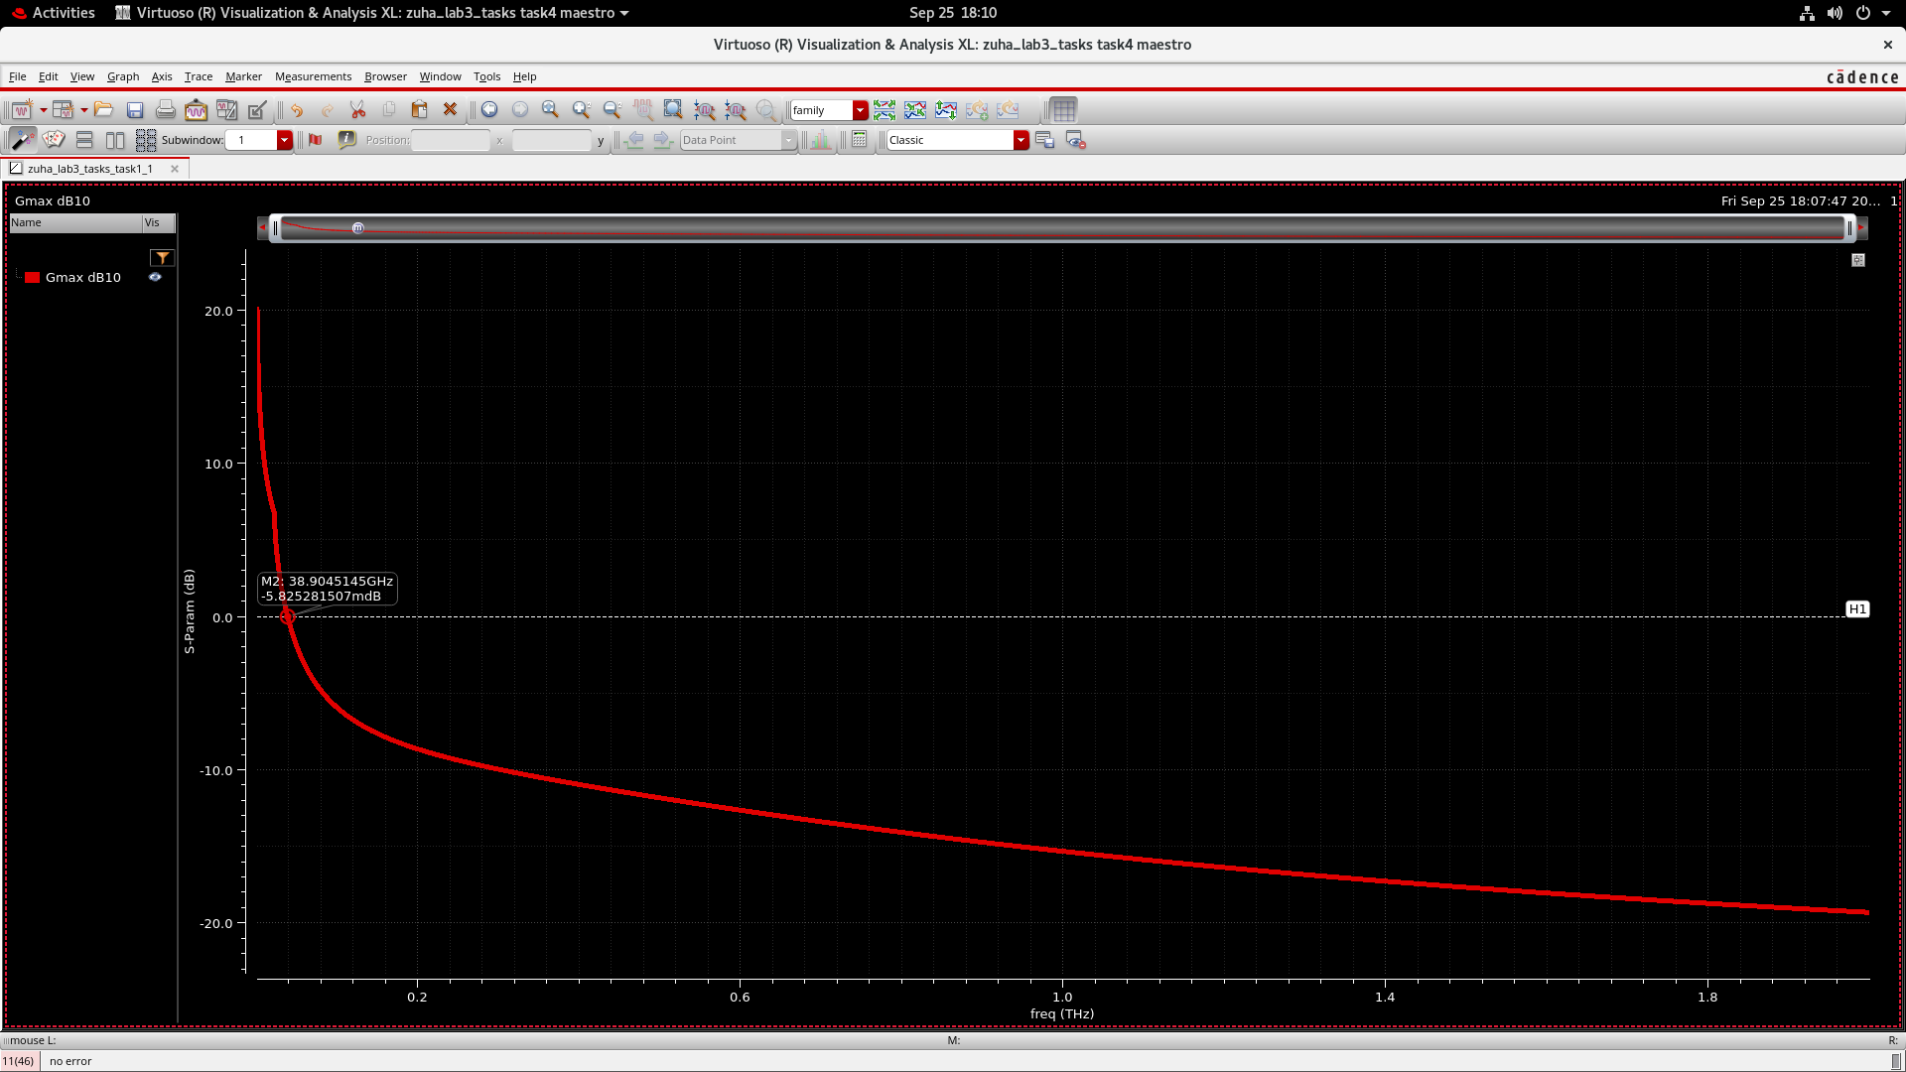
Figure 42. RF PMOS marker at 38.90 GHz and −5.83 mdB, close to 0 dB.
The RF PMOS crossing is about 38.9 GHz versus 130 GHz for the 16-finger RF NMOS. However, this PMOS schematic retains the external 50 Ω gate resistor, unlike the Part C RF setup; the comparison includes that additional loss.

