


COURSE TITLE (i.e., EE809 Analog IC Design)
MSEE (ICS) 2026
Tutorial # (01)
Introduction to Cadence

Name | Zuha Fatima
Reg # | 582671
Instructor | Dr. Saman Fatima
Date | 11th September, 2026

Table of Contents
1. Task 1 2
1.1. Objective 2
2.1. Device Sizing Comparison 2
3.1. Inverter Using Minimum Size Transistors (Schematic + Simulation Graph) 2
4.1. Inverter Using Maximum Size transistors (Schematic + Simulation Graph) 3
5.1. Comparison of Transient Responses: 5
2. Task 2 5
2.1. Objective 5
2.2. Schematic 5
2.3. Simulation Graph 6
3. Task 3 6
2.4. Schematic 6
2.5. Simulation Graph 7
4. Conclusion 7

- Task 1
- Objective
In Tutorial 1, we are asked to repeat the tutorial exercise in Lab manual (inverter using mosfets) using the largest PMOS and NMOS sizes the tsmc65N pch_mac and nch_mac will accept and to compare the current (maximum size) graphs results against the previous (minimum-size) tutorial task.
- Device Sizing Comparison
Table 1 Sizing of PMOS and NMOS
Parameter | Minimum Size | Maximum Size
M1 pch_mac W | 200 nm | 900 µm
M1 pch_mac L | 120 nm | 20 µm
M0 nch_mac W | 200 nm | 450 µm
M0 nch_mac L | 60 nm | 10 µm

- Inverter Using Minimum Size Transistors (Schematic + Simulation Graph)
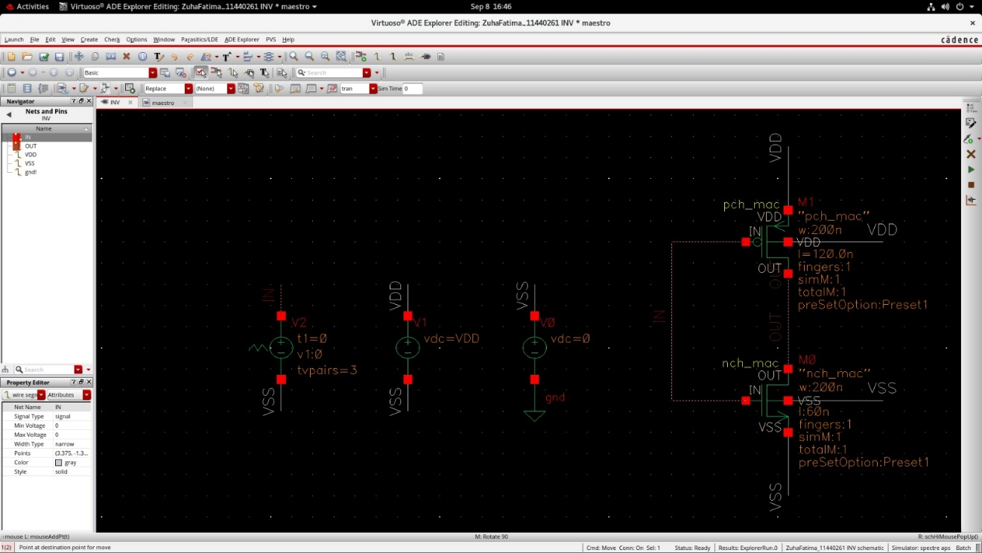
Figure 1. Schematic of the minimum-size inverter. M1 pch_mac at W = 200 nm, L = 120 nm; M0 nch_mac at W = 200 nm, L = 60
The CMOS inverter in schematic has one PMOS on top connected to VDD and one NMOS on bottom connected to VSS/ground. Both gates share the same input IN, and their drains join at OUT.
The sizing of NMOS is supposed to be half of PMOS to compensate for the lower hole mobility in PMOS.
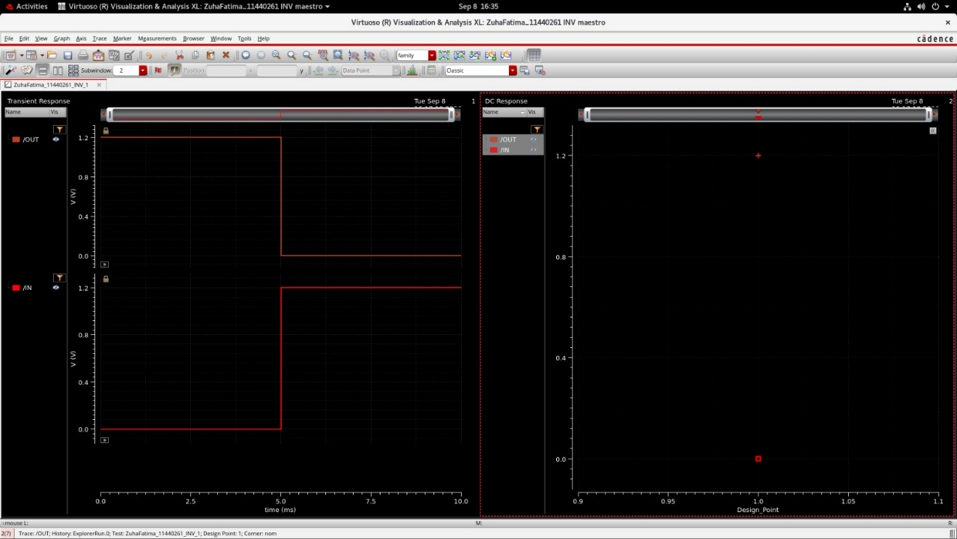
Figure 2 Transient response of the minimum-size inverter over the full 10 ms window. OUT falls from 1.2 V to 0 V as IN rises from 0 V to 1.2 V at t = 5 ms.
When /IN is low, /OUT stays high; when /IN goes high around 5 ms, /OUT switches state, confirming NOT-gate behavior.
- Inverter Using Maximum Size transistors (Schematic + Simulation Graph)
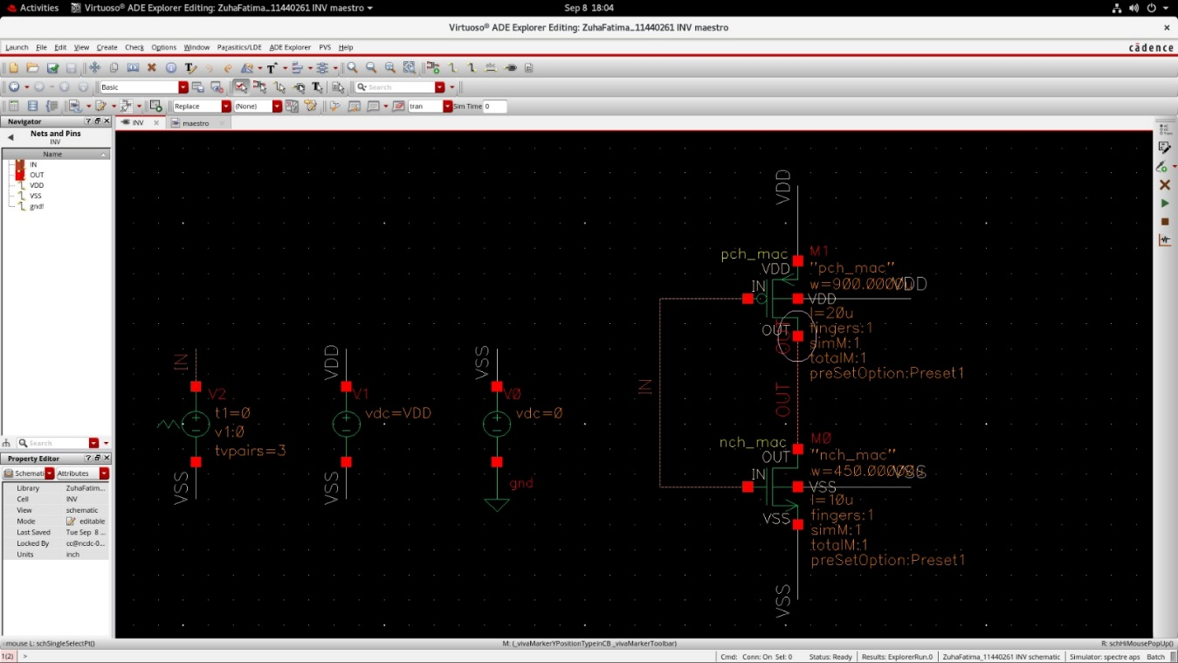
Figure 3 Schematic of the maximum-size inverter. M1 pch_mac at W = 900 µm, L = 20 µm; M0 nch_mac at W = 450 µm, L = 10 µm
This is the same inverter but now the width is increased to 900u m in case of PMOS and 450nm in case of NMOS because that is the maximum width that could be used. Maximum length for PMOS is 20um and for NMOS is 10um in tsmc65N.
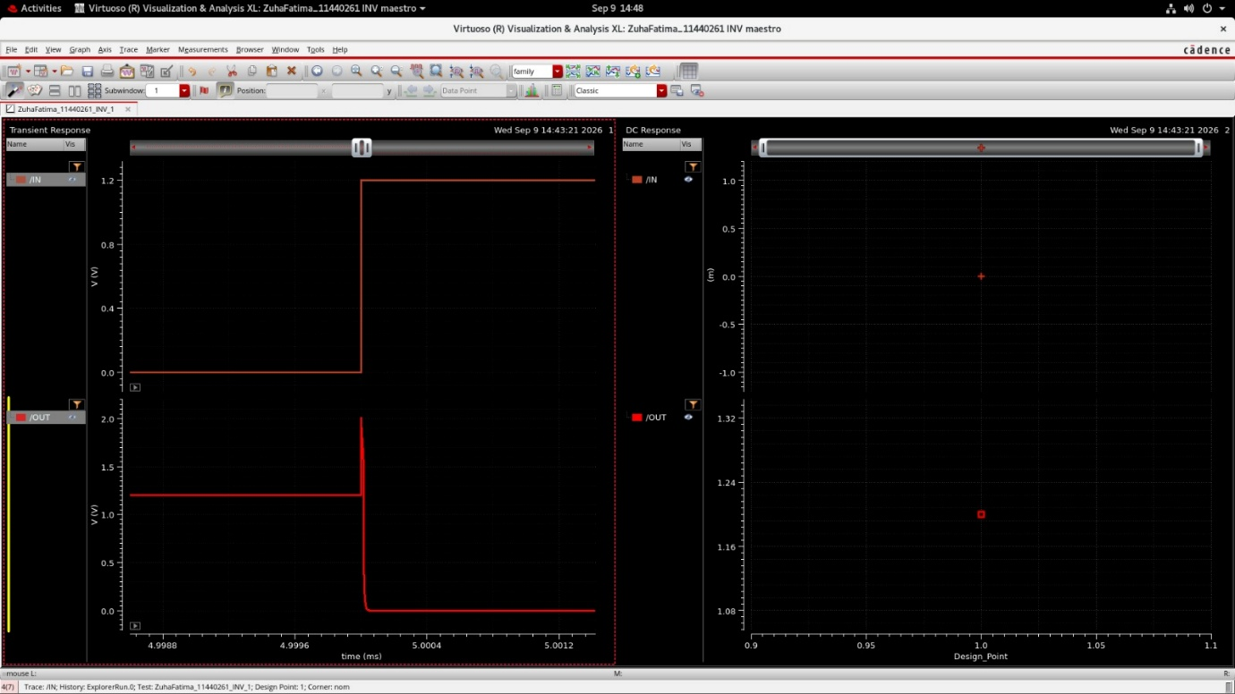
Figure 4 Transient response, horizontal span about 2.4 µs

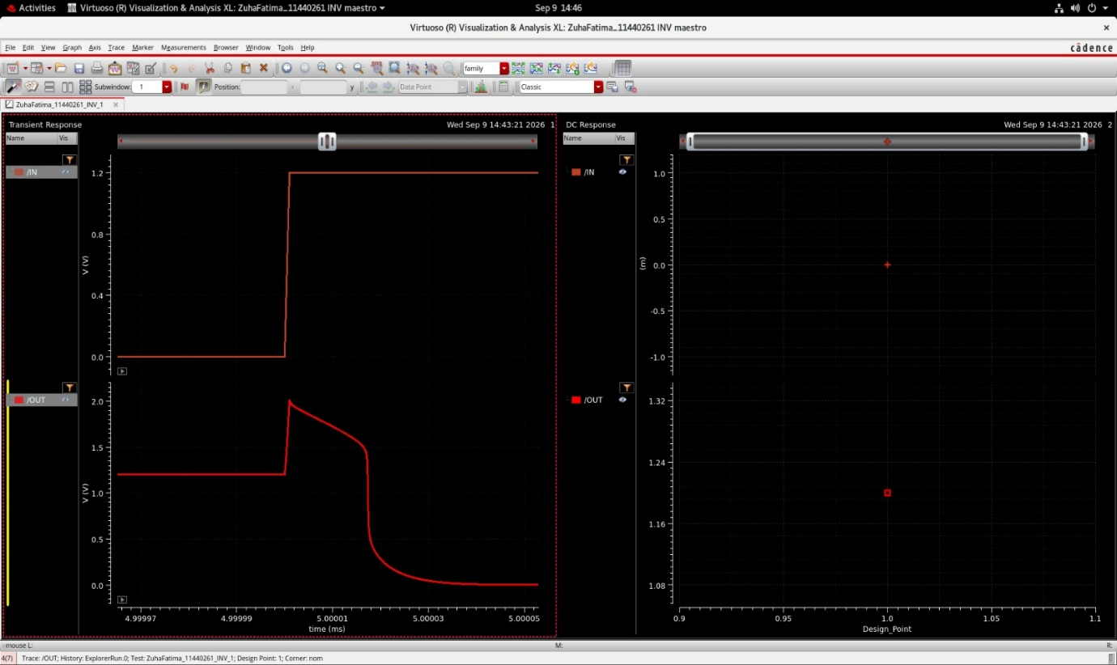
Figure 5 . Transient response, 80 ns span. The overshoot, the decay through a plateau near 1.5 V, and the fall to 0 V

This still exhibits NOT gate behavior but there is a spike on the edge. We will see the explanation below in the comparison section.
- Comparison of Transient Responses:
The minimum W/L inverter has a clean transition: output changes from 1.2V to 0V without overshoot whereas the maximum W/L inverter shows a large transient spike at switching.
With maximum width/length, the transistors have much larger parasitic capacitances, especially gate-drain capacitance. When IN switches suddenly, this capacitance couples charge into the OUT node, causing a temporary spike.
With minimum W/L, parasitic capacitances are much smaller, so the coupling is weak and the output switches cleanly without a visible spike.
- Task 2
  - Objective
In task 2, we draw a circuit for 2 input AND gate (CMOS Logic) using tsmc65N nch_mac and pch_mac transistor and observe its output.
  - Schematic
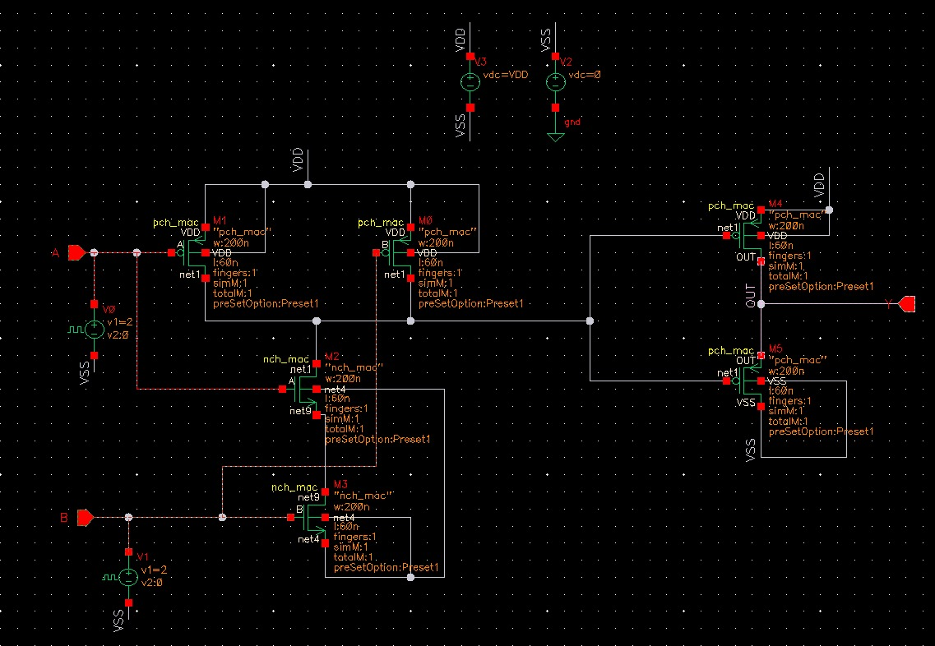
Figure 6 2 Input And gate from NAND connected to Inverter
This circuit uses a NAND network followed by an inverter. The PMOS transistors are in parallel and the NMOS transistors are in series, so the internal NAND output goes low only when both A and B are high. The final inverter reverses this, giving OUT = A · B; the output is high only for A = 1 and B = 1.
  - Simulation Graph
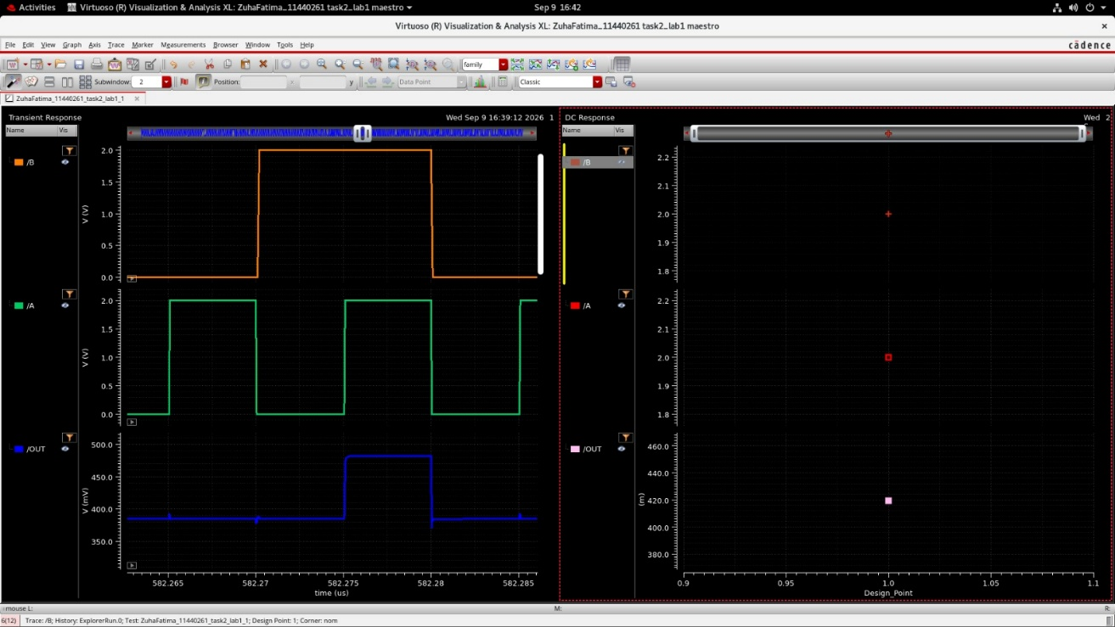
Figure 7 Simulation results for 2 input AND gate
The output shows classic AND gate behavior. The output is only high when both inputs A and B are high.
- Task 3
In task 3, we draw a circuit for 2 input OR gate (CMOS Logic) using tsmc65N nch_mac and pch_mac transistor and observe its output.
  - Schematic
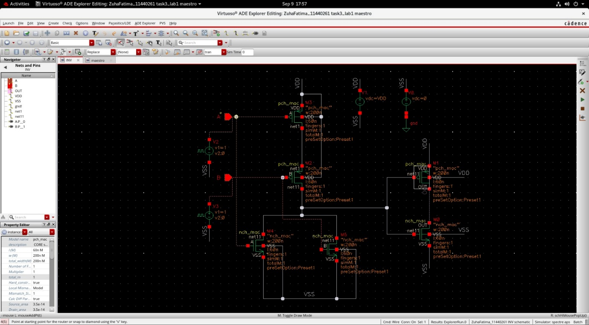
Figure 8 . AND gate as NAND followed by an inverter.
This circuit uses a NOR network followed by an inverter. Its PMOS transistors are in series and NMOS transistors are in parallel, so the internal NOR output is high only when both inputs are low. The inverter reverses it, giving OUT = A + B; the output is high whenever either input, or both, is high.
  - Simulation Graph
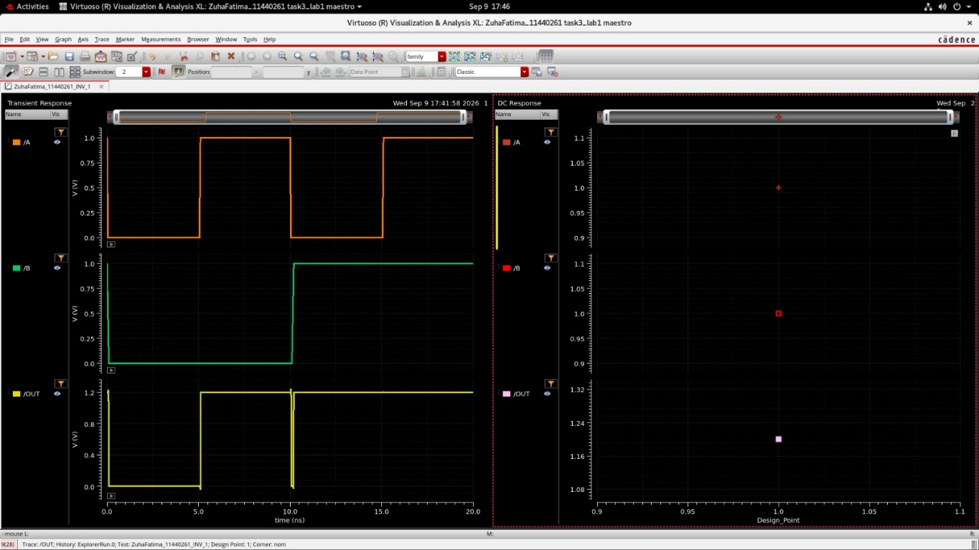
Figure 9 OR gate output
This graph verifies the 2-input OR gate. OUT is low only when both A and B are low (0–5 ns); it becomes high when A goes high at 5 ns and stays high once B becomes high at 10 ns.The small dip at 10 ns occurs because A falls while B rises at the same instant.
- Conclusion
We successfully implemented and simulated CMOS inverter, 2-input AND, and 2-input OR gates using nch_mac and pch_mac transistors in Cadence. The simulations verified the expected logic behavior of all circuits. Comparing the inverters showed that increasing transistor dimensions increases parasitic capacitances, which caused a transient output spike during switching, while the minimum-size inverter produced a cleaner transition.

