Traffic Sign Recognition System

AI Domain:
Computer Vision

Dataset Overview:
The dataset contains self-collected images of traffic signs captured from real roads. All images are annotated with bounding boxes and labels in YOLO format, covering only the traffic sign classes relevant to the project.

This dataset is suitable because it includes real-world traffic sign images captured under different lighting conditions, angles, and backgrounds. The YOLO-formatted annotations make it directly usable for traffic sign detection models, and the use of relevant sign classes improves accuracy and efficiency.

Problem Statement:
As road traffic continues to increase globally, ensuring road safety becomes critical. Traffic signs are vital in guiding and controlling the flow of traffic, but drivers and autonomous vehicles need to constantly interpret and respond to these signs. Manual driving can sometimes miss or misinterpret these signs, leading to accidents, especially in high-traffic or low-visibility areas. This system aims to detect and recognize different types of traffic signs such as stop signs, speed limits, yield signs.

Datasets Used:

Publicly Available:

- GTRSB (German Traffic Sign Detection Dataset):
German Traffic Sign Detection (GTSDB )Dataset (kaggle.com)
  - It contains images of German road signs taken from real-world environments with varying conditions (e.g., weather, lighting).
  - The dataset includes a variety of traffic signs categorized into different classes. It typically has around 43 classes ( Speed signs, warning signs etc.).

- LISA Traffic Sign Dataset:
lisa/examples/AllImages/addedLane.pdf at main · AminJun/lisa · GitHub
  - It contains images of traffic signs captured under different conditions (weather, time of day) and from various angles.

  - The LISA dataset is collected in the United States, focusing on traffic signs that are commonly seen on American roads.
  - It also provides traffic sign images with challenges like occlusions, varying sizes, and complex backgrounds, making it more challenging for training models.

- Signs Detection for Self-Driving Cars Dataset: Traffic Signs Detection (kaggle.com)
  - The dataset contains multiple categories of traffic signs, which may overlap with those found in other datasets like GTSDB or LISA.
  - The dataset typically includes images and labels in formats that are easy to use for deep learning purposes. It’s often prepared for object detection tasks, and the images are typically annotated with bounding box coordinates around each traffic sign.
- Traffic Sign Classification Dataset:
Traffic Sign Dataset - Classification (kaggle.com)
  - The dataset includes images and labels (the class of the traffic sign for each image). The main task here is image classification, where each image of a traffic sign is labelled with its corresponding category.
  - Some images contain partially obscured signs or signs that are cluttered with other objects (e.g., trees, vehicles).

- Images for Traffic Sign Classification and Recognition: Traffic Sign Classification and Recognition (kaggle.com)
  - The dataset contains thousands of images of traffic signs from various countries and environments. These images are diverse in terms of lighting, angles, and backgrounds to simulate real-world conditions.
  - Each image is labelled with its corresponding traffic sign class. The dataset provides labels in the form of class names or class IDs for each image.
  - It has similar classes as above.
- Vietnam Road Signs Dataset (VNTS): Vietnam Traffic Signs (kaggle.com)
  - Each image is labelled with its corresponding traffic sign class. The dataset provides labels in the form of class names or class IDs for each image.
  - It has similar classes as above.

- Traffic-Signs-Dataset:
Traffic-Signs-Dataset (kaggle.com)
  - The dataset is especially relevant for training self-driving cars to recognize and respond to traffic signs on the road. It is a key component in developing safe and reliable autonomous driving systems.

- Cropped Images of Traffic Sign Dataset:
Traffic Sign Recognition Cropped Images (kaggle.com)
  - The dataset includes a set of traffic sign categories.

  - It has 20-50 classes.
  - The cropped images are usually provided in standard image formats such as JPEG or PNG, making it easy to load and pre-process the data for training.

- Traffi c-Sign Detection and Classification in the Wild: TT100K (kaggle.com)
  - TT100K contains over 100,000 images of traffic signs from real-world scenarios. The images are taken under various conditions, including different weather, lighting, and background environments, providing a realistic dataset for training models.
  - It has 100 distinct traffic sign types.

- Traffic Signs Detection Dataset: Traffic Signs Detection (kaggle.com)
  - It includes around 30-50 different types of signs.
  - The dataset features images captured in real-world conditions, with variations in lighting, angles, weather, and occlusions.
- Pakistani Traffic sign Dataset:
https://ieee-dataport.org/open-access/pakistani-traffic-sign-recognition-dataset
  - Specifically contains traffic signs in Pakistan
  - Contains 359 images which are arranged in folders with corresponding names.
- Traffic Sign Dataset
.https://www.kaggle.com/datasets/mehmetokuyar/traffic-sign-dataset
  - Traffic sign dataset divided into classes

Self-Collected Dataset:
  - For this project, a custom traffic sign dataset was self-collected by visiting real roads and capturing images of traffic signboards using a smartphone camera. Only those traffic signs that were relevant to the scope of our project were collected. To improve the robustness of the dataset, images were captured under different real-world conditions, including varying angles, distances, lighting conditions, and backgrounds.
  - After data collection, a data cleaning process was carried out. Irrelevant images, duplicate images, and low-quality images such as blurry or unclear samples were removed to ensure dataset quality. For annotation, a semi-automatic labeling strategy was adopted. The MakeSense.ai annotation tool was used to label each traffic sign image manually with bounding boxes. The annotated dataset was then exported in YOLO format, making it suitable for training object detection models.

Dataset Features:
  - Image-based data: Images of traffic signs captured using a smartphone camera.
  - Real-world conditions: Images collected from actual roads with variations in lighting (daylight, shadows), angles, distances, and backgrounds.
  - Multiple viewpoints: Traffic signs captured from different perspectives and orientations.

  - Relevant classes only: Dataset includes only traffic sign categories required for the project.
  - High-quality samples: Blurry, duplicate, and irrelevant images were removed during data cleaning.
  - Annotated data: Each image is labeled with bounding boxes and class labels.
  - YOLO format annotations: Annotations are stored in YOLO format, enabling direct use with YOLO-based object detection models.
  - Custom/local data: Self-collected dataset tailored to the local road environment, improving practical performance.

Classes:
The dataset includes multiple traffic sign classes relevant to the project. Each traffic sign type is assigned a unique label for annotation and model training. The classes used in the dataset are as follows:

  - Speed Limit 40 km/h
  - Speed Limit 60 km/h
  - Give Way Sign
  - No Parking Sign
  - Turn Left Sign
  - Turn Right Sign
  - Go Ahead (Straight) Sign
  - U-Turn Sign

Dataset Statistics:

Total Number of Samples:
The dataset contains a total of 578 annotated traffic sign images.

Number of Features:
Since this is an image-based dataset, explicit handcrafted features are not defined. The features are automatically learned by the YOLO deep learning model from the image pixels during training.

Dataset Size:
The total size of the dataset is approximately 178 KB.

Class Distribution Summary:
The dataset includes multiple traffic sign classes such as speed limit signs (40 km/h and 60 km/h), give way, no parking, directional signs (left, right, go ahead), and U-turn signs. Images were collected with the aim of maintaining a reasonable distribution across classes. (Exact per-class counts were not computed.)

Train / Validation / Test Split:
The dataset was split into training, validation, and testing sets.

Annotation / Labeling Details

Annotation Approach Used:
A manual annotation approach was used, where each image was manually reviewed and annotated to ensure accurate labeling of traffic signs.

Tools Used for Annotation:
The MakeSense.ai online annotation tool was used to draw bounding boxes and assign class labels to all traffic sign images.

Annotation Format:
All annotations were exported in YOLO format (.txt files), where each annotation contains the class ID and normalized bounding box coordinates.

Data Preparation:
    - Removed irrelevant, duplicate, and low-quality images (e.g., blurry or unclear samples).
    - Ensured the dataset contains only useful and reliable traffic sign images.
    - Image resizing handled automatically by YOLO to match required input dimensions.

Dataset Drive Links:
https://drive.google.com/drive/folders/1d7CtOJcDaSGvF8jX90IUDSB9b2q--dKV?usp=drive_link

https://drive.google.com/drive/folders/176pe7oBkGasinwx-pX_BMjMmzrZINVbw?usp=drive_link

https://drive.google.com/drive/folders/1NWe154iUDXCwYfPfP9rCl86s6nOiOS-u?usp=sharing

Model Training for Traffic Sign Recognition
This section details the training of the YOLO26n model on a custom traffic sign dataset. The model was trained to accurately detect and classify traffic signs such as Go Ahead, Turn Left, Turn Right, and Stop. During training, the network learned to predict bounding boxes, objectness scores, and class probabilities through iterative optimization. Key performance metrics, including loss, precision, and recall, were closely monitored to ensure effective learning. The model achieving the best validation performance was saved as best.pt for subsequent evaluation and deployment.
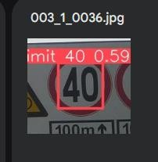
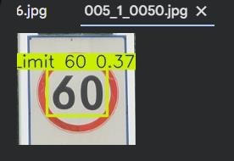
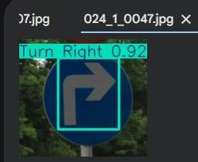

Validation and Performance Assessment
This section presents the validation results of the trained model on unseen images from the dataset. The evaluation measures the model’s performance in terms of precision, recall, and mean Average Precision (mAP) for each traffic sign class. Validation ensures that the model generalizes well to new

data and identifies areas for improvement, such as misclassifications or low-confidence predictions.
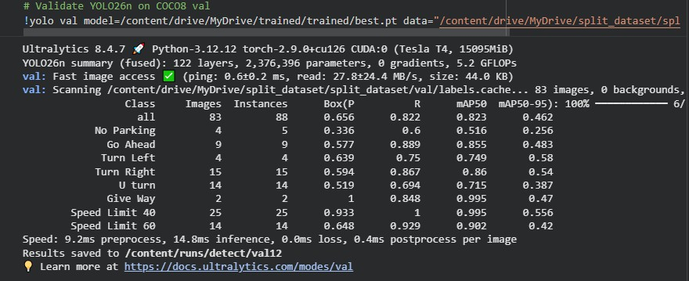

YOLO Model Code Repository
https://colab.research.google.com/drive/1FK_Dt6JlDpSA8l6hQXQBpJD5mPlMC0tA?usp=drive_link

