Dataset

[Medical Diagnosis-20F20691 - Jupyter Notebook](http://localhost:8888/notebooks/Medical%20Diagnosis-20F20691.ipynb)

[http://localhost:8888/notebooks/Medical%20Diagnosis%20with%20CNN%26%20Transfer-20F20691.ipynb#](http://localhost:8888/notebooks/Medical%20Diagnosis%20with%20CNN%26%20Transfer-20F20691.ipynb)

[Medical Diagnosis with CNN& Transfer Learning-20F20691. - Jupyter Notebook](http://localhost:8889/notebooks/Medical%20Diagnosis%20with%20CNN%26%20Transfer%20Learning-20F20691..)

<http://localhost:8889/notebooks/Medical%20Diagnosis%20with%20CNN20F20691>.

http://localhost:8889/notebooks/Medical%20Diagnosis%20with%20CNN20F20691.

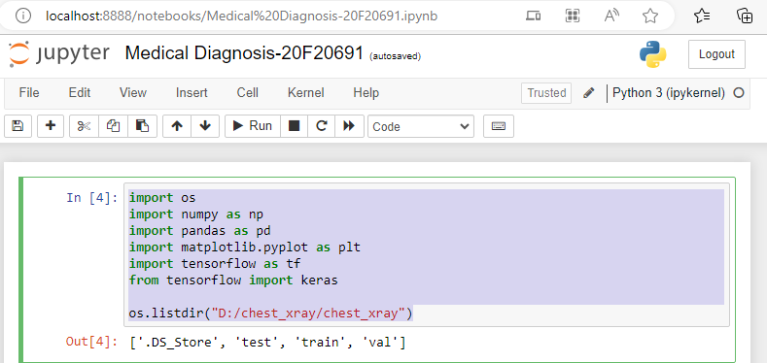

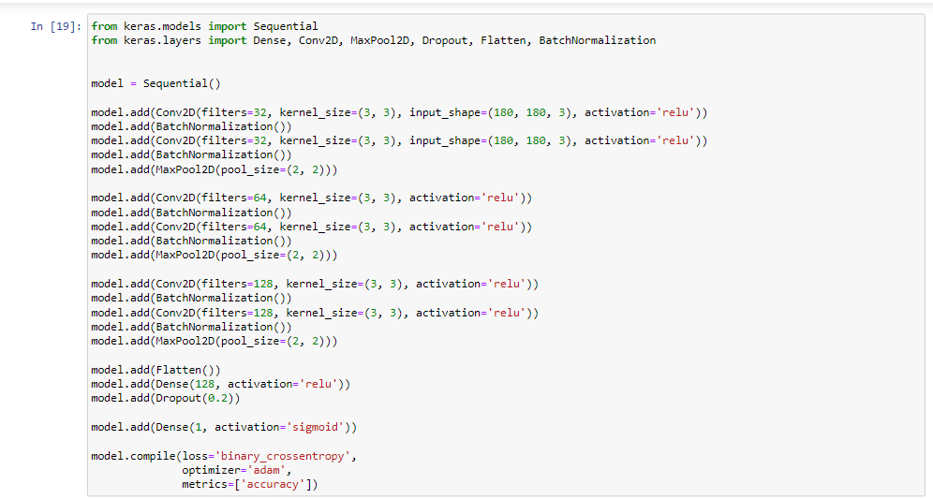



* A screenshot of a computer

  Description automatically generated with medium confidence
* A screenshot of a computer

  Description automatically generated with low confidence



