1-Apply
Create Once. Apply Everywhere.
An AI-powered personal application agent that remembers your experience, finds opportunities, prepares applications, and keeps track of everything you submit.

1. The Problem
Applying for jobs, internships, scholarships, hackathons, fellowships, grants, and other opportunities is repetitive.
A user may already have all the information required to apply:
- Personal information
- Education
- Skills
- Projects
- Work experience
- Achievements
- Certificates
- Multiple versions of their resume (Resumes tailored for different roles)
- Previous application answers
- Portfolio and GitHub links
Yet every new opportunity asks them to enter the same information again.
The user must repeatedly:
- Search for opportunities.
- Open different websites and forms.
- Find the appropriate resume.
- Upload documents.
- Rewrite questions such as "Why are you interested in this role?", “Why should you be selected?” etc.
- Search through old applications for answers.
- Track deadlines manually.
- Remember whether they already applied.
- Follow up after submitting.
The problem is not that applicants lack information.
The problem is that their information is scattered and cannot intelligently follow them from one application to another.

2. The 1-Apply Solution
1-Apply creates a persistent application memory for the user.
Instead of reconstructing themselves for every application, the user creates their profile once.
1-Apply remembers:
Who you are → What you have done → What you have achieved → What documents you have → What you previously submitted → What opportunities you are pursuing

The user can then bring any opportunity to 1-Apply through a link, browser extension, or manual entry.
The AI analyzes the opportunity, determines the user's fit, selects relevant evidence and documents, generates grounded answers, and prepares the application.
The user reviews and approves the final application.

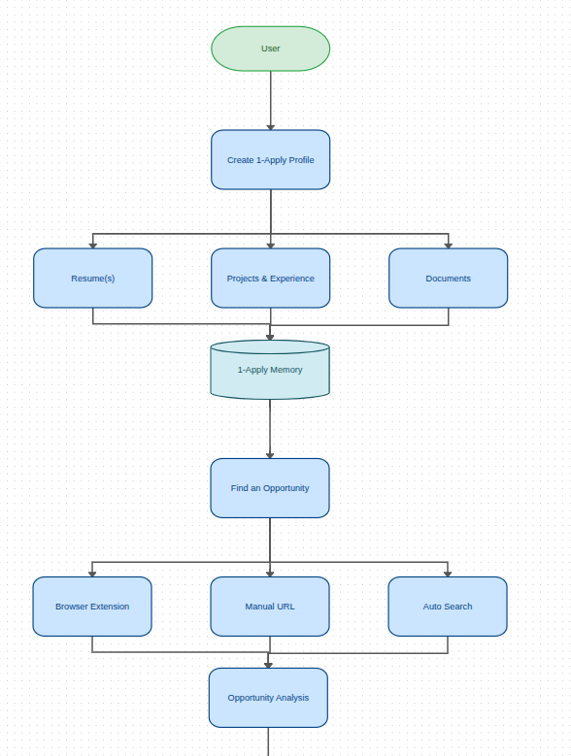
The complete experience
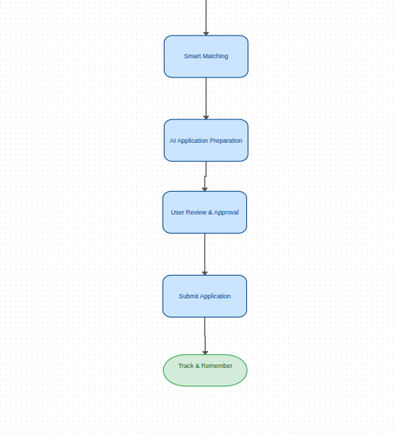

3. How 1-Apply Works

Step 1 — Create Your Application Memory
The user uploads one or more resumes and supporting documents.
1-Apply extracts and organizes:
- Personal information
- Education
- Skills
- Projects
- Experience
- Achievements
- Certifications
- Leadership
- Links
- Relevant supporting evidence
The user verifies the extracted information.
This becomes their Application Memory.
Create once. Reuse everywhere.

4. Step 2 — Bring Opportunities to 1-Apply
Users can discover opportunities in multiple ways.

A. Browser Extension
The user visits any job, internship, scholarship, hackathon, fellowship, or application page.
They click:
"Save to 1-Apply"
The extension captures the URL and sends the opportunity to their dashboard.
The extension can also provide an optional:
"Find Opportunities"
mode that helps discover relevant opportunities.

B. Paste a Link
The user simply pastes an opportunity URL into 1-Apply website.

C. Manual Entry
For opportunities such as offline forms, private portals, or Google Forms, the user can manually enter the relevant information.

D. AI Opportunity Discovery
Users can specify:
"Find AI/ML internships in Pakistan or remote opportunities for undergraduate students."
1-Apply can search for matching opportunities and bring them into the user's opportunity pipeline.

5. Step 3 — Understand the Opportunity
Once an opportunity enters 1-Apply, the AI analyzes it.
It extracts:
- Role/program name
- Organization
- Requirements
- Eligibility criteria
- Deadline
- Application questions
- Required documents
- Skills
- Experience requirements
- Location
- Important dates
The system then compares these requirements with the user's Application Memory.

Example
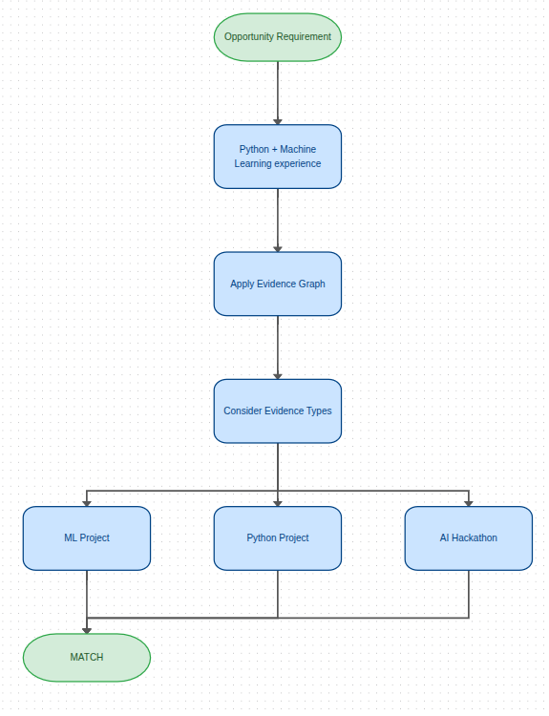

6. Step 4 — Fit Index
Instead of simply saying:
"You are a good fit."
1-Apply explains why.

Example
1-APPLY FIT INDEX
87 / 100
████████████████░░
Skills Match 92%
Experience Match 84%
Education Match 100%
Project Relevance 91%
Eligibility 100%
Missing / Unclear:
• 6-month availability not specified
• Professional ML experience preferred
The Fit Index gives the applicant an immediate understanding of:
Should I apply?
More importantly, it tells them:
What is missing?

7. Step 5 — Automatically Choose the Best Resume
Many applicants maintain multiple resumes:
- Software Engineering Resume
- AI/ML Resume
- Web Development Resume
- Research Resume
- General Resume
1-Apply compares the opportunity against the user's resumes and recommends the best version.
Opportunity
│
▼
Resume Matcher
│
┌──────────────────┐
▼ ▼ ▼
AI Web General
82% 61% 54%
│
▼
Recommended Resume
AI/ML Resume
If no existing resume is a strong match, 1-Apply can suggest:
"Your current resumes have a 64% fit. Consider creating an AI-focused version highlighting these three projects."

8. Step 6 — AI Answers From YOUR Evidence
This is one of the core differentiators of 1-Apply.
Instead of asking a generic AI:
"Write why I am interested in this internship."
1-Apply retrieves the user's relevant experiences.
For example:
Question:
Why are you interested in this AI internship?
Relevant Evidence:
✓ Machine Learning Project
✓ AI Hackathon
✓ Python experience
✓ Research project
The AI generates an answer using those approved facts.
Every generated answer can show:
"Why did I write this?"
Generated sentence
│
├── Based on: AI Project
├── Based on: Hackathon
└── Based on: Python Experience
If the system does not know something, it asks the user instead of inventing it. It will in fact, always email notify through the website and email first. Then when the application deadline is about to be reached; the AI will generate the answers (if not given by the user or generated by the user), and will automatically be submitted before the deadline.
Principle:
No evidence → No claim.
This makes 1-Apply more trustworthy than a generic AI writing assistant.

9. Step 7 — Smart Autofill
Once the user approves the answers, 1-Apply can use its browser extension to map approved information to application fields.
Application Form
│
▼
Field Detection
│
▼
1-Apply Memory
│
▼
Suggested Values
│
▼
User Preview
│
▼
Approved Autofill
The user can control exactly what information 1-Apply is allowed to fill.
Sensitive or consequential fields remain under explicit user control.
1-Apply does not bypass CAPTCHAs, signatures, attestations, payments, or other security mechanisms. Whenever there is a captcha or account creation first, the user will be notified through website and email to solve the captcha but you know what, the info will be filled automatically by the Extension and the missing info would be prompted to user to be filled or generated.

10. Step 8 — Deadline Intelligence
This is where 1-Apply becomes more than an autofill tool.
Every opportunity has a lifecycle.
Saved
↓
Analyzing
↓
Ready to Apply
↓
In Progress
↓
Review Required
↓
Submitted
↓
Under Review
↓
Interview / Next Stage
↓
Accepted / Rejected
1-Apply tracks (through reading all my emails and getting the context or the actual application portals):
- Application deadline
- Missing information
- Pending documents
- Submission status
- Interview dates
- Contacts
- Follow-ups
- Previous answers
- Submitted documents
Users receive reminders before important deadlines.
If an application is prepared but incomplete, 1-Apply can notify the user:
"Your Google internship application is 80% complete. Deadline is tomorrow at 11:59 PM. One question remains."
and if the user failed to enter, the info will be generated by ai as described above.

11. Application History
Every application becomes part of the user's long-term memory.
For each opportunity, 1-Apply stores:
Opportunity
│
├── Resume used
├── Documents used
├── Answers submitted
├── Submission date
├── Deadline
├── Status
├── Interview information
└── Follow-up history
This solves a problem most application tools ignore:
"What exactly did I submit six months ago?"

12. Document Versioning
1-Apply maintains versions of:
- Resumes
- Cover letters
- Transcripts
- Certificates
- Portfolios
- Other application documents
For every application, the system records the exact version used. And will always submit the latest version (tho there will be options of using any other version if the user wanna alter manually).

Example:
Google STEP Internship
Resume | Resume_AI_v3.pdf
Transcript | Transcript_2026.pdf
Cover Letter | CL_Google_v2.pdf
Submitted | 16 August 2026
This prevents users from accidentally submitting outdated documents.

13. Email & Calendar Integration
1-Apply can connect with the user's email and calendar to maintain the complete application lifecycle.

Email intelligence
The system can detect relevant emails such as:
- Application received
- Interview invitation
- Assessment
- Rejection
- Offer
- Follow-up request

Calendar
If an interview is detected:
Email
↓
Interview detected
↓
User confirmation
↓
Calendar event
↓
Reminder
The application is no longer forgotten after submission.

14. The Complete User Journey
┌──────────────────┐
│ CREATE PROFILE │
└────────┬─────────┘
↓
┌──────────────────┐
│ UPLOAD RESUMES & │
│ DOCUMENTS │
└────────┬─────────┘
↓
┌──────────────────┐
│ VERIFY PERSONAL │
│ EVIDENCE │
└────────┬─────────┘
↓
┌───────────────────────┐
│ FIND / SAVE │
│ OPPORTUNITY │
└───────────┬───────────┘
↓
┌───────────────────────┐
│ AI ANALYZES │
│ REQUIREMENTS │
└───────────┬───────────┘
↓
┌───────────────────────┐
│ ELIGIBILITY + │
│ FIT INDEX │
└───────────┬───────────┘
↓
┌───────────────────────┐
│ MATCH RESUME + │
│ EVIDENCE │
└───────────┬───────────┘
↓
┌───────────────────────┐
│ GENERATE GROUNDED │
│ APPLICATION ANSWERS │
└───────────┬───────────┘
↓
┌───────────────────────┐
│ USER REVIEWS & │
│ APPROVES │
└───────────┬───────────┘
↓
┌───────────────────────┐
│ SMART AUTOFILL │
└───────────┬───────────┘
↓
┌───────────────────────┐
│ SUBMIT │
└───────────┬───────────┘
↓
┌───────────────────────┐
│ TRACK + EMAIL + │
│ CALENDAR + FOLLOW-UP │
└───────────────────────┘

15. Why 1-Apply Is Different
Existing application tools focus on one step.
Job boards help users find jobs.
Resume builders help users build resumes.
AI writing tools help users write answers.
Autofill tools help users fill forms.
Spreadsheets help users track applications.
1-Apply connects all of them.
FIND
↓
ANALYZE
↓
MATCH
↓
GENERATE
↓
REVIEW
↓
AUTOFILL
↓
APPLY
↓
TRACK
↓
REMEMBER
│
└──────────→ next application
The result is not simply faster applications.
The result is an application system that gets more useful every time the user applies.

16. Responsible AI
1-Apply is designed around a simple rule:
Truth before fluency.
The AI should never make an applicant sound more qualified by inventing experience.
Therefore:
- Generated claims must come from approved evidence.
- Missing information becomes a question for the user.
- Eligibility results explain the underlying requirement.
- Users approve generated answers before submission.
- Users control which documents are used.
- External webpage instructions are treated as untrusted data.
- Sensitive actions require explicit user control.

17. Technical Architecture
┌──────────────────┐
│ Browser / User │
└────────┬─────────┘
│
┌───────▼─────────┐
│ Chrome Extension │
└────────┬─────────┘
│
▼
┌─────────────────────┐
│ 1-APPLY API │
└─────────┬───────────┘
│
┌──────────────────┼─────────────────┐
▼ ▼ ▼
┌─────────────┐ ┌─────────────┐ ┌─────────────┐
│ PostgreSQL │ │ Document │ │ AI Layer │
│ + pgvector │ │ Storage │ │ │
└─────────────┘ └─────────────┘ └──────┬──────┘
│
┌──────────▼──────────┐
│ Extraction │
│ Retrieval │
│ Matching │
│ Eligibility │
│ Generation │
└─────────────────────┘

Proposed Stack
Frontend
- Next.js
- TypeScript
Backend / Data
- Supabase
- PostgreSQL
- pgvector
- Private document storage
AI
- OpenAI structured outputs
- Retrieval-augmented generation
- Evidence-based generation
Browser Automation
- Chrome Manifest V3 Extension
Testing
- Vitest
- Playwright
- AI evaluation tests

18. MVP for the Hackathon
The hackathon prototype will focus on proving the central loop:
Create → Analyze → Match → Generate → Review → Track
The MVP will demonstrate:
- User profile creation
- Resume/document upload
- Persistent application memory
- Opportunity URL ingestion
- Opportunity requirement extraction
- Eligibility analysis
- Fit Index
- Resume matching
- Evidence-grounded answer generation
- User approval
- Controlled browser autofill
- Application tracking
- Document versioning
Advanced features such as large-scale opportunity discovery, deeper email intelligence, and calendar automation can follow after the MVP.

19. Success Metrics
The success of 1-Apply should be measurable.
Metric | MVP Goal
Profile → first application | < 5 minutes
Opportunity → analyzed workspace | < 2 minutes
Generated factual claims backed by evidence | ≥ 95%
Correct document selection | ≥ 95%
Unintended submission | 0
Cross-user data exposure | 0
Applications tracked after submission | ≥ 90%

20. Future Vision
1-Apply begins with jobs, internships, scholarships, hackathons, and fellowships.
The same application memory can eventually support:
- University applications
- Grants
- Accelerators
- Conferences
- Ambassador programs
- Research programs
- Professional certifications
- Carefully scoped visa workflows
The underlying system does not need to change.
Only the requirements, document types, and application rules change.

21. The Vision
Today, applicants have to repeatedly answer:
"Who are you?"
Tomorrow, 1-Apply should already know.
Not because the AI invented an answer.
But because the user created their trusted application memory once.
Every opportunity then becomes another context in which that memory can be used.
1-Apply
Create once. Apply everywhere.

