|  |  |  |
| --- | --- | --- |
| **Name** | **ID** | **STUDENT SIGN** |
| **Zuhair Ahmed** | **20-42115-1** | **Zuhair** |

**Class Test 04**

1. Normalize the ER Diagram given below up to 3rd Normal Form and finalize the tables that needs to be created. Then (in Oracle using SQL) write down the queries that are required to create all the tables with necessary constraints. Also insert at least 3 rows of data in each created table.

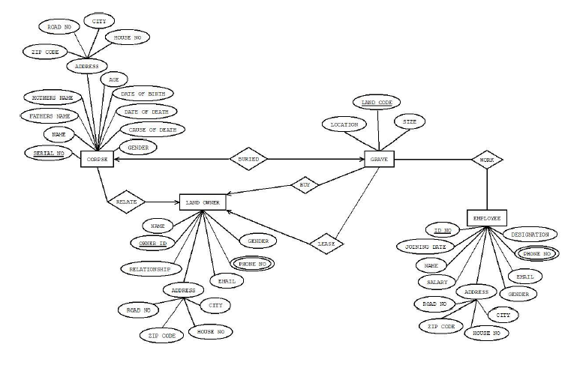

Answer Box (Normalization steps in detail as shown in Normalization Tutorial Slide + all the queries required to create the tables and insert data after Normalization):

**Buried-**(SERIAL NO, NAME, FATHER NAME, MOTHER NAME, ZIP CODE, ROAD NO, CITY, HOUSE NO, AGE, DATE OF BIRTH, date of death, cause of death,, gender, location, land code, size.)  
  
1NF: No multivalued attribute.  
(serial no, name, father name, mother name, zip code, road no, city, house no, age, date of birth, date of death, cause of death,, gender, location, land code, size.)  
  
2NF: 1..Serial no, name, father name, mother name, zip code, road no city house no, age, date of birth, date of death, cause of death, gender.  
  
2..land code, location, size.  
  
3NF: 1..Serial no, name, father name, mother name, age, date of birth, date of death, cause of death, gender.  
  
2..A-id, zip code, road no, city, house no.  
  
3..land code, location, size.

**Work:**(land code, location, size, Id no, joining date, name, salary, road no, zip code, house no, city, gender, email, phone no, designation.)  
  
1NF: Phone is multivalued attribute.   
(land code, location, size, Id no, joining date, name, salary, road no, zip code, house no, city, gender, email, phone no, designation.)

2NF:1.. Land code, location, size  
2..Id no, joining date, name, salary, road no, zip code, house no, city, gender, email, phone no, designation.   
  
3NF: 1..Land code, location, size.  
2..Id no, joining date, name, salary, gender, email, designation.   
  
3..A-id, road no, zip code, house no, city.

**Buy-**(land code, location, size, name, owner id, relationship, road no, zip code, house no, city, email, phone no, gender)  
  
1NF: phone no is multivalued attribute.   
(land code, location, size, name, owner id, relationship, road no, zip code, house no, city, email, phone no, gender)  
2NF:1..land code, location, size.  
2..owner id, name, relationship, road no, zip code, house no, city, email, phone no, gender.

3NF:1...land code, location, size.  
2..Owner id, name relationship, email, phone no, gender.  
3..A-id, road no, zip code, house no, city.

**Lease-**(land code, location, size, name, owner id, relationship, road no, zip code, house no, city, email, phone no, gender)  
  
1NF: phone no is multivalued attribute.   
(land code, location, size, name, owner id, relationship, road no, zip code, house no, city, email, phone no, gender)  
2NF:1..land code, location, size.  
2..owner id, name, relationship, road no, zip code, house no, city, email, phone no, gender.

3NF:1...land code, location, size.  
2..Owner id, name relationship, email, phone no, gender.  
3..A-id, road no, zip code, house no, city.

**Relate-**(serial no, name, father name, mother name, zip code, road no, city, house no, age, date of birth, date of death, cause of death, gender, owner id, name, relationship, road no, zip code, house no, city, email, phone no, gender)  
  
1NF: Phone no is a multivalued attribute.   
(serial no, name, father name, mother name, zip code, road no, city, house no, age, date of birth, date of death, cause of death, gender, owner id, name, relationship, road no, zip code, house no, city, email, phone no, gender)  
  
2NF: 1..serial no, name, father name, mother name, zip code, Road no, city, house no, Age, Data of birth, Date of death, Cause of death, gender.  
  
2..Owner id, Name, relationship, email, phone no, gender, Zip code, House no, city.  
  
3NF:1..serial no, name, father name, mother name, age, date of birth, date of death, cause of death, gender.  
  
2..A-id, zip code, house no, city, road.  
3..owner id, name, relationship, email, phone no, gender.

CREATE TABLE Corpse (

serial_no NUMBER PRIMARY KEY,

name VARCHAR2(100),

father_name VARCHAR2(100),

mother_name VARCHAR2(100),

gender VARCHAR2(10),

cause_of_death VARCHAR2(100),

date_of_death DATE,

date_of_birth DATE,

age NUMBER,

zip_code VARCHAR2(10),

road_no VARCHAR2(100),

city VARCHAR2(100),

house_no VARCHAR2(100)

);

INSERT INTO Corpse VALUES (1, 'John Doe', 'Michael Doe', 'Jane Doe', 'Male', 'Natural causes', TO_DATE('2023-01-10', 'YYYY-MM-DD'), TO_DATE('1978-05-15', 'YYYY-MM-DD'), 45, '12345', 'Road 1', 'City A', 'House 10');

INSERT INTO Corpse VALUES (2, 'Jane Smith', 'Robert Smith', 'Emily Smith', 'Female', 'Accident', TO_DATE('2023-05-20', 'YYYY-MM-DD'), TO_DATE('1991-09-02', 'YYYY-MM-DD'), 32, '54321', 'Road 2', 'City B', 'House 20');

INSERT INTO Corpse VALUES (3, 'David Johnson', 'Steven Johnson', 'Sarah Johnson', 'Male', 'Heart attack', TO_DATE('2023-04-05', 'YYYY-MM-DD'), TO_DATE('1965-12-08', 'YYYY-MM-DD'), 58, '67890', 'Road 3', 'City C', 'House 30');

CREATE TABLE Employee (

id_no NUMBER PRIMARY KEY,

joining_date DATE,

name VARCHAR2(100),

salary NUMBER,

gender VARCHAR2(10),

email VARCHAR2(100),

phone_no VARCHAR2(20),

designation VARCHAR2(100),

zip_code VARCHAR2(10),

road_no VARCHAR2(100),

city VARCHAR2(100),

house_no VARCHAR2(100)

);

INSERT INTO Employee VALUES (101, TO_DATE('2022-03-10', 'YYYY-MM-DD'), 'John Doe', 5000.00, 'Male', 'john.doe@example.com', '1234567890', 'Manager', '12345', 'Road 1', 'City A', 'House 10');

INSERT INTO Employee VALUES (102, TO_DATE('2022-05-20', 'YYYY-MM-DD'), 'Jane Smith', 4500.00, 'Female', 'jane.smith@example.com', '9876543210', 'Assistant', '54321', 'Road 2', 'City B', 'House 20');

INSERT INTO Employee VALUES (103, TO_DATE('2021-09-01', 'YYYY-MM-DD'), 'David Johnson', 6000.00, 'Male', 'david.johnson@example.com', '2468135790', 'Supervisor', '67890', 'Road 3', 'City C', 'House 30');

CREATE TABLE Land_Owner (

owner_id NUMBER PRIMARY KEY,

name VARCHAR2(100),

relationship VARCHAR2(100),

email VARCHAR2(100),

phone_no VARCHAR2(20),

gender VARCHAR2(10),

zip_code VARCHAR2(10),

road_no VARCHAR2(100),

city VARCHAR2(100),

house_no VARCHAR2(100)

);

INSERT INTO Land_Owner VALUES (201, 'John Doe', 'Father', 'john.doe@example.com', '1234567890', 'Male', '12345', 'Road 1', 'City A', 'House 10');

INSERT INTO Land_Owner VALUES (202, 'Jane Smith', 'Sister', 'jane.smith@example.com', '9876543210', 'Female', '54321', 'Road 2', 'City B', 'House 20');

INSERT INTO Land_Owner VALUES (203, 'David Johnson', 'Brother', 'david.johnson@example.com', '2468135790', 'Male', '67890', 'Road 3', 'City C', 'House 30');

CREATE TABLE Grave (

location VARCHAR2(100),

land_code VARCHAR2(10) PRIMARY KEY,

grave_size VARCHAR2(20)

);

INSERT INTO Grave VALUES ('Cemetery A', 'LC001', '10x10');

INSERT INTO Grave VALUES ('Cemetery B', 'LC002', '8x12');

INSERT INTO Grave VALUES ('Cemetery C', 'LC003', '12x12');