DATABASE SYSTEMS LAB
Local Tutor Matching System

Student 1 | Abdur Rahim Ajmal
Student 2 | Zuhair Nasir
Submitted To | Ali Hassan
Subject | Database Management Systems
Semester | IV Session 2024-2028
Date | April 24, 2025

Version 1.1
1. Version Control Table

Version | Milestone | Description | Status
v1.0 | Project Proposal | Problem statement, objectives, scope, and preliminary data design submitted. | Completed
v1.1 | ERD Diagram | Entity Relationship Diagram showing table relationships and cardinality. | Completed
v1.1 | Schema Update | Added Bookings table and Categories table; updated Subjects FK. | Completed

2. Entity-Relationship Diagram (ERD)
The ERD below represents all 10 tables of the Local Tutor Matching System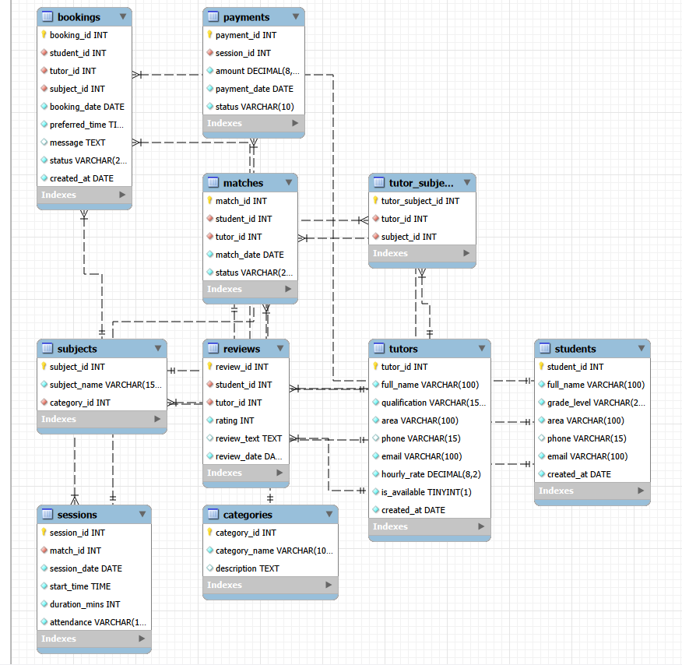

3. Relational Database Schema
The database consists of 10 normalized tables designed to 3rd Normal Form (3NF).

Table Name | Key Attributes | Primary Key | Foreign Keys
Students | student_id, full_name, grade_level, area, phone, email, created_at | student_id | --
Tutors | tutor_id, full_name, qualification, area, phone, email, hourly_rate, is_available, created_at | tutor_id | --
Subjects | subject_id, subject_name, category_id | subject_id | category_id -> Categories
Categories | category_id, category_name, description | category_id | --
Tutor_Subjects | tutor_subject_id, tutor_id, subject_id | tutor_subject_id | tutor_id -> Tutors, subject_id -> Subjects
Matches | match_id, student_id, tutor_id, match_date, status | match_id | student_id -> Students, tutor_id -> Tutors
Bookings | booking_id, student_id, tutor_id, subject_id, booking_date, preferred_time, message, status, created_at | booking_id | student_id -> Students, tutor_id -> Tutors, subject_id -> Subjects
Sessions | session_id, match_id, session_date, start_time, duration_mins, attendance | session_id | match_id -> Matches
Payments | payment_id, session_id, amount, payment_date, status | payment_id | session_id -> Sessions
Reviews | review_id, student_id, tutor_id, rating, review_text, review_date | review_id | student_id -> Students, tutor_id -> Tutors

3.1 Students
Stores every student profile. Email has a UNIQUE constraint. student_id is referenced by Matches, Bookings, and Reviews.
3.2 Tutors
Stores tutor profiles including qualifications, hourly rate, area, and availability. is_available (TINYINT) toggles between 1 (accepting) and 0 (unavailable).
3.3 Subjects
Catalogue of academic subjects. The old category VARCHAR field has been replaced by category_id (FK -> Categories) to achieve proper 3NF normalization.
3.4 Categories
Standalone lookup table for subject categories (Science, Arts, Commerce, Technology). Separating categories eliminates repeating text values across the Subjects table.
3.5 Tutor_Subjects
Junction table resolving the many-to-many relationship between Tutors and Subjects. A composite UNIQUE constraint on (tutor_id, subject_id) prevents duplicates.
3.6 Matches
Records a confirmed student-tutor pairing. Status is Active or Closed. One match generates many sessions over time.
3.7 Bookings
Captures a student booking request before a formal Match is created. Stores preferred date, time slot, and an optional message. Status: Pending / Confirmed / Cancelled.
3.8 Sessions
Each row is one tutoring session under a match. Stores date, start time, duration in minutes, and attendance (Present / Absent / Cancelled).
3.9 Payments
One payment per session (UNIQUE on session_id). Status restricted to Paid / Pending / Due.
3.10 Reviews
Students rate tutors 1-5. A composite UNIQUE on (student_id, tutor_id) limits each student to one review per tutor.

4. Key Relationships
Tutor <-> Subject (Many-to-Many)
A tutor teaches multiple subjects; a subject can be taught by multiple tutors. Resolved via Tutor_Subjects.
Subject <-> Category (Many-to-One)
Each subject belongs to exactly one category; a category contains many subjects. Linked via category_id FK.
Student <-> Tutor (Many-to-Many via Bookings)
A student can request multiple tutors; a tutor receives requests from multiple students. Each request is one Booking record.
Student <-> Tutor (Many-to-Many via Matches)
A student can be matched with multiple tutors and vice versa. Each confirmed pairing is one Match record.
Match -> Session (One-to-Many)
One match produces multiple sessions over time; each session belongs to exactly one match.
Session -> Payment (One-to-One)
Every session generates exactly one payment record.
Student/Tutor -> Review (One-to-Many)
A student writes many reviews; a tutor receives many reviews. Each review ties to one student and one tutor.

5. Data Integrity Constraints
- Primary Keys: Every table has an AUTO_INCREMENT integer primary key ensuring uniqueness.
- Foreign Keys: All inter-table references enforced with FOREIGN KEY constraints (InnoDB engine).
- NOT NULL: Core fields such as names and emails cannot be left empty.
- UNIQUE: Email fields in Students and Tutors prevent duplicate accounts. (student_id, tutor_id) in Reviews and (tutor_id, subject_id) in Tutor_Subjects prevent duplicate entries.
- CHECK Constraints: Payment status in (Paid, Pending, Due). Booking status in (Pending, Confirmed, Cancelled). Review rating between 1 and 5.
- Normalization: Schema is in 3NF. The former category VARCHAR in Subjects was moved to a separate Categories table in v1.2.

