

SUBJECT NAME: DATA SCIENCE PRACTICAL FILE
SESSION: 2025-26

SUBMITTED BY:
MOHD ZUHEIB ALAM
(UNIVERSITY ROLL NO. UU242010038 )

SUBMITTED TO:
MR.SAMARTH AMRUTE
(ASSISTANT PROFESSOR, CSE)

COURSE: BCA IBM
SEMESTER: 3RD

UNITED UNIVERSITY
RAWATPUR, PRAYAGRAJ, UTTAR PRADESH- 211012

EXPLORING THE DATASET -
##Reading the CSV file and importing libraries

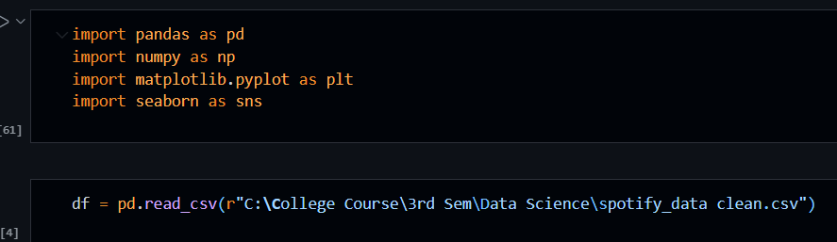

#Using Methods to get Overview of the Dataset

1. Shape – returns the dimensions of the Dataset i.e. Rows x Columns;
2. Head – displays the first five rows of the dataset;
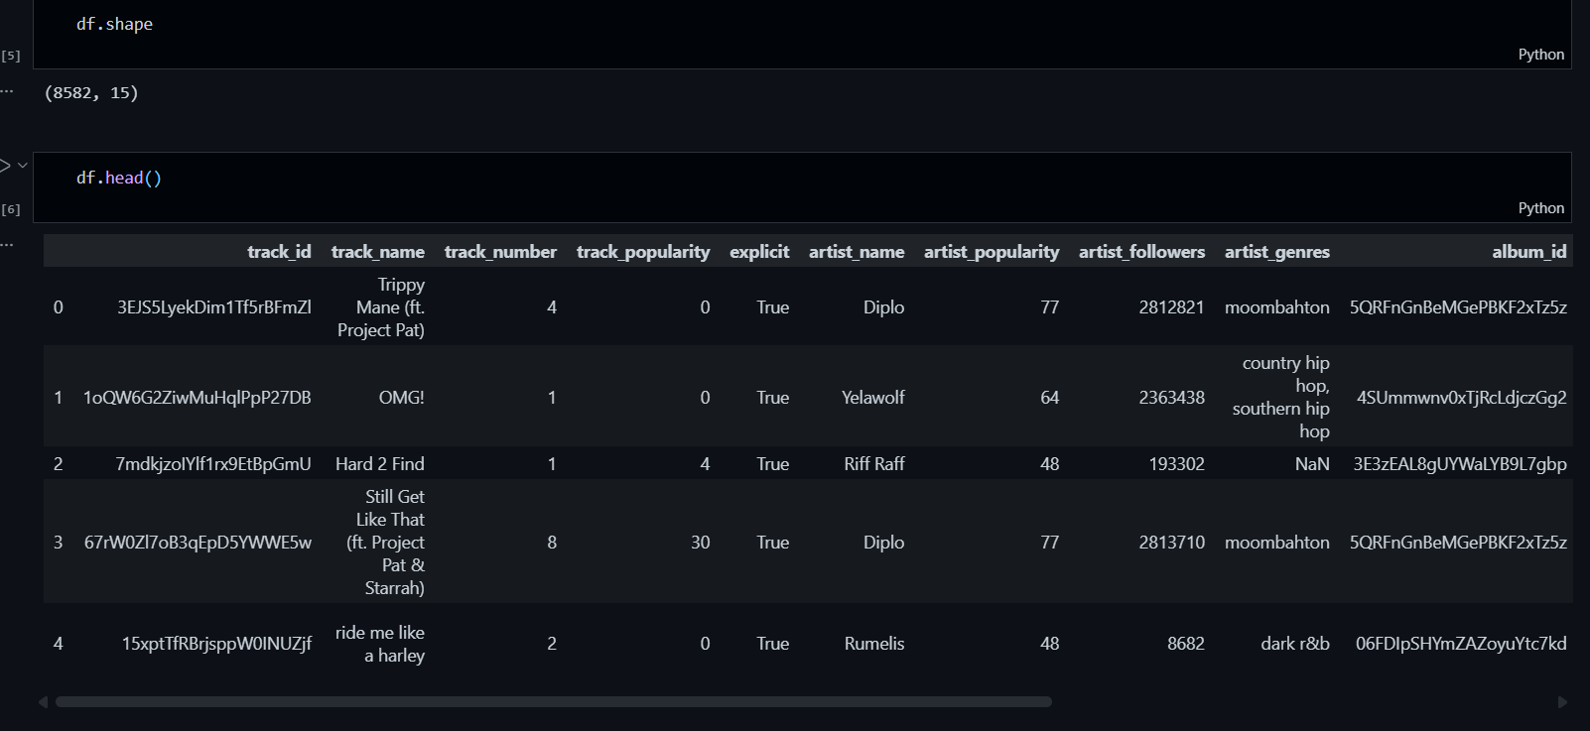

3. Tail – displays the last five rows of the dataset;
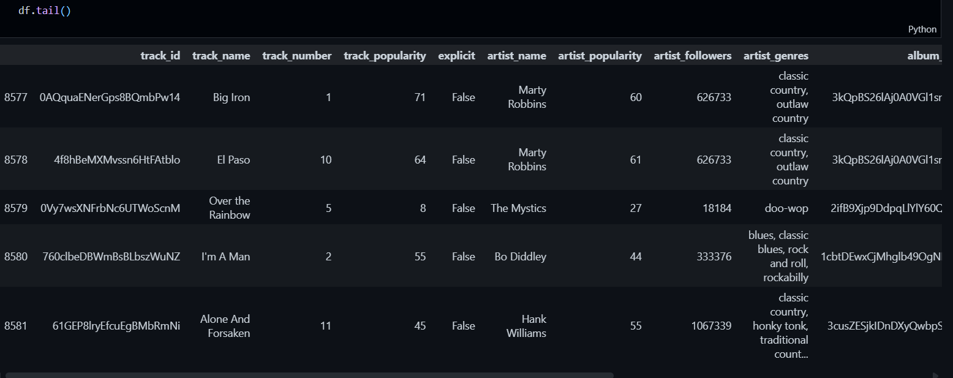

4. Columns – prints all the different columns present in a dataset;
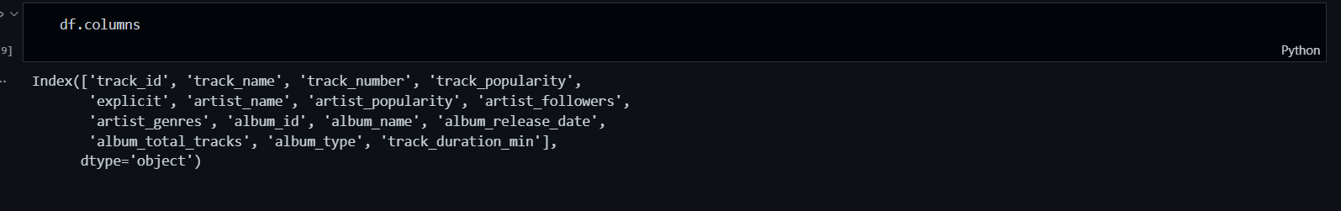

5. column_name – prints the particular column data;
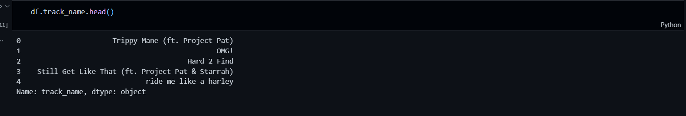

6. info() - provides the columns data types along with non-null values count.
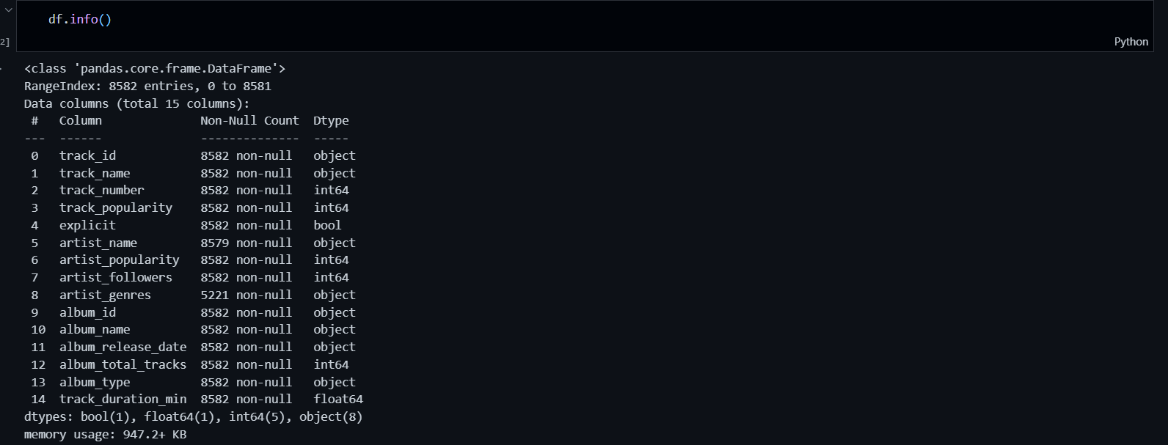

7. describe() - used to derive the statistical analysis of the dataset such as count, mean, min/max etc.
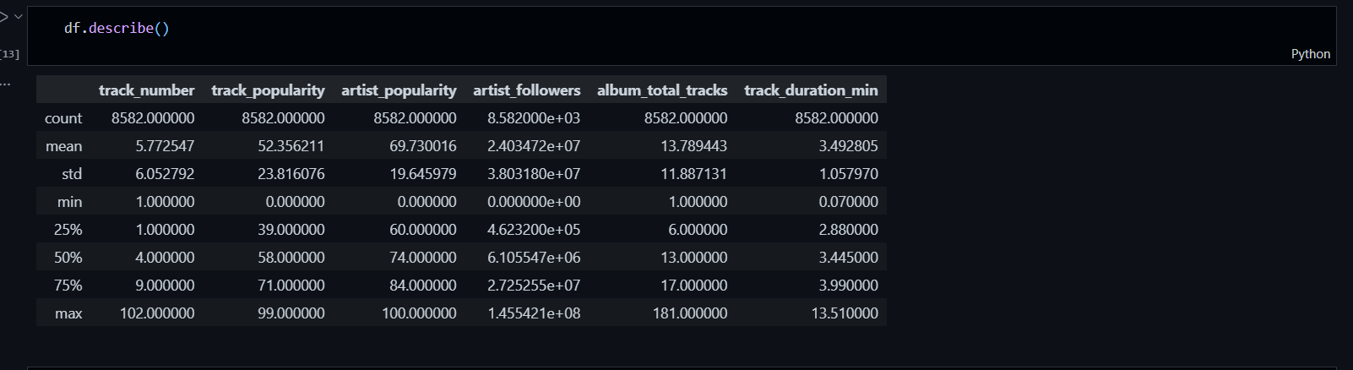

Unique - It returns all the different track names that appear in the track_name column of the DataFrame.

Meaningful insights –

counts = df['track_name'].value_counts() is used to count how many times each value appears in the track_name column.
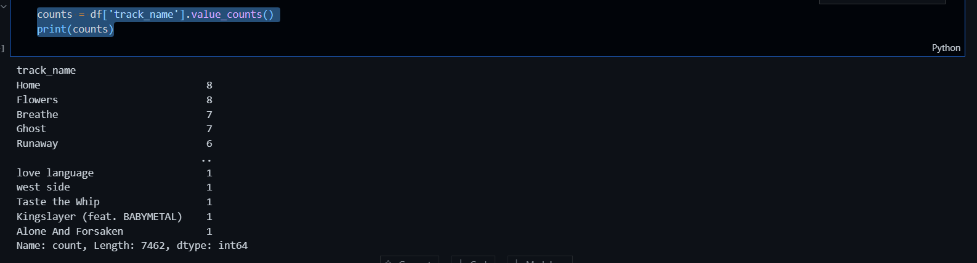

- value_counts() – counts how many times each unique value appears in a column.
- idxmax() – returns the label of the highest value in a series.
- loc[] – selects rows and columns based on labels/conditions.
- iloc[] – selects rows and columns by integer position (index number).
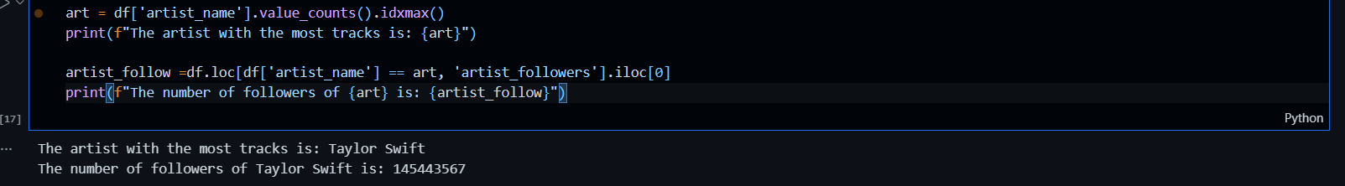

It groups songs by artist, combines their track names, and sorts artists in descending order.

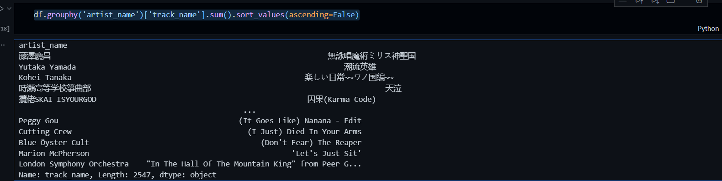
groupby('artist_name') → group data by artist
['track_name'] → select the track_name column
.sum() → join (concatenate) all track names for each artist
.sort_values(ascending=False) → sort longest concatenated result first
.head(3) → display only the top 3 artists

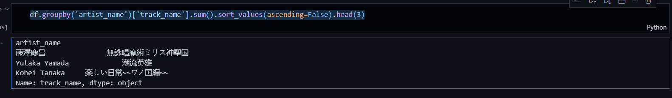

It calculates the average track popularity for every artist.
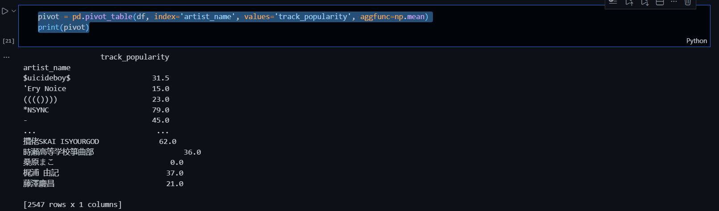

It creates a table showing each artist and their albums, with track names combined under each album, replacing empty entries with 0.

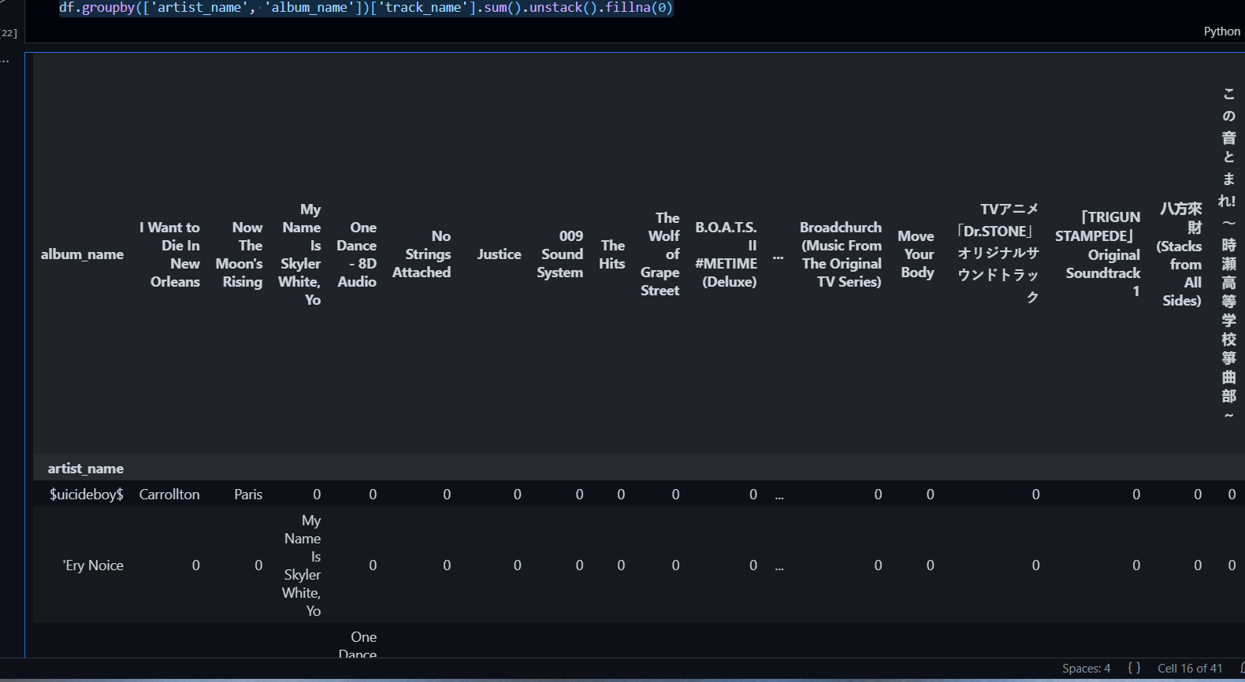

It finds the 3 popularity scores that appear most frequently in the dataset based on the count of albums
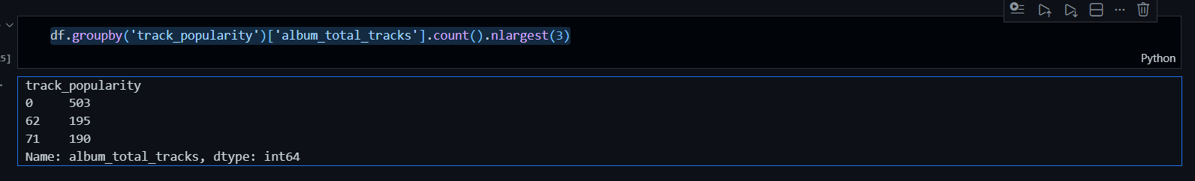

It returns the mean (average) track duration in minutes.

It gives the first stored genre for each album by grouping on album_id.
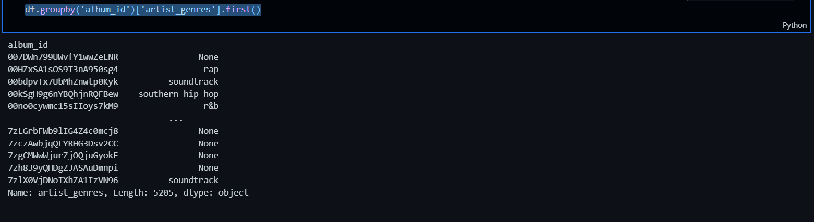

This code loads the dataset, previews it, lists the columns, displays unique genres, and counts how many unique artists are present.

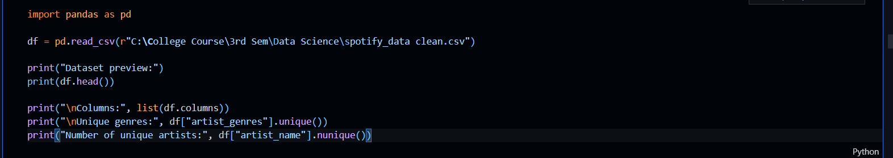

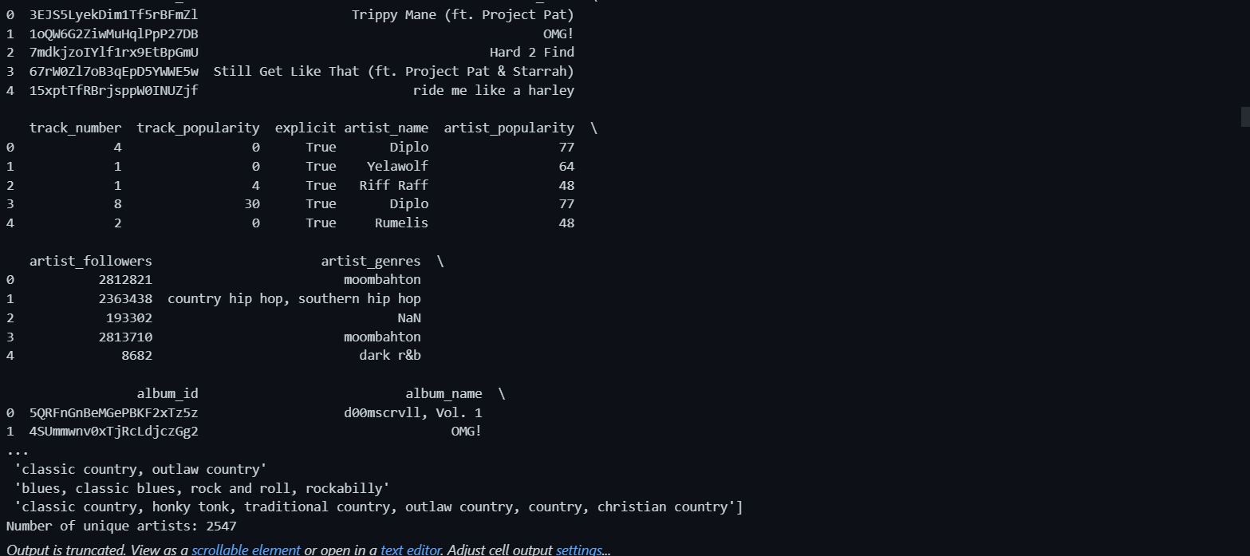

It plots a line chart to visualize how track popularity varies across the dataset samples.

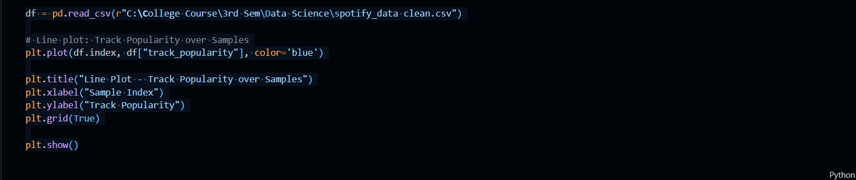

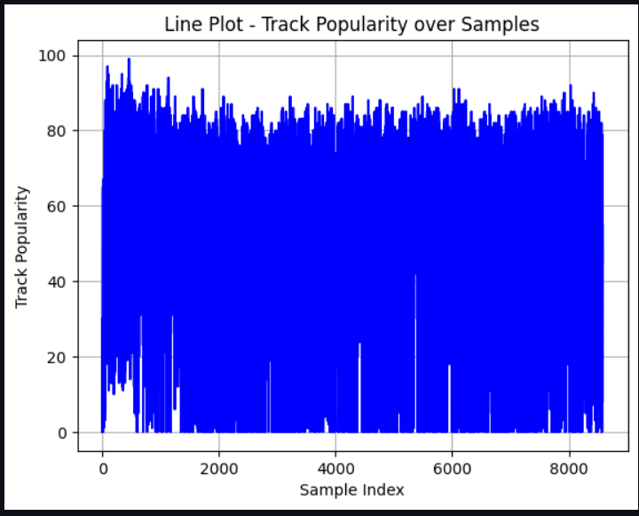

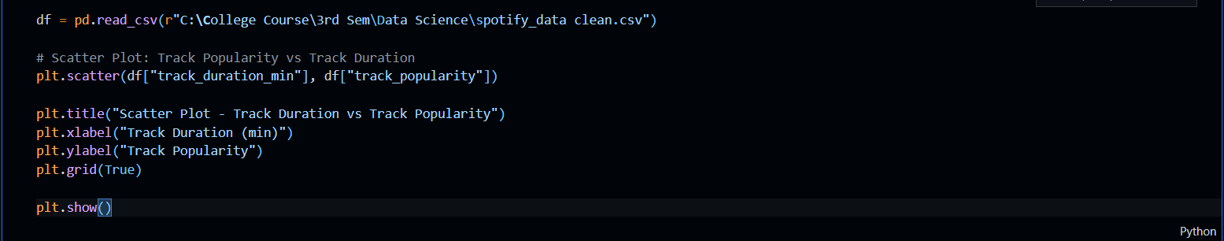

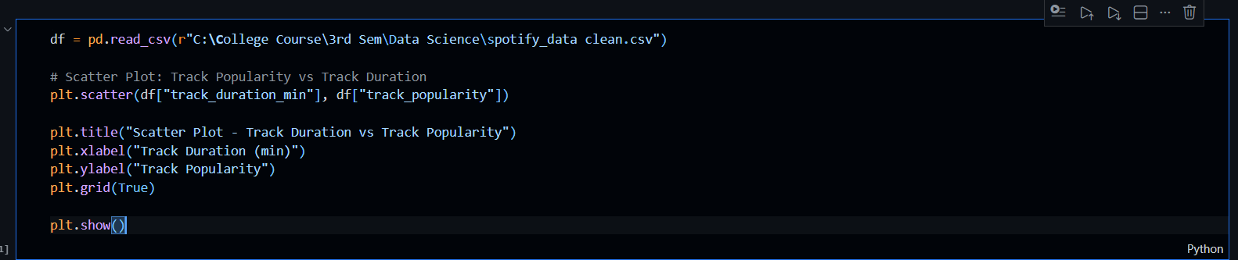

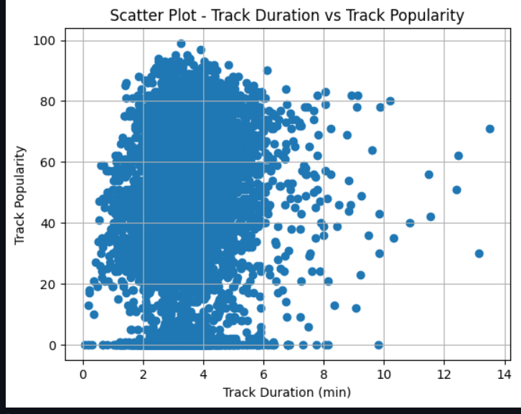

It calculates the average popularity of tracks for each album type and visualizes it using a bar chart.
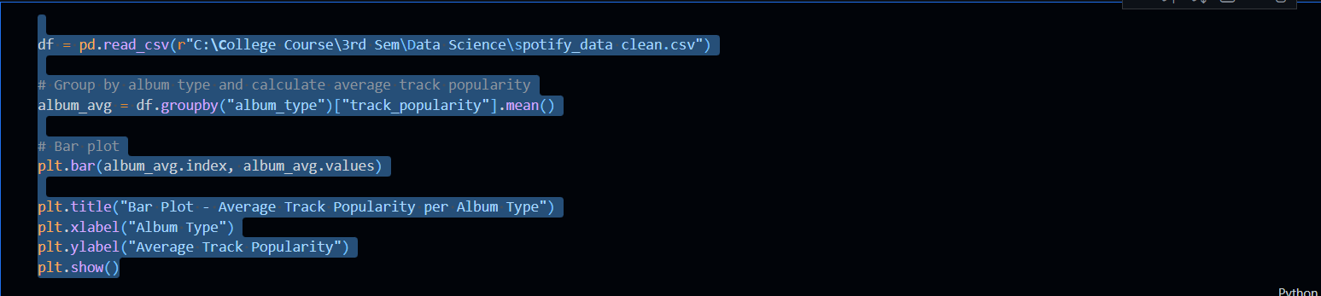
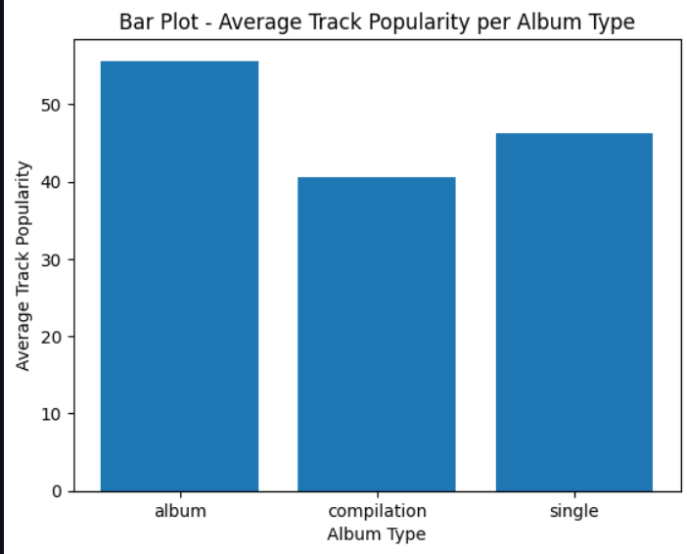

It plots a histogram to show the frequency distribution of track durations in the dataset.

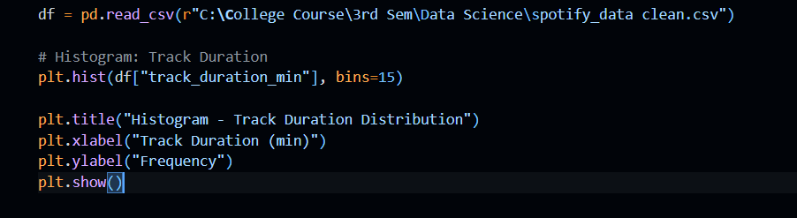

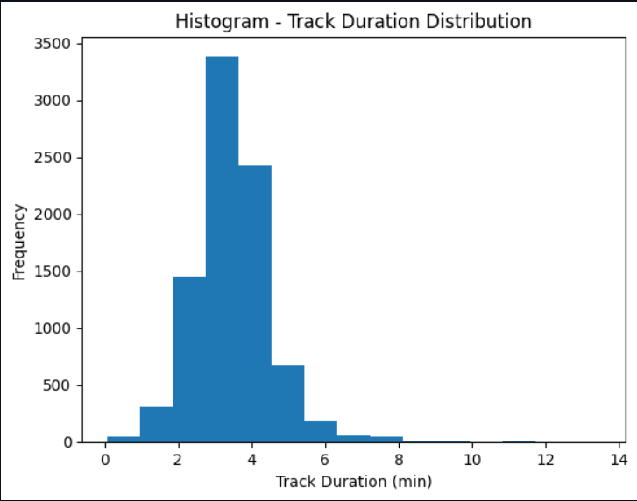

It generates a box plot to visualize the distribution and outliers of track duration in minutes.

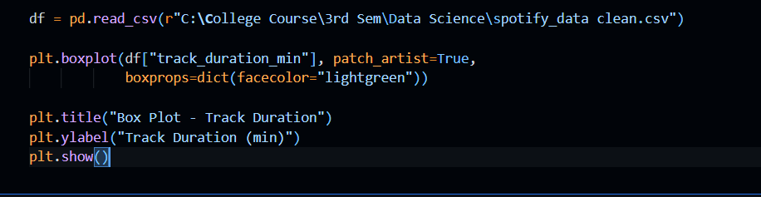

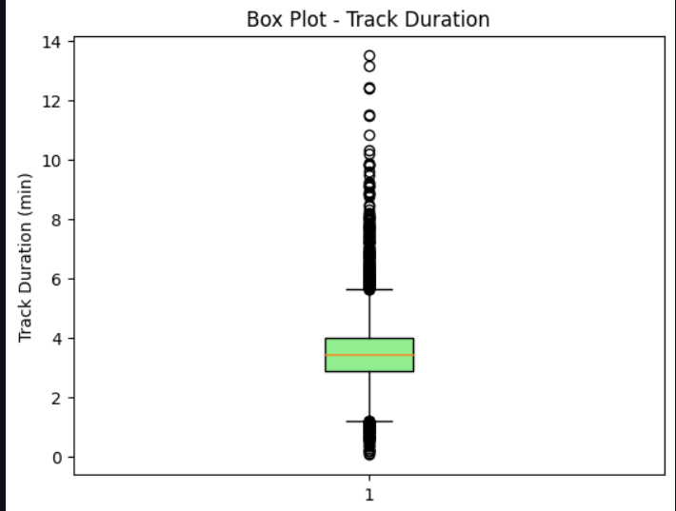

It calculates the number of albums in each album type and displays their percentage distribution using a pie chart.

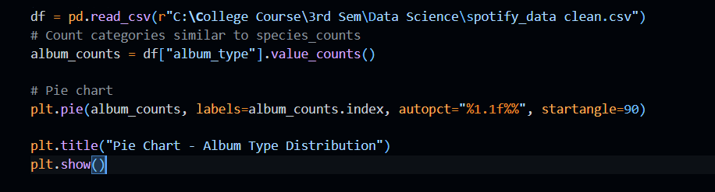

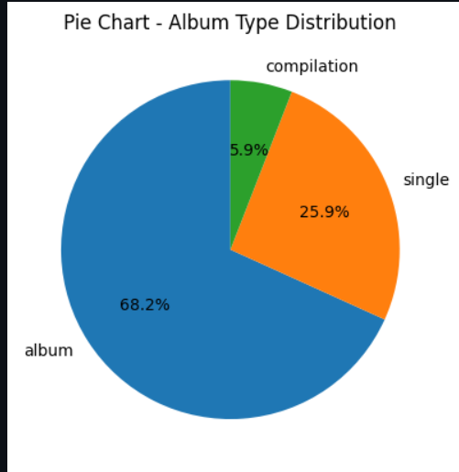

It creates two visualizations side-by-side: a histogram of track duration and a scatter plot showing the relationship between duration and popularity.

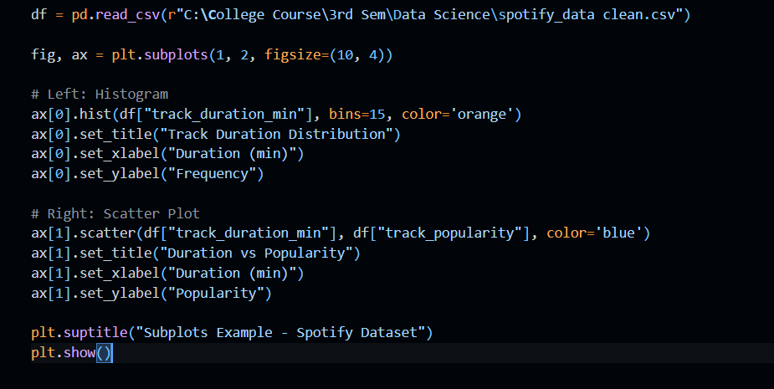

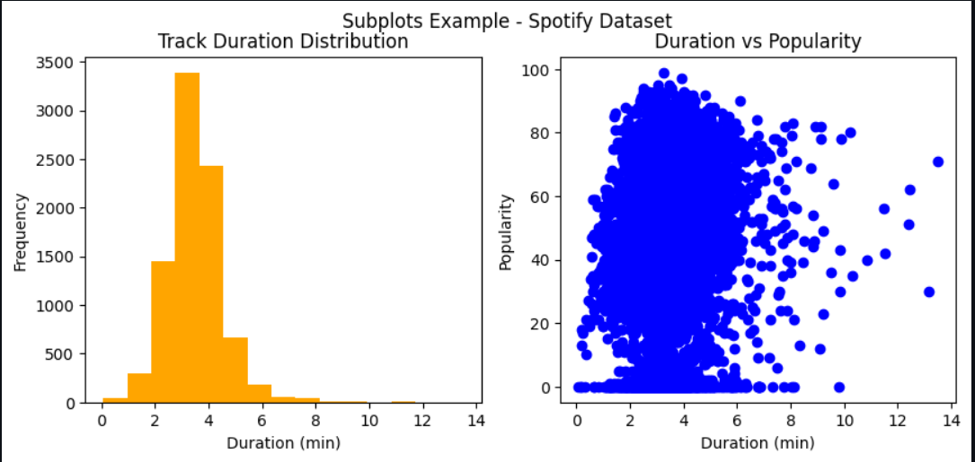

It computes the correlation between all numeric features in the dataset and displays it visually using a heatmap.
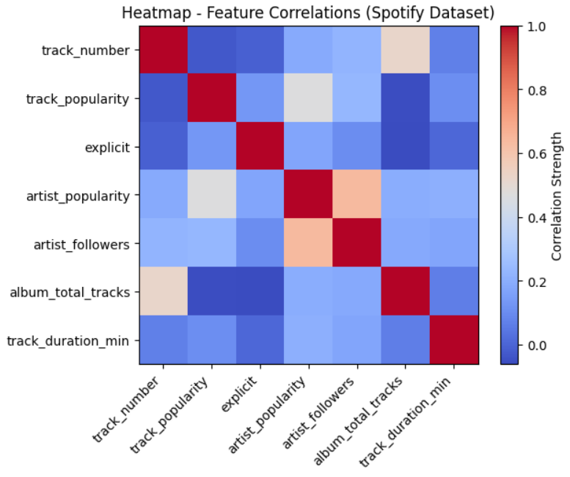

It generates a line plot showing how track popularity changes with track duration, saves the plot as an image file, and then displays it.

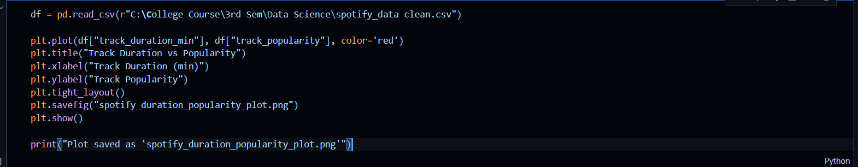
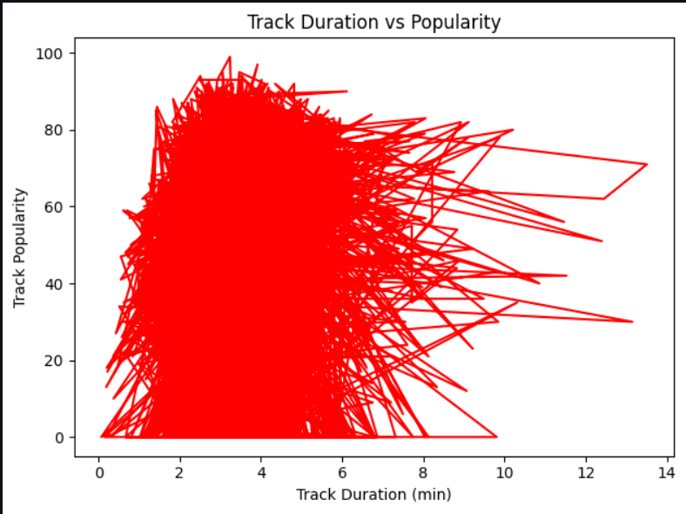

It uses a scatter plot to visually show the relationship between track duration (in minutes) and track popularity.

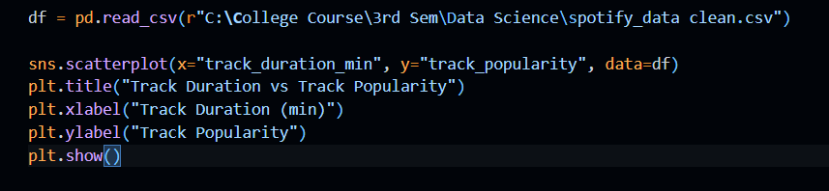

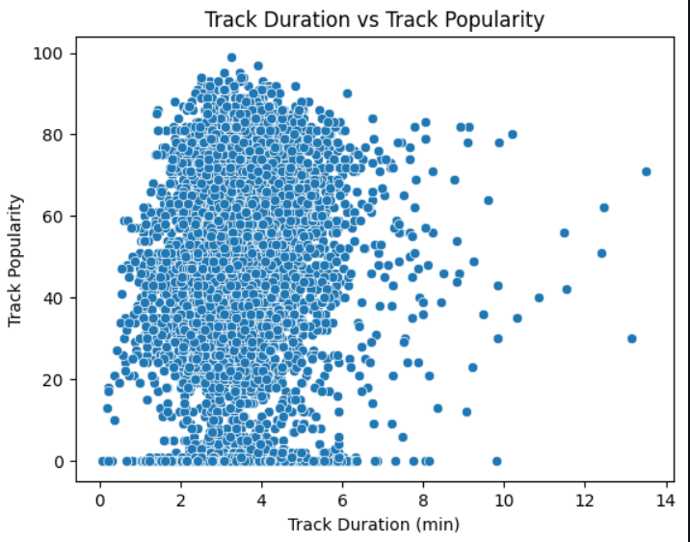

It generates a pairplot to visualize pairwise relationships between multiple numeric variables, grouped by album type.

