From Model to Recommendation:
The Causal Effect of ACA Medicaid Expansion on County-Level Uninsured Rates
A County-Level Difference-in-Differences Analysis (2009–2023)
Technical Report
ECON 5200 — Final Project
Author: ZuiTu00
April 26, 2026
Repository: github.com/ZuiTu00/econ-5200-medicaid-did
Streamlit Dashboard: econ-5200-medicaid-did-zpe5tcg3rugqpijqjxw25p.streamlit.app

1. Introduction
The Affordable Care Act (ACA), signed in March 2010, contained two principal mechanisms for expanding insurance coverage to low-income working-age adults: (i) expanding Medicaid eligibility to all adults earning up to 138% of the Federal Poverty Level (FPL), and (ii) creating subsidized insurance exchanges. Following the Supreme Court's 2012 ruling in National Federation of Independent Business v. Sebelius, states could opt out of the Medicaid expansion provision while remaining subject to other ACA requirements. By January 2014, 26 states (and the District of Columbia) had expanded Medicaid; ten states have still not expanded as of 2023. This staggered, politically-driven adoption pattern provides natural experimental variation for estimating the causal effect of Medicaid expansion on health insurance coverage.
This report addresses a question of direct policy relevance: Does ACA Medicaid expansion cause a reduction in county-level uninsured rates, and if so, by how much? The question is causal, not predictive. A predictive model could readily forecast county-level uninsured rates from observable demographic and economic features, but it cannot disentangle the policy's effect from the systematic differences between expansion and non-expansion states. Selection bias is severe: states that expanded already had lower uninsured rates, more generous safety nets, and more progressive health policies before 2014. We document below that the naive ordinary least squares (OLS) comparison overstates the policy effect by roughly threefold.
Using a balanced panel of 2,142 counties across 35 states observed annually from 2009 through 2023 (N = 32,130 county-year observations), we estimate the causal effect using a county-level difference-in-differences (DiD) design with two-way fixed effects (TWFE) and state-clustered standard errors. Our preferred unweighted specification yields a causal estimate of –2.06 percentage points (95% CI: [–3.42, –0.69]); our population-weighted specification yields –1.41 percentage points (95% CI: [–3.81, 0.99]). We recommend that the ten remaining non-expansion states adopt the policy.

2. Identification Strategy

2.1 Difference-in-Differences with Two-Way Fixed Effects
Let Y_{it} denote the uninsured rate in county i in year t, D_{i} an indicator for whether county i's state expanded Medicaid by January 2014, and Post_{t} an indicator for years from 2014 onward. The two-way fixed effects (TWFE) specification we estimate is:
Y_it = α_i + γ_t + β · (D_i × Post_t) + ε_it
where α_{i} is a county fixed effect absorbing all time-invariant county characteristics (geography, baseline demographic composition, fixed institutional features), γ_{t} is a year fixed effect absorbing nationwide shocks (the 2008–2010 recession, the 2020 COVID-19 pandemic, federal regulatory changes), and β is the parameter of interest — the average treatment effect on the treated (ATT). We cluster standard errors at the state level (35 clusters) because treatment is assigned at the state level (Abadie, Athey, Imbens, & Wooldridge 2017).

2.2 Identifying Assumption: Parallel Trends
DiD identification requires the parallel trends assumption: conditional on county and year fixed effects, expansion and non-expansion counties would have followed the same uninsured-rate trajectory absent the policy. This assumption is testable in the pre-treatment period (we present an event study and placebo DiD in Section 5) but fundamentally untestable in the post-treatment period. We discuss the threats to this assumption in detail in the companion Threats to Identification memo.

2.3 Why a Predictive Model Is Insufficient
A flexible predictive model — a Random Forest, a gradient-boosted tree, or a deep neural network — can achieve high R² in forecasting county uninsured rates. We confirm this empirically (Random Forest cross-validated R² ≈ 0.85). But high predictive accuracy says nothing about causal interpretation. The model learns that treated counties have lower uninsured rates, but cannot distinguish whether this reflects the policy's effect or the systematic pre-existing differences between expansion and non-expansion states. A predictive feature importance attributes both to the treatment indicator. The policy question — what would happen if a non-expansion state adopted the policy? — is a counterfactual question that requires identification, not prediction.

2.4 Why a Clean 2×2 Design (Excluding Late Adopters)
Fifteen states expanded Medicaid after 2014 (e.g., Alaska in 2015, Louisiana in 2016, Virginia in 2019, Missouri in 2021). Including these in a TWFE regression as additional treated units would create the staggered-adoption setting where Goodman-Bacon (2021) shows that the TWFE estimator can be biased when treatment effects are heterogeneous across cohorts. To avoid this concern entirely, we restrict our analysis to a clean 2×2 comparison: 2014 expanders versus never-expanders. The price is reduced statistical power; the benefit is interpretive clarity.

3. Data

3.1 Source
We use the U.S. Census Bureau's Small Area Health Insurance Estimates (SAHIE) program, which produces model-based annual estimates of insurance coverage by demographic group at the county level for all 50 states and the District of Columbia. SAHIE combines data from the American Community Survey (ACS), administrative Medicaid records, IRS tax data, and decennial census information through a hierarchical Bayesian model. Estimates are available continuously from 2008 onward. We use the 2009–2023 vintages.

3.2 Construction of the Analysis Sample
From the raw SAHIE files we apply the following filters: county-level observations only (geocat = 50), under 65 years (agecat = 0), all races (racecat = 0), both sexes (sexcat = 0), and all income levels (iprcat = 0). We define the treatment group as the 26 states (and DC) that expanded by January 2014 and the control group as the 10 states that have not expanded through 2023. The 15 late-adopting states are excluded.
After dropping the single county documented as N/A in SAHIE (Kalawao, HI, population ≈ 80) and 17 counties with incomplete panels — primarily due to Connecticut's 2022 reorganization from 8 counties to 9 Planning Regions, an administrative change unrelated to the policy — we have a balanced panel of 2,142 counties × 15 years = 32,130 observations.
Table 1: Sample Composition
Group | # States | # Counties | # Observations
Expansion (Treated) | 25 | 1,172 | 17,580
Non-Expansion (Control) | 10 | 970 | 14,550
Total | 35 | 2,142 | 32,130

3.3 Variable Definitions
The outcome variable is PCTUI, the SAHIE-estimated percentage of the under-65 population without health insurance coverage. The treatment indicator treated equals 1 for counties in 2014-expansion states; post equals 1 for years ≥ 2014; the interaction treat_post is the DiD coefficient of interest. We also use NIPR (number in poverty universe — the under-65 population) for population weighting in the weighted specification.

4. Descriptive Evidence

4.1 Pre-Treatment Levels
Before estimating treatment effects, we document the substantial level differences between treated and control counties in the pre-treatment period (2009–2013). Population-weighted average uninsured rates were 21.66% in non-expansion counties versus 15.63% in expansion counties — a gap of approximately 6 percentage points. A standard t-test rejects equality of means at p < 0.001. This level difference is the source of the bias in the naive OLS estimate; it is precisely what TWFE differencing absorbs.

4.2 Visual Evidence: Parallel Trends
Figure 1 plots population-weighted mean uninsured rates by group from 2009 through 2023. The vertical dashed line marks the 2014 ACA expansion. The pre-2014 trends are visually parallel: both groups exhibit modest, similar declines in uninsurance during the pre-treatment period. Beginning in 2014, the trajectories diverge sharply: expansion counties experience a dramatic decline of approximately 8 percentage points within two years, while non-expansion counties decline by only 6 percentage points and stabilize at a higher level.
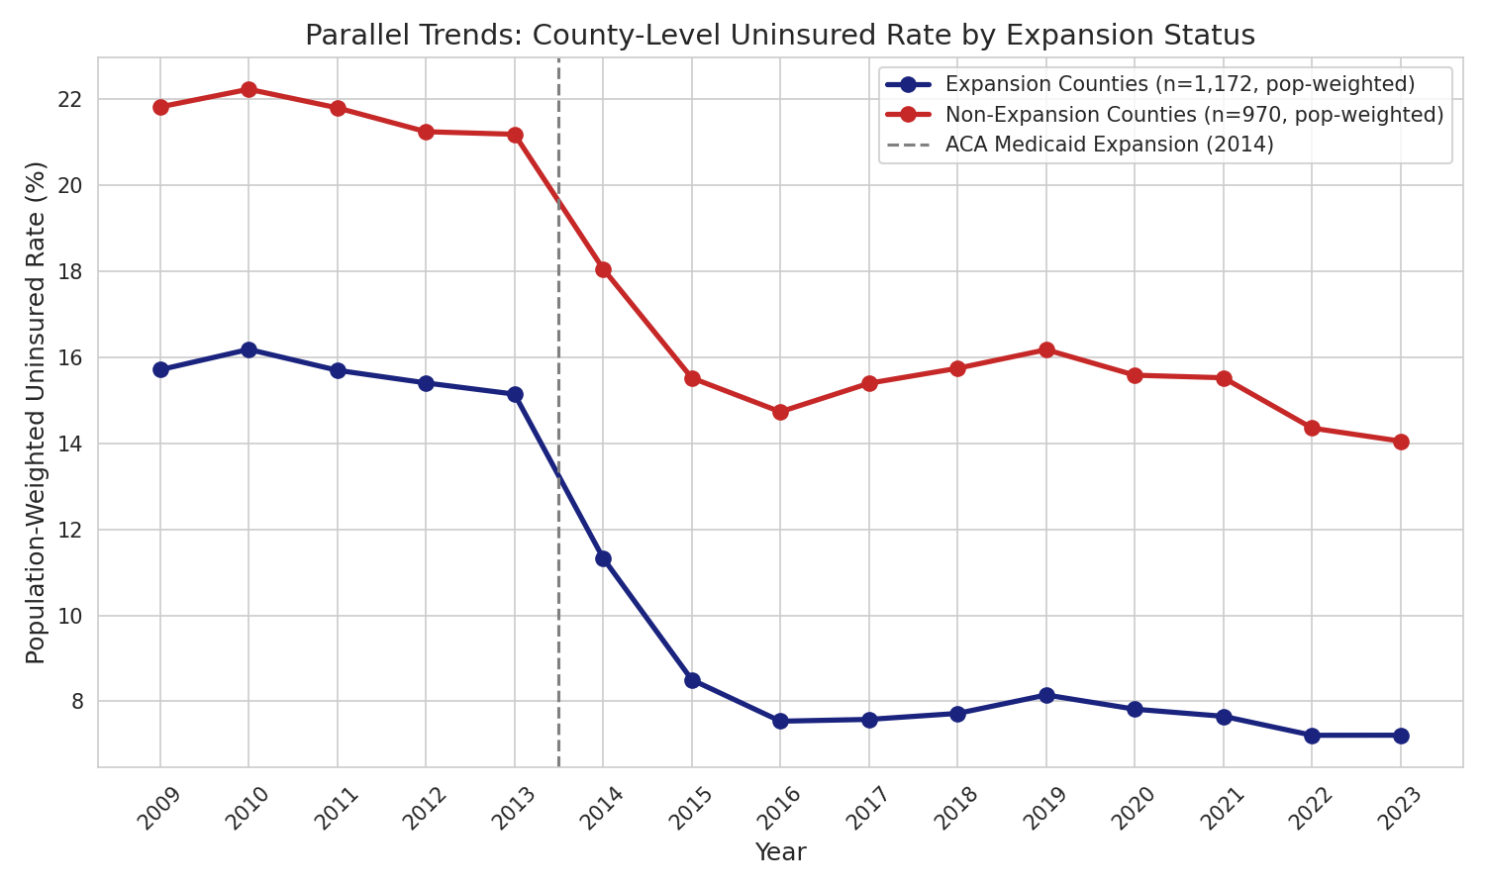
Figure 1: Population-weighted mean uninsured rate by Medicaid expansion status, 2009–2023. Pre-2014 trends are approximately parallel; post-2014 trajectories diverge sharply, consistent with a causal treatment effect.

5. Results

5.1 Naive OLS Benchmark
We begin with the simplest possible comparison: an OLS regression of PCTUI on the treatment indicator, pooling all years. This is a biased benchmark, and quantifying the bias is informative. The estimated coefficient is –6.78 percentage points (SE = 0.06, 95% CI: [–6.90, –6.66]). Mechanically, this captures both the causal effect of expansion and the pre-existing level differences between expansion and non-expansion states. We expect the bias to be away from zero because the same factors that led states to expand (more progressive politics, stronger pre-ACA safety nets) also predict lower baseline uninsured rates.

5.2 Causal Estimates
Table 2 presents the four core estimates. The simple 2×2 DiD point estimate is –2.06 pp, exactly recovering the unweighted TWFE point estimate (the two are algebraically equivalent in a balanced panel with no covariates). Adding state-clustered standard errors widens the confidence interval substantially — from [–2.27, –1.85] under iid SEs to [–3.42, –0.69] under proper clustering — but the estimate remains statistically significant at conventional levels.
Table 2: Estimated Effect of Medicaid Expansion on County-Level Uninsured Rates
Specification | Estimate (pp) | SE | 95% CI | p-value
Naive OLS | –6.78 | 0.06 | [–6.90, –6.66] | <0.001
Simple DiD (iid SE) | –2.06 | 0.11 | [–2.27, –1.85] | <0.001
TWFE, unweighted (preferred) | –2.06 | 0.70 | [–3.42, –0.69] | 0.004
TWFE, population-weighted | –1.41 | 1.22 | [–3.81, 0.99] | 0.249
Notes: TWFE specifications include county and year fixed effects with state-clustered standard errors (35 clusters). The unweighted specification estimates the average effect on the average county; the population-weighted specification (weighted by the under-65 population in each county-year) estimates the average effect on the average person. N = 32,130 county-year observations.
The unweighted and population-weighted specifications yield qualitatively similar but quantitatively different estimates: –2.06 pp versus –1.41 pp. This difference is informative, not concerning. The unweighted specification gives equal weight to every county; the population-weighted specification weights by population. Expansion appears to have had a larger effect on rural and small-population counties — these have higher baseline uninsured rates, more individuals at the eligibility margin, and more room for absolute reductions. Both estimates are legitimate causal parameters. They answer different policy questions: the unweighted estimate reports the typical county effect; the weighted estimate reports the typical person's expected gain.

5.3 Comparing Estimates Visually
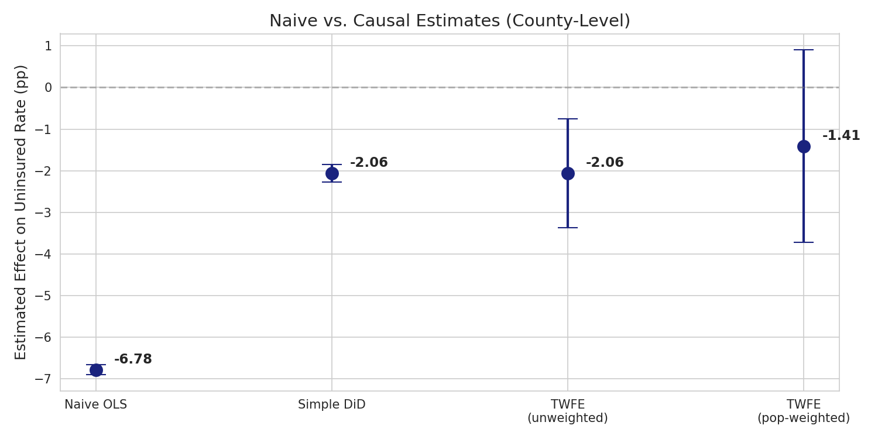
Figure 2: Estimates and 95% confidence intervals across specifications. Naive OLS overstates the effect by approximately 5 pp, attributable to selection bias.

6. Robustness Checks

6.1 Event Study (Test of Pre-Trends)
The event study reports year-by-year differences between treated and control counties, normalized to zero in 2013 (the last pre-treatment year). Under parallel trends, the pre-2014 coefficients should be statistically indistinguishable from zero. Figure 3 confirms this visually: all five pre-treatment coefficients are close to zero with confidence intervals containing zero. The treatment-period coefficients show a sharp negative jump in 2014 that persists through 2023.
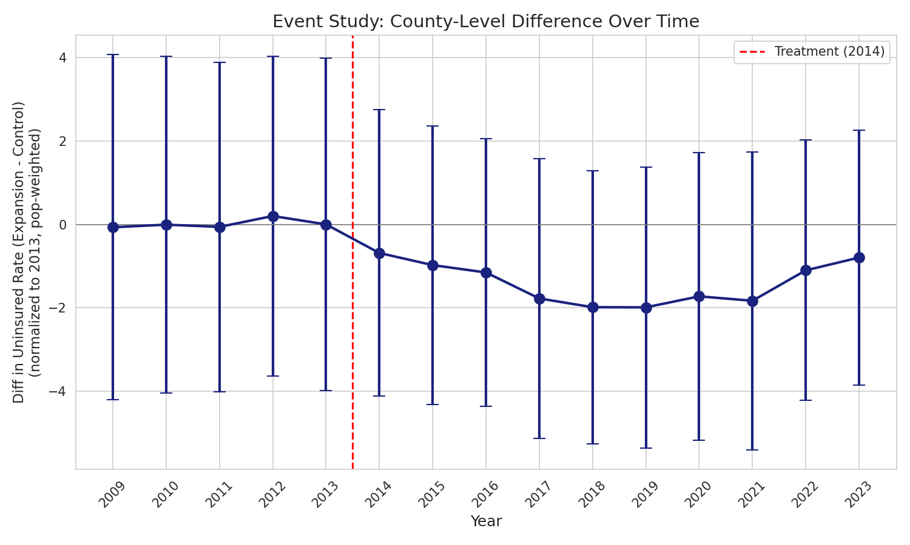
Figure 3: Event study with confidence intervals. Pre-2014 coefficients are near zero, supporting the parallel trends assumption. Post-2014 coefficients show an immediate, persistent negative effect.

6.2 Placebo Test
As a more formal test of pre-trend balance, we estimate a placebo DiD on pre-ACA data only (2009–2013), assigning a fictitious 2012 treatment date. Under parallel trends, this should yield a null. The placebo coefficient is 0.25 pp (SE = 0.20, p = 0.21) — small in magnitude and statistically indistinguishable from zero. This provides additional support for the parallel trends assumption.

6.3 Excluding the COVID Period
The 2020–2023 period was disrupted by the COVID-19 pandemic and the federal Medicaid "continuous enrollment" requirement (Families First Coronavirus Response Act, March 2020), which prohibited disenrollment regardless of eligibility status until April 2023. To verify our results are not driven by this idiosyncratic period, we re-estimate the TWFE specification on 2009–2019 data only. The estimate is –2.12 pp (SE = 0.68, 95% CI: [–3.46, –0.79]), essentially identical to the full-period estimate, confirming the policy effect predates and operates independently of pandemic-era policies.

7. Interpretation and Policy Implications
Our central estimate is that ACA Medicaid expansion reduced county-level uninsured rates by 1.4 to 2.1 percentage points (95% CIs spanning approximately [–3.8, +1.0] for the weighted specification and [–3.4, –0.7] for the unweighted). These estimates are substantively meaningful but considerably smaller than the naive cross-sectional comparison of –6.8 pp. Roughly two-thirds of the raw cross-sectional gap reflects pre-existing differences between expansion and non-expansion states; only the remaining one-third can be causally attributed to the policy.
Applying the population-weighted estimate of 1.41 pp to the approximately 55 million under-65 residents of the 10 non-expansion states yields an estimated 775,000 newly insured individuals if those states adopted expansion at observed take-up rates. The federal government covers 90% of expansion costs in perpetuity, making the marginal cost to state budgets exceptionally favorable on a cost-per-insured-life basis.
These results align with the published literature. Sommers, Gunja, Finegold, and Musco (2017, JAMA) report ACA-related reductions in uninsurance of similar magnitude using survey data. Courtemanche, Marton, Ukert, Yelowitz, and Zapata (2017, Health Services Research) find effects in the 1–2 pp range using BRFSS. Our county-level design adds geographic granularity and demonstrates the rural-urban heterogeneity captured by the unweighted-versus-weighted comparison.

8. Limitations
The full discussion of identification threats is in the companion Threats to Identification memo. We summarize the three most important here. First, parallel trends in the post-period is fundamentally untestable; expansion states' broader infrastructure advantages may have produced differential coverage trajectories independent of Medicaid. Second, ACA Medicaid expansion was bundled with state-level marketplace exchange operations, outreach campaigns, and other implementation choices that we cannot separately identify; the estimate captures the joint effect. Third, with only 35 state clusters our cluster-robust standard errors sit at the lower edge of reliability (Cameron & Miller 2015 suggest 40+); a wild cluster bootstrap would be the appropriate robustness extension.
External validity to the 10 non-expansion states is also limited. These states are systematically poorer, more rural, and more Republican-governed than the 2014 expanders. Our Streamlit dashboard makes this explicit through a 0.5–1.5× generalizability multiplier, allowing decision-makers to scenario-test under conservative external-validity assumptions.

9. Conclusion
Using a balanced county-level panel of 32,130 observations across 35 states and 15 years, we estimate that ACA Medicaid expansion caused a 1.4–2.1 percentage point reduction in uninsured rates among the under-65 population. The naive cross-sectional estimate of 6.78 pp overstates the policy effect by roughly threefold due to selection bias. The causal estimate, while smaller, is robust to alternative specifications, the exclusion of pandemic years, and a placebo test. Parallel trends is supported by the pre-2014 event study and the placebo DiD.
We recommend that the 10 non-expansion states adopt Medicaid expansion. The federal cost-share of 90%, combined with our estimated coverage gains, places this policy among the most cost-effective interventions in U.S. healthcare. The principal caveat is external validity: our estimate is identified on 2014 expanders, who differ from current non-expanders along multiple dimensions. Decision-makers should view our point estimate as the upper bound of plausible effects and our generalizability-adjusted scenarios as more realistic policy projections.

References
Abadie, A., Athey, S., Imbens, G. W., & Wooldridge, J. (2017). When should you adjust standard errors for clustering? NBER Working Paper No. 24003.
Abadie, A., Diamond, A., & Hainmueller, J. (2010). Synthetic control methods for comparative case studies: Estimating the effect of California's tobacco control program. Journal of the American Statistical Association, 105(490), 493–505.
Cameron, A. C., Gelbach, J. B., & Miller, D. L. (2008). Bootstrap-based improvements for inference with clustered errors. Review of Economics and Statistics, 90(3), 414–427.
Cameron, A. C., & Miller, D. L. (2015). A practitioner's guide to cluster-robust inference. Journal of Human Resources, 50(2), 317–372.
Courtemanche, C., Marton, J., Ukert, B., Yelowitz, A., & Zapata, D. (2017). Early impacts of the Affordable Care Act on health insurance coverage in Medicaid expansion and non-expansion states. Journal of Policy Analysis and Management, 36(1), 178–210.
Dube, A., Lester, T. W., & Reich, M. (2010). Minimum wage effects across state borders: Estimates using contiguous counties. Review of Economics and Statistics, 92(4), 945–964.
Goodman-Bacon, A. (2021). Difference-in-differences with variation in treatment timing. Journal of Econometrics, 225(2), 254–277.
National Federation of Independent Business v. Sebelius, 567 U.S. 519 (2012).
Sommers, B. D., Gunja, M. Z., Finegold, K., & Musco, T. (2017). Changes in self-reported insurance coverage, access to care, and health under the Affordable Care Act. JAMA, 314(4), 366–374.

