**Names:\_\_\_\_\_Vu Huynh\_\_\_\_\_\_\_\_\_\_\_\_\_\_\_\_\_\_ \_\_\_\_\_\_\_\_\_\_\_\_Daniel Nascimento\_\_\_\_\_\_\_\_\_\_\_\_\_\_\_\_\_\_**

**Lab 1 Entities, Instances, attributes**

**Submission requirements:**

Note:

**In-person attendance is mandatory.**

Work submitted must belong to you, if it matches with someone else, your work will be graded as 0 and will be reported to Associate Dean.

1. Use any software or hardcopy to complete this task.
2. Take screen capture or take picture of hard copy of the data model and embed it in the response to that question. **Your name must appear in the diagram(s).**
3. Complete the questions that you can in the same document.
4. Resave the document with **your name\_lab#\_db. (E.g Amrit\_lab#\_db)**
5. SUBMIT ONLY WORD DOCUMENT or PDF.
6. Submit the document in link provided in assignment section.

**Question 1**



**College Library System**

A college library allows students and faculty to borrow books.

1. Each book has a unique ISBN, title, author(s), publication year, and category (e.g., science, history, fiction).
2. The library tracks multiple copies of each book. Each copy has a unique copy number and condition status (new, good, damaged).
3. Students and faculty members are considered borrowers. The library records their ID, name, email, phone, and type (student/faculty).
4. Borrowers can borrow many books, but each loan must record the borrow date, due date, and return date.

**Rubric:**

Draw ERD Entity relationship diagram that shows the following (pts. 2):

1. **entities**
2. their **attributes**
3. and their **relationships** (optional)

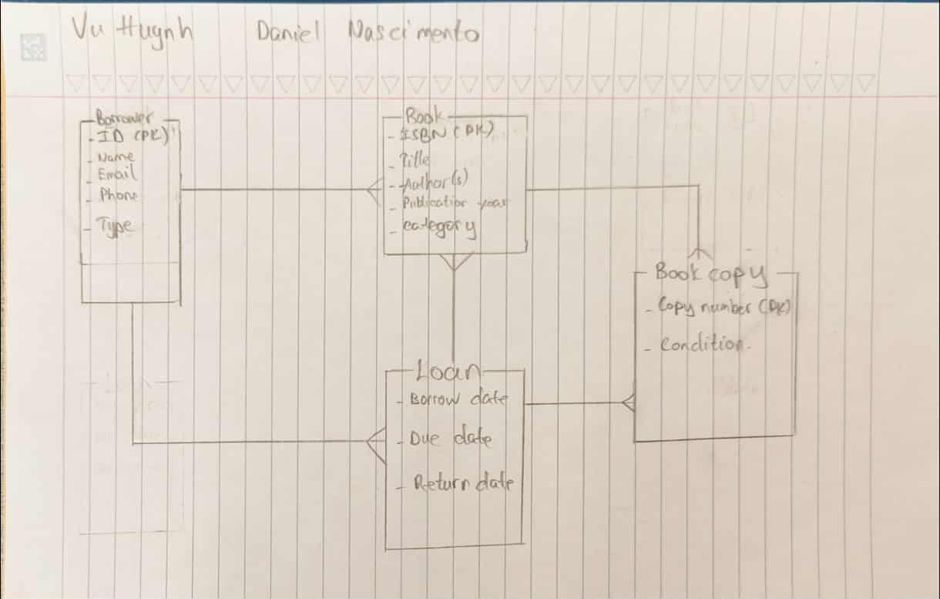

**Question 2.**

1. Choose one entity from Question 1 that has at least 5 attributes. Add 5 instances (rows of data) into that entity. (pts. 1)

|  |  |  |  |  |
| --- | --- | --- | --- | --- |
| ID # | Name | Email | Phone | Type |
| n10406420 | Daniel Nascimento | [faveyoc931@inupup.com](mailto:faveyoc931@inupup.com" \t "https://mail.google.com/mail/u/1/" \l "inbox/_blank) | +1 6044422323 | Student |
| n89381421 | Eric Huynh | [xawikoh747@inupup.com](mailto:xawikoh747@inupup.com" \t "https://mail.google.com/mail/u/1/" \l "inbox/_blank) | +1 3822278561 | Student |
| n21628704 | Auda Ulisse | [nejiyas832@knilok.com](mailto:nejiyas832@knilok.com" \t "https://mail.google.com/mail/u/1/" \l "inbox/_blank) | +1 9054482451 | Student |
| n35744065 | Virva Sofia | [tivabat974@knilok.com](mailto:tivabat974@knilok.com" \t "https://mail.google.com/mail/u/1/" \l "inbox/_blank) | +1 7428785308 | Teacher |
| n07404901 | Pelle Antonius | [giwecop864@knilok.com](mailto:giwecop864@knilok.com" \t "https://mail.google.com/mail/u/1/" \l "inbox/_blank) | +1 3438402751 | Student |