Consumer Finance in Pakistan
Product Opportunity Assessment for a Digital Retail Bank (2020–2025)
Contents
1. Executive Summary 2
2. Pakistan’s Consumer Finance Landscape 2
2.1. Key Consumer Finance Products 2
2.2. Macroeconomic Environment 3
2.3. Key Challenges in Consumer Lending 3
3. Data and Methodology 4
4. Dashboard Insights 4
4.1. How large is the consumer finance market? 4
4.2. What is the real growth after inflation? 6
4.3. Who is currently serving the market? 6
4.4. Which banks focus on consumer finance? 7
5. Product Evaluation for a Digital Retail Bank 8
5.1. Product Comparison 8
5.2. Product Fit Matrix 8
6. Recommendation 9
6.1. Recommended Product: Digital Personal Loans 9
6.2. Why Not Auto or Home Finance First 9
6.3. Implementation Roadmap 9
6.4. Additional Opportunities 10
7. Limitations 10
8. Conclusion 10

1. Executive Summary
Consumer finance in Pakistan, made up of personal loans, auto finance, home finance and credit card financing, grew from PKR 683.3 billion in 2020 to PKR 956.9 billion in 2025, a nominal CAGR of about 7.0%. However, the period was dominated by very high inflation, which peaked at 30.8% in 2023. Once prices are adjusted to 2020 levels, the consumer finance market actually shrank by about 6.9% a year in real terms.
Product performance has been uneven. Credit card financing was the fastest-growing product (25.0% nominal CAGR, 8.8% real), and home finance was the only other product with positive real growth (3.3%). Auto finance was highly volatile, falling sharply in 2022–2024 under regulatory tightening and high interest rates before recovering 35.5% in 2025. Personal loans declined in both nominal (−1.3%) and real (−14.1%) terms, falling from PKR 282.9 billion to PKR 132.2 billion in 2020 prices.
The market is concentrated among a few large banks. Across the 39 banks analysed, the top five hold 60.7% of consumer finance and the top ten hold 80.3%, with Habib Bank Limited (HBL) the largest lender at PKR 177.0 billion. Yet for most of these banks consumer lending is a small part of the balance sheet: conventional banks allocate only 4.4% of their advances to consumer finance.
The contrast with digital and microfinance models is striking. Easypaisa Bank, the only digital bank with an active loan book, allocates 68.9% of its advances to consumer finance, and microfinance banks allocate 18.9%. This shows that small-ticket, digitally delivered consumer lending can sustain a dedicated business model.
Based on a weighted product fit assessment, this report recommends that a Digital Retail Bank (DRB) launch with digital personal loans (fit score 4.35 out of 5), introduce auto finance in the second year through dealer partnerships, and add home finance from the third year once a stable deposit base is established. Credit card financing and Buy Now Pay Later (BNPL) can be offered alongside personal loans, and a Shariah-compliant personal loan offers an additional opportunity, as the two Islamic digital banks have not yet started lending.

2. Pakistan’s Consumer Finance Landscape
Consumer finance refers to loans extended to individuals for personal and household needs rather than for business purposes. In Pakistan it is a relatively small part of total bank lending, which remains dominated by corporate and government-related borrowing. As a result, a large share of salaried and self-employed individuals still has limited access to formal credit.

2.1. Key Consumer Finance Products
This report covers the four main consumer finance products offered by Pakistani banks:
- Personal loans: unsecured loans, usually for salaried individuals, used for household expenses, education, medical needs and emergencies.
- Auto finance: secured loans for purchasing cars and motorcycles, typically repaid over several years.
- Home finance: long-term loans for purchasing, building or renovating a house, with tenors that can extend to 15–20 years.
- Credit card financing: revolving credit that allows customers to make purchases and repay over time.

2.2. Macroeconomic Environment
Macro environment refers to the external forces within an economy. Macro environment factors like inflation, fiscal policy, monetary policy, consumer spending, GDP, and employment rates considerably affect business operations.
The 2020–2025 period was one of the most difficult for Pakistan’s consumers in recent decades. Average inflation rose from 9.7% in 2020 to 19.9% in 2022 and 30.8% in 2023, before easing to 12.6% in 2024 and 3.6% in 2025. Over the full period, the general price level roughly doubled.
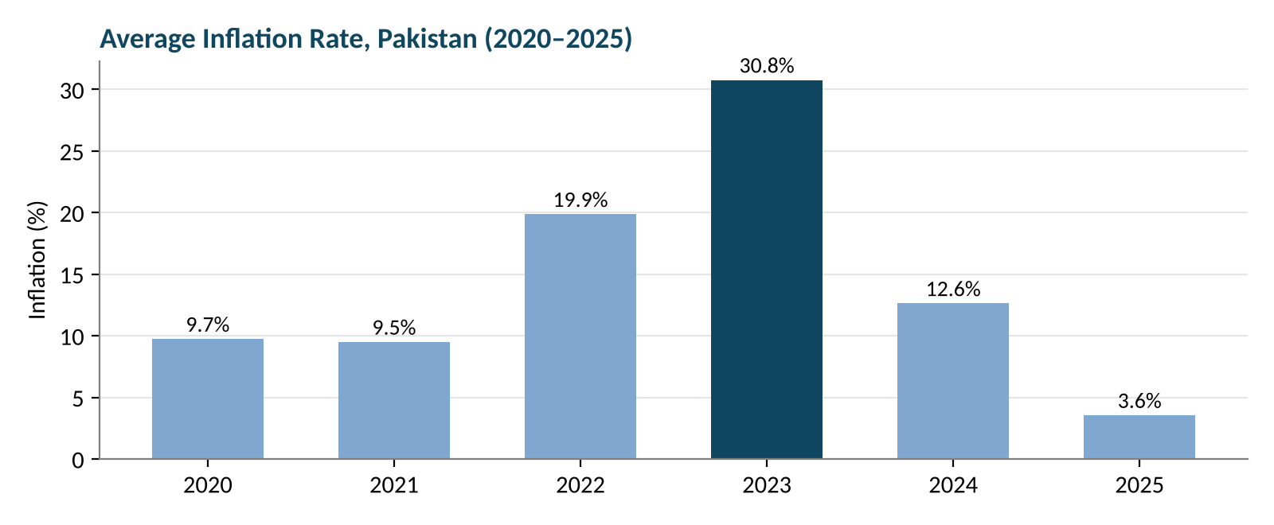
Figure 1: Average inflation rate in Pakistan, 2020–2025
To control inflation, the State Bank of Pakistan (SBP) raised the policy rate to a peak of about 22%. As inflation fell, the SBP cut rates aggressively during 2025, bringing the policy rate down toward 11%. Lower rates reduce monthly instalments for borrowers and are a key reason for the recovery in consumer lending seen in 2025.

2.3. Key Challenges in Consumer Lending
- High interest rates and inflation. Rising borrowing costs and falling real incomes reduced both the demand for loans and borrowers’ ability to repay.
- Regulatory tightening. In 2022 the SBP introduced stricter rules on consumer and auto financing, including shorter loan tenors, higher down payments and lower debt-burden limits, to reduce import demand and cool the economy.
- Limited credit histories. Many potential borrowers, particularly self-employed and informal-sector workers, have little or no formal credit record, which makes risk assessment difficult for traditional banks.
- High cost of serving small loans. Branch-based processing makes small-ticket lending expensive, so traditional banks tend to focus on larger, lower-risk corporate borrowers.
Impact: These factors explain why consumer finance has lost ground in real terms and why most commercial banks treat it as a marginal activity. At the same time, they leave a gap that a low-cost digital lender is well placed to fill.

3. Data and Methodology
The analysis uses a dataset (Personal_Loans_Estimation) covering 39 banks over six years (2020–2025), giving 234 bank-year records. The dataset has three parts:
Dataset | Content | Records
Bank data | Advances, total assets, total deposits and consumer finance (PKR Bn) for each bank, with bank type | 234
Product data | Industry-wide personal loans, home finance, auto finance and credit card financing (PKR Bn) | 6
Inflation data | Average annual inflation rate for Pakistan | 6

The data was checked for missing values, duplicates and negative values; none were found, and every bank appears once in each year. Column names were standardized before analysis. The following measures were calculated:
- Year-on-year (YoY) growth for each product and each bank.
- Compound annual growth rate (CAGR) for 2020–2025.
- Real growth, using a price index built from annual inflation (2020 = 1) to express values in 2020 prices.
- Market share and concentration (top five and top ten banks) for 2025.
- Consumer finance as a share of advances, to measure how focused each bank or bank type is on consumer lending.
- Volatility, measured as the standard deviation of annual growth rates, as an indicator of risk.
- A weighted product fit score assessing how suitable each product is for a new digital bank.

4. Dashboard Insights

4.1. How large is the consumer finance market?
As per the data collected the total consumer finance across the four products grew from PKR 683.3 billion in 2020 to PKR 956.9 billion in 2025, a nominal CAGR of 7.0%. Growth was not steady: the market rose strongly in 2021, flattened in 2022, contracted in 2023 and 2024, and recovered in 2025.
Product | 2020 | 2021 | 2022 | 2023 | 2024 | 2025 | CAGR
Personal Loans | 282.9 | 300.5 | 267.9 | 268.0 | 239.0 | 264.6 | −1.3%
Auto Finance | 256.5 | 353.6 | 333.8 | 251.3 | 235.5 | 319.0 | 4.5%
Home Finance | 93.7 | 158.0 | 211.0 | 208.0 | 204.0 | 220.3 | 18.6%
Credit Card Financing | 50.2 | 71.0 | 101.3 | 114.7 | 122.0 | 153.0 | 25.0%
Total | 683.3 | 883.2 | 914.0 | 842.0 | 800.5 | 956.9 | 7.0%
Values in PKR billion.
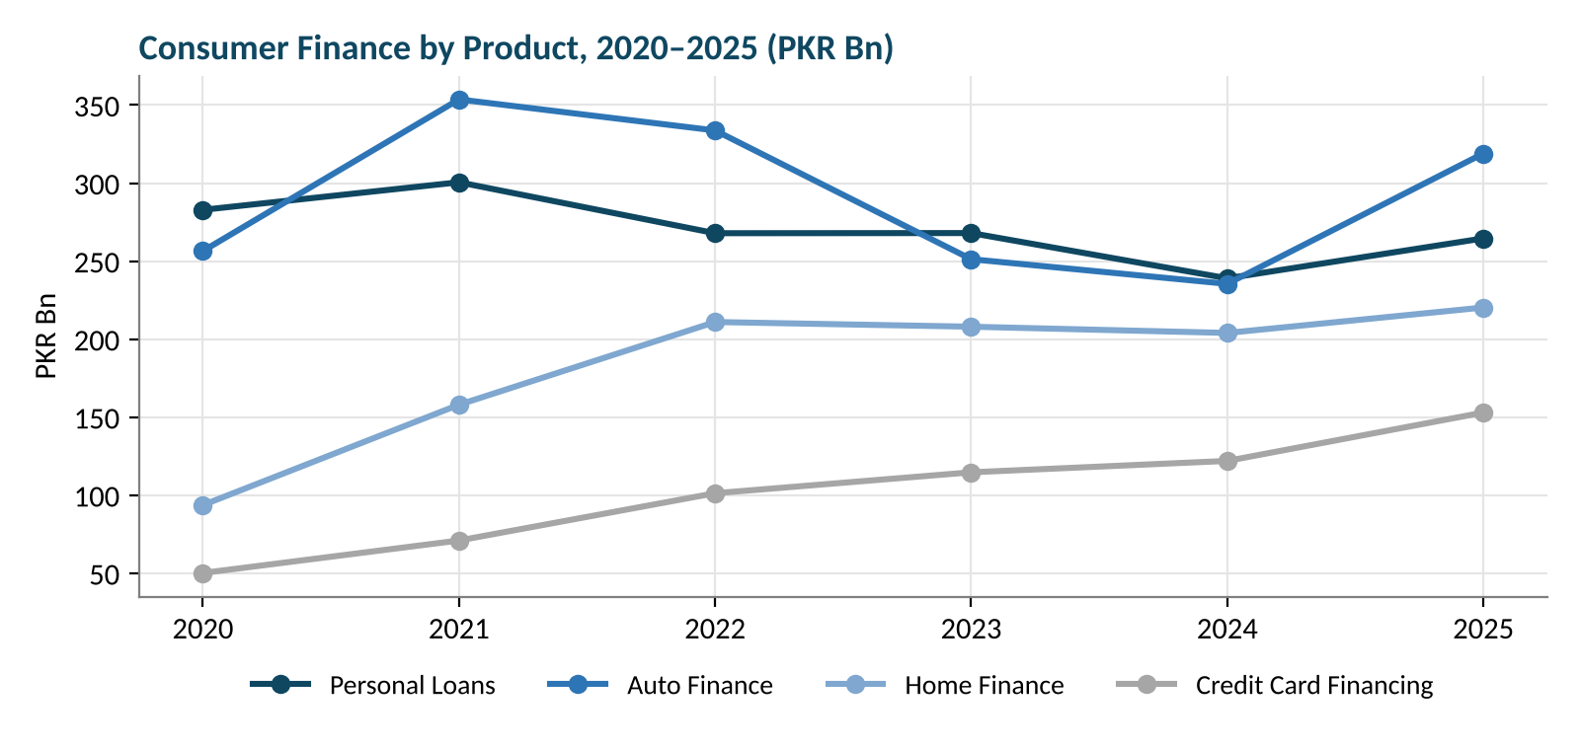
Figure 2: Consumer finance by product, 2020–2025
The product mix has shifted significantly. Personal loans fell from 41.4% of the portfolio in 2020 to 27.7% in 2025, while home finance rose from 13.7% to 23.0% and credit card financing from 7.3% to 16.0%. Auto finance is now the largest single product at 33.3%.
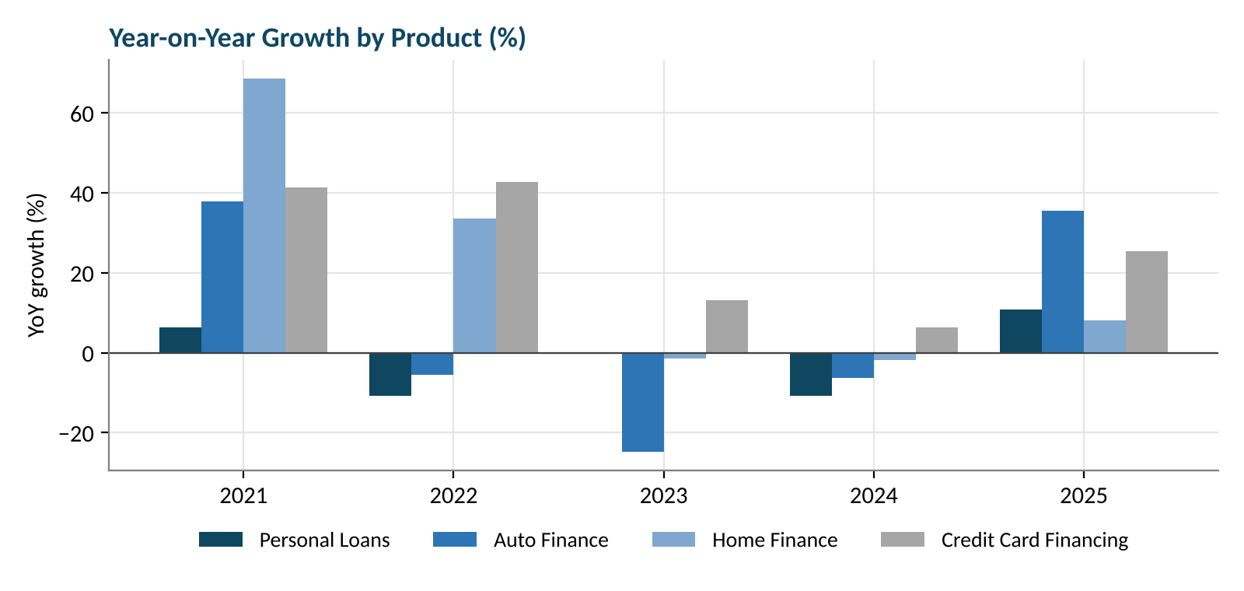
Figure 3: Year-on-year growth by product
Auto finance was the most cyclical product. It grew 37.9% in 2021, then fell for three consecutive years (−5.6%, −24.7% and −6.3%) due to SBP restrictions, high interest rates and soaring car prices. In December 2024, auto financing stood at around PKR 235 billion, down 6.3% from a year earlier. In 2025, as rates fell, it rebounded by 35.5%. Credit card financing grew in every year, while personal loans fell in 2022 and 2024 before recovering 10.7% in 2025.

4.2. What is the real growth after inflation?
Because prices roughly doubled between 2020 and 2025, nominal figures overstate the true expansion of consumer lending. Adjusted to 2020 prices, the total market fell from PKR 683.3 billion to about PKR 478.0 billion, a real decline of about 6.9% a year.
Product | Nominal CAGR | Real CAGR | 2020 value | 2025 value (2020 prices)
Credit Card Financing | 25.0% | 8.8% | 50.2 | 76.4
Home Finance | 18.6% | 3.3% | 93.7 | 110.0
Auto Finance | 4.5% | −9.1% | 256.5 | 159.4
Personal Loans | −1.3% | −14.1% | 282.9 | 132.2
Values in PKR billion. Real values are calculated using a price index based on average annual inflation (2020 = 1).
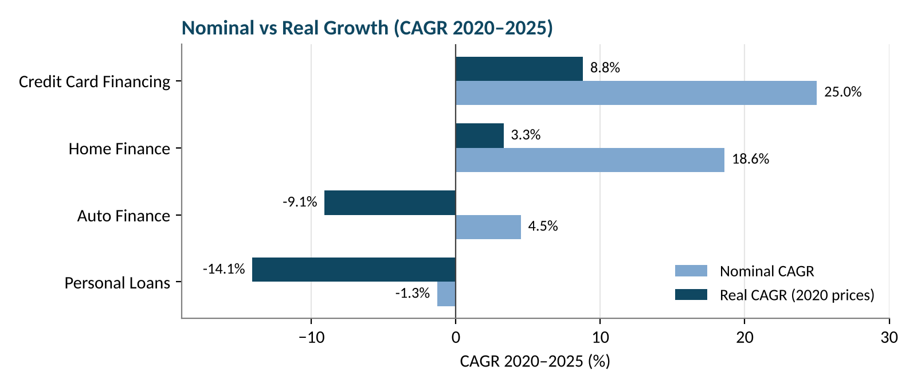
Figure 4: Nominal vs real CAGR by product, 2020–2025
Only credit card financing and home finance grew in real terms. Personal loans suffered the largest real decline, more than halving in real value. This reflects a contraction in supply, driven by tighter regulation and high rates, rather than a lack of demand: as soon as inflation and interest rates eased in 2025, personal lending started growing again.

4.3. Who is currently serving the market?
Bank-level consumer finance totaled PKR 958.8 billion in 2025. The market is highly concentrated: the top five banks account for 60.7% and the top ten for 80.3%, leaving the remaining 29 banks with less than a fifth of the market.
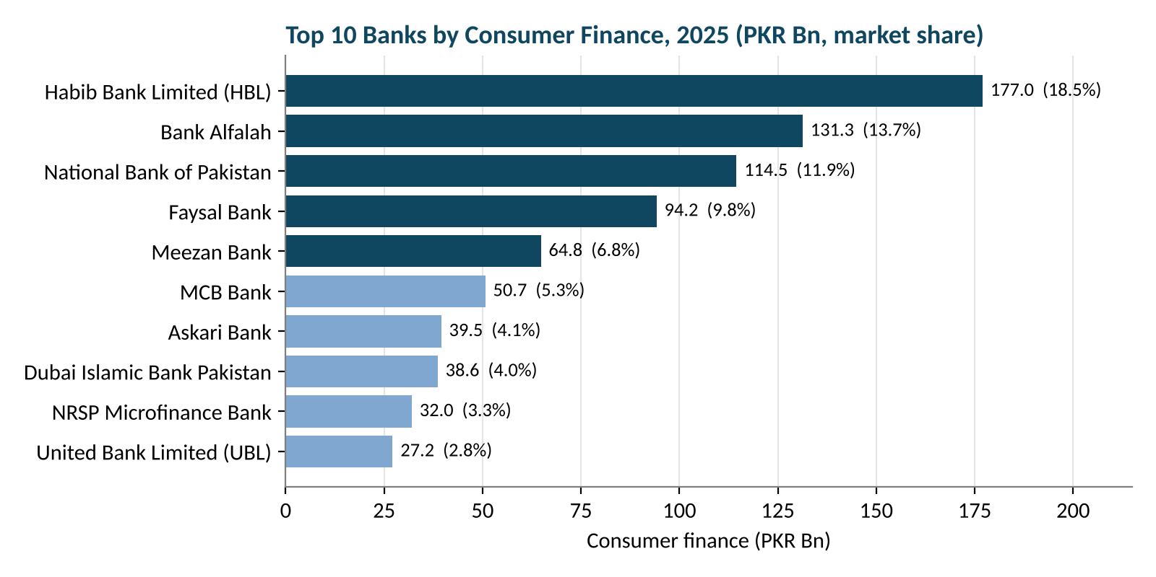
Figure 5: Top 10 banks by consumer finance, 2025
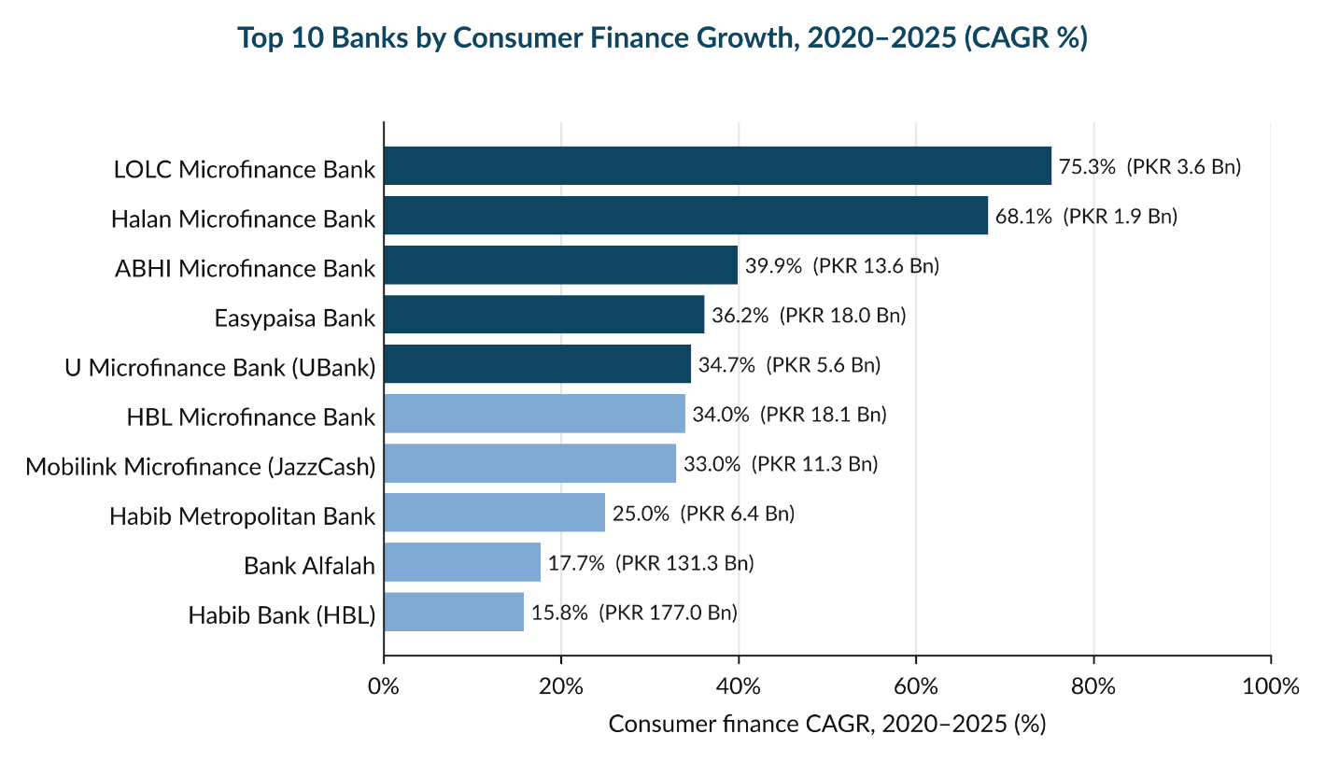
Habib Bank Limited (HBL) is the largest consumer lender with PKR 177.0 billion (18.5% share), followed by Bank Alfalah (PKR 131.3 billion) and the National Bank of Pakistan (PKR 114.5 billion). NRSP Microfinance Bank is the only microfinance bank in the top ten, with PKR 32.0 billion.

Digital and microfinance banks are the fastest-growing consumer lenders. Seven of the ten banks in this chart are microfinance or digital banks, and all of them grew their consumer finance books by more than 33% a year between 2020 and 2025, nearly three times the industry average of 11.9%.
- Easypaisa Bank, the only digital bank with lending, grew 36.2% a year to PKR 18.0 Bn, about the same size as HBL Microfinance Bank.
- LOLC (75.3%) and Halan (68.1%) recorded the highest growth, but from very small bases. Their books are still under PKR 4 Bn.
- Bank Alfalah (17.7%) and HBL (15.8%) are the only large lenders in the top 10. They hold the biggest books (PKR 131.3 Bn and 177.0 Bn) but grow at about half the pace of digital and microfinance banks.

4.4. Which bank types focus on consumer finance?
Market share shows scale, but the share of advances given to consumer finance shows focus. On this measure, the picture is reversed.
Bank type | Consumer finance (PKR Bn) | % of advances | Market share
Conventional + Islamic Banking | 622.0 | 4.4% | 64.9%
Full Islamic | 221.8 | 6.6% | 23.1%
Microfinance Bank | 96.4 | 18.9% | 10.1%
Digital Bank | 18.0 | 68.9% | 1.9%
Foreign Commercial | 0.6 | 0.1% | 0.1%
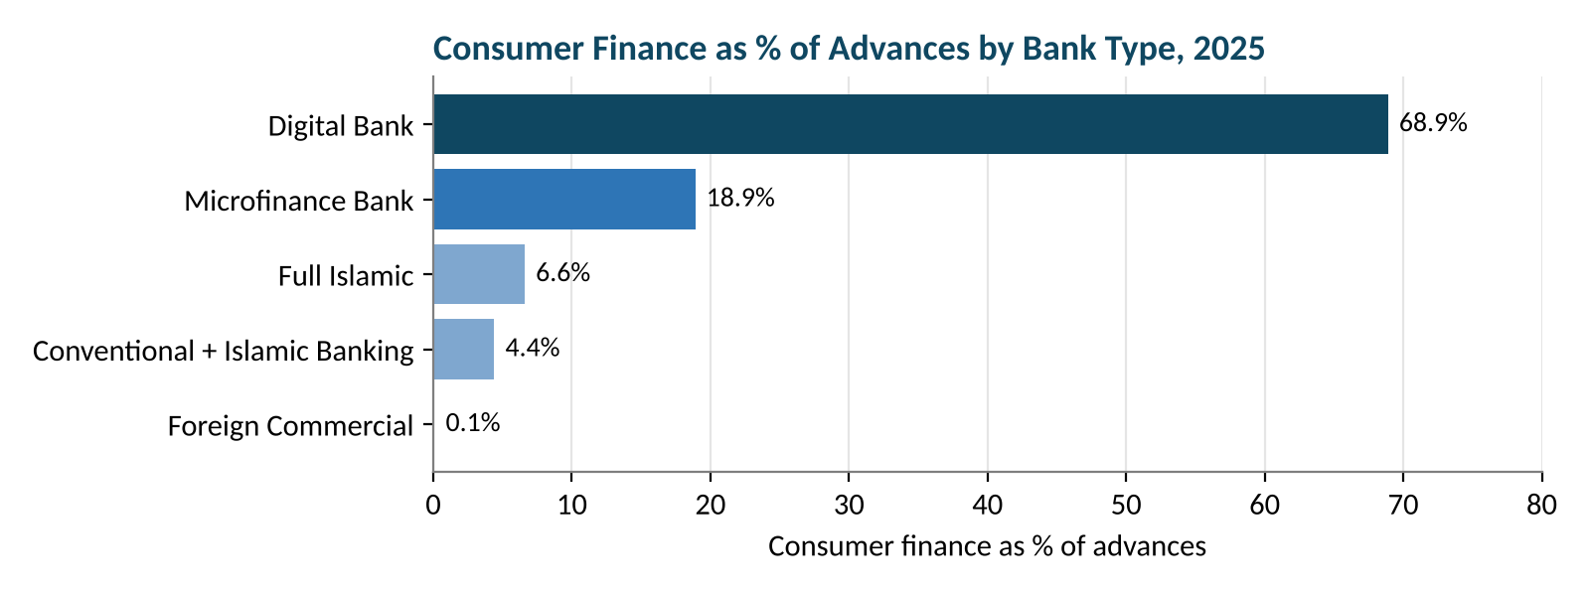
Figure 6: Consumer finance as a share of advances by bank type, 2025
Conventional banks hold almost two-thirds of the market, but consumer finance is only 4.4% of their loan books. They are large consumer lenders because they are large banks, not because consumer lending is a priority.
The industry as a whole lends only about 46% of its deposits, showing that banks have significant liquidity that is not being directed to individual borrowers. This confirms a clear gap in the market that a focused digital lender can serve.

5. Product Evaluation for a Digital Retail Bank

5.1. Product Comparison
Credit card financing is closely linked to personal lending and is treated as an add-on. The three main lending products were compared on growth, risk and recovery:
Product | 2020 | 2025 | Nominal CAGR | Real CAGR | Volatility | 2025 growth
Personal Loans | 282.9 | 264.6 | −1.3% | −14.1% | 9.8% | 10.7%
Auto Finance | 256.5 | 319.0 | 4.5% | −9.1% | 27.9% | 35.5%
Home Finance | 93.7 | 220.3 | 18.6% | 3.3% | 30.1% | 8.0%
Values in PKR billion. Volatility is the standard deviation of annual growth rates.
Personal loans are by far the most stable product (volatility 9.8%), while auto and home finance are around three times as volatile. Auto finance has the strongest recent momentum, and home finance has the strongest long-term real growth.

5.2. Product Fit Matrix
Each product was scored from 1 to 5 on five factors that matter for a new digital bank, and the scores were combined using the weights below.
Factor | Weight | What it measures | Personal | Auto | Home
Digital ease | 25% | Can the product be delivered fully through an app? | 5 | 3 | 1
Short tenor | 20% | Does the loan term match a new bank’s short-term deposits? | 5 | 3 | 1
Low risk | 20% | How stable is the product (based on volatility)? | 4 | 2 | 2
Market gap | 20% | How underserved is the segment by existing banks? | 5 | 3 | 4
Real growth | 15% | Growth after inflation | 2 | 2 | 4
Total score | 100% |  | 4.35 | 2.65 | 2.25

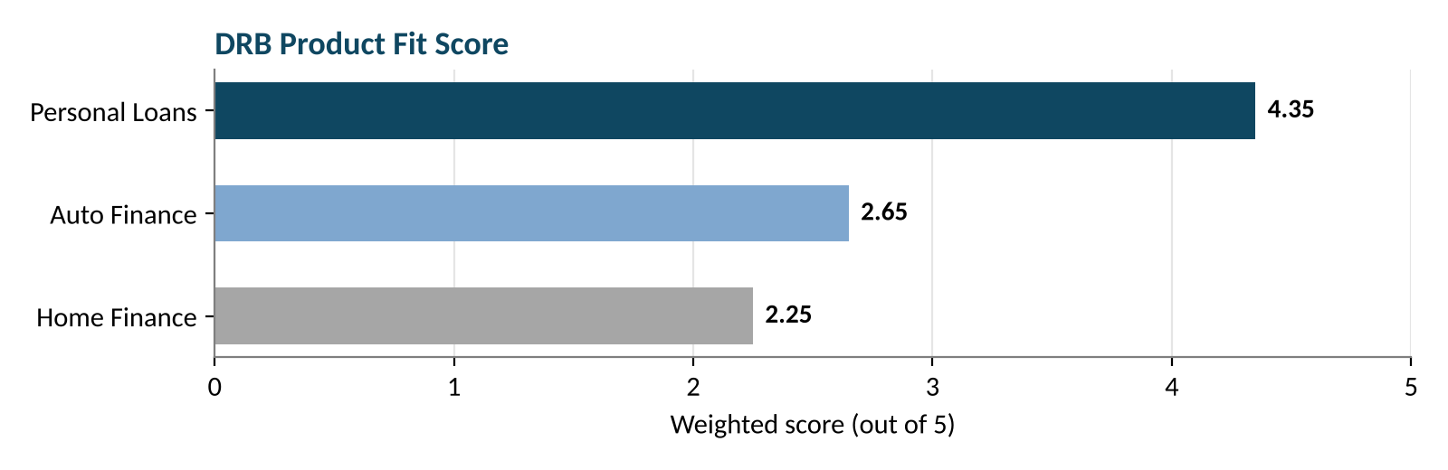
Figure 7: DRB product fit score (out of 5)
Digital personal loans score highest (4.35 out of 5). They can be delivered entirely through an app, need no collateral or dealer network, have short tenors and are the least volatile product. Their only weakness is negative real growth, which reflects reduced supply rather than weak demand.

6. Recommendation

6.1. Recommended Product: Digital Personal Loans
Based on the analysis, the DRB should launch with digital personal loans, add auto finance in the second phase and introduce home finance later. The reasons for starting with personal loans are:
- Best Digital Compatibility: Personal loans can be offered through a fully digital process, including application, verification, approval and disbursement, reducing the need for physical branches.
- Shorter Loan Tenure: Compared with home and auto finance, personal loans generally have shorter repayment periods, making them more suitable for a new bank managing its funding and liquidity.
- Lower Operational Complexity: Personal loans do not require property valuation, vehicle inspections or dealer partnerships, making product launch and management simpler.
- More Stable Performance: Personal loans showed relatively lower growth volatility than other products, making their performance more predictable.
- Strong Market Opportunity: Consumer finance remains a relatively small part of conventional banks' lending portfolios, creating an opportunity for a digital bank to serve underserved borrowers.

6.2. Why Not Auto or Home Finance First
- Auto Finance: Recovered strongly in 2025 (+35.5%), but its high volatility (27.9%) and reliance on dealer partnerships and vehicle prices make it more complex for a new digital bank to launch.
- Home Finance: Recorded positive real growth (+3.3%), but requires long-term funding (15–20 years), property verification and significant capital, making it more suitable for a later phase.

6.4. Additional Opportunities
Credit cards and BNPL: Credit card financing is the fastest-growing product (25.0% nominal CAGR) and one of only two with positive real growth. A digital card or Buy Now Pay Later option can be offered alongside personal loans to the same customer base.
Islamic digital lending: The two Islamic digital banks, Raqami Islamic Digital Bank and Mashreq Bank Pakistan, had no lending activity in 2025. A Shariah-compliant digital personal loan would therefore face almost no direct digital competition, while full Islamic banks already hold 23.1% of the consumer finance market.

7. Limitations
- Limited Public Data: Detailed banking and consumer finance data is not consistently available publicly in Pakistan.
- Incomplete Disclosure: Several banks do not publish detailed product-level lending figures.
- Estimated Figures: Some consumer finance figures, particularly for microfinance banks, are estimates due to limited data availability.
- Inconsistent Reporting: Data formats and disclosures vary across banks and years.
- Limited Product Transparency: Bank-wise breakdowns of personal, auto and home finance are not consistently available.

8. Conclusion
Pakistan’s consumer finance market has grown in nominal terms since 2020, but after adjusting for inflation it has shrunk by about 6.9% a year. High inflation, high interest rates and tighter regulation reduced the supply of consumer credit, particularly personal loans, which lost more than half of their real value. Lending remains concentrated among a few large banks for which consumer finance is a marginal activity.
The environment is now changing. Inflation has fallen to 3.6%, interest rates have been cut sharply, and consumer lending returned to growth in 2025. The success of Easypaisa Bank and the microfinance banks shows that a lender focused on small-ticket, digitally delivered consumer finance can build a viable business.
For a Digital Retail Bank, the opportunity is therefore both real and timely. Digital personal loans offer the best entry point because of their:
- large unmet demand and low competition from conventional banks,
- stability and short tenor, and
- suitability for fully digital, collateral-free delivery.
A phased strategy, starting with personal loans and credit cards, then adding auto finance and later home finance, supported by a Shariah-compliant option, would allow a DRB to grow sustainably while expanding access to formal credit in Pakistan.
References
State Bank of Pakistan. (n.d.). Statistics and publications. https://www.sbp.org.pk
Pakistan Bureau of Statistics. (n.d.). Price statistics. https://www.pbs.gov.pk
Annual financial statements of the banks included in the analysis, 2020–2025.

