2011 年大理、楚雄、文山、保山、丽江、怒江、迪庆、临沧
高中(中专)招生统一考试
英语试题卷参考答案及评分标准
注意事项：
1：本卷为试题卷。考生解题作答必须在答题卷(答题卡)上。答案书写在答题卷(答
题卡)相应位置上，在试题卷、草稿纸上作答无效。
2．考试结束后，请将试题卷和答题卷(答题卡)一并交回。
第一部分听力(共四节，满分30分)
第一节听句子，选出与句子内容相关的图画，并将所选答案的字母代号填入答题卷相应空
格内，每个句子听两遍。(共5小题，每小题1分，满分5分)
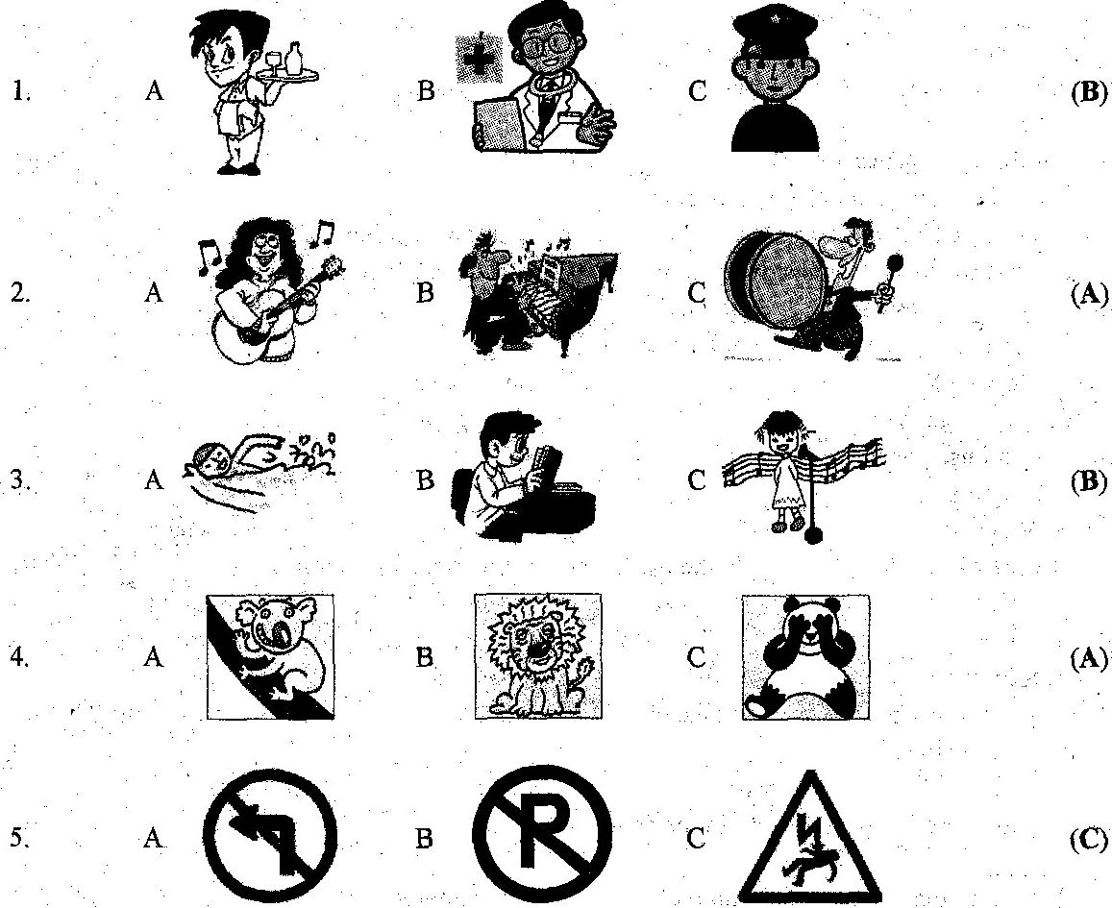
第二节听句子，选出与所听句子内容相符的正确答语，并将所选答案的字母代号填入答题卷相应空格内，每个句子听两遍。(共5小题，每小题l分，满分5分)
6. A. Yes, please. B. Good ides C. Thanks a lot. (B)
7. A. Because he was cool. B. I like him. C. So do I. (A)
8. A. It doesn't matter. B. I am OK, C. Better not. (A)
9. A. It's Saturday, B. It's 5 o'clock, C. It's rainy. (C)
10. A Great B. Not at all. C. I agree. (C)
第三节听对话，选出能回答问题的正确选项，并将其字母代号填入答题卷相应空格内，每
段对话听两遍。(共l0小题，每小题l分，满分l0分)
听第一段对话，回答第ll～12小题。
11. What party is it? (A)
A. A birthday party. B. An English party. C. A welcome party.
12.When will they have the party? (B)
A. On Friday night, B. On Saturday night. C. On Sunday night.
听第二段对话，回答第l3～14小题。
13. What kind of dumplings does the man want? (C)
A. Chicken and carrot.
B. Beef and potato.
C. Beef and carrot.
14. How much are they? (A)
A． 8 Yuan. B. 9 Yuan. C. 10 Yuan.
听第三段对话，回答第l5～17小题。
15. Where is John going? (C)
A. The beach. B. The park, C. The mountains.
16. Who is John going with? (A)
A. His family B. His classmates. C. His friends.
17. what's wrong with Helen's grandfather? (C)
A. Had a fever. B. Had a cold. C. Hurt his back.
昕第四段对话，回答第l8～20小题。
18. What is Mike doing? (C)
A. Playing chess
B. Playing volleyball.
C. Playing computer games.
19. What does the girl like? (B)
A. Painting.
B. Collecting stamps.
C. Writing.
20. How often does she write to her pen pals? (B)
A. Every Sunday. B. Twice a month, C. Twice a year.
第四节听对话，完成下列信息表格。将所选答案的字母代号填入答题卷相应空格内。对话
听两遍。(共5小题，每小题2分。满分l0分)
An Interview
Tom is good at(21) | He goes t0 (24) club．
He wants to be a(an) (22) | His favorite star is (25) ．
He thinks the job is (23) ．
21. A. singing B. acting C. playing soccer (C)
22. A. policeman B. singer C. athlete (A)
23, A. interesting B. exciting C. relaxing (B)
24. A. Kung Fu B. music C. sports (A)
25. A. Liu Xiang B. Jay Zhou C, Jackie Chan (C)

第二部分英语知识运用(共兰节，满分35分)
第一节词语释义(共5小题，每小题l分，满分5分)
选择与句中划线部分意义最接近的解释，并将其字母代号填入答题卷相应空格内。
26. Yang Shanzhou becomes well-known in China for planting so many trees for people.(B)
A. great B. famous C. friendly D. warm
27. Try again, maybe you will come up with a better idea. (D)
A. turn up B. put up C. get up D. think up
28. It's a chicken-and-egg question. I can't answer you now. (C)
A. easy 13. clear C. difficult D. funny
29. Come and join us. We are short of hands. (A)
A. We need help. B. We hurt our hands.
C. Our hands are short. D. We can do it by ourselves,
30. --Dad, did you tell mother about our gift for her birthday? (B)
--No. Don’t let the cat out of the bag. Let's give her a surprise
A. ask her B. let her know C. take away the eat D. give her a eat
第二节单项填空(共20小题，每小题l分，满分20分)
从A、B、C、D四个选项中选择能填入空白处的正确答案，并将其字母代号填入答题卷相应空格内。
31. Linda is kind girl. Everyone in our class likes her (A)
A. a B. an C. the D.\
32. --Jenny, what's your favorite_ ? (B)
--I like bananas best.
A. vegetable B. fruit C, meat D. drink
33. --Wish you good luck in the exam. (D)
-- .The same to you,
A. Me, too B. See you
C. I'm sorry to hear that D. Thank you
34. You drink wine before driving, or the police will take your license away.(C)
A. don't have to B. needn't C. mustn't D. may not
35. --Mum, we have to buy some more salt. (D)
-- .There is enough salt in our country.
A. Why not? B. Sure. C. I think so. D. Don't worry.
36 the movie star goes, there are lots of fans waiting to see her. (C)
A. Whatever B. However C. Wherever D. Whoever
37 --what is Mum cooking in the kitchen? " (B)
--Fish, I guess. How nice it !
A. looks B. sounds C. tastes D. smells
38.---Boys, would you mind not playing basketball here? (B)
-- ,Mr. Li.
A. No, thanks B. Sorry, we won't do it again
C. You are welcome D. I can't stand it
39. "I want my leg! I want to run! I want to jump!", a girl cried in the hospital in Libya(利比亚). (A)
A. 5-year-old B. 5-years-olds C. 5 year old D. 5 -years -old
40. Wang Shasha often acts in TV plays and movies, she does well in her schoolwork. (A)
A. Although B. But C. If D. So
41. There are many beautiful flowers in the world, but in parents' eyes, their children are the of all. (D)
A. as beautiful as B. more beautiful
C. less beautiful D. most beautiful
42. --How do you usually come to school, by bus or by bike? (B)
-- . I walk.
A. Either B. Neither C. Both D. Any
43. Nobody is perfect, bat everyone is different __ others. (A)
A. from B. of C. with D. in
44. -Could you please tell me in America? （B)
--On the fourth Thursday in November.
A. when is Thanksgiving Day B. when Thanksgiving Day is
C. what we eat on Thanksgiving Day D. what do we eat on Thanksgiving Day
45. -- you ever Dali? (B)
--Never. But I am going there this vacation.
A. Do…go to B. Have...bean to
C. Have…gone to D. Will…go to
46 --Can I use your mobile phone? (D)
--Of course. .
A. Very well B. I can C. I am using it D. Here you are
47. At least 24 people in the earthquake in Yingjiang on March 10th. (B)
A. killed B. were killed C. are killed D. have killed
48. Yunnan is colorful millions of people come to enjoy themselves every year. (B)
A. too…to B. so…that C. not…until D, so…but
49. China is trying to find ways to take care of the children parents have left their homes to work in cities. (C)
A. that B. who C. whose D. which
50. --Dad, our class won the first in the sports meeting. (A)
--- .
A. Congratulations! B. Good luck. C. That's interesting. D. Nothing serious.
第三节 完形填空(共10小题，每小题l分，满分l0分)
从A、B、C、D四个选项中选择能填入空白处的正确答案，并将其字母代号填入答
题卷相应空格内。
"Who did this?" Mrs. Green asked with a piece of broken glass in her hand. She had never been so 51 with us. The classroom was so quiet. All students looked at the window except me. I kept my head 52 . I knew it was me. I broke it when I practiced 53 baseball. But should I tell the truth? If I did, I would be in trouble, I didn't have enough 54 . How could I afford to buy such an expensive window? I really didn't want to put up my hand, 55 at last I said. “I did it. I am sorry.” It was not 56 for me to say those words.
Mrs. Green went to the book shelf and took down a book. Then she walked to me. Looking at 57 , I was a little afraid. To my surprise, she said, "I know you like 58 .Here is the book about them. It's yours now. I give it to you not because you broke the window, but because you are 59 ." I couldn't believe it. I wasn't punished(惩罚). However, I was given my favorite book about birds.
It happened 20 years ago, but I still 60 the book. The lesson my teacher taught me that day will be in my heart forever.
51. A. excited B. angry C. happy D. nervous (B)
52. A. up B. down C. over D. out (B)
53. A. play B. to play C. playing D. played (C)
54.A. glass B. books C. time D. money (D)
55. A. and B. but C. so D. or (B)
56. A. easy B. difficult C. sad D. terrible (A)
57. A. she B. her C. herself D. hers (B)
58. A. sports B. baseball C. birds D. dogs (C)
59. A. careful B. smart C. kind D. honest (D)
60. A. keep B. give C. borrow D. lose (A)
第三部分阅读理解(共l5小题，每小题2分，满分30分)
A
When we meet someone for the first time, we often would like to talk about ourselves. We just want to show the best to others. But why not listen? Sometimes, listening is better than talking. Then how to be a good listener? Here are a few suggestions:
◆Look at the speaker. It shows you are listening carefully. It's also a good way to “talk” to your friend with your eyes.
◆Don't cut in. Give your friend enough time to say what she or he thinks. Don't stop your friend's words. Even if you want to say something, you should wait till your friend finishes.
◆ Try to understand. When you are listening, try to catch her or his feelings and ideas. It helps you know your friend better. And your friend will feel better about you. She or he may think you are the right person to talk with.
◆Show your ideas at the right time. "It’s interesting." "What happened next?" … These are useful when you are listening. And you can give advice when your friend asks for it.
It's never too late to become a good listener. It can change your life and the lives of the people in your life.
根据短文内容，判断以下句子的正误。你认为正确的句子，请在答题卷相应空格内写“T”，错误的写“F”。（共5小题，每小题2分，满分l0分)
61. When we meet someone for the first time, we often would like to talk about
others. (F)
62. Looking at the speaker is impolite when you are listening. (F)
63. Though you want to say something, you should not cut in at once. (T)
64. To be a good listener, you should say nothing. (F)
65. Listening is better than talking sometimes. (T)
B
Many years ago, there was an old man who had four sons. He wanted his sons to learn not to judge(判断) things too quickly. So he told them to go and look at a pear tree. It was far away from his home. The first son went in winter, the second in spring, the third in summer, and the youngest son in autumn.
When the sons came back, the old man asked them to say what they had seen.
The first son complained the tree was ugly. The second son said the tree was covered with buds and full of hope. The third son said the tree was full of green leaves. They looked so beautiful, and it was the most wonderful thing he had ever seen. The youngest son said that the tree was bowed down with heavy fruits. It was full of life and fulfillment(收获).
The man explained that all of his sons were right, but each of them had seen just one season of the tree. He told them that they couldn't judge a tree or a person by only one season. "If you give up when it's winter, you will miss the hope of your spring, the beauty of your summer, and the fulfillment of your autumn." said the old man
It is true that we shouldn't let the hard season break the happiness of the other seasons. Never give up during the difficult days and better times are sure to come some day.
根据短文内容，选择正确答案，并将其字母代号填入答题卷相应空格内。(共5小题，每小题2分，满分l0分)
66. Why did the old man ask his sons to look at the pear tree? (C)
A. Because he liked. eating pears.
B. Because the tree was important to his family.
C. Because he wanted to teach them not to judge things too quickly.
D. Because his sons didn't judge things quickly.
67. The fourth son went to see the tree in . (C)
A. Spring B. Summer C. Autumn D. Winter
68. The underlined word "buds" probably means in Chinese. (D)
A. 叶子 B.枝条 C.果实 D. 花蕾
69. Which of the following is true? (B)
A. The pear tree was near his home.
B. The third son said the tree was beautiful.
C. The four sons all liked the tree.
D. Even you give up in winter, you can still get hope in other seasons
70. What's the main idea of this passage? (A)
A. Don't judge a life by one difficult season.
B. Father's love is great.
C. Every tree has four seasons.
D. Life is different for everyone.
C
In many countries, unusual names for children are becoming more popular, especially when more and more stars give their children special names. In Britain, you can call a child almost anything you like except dirty words.
Some parents choose names which come from popular culture. Because of the film the Lord of the Rings(指环王), six boys were named Gandalf. Names about sport are very common, too. Since 1984, 36 children have been called Arsenal after the football team.
Other parents like to make up names, or combine(合并) two names to make a special one. A mother in Britain invented the name Tiaamii for her daughter. She combined the names Thea and Amy (the two grandmothers).
In China, there are some rules about names ―- you can't use foreign letters or symbols(符号) in a Chinese name. For example, parents are not allowed to name their baby @. In New Zealand, a name beginning with a number is not allowed. Other countries have stricter rules about calling children. For example, Japan, Denmark, Spain, Germany and Argentina have a list of names. Parents must choose the names in the lists for their children.
In Britain, some old-fashioned(过时的) names have become popular again, such as Maisie or Ella for a girl, and Alfie or Noah for a boy. But the most popular names are not the strange ones. The top names are very traditional--Jack and Thomas for boys, or Grace and Jessica f6r girls.
根据短文内容，选择正确答案，并将其字母代号填入答题卷相应空格内。(共5小题,每小题2分，满分l0分)
71. In Britain, people can't use words in their children's names. (D)
A. strange B. popular C. old-fashioned D. dirty
72. Thirty-six children were called Arsenal because of a . (C)
A. movie star B. football star C. football team D. film
73. According to the passage, which of the following names is NOT allowed? (C)
A. Gandulf in Britain B. Tiaarnii in Britain
C.李@in China D. Real in New Zealand
74. In , people must name their children according to the list. (A)
A. Japan B. Britain C. America D. China
75. From the last paragraph(段落), we know today. (D)
A. you can name a girl Alfie in Britain
B. strange names are the most popular in Britain
C. people don't use old names in Britain
D. the most popular names are the traditional names in Britain
第四部分写作(共三节，满分25分)
第一节根据句意，用括号中所给词的适当形式填空，并将所填单词写在答题卷相应位置。
． (共5小题，每小题l分，满分5分)
76. Let me try, and I will understand. (I)
77. I have met many kind teachers in the past three years. I think I am a lucky girl. (luck)
78. Life to everyone is only once, we shouldn't waste time. ( one )
79. Give up smoking! It's bad for your health. (smoke) (smokeing ,得 0.5 分 )
80. Li Na is one of the best tennis is players in the world. （play) (player得0.5分 )
第二节将下列句子中汉语部分译成英语，注意使用适当的形式，并将所填单词写在答题卷
相应位置。(共5小题，每小题l分，满分5分)
(81-85题写出部分相关词每小题得0.5分，全对得1分，大小写不扣分。)
81. If you learn to get over difficulties, you will be the winner in life. (克服)
82. I often have a glass of sweet milk and an egg for breakfast. (甜牛奶)
83. People are not allowed to take photos\ take a photo in a museum.(拍照)
84. Water pollution is becoming more and more serious in today's world. (水污染)
85. As students, we should study hard, at the same time it's important for us to gel on well with others. (同时)
第三节书面表达(满分l5分)
I Am Not a Child Any More
提示：在阳光雨露里，我．已长高、长壮!但这还不是全部，长大还应包括什么?是关心、
帮助同学?是体贴、理解父母?是感恩、回报亲朋师长?还是……成长的点点滴滴，久久不能忘记。请以‘‘I Am Not a Child Any More”为题记叙你在学习生活中经历的一件或两件事，表明你已不再是一个小孩。
要求：1请根据所给的题目，用英语写一篇短文，词数不少于60个；
2语言流畅、书写规范、卷面整洁；
3文中不得使用你的真实姓名、校名，否则以零分记； 。
4．短文必须写在答题卷上，如在本卷作答，一律不得分。
I Am Not a Child Any More
I am a 16-year-old girl now. I have changed a lot, I used to be weak and short. But now, I am stronger and as tall as my mother. The most important thing is that I have learned to understand and care about others.
It was a Wednesday evening. When I went back home, no one was in. So I cooked the meal. I didn't know my mother was ill until my parents came back from the hospital. They both said the meal was very delicious, although it tasted salty. After supper, I found they were too tired, I got hot water for them. When my mother put her feet into the water, with tears in her eyes she said: "Dear, you have grown up."
It was the first time that I cared about my parents. I realized I was not a child any more.
书面表达评分标准
一档(13～15分)：内容切题、层次清楚、语言流畅、基本无语言表达错误。
二档(10～12分)：内容切题、层次比较清楚、语言比较流畅、语言表达错误较少。
三档(6～9分)： 内容基本切题、层次不够分明、语言表达错误较多。
四档(1～5分)： 有一定的内容，但语言表达错误较多。
(注意：书面表达语法错误全卷扣分不得超过2分；单词拼写错误全卷扣分不得超过2分；
直接抄袭卷中阅读材料的，抄袭部分不给分。)

