机密★
2014年云南省初中学业水平考试
英语 试题卷
(全卷四个部分，共8页；满分100分，考试用时120分钟)
注意事项:
1.本卷为试题卷。考生必须在答题卡上解题作答。答案应书写在答题卡的相应位置上，在试题卷、草稿纸上作答无效。
2.考试结束后，请将试题卷和答题卡一并交回。
第一部分听力(共四节，满分25分)
做题时，先将答案标在试题卷的相应位置，听力测试结束后，请将试题卷上的答案转涂到答题卡上。
第一节 听句子，从题中所给的A, B, C三个选项中选出与所听句子内容相关的图画。每个句子听两遍。(共5小题；每小题1分，满分5分)
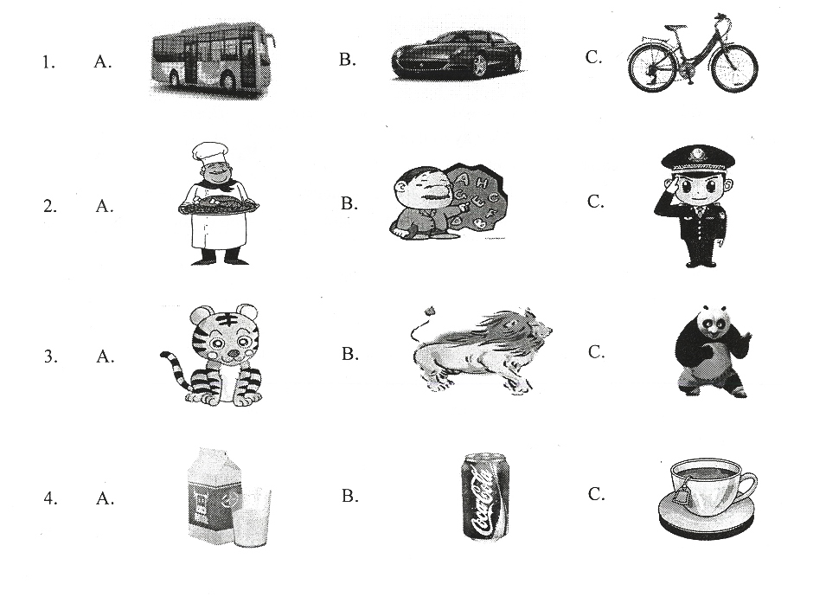

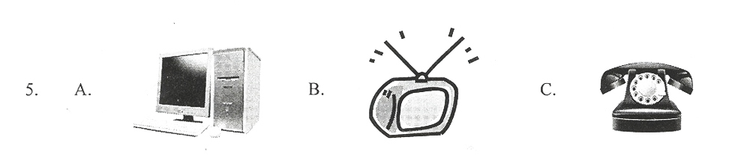

第二节 听句子，从题中所给的A、B、C三个选项中选出与所听句子内容相符的正确答语。 每个句子听两遍。〔共5小题；每小题1分，满分5分〕
6. A. What a pity! | B. It’s my pleasure. | C. That’s right.
7. A. Congratulations! | B. Just so-so. | C. Good luck.
8. A. Three years ago. | B. In three years. | C. For three years.
9. A. All right. | B. Sorry to hear that | C. Never tried.
10. A. Good idea. | B. Well done. | C. It doesn’t matter.
第三节 听对话，从题中所给的A、B、C三个选项中选出能回答问题的正确选项。每段对话听两遍，(共5小题；每小题1分，满分5分)
听第一段对话，回答第11、12小题。
11. What kind of noodles would the woman like?
A. Potato noodles.
B．Beef noodles.
C. Egg noodles.
12. What’s the woman’s phone number?
A. 436-1789.
B. 463-1798.
C. 463-1789.
听第二段对话，回答第13~ 15小题。
13. What are the two speakers doing now?
A. They’re talking on the phone.
B. They’re visiting Beijing.
C. They are visiting the hospital.
14. Who is Maria going to travel with?
A. Mike.
B. Mike’s grandma.
C. Her parents.
15. What will Mike do during his summer vacation?
A. Study in England.
B. Travel to Beijing.
C. Look after his grandma.
第四节 听短文，从题中所给的A、 B、 C三个选项中选出能完成下列信息表格的正确选项。短文听两遍。〔共5小题；每小题2分，满分10分)
Information about a talk
Speaker | Mr. Black, a famous 16 2
Place | 1 17 *
Time | 18 on Saturday evening
Experiences | travelled through 19 different countries
About | all his experiences in 20 *

16. A. actor | B. student | C. writer
17. A. in the library | B. in the hall | C. at a university[来源:Z.xx.k.Com]
18. A. at 7:15 | B. at 7:30 | C. at 7:45
19. A. Three | B. five | C. seven
20. A. England | B. Africa | C. China

第二部分 英语知识运用(共三节，满分30分)[来源:学科网]
第一节 词语释义(共5小题；每小题1分，满分5分)
从题中所给的A、 B、 C、 D四个选项中选出与句中划线部分意义最接近的解释，并将所选答案涂到答题卡的相应位置上。
21. I hope I’ll travel all over the world one day.
A. the next day B. in the future
C. at that time D. the whole day
22. Jack takes after his father. They’re both tall and strong.
A. looks like B. waits for C. takes care of D. feels excited about
23. It’s reported that a person throws away 50kg of food every year. We should save food.
A. cooks B. takes C. eats D. wastes
24.—You’ll have a free trip to Hong Kong!
—Really? That’s music to my ears. I can’t wait!
A. That’s good news. B. That’s beautiful music.
C. Have a good time. D. I’m afraid not.
25. The news about the missing plane broke many people’s hearts. We hope the passengers can come back home safely.
A. lost many people’s lives B. cheered many people up
C. made many people sad D. surprised many people
第二节 单项填空(共15小题；每小题1分，满分15分)
从题中所给的A、B、 C、 D四个选项中选出能填入空白处的正确选项，并将所选答案涂到答题卡的相应位置上。
26. —Eric, you look so cool with your sunglasses.
—___________
A. Not really | B. It’s not true | C. Nothing much | D. Thank you
27. My favorite ________ is summer. I can swim with my friends.
A. month | B. day | C. season | D. weekend
28.— Excuse me. Could you tell me the way _______ the nearest supermarket?
— Go down the street and turn left. Then you’ll see it.
A. to B. of C. in D. at[来源:学.科.网]
29.— May I take a look at your new iPad?
— _______Here you are.
A. I hope not B. Not at all C. Of course D. No way
30. If there _____ no buying and selling of animals, there will be no killing in nature.
A. is B. will be C. has D. will have[来源:Z|xx|k.Com]
31.—Oh, dear! Your room is untidy.
—Sorry, mom. I’ll __________.
A. set it up B. clean it up C. put it up D. look it up
32.—What do you think of the Sochi Winter Olympic Games?
—_________.They are exciting.
A. I love them B. I can’t stand them
C. Sounds terrible D. I don’t mind them
33.—______sweet song it is!
—Yeah, it’s My Heart Will Go On sung by Celine Dion.
A. How B. How a C. What a D. What
34. We_____ use mobile phones when the plane takes off
A. may not B. shouldn’t C. needn’t D. mustn’t
35. China’s hot words, like tuhao, dama and lianghui, ____in the western media(媒体).
A. use widely B. is widely used C. uses widely D. are widely used
36. —Kunming is really a comfortable city to live in.
—_________.The weather is pleasant.
A. So it is B. So is it C. So it does. D. So does it
37. —To achieve a bright future, we should______ study hard____ keep in good health.
—I agree with you.
A. not; but B. not only; but also C. neither; nor D. either; or
38.—You look really tired. ________?
—I didn’t sleep well last night. I had a headache.
A. How about you B. What should I do
C. What’s the matter D. How are you feeling now
39. Keep on. Don’t stop. The_____ you climb, the_______ you will see.
A. highest; farthest B. highly; farther
C. high; far D. higher; farther
40. —Do you know_______ in America?
—Sure. It’s the third Sunday of June.
A. when Father’s Day is B. how is Father’s Day
C. when is Father’s Day D. how Father’s Day is
第三节 完形填空(共10小题；每小题1分，满分10分)
从题中所给的A、 B、C、D四个选项中选出能填入空白处的正确选项，并将所选答案涂到答题卡的相应位置上。
There was once a little monkey in the forest. He liked to 41 everyone. He jumped from tree to tree, called all the other 42 bad names and threw bananas or stones at them.
One day he saw a baby elephant near the river. “Hey, baby elephant, you are so 43 , and you’ll never catch me.” said the monkey.
“ 44 do you have to laugh at me?” the baby elephant asked. “I 45 make trouble or make anyone upset.”
“It’s so fun.” said the monkey.
The monkey 46 , jumping from tree to tree. Then he saw a turtle(乌龟) 47 with his mouth open. The monkey thought it would be a lot of fun putting his finger 48 the turtle’s mouth. He did so, 49 the turtle shut his mouth just at that time. The monkey shouted 50 .The nice turtle woke up and let the monkey go. The monkey climbed up a tree and shouted all the way.
41. A. look at B. laugh at C. smile at D. point at
42. A. animals B. monkeys C. babies D. elephants
43. A. quick B. smart C. slow D. ugly
44. A. How B. What C. When D. Why
45. A. always B. sometimes C. ever D. never
46. A. came back B. fell asleep C. went away D. sat down
47. A. sleeping B. playing C. living D. walking
48. A. from B. off C. for D. into
49. A. because B. but C. if D. so
50. A. in trouble B. in peace C. in pain D. in danger
第三部分 阅读理解(共15小题;满分25分)
A
Some people think that chicken soup is good for a cold. Others believe that it is unhealthy not to eat meat. The question is, are they right?
Here are some facts.
For centuries, people have believed that chicken soup helps to fight a cold. Now, doctors say it may be true. They think that chicken soup has something that stops a cold from getting worse. Heat from the soup can also make a person feel better.
Many people think that it is unhealthy not to have meat. 1t is true that meat, especially red meat, has protein(蛋白质)that the body needs. A person who doesn’t eat meat can get enough protein and be healthy by eating tofu, eggs, and some vegetables.
A study showed that tea is better than coffee. Tea has something that can protect your heart, fight cancer, and make you less fat. Coffee does not do this.
Many people believe that bread and potatoes can easily make people fat. In fact, bread and potatoes do not have fat in them. But eating too much and not exercising can make people fat. Also, adding things like butter to them can raise the chance of becoming fat.
根据短文内容，判断下列句子的正误。正确的填“T” 错误的填“F”，并在答题卡上将该项涂黑。(共5小题；每小题1分，满分5分)
51. It is helpful to eat some chicken soup to fight a cold.
52. To get enough protein and be healthy, people must eat meat.
53. Protein can be found in tofu, eggs and some vegetables.
54. Tea is better than coffee in fighting cancer.
55. People who like bread and potatoes become fat easily.
B
Sometimes it may seem difficult to improve our health. If so, the following health habits may help you.
Eat breakfast every morning.
Research shows that if you eat a meal in the morning you may not become too fat or eat too much during lunch. Dating breakfast can help people feel better through the day.
Get enough sleep.
Poor sleep can influence our memory and learning. It can also cause traffic accident! Studies show that people who don’t get enough sleep seem to get into more accidents. So stay safe and get enough sleep!
Take a walk every day.
Walking is an easy way to exercise. You’d better meet friends for a walk, not for a meal. As you walk, you will see the beautiful world around you. Once you try, you will find that adding a walk into your daily life is very easy.
Join social groups.
Social groups can provide support. They might include sport teams, art or music groups. The people in the group can offer advice and can help each other in difficult times. Also, being in a group keeps your mind busy. An active mind is a healthy mind!
Have a hobby.
A hobby could be running, reading or making something with your hands. Hobbies help people to relax and rest. Hobbies bring us joy as well.
根据短文内容，从题中所给的A、B、C、D四个选项中，选出正确选项，并将所选答案涂到答题卡的相应位置上。(共5小题；每小题2分，满分10分)
56. You may have a good memory and learn better if you________.
A. eat breakfast every morning B. have a good sleep
C. take a walk every day D. join a social group
57. If you need help and want to help others, you’d better _______.
A. invite your friend to a meal B. make something with your friends
C. become a member of a social group D. have a hobby
58. Which of the following is TRUE?
A. If you have breakfast every morning, you’ll be fat.
B. All the traffic accidents are caused by poor sleep.
C. To join a social group helps you have a healthy mind.
D. Having a hobby is the best way to relax.
59. The passage is mainly written for ________.
A. students at school B. people who don’t like running
C. students who never have breakfast D. people who want to improve health
60. Which is the best title(标题)of the passage?
A. Ways to Improve Your Health B. Reasons for Keeping healthy
C. Good Habits D. Breakfast and Exercise
C
Last week my youngest son and I visited my father at his new house in Arizona. He moved there a few years ago, and I wanted very much to see his new place and meet his friends.
In my earliest memories my father was a tall, handsome and successful man. He loved his work and family, but was uncomfortable with his children. As a child I loved him; as a school girl and young adult I was afraid of him. He seemed unhappy with me unless I got straight A’s in my study and unhappy with my boyfriends if their fathers were not as “successful” as he was. Whenever I went out with him on weekends, I used to try hard to think up things to say to protect myself.
On the first day of my visit, we went out with one of my father’s friends for lunch. We walked along that afternoon, did some shopping, ate on the street table, and laughed over my son’s funny talks. My father’s critical(挑剔的)air and strict rules were gone. He seemed so friendly and interesting to be with us.
The next day my dad pulled out his childhood pictures and told me many stories about his own childhood. Although our times together became easier over the years, I never felt closer to him at that moment. After so many years, I’m at last seeing another side of my father. And in so doing, I’m happy with my new friend. My dad, in this new home in Arizona, is back to me from where he was.
根据短文内容，从题中所给的A、B、C、D四个选项中，选出正确选项，并将所选答案涂到答题卡的相应位置上（共5小题；每小题2分，满分10分）
61. The father was unhappy with the writer because________.
A. he didn’t like her B. he expected too much of her
C. she had a boyfriend D. she was uncomfortable
62. The underlined words straight A’s in Paragraph 2 mean ______ in Chinese.
A. 全优 B.及格 C.中等 D.不及格
63. When the writer went out with his father for a walk on weekends she felt ____.
A. tired B. happy C. satisfied D. nervous
64. What does the writer think of her father after visiting him in Arizona’?
A. Strict and hard-working. B. More critical
C. Friendly and interesting. D. More successful.
65. When the writer says “my new friend” in the last paragraph, she is talking about_____.
A. her son B. her father
C. her boyfriend D. her father’s friend
第四部分 写作(共三节，满分20分)
第一节 根据句意，用括号中所给词的适当形式填空，并将答案写在答题卡的相应位置上。(共5小题；每小题l分，满分5分)
66. It is a good habit to brush your teeth at least ______ a day. (two)
67. After the rain, the village looks ______ from the top of the hill. (wonder)
68. I don’t know whether the dream can come true, but I will try ______ best. (I)
69. Spring Festival is the _____ festival in China. It is a good time for family members to get together. (big) ;
70. A good teacher is a good ____. A teacher is there to listen to every student and help them out. (listen)
第二节 将下列句子中汉语部分译成英语，注意使用适当的形式，并将答案写在答题卡的相应位置上。(共5小题；每小题1分，满分5分)
71. You are welcome to join our _______. You can have a lot of fun here.(篮球俱乐部)
72. Let’s build ________ to make our mother earth healthy and clean.(绿色城市)
73. We can enjoy fresh air when we ______ in the countryside.(去钓鱼)
74. I’m trying to sleep. Would you mind ______ the music? (调低)
75. When we are in trouble, we should face the challenges _____ worrying about our problems. (代替)
第三节 书面表达（满分10分）
My Plan for the Coming School Year
提示:难忘的初中生活即将结束，请以“My Plan for the Coming School Year"为题，用英语写一篇短文，谈谈你初中结束后一学年内的打算。
要求: 1. 语言流畅、书写规范、卷面整洁，词数不少于60个；
2. 文中不得使用真实姓名、校名，否则以零分计；
3. 将短文写在答题卡上。写在本试题卷上无效。
英语试题卷·第7页(共8页)

参考答案（仅供参考）
1 | 2 | 3 | 4 | 5 | 6 | 7 | 8 | 9 | 10 | 11 | 12 | 13 | 14 | 15
C | A | C | B | A | B | A | C | B | A | B | C | A | C | C
16 | 17 | 18 | 19 | 20 | 21 | 22 | 23 | 24 | 25 | 26 | 27 | 28 | 29 | 30
C | C | B | A | B | B | A | D | A | C | D | C | A | C | A
31 | 32 | 33 | 34 | 35 | 36 | 37 | 38 | 39 | 40 | 41 | 42 | 43 | 44 | 45
B | A | C | D | D | A | B | C | D | A | B | A | C | D | D
46 | 47 | 48 | 49 | 50 | 51 | 52 | 53 | 54 | 55 | 56 | 57 | 58 | 59 | 60
C | A | D | B | C[来源:学科网] | T | F | T | T | F | B | C | D | D | A
61 | 62 | 63 | 64 | 65
B | A | B | C | B
66.twice 67.wonderful 68.my 69.biggest 70.listener
71.basketball club 72.green cities 73.go fashing 74. turning down 75.instead of
书面表达略

