Task 1: Activity B – AI Log
AI model used | ClaudeAi
Problem to be solved | Prompts used | Output generated | Review of generated code
Figuring out how to interlink the models | 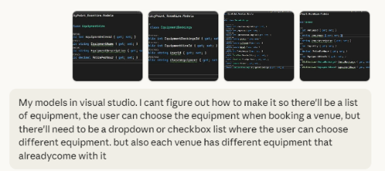  My models in visual studio. I cant figure out how to make it so there'll be a list of equipment, the user can choose the equipment when booking a venue, but there'll need to be a dropdown or checkbox list where the user can choose different equipment. but also each venue has different equipment that already come with it | // Equipment available in the system  public class EquipmentHire  {  public int EquipmentHireId { get; set; }  public string EquipmentName { get; set; }  public string EquipmentDescription { get; set; }  public decimal PricePerHour { get; set; }  }  // Link table: What equipment comes WITH each venue  public class VenueEquipment  {  public int VenueEquipmentId { get; set; }  public int VenueId { get; set; }  public int EquipmentHireId { get; set; }  public bool IsIncluded { get; set; } // true = included, false = available as add-on  public Venues Venue { get; set; }  public EquipmentHire Equipment { get; set; }  }  // What the user actually books  public class EquipmentBookings  {  public int EquipmentBookingsId { get; set; }  public int VenueBookingsId { get; set; }  public int EquipmentHireId { get; set; }  public int Quantity { get; set; } // How many of this item?  public VenueBookings VenueBooking { get; set; }  public EquipmentHire Equipment { get; set; }  }  public class VenueBookings  {  public int VenueBookingsId { get; set; }  public int VenuesId { get; set; }  public string UserId { get; set; }  public DateTime BookingDate { get; set; }  public TimeSpan TimeSpanBook { get; set; }  public Venues Venue { get; set; }  public ICollection<EquipmentBookings> EquipmentBookings { get; set; }  }  public class Venues  {  public int VenuesId { get; set; }  public string VenueName { get; set; }  public string VenueDescription { get; set; }  public int Capacity { get; set; }  public decimal PricePerHour { get; set; }  public ICollection<VenueBookings> VenueBookings { get; set; }  public ICollection<VenueEquipment> VenueEquipment { get; set; }  }  How it works:  - VenueEquipment links venues to equipment and marks what's included vs. available as add-on  - When user books, you show them: included items + available add-ons for that specific venue  - EquipmentBookings records only the add-ons they actually select  Quick tips:  - Remove EquipmentHireId from Venues (use VenueEquipment instead)  - Use proper navigation properties for Entity Framework  - Consider adding Quantity to track multiple units of same equipment  Want me to show you the controller/view code for the booking form with checkboxes?
[Add additional rows as needed then delete this instruction]

Copyright and Acknowledgements
‘T-LEVELS’ is a registered trademark of the Department for Education.
‘T Level’ is a registered trademark of the Institute for Apprenticeships and Technical Education.
The T Level Technical Qualification is a qualification approved and managed by the Institute for Apprenticeships and Technical Education.
‘Institute for Apprenticeships & Technical Education’ and logo are registered trademarks of the Institute for Apprenticeships and Technical Education.
Pearson Education Limited is authorised by the Institute for Apprenticeships and Technical Education to develop and deliver this Technical Qualification.
Pearson and logo are registered trademarks of Pearson.
Copyright in this document belongs to, and is used under licence from, the Institute for Apprenticeships and Technical Education, © 2025

