Task 1: Activity B – AI Log
AI model used | Claude Ai
Problem to be solved | Prompts used | Output generated | Generated Code | Review of Code
Seeded user roles however an error saying “Role FARMER does not exist.” | “Yo I have an error”  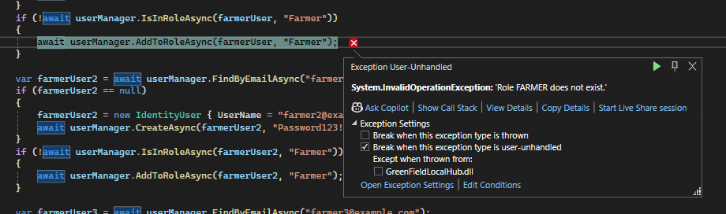 | The error says 'Role FARMER does not exist' — this is happening because your roles are being created inside the foreach loop but the user seeding code is also inside that loop, so it's trying to assign the "Farmer" role before all roles have been created.  The fix is to separate the role creation from the user creation — create all roles first, then create the users. | // FIRST - create all roles  string[] roleNames = { "Admin", "Farmer", "Standard", "Loyalty", "Developer" };  foreach (string roleName in roleNames)  {  var roleExists = await roleManager.RoleExistsAsync(roleName);  if (!roleExists)  {  await roleManager.CreateAsync(new IdentityRole(roleName));  }  }  // THEN - create all users after roles exist  var farmerUser = await userManager.FindByEmailAsync("farmer@example.com");  if (farmerUser == null)  {  farmerUser = new IdentityUser { UserName = "farmer@example.com", Email = "farmer@example.com", EmailConfirmed = true };  await userManager.CreateAsync(farmerUser, "Password123!");  }  if (!await userManager.IsInRoleAsync(farmerUser, "Farmer"))  {  await userManager.AddToRoleAsync(farmerUser, "Farmer");  }  // rest of your users below...
Farmuser1 is not null here | “Why”  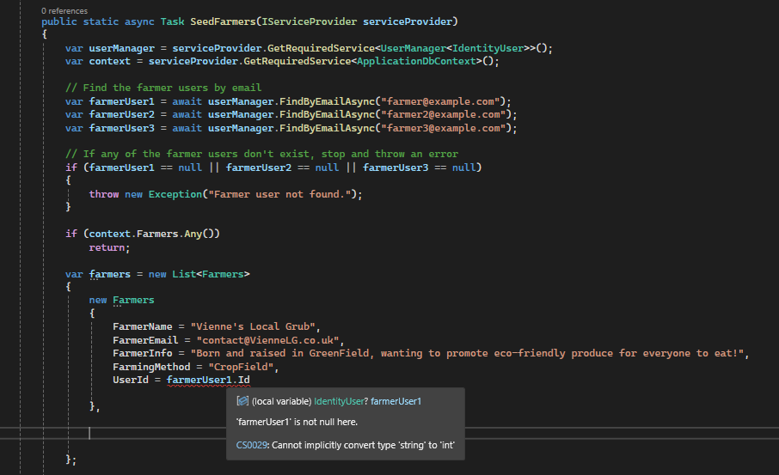 | The error "Cannot implicitly convert type 'string' to 'int'" is because in your Farmers model, UserId is set as int but Identity stores user IDs as string. | public string UserId { get; set; } // Change to string to match Identity
When I pressed “add to basket” it sent me to an error 401 page | “When I press add to basket, it gives me an error 401 page” | The 401 error means you're not logged in when pressing Add to Basket. Your Create method returns Unauthorized() when userId == null, which happens when no one is logged in.  You need to add [Authorize] above your POST Create method so it redirects to the login page instead of showing a 401 error: | [HttpPost] [Authorize] // Add this - redirects to login if not logged in [ValidateAntiForgeryToken] public async Task<IActionResult> Create(int ProductsId) { // rest of your code... }
The name “basketId” doesn’t exist | “Why does this happen?”  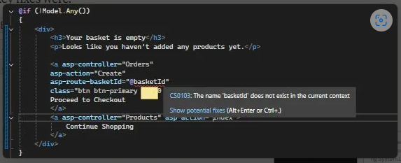I also sent a copy of my orders controller | The error is because basketId doesn't exist as a variable in your view — it's stored in ViewBag.BasketId, not a local variable.  Fix — change @basketId to @ViewBag.BasketId: | <a asp-controller="Orders"  asp-action="Create"  asp-route-basketId="@ViewBag.BasketId"  class="btn btn-primary">  Proceed to Checkout  </a>
My proceed to checkout button wasn’t there even when I coded it | “Where’s my proceed to  checkout button”  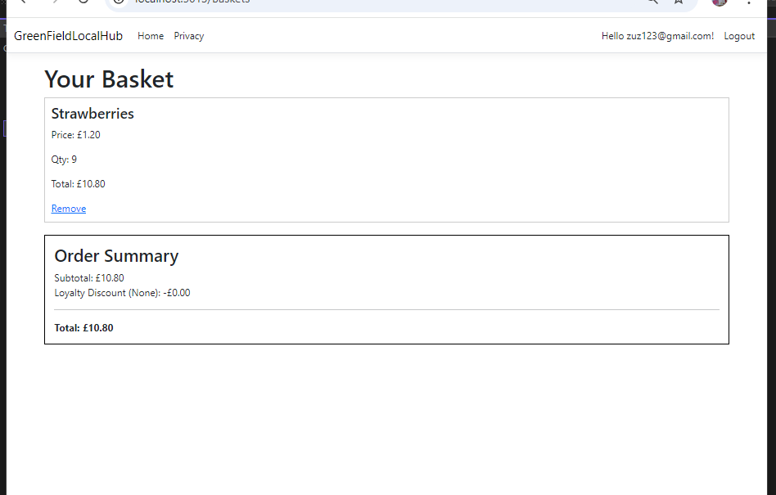 | The checkout button is inside the @if (!Model.Any()) block — meaning it only shows when the basket is empty. You need to move it to the else block, after the Order Summary: | <div style="border:1px solid #000; padding:15px; margin-top:20px;">  <h3>Order Summary</h3>  <div>  <span>Subtotal:</span>  <span>£@(((decimal)ViewBag.Subtotal).ToString("0.00"))</span>  </div>  <div>  <span>Loyalty Discount (@ViewBag.Tier):</span>  <span>-£@(((decimal)ViewBag.DiscountAmount).ToString("0.00"))</span>  </div>  <hr />  <div>  <strong>Total:</strong>  <strong>£@(((decimal)ViewBag.Total).ToString("0.00"))</strong>  </div>  <!-- MOVED HERE -->  <a asp-controller="Orders"  asp-action="Create"  asp-route-basketId="@ViewBag.BasketId"  class="btn btn-primary w-100 mb-2">  Proceed to Checkout  </a>  </div>  }
Access denied when I log in as a farmer and access the farmer dasshbaord | Why do I get access denied when I log in as “farmer@example.com” | The issue is a typo in your controller's [Authorize] attribute. You wrote "Farmers" but the role is actually called "Farmer" (no S) in your seed data. | [Authorize(Roles = "Farmer")]
Farmer couldn’t see any orders that have been placed | Farmers cant see any of the orders that have been placed when going to the orders index | The issue is in your Index action — it checks for "Supplier" role but your actual role is "Farmer". Change it in the controller: | else if (User.IsInRole("Farmer"))  {  var supplierProducts = await _context.Products  .Where(p => p.Farmers.UserId == userId)  .Select(p => p.ProductsId)  .ToListAsync();  var supplierOrders = await _context.OrderProducts  .Where(op => supplierProducts.Contains(op.ProductsId))  .Include(op => op.Orders)  .Include(op => op.Products)  .ToListAsync();  return View(supplierOrders.Select(op => op.Orders).Distinct().ToList());  }
When trying to put the discount amount in the order details view, it wouldn’t simplify to 2 decimals and would show the whole thing | “It should be -£0.02”  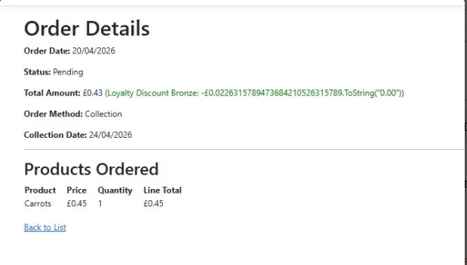 | The issue was the .ToString("0.00") was being treated as plain text rather than called as a method. The extra brackets around the cast fix that. | <span style="color:green;">(Loyalty Discount @ViewBag.Tier: -£@(((decimal)ViewBag.DiscountAmount).ToString("0.00")))</span>
[Add additional rows as needed then delete this instruction]

Copyright and Acknowledgements
‘T-LEVELS’ is a registered trademark of the Department for Education.
‘T Level’ is a registered trademark of the Institute for Apprenticeships and Technical Education.
The T Level Technical Qualification is a qualification approved and managed by the Institute for Apprenticeships and Technical Education.
‘Institute for Apprenticeships & Technical Education’ and logo are registered trademarks of the Institute for Apprenticeships and Technical Education.
Pearson Education Limited is authorised by the Institute for Apprenticeships and Technical Education to develop and deliver this Technical Qualification.
Pearson and logo are registered trademarks of Pearson.
Copyright in this document belongs to, and is used under licence from, the Institute for Apprenticeships and Technical Education, © 2025

