Development Documentation
Development Diary
Day 1 – Version 1.0
- I opened Visual Studio 2022 and created a new ASP.NET Model View Controller project, selecting .NET 9.0 and setting the authentication type to Individual Accounts.
- I installed the following 3 NuGet packages:
  - Microsoft.VisualStudio.Web.CodeGeneration.Design -Version 9.0.12
  - Microsoft.EntityFrameworkCore.Design -Version 9.0.12
  - Microsoft.EntityFrameworkCore.SqlServer
- 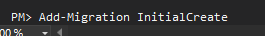
- I ran Add-Migration and Update-Database to create the SQL database required for the Individual Accounts authentication type.
- I ran the application using HTTP and tested both the login and registration functionality.
- 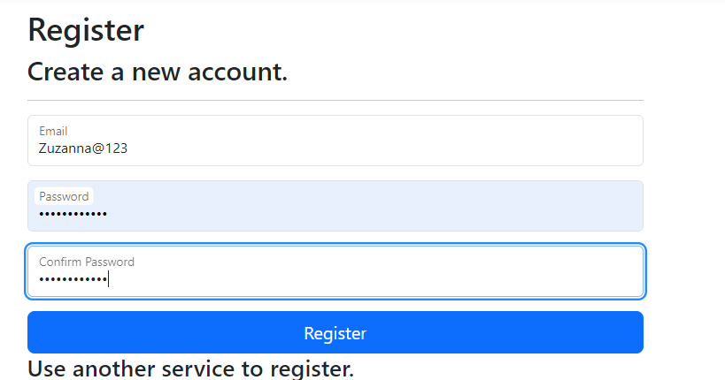
- 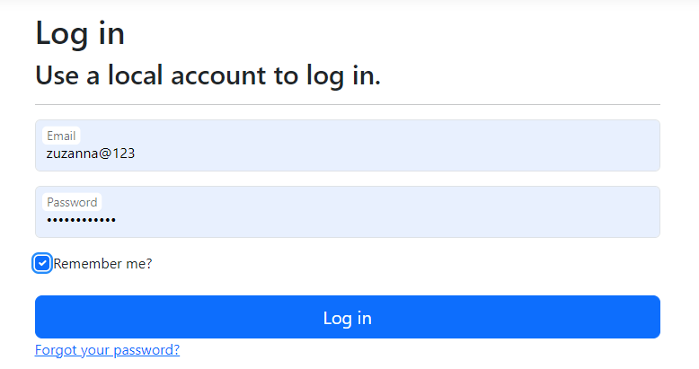
- No errors occurred during testing.
Models
- 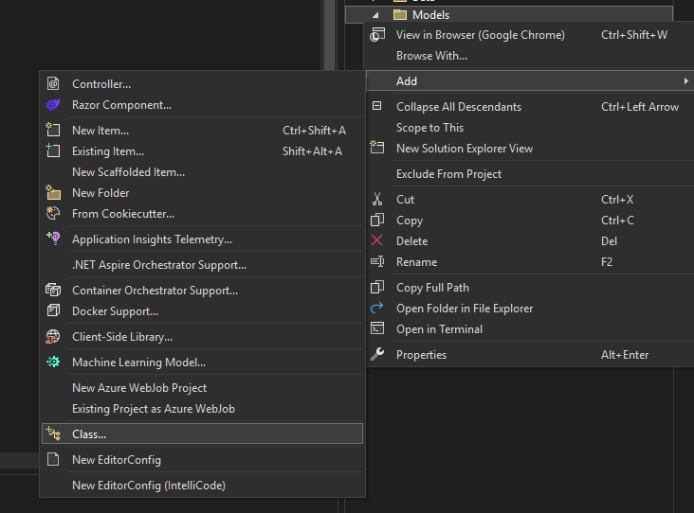
- To create a model, I right clicked on the “Models” folder, then went to add + class. I made a total of __ models:
  - Basket
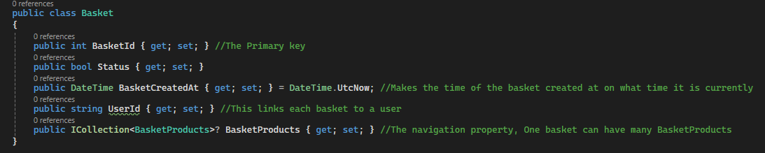
  - BasketProducts
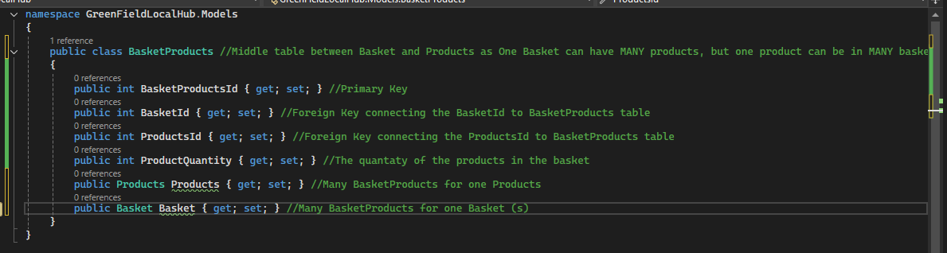
  - OrderProducts
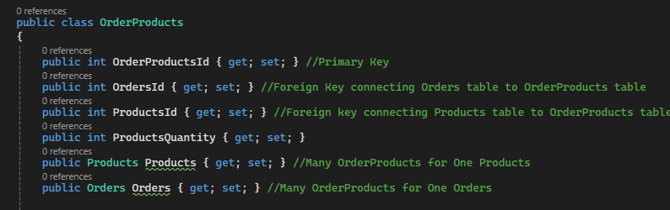

  - Orders
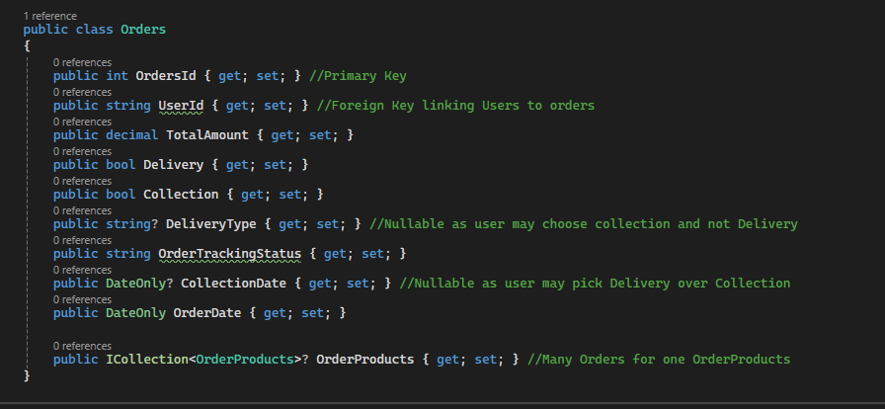
  - Products
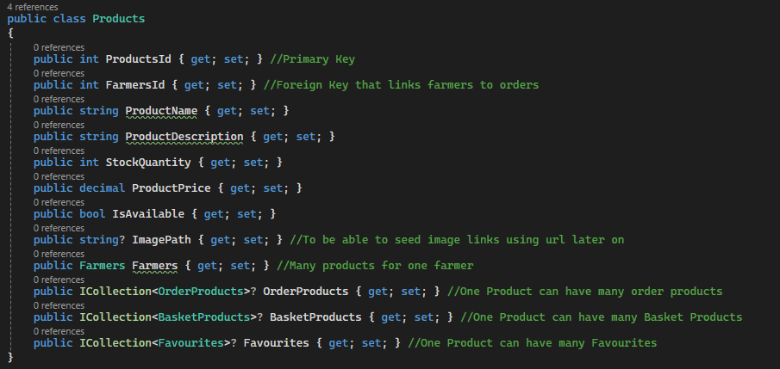

  - Farmers
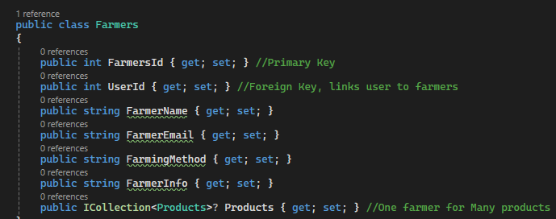
  - Favourites
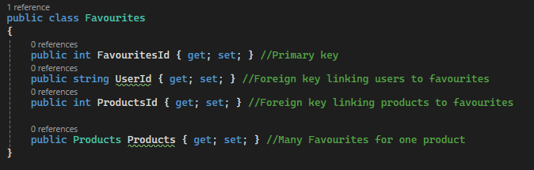
  - Loyalty Account
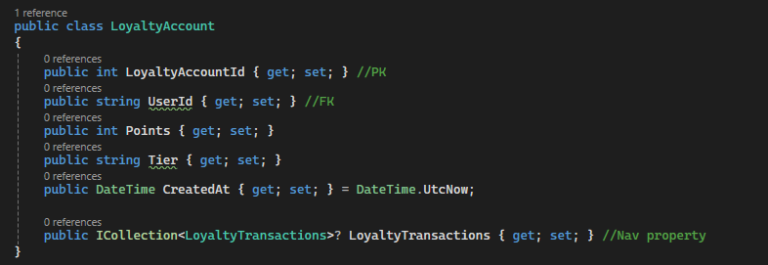

  - Loyalty Transactions
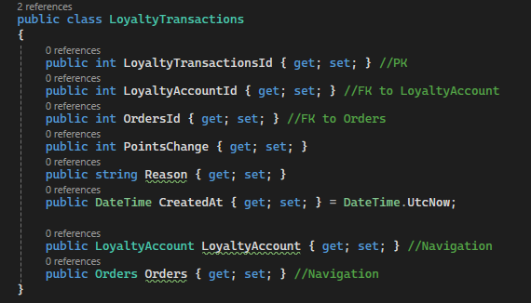
Controllers
- I automatically scaffolded a controller for each model, since every model requires its own controller.
- 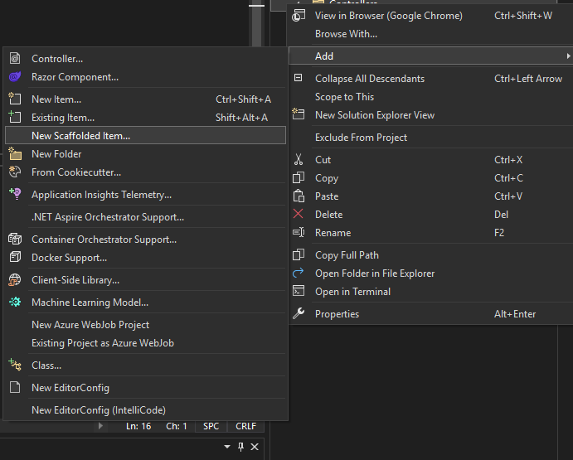
- To do this, I right-clicked on the Controllers folder and selected Add > Scaffolded Item.
- I chose "MVC Controller with views, using Entity Framework", as this automatically generates both the controller and views for each model.
- 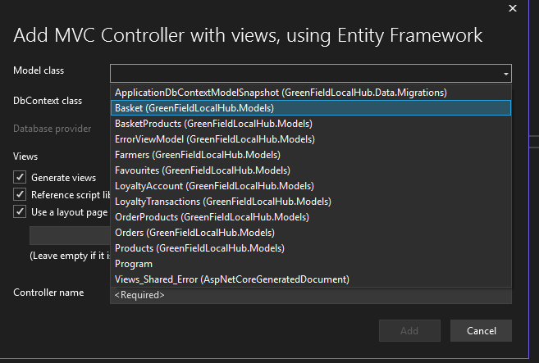
- I selected each model and clicked Add, using ApplicationDbContext as the DbContext class.
- I then ran Add-Migration and Update-Database again to apply the new changes.
- I ran the application using HTTP to test each of the endpoints.
- 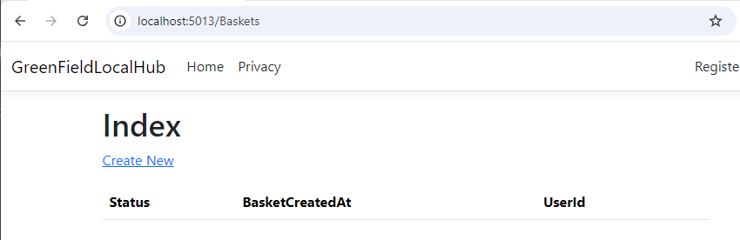
- The Baskets endpoint loaded correctly, and each of the other endpoints followed the same pattern.
Seeding Data
- Right clicked the Data folder and pressed add class, naming it “Seed Data”
- 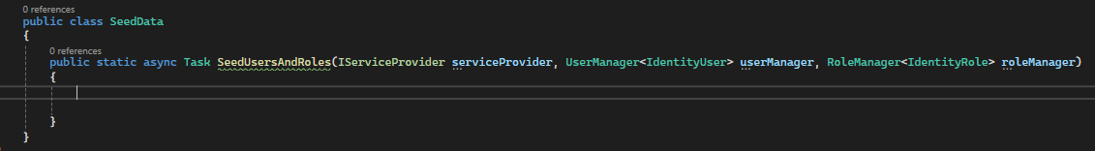
- Inside this class, I wrote code to pre-fill the database with default users and roles.
- I added the Admin, Farmer, Standard, Loyalty, and Developer roles.
- I also created three seeded farmer user accounts.
- I then registered the seed data call in Program.cs.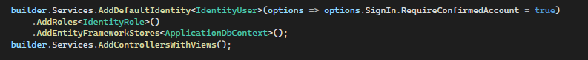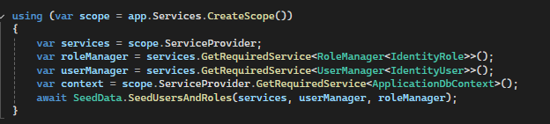
- I ran Add-Migration and Update-Database to apply the changes.
- I ran the application and tested whether the seeded roles were working correctly.
- 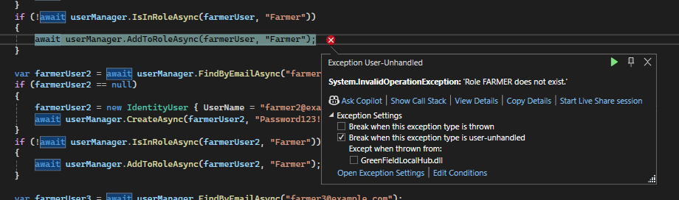
- An error was encountered during testing.
- To fix it, I moved the role-seeding code outside of the foreach loop.
- I tested the code again after making the fix.
- 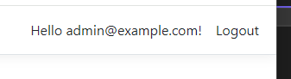
- I was then able to successfully log in using the seeded user accounts.
- Next, I seeded data into the Farmers table.
- 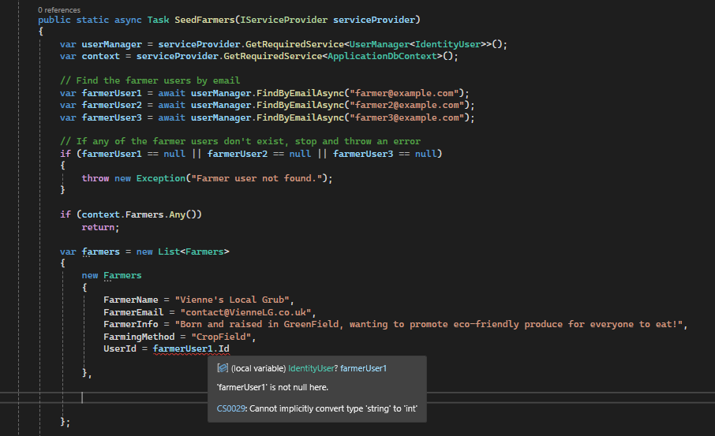
- When seeding farmer info, an error occurred saying “farmerUser1 is not null here”

- 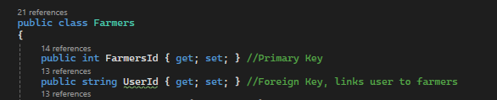
- The cause of the error was that the UserId property in the model was set to int instead of string, so I corrected it to string.
- I ran Add-Migration and Update-Database to apply the fix.
- 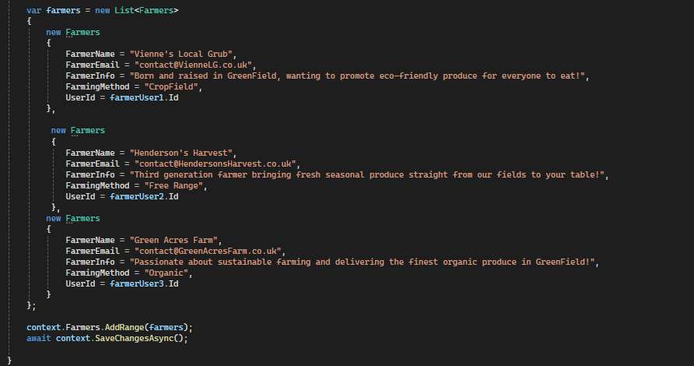
- I seeded a total of three farmers into the database.
- I registered the seed data call in Program.cs.
- I ran the application to confirm the data had seeded successfully.
- 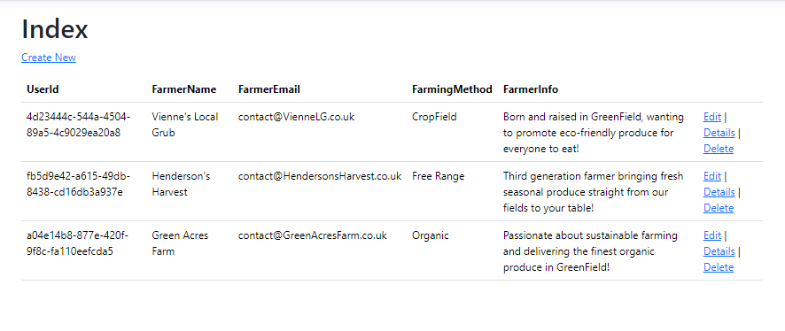
Day 2 - Version 1.1

- I opened the project from the GitHub repository I had uploaded the previous day for version control. Upon opening it, I ran Add-Migration and Update-Database to ensure the database was up to date.
Seed Data
- 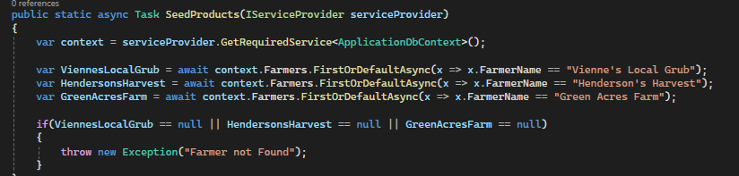
- This code looks up each farmer from the Farmers table by name, allowing products to be linked to the correct farmer.
- I began seeding products linked to farmers, adding four different products spread across my three farmers.
- 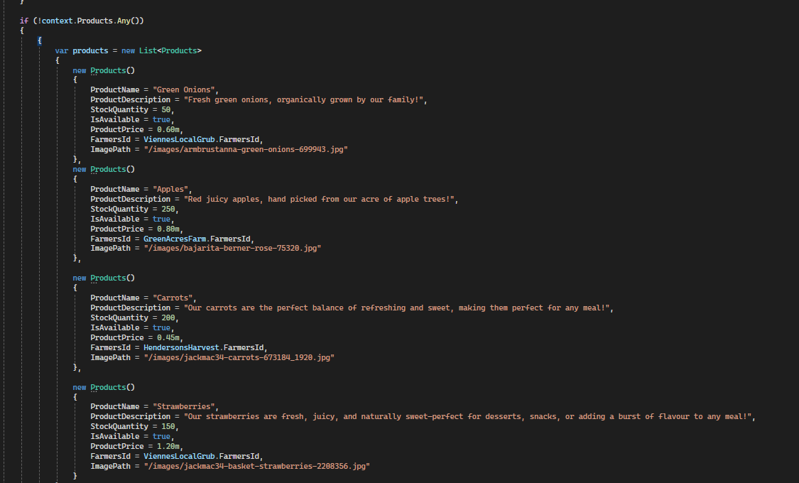
- Then in program.cs I add “await SeedData.SeedProducts(services);
- 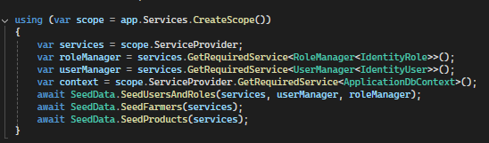
- I ran the application to check whether it worked correctly and whether any errors occurred.
- 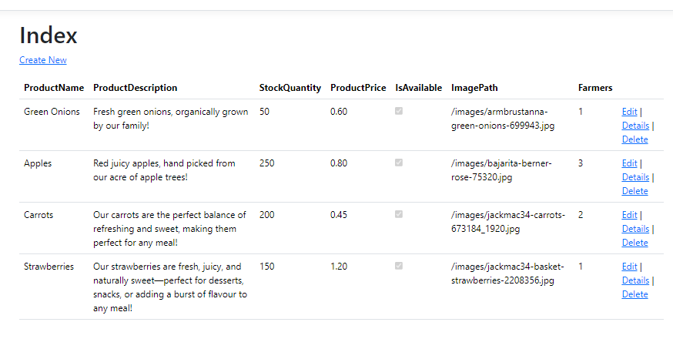
- It worked!
Basket
- I go to the index page of the products view and add the “add to basket” button
- 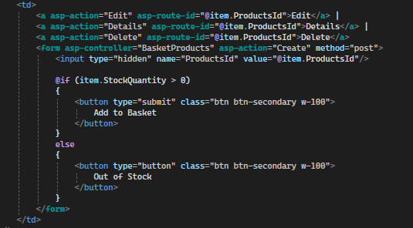
- I ran the application to test whether it worked.
- 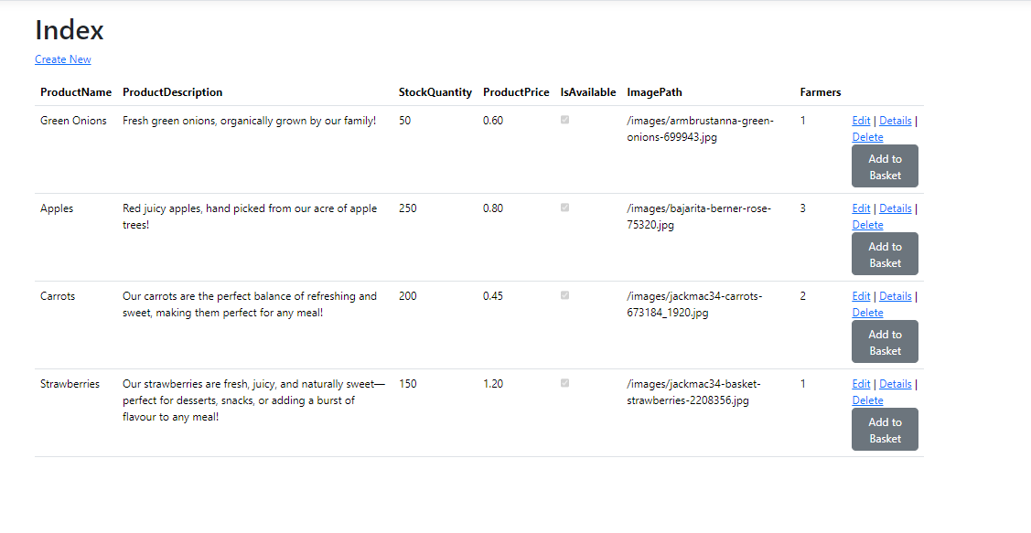
- The "Add to Basket" button appeared successfully.
- I press the button but it wont let me create as I cant input anything in “basketId”
- 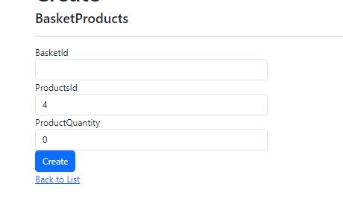
- I navigated to the BasketProducts controller and reviewed the POST Create function.
- 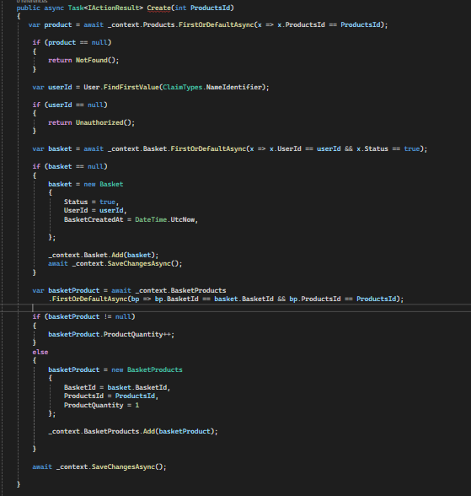
- I attempted to run the application again.
- 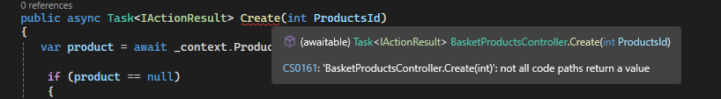
- An error occurred, so I referred back to my revision PowerPoints and discovered I had missed a line of code at the very bottom of the method.
- 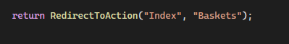
- I attempted to run the application again after adding the missing line.
- 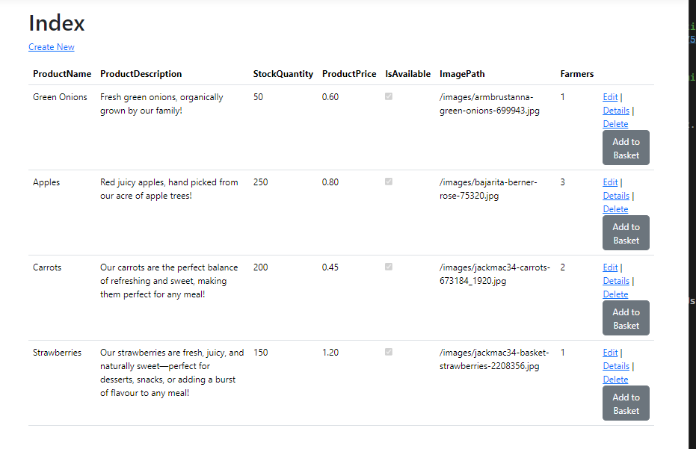
- Loads the website, I press add to basket
- 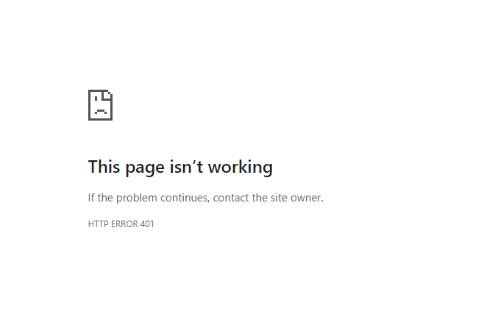
- An error occurred.
- I asked AI what was the issue and it said it was because I wasn’t logged in as the return unauthorized creates an error 401 error
- I logged in and ran the application to test the basket again.
- 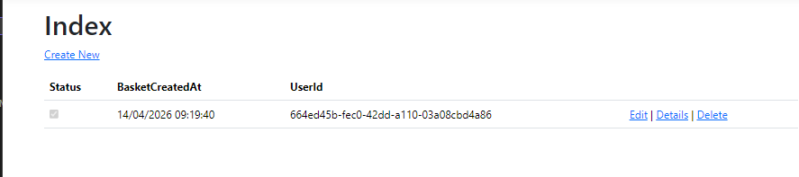
- It worked!
- I went to the Baskets controller and located the Index action so I could include the relevant product information that the user would actually want to see.
- 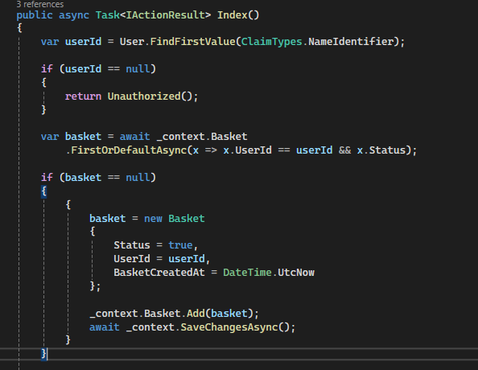
- I find in the logged in user, then check if they have a basket, and if they don’t then the code creates one for them
- 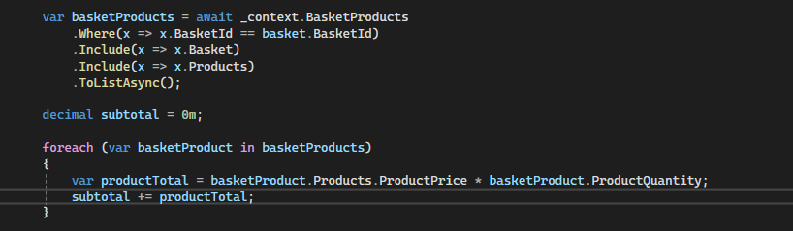
- It then retrieves all the products in the basket and calculates the subtotal.
- 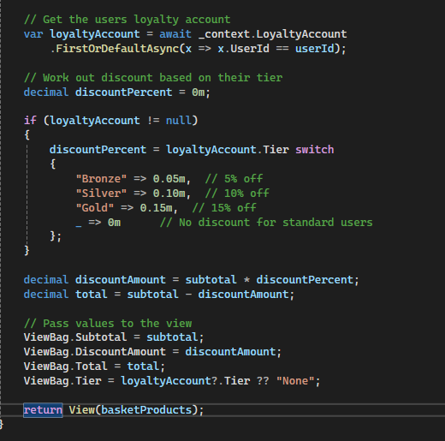
- I also retrieve the user's loyalty account and calculate any applicable discount based on their loyalty tier.
- In the Basket Index view, I updated it to display the product name, unit price, quantity, and the total amount spent.
- 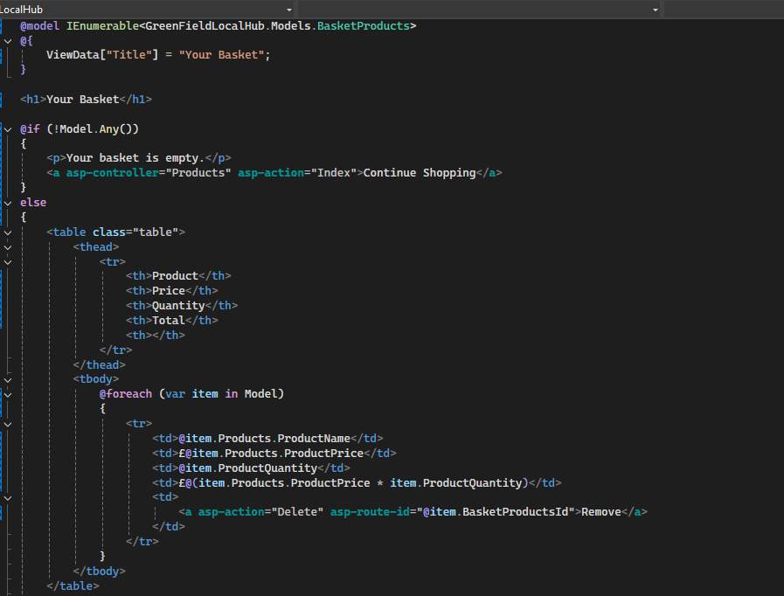
- 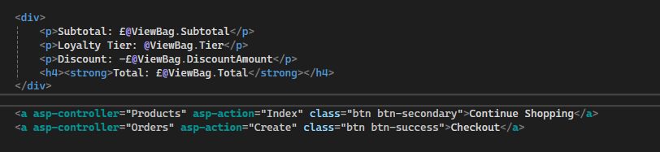
- I ran the application to test the changes.
- 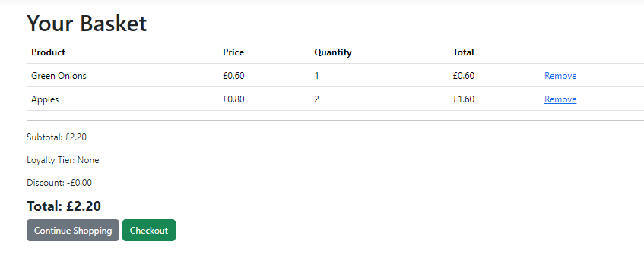
- It worked!
Version 1.2 – Day 3
- I go to the basket index view and delete everything, then write code that displays a message if the basket is empty, and if it isn’t then it displays the price and quantity of each item

- I ran the application to test whether it worked.
- 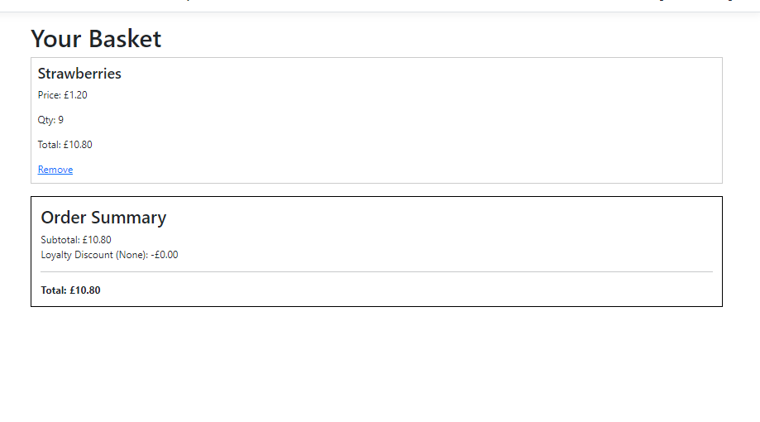
- It worked!
- I added a checkout button to the Basket Index view, but doing so caused an error.
- 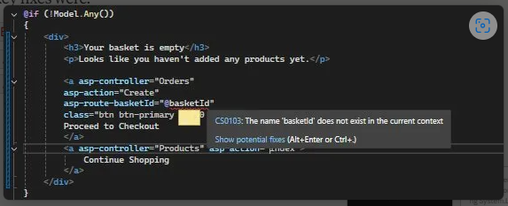
- I asked an AI assistant to help me understand the cause of the error and how to fix it.
- 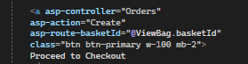
- Following the advice, I switched to using ViewBag to pass the data, which resolved the error.
- I opened the Orders Create view (Create.cshtml) and cleared its existing contents.
- 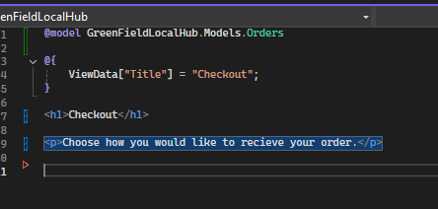
- I then built the checkout form from scratch.
- 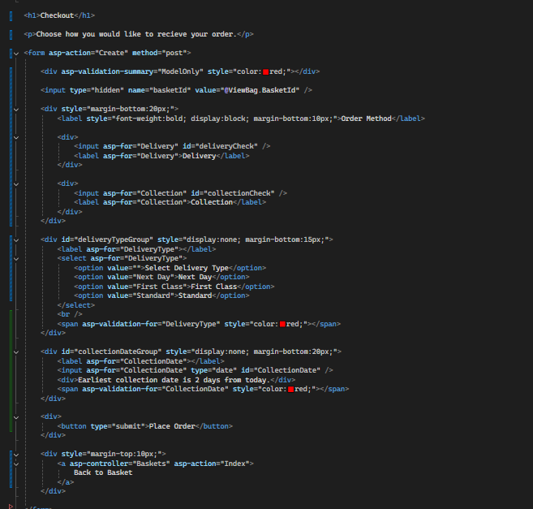
- I also added JavaScript at the bottom of the page to dynamically show or hide the delivery group type and collection date fields depending on whether the user selects delivery or collection.
- 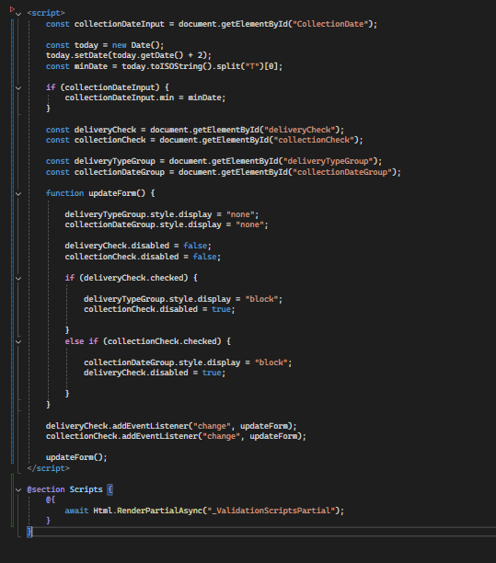
- I ran and tested the application.

- Realize I don’t have a proceed to checkout button

- 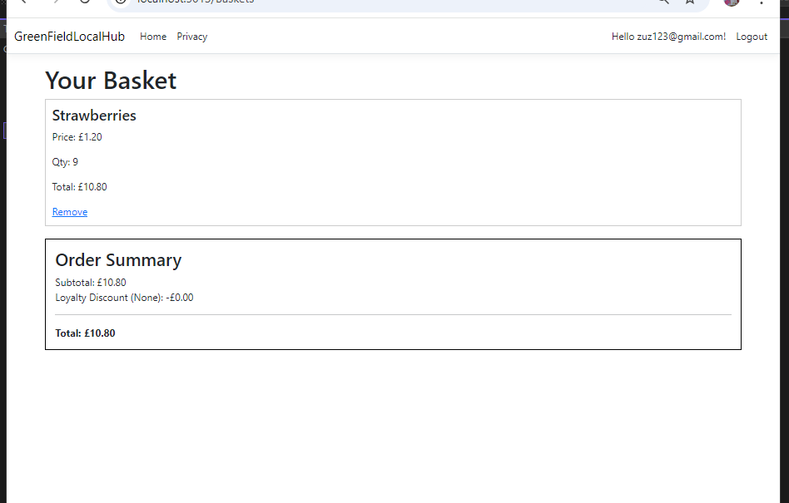
- I asked an AI assistant to help identify the problem.
- 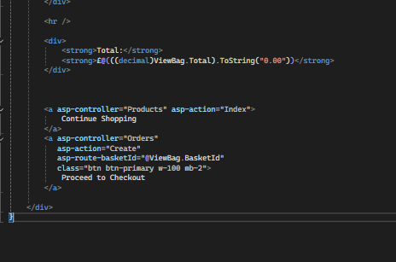
- Following the suggestion, I moved both the "Continue Shopping" and "Proceed to Checkout" buttons to the bottom of the Basket Index view.
- I ran the application again.
- 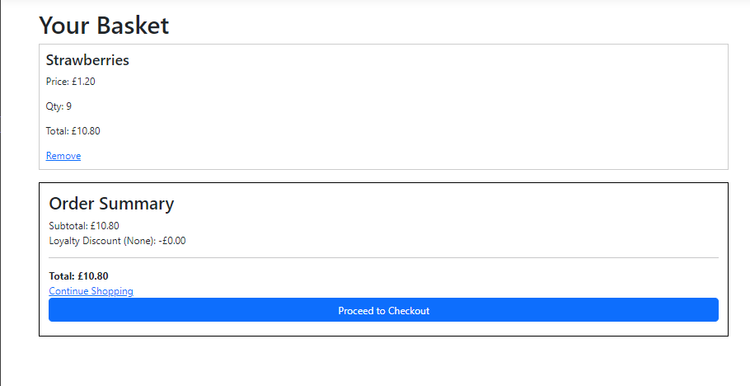
- The button appeared successfully.
- 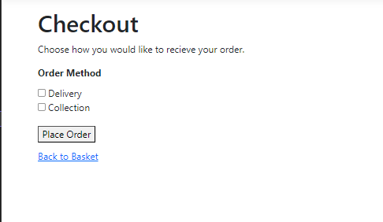
- The checkout form also appeared correctly.
- I then worked on the POST Orders/Create controller action.
- 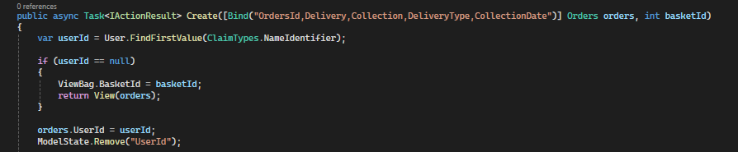
- I updated the parameters to retrieve the currently logged-in user and assign the relevant values to the order.
- 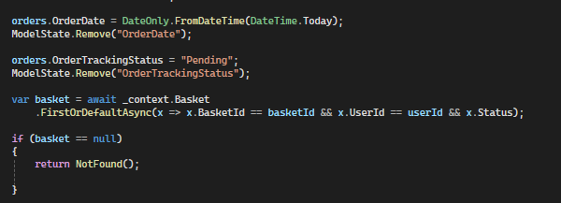
- I set the order date and the initial tracking status.
- I then retrieved all items currently in the user's basket.
- 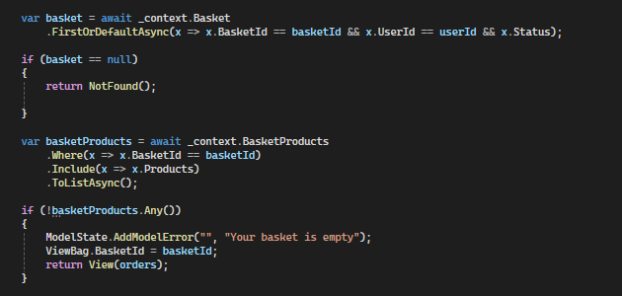
- I calculated the subtotal from those items.
- 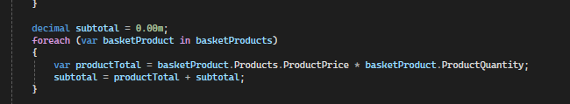
- I added the discount calculation logic.
- 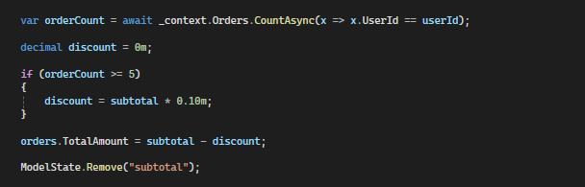
- I also handled whether the order was set to delivery or collection.
- 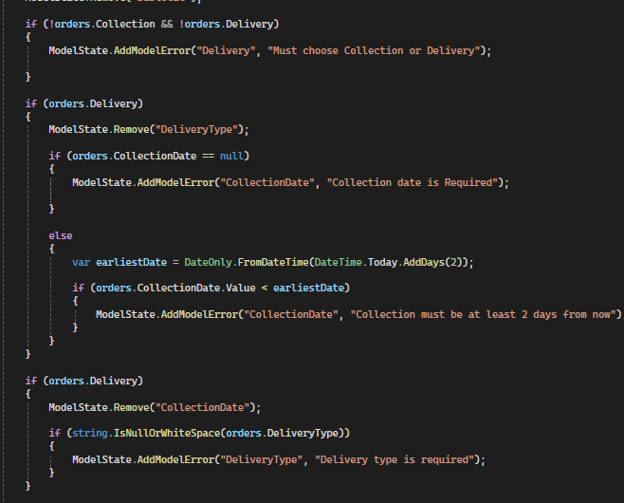
- I added error checking to catch any issues.
- 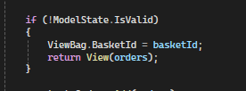
- Finally, the order is created and the product stock levels are updated accordingly.
- 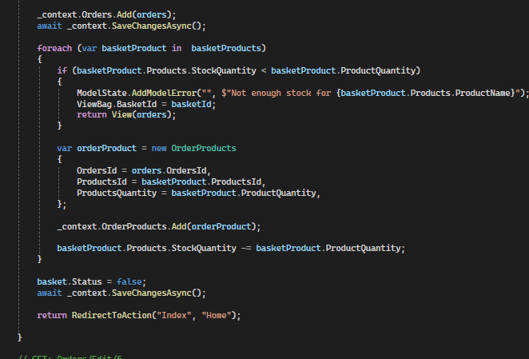
- I ran the application and placed a test order.
- I selected delivery, placed the order, and was redirected to the Home Index page as expected.
- I navigated to the Orders page and confirmed the order appeared correctly.
- 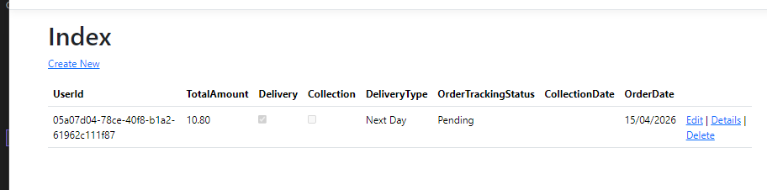
- The next feature I worked on was updating the Order Index to list orders, with the Details view showing a full breakdown of the products within each order.
- I opened the Orders Details view (Details.cshtml).
- 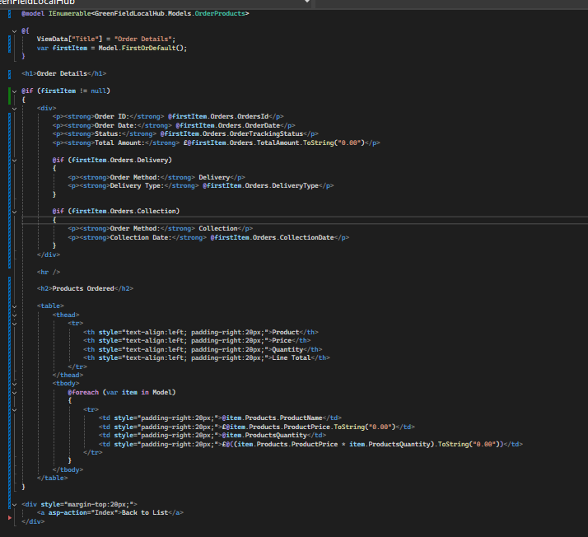
- I then updated the GET controller method for the Orders Details action.
- 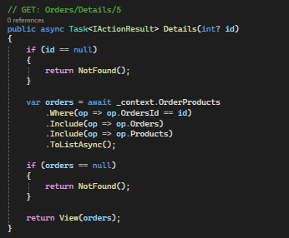
- I ran the application to test the changes.
- 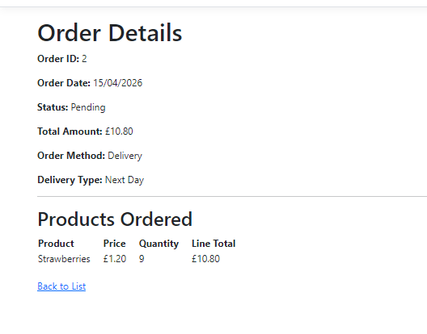
- It worked!
- I then reviewed the Index action in the Orders controller.
- 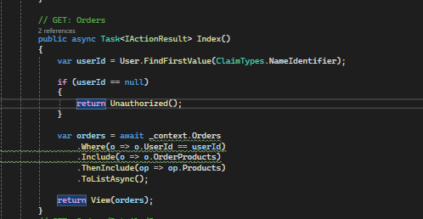
- At this point it only displayed the order history for the currently logged-in user.
- However, Admin and Farmer users should be able to see all orders from every customer.
- 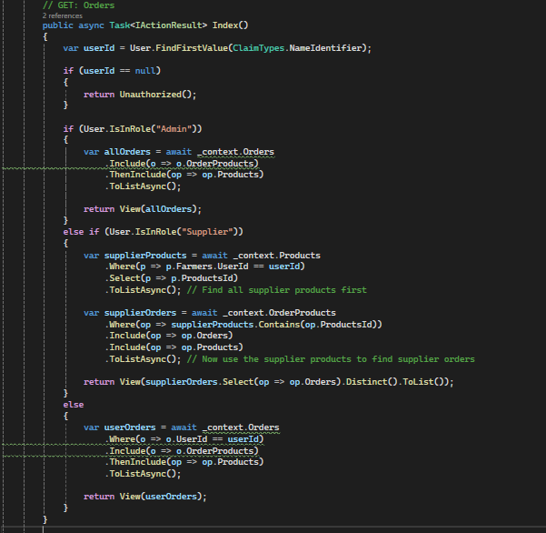
- With that in mind, I decided it was time to create the Farmer Dashboard.
- I created a new controller named FarmerDashboardController.
- 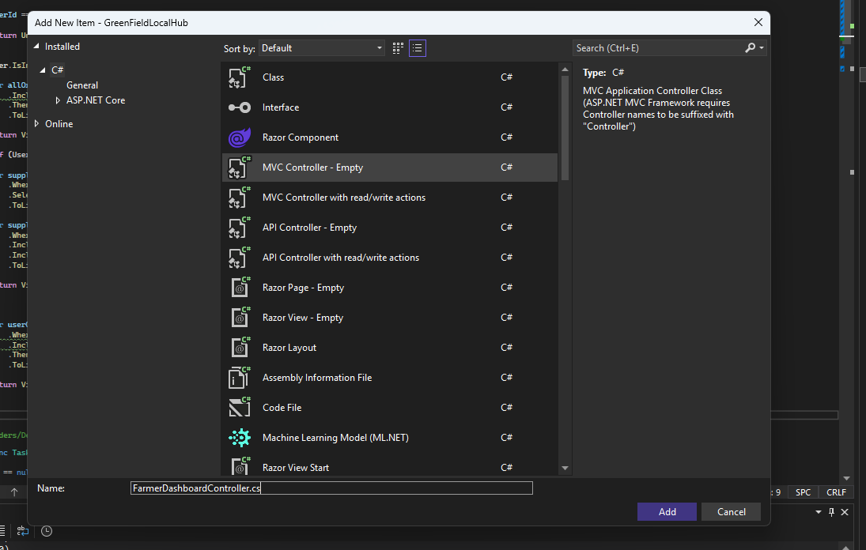
- I create a new folder in views called “FarmerDashboard”
- 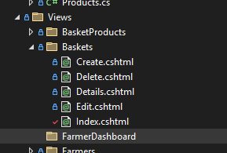
- I added an Index.cshtml page to that folder.
- In the FarmerDashboard controller, I applied an [Authorize] attribute to restrict access to the Farmer role only.
- 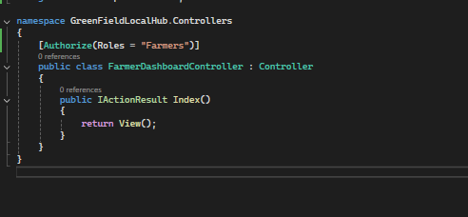
- I then injected the database context (_context) into the controller.
- 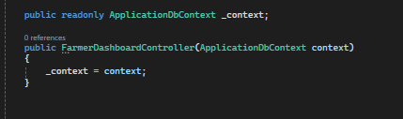
- 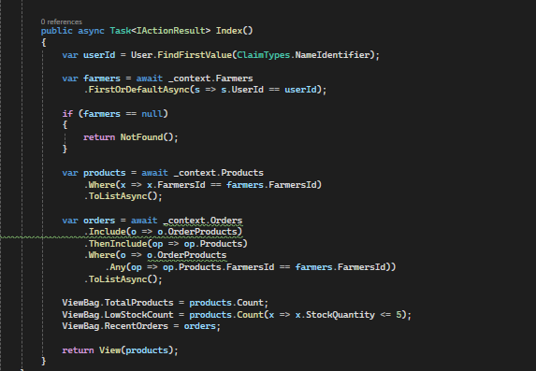
- I updated the Index method to retrieve the currently logged-in user's ID, find the associated farmer record, load the farmer's products, load all orders that contain those products, and calculate the relevant dashboard statistics.
- I then opened the Farmer Dashboard Index view.
- 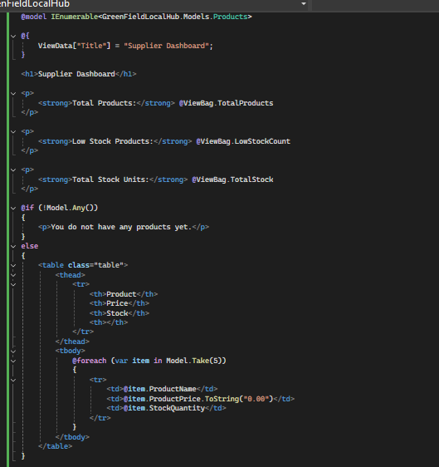
- 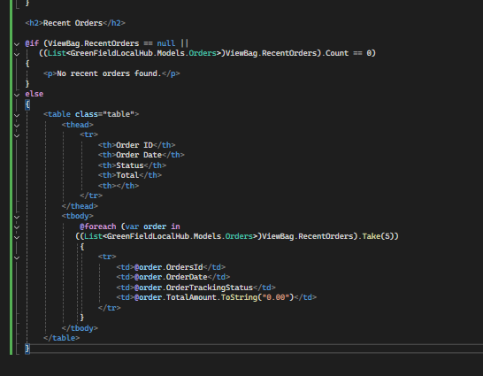
- I ran the application.
- 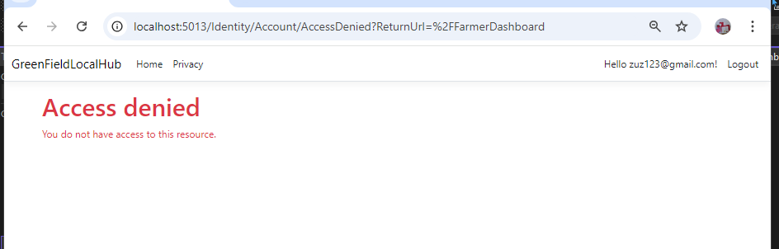
- Access was correctly denied for a normal user account, so I logged in as a farmer account to continue testing.
- I logged in using farmer@example.com.
- 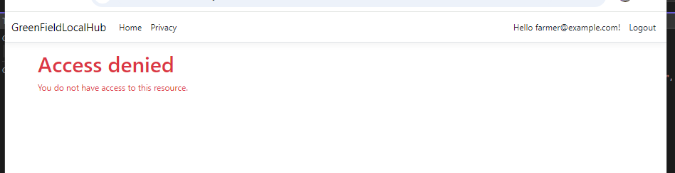
- Access was still denied.
- 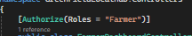
- Change from “farmers” to “Farmer”
- I ran the application again.
- 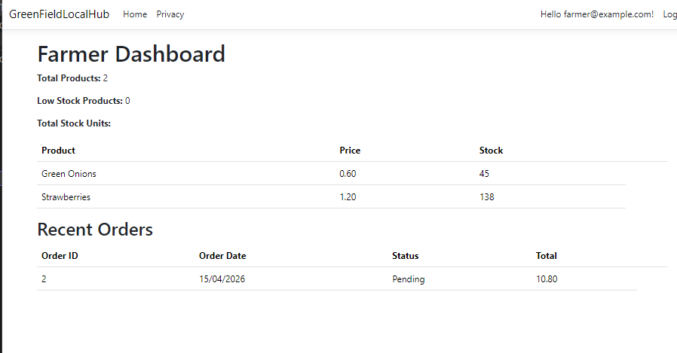
- It worked!
- I then added management buttons to the dashboard, including options to manage stock levels, view all their products (rather than just the first five), update product details, and view all orders.
- 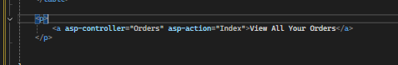
- I added these buttons to the bottom of the Farmer Dashboard Index page.
- I ran the application.
- 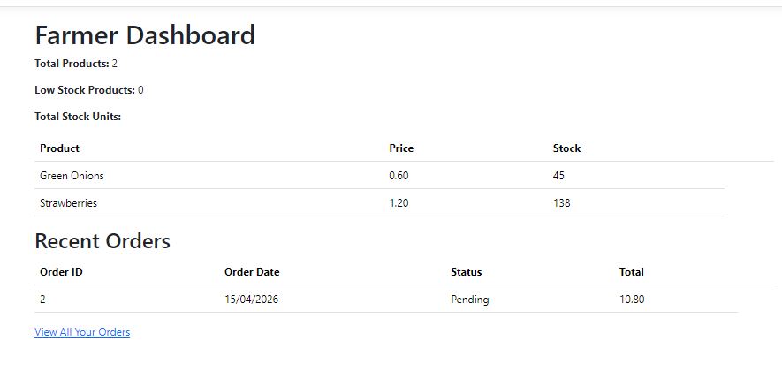
- The button appeared correctly.
- 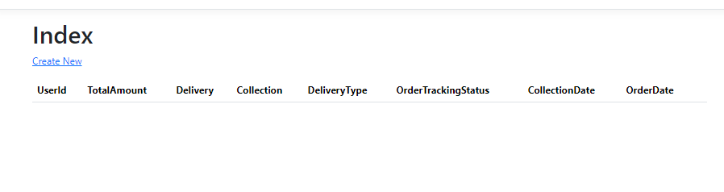
- When I pressed the button, it functioned as expected.
- 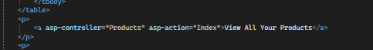
- I also added that element above the orders section.
- I navigated to the Products controller Index action.
- 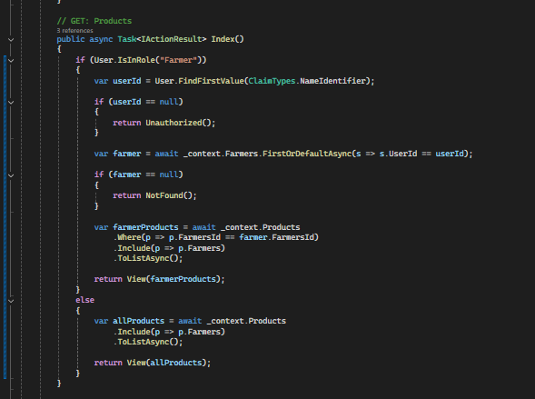
- I ran the application.
- 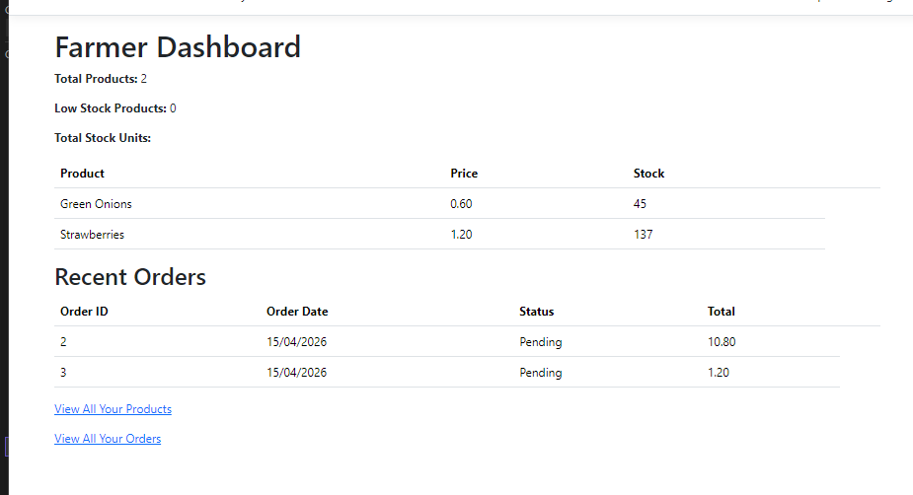
- Both buttons appeared on the page.
- I also adjusted the placement of the "View All Products" button.
- 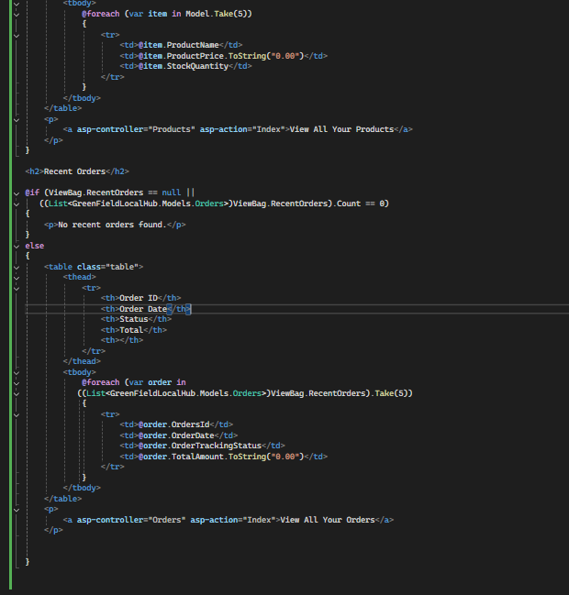
- I restricted the Edit and Delete buttons so they are only visible to users in the Farmer role.
- 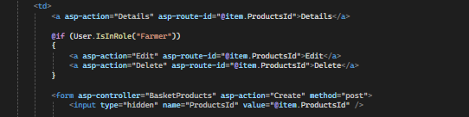
- I removed the FarmersId field from the edit form, as it should not be editable.
- 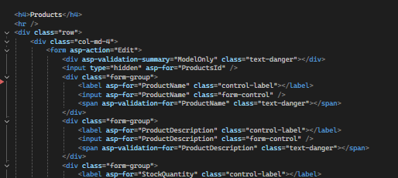
- I also removed the corresponding line in the Products controller.
- 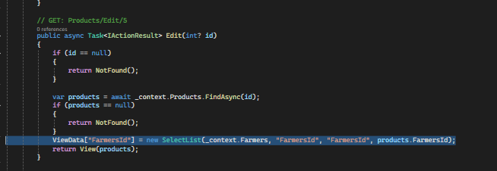
- I removed FarmersId from the POST Edit method as well.
- 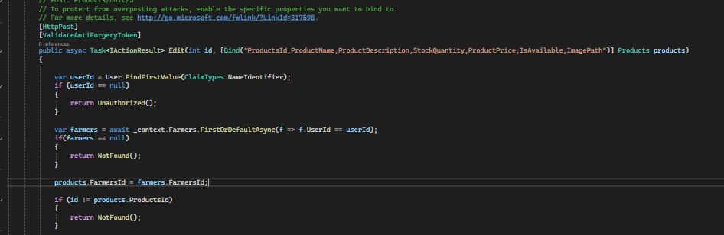
- I added the appropriate replacement logic to the POST Edit method.
- I applied the same changes to the product deletion functionality.
- 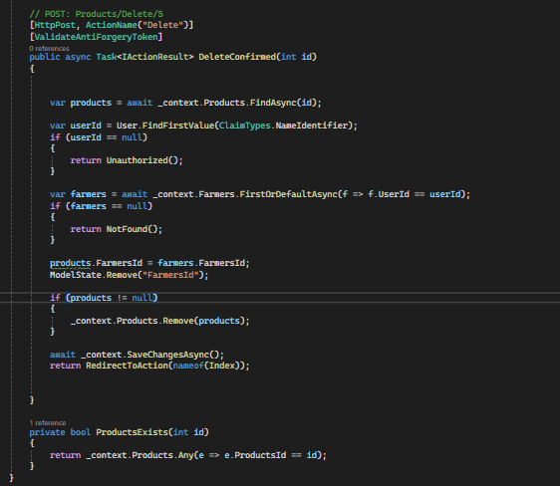
- I ran the application to verify everything was working.
- 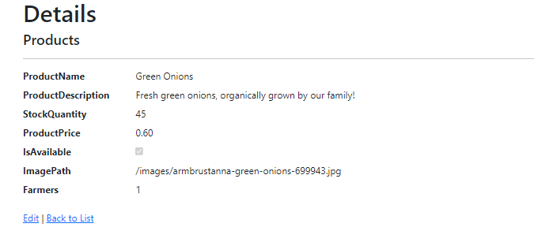
- I noticed that a normal user was still able to access the edit functionality from the Details page.
- To fix this, I added an [Authorize] attribute to the GET Edit action in the Products controller.
- 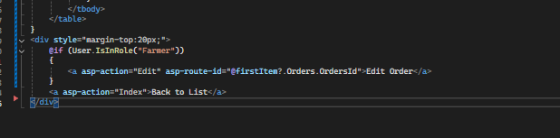
- I also updated the Product Details view to conditionally show edit and delete options based on the user's role.
- I ran the application.
- 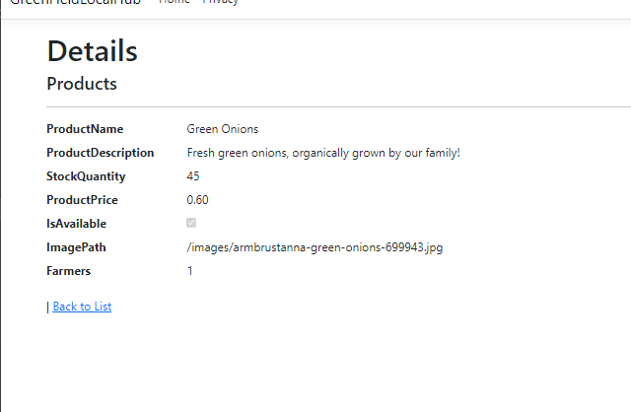
- It worked!
- 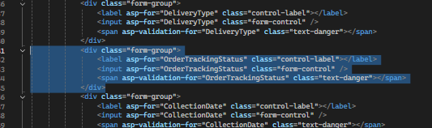
- I removed the unnecessary highlighted element from the Orders edit view.
- 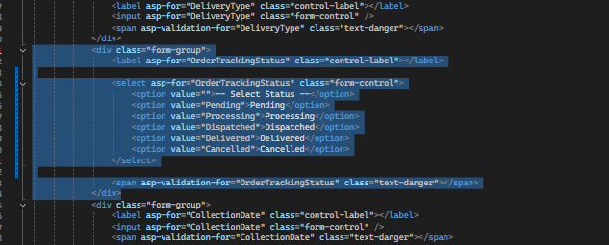
- I replaced it with updated code.
- I ran the code to test the change.
- I realized that farmers aren’t able to see all orders
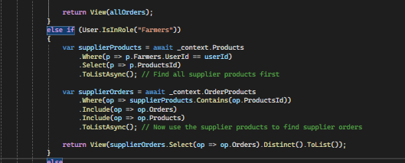
- The role check was referencing "Suppliers" instead of "Farmers".
- I tested the application again.
- 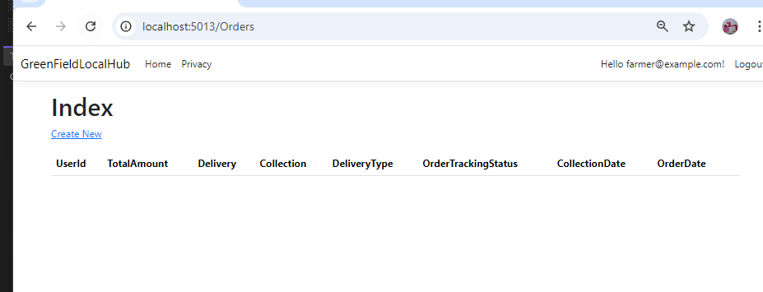
- The issue persisted.
- 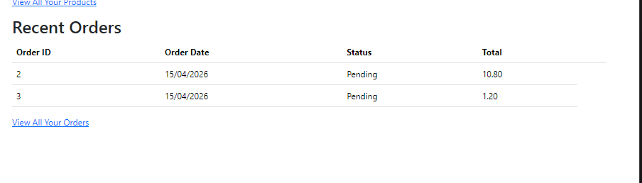
- The correct role name appeared in the Recent Orders section but not on the Orders Index page.
- Changed from “Farmers” to “Farmer”
- I ran the application again.
- 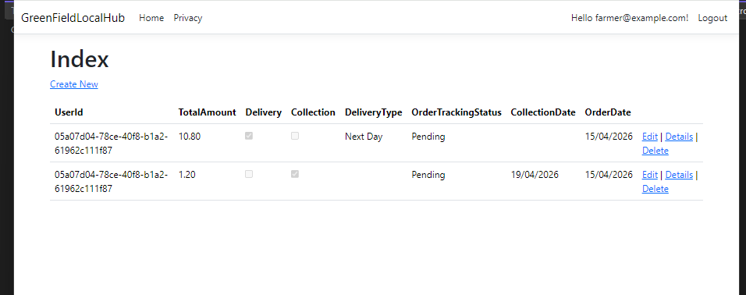
- It worked — farmers were now able to see all orders.
- I then tested whether farmers could update the order tracking status.
- 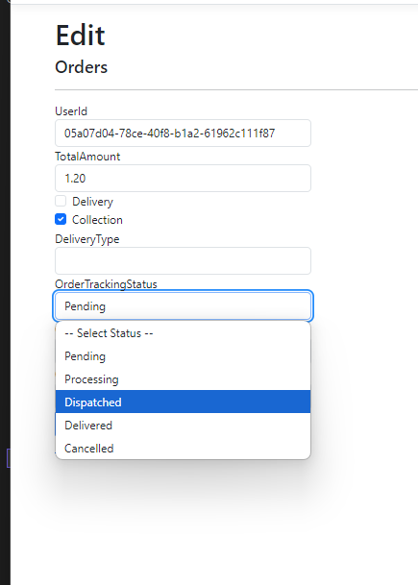
- It worked!
- I added navigation buttons to every page for easier access.
- 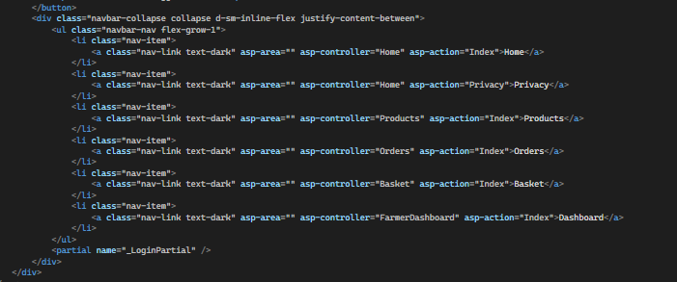
- I ran the application to verify everything was working.
- 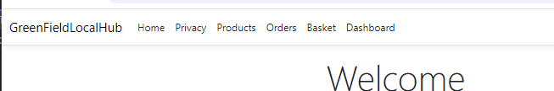
- Basket doesn’t work
- The issue was a typo — the nav bar link was missing the "s" at the end of "Baskets".
- I ran the application again.
- All navigation buttons were then working correctly.
- I also needed to ensure the Dashboard link in the nav bar was only visible to users in the Farmer role.
- 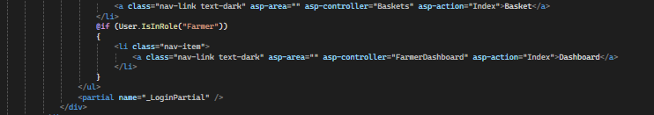
- I ran the application to test the changes.
- 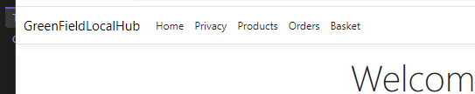
- When logged in as a standard user, the Dashboard link does not appear.
- 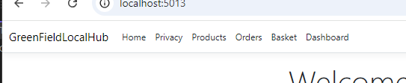
- When logged in as a farmer, the Dashboard link appears as expected.
- Now I need to make it so user id isn’t shown in orders and shows user email instead
- 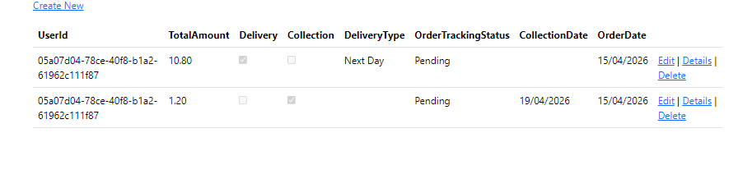
Version 1.3 – day 4
- I began by working on the loyalty accounts functionality.
- 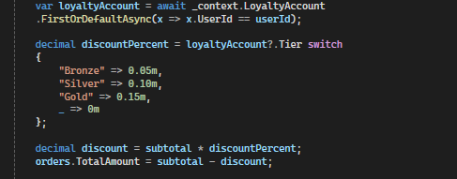
- I added the loyalty points logic to the POST Orders Create controller action.
- 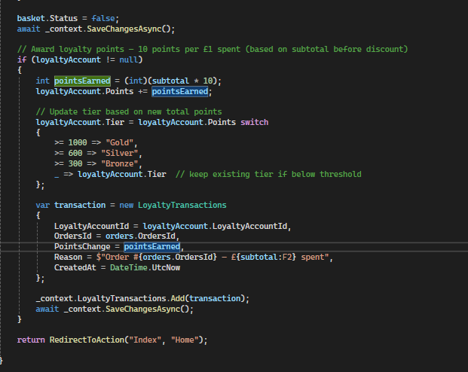
- I configured the system to award 10 points for every £1 spent, which provides a clear incentive for users to make purchases.
- 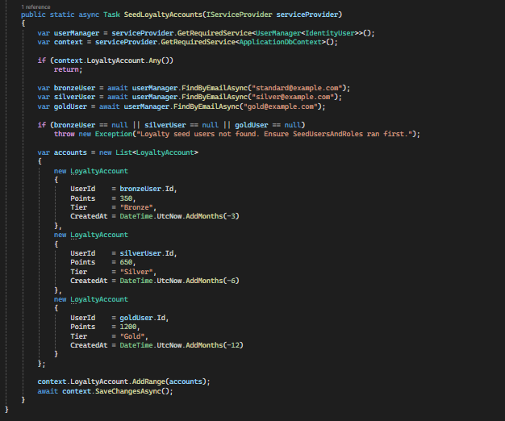
- I seeded the different loyalty tiers to a test user to verify that the discount calculation was working correctly.
- I then added the loyalty account seeding call to Program.cs.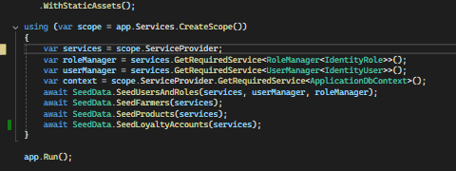
- I ran the application and attempted to log in with the newly seeded users.
- 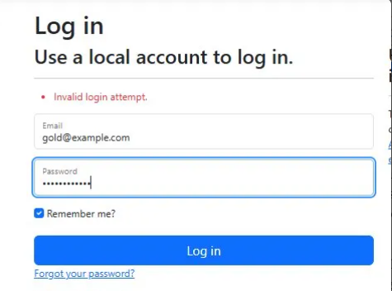
- Doesn’t work!!
- I decided to add Bronze, Silver, and Gold to the seed users and roles section.
- 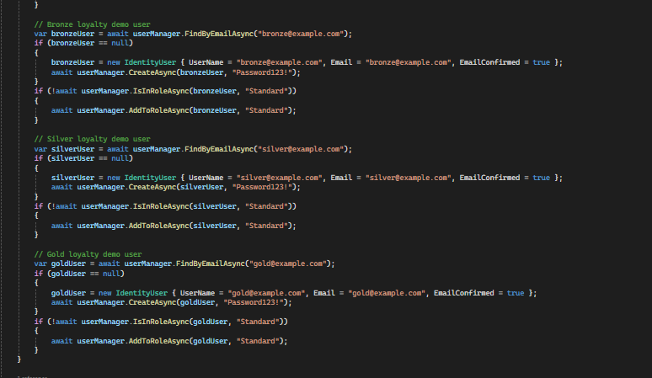
- I added Bronze, Silver, and Gold tier roles to the seed users and roles section.
- I then ran Drop-Database to clear all existing data, followed by Update-Database to rebuild and repopulate the database from scratch.
- I fix the sign up page so that if a loyalty account user already has a loyalty account, it goes straight to my account instead of sign up, and if they don’t have a loyalty account already then it goes to sign up
- 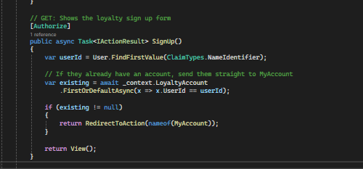
- I ran the application again to test the changes.
- 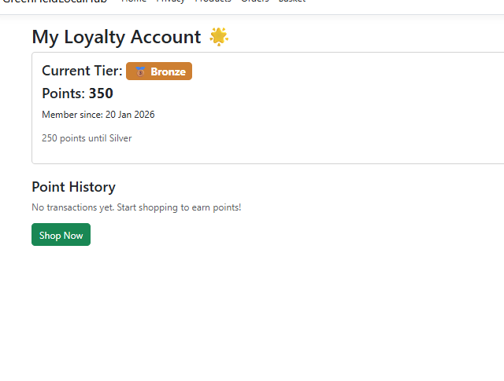
- The Bronze tier points were displayed correctly.
- 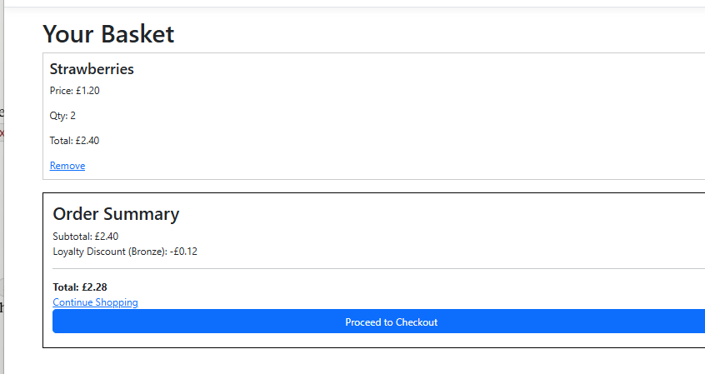
- The 5% discount for Bronze tier was applied correctly.
- 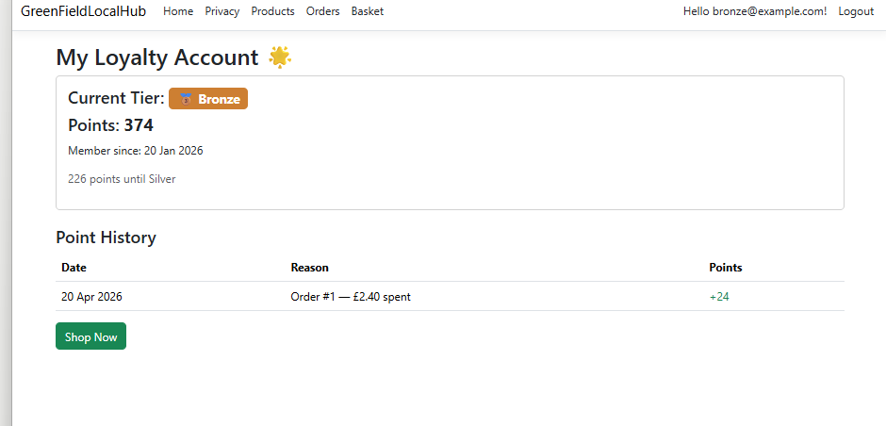
- I placed an order and received points — 10 for every £1 spent, as intended.
- I confirmed this behaviour worked correctly for every loyalty tier.
- 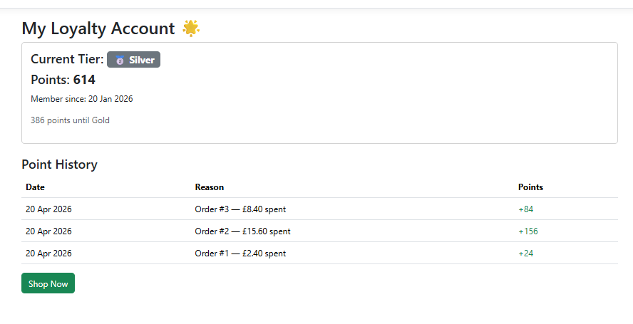
- I also tested whether accumulating enough points would upgrade the loyalty tier, and it did.
- I ran Drop-Database and Update-Database to reset the test data for the bronze@example.com account.
- 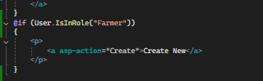
- In the Products Index view, I wrapped the "Create New" button in a role check so that only Farmer accounts can see and use it.
- I ran the application.
- 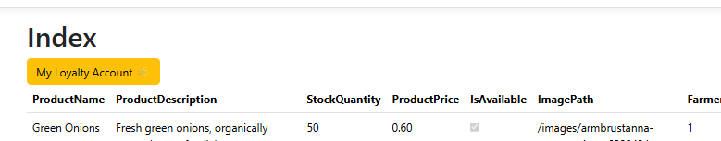
- The button was not visible to normal users.
- 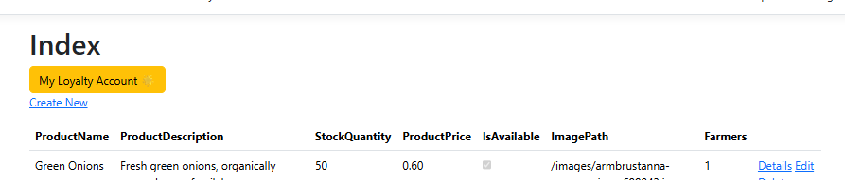
- The button appeared correctly for farmer accounts.
- This was a satisfying moment — everything was working as intended.
- 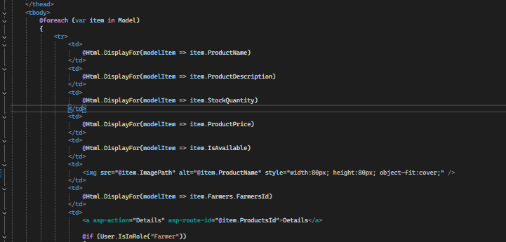
- I replaced the @Html.DisplayFor that was showing the image file path with an <img> tag so the actual image is displayed instead.
- This means the product image now displays inline rather than showing the raw file path.
- I ran the application.
- 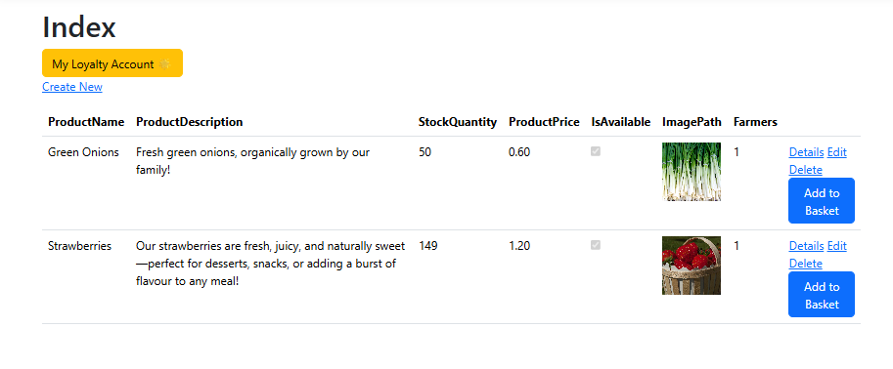
- The image appeared correctly.
- I noticed the table was displaying the FarmerId rather than the farmer's name, which I wanted to fix.
- 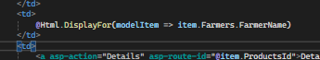
- I updated the view to display FarmerName instead of FarmerId.
- I ran the application.
- 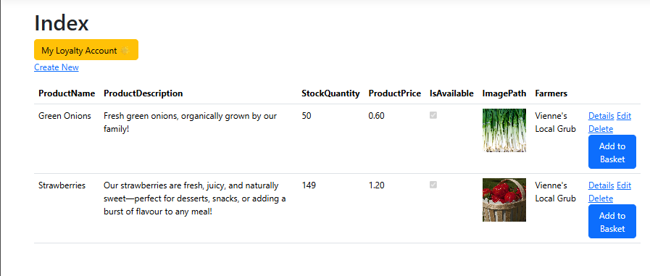
- It worked!
- I then decided to take on a more ambitious feature — a slide-out side panel for the basket.
- I added a button to trigger the side panel.
- I created a new method in the Products controller called SidebarPartial.
- 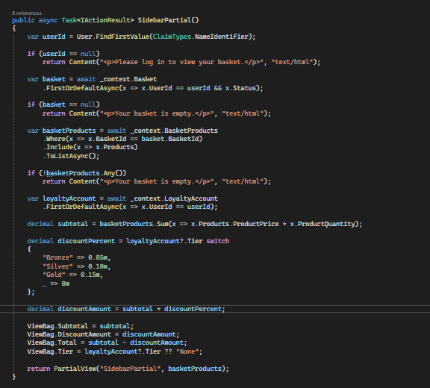
- I created a corresponding partial view named SideBarPartial.
- 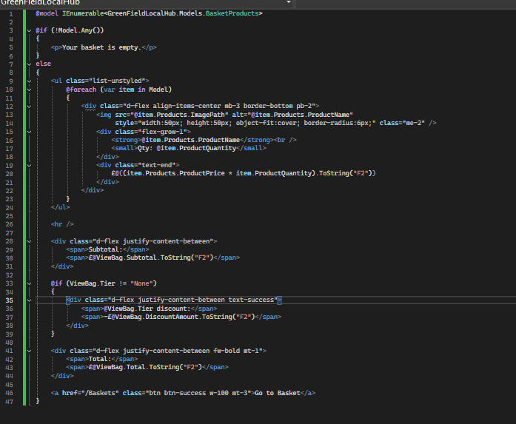
- 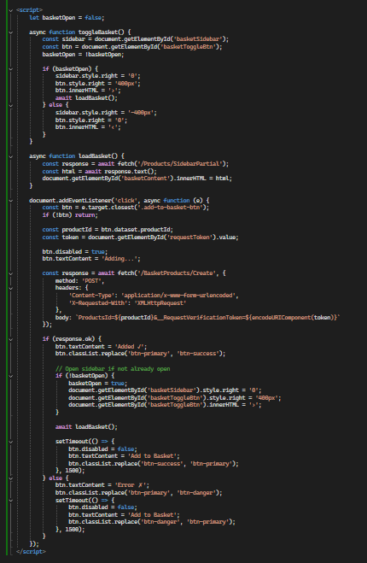
- I added JavaScript to handle the open and close behaviour of the panel.
- 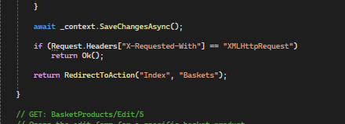
- I updated the POST Create method in the BasketProducts controller so that pressing "Add to Basket" adds the item directly to the side panel.
- I ran the application to see whether it worked.
- 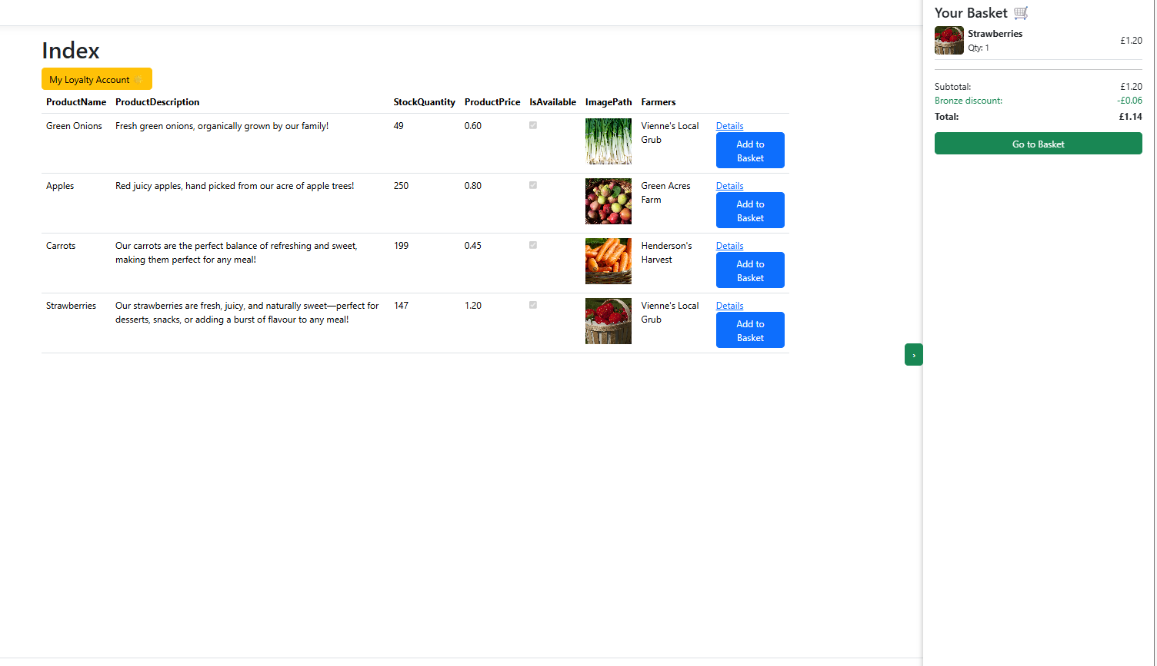
- It worked!
Version 2.0 – Day 5
- When a farmer creates a new product, it says farmerId, we don’t want that
- 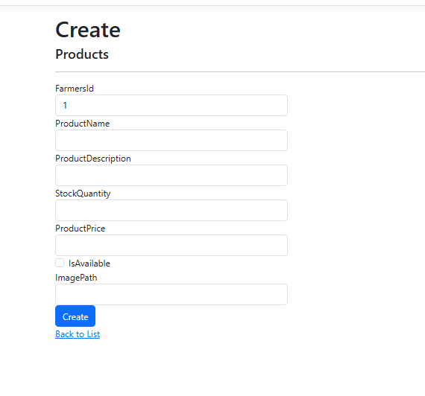
- 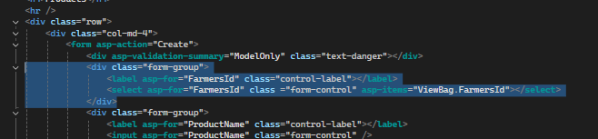
- I removed the FarmerId field from the Product Create view.
- 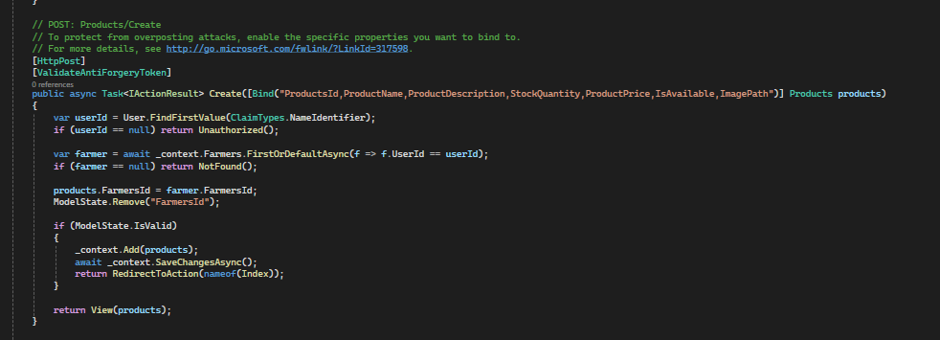
- I updated the POST Create action in the Products controller accordingly.
- I ran the application and attempted to create a new product.
- 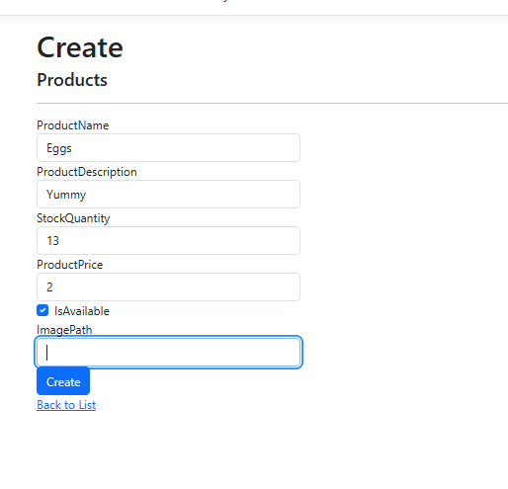
- Doesn’t let me press create. Might be because theres no imagepath
- 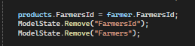
- I added logic to handle this in the controller.
- I also made the ImagePath property nullable so the form could be submitted without an image.
- I ran the application.
- 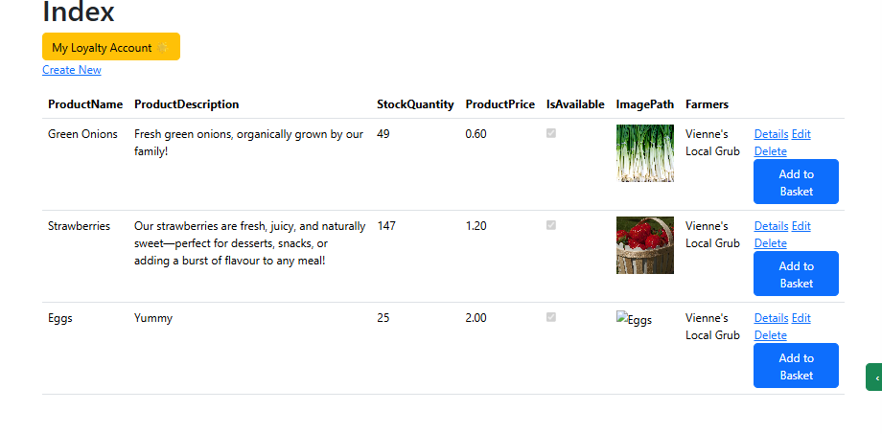
- It worked.
- I then added functionality to allow farmers to upload their own product image, with a fallback default image if none is provided.
- 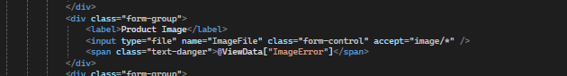
- I added a file upload input to the Product Create view.
- I added enctype="multipart/form-data" to the form tag to support file uploads.
- 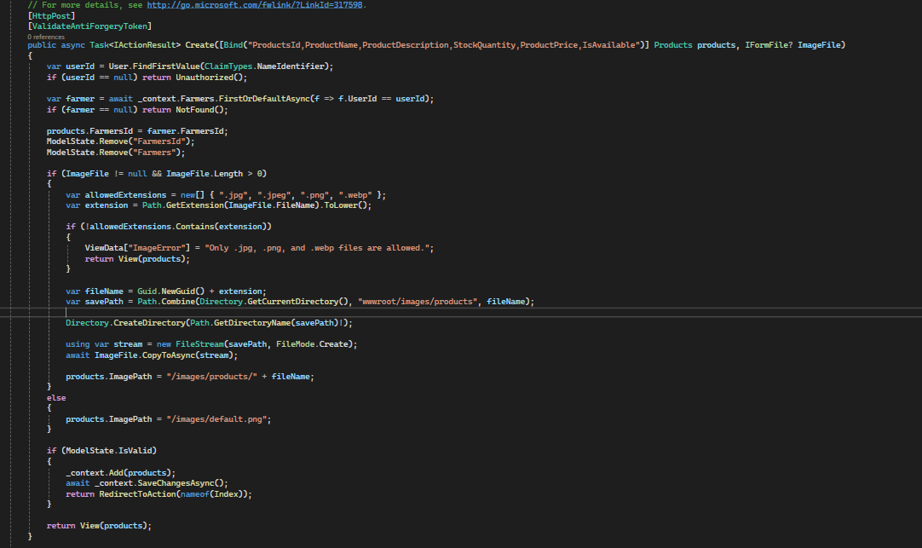
- I updated the POST Create action in the controller to handle the uploaded file.
- Added a default image to wwwroot/images incase the file the farmer uploads doesn’t work
- I ran the application and tested the feature.
- 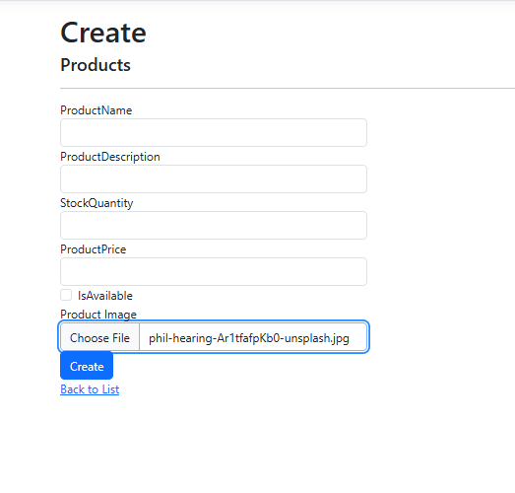
- 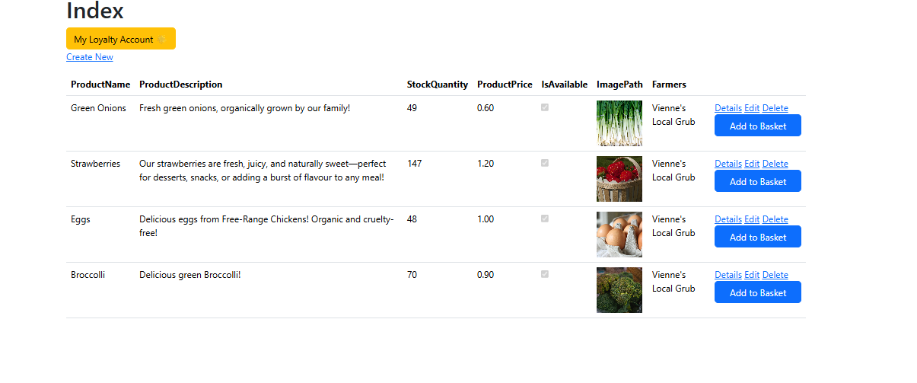
- It worked!
- I then wanted to add an image preview so farmers could see the selected image before submitting the form.
- 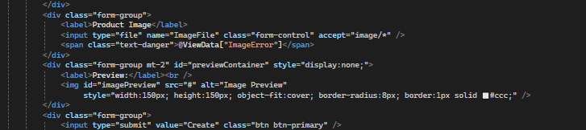
- I added the image preview element to the view.
- 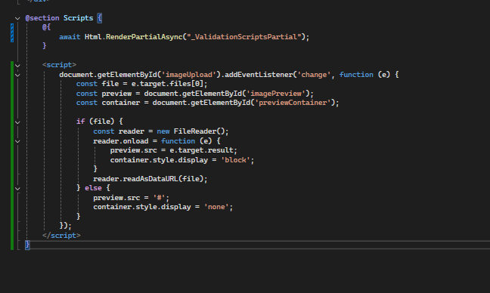
- I also added a JavaScript script at the bottom of the page to handle updating the preview when a file is selected.
- I tested and ran the application.
- 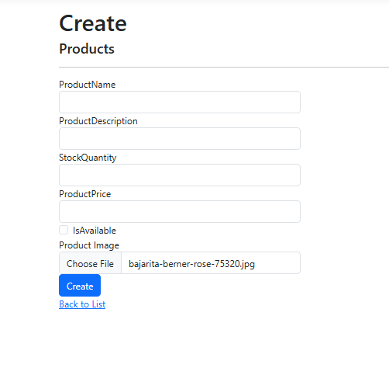
- The preview was not showing and an error occurred.
- 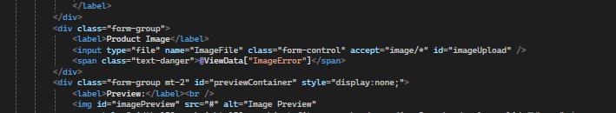
- I identified and corrected the problematic line of code.
- I ran the application again.
- 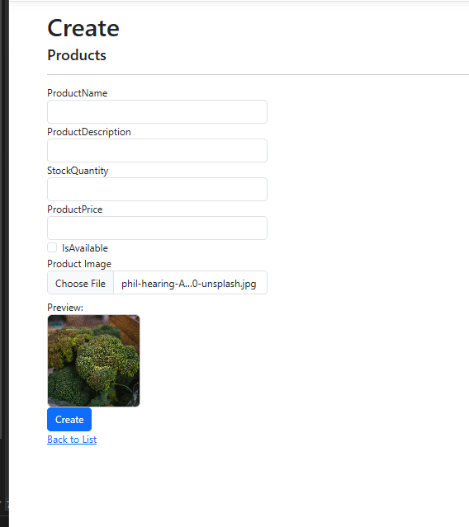
- It worked!
- 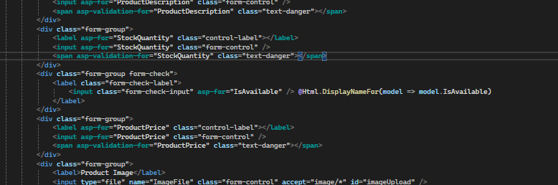
- I repositioned the "Is Available" field on both the Product Create and Index pages.
- 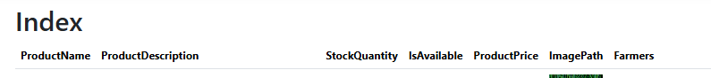
- 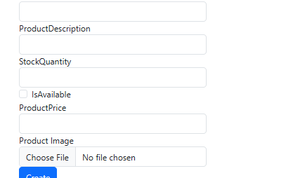
- "Is Available" now appears directly beneath the Stock Quantity field.
- For the image upload functionality, I added the same file input and handling code to the Product Edit view.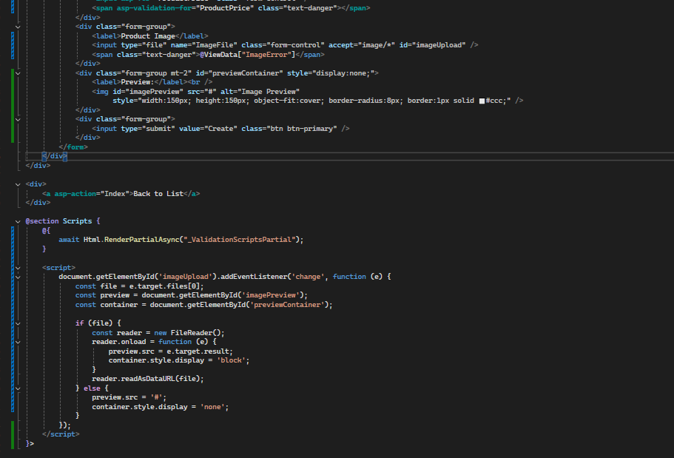
- I applied the same image handling code to the Product Edit view and its corresponding POST controller action.
- 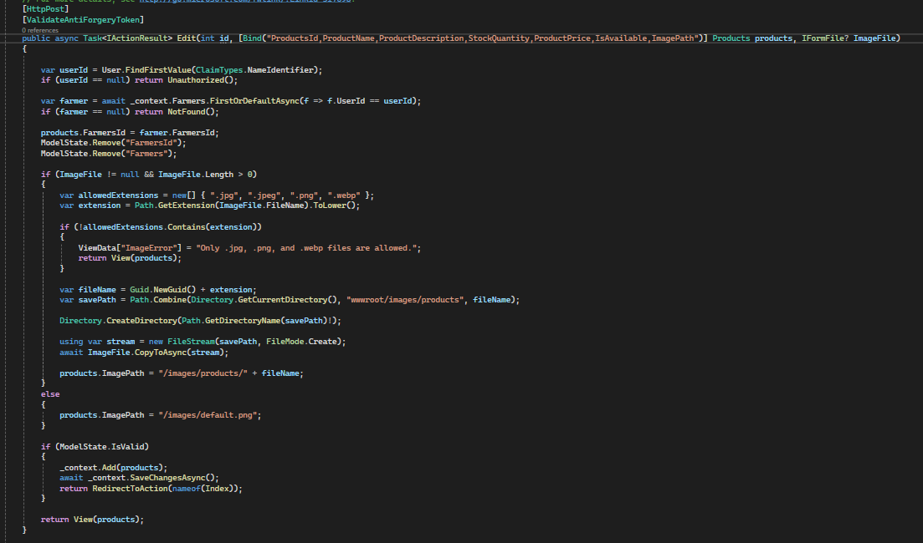
- I ran the application.
- 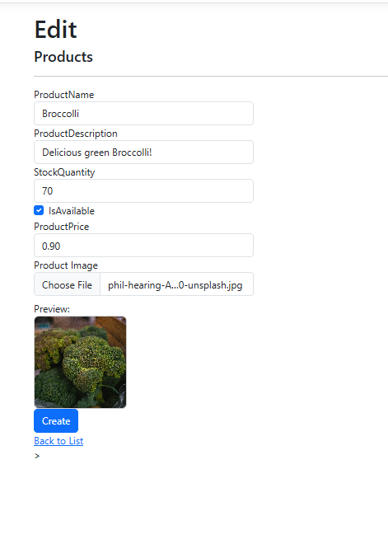
- The image upload worked correctly on the Edit page as well.
- 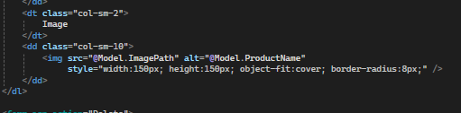
- Added this to delete products view so farmer id doesn’t appear and so the picture also appears
- I ran the application.
- 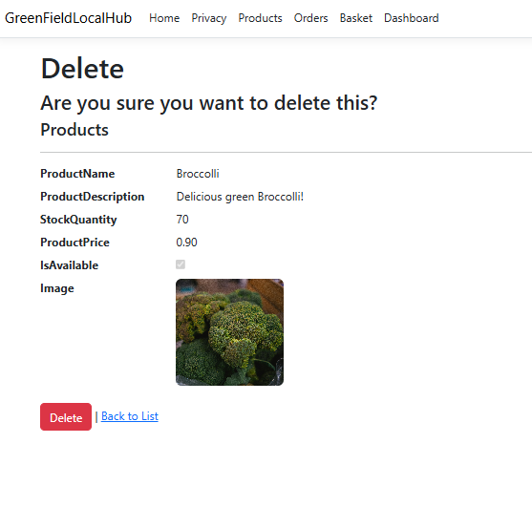
- It worked!
- I then applied the same image and FarmerId changes to the Product Details view.
- 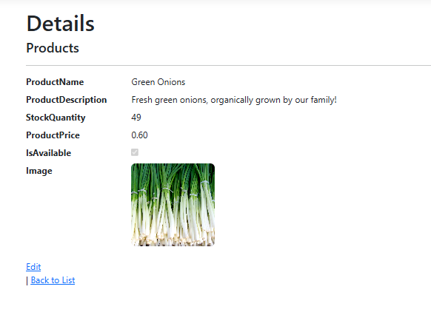
- It worked!
- 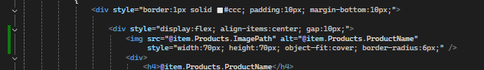
- I also updated the Basket view to display product images.
- 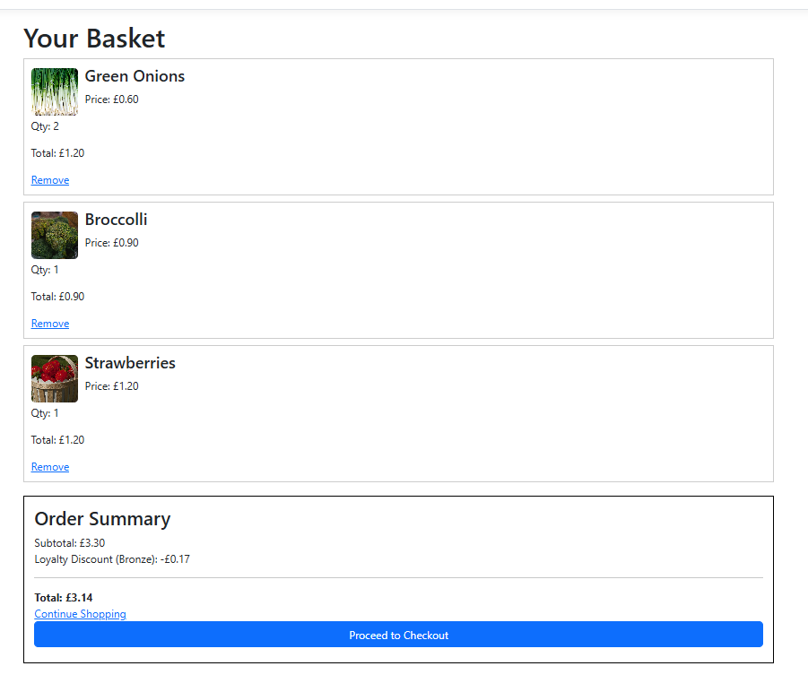
- It worked!
- I also fixed a bug where pressing the delete button on a basket item was incorrectly redirecting the user to the BasketProducts Index page instead of returning them to the basket.
- I removed the UserId column from the Orders Index page.
- 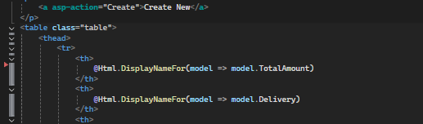

Day 6 – Version 2.1
- 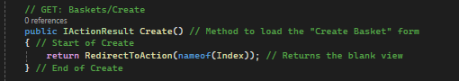
- I wanted to make it so the user can’t access the Basket/Create page, so I redirect the user to the index instead
- I ran the application to test whether it worked.
- It worked — users are now correctly redirected to the Baskets page.
- I wanted in the Order’s Index page to list the items in each order so that the farmers could easily see what customers ordered, and the user can see what they themselves ordered too.
- In the Order’s Controller I included these two highlighted lines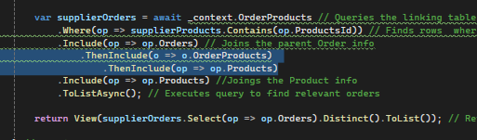
- This ensures that for every order, all linked OrderProduct rows are loaded along with their full product details.
- Then in Order’s Index view, I create a new column titled Items, and in the foreach loop I add this line of code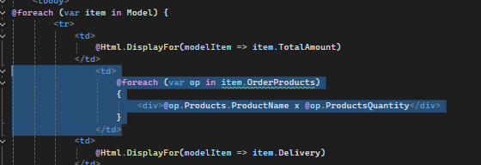
- Which gets each product and its quantity and puts it in the table under the “items” column
- I ran the application to test the changes.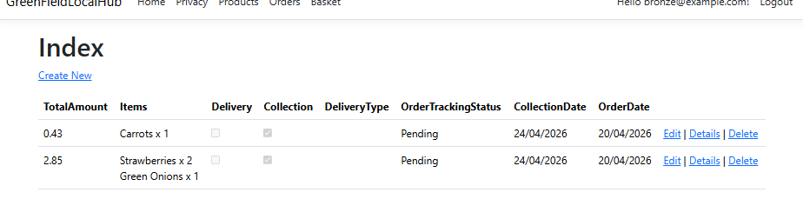
- It worked!
- I removed the "Create New" button from the Orders Index view by deleting the relevant code.
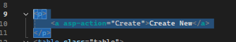
- I decided that the Edit and Delete buttons on orders should be removed for both farmers and standard users.
- I deleted both buttons from the view.
- I also wanted to allow farmers to update the order tracking status directly from the Details page, without needing to navigate to a separate Edit page.
- In the Orders Details view, I replaced the static status text with a form containing a dropdown that posts to the Orders controller's UpdateTrackingStatus action.
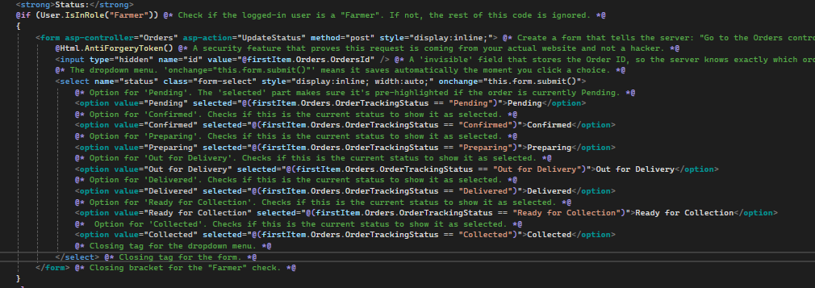
- I then created a new UpdateTrackingStatus action in the Orders controller.
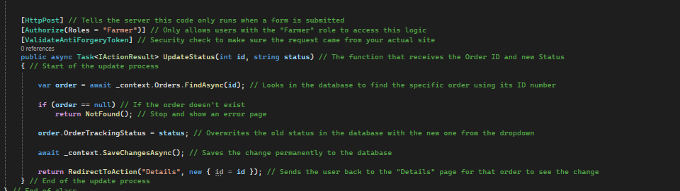
- This action saves whichever tracking status the farmer selects from the dropdown directly to the database, so changes take effect immediately.
- I removed the OrderId field from the Details view, since IDs should not be exposed to users.
- I ran the application to test whether everything was working.
- The dropdown menu appeared correctly.
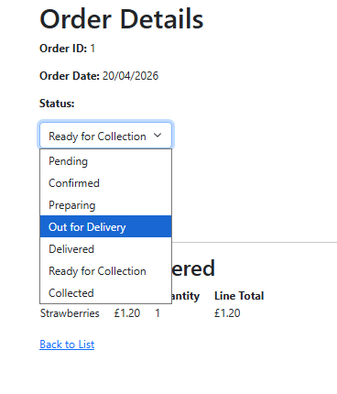
- The table updated to display the option I selected from the dropdown.
- I checked the linked account to confirm the change had been saved to the database.
- It was confirmed — the database had updated correctly.
- I also noticed that I had highlighted the OrderId in a screenshot but had forgotten to actually remove it from the code, so I deleted it properly this time.
- I wanted the applied loyalty discount to be shown on the Order Details page.
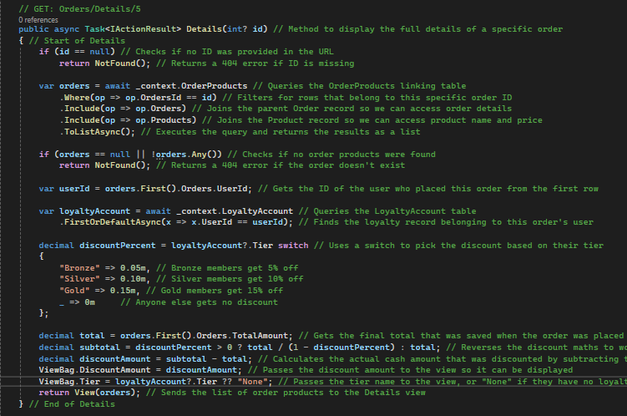
- I updated the GET Orders Details controller action to retrieve the user's loyalty account and tier information, making it available to the view via ViewBag.
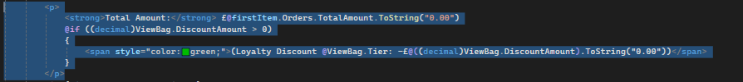
- I updated the Total Amount section of the Details view to pull the discount amount from the ViewBag and display it alongside the total.
- I ran the application to test whether it worked.
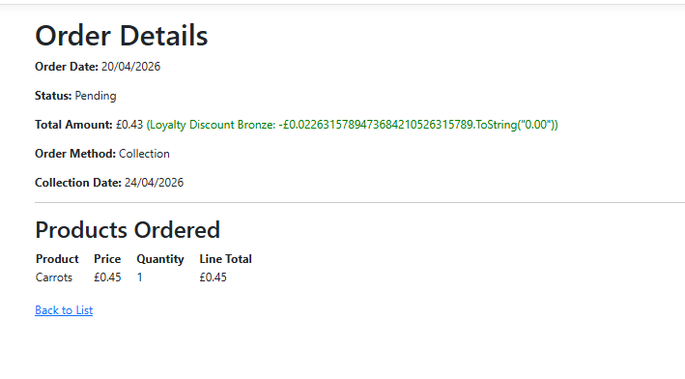
- Something went wrong during testing, so I consulted an AI assistant for help.
- The .ToString(“0.00”) was being treated as text, and not as string!
- I ran the application again after making the fix.
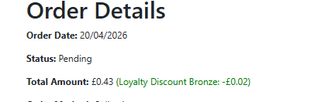
- It worked!
- I then logged in with a standard user account to test the behaviour for non-loyalty users.
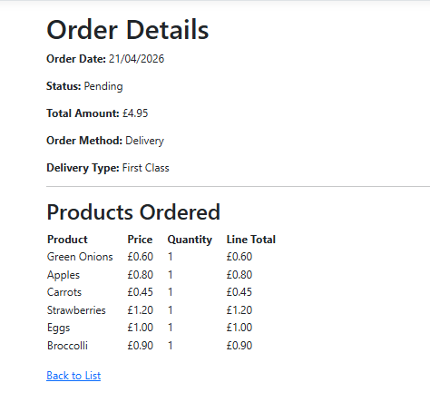
- No loyalty discount was displayed for the standard account, which was the correct behaviour.
- I removed the UserId field from the Orders Delete view.
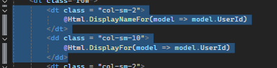
- I made the decision to remove the Favourites feature entirely. I deleted the model, removed the nav link, deleted the controller and views, and removed the Favourites reference from ApplicationDbContext. I then ran Add-Migration and Update-Database, and it completed without errors.
- I wanted to restrict access to the Loyalty Accounts Index view to only Admin and Developer roles, and to display the user's email address rather than their UserId.
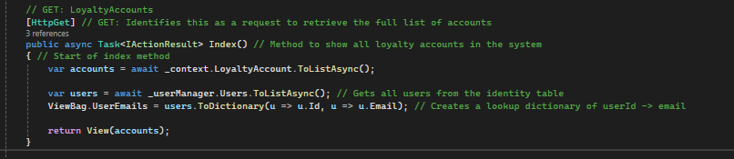
- In the Index action of the Loyalty Accounts controller, I retrieved all users and built a dictionary mapping each UserId to their email address. This dictionary is passed to the view via ViewBag, which uses it to look up and display the correct email for each loyalty account.
- In the Loyalty Accounts Index page I change the column name to “Email” and in the foreach look I make it so it grabs from the dictionary the email
- I added the appropriate [Authorize] attribute to every action in the Loyalty Accounts controller.
- For the sign-up and My Account actions, I used the basic [Authorize] attribute without a role restriction, since all authenticated users should be able to access those pages.
- I ran the application to test the changes.
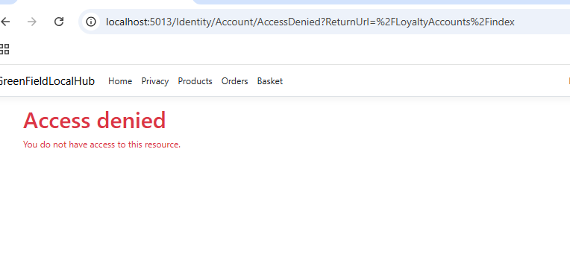
- A standard user attempting to access the Loyalty Accounts Index via a direct URL was correctly denied access.
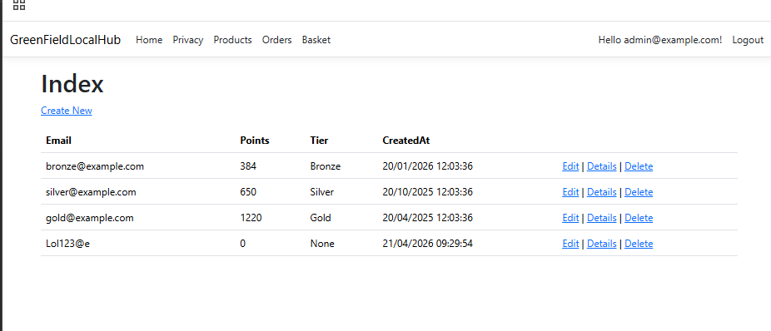
- An Admin account was able to access the Index and all other pages as expected.
- I also decided to add an Email column to the Orders Index page so that farmers could see which customer had placed each order.
- I replaced the UserId display with a conditional that only shows the customer's email when the logged-in user is a Farmer or Admin.
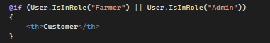
- I added a private readonly UserManager field to the controller.
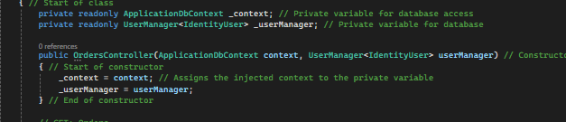
- I then change the index action to get all registered users, and build a userId to email dictionary so the application can find the users email that’s linked to the ID
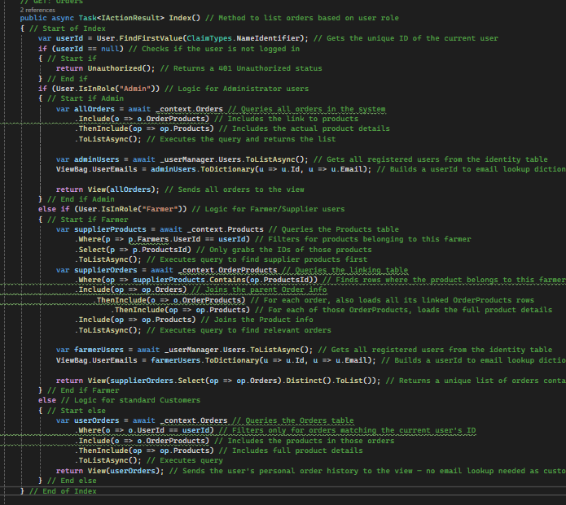
- In the Index view, I added code to pull the email from the ViewBag dictionary and display it in the table.
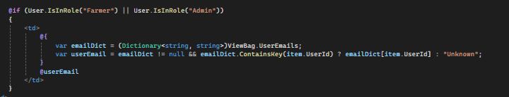
- I ran the application to test the changes.
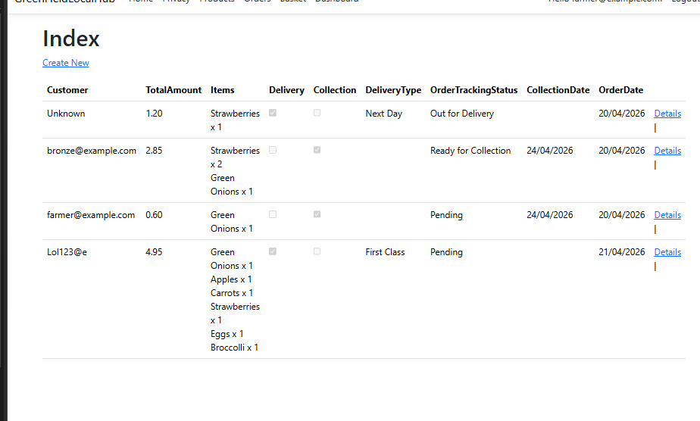
- It worked!
- I also removed the "Create New" button from the view.
- I also wanted the Farmer Dashboard to display the products ordered and the customer's email address in the Recent Orders section.
- I injected UserManager into the Farmer Dashboard controller.
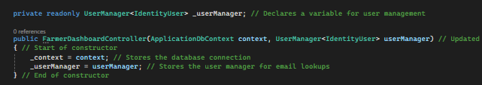
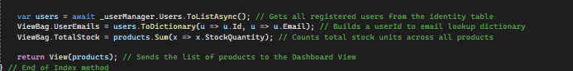
- I built a UserId-to-email lookup dictionary and stored it in the ViewBag.
- I updated the Farmer Dashboard Index view to display both the customer's email and the products they ordered.
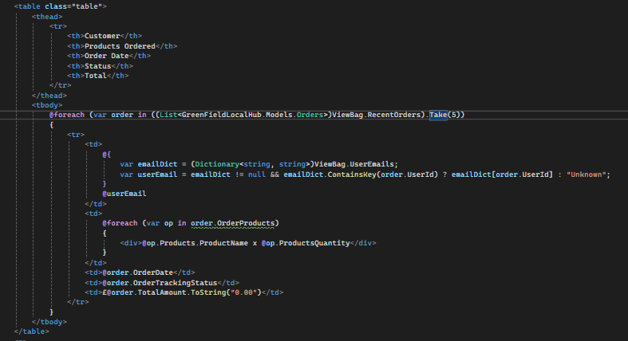
- I ran the application to test the changes.
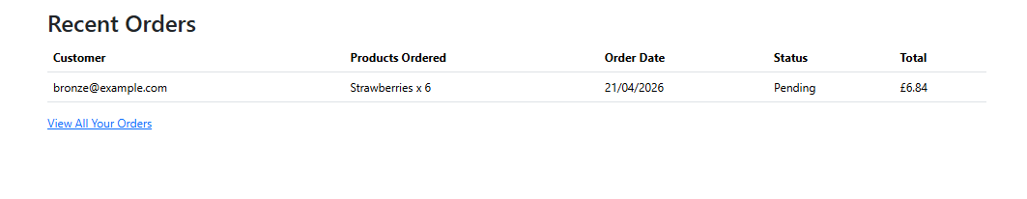
- It worked!
- I want to make it so Farmers cant access the basket, as they’d have a personal account where they’d order things
- In layout.cshtml I add this code, which makes it so farmers don’t get the nav link!
- I also applied [Authorize] to all actions in the Basket controller.
- This restricts full basket access to Developers, while normal users, Admins, and Developers can view the basket.
- I applied [Authorize] to all actions in the BasketProducts controller so that only Developers can access those views directly.
- In the Farmers Index view, I removed the UserId column and the Edit and Delete buttons.
- I also removed the UserId from the Details, Edit, and Delete views.
- I removed the "Create New" button.
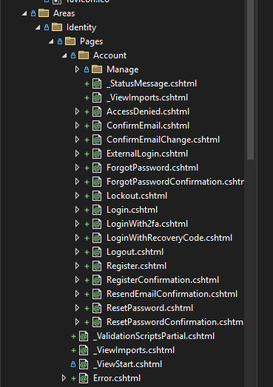
- I scaffolded all of the ASP.NET Identity pages to gain full control over them.
- I updated the registration flow so that users can choose to register as either a standard user or a Farmer account.
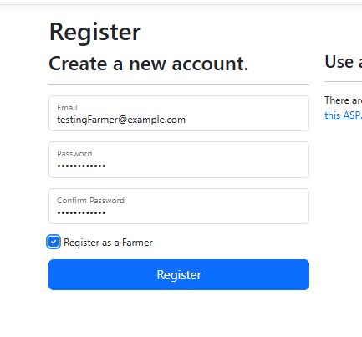
- It all worked correctly.
- I’m going to start cssing the shared layout tomorrow

Day 7 – version 2.2
- I began by working on the shared layout to establish a consistent colour scheme and set of shared elements across all pages.
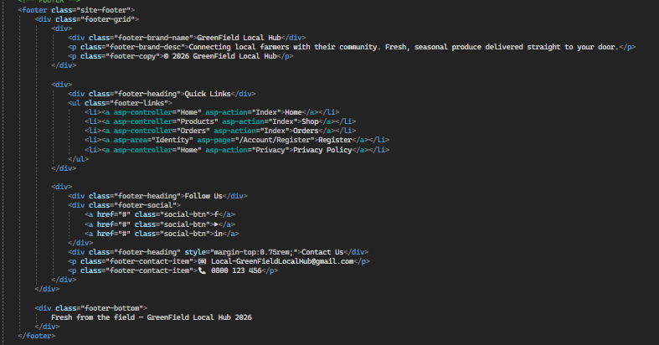
- I started with the footer, since every page in my wireframe uses the same footer design.
- I grouped Orders and Basket under a "Shop/Products" dropdown menu to keep them together, and also added a Farmers button so users can browse the farmers who grow the produce.
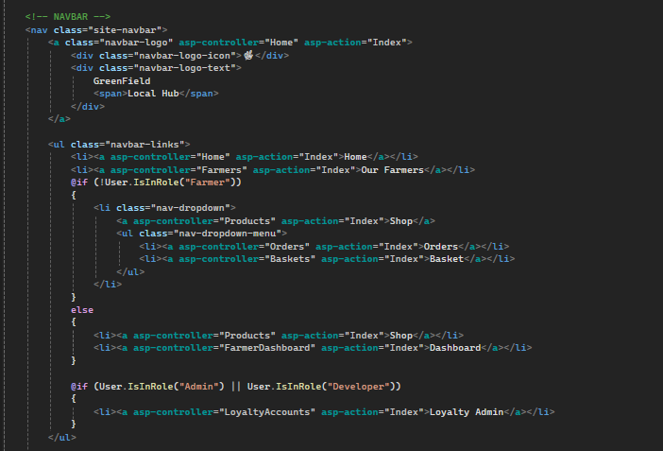
- I also wanted the login and register options to appear as a dropdown when the user clicks the user icon, mirroring the approach used on many modern websites.
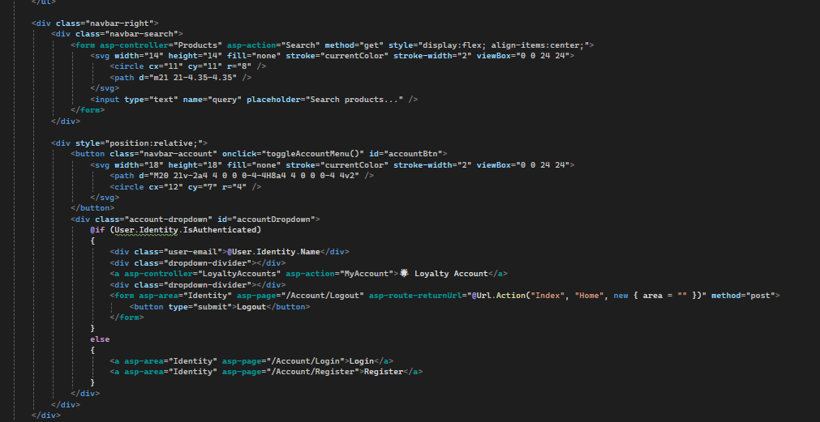
- In doing so, I accidentally removed the ability for users to change their password and manage their account, so I restored that functionality.
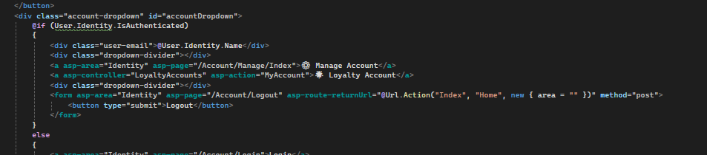
- I added a button linking to the Account Index, so users can still access their account information, change their password, and so on.
- I then added the CSS to wwwroot/css/site.css to begin styling the website.
- Unfortunately, the CSS I added broke the site, so I rolled back the changes.
- I created a separate CSS file called hopep.css in wwwroot to avoid conflicts with the existing stylesheet.
- I redid all of the changes I had made to the Home controller and Index view.
- I added the CSS from the new file.
- I ran the application.
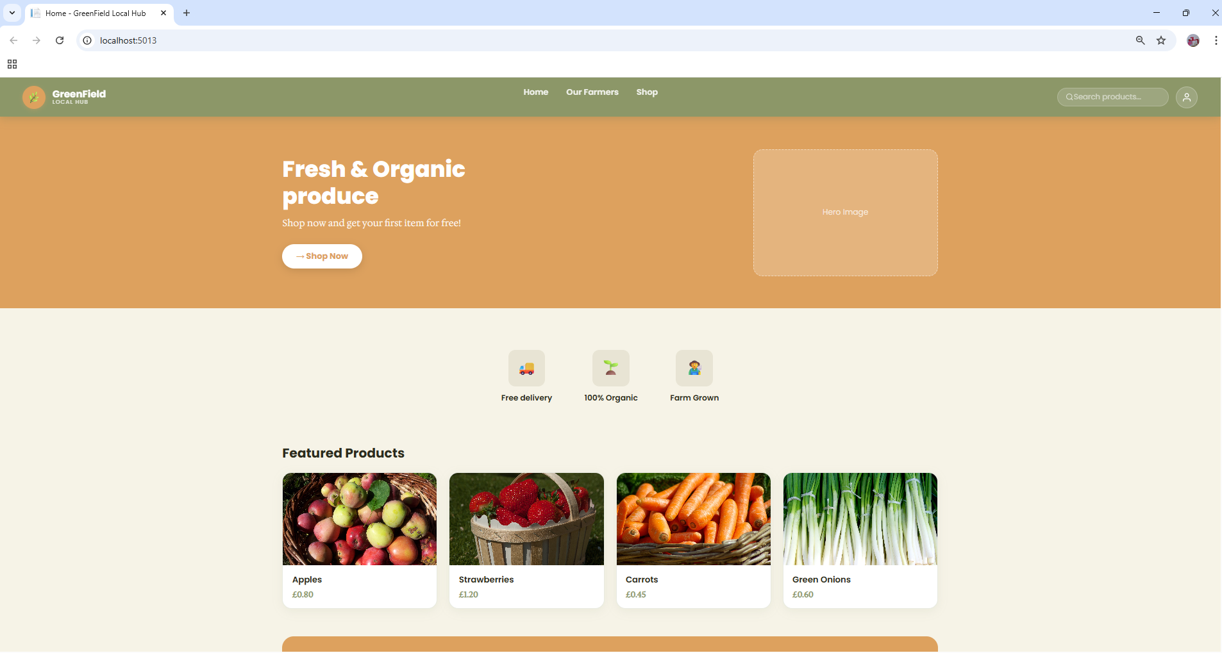
- The styling looked great!
- The design felt a little flat, so I added some animations and other visual enhancements to bring it to life.
- I wrote CSS for everything. The home page, privacy policy, our farmers, products, basket including the create, edits, details pages.
- I needed to seed more farmers and products, this is because the website would’ve looked really empty with just 4 products and 3 farmers!
- I coded a privacy policy page, as that was one of my functional requirements. I also coded CSS for it!
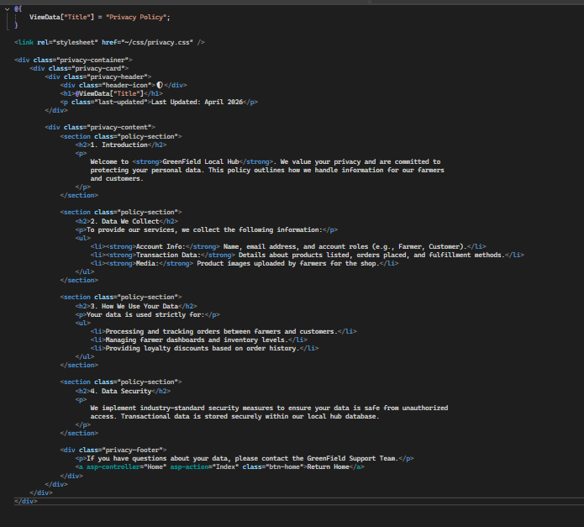
- I went into my controllers and made sure to Authorize everything I could to the right roles and to make it so people have to be logged in to access the basket and orders pages.
- I needed to add google authentication, so I installed the package first
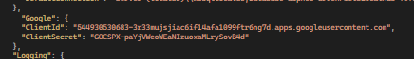
- In appsettings.json I added the google authentication client
- In program.cs I added the code to ensure that users are now able to register and log in through google!
