Task 1: Activity B – AI Log
AI model used | Claude Ai
Problem to be solved | Prompts used | Output generated | Review of generated code
Seeded user roles however an error saying “Role FARMER does not exist.” | “Yo I have an error”  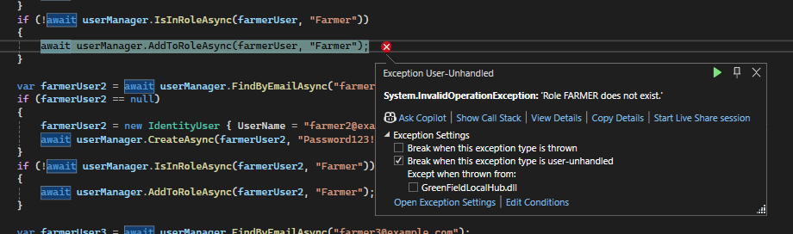 | The error says 'Role FARMER does not exist' — this is happening because your roles are being created inside the foreach loop but the user seeding code is also inside that loop, so it's trying to assign the "Farmer" role before all roles have been created.  The fix is to separate the role creation from the user creation — create all roles first, then create the users. | // FIRST - create all roles  string[] roleNames = { "Admin", "Farmer", "Standard", "Loyalty", "Developer" };  foreach (string roleName in roleNames)  {  var roleExists = await roleManager.RoleExistsAsync(roleName);  if (!roleExists)  {  await roleManager.CreateAsync(new IdentityRole(roleName));  }  }  // THEN - create all users after roles exist  var farmerUser = await userManager.FindByEmailAsync("farmer@example.com");  if (farmerUser == null)  {  farmerUser = new IdentityUser { UserName = "farmer@example.com", Email = "farmer@example.com", EmailConfirmed = true };  await userManager.CreateAsync(farmerUser, "Password123!");  }  if (!await userManager.IsInRoleAsync(farmerUser, "Farmer"))  {  await userManager.AddToRoleAsync(farmerUser, "Farmer");  }  // rest of your users below...
Farmuser1 is not null here | “Why”  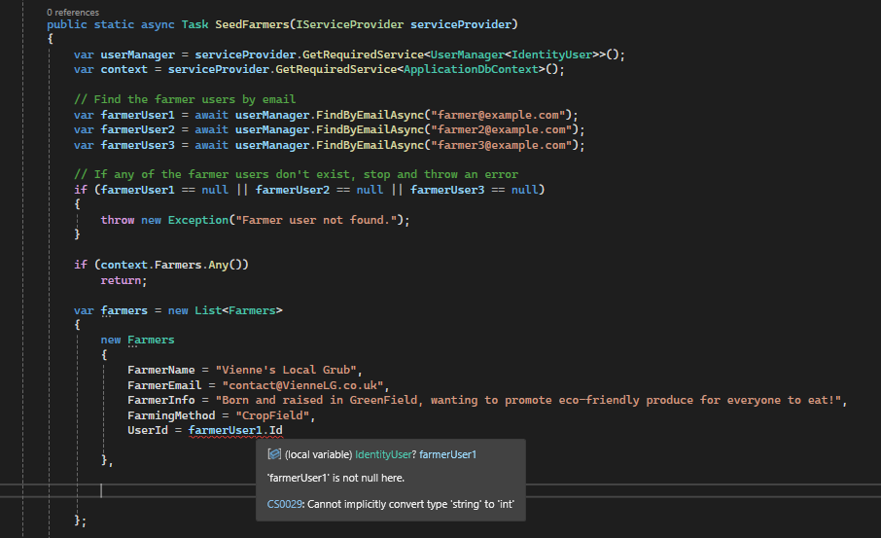 | The error "Cannot implicitly convert type 'string' to 'int'" is because in your Farmers model, UserId is set as int but Identity stores user IDs as string. | public string UserId { get; set; } // Change to string to match Identity
[Add additional rows as needed then delete this instruction]

Copyright and Acknowledgements
‘T-LEVELS’ is a registered trademark of the Department for Education.
‘T Level’ is a registered trademark of the Institute for Apprenticeships and Technical Education.
The T Level Technical Qualification is a qualification approved and managed by the Institute for Apprenticeships and Technical Education.
‘Institute for Apprenticeships & Technical Education’ and logo are registered trademarks of the Institute for Apprenticeships and Technical Education.
Pearson Education Limited is authorised by the Institute for Apprenticeships and Technical Education to develop and deliver this Technical Qualification.
Pearson and logo are registered trademarks of Pearson.
Copyright in this document belongs to, and is used under licence from, the Institute for Apprenticeships and Technical Education, © 2025

