Project Proposal
Zuzanna Krzysztoszek

Contents

Research: 4 - 13
Business Context: 14 - 16
Project Aim: 16
Functional Requirements: 16 – 32
Non-Functional Requirements: 32 – 34
Hierarchy Diagram: 35
Ui Considerations: 35 – 36
Security Considerations: 36 – 38
Legal and Regulatory Guidelines: 38 – 40

Set task brief
You work for a software development company. The company has secured a new contract to develop a digital solution for Greenfield Local Hum (GLH). GLH is a cooperative of local farmers and food producers. GLH offers:
- A single location retail outlet for locally produced food and drink
- Collective marketing for local farmers and food producers
- Product management, stock control, and product traceability
GLH (the client) would like to develop a digital solution that will:
- Provide information about the producers, their methods, and the benefit of buying locally
- Allow customers to:
  - View products with transparent pricing and availability
  - Place orders for collection or delivery
  - Manage their accounts and view order history
- Provide a dashboard to enable producers to manage stock levels, update product details, and view orders
The client has conducted market research with existing customers to identify features that could be included in the digital solution. The features suggested by the client are:
- Order management, scheduling and tracking features
- A loyalty scheme that provides discounts and special offers
- Accessibility features to support a wide range of users.

Sections
- Business context
- Project aim
- Functional Requirements
- Non-Functional Requirements
- Hierarchy Diagram
- UI considerations
- Security and Risk mitigation (risk matrix)
- Legal and regulatory guidelines

Above is a reminder for the task and not part of the exam!

Research
Website 1: Riverford.co.uk
Summary
Riverford is an online farm shop that delivers farm grown and organic food to customers while promoting and advertising sustainability and ethical food production.
System Requirements
Since the website is opened on a standard browser, it means the website can be accessed on many devices.
Low hardware is needed, as long as the user has access to a browser and the internet, the user is able to access the website.
It’s compatible with many different browsers, such as: Google Chrome, Microsoft Edge, and Safari. Due to this, this makes the website widely accessible and available.
Overview of the features
The target audience is people who are interested in organic food and want produce that is locally sourced. Due to Riverford promoting sustainability and ethical food production, the target audience also will be people who care about the environment and want to stay sustainable. Families who also want fresh food delivered to their home will also be the target audience!
Generic features include:
- A product catalogue showing available fruits and vegetables
- Pricing and product information
- A basket and checkout
- Customer accounts
- Delivery schedules
- Order History
All these features are industry standard for a shopping website
Unique Features
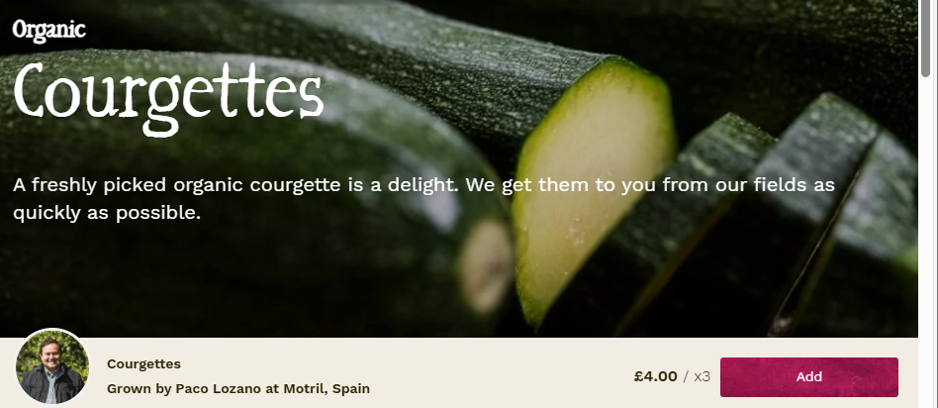

One unique feature of Riverford is that it tells the users where the food was grown and who produced it! Usually on shopping websites, such as Tesco and Asda, you may be able to find where something was produced on a packaging, but definitely not who made it. This uniqueness builds trust with a customer because they are able to know exactly where their food is coming from. This is especially good because Riverford promotes sustainability and ethical food production! A lot of users and customers want to support their local ethical and farming too, so this encourages users to buy from Riverford! However, this requires extra data management and storage, because users who upload their organically grown food will need their food linked to their name and account through the database!

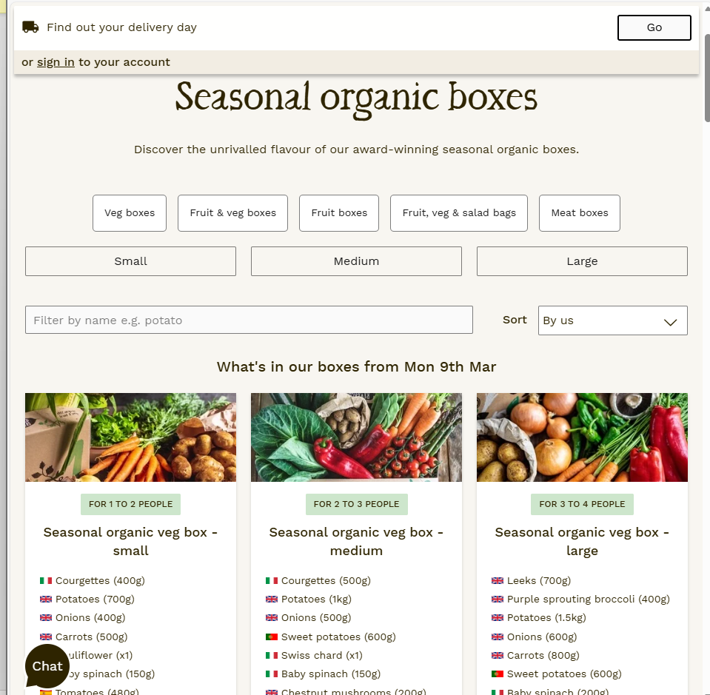
Another unique feature they have is seasonal vegetable boxes! This means that customers are able to purchase a box with seasonal fruits and vegetables. This proves to the users that the company promotes sustainable farming because crops are being harvested at their natural season instead of being genetically modified (as most fruits and vegetables are in supermarket chains) to stay ripe for longer! This also helps reduce food waste, because farmers are only harvesting what’s needed. However, these boxes mean that users have less control over each individual item. That is important because if someone was allergic to something in the box, they wouldn’t be able to remove said item!
Newly emerging technology
The technology used is touch-based interfaces for users who are viewing the website on mobile, responsive design for different screen sizes, (if you were to decrease the size of the windows, the elements follow suit), and online account systems with automated ordering.
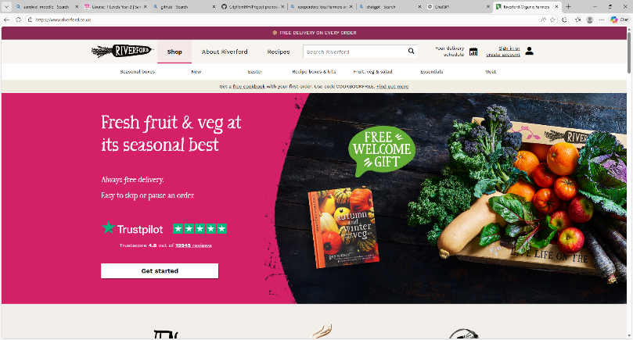
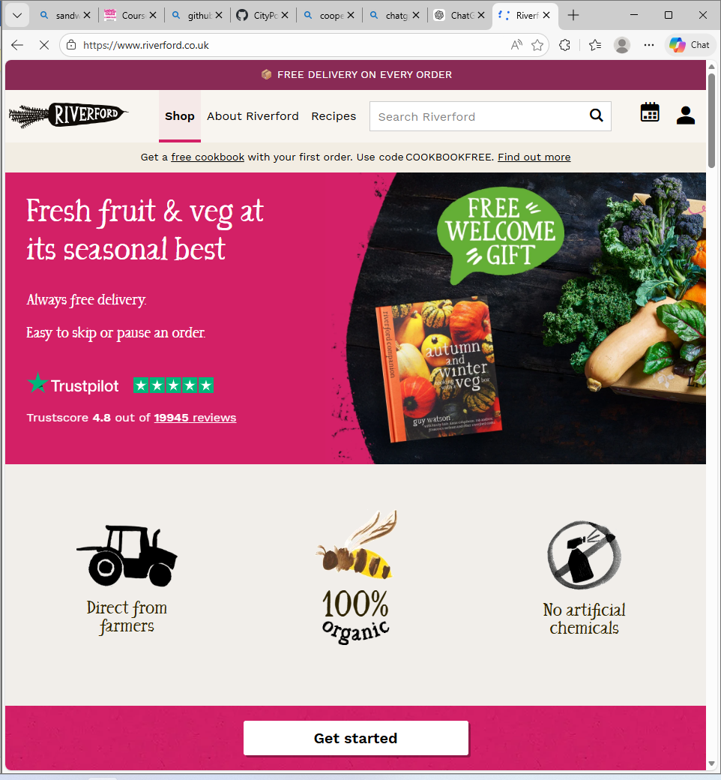
Above is an example of the elements adjusting based on screen size!
The touch-based interface is effective for phones and tablets, this makes the website more accessible because many users have mobile devices to carry around instead of desktops or laptops.
User Interface
Overall Design
The interface has cleat navigation menus via a navigation bar at the top of the screen
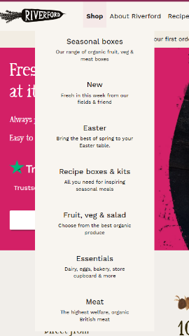
And when the screen size is adjusted it turns the nav par into a drop down!
This makes the navigation especially easy to understand, mostly because this
feature is industry standard, many websites have their nav bar set out like this,
making this website accessible to even people with low technical capabilities.
This makes important information especially easy to find! And makes the
system suitable for a wide range of users

From my observations, the colours used are mostly green, pink, and an off-white. Green is usually associated with nature, farming, and sustainability, and the pink contrasts it in a nice way. It almost invokes a feeling of farming itself. Which supports Riverford’s brand identity
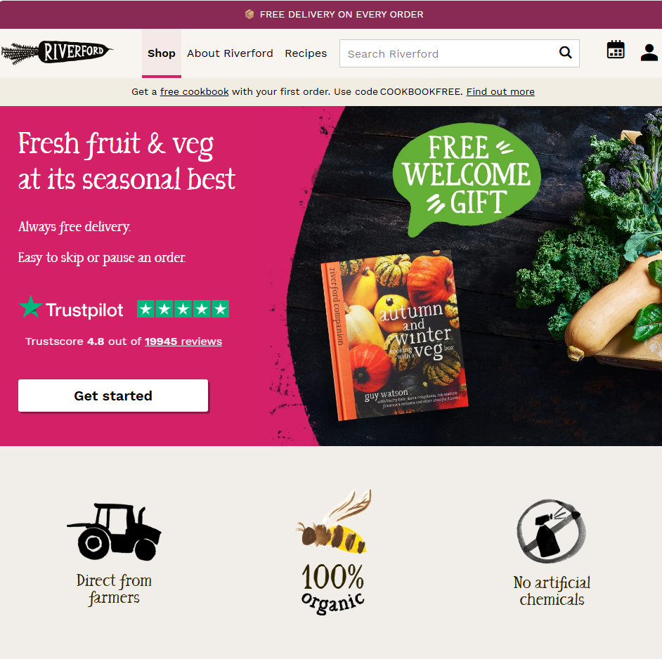
Graphics include high quality photos of vegetable and food, photos of the farmers themselves, and the product images.
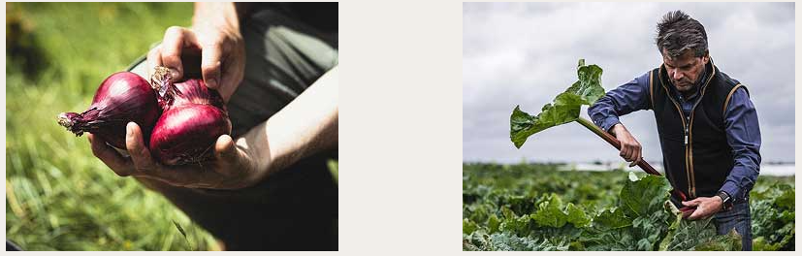
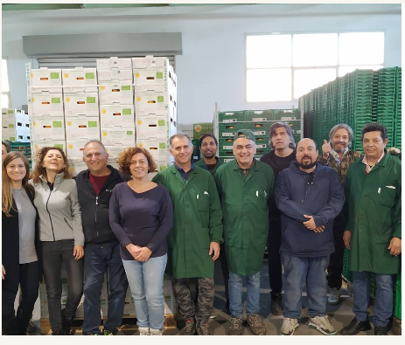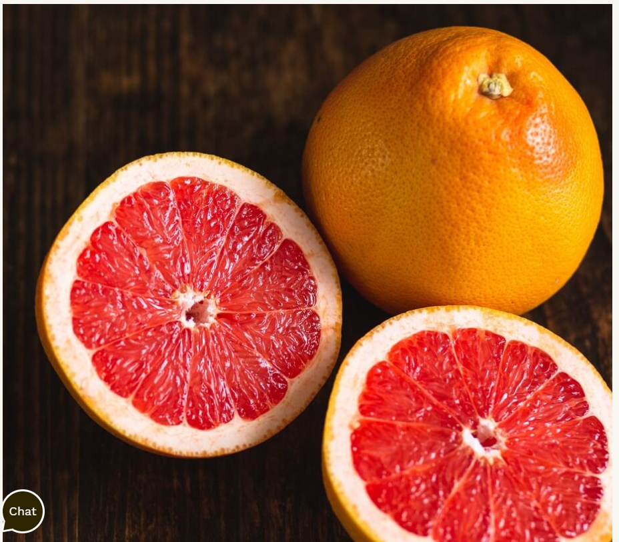
From what I have found, there are no videos or animation. This helps the website load quickly and not overwhelm the user with too much information
The fonts are a simple sans-serif font and Times New Roman for headings. Serif fonts usually improve readability for users and make the website feel professional and trustworthy! This is usually industry standard, as any serif fonts are usually considered accessible when it comes to reading disabilities
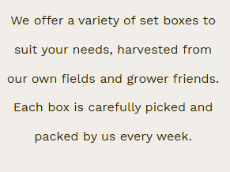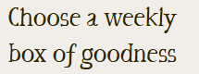
The language used is friendly, informative, and easy to understand. It doesn’t use any language that might be too technical for an average user who isn’t a farmer! This makes the website accessible to a wide range of users including their target audience as you can see above!
Accessibility Features
From what I can tell, Riverford does not have an accessibility menu, therefore more advanced features, such as: Text-to-speech, adjustable font sizes, or dark mode are unavailable therefore it narrows down the customer base that Riverford could be reaching out to. However, it does have clear navigation, readable fonts, responsive design, FAQ and Live chat. These features help a wide range of users to access the website!
Security and Legal
The website includes secure login accounts, password authentication, HTTPS encryption and cookie notification. These help protect user data and information while also ensuring no unauthorised access is allowed to take a user’s private information!

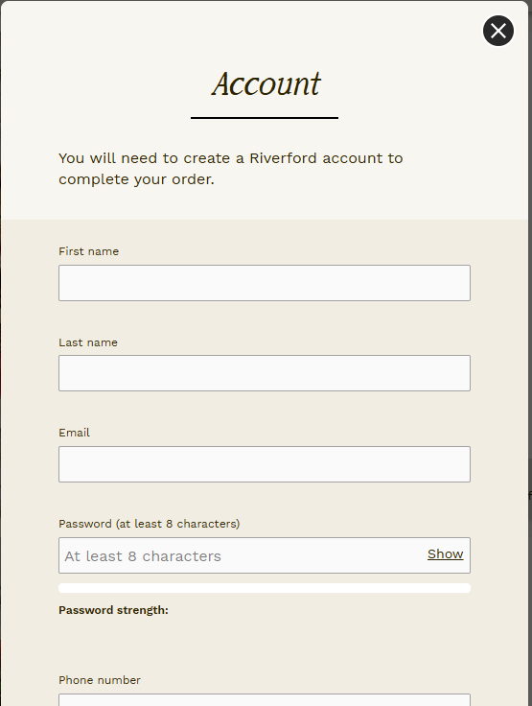
The website ensures you need to make an account in order to check out from the basket!

The website also follows legal standards as the General Data Protection Regulation (GDPR) that protects personal data collected from users. It follows the standard by making the user accept cookies before data is collected, personal data is stored securely, and users can access privacy policies explaining how their data is being used.
Another law is the Data Protection Act 2018 (DPA) which works alongside GDPR to control how businesses use and handle personal data. The website follows DPA by storing customer account information securely, allowing users to request deletion or access to their data, and explaining how information is collected and used
Consumer Rights Act 2015 (CRA) protects customers when buying goods or services online. The website follows this law by providing accurate product descriptions, clearly showing pricing, and allowing users to complain or request refunds if the product is faulty.
Riverford also follows the copyright, designs, and patents act. This law protects images, videos, text, and other creative content. They follow this law by using original photos of farms and produce, it owns or has permission to use website images and graphics, and it protects its own content from being copied without permission.

Website 2: Abel & Cole
Summary
Abel & Cole is an online shopping retail platform that delivers sustainable and organic food directly to customers! The website promotes and advertises organic farming, ethical food, and environmentally friendly ways to manage food production!
System Requirements
Since the website is opened on a standard browser, it means the website can be accessed on many devices.
Low hardware is needed, as long as the user has access to a browser and the internet, the user is able to access the website.
It’s compatible with many different browsers, such as: Google Chrome, Microsoft Edge, and Safari. Due to this, this makes the website widely accessible and available.
The website is also mobile responsive meaning it adjusts to different screen sizes!
Overview of Features
The target audience of Abel & Cole is very similar to Riverford.
The target audience includes: Customers who are interested in organic food, people who care about sustainability and ethical farming, families who want fresh food delivered to their home, and environmentally conscious consumers who want to support local producers
Generic features include:
- A product catalogue showing available fruits and vegetables
- Pricing and product information
- A basket and checkout
- Customer accounts
- Delivery schedules
- Order History
All these features are industry standard for a shopping website
Unique Features
One unique feature of the Abel & Cole website is their organic food subscription boxes. Customers are able to: Subscribe to weekly fruit and vegetable boxes, choose the size of the box, and select delivery days. This allows customers to receive regular deliveries of fresh organic produce without needing to manually place an order each week.
This feature is good because it makes shopping more convenient for busy customers. It also helps the company predict demand and reduce food waste because farmers know how much produce needs to be harvested.
However, this feature also has some disadvantages. Because the boxes are pre-selected, customers may have less control over the specific items they receive. This could be bad if customers dislike certain foods or have allergies.
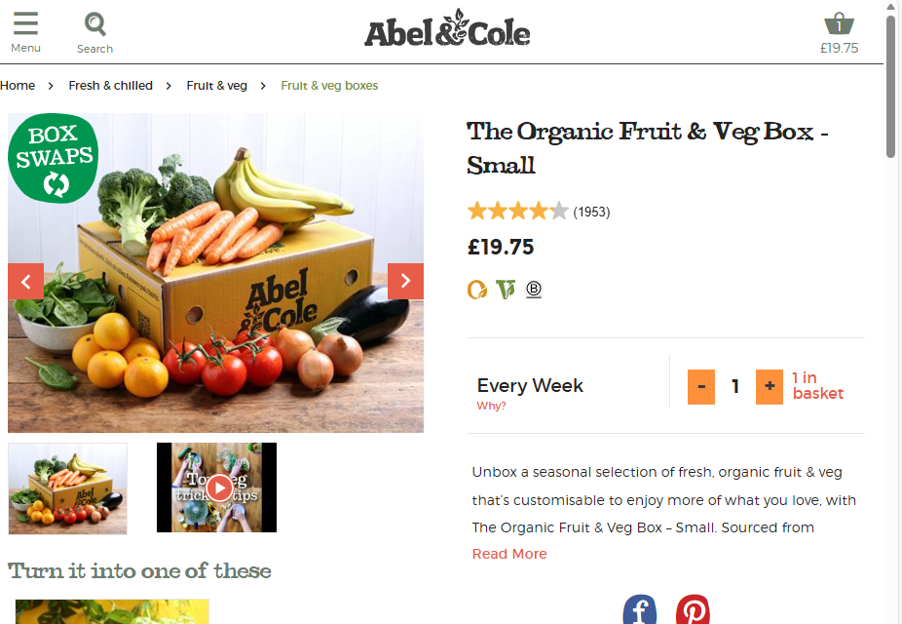
Another unique feature is sustainability tracking. The website emphasises the importance of environmental practices, such as: Low-carbon farming, reduced packaging, and organic farming standards. This feature appeals to environmentally friendly people and encourages customers to engage in such practices
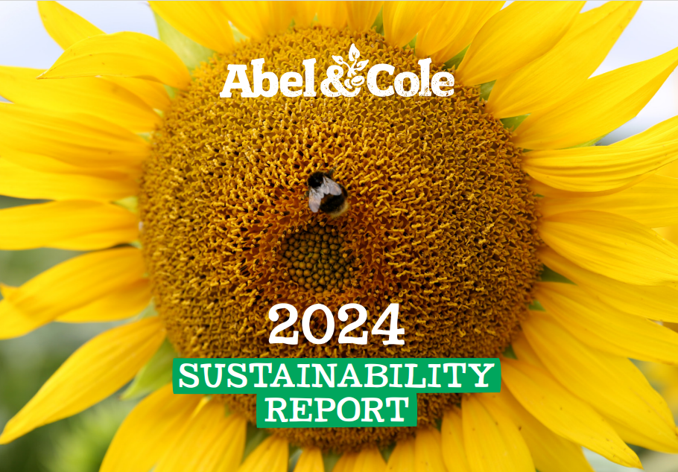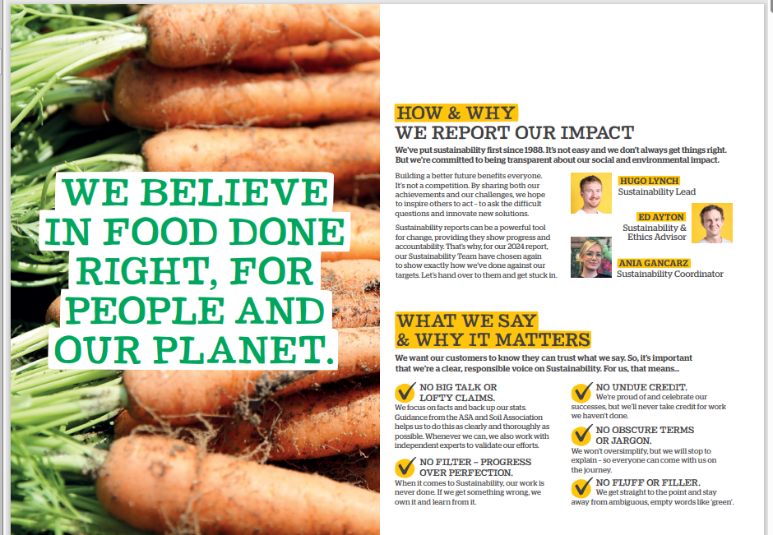
Newly Emerging Technologies
The technology used is touch-based interfaces for users who are viewing the website on mobile, responsive design for different screen sizes, (if you were to decrease the size of the windows, the elements follow suit), and online account systems with automated ordering.
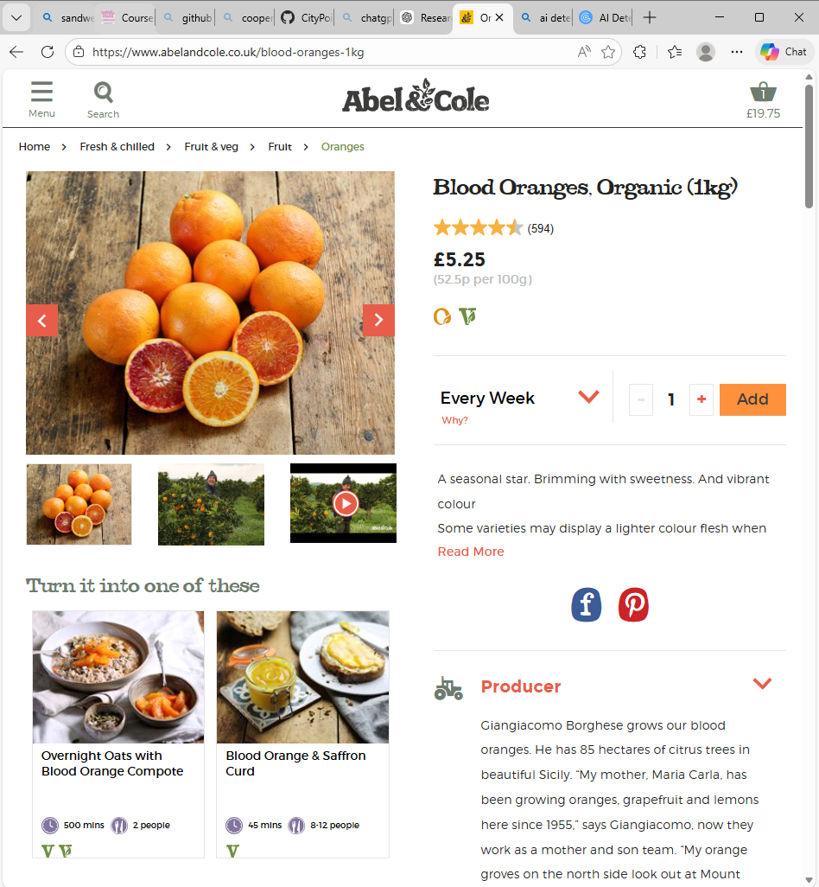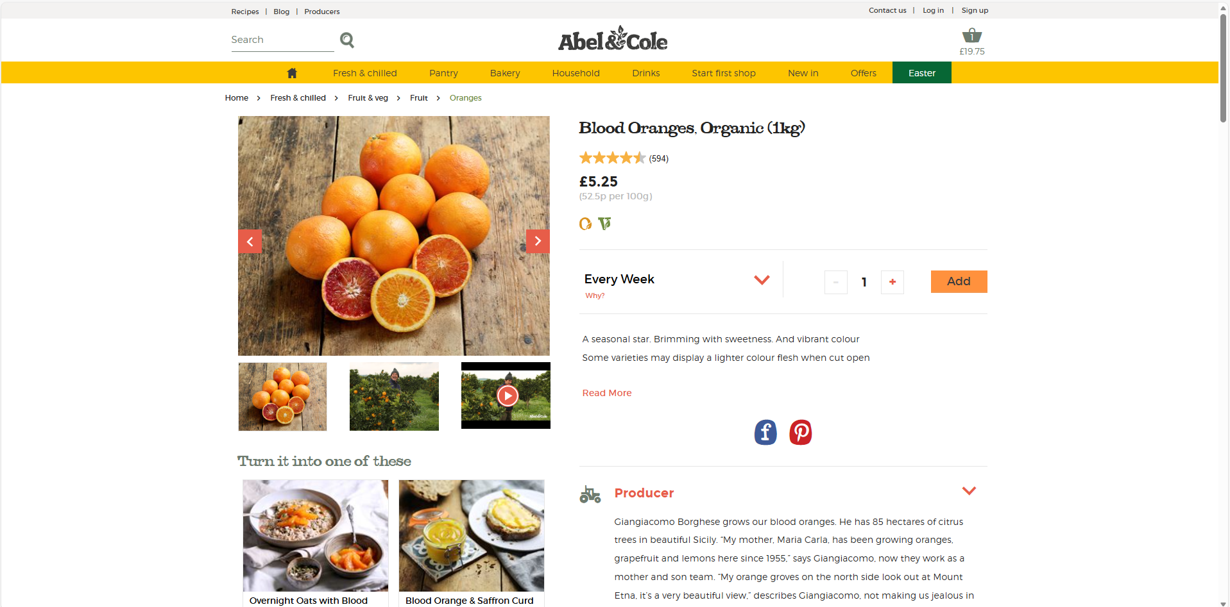
Above is an example of the website being fully open vs resized.
Overall Design
Overall, the design is simple, modern and visually appealing. The navigation bar is at the top of the website, and when the screen is resized the navigation bar turns into a hamburger menu as seen in the images above! This improves usability on mobile devices! The layout overall is industry standard for a shopping website.
The colours used are mainly white, amber, and orange. This allows for contrast for the website whilst keeping a clean modern look
The graphics uses are high quality images of produce and food photography, whilst also using icons to make the website more visually accessible. This helps the users engage with the website while being able to see what they’re ordering.
The fonts used are ACMontserratLightFont, ACFont, Which aren’t considered industry standard, as serif fonts are. This is because serif fonts allow easier readability! However, the text is big enough for any user to read!
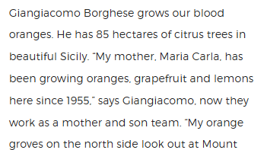
The language they use is a friendly tone with non-technical language so any customer who doesn’t know how to farm can understand what they’re reading!
Accessibility Features
I do not see an accessibility menu, which means that users are unable to change the website to dark mode, or adjust font text, or enable Text-To-Speech. However, the website does have help tools such as an FAQ and a call us section!
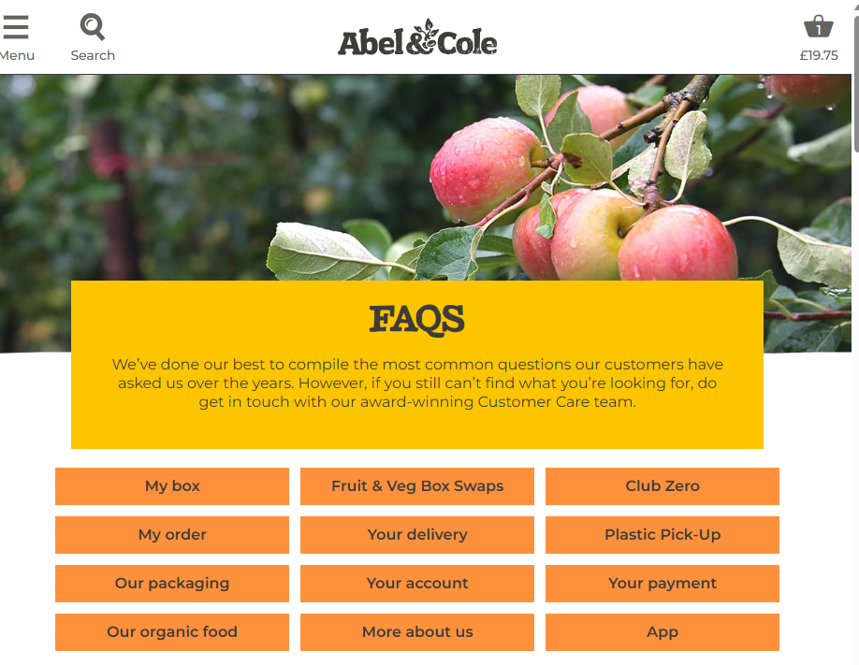
However, due to the lack of an accessibility menu, the accessibility is not effective!
Security and legal
The website includes secure login accounts, password authentication, HTTPS encryption and cookie notification. These help protect user data and information while also ensuring no unauthorised access is allowed to take a user’s private information!
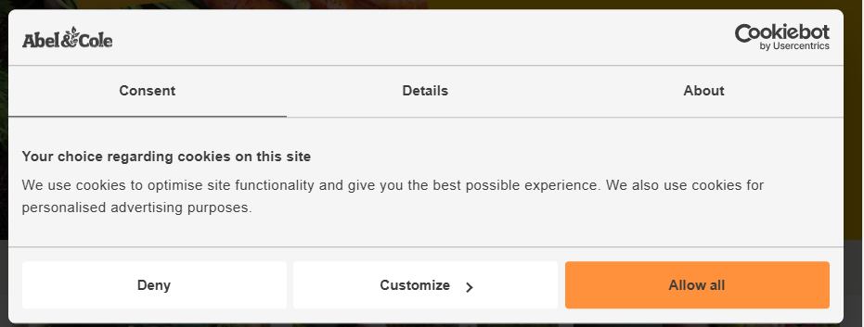The website also follows legal standards as the General Data Protection Regulation (GDPR) that protects personal data collected from users. It follows the standard by making the user accept cookies before data is collected, personal data is stored securely, and users can access privacy policies explaining how their data is being used.
Another law is the Data Protection Act 2018 (DPA) which works alongside GDPR to control how businesses use and handle personal data. The website follows DPA by storing customer account information securely, allowing users to request deletion or access to their data, and explaining how information is collected and used
Consumer Rights Act 2015 (CRA) protects customers when buying goods or services online. The website follows this law by providing accurate product descriptions, clearly showing pricing, and allowing users to complain or request refunds if the product is faulty.
Abel & Cole also follows the copyright, designs, and patents act. This law protects images, videos, text, and other creative content. They follow this law by using original photos of farms and produce, it owns or has permission to use website images and graphics, and it protects its own content from being copied without permission.
Business Context
A single location retail outlet for locally produced food and drink
The client offers a single location retail outlet for locally produced food and drinks! Making the website would allow customers to discover and support Greenfield Local Hub (GLH) and make purchases easier. Especially because a single location is not guaranteed to have many customers, and a lot of people go shopping for groceries online now! However, being a single retail outlet for locally produced foods and drinks shows customers that everything is local and not around the world. This helps increase sails because people will trust GLH to be completely organic and sustainable, and its people who care about the environment who are the target audience.
Collective marketing for local farmers and food producers
The client wants the platform to support collective marketing for local farmers and food producers. By bringing multiple food producers under one platform, the GLH can promote a variety of different crops and produce which will be suitable for any demographic, and be accessible to customers who are picky in taste, or have allergies. This also benefits farmers who don’t have the resources to sell independently and attracts customers who want to support their local businesses and are interested in being sustainable and environmentally friendly.
Product management, stock control, and product traceability
The client requires a system for product management, stock control, and product traceability. This ensures that GLH can be accurate in tracking different available products, updating stock levels, and managing the inventory efficiently. Traceability is important in food industries because it allows GLH to identify where the products come from and respond quickly to any quality and safety issues, because if there are any quality issues and GLH doesn’t have the traceability to fix it, then GLH will lose money. This improves efficiency and ensures customers get the most accurate information possible.
Provide information about the producers, their methods, and the benefit of buying locally
The client wants to provide information about the producers, their methods, and the benefits of buying locally. Providing information is especially important when promoting organic and a sustainable website, as it builds trust between GLH and their target audience. This helps the audience understand the story behind each produce they buy and create an emotional attachment between the producers and the customers. This means GLH is more likely to have customer retention because of the emotional connection. Displaying their methods and the benefits of buying locally also builds that same trust.
View products with transparent pricing and availability
The client wants customers to be able to view products with transparent pricing and availability. This allows customers to browse products easily and compare items before making a purchase. Transparent pricing and availability help prevent customers getting frustrated by unavailable products and know how much exactly a product is. Transparent availability also means the customer will be able to see when it’s next available and wait for that time to purchase the produce!
Place orders for collection or delivery
The client wants the system to allow customers to place orders for collection or delivery. Offering both options provide flexibility and convenience for customers with different needs and preferences. Some customers may prefer collecting orders to save on delivery costs, while others may prefer the convenience of home delivery. This flexibility helps increase customer satisfaction and makes the service accessible to a wider audience. Especially because some people may live 1 hour away from the store, making them be able to choose the option to have delivery will make it more likely people buy from GLH.
Manage their accounts and view order history
The client has asked to include the ability to manage their accounts and view order history. This improves the user experience by allowing customers to quickly reorder items they have purchased before. It also encourages repeat purchases and helps build long-term customer loyalty with the business. And by managing their account, a farmer would be able to upload photos they took themselves about the produce they’re selling, or see what people have ordered to test what produce people want more in stock! This helps increase sales as selling produce people want means more purchases.
Dashboard to enable producers to manage stock levels, update product details, and view orders
The client has requested a dashboard that allows producers to manage stock levels, update product details, and view orders. Giving producers direct access to manage their products ensures information stays accurate and up to date, which is important because if the information is inaccurate, customers would get frustrated and customer retention wouldn’t stay. Managing stock levels is important with viewing orders because if there’s not enough stock for the number of orders, then customers are bound to not get the product they purchased, meaning GLH would be losing money!
Order management, scheduling and tracking features
The client wants the system to allow order management, scheduling, and tracking features. This ensures the orders are processed in the most efficient way possible. Order management enables organisation for GLH, so instead of getting lost with the amount of orders coming through, they’ll be able to get managed so no farmer accidentally misses a customer’s order ensuring customer retention is still happening. Scheduling and would enable customers to track when their order is prepared to be picked up or where it is in its delivery, which increases customer trust with GLH. This also helps the business maintain organisation and ensures the customers receive their order in time.
Loyalty scheme that provides discounts and special offers
The client wants to introduce a loyalty scheme that rewards repeat customers with discounts and special offers. Loyalty schemes encourage customers to continue purchasing from the business instead of competitors. This helps increase long-term revenue and strengthens the relationship between the business and its customer base because if the user were to purchase from a competitor, they would lose their discounts and offers.
Accessibility features to support a wide range of users.
The client has requested accessibility features to support a wide range of users. These features ensure that the platform can be used by people with different abilities and needs, promoting inclusivity. Accessibility is also an industry standard and helps the business comply with legal accessibility requirements while expanding the target audience. If there were no accessibility features then people who need the features are excluded, which causes a decrease in revenue
Project Aim
The aim of the project is to produce an online web application that has the following features:
- A single location retail outlet for locally produced food and drink
- Collective marketing for local farmers and food producers
- Product management, stock control, and product traceability
- Provide information about the producers, their methods, and the benefit of buying locally
- Allow customers to:
  - View products with transparent pricing and availability
  - Place orders for collection or delivery
  - Manage their accounts and view order history
- Provide a dashboard to enable producers to manage stock levels, update product details, and view orders
- Order management, scheduling and tracking features
- A loyalty scheme that provides discounts and special offers
- Accessibility features to support a wide range of users.

Functional Requirements and User Acceptance Criteria
User Stories
Timmy is a farmer, every season he has a bountiful harvest and wants the ability to sell his produce as it’s simply too much for him!
Lizzie doesn’t know anything about crops, but she’s openly environmentally friendly. She doesn’t like chemicals in her food and wants to eat organically and healthily. She wears glasses but they recently broke.
Joel is a single dad with 2 kids, he simply doesn’t have the time to go out shopping to buy healthy, organic food. But he’s interested in it because he wants his kids to grow up healthy.
Functional Requirement | User Story | User Acceptance Criteria | Justification
Register | As a Timmy  I want to register  So that I can sell my crops  As a Lizzie  I want to register  So I can purchase from my local farmers healthy food! | Users can access the registration page from the main navigation.  Users can choose whether they are a farmer or a customer.  Users can enter their personal details including name, email, and password.  Users can enter their address and contact information.  The solution must validate that all required fields are filled.  The solution must validate fields are in the correct format (e.g., email, phone number).  Users should receive a confirmation message after successful registration.  Users should be able to log in after registering.  User’s personal details must be stored securely.  The page must comply with Web Accessibility Guidelines (WCAG). | Allowing users to create an account ensures both farmers and customers can access everything securely on the website. Timmy will be able to store his farm and personal details so he can easily manage and upload crops without having to reinput the same information.  Lizzie will also be able to store her delivery and contact details, making the buying crops process more efficient and convenient. This improves the user experience and ensures the products are linked to verified accounts! This simplifies the process for the future.
Log In | As a Joel  I want to log in  So that I can browse information about organic food  As a Timmy  I want to log in  So that I can upload my crops to sell them | Users can access the login page from the main navigation.  Users can enter their username/email and password.  The solution must validate login credentials.  Users should receive an error message if credentials are incorrect.  Users should be redirected to the correct dashboard after login.  Users must be able to log out securely.  The page must comply with Web Accessibility Guidelines (WCAG). | Allowing users to securely log in ensures both Timmy and Joel can access their registered accounts and access personalised features.  Timmy will be able to upload crops, manage stock, and view orders, whereas Joel can brose organic produce and manage his purchases. He’ll also be able to view blogs recommended to him.  Logging in also ensures that only authorised users can access data tailored to them only, improving the security of the website.
Product Management | As Timmy  I want to manage my products  So that I can remove or add any new produce | Users can access the product management page from the dashboard.  Users can add a new product including name, description, price, and stock.  Users can remove existing products.  Users can update product details.  The solution must validate that product fields are filled and in correct format.  Users should see a confirmation message after adding, updating, or removing a product.  The page must comply with Web Accessibility Guidelines (WCAG). | Allowing farmers to manage their products ensures they can easily add, update, or remove produce as availability changes. This allows farmers like Timmy to keep product information accurate, including prices, descriptions, and quantities. Keeping product information up to date ensures customers always see reliable details when browsing the platform. This reduces confusion, improves customer trust, and helps farmers maintain accurate listings which can increase sales and customer satisfaction.
Stock Control | As Timmy  I want stock control  So that I can let customers know what is in stock  As Lizzie  I want stock control  So that I can see what’s in stock | Users can access stock control from the farmer dashboard or customer product pages.  Users can view current stock levels for all products.  Users can update stock quantities from the stock control page.  The solution must reflect real-time stock updates for customers.  Customers should see only available stock.  The page must comply with Web Accessibility Guidelines (WCAG). | Allowing farmers to control the stock levels ensures that the available products is always accurate for customers like Lizzie who are browsing the produce. Timmy can update what produce is in stock, and Lizzie can see the items that are available. This reduces the risk of the produce being ordered that is out of stock and improves the trust between users and farmers.
Product traceability | As Lizzie  I want to trace the products I buy  So that I can see what farmer grew the produce  As Timmy  I want product traceability  So that if a faulty product is reported I can trace to see which one it is! | Users can access product traceability from the product detail page or order history.  Customers can see which farmer grew each product.  Farmers can track which product batch has been sold.  The solution must store and display batch and farmer information accurately.  Traceability information should be secure and accessible only to relevant users.  The page must comply with Web Accessibility Guidelines (WCAG). | Allowing products to be traced back to the farmer ensures accountability on the website. Customers such as Lizzie can see exactly who grew the produce she purchases, helping her make informed decisions and support local farmers. Farmers such as Timmy can also track batches of produce in case an issue or complaint occurs. This improves food safety, builds trust between farmers and customers, and ensures problems can be resolved quickly if they arise.
Producer news/blog page | As Joel  I want to view a blog  So that I can read up on organic and farming information  As Timmy  I want a producer news/Blog page  So that I can keep customers updated on the latest updates about my crops  As Timmy  I want a producer news/blog page  So that I can inform customers why farming sustainably is good | Users can access the blog page from the main navigation.  Users can read articles about organic farming, seasonal produce, and sustainability.  Farmers can create, edit, and delete blog posts from the blog management page in their dashboard.  Users should be able to filter blog posts by topic or date.  The page must comply with Web Accessibility Guidelines (WCAG). | Allowing farmers to publish blog posts and updates allows them to share news about crops, sustainability, and farming practices with customers. This helps farmers like Timmy communicate directly with customers about his produce and explain the benefits of sustainable and organic farming. Customers such as Joel can also learn more about organic food and seasonal produce. This strengthens the relationship between producers and customers while also educating users about healthy and sustainable food choices.
View producers | As Lizzie  I want to view the producers  So that I can support my local farmers  As Joel  I want to view the producers  So that I know who grows the food | Users can access the producers list from the main navigation or homepage.  Users can click on a producer to view their details and products.  Users should see ratings and reviews for each producer.  Users should access products page  User should select products  Users should see the producers  The page must comply with Web Accessibility Guidelines (WCAG). | Allowing users to view producers helps customers identify and support local farmers. Lizzie can learn more about who grows her food, view ratings and reviews, and browse products directly from the farmer. This creates transparency in the website and helps customers feel more confident about where their food comes from.
View benefits of buying locally | As Joel  I want to know the benefits of buying locally  Because I want to find out more so my kids can eat healthy | Users can access the benefits page from main navigation.  Users can read information about health, environmental, and community benefits.  Users can click links to related articles.  The page must comply with WCAG. | Allowing users to learn about the benefits of buying local produce helps customers learn about healthier and more sustainable food choices, while also promoting healthy eating. Joel can understand how locally grown food supports farmers, reduces environmental impact, and improves community wellbeing. Providing this information encourages customers to make more informed purchasing decisions and increases awareness of the advantages of supporting local farms
Place order for collection / delivery | As Lizzie  I want to place an order for collection  So that I can pick up the produce locally  As Joel  I want to place order for delivery  So that I can still take care of my kids and feed them healthily | Users can access the shopping basket from the main navigation or product page.  Users can select products and add them to their basket.  Users can choose between collection or delivery from the basket/checkout page.  Users can select collection or delivery date and time from the checkout page.  The solution must validate that required fields are entered.  Users should receive a confirmation after placing the order.  Users should be able to view and track their orders from their account or dashboard.  The page must comply with Web Accessibility Guidelines (WCAG). | Allowing customers to place orders for either collection or delivery ensures the platform is convenient for different users. Customers, such as Lizzie, can collect produce locally while users such as Joel can choose delivery if he is busy or unable to travel. This flexibility makes the service accessible to more users while ensuring farmers can prepare and organise orders more efficiently.
Manage account | As Joel  I want to manage my account  So that I can update my account details so they stay accurate  As Timmy  I want to manage my account  So that I can update my account information | Users can access their account page from the main navigation.  Users can update personal information, contact details, and password.  The solution must validate updated fields for correct format.  Users should receive confirmation when changes are saved.  The page must comply with Web Accessibility Guidelines (WCAG). | Allowing users to manage their account information ensures that personal details remain accurate. Customers and farmers can update their email, address, or password whenever needed. Keeping this information up to date helps prevent delivery issues and ensures communication between users and farmers stays reliable. This also improves security by allowing users to manage their login credentials.
View order history | As Joel  I want to view my order history  So that if I liked a produce from a specific farmer, I can rebuy it again | Users can access order history from their account page.  Users can view details for all previous orders, including product, quantity, date, and status.  Users should be able to reorder products from past orders.  The page must comply with Web Accessibility Guidelines (WCAG). | Allowing users to view their order history makes it easier for customers to track past purchases and reorder products they enjoyed. Users such as Joel can quickly find items from a specific farmer and purchase it again without searching through the entire catalogue. This makes it convenient for customers while also encouraging repeat purchases which benefits farmers and the platform.
Producer Dashboard | As Timmy  I want a dashboard  So that I can manage my products and orders on one page | Farmers can access the dashboard from the main navigation after login.  Users can see orders that are pending, completed, or in progress.  Users can manage products and stock directly from the dashboard.  The solution must display real-time updates for orders and stock.  The page must comply with Web Accessibility Guidelines (WCAG). | Allowing farmers to access a dashboard provides them with a central location to manage their products, stock, and orders. Farmers such as Timmy can quickly see pending orders, update stock levels, and monitor sales. Having all management tools in one place makes the platform easier to use and reduces the time required to manage farm operations online. This improves efficiency and helps farmers keep their business organised.
Update product details | As Timmy  I want to update my products details  So the information about the product stays accurate | Users can access product details from product management page.  Users can edit name, description, price, stock.  Solution must validate all fields.  Users should receive confirmation after update.  Page must comply with WCAG. | Allowing farmers to update product details ensures that descriptions, pricing, and availability stay correct. Farmers such as Timmy can edit product information whenever necessary to reflect seasonal changes or improvements. Accurate product details help customers make informed purchasing decisions and reduce confusion about what is being sold.
View orders | As Timmy  I want to view my orders  So that I know what produce to prepare | Users can access orders from nav bar.  Users can view all orders with product, quantity, customer, and status.  Users can filter orders by status.  Solution updates orders in real time.  Page must comply with WCAG. | Allowing farmers to view all orders ensures they know exactly what produce needs to be prepared and delivered. Farmers can see details such as quantities, customer information, and order status. This helps farmers organise their workload and ensures orders are completed accurately and on time.
Order management | As Timmy  I want to manage my orders  So that I can see which orders are complete and which ones I still must do | Users can access order management from dashboard.  Users can mark orders as complete, in progress, or pending.  Users should see confirmation after status update.  Page must comply with WCAG. | Allowing farmers to manage order statuses helps them track which orders are pending, in progress, or completed. This improves organisation and ensures customers are kept informed about the progress of their orders. Clear order tracking also reduces the risk of missed or delayed deliveries.
Scheduling and tracking feature | As Joel  I want to schedule and track my order  So that I can see when the produce will arrive and so I can have my produce on certain days  As Timmy  I want to schedule and track orders  So that I know when to send out the package | Users can access order scheduling and tracking from the order history page or dashboard.  Users can select a date and time for delivery or collection.  Users can track the status of their order in real time.  Farmers can schedule orders for dispatch from their dashboard.  The solution should notify users of changes in order status.  Page must comply with WCAG. | Allowing customers to schedule and track orders will ensure that they know when exactly the produce they ordered will arrive or be ready for collection. Customers like Joel can plan their week around the delivery time whereas farmers can schedule shipping in a more efficient way. This improves the reliability, stops confusion, and ensures both farmers and customers have clear ideas about delivery or collection times
Loyalty scheme | As Lizzie  I want a loyalty scheme  So that I can get produce for cheaper for buying at GLH | Users can access loyalty information from their account page.  Users can view points earned from previous purchases.  Users can redeem points for discounts.  The solution must update loyalty points automatically after each purchase.  Page must comply with WCAG. | Allowing customers to earn and redeem loyalty points encourages repeat purchases and rewards regular customers. Customers such as Lizzie can accumulate points from previous orders and redeem them for discounts on future purchases. This increases customer satisfaction while also encouraging users to continue purchasing from the platform.
Accessibility features | As Lizzie  I want accessibility features  So that I can see the products on the website without my glasses | Users can access accessibility settings from any page header or navigation menu.  Users can adjust text size and contrast for readability.  Users can navigate the site using keyboard only.  The page must comply with WCAG guidelines. | Accessibility features ensures the platform can be used by people with different needs or disabilities. Users can adjust text size, contrast, or navigate the website using a keyboard. Making the platform accessible ensures it complies with accessibility standards while also allowing more users to comfortably browse and purchase products.
FAQ page | As Joel  I want a FAQ page  So that I can see whether any questions I’ve got have already been answered | Users can access FAQ from the main navigation.  Users can search for frequently asked questions.  Users should see answers clearly organized by topic. | Allowing users to access a FAQ page helps them quickly find answers to common problems or questions. Customers such as Joel can check whether their question has already been answered without needing to contact support. This saves time for both users and farmers while improving the overall usability of the platform.
Seasonal Fruit and Vegetable boxes | As Lizzie  I want to buy seasonal boxes  So that I can receive fresh food that’s in season  As Joel  I want to buy seasonal boxes  So that I can learn what vegetables and fruits are in season | Users can access seasonal boxes from main navigation or product page.  Users can view products in seasonal boxes.  Users can select box and add to basket.  Page must comply with WCAG. | Allowing customers to purchase seasonal fruit and vegetable boxes encourages them to buy fresh produce that is currently in season. Customers can discover new fruits and vegetables while farmers can promote produce that is currently in harvest. This supports sustainable farming practices and helps reduce food waste.
Recipes | As Joel  I want to know some recipes  So that I know what healthy food I should cook for my kids using the produce I buy | Users can access recipes from main navigation or product pages.  Users can view healthy recipes using available produce.  Users can filter by meal type or ingredient.  Page must comply with WCAG. | Allowing users to access recipes helps them learn how to cook healthy meals using the produce they purchase. Customers such as Joel can find recipes suitable for families and discover new ways to prepare fresh vegetables and fruits. This encourages healthier eating habits while also increasing the value customers receive from the produce they buy.  It also increases the purchase rate of the produce because if they see a recipe they like, then they’ll buy the produce necessary for it.
Reviews | As Timmy  I want to see reviews  So that I know what customers think of my crops  As Joel  I want to see reviews  So that I can know what other people think of produce  As Lizzie  I want to create reviews  So that I can share my experience with the produce | Users can submit reviews from the product page or order history page.  Users can read reviews from other customers on product pages.  Farmers can respond to reviews from the dashboard.  The solution must validate those reviews contain required fields.  Page must comply with WCAG. | Allowing customers to leave reviews enables them to share feedback about products and their experience. Farmers such as Timmy can read reviews to understand customer satisfaction and improve his produce if necessary. Reviews also help new customers make informed decisions before buying produce.
Shopping Basket | As Lizzie  I want a shopping basket  So that I can buy multiple products at once | Users can access the shopping basket from the main navigation or product pages.  Users can view and edit the basket before checkout.  Users can enter payment information securely on the checkout page.  The solution must validate payment fields and confirm successful payment.  Users should receive an order confirmation.  Page must comply with WCAG. | Allowing customers to use a shopping basket allows them to collect multiple products before completing a purchase. This makes the shopping process more convenient and allows users to review and modify their selections before checkout. A well-designed basket improves usability and ensures customers can easily complete their purchases.
Product browsing | As Joel  I want to browse products  So that I can see all the different produce to buy | Users can access product catalogue from main navigation or homepage.  Users can view products by category or search.  Users can click products to view details.  Page must comply with WCAG | Allowing users to browse products helps them explore the range of available produce and discover new items to purchase. Customers such as Joel can search by category or product name, making it easier to find specific items. Clear browsing features improve the user experience and encourage customers to purchase more products.
Checkout and payment | As Lizzie  I want to checkout and make a payment  So I can buy the produce I want | Users can access checkout from basket.  Users can confirm products and select payment method.  Users can enter payment info securely.  Solution validates payment fields.  Users receive order confirmation.  Page must comply with WCAG. | Allowing customers to securely checkout and make payments ensures that purchases can be completed safely and efficiently. Secure payment validation protects sensitive financial information while order confirmation provides reassurance that the purchase was successful. This improves customer trust in the platform.
Delivery Scheduling | As Timmy  I want delivery scheduling  So that I can know when to ship out a product  As Joel  I want delivery scheduling  So that I can make my order arrive on a day I need it to. | Users can access scheduling from dashboard or order page.  Users can select delivery/collection date.  Users should receive confirmation of scheduled delivery.  Page must comply with WCAG. | Allowing users to schedule deliveries ensures that both farmers and customers can plan convenient delivery times. Customers can select a date that suits them while farmers can organise dispatch and delivery routes effectively. This reduces missed deliveries and improves overall service reliability.
Search and filtering | As Lizzie  I want to search and filter for produce  So that when I want to buy something specific, it’s easy to find | Users can access search from the main navigation or homepage search bar.  Users can search for products by name or category.  Users can filter products by price, availability, and season.  The solution must display search results accurately and update in real time.  Page must comply with WCAG. | Allowing users to search and filter products helps them quickly find specific items they want to purchase. Customers such as Lizzie can filter produce by price, availability, or season, making the shopping experience faster and easier. Efficient search tools improve usability and help customers locate products without unnecessary effort.
Customer Support | As Joel  I want customer support  So that if I want to know more, I can ask someone for help | Users can access customer support from the main navigation or footer link.  Users can submit queries or requests for help.  Support staff should be able to respond to user requests.  Page must comply with WCAG. | Allowing users to contact customer support ensures they can receive assistance if they encounter problems or have questions. Customers such as Joel can submit queries and receive help from support staff. Providing support improves trust in the platform and ensures issues can be resolved quickly.
Local food promotion | As Timmy  I want local food promotion  So that my produce is advertised and more people buy from me | Farmers can access promotion tools from the dashboard.  Users should see active promotions in product listings.  The solution must ensure only authorised users can create promotions.  Page must comply with WCAG. | Allowing farmers to promote their produce increases visibility and encourages more customers to purchase locally grown food. Farmers can highlight special offers or seasonal produce to attract buyers. This benefits farmers by increasing sales while also helping customers discover new local products.
Location of map of where the store is | As Lizzie  I want a location map of where the store is  So that I know where to go in person to collect my orders | Users can access store location map from main navigation or product page.  Users can see map with store location.  Users can get directions from map.  Page must comply with WCAG | Allowing users to view a map showing the store location helps customers easily find where to collect their orders. Customers such as Lizzie can view directions and plan their journey in advance. This reduces confusion and ensures collection is convenient and straightforward.
Farmer account | As Timmy  I want a farmer account  So customers can’t access any orders I need to manage | Farmers can register and access farmer account from main navigation.  Customers cannot access farmer orders.  Solution must restrict access to authorized users only.  Page must comply with WCAG. | Allowing farmers to have a dedicated account ensures that sensitive information such as orders and product management tools are restricted to authorised users. This protects important business data and ensures customers cannot access administrative features intended only for fsarmers.
Collection time slot | As Lizzie  I want a collection time slot  So that I know when to pick up my order | Users can select a time slot for collection from the checkout page.  The solution must prevent double booking for the same slot.  Users should receive confirmation of their selected time slot  Page must comply with WCAG. | Allowing customers to select a collection time slot ensures that order pickups are organised and efficient. The system prevents multiple users from booking the same time slot, reducing congestion and confusion at collection points. This ensures a smoother collection process for both customers and farmers.

Non-Functional Requirements
Performance
Non-Functional Requirement | Justification | KPI
The website must load efficiently and consistently | A fast-loading website improves user experience and prevents users from leaving the site due to slow performance. Customers browsing products and farmers managing stock should be able to access pages quickly without delays. | Load within 15ms of opening  After 2 hours, still load within the 15ms  No page returns an error during normal navigation
The website must maintain performance over time. | Ensures the system remains responsive even after being used for extended periods such as browsing products or managing orders. This prevents slowdowns that could negatively affect the user experience. | After 2 hours of continuous use, still load pages within 1.5 seconds.  Forms submit within 2 seconds  System can navigate between pages without freezing or errors
All images should be high quality without effecting the loading speeds | High quality images make the website look professional and help customers clearly see produce before purchasing. However, images must also be optimised to prevent slow loading speeds. | The images should be at a minimum of 1920 x 1080 pixels.  Each image loads under 3 seconds
Security
Non-Functional Requirement | Justification | KPI
Log in data must be held securely in a database that users can’t access | Protecting user data such as login credentials is important to prevent unauthorised access to accounts. Secure storage helps protect both farmers’ and customers’ personal information. | Users cannot view or access other users’ account data through the interface or database.  Only logged in users can access account pages
User passwords must be hashed before storing in the database. | Encrypting or hashing passwords protects sensitive data and ensures passwords cannot be read directly from the database if accessed. | Passwords stored in the database appear as encrypted/hashed strings rather than plain text.
Users must only access features relevant to their role. | Farmers should be able to manage products and orders while customers should only browse and purchase produce. Restricting access ensures sensitive management tools are protected. | Customer accounts cannot access farmer dashboards or product management pages.
Scalability
Non-Functional Requirement | Justification | KPI
The system must support additional users without breaking functionality. | As more farmers and customers register on the platform, the system should continue to operate correctly without errors or crashes. | The system works correctly with at least 20 test accounts created in the database and maintains a response time below 2 seconds
The system must be able to scale horizontally to accommodate more users. | Supports business growth and increasing demand without compromising performance. | Horizontal scalability with automatic scaling to maintain response time below 2 seconds
The system should allow new products and producers to be added easily. | As more farmers join the platform, the system must support the addition of new products without affecting existing data or performance. | The system successfully stores and displays at least 100 products in the product catalogue.
Capacity
Non-Functional Requirement | Justification | KPI
The database must store user accounts, orders, and products efficiently. | The system must store enough data to support the platform as more users and products are added over time. Efficient data storage ensures the system remains responsive. | There shouldn't be any complaints of delay or errors when multiple users attempt to register an account or create or purchase a product
The database must store product images and descriptions. | Product images help customers make informed purchasing decisions, so the system must support storing and retrieving images alongside product details. | Ability to store and retrieve 30 high-resolution images with load times under 5 seconds per image.
Reliability
Non-Functional Requirement | Justification | KPI
The website must be consistent and not crash during use. | A reliable system ensures customers can browse products and place orders without interruptions while farmers can manage stock and orders efficiently. | The website should have a 99.99% uptime  During testing, the system runs for 1 hour of normal use without crashes or major errors.
The website must have a crash recovery plan to minimise downtime and ensure full site recovery | Ensures that user and business data are safely stored and recoverable in case of accidental loss. | The solution should take no longer than 30m to get back online and back up on github every hour.
The system must regularly save and store data. | Regular saving ensures important information such as products, users, and orders is not lost if the system stops unexpectedly. | All database changes (orders, product updates) appear immediately after saving or refreshing the page.
Usability
Non-Functional Requirement | Justification | KPI
The website interface must be simple and easy to navigate. | A clear and intuitive interface ensures users can quickly find products, manage orders, or access important features without confusion. | At least 4 out of 5 test users can complete tasks such as browsing products and placing an order without assistance.
Users must be able to easily reset forgotten passwords. | Allowing password resets ensures users can regain access to their accounts if they forget their login credentials. | Test users can successfully reset their password within 3 minutes using the reset feature.
Accessibility
Non-Functional Requirement | Justification | KPI
The website must meet WCAG 2.1 AA accessibility standards. | Ensuring accessibility allows people with visual or physical impairments to use the website effectively and access information about products. | All images contain alt text, and pages can be navigated using a keyboard, contains an accessibility menu
The website must offer high-contrast modes for visually impaired users | Provides a clear visual interface for users with low vision. | High-contrast mode should be accessible with one-click toggle, and 100% of text should be legible in high contrast mode.
The website must offer readable text and clear contrast. | Good contrast and readable text improve usability for users with visual impairments or those viewing the website in different lighting conditions. | Text is readable with minimum 16px font size and clear contrast between background and text.

Hierarchy Diagram
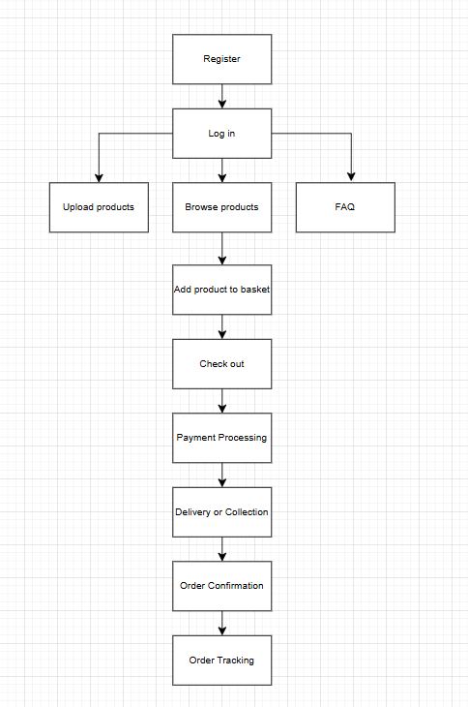

UI Consideration
Some key aspects I have considered implementing for the design phase include the colour scheme, general aesthetic, spacing, images, and text.
The colour scheme should follow very earthy tones, I have attached an image below of the general colours I plan on using. The whitespace should be the off-white, with the text colour being the dark green for easier contrast and readability. During my research, I noticed the websites tended to use earthy colours to simulate the vibe of a farm on the actual website. Greens and browns are often correlated with farming, but also green is associated with sustainability. This ties into the idea of the website sustainably and ethically farming alongside being organic. A lot of organic brands tend to use the colour green, also implying it’s the industry standard for locally produced produce websites. I plan on using the brown as an accent colour, as seen in Riverford in my research, it uses pink to catch the user’s attention on certain parts of the screen, especially near images and icons. So, I plan to use brown on certain parts drawing the user’s attention on any important information or advertising.
The images used will be copyright free, taken from stock.adobe.com, which are stock images uploaded, meaning I am allowed to use them on my website. I plan on using photos of vegetables and fruit to stay consistent with the set task brief, while also adding copyright free photographs of farmers to meet the functional requirement that users are able to view the producers.
I want to incorporate professional icons, both Riverford and Abel & Cole use them, with Riverford going for a more friendly and soft approach, and Abel & Cole going for a modern, professional approach. I plan to go for a more friendly approach with the icons so that it fits the aesthetic of a local retail shop and fits in with the earthy colours I have chosen.
The font I have decided to use is poppins because it’s a font that feels clean, modern, and readable. However, my research with both Riverford and Abel & Cole suggests I use sans serif, which will be the font the whole website is using, and only using poppins when I want to draw the user’s attention. Text and language wise, I want to use a friendly approach with non-technical language. This ensures the website is accessible to all ages, and especially to the target audience who doesn’t know anything about farming or produce but wants to find out more.
I plan on utilising whitespace when I can, so the GLH website doesn’t feel overcrowded with all the elements. A benefit of this is that the elements will stand out making the UI feel clean and easier to navigate.

Security Considerations
Risk Description | Probability | Impact | Mitigation
(R1) System Failure | Moderate | High | Save and back up the website during development on GitHub, therefore if the database fails it can be restored to a prior back up
(R2) Data Security Breach | Low | High | MVC automatically hashes passwords, ensuring accounts can’t be hacked.  Also make it unable for log in details or sensitive data to be viewed via the interface.  Add secure log in validation and add a notice saying users can’t post their personal information.
(R3) SQL Injection | Low | High | Use ASP.NET core MVC that has built in SQL protection.
(R4) DDOS Attack | Low | High | Add email validation and require all required fields before registering.  Add simple verification such as confirming email addresses before account activation
(R5) Brute Force to gain unauthorised access to a users account | Moderate | Significant | Include 2 step verification system so a code will be sent to a user’s phone or email  Also implement an account lockout after too many incorrect password attempts.  Also require strong passwords with complex rules.
(R6) Confusing Interface | Moderate | Significant | Do usability testing and make sure navigation is simple, clear, and easy to use
(R7) Customers ordering produce that is out of stock | Moderate | High | Implement automatic stock updates when products are purchased and prevent customers from ordering items with zero stock.
(R8) Farmers entering incorrect product information (price, stock, description) | Low | Significant | Implement validation checks when farmers add or edit products to ensure required fields are filled and prices or stock values are valid numbers.  Add an “Are you sure” pop up after pressing confirm
(R9) Inappropriate or misleading reviews being posted | Low | Moderate | Require reviews to be submitted by logged-in users and allow farmers to remove inappropriate reviews if necessary.
(R10) Critical bugs after updates breaking the website | High | High | Make backups of the website every hour and roll back if the website breaks via GitHub

Risk Matrix
Impact
High | R2 R3 R4 R8 | R1 R7 |  | R10
Significant |  | R5 R6
Moderate
Low
 | Low | Moderate | Significant | High
Probability

Legal and Regulatory Guideline Considerations
GLH will have to follow data protection acts such as the General Data Protection Regulations (GDPR) and the Data Protection Act 2018. When a customer makes an account or buys some produce from GLH, their data will be collected. These laws ensure that the personal data that is collected is protected, this includes names, emails, addresses, etc, with user consent. This will be done by gaining consent from the user via cookies, which requires users to accept or deny them (cookies are small files placed on a user’s device by a web browser when visiting a website, designed to store data for tracking, authentication, and personalisation). Users must also have the ability to view, edit, delete their data and be informed clearly on what their data is being used for and how it’s being stored. To apply this law the system will also include a privacy policy page which will explain to people like Lizzie and Joel their user rights, and how they can manage their data. Passwords will also be hashed as MVC in visual studio automatically hashes and encrypts passwords! All this ensures that GLH will comply to the GDPR and DPA.
GLH will also need to follow the Copyright, Designs, and Patents Act 1988. This law protects images, videos, texts, and other creative content. To follow this law, GLH will only use original or licensed images from a stock website. Also, GLH should implement content protection which disallows users to download any of the images used on the website. In addition, all descriptions should be original! Following this law complies with the copyright laws and ensures GLH will not get sued for using an image without having the rights to use them.
Another law to follow is the Consumer Rights Act 2015 (CRA). This applies to GLH because users are buying goods online. To follow this law, GLH will provide accurate descriptions, clear pricing, and up-to-date stock levels on each product. And if there is an issue in any of the products, customers, like Lizzie, will be able to request a refund or replacement of the produce sold. Complying to this law means customers should be able to request refunds or replacements via a contact form, ensuring the process is simple, quick, and transparent. This ensures the customers are treated fairly and GLH complies with the CRA.
Because GLH sells food online, and in person, the system must comply with the Consumer Contracts (Information, Cancellation and Additional Charges) Regulations 2013. This law requires that GLH provides clear information before a purchase is made. To ensure GLH complies with this law, the website will clearly display the total price, delivery costs, payment methods, and estimated delivery time before the customer, such as Joel, confirms their order. GLH should automatically send an order confirmation email with the details of the purchase and inform the customer about their cancellation rights!
The Electronic Commerce (EC Directive) Regulations 2002 (ECR) applies to all businesses that sell online, therefore GLH must follow this law. To comply, GLH should clearly display the business name and contact information, email address, pricing information, and Terms and Conditions (T&Cs). To do this GLH will place the information on the footer of the website, redirecting the user to a page with the information necessary on it. T&Cs will also be shown as a pop up as it will decrease the legal liability as GLH would be able to dispute any claims because they would be shown in the T&Cs. This also links towards the GDPR and DPA as it complies via informing users of their data being collected.
As GLH sells food online, allowing farmers to list their produce, GLH must comply with the Food Information Regulations 2014 (FIR). This ensures customers are provided with clear information about food products, especially regarding to allergens, before buying. To comply, GLH will ensure each product lists out ingredients, allergen warnings, storage instructions, and weight or quantity of the produce. Farmers, such as Timmy, will be able to fill out the information fields for each requirement before uploading. This helps protect customers with allergies and ensures GLH complies with food information regulations.
The Food Safety Act 1990 (FSA) requires that food sold to customers is safe to eat and not described incorrectly. This applies to GLH because farmers, like Timmy, will be selling their produce online and in person. To comply with this act, descriptions of products will be accurate and not misleading. Also, farmers will have to confirm their products meet the Food Safety standards before uploading to GLH. This adds transparency towards the farmer and customer and means GLH complies with this act.
Finally, there will be a variety of customers using GLH, therefore the website must include accessibility features to ensure everyone can access and use the website. Adding accessibility features complies with the Web Content Accessibility Guidelines (WCAG). Features to include in an easily accessed accessibility menu would include: text resizer, text-to-speech, colour modes like dark mode or high contrast. This ensures users are provided with a better experience, such as Lizzie who has bad eye-sight who would need a text resizer to be able to read the text!

