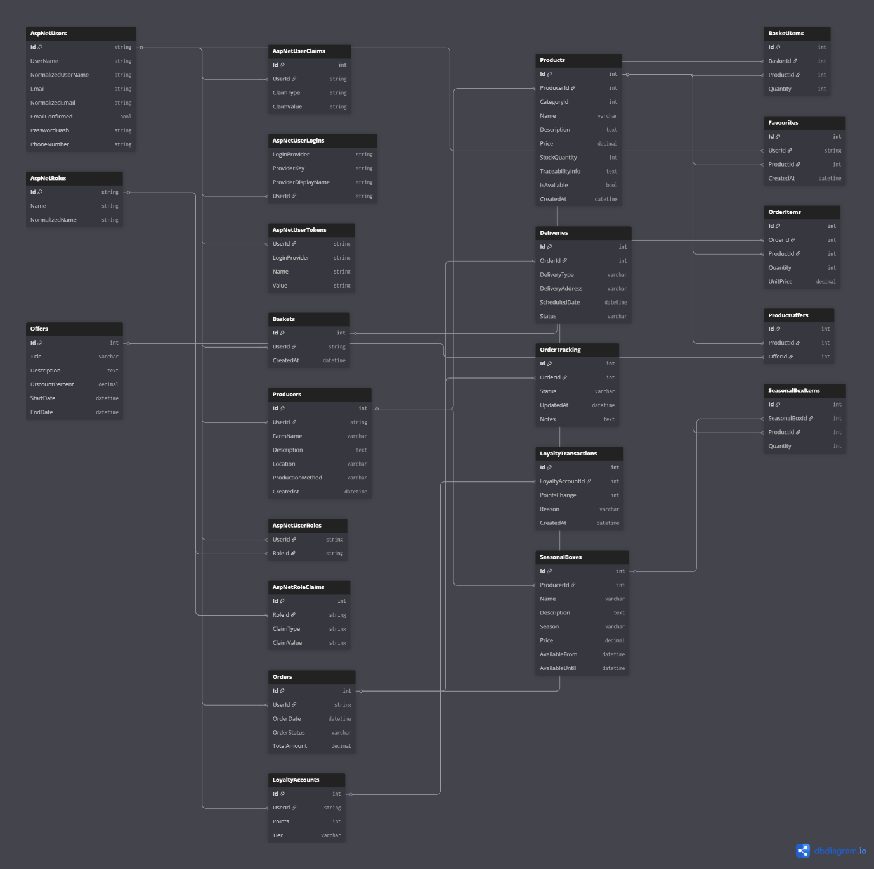
Producers
Column | Data Type | Required | Validation | Key
Id | int | yes | >0 | PK
UserId | string | yes | Not Null | FK
FarmName | string | yes | Max 255 characters
Description | string | No
Location | string | Yes | Address format
Production Method | string | No
CreatedAt | datetime | Yes | Valid Date

Products
Column | Data Type | Required | Validation | Key
Id | int | Yes | > 0 | PK
ProducerId | int | Yes | Exists in Producers | FK
CategoryId | int | Yes | Exists in Categories | FK
Name | varchar | Yes | Max 255 chars
Description | text | No
Price | decimal | Yes | ≥ 0
StockQuantity | int | Yes | ≥ 0
TraceabilityInfo | text | No
IsAvailable | bool | Yes | true/false
CreatedAt | datetime | Yes | Valid date

Basket
Column | Data Type | Required | Validation | Key
Id | int | Yes | > 0 | PK
UserId | string | Yes | Not Null | FK
CreatedAt | datetime | Yes | Valid date

BasketItems
Column | Data Type | Required | Validation | Key
Id | int | Yes | > 0 | PK
BasketId | int | Yes | Exists in Baskets | FK
ProductId | int | Yes | Exists in Products | FK
Quantity | int | Yes | > 0

Favourites
Column | Data Type | Required | Validation | Key
Id | int | Yes | > 0 | PK
UserId | string | Yes | Not Null | FK
ProductId | int | Yes | Exists in Products | FK
CreatedAt | datetime | Yes | Valid date

Orders
Column | Data Type | Required | Validation | Key
Id | int | Yes | > 0 | PK
UserId | string | Yes | Not Null | FK
OrderDate | datetime | Yes | Valid date
OrderStatus | varchar | Yes | Predefined values
TotalAmount | decimal | Yes | ≥ 0

Orderitems
Column | Data Type | Required | Validation | Key
Id | int | Yes | > 0 | PK
OrderId | int | Yes | Exists in Orders | FK
ProductId | int | Yes | Exists in Products | FK
Quantity | int | Yes | > 0
UnitPrice | decimal | Yes | ≥ 0

Deliveries
Column | Data Type | Required | Validation | Key
Id | int | Yes | > 0 | PK
OrderId | int | Yes | Exists in Orders | FK
DeliveryType | varchar | Yes | Standard / Express
DeliveryAddress | varchar | Yes | Max 255 chars
ScheduledDate | datetime | Yes | Valid future date
Status | varchar | Yes | Predefined values

OrderTracking
Column | Data Type | Required | Validation | Key
Id | int | Yes | > 0 | PK
OrderId | int | Yes | Exists in Orders | FK
Status | varchar | Yes
UpdatedAt | datetime | Yes | Valid date
Notes | text | No

LoyaltyAccounts
Column | Data Type | Required | Validation | Key
Id | int | Yes | > 0 | PK
UserId | string | Yes | Not Null | FK
Points | int | Yes | ≥ 0
Tier | varchar | Yes | Bronze/Silver/Gold

LoyaltyTransactions
Column | Data Type | Required | Validation | Key
Id | int | Yes | > 0 | PK
LoyaltyAccountId | int | Yes | Exists in LoyaltyAccounts | FK
PointsChange | int | Yes | Positive or negative
Reason | varchar | Yes
CreatedAt | datetime | Yes | Valid date

Offers
Column | Data Type | Required | Validation | Key
Id | int | Yes | > 0 | PK
Title | varchar | Yes | Max 255 chars
Description | text | No
DiscountPercent | decimal | Yes | 0–100
StartDate | datetime | Yes | Valid date
EndDate | datetime | Yes | > StartDate

ProductOffers
Column | Data Type | Required | Validation | Key
Id | int | Yes | > 0 | PK
ProductId | int | Yes | Exists in Products | FK
OfferId | int | Yes | Exists in Offers | FK

SeasonalBoxes
Column | Data Type | Required | Validation | Key
Id | int | Yes | > 0 | PK
ProducerId | int | Yes | Exists in Producers | FK
Name | varchar | Yes | Max 255 chars
Description | text | No
Season | varchar | Yes
Price | decimal | Yes | ≥ 0
AvailableFrom | datetime | Yes | Valid date
AvailableUntil | datetime | Yes | > AvailableFrom

SeasonalBoxItems
Column | Data Type | Required | Validation | Key
Id | int | Yes | > 0 | PK
SeasonalBoxId | int | Yes | Exists in SeasonalBoxes | FK
ProductId | int | Yes | Exists in Products | FK
Quantity | int | Yes | > 0

AspNetUsers
Column | Type | Required | Validation | Key
Id | string | Yes |  | PK
UserName | string | Yes
NormalizedUserName | string | Yes
Email | string | Yes | Must include “@”, valid format and domain
NormalizedEmail | string | Yes
EmailConfirmed | bool | Yes | Must be confirmed
PasswordHash | string | Yes
SecurityStamp | string | No
ConcurrencyStamp | string | No
PhoneNumber | string | No
PhoneNumberConfirmed | bool | No
TwoFactorEnabled | bool | No
LockoutEnd | datetime | No
LockoutEnabled | bool | No
AccessFailedCount | int | No | ≥ 0

AspNetUserRoles
Column | Type | Required | Validation | Key
UserId | string | Yes | Must exist in AspNetUsers | PK, FK
RoleId | string | Yes | Must exist in AspNetRoles | PK, FK

AspNetRoles
Column | Type | Required | Validation | Key
Id | string | Yes |  | PK
Name | string | Yes
NormalizedName | string | Yes
ConcurrencyStamp | string | No

