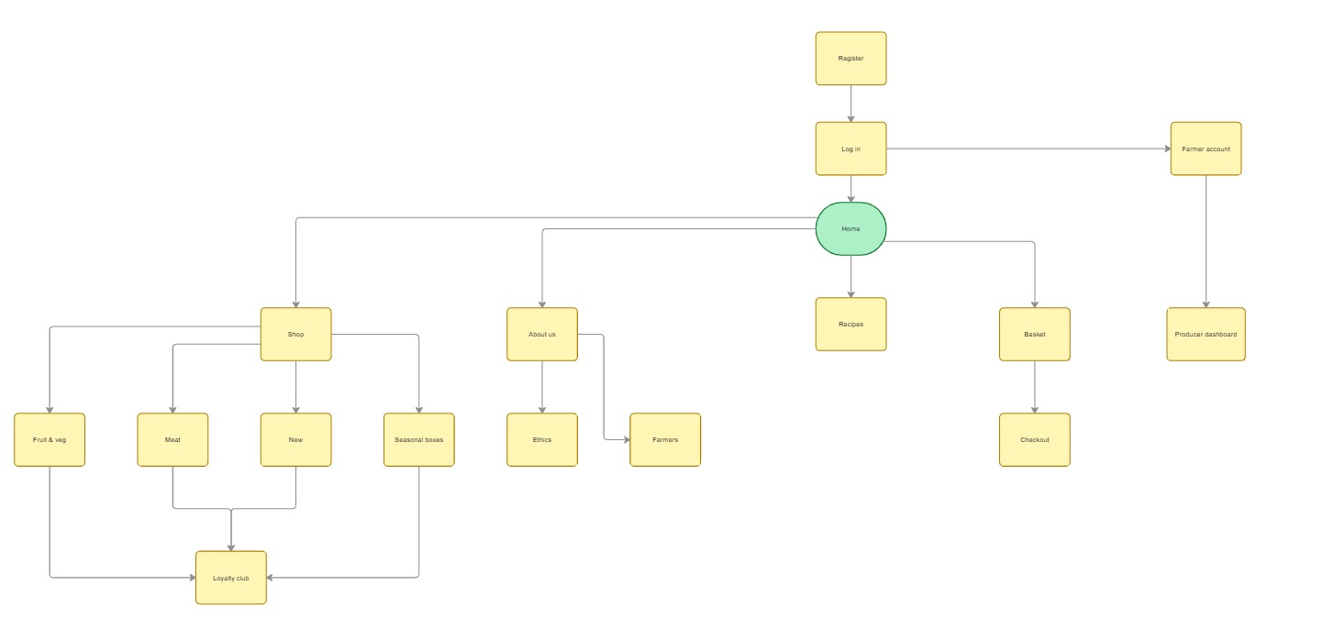
Sitemap

Visual Designs: https://www.figma.com/design/VZS1IktsLfNhP8oa4LRkp8/GLH-Wireframe?node-id=0-1&t=StBsFskbw3KlC3cD-1
(If for any reason this link does not work, contact my college for a working link! Thank you)

