**google chrome**

**1**. DOC-AS-CODE ------- > ADD button

**2**. "Contact us on" link

**3.** 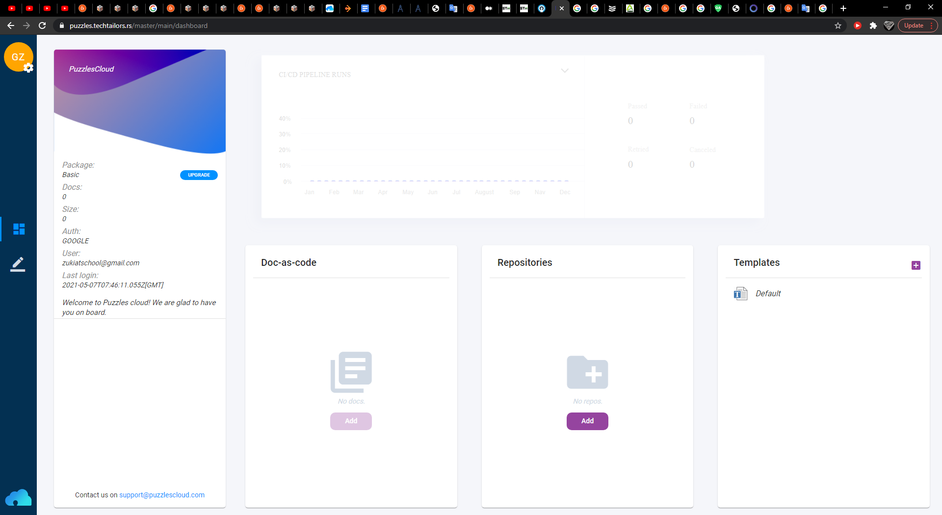

**4.** 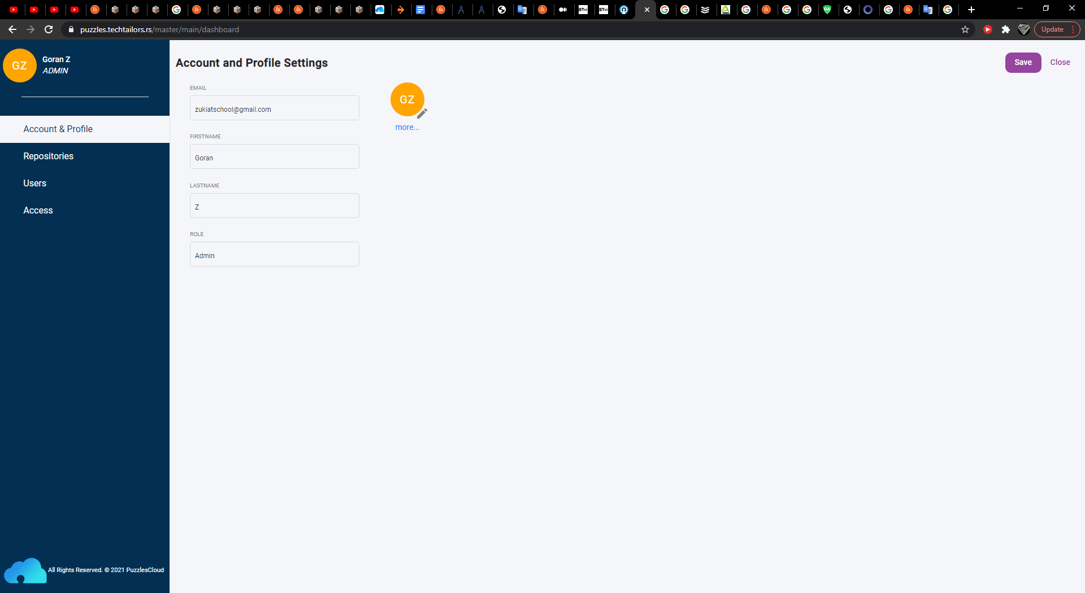 Avatar - "More" options ...

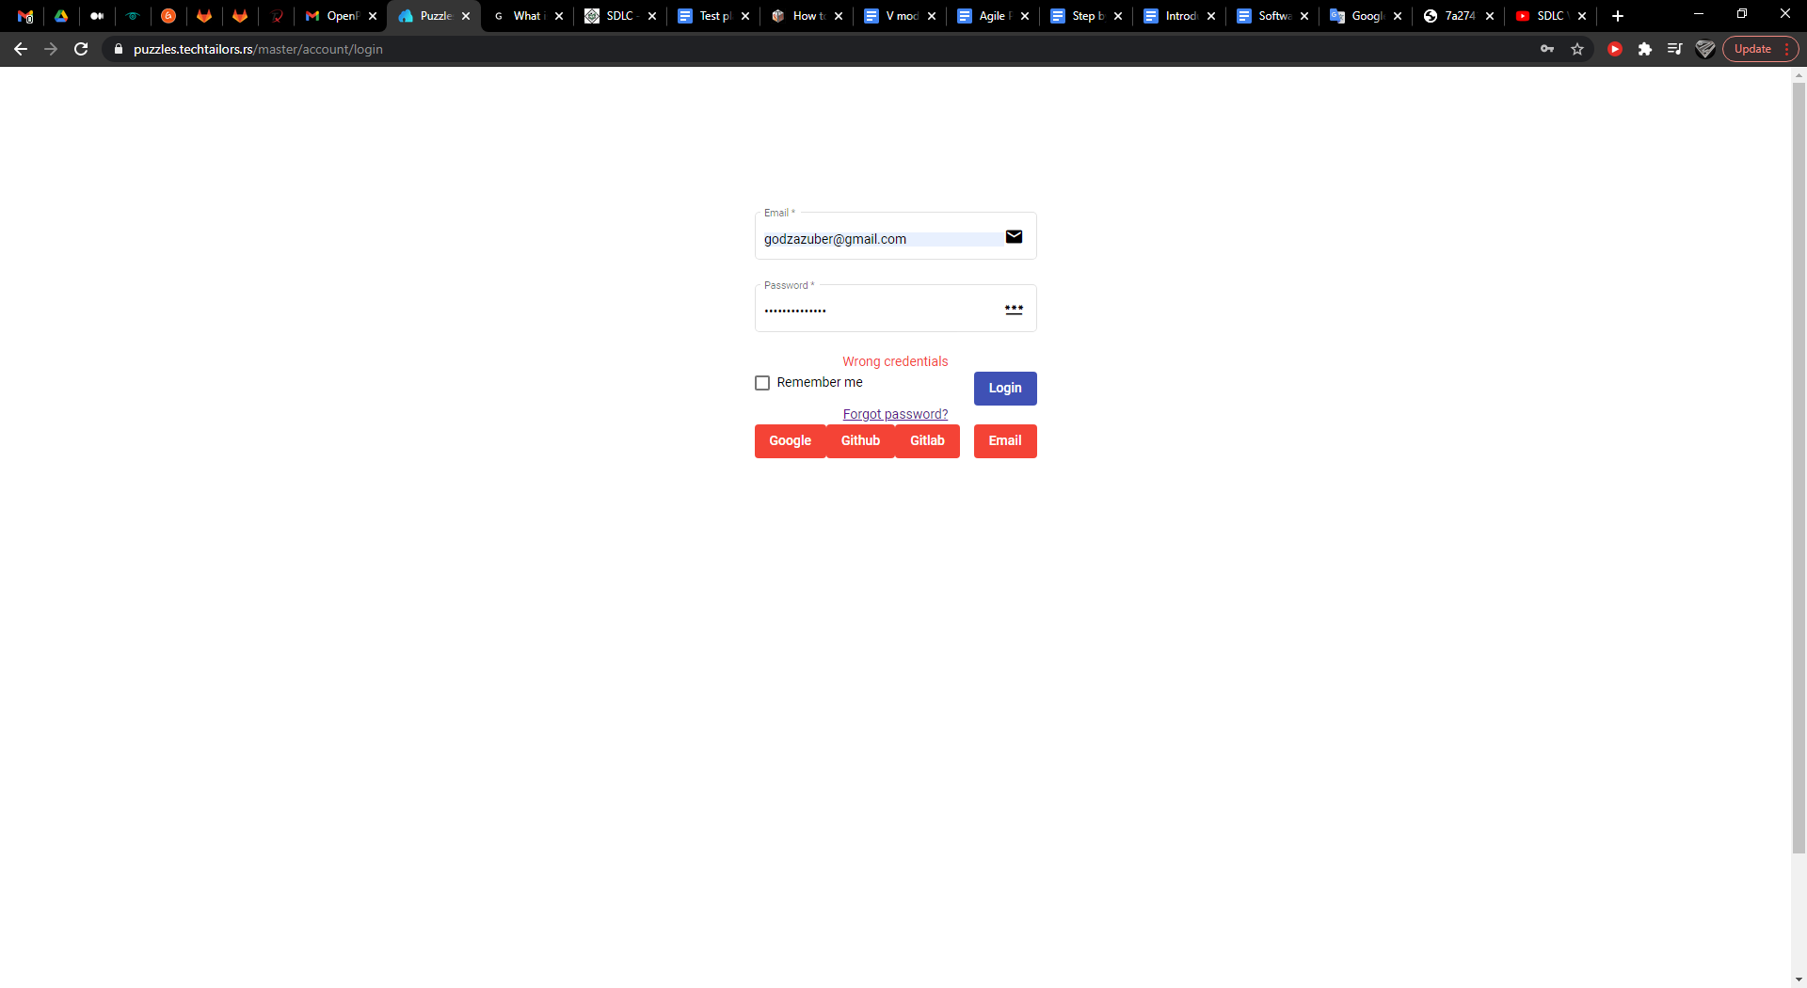**5**.

Logovanje na stranu preko dugmeta LOGIN

(password i email)

**Android 8 or later Phone**

1. Response - opcija "settings"

2. DOC-AS-CODE ------- > ADD button

3. 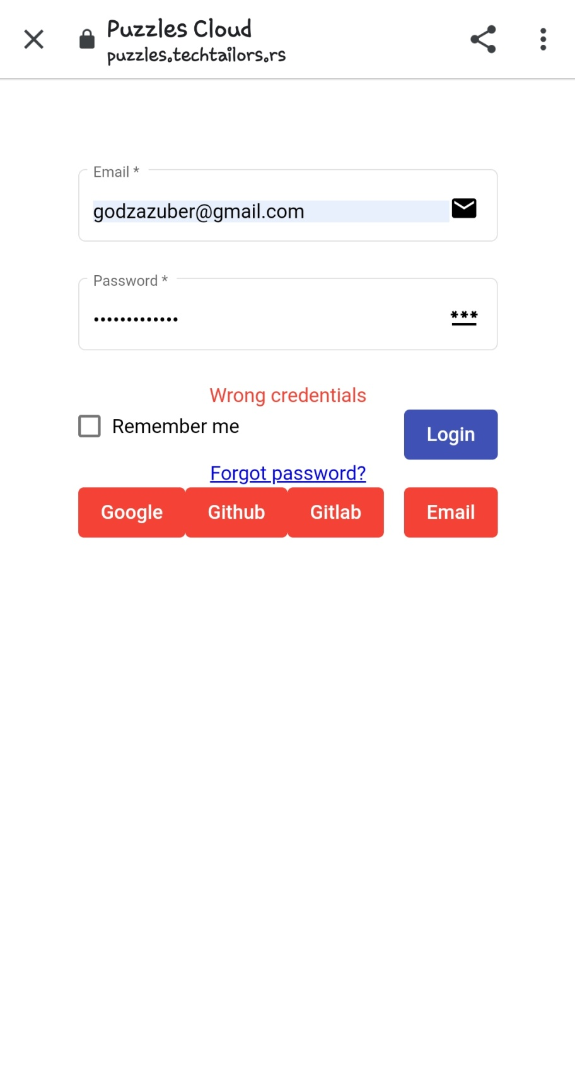

Uneti ispravni podaci - nemogucnost logovanja "Wrong credentials"

________________________________________________________________________________

*** Buttons "Google, GitHub, GitLab, Email" - official

