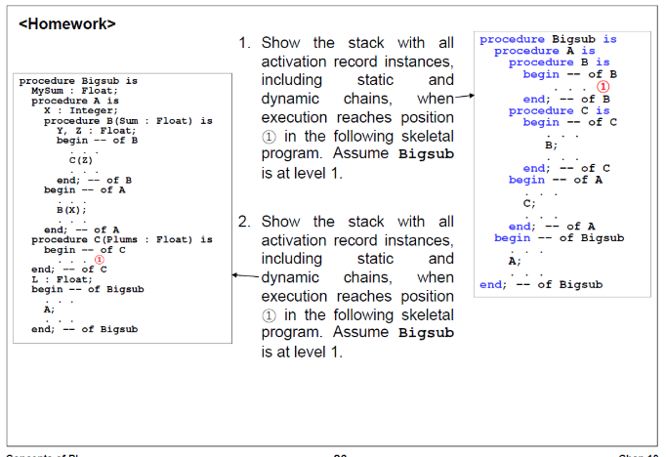

1.

|  |  |
| --- | --- |
| ARI  for  B | dynamic link |
| static link |
| return(C) |
| ARI  for  C | dynamic link |
| static link |
| return(A) |
| ARI  For  A | dynamic link |
| static link |
| return(Bigsub) |

2.

|  |  |
| --- | --- |
| ARI  For  C | dynamic link |
| static link |
| return(B) |
| Parameter(Plums:Z) |
| ARI  For  B | dynamic link |
| static link |
| return(A) |
| local(Y) |
| local(Z) |
| parameter(Sum:X) |
| ARI  For  A | dynamic link |
| static link |
| return(Bigsub) |
| local(X) |
| ARL  For  Bigsub | local(MySum) |
| Local(L) |

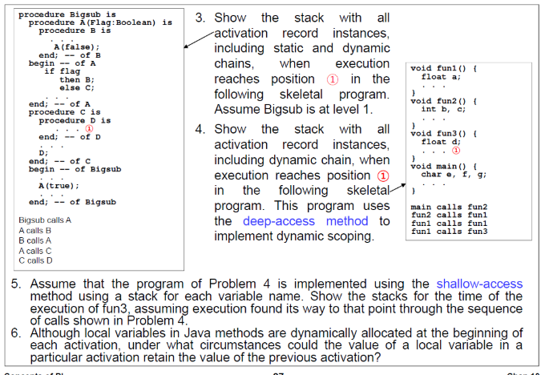

3.

|  |  |
| --- | --- |
| ARI  For  D | dynamic link |
| static link |
| return(C) |
| ARI  For  C | dynamic link |
| static link |
| return(A) |
| ARI  For  A | dynamic link |
| static link |
| return(B) |
| parameter(Flag:false) |
| ARI  For  B | dynamic link |
| static link |
| return(A) |
| ARI  For  A | dynamic link |
| static link |
| return(Bigsub) |
| parameter(Flag:true) |

4.

|  |  |
| --- | --- |
| ARI  For  fun3 | dynamic link |
| return(fun1) |
| local(d) |
| ARI  For  fun1 | dynamic link |
| return(fun1) |
| local(a) |
| ARI  For  fun1 | dynamic link |
| return(fun2) |
| local(a) |
| ARI  For  fun2 | dynamic link |
| return(main) |
| local(b) |
| local(c) |
| ARI  For  main | local(e) |
| local(f) |
| local(g) |

5.

|  |  |  |  |  |  |  |
| --- | --- | --- | --- | --- | --- | --- |
|  |  |  |  |  | fun1 |  |
| main | main | main | fun2 | fun2 | fun1 | fun3 |
| e | f | g | b | c | a | d |

6.

1) 변수들이 static으로 선언되면 이전 값을 유지할 수 있다.

2) 변수는 할당된 위치에 저장된 값을 가지므로 변수에 대한 초기화 문장이나 명령문이 없다면 리턴 후 이전 호출에서와 같은 스택 위치의 값을 갖는다.