Kelompok :  
Bagas  
Rifki  
Zul Ham Fahlevi (41520010167)

App.Js  
import \* as React from 'react';

import { Provider as PaperProvider, DefaultTheme } from 'react-native-paper';

import Navigation from './Navigation';

*const* theme = {

  ...DefaultTheme,

  roundness: 2,

  colors: {

    ...DefaultTheme.colors,

    primary: '#128C7E',

    accent: '#f1c40f',

  },

};

export default *function* App() {

  return (

    <*PaperProvider* theme={theme}>

      <*Navigation* />

    </*PaperProvider*>

  );

}

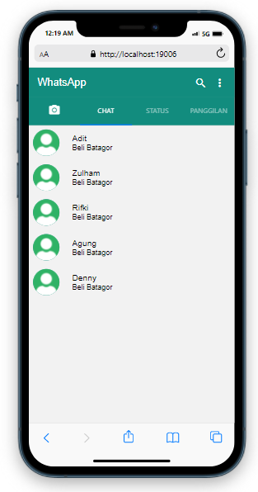

Navigation.js  
import React from 'react';

import { NavigationContainer } from '@react-navigation/native';

import { createNativeStackNavigator } from '@react-navigation/native-stack';

*const* Stack = createNativeStackNavigator();

import HomeScreen from './screen/HomeScreen';

import SettingScreen from './screen/SettingScreen';

import Chat1 from './screen/TabScreen/ChatScreen/Chat1';

import Chat2 from './screen/TabScreen/ChatScreen/Chat2';

import Chat3 from './screen/TabScreen/ChatScreen/Chat3';

*function* Navigation() {

  return (

    <*NavigationContainer*>

      <*Stack.Navigator*

        screenOptions={{headerShown:false}}>

        <*Stack.Screen* name="HomeScreen" component={HomeScreen} />

        <*Stack.Screen* name="SettingScreen" component={SettingScreen} />

        <*Stack.Screen* name='Chat1' component={Chat1}/>

        <*Stack.Screen* name='Chat2' component={Chat2}/>

        <*Stack.Screen* name='Chat3' component={Chat3}/>

      </*Stack.Navigator*>

    </*NavigationContainer*>

  );

}

export default Navigation;

SettingScreen.js  
import React from 'react';

import { Appbar,List, Avatar} from 'react-native-paper';

*function* SettingScreen({*navigation*}) {

  return (

    <>

      <*Appbar.Header*>

        <*Appbar.BackAction* onPress={() *=>* *navigation*.goBack()} />

        <*Appbar.Content* title="Setelan" />

      </*Appbar.Header*>

    <*List.Item*

      title="Adit"

      titleStyle={{color: 'black'}}

      description="Available"

      descriptionStyle={{color: 'black'}}

      left={*props* *=>* <*Avatar.Image* {...props} source={require('./TabScreen/ChatScreen/avatar.jpg')} size={50}/>}

      right={*props* *=>* <*List.Icon* {...props} icon="qrcode" color='#128C7E' />}/>

    <*List.Item*

        title="Akun"

        titleStyle={{color: 'black'}}

        description="Privasi, keamanan, ganti nomor"

        descriptionStyle={{color: 'black'}}

        left={*props* *=>* <*List.Icon* {...props} icon="key" />}

      />

      <*List.Item*

        title="Chat"

        titleStyle={{color: 'black'}}

        description="Tema, wallpaper, riwayat chat"

        descriptionStyle={{color: 'black'}}

        left={*props* *=>* <*List.Icon* {...props} icon="chat-outline" />}

      />

      <*List.Item*

        title="Notifikasi"

        titleStyle={{color: 'black'}}

        description="Pesan, grup dan nada dering panggilan"

        descriptionStyle={{color: 'black'}}

        left={*props* *=>* <*List.Icon* {...props} icon="bell" />}

      />

      <*List.Item*

        title="Penyimpanan dan data"

        titleStyle={{color: 'black'}}

        description="Penggunaan jaringan, unduh otomatis"

        descriptionStyle={{color: 'black'}}

        left={*props* *=>* <*List.Icon* {...props} icon="circle-outline" />}

      />

      <*List.Item*

        title="Bantuan"

        titleStyle={{color: 'black'}}

        description="Pusat bantuan, hubungi kami, kebijakan privasi"

        descriptionStyle={{color: 'black'}}

        left={*props* *=>* <*List.Icon* {...props} icon="help-circle-outline" />}

      />

      <*List.Item*

        title="Undang temam"

        titleStyle={{color: 'black'}}

        left={*props* *=>* <*List.Icon* {...props} icon="account-multiple" />}

      />

    </>

  );

}

export default SettingScreen;  
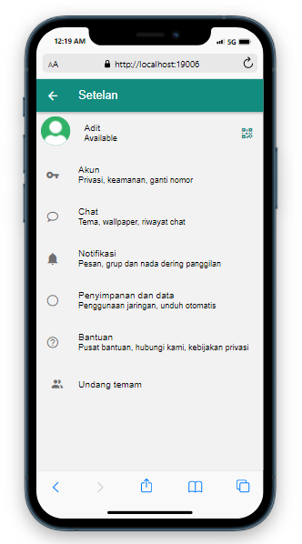

CameraScreen.js  
import React from 'react';

import { Text } from 'react-native-paper';

*function* CameraScreen({*navigation*}) {

  return (

    <>

      <*Text* style={{textAlign:"center", fontSize:50, paddingTop:200}}>Camera Screen</*Text*>

    </>

  );

}

export default CameraScreen;  
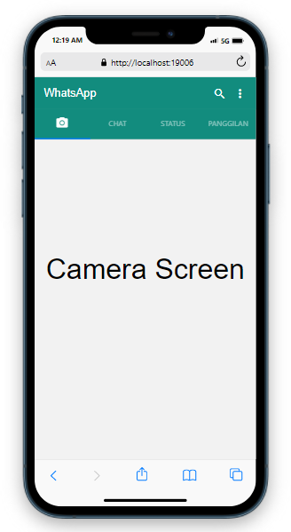

ChatScreen.js  
import React from 'react';

import {View,TouchableOpacity} from 'react-native';

import { List, Avatar} from 'react-native-paper';

*function* ChatScreen({*navigation*}) {

  return (

    <>

    <*View*>

      <*TouchableOpacity* onPress={() *=>* *navigation*.navigate('Chat1')}>

          <*List.Item*

            title="Adit"

            titleStyle={{color: 'black'}}

            description="Beli Batagor"

            descriptionStyle={{color: 'black'}}

            left={*props* *=>* <*Avatar.Image* {...props} source={require('./ChatScreen/avatar.jpg')} size={50}/>}

          />

      </*TouchableOpacity*>

      <*TouchableOpacity* onPress={() *=>* *navigation*.navigate('Chat2')}>

          <*List.Item*

            title="Zulham"

            titleStyle={{color: 'black'}}

            description="Beli Batagor"

            descriptionStyle={{color: 'black'}}

            left={*props* *=>* <*Avatar.Image* {...props} source={require('./ChatScreen/avatar.jpg')} size={50}/>}

          />

      </*TouchableOpacity*>

      <*TouchableOpacity* onPress={() *=>* *navigation*.navigate('Chat3')}>

          <*List.Item*

            title="Rifki"

            titleStyle={{color: 'black'}}

            description="Beli Batagor"

            descriptionStyle={{color: 'black'}}

            left={*props* *=>* <*Avatar.Image* {...props} source={require('./ChatScreen/avatar.jpg')} size={50}/>}

          />

      </*TouchableOpacity*>

      <*List.Item*

            title="Agung"

            titleStyle={{color: 'black'}}

            description="Beli Batagor"

            descriptionStyle={{color: 'black'}}

            left={*props* *=>* <*Avatar.Image* {...props} source={require('./ChatScreen/avatar.jpg')} size={50}/>}

          />

      <*List.Item*

            title="Denny"

            titleStyle={{color: 'black'}}

            description="Beli Batagor"

            descriptionStyle={{color: 'black'}}

            left={*props* *=>* <*Avatar.Image* {...props} source={require('./ChatScreen/avatar.jpg')} size={50}/>}

          />

    </*View*>

    </>

  );

}

export default ChatScreen;  


StatusScreen.js  
import React from 'react';

import {List, Avatar} from 'react-native-paper';

import {Text} from 'react-native';

*function* StatusScreen({*navigation*}) {

  return (

    <>

      <*List.Item*

        title="Status saya"

        titleStyle={{color: 'black'}}

        description="Ketuk untuk menambahkan pembaruan sta..."

        descriptionStyle={{color: 'black'}}

        left={*props* *=>* <*Avatar.Image* {...props} source={require('./ChatScreen/avatar.jpg')} size={50}/>}

      />

      <>

      <*Text*>Pembaruan terkini</*Text*>

       </>

      <*List.Item*

        title="Adit"

        titleStyle={{color: 'black'}}

        description="Hari ini 19.00"

        descriptionStyle={{color: 'black'}}

        left={*props* *=>* <*List.Icon* {...props} icon="account" />}

      />

      <*List.Item*

        title="Rifki"

        titleStyle={{color: 'black'}}

        description="Hari ini 12.53"

        descriptionStyle={{color: 'black'}}

        left={*props* *=>* <*List.Icon* {...props} icon="account" />}

      />

      <*List.Item*

        title="Zulham"

        titleStyle={{color: 'black'}}

        description="Hari ini 09.48"

        descriptionStyle={{color: 'black'}}

        left={*props* *=>* <*List.Icon* {...props} icon="account" />}

      />

    </>

  );

}

export default StatusScreen;  
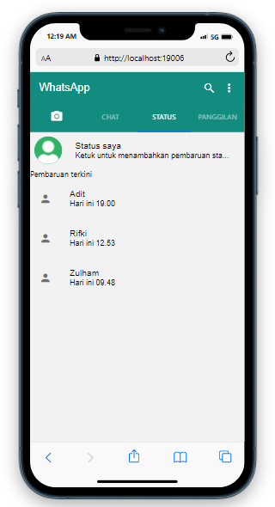

PanggilanScreen.js  
import React from 'react';

import { List, Avatar} from 'react-native-paper';

*function* PanggilanSreen({*navigation*}) {

  return (

    <>

      <*List.Item*

        title="Adit"

        titleStyle={{color: 'black'}}

        description="Hari ini 19.00"

        descriptionStyle={{color: 'black'}}

        left={*props* *=>* <*Avatar.Image* {...props} source={require('./ChatScreen/avatar.jpg')} size={50}/>}

        right={*props* *=>* <*List.Icon* {...props} icon="phone" color='#128C7E'/>}

      />

      <*List.Item*

        title="Rifki"

        titleStyle={{color: 'black'}}

        description="kemarin 04.30"

        descriptionStyle={{color: 'black'}}

        left={*props* *=>* <*Avatar.Image* {...props} source={require('./ChatScreen/avatar.jpg')} size={50}/>}

        right={*props* *=>* <*List.Icon* {...props} icon="video" color='#128C7E' />}

      />

      <*List.Item*

        title="Zulham"

        titleStyle={{color: 'black'}}

        description="kemarin 19.00"

        descriptionStyle={{color: 'black'}}

        left={*props* *=>* <*Avatar.Image* {...props} source={require('./ChatScreen/avatar.jpg')} size={50}/>}

        right={*props* *=>* <*List.Icon* {...props} icon="phone" color='#128C7E' />}

      />

    </>

  );

}

export default PanggilanSreen;  
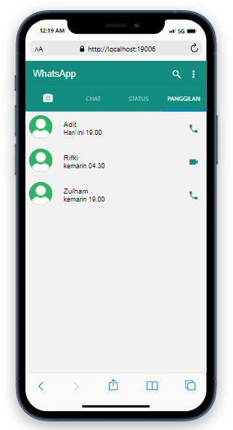

Chat1.js  
import React from 'react';

import { StyleSheet, View } from 'react-native';

import { Appbar, Text, Avatar } from 'react-native-paper';

// import { loremIpsum } from 'react-lorem-ipsum';

*function* Chat1({*navigation*}) {

  return (

    <>

      <*Appbar.Header*>

        <*Appbar.BackAction* onPress={() *=>* *navigation*.goBack('') }/>

        <*Avatar.Image* size={50} source={require('./avatar.jpg')} />

        <*Appbar.Content* title="Adit" subtitle="Online" />

        <*Appbar.Action* icon="video" onPress={() *=>* {}} />

        <*Appbar.Action* icon="phone" onPress={() *=>* {}} />

        <*Appbar.Action* icon="dots-vertical" onPress={() *=>* {}} />

      </*Appbar.Header*>

      <*View*>

        <*Text* style={styles.container}>beli batagor</*Text*>

        <*Text* style={styles.container2}>dimana</*Text*>

        <*Text* style={styles.container}>dirumah bagas</*Text*>

        <*Text* style={styles.container2}>ayooo</*Text*>

      </*View*>

    </>

  );

}

*const* styles = StyleSheet.create({

  container : {

    flex: 0.3,

    justifyContent: "space-between",

    backgroundColor: "beige",

    padding: 20,

    margin: 10,

    borderWidth : 5,

    borderRadius: 20

  },

  container2 : {

    flex: 0.3,

    justifyContent: "space-between",

    backgroundColor: "beige",

    padding: 20,

    margin: 10,

    borderWidth : 5,

    textAlign : 'right',

    borderRadius: 20

  }

});

export default Chat1;  
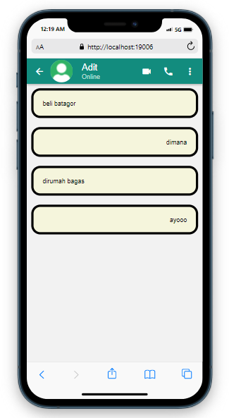

Chat2.js  
import React from 'react';

import { StyleSheet, View} from 'react-native';

import { Appbar, Text, Avatar} from 'react-native-paper';

*function* Chat2({*navigation*}) {

  return (

    <>

      <*Appbar.Header*>

        <*Appbar.BackAction* onPress={() *=>* *navigation*.goBack('') }/>

        <*Avatar.Image* size={50} source={require('./avatar.jpg')} />

        <*Appbar.Content* title="Zulham" subtitle="Online" />

        <*Appbar.Action* icon="video" onPress={() *=>* {}} />

        <*Appbar.Action* icon="phone" onPress={() *=>* {}} />

        <*Appbar.Action* icon="dots-vertical" onPress={() *=>* {}} />

      </*Appbar.Header*>

      <*View*>

        <*Text* style={styles.container}>Kameranya lu atur gas</*Text*>

        <*Text* style={styles.container}>Cari aja tutorial atur kamera render</*Text*>

        <*Text* style={styles.container}>agak susah jelasinnya gw</*Text*>

        <*Text* style={styles.container2}>oh ok zul</*Text*>

      </*View*>

    </>

  );

}

*const* styles = StyleSheet.create({

  container : {

    flex: 0.3,

    justifyContent: "space-between",

    backgroundColor: "beige",

    padding: 20,

    margin: 10,

    borderWidth : 5,

    borderRadius: 20

  },

  container2 : {

    flex: 0.3,

    justifyContent: "space-between",

    backgroundColor: "beige",

    padding: 20,

    margin: 10,

    borderWidth : 5,

    textAlign : 'right',

    borderRadius: 20

  }

});

export default Chat2;  
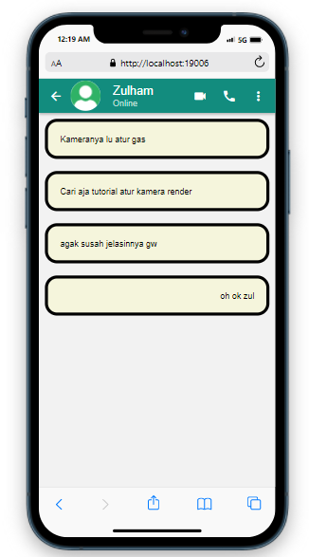

Chat3.js  
import React from 'react';

import { StyleSheet, View } from 'react-native';

import { Appbar, Text, Avatar} from 'react-native-paper';

*function* Chat3({*navigation*}) {

  return (

    <>

      <*Appbar.Header*>

        <*Appbar.BackAction* onPress={() *=>* *navigation*.goBack('') }/>

        <*Avatar.Image* size={50} source={require('./avatar.jpg')} />

        <*Appbar.Content* title="Rifki" subtitle="Online" />

        <*Appbar.Action* icon="video" onPress={() *=>* {}} />

        <*Appbar.Action* icon="phone" onPress={() *=>* {}} />

        <*Appbar.Action* icon="dots-vertical" onPress={() *=>* {}} />

      </*Appbar.Header*>

      <*View*>

        <*Text* style={styles.container2}>Di suruh japri ki abo</*Text*>

        <*Text* style={styles.container}>Japri gimana?</*Text*>

        <*Text* style={styles.container2}>Liat grup dah</*Text*>

        <*Text* style={styles.container}>ya iya ngomong gimana</*Text*>

        <*Text* style={styles.container}>bilang gini aja ya kira kira tugasnya apa pak?</*Text*>

      </*View*>

    </>

  );

}

*const* styles = StyleSheet.create({

  container : {

    flex: 0.3,

    justifyContent: "space-between",

    backgroundColor: "beige",

    padding: 20,

    margin: 10,

    borderWidth : 5,

    borderRadius: 20

  },

  container2 : {

    flex: 0.3,

    justifyContent: "space-between",

    backgroundColor: "beige",

    padding: 20,

    margin: 10,

    borderWidth : 5,

    textAlign : 'right',

    borderRadius: 20

  }

});

export default Chat3;  
