## **ASSIGNMENT**

## **ON**

## GUI Class hierarchy

**COURSE NAME: ADVANCE ENTERPRISE JAVA (THEORY)**

**COURSE CODE: SE 409**

SUBMITTED TO:

MD. SAFAET HOSSAIN

ASSOCIATE PROFESSOR AND HEAD

DEPARTMENT OF CSE

SUBMITTED BY:

ZULKAR NINE

163432601

43RD BATCH

DEPARTMENT OF CSE

SUBMITTED DATE: 30-10-2020

**Java Swing tutorial** is a part of Java Foundation Classes (JFC) that is used to create window-based applications. It is built on the top of AWT (Abstract Windowing Toolkit) API and entirely written in java.

The javax.swing package provides classes for java swing API such as JButton, JTextField, JTextArea, JRadioButton, JCheckbox, JMenu, JColorChooser etc.

Hierarchy of Java Swing classes

**The hierarchy of java swing API is given below.**

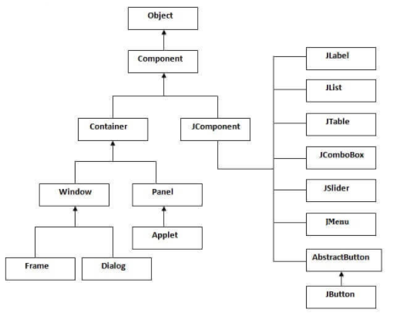**Java JButton**

The JButton class is used to create a labeled button that has platform independent implementation. The application result in some action when the button is pushed. It inherits AbstractButton class.

1. **import** javax.swing.*;
2. **public** **class** ButtonExample {
3. **public** **static** **void** main(String[] args) {
4. JFrame f=**new** JFrame("Button Example");
5. JButton b=**new** JButton("Click Here");
6. b.setBounds(50,100,95,30);
7. f.add(b);
8. f.setSize(400,400);
9. f.setLayout(**null**);
10. f.setVisible(**true**);
11. }
12. }

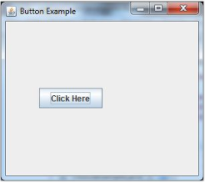

**Java JLabel**

The object of JLabel class is a component for placing text in a container. It is used to display a single line of read only text. The text can be changed by an application but a user cannot edit it directly. It inherits JComponent class.

1. **import** javax.swing.*;
2. **class** LabelExample
3. {
4. **public** **static** **void** main(String args[])
5. {
6. JFrame f= **new** JFrame("Label Example");
7. JLabel l1,l2;
8. l1=**new** JLabel("First Label.");
9. l1.setBounds(50,50, 100,30);
10. l2=**new** JLabel("Second Label.");
11. l2.setBounds(50,100, 100,30);
12. f.add(l1); f.add(l2);
13. f.setSize(300,300);
14. f.setLayout(**null**);
15. f.setVisible(**true**);
16. }
17. }

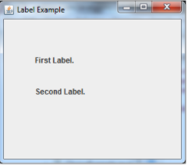

# **Java JTextField**

The object of a JTextField class is a text component that allows the editing of a single line text. It inherits JTextComponent class.

1. **import** javax.swing.*;
2. **class** TextFieldExample
3. {
4. **public** **static** **void** main(String args[])
5. {
6. JFrame f= **new** JFrame("TextField Example");
7. JTextField t1,t2;
8. t1=**new** JTextField("Welcome to Javatpoint.");
9. t1.setBounds(50,100, 200,30);
10. t2=**new** JTextField("AWT Tutorial");
11. t2.setBounds(50,150, 200,30);
12. f.add(t1); f.add(t2);
13. f.setSize(400,400);
14. f.setLayout(**null**);
15. f.setVisible(**true**);
16. }
17. }

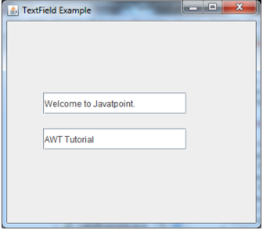

# **Java JTextArea**

The object of a JTextArea class is a multi line region that displays text. It allows the editing of multiple line text. It inherits JTextComponent class

1. **import** javax.swing.*;
2. **public** **class** TextAreaExample
3. {
4. TextAreaExample(){
5. JFrame f= **new** JFrame();
6. JTextArea area=**new** JTextArea("Welcome to javatpoint");
7. area.setBounds(10,30, 200,200);
8. f.add(area);
9. f.setSize(300,300);
10. f.setLayout(**null**);
11. f.setVisible(**true**);
12. }
13. **public** **static** **void** main(String args[])
14. {
15. **new** TextAreaExample();
16. }}

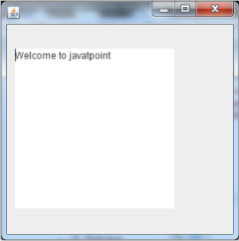

# **Java JPasswordField**

The object of a JPasswordField class is a text component specialized for password entry. It allows the editing of a single line of text. It inherits JTextField class.

1. **import** javax.swing.*;
2. **public** **class** PasswordFieldExample {
3. **public** **static** **void** main(String[] args) {
4. JFrame f=**new** JFrame("Password Field Example");
5. JPasswordField value = **new** JPasswordField();
6. JLabel l1=**new** JLabel("Password:");
7. l1.setBounds(20,100, 80,30);
8. value.setBounds(100,100,100,30);
9. f.add(value);  f.add(l1);
10. f.setSize(300,300);
11. f.setLayout(**null**);
12. f.setVisible(**true**);
13. }
14. }

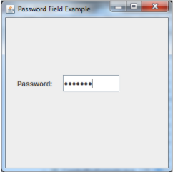

# **Java JCheckBox**

The JCheckBox class is used to create a checkbox. It is used to turn an option on (true) or off (false). Clicking on a CheckBox changes its state from "on" to "off" or from "off" to "on ".It inherits [JToggleButton](https://www.javatpoint.com/java-jtogglebutton) class.

1. **import** javax.swing.*;
2. **public** **class** CheckBoxExample
3. {
4. CheckBoxExample(){
5. JFrame f= **new** JFrame("CheckBox Example");
6. JCheckBox checkBox1 = **new** JCheckBox("C++");
7. checkBox1.setBounds(100,100, 50,50);
8. JCheckBox checkBox2 = **new** JCheckBox("Java", **true**);
9. checkBox2.setBounds(100,150, 50,50);
10. f.add(checkBox1);
11. f.add(checkBox2);
12. f.setSize(400,400);
13. f.setLayout(**null**);
14. f.setVisible(**true**);
15. }
16. **public** **static** **void** main(String args[])
17. {
18. **new** CheckBoxExample();
19. }}

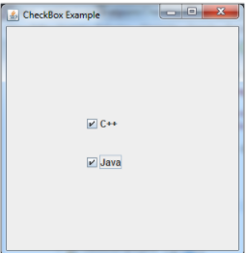

# **Java JRadioButton**

The JRadioButton class is used to create a radio button. It is used to choose one option from multiple options. It is widely used in exam systems or quiz.

It should be added in ButtonGroup to select one radio button only.

1. **import** javax.swing.*;
2. **public** **class** RadioButtonExample {
3. JFrame f;
4. RadioButtonExample(){
5. f=**new** JFrame();
6. JRadioButton r1=**new** JRadioButton("A) Male");
7. JRadioButton r2=**new** JRadioButton("B) Female");
8. r1.setBounds(75,50,100,30);
9. r2.setBounds(75,100,100,30);
10. ButtonGroup bg=**new** ButtonGroup();
11. bg.add(r1);bg.add(r2);
12. f.add(r1);f.add(r2);
13. f.setSize(300,300);
14. f.setLayout(**null**);
15. f.setVisible(**true**);
16. }
17. **public** **static** **void** main(String[] args) {
18. **new** RadioButtonExample();
19. }
20. }

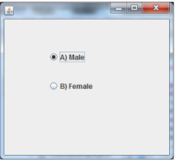

**Java JComboBox**

The object of Choice class is used to show popup menu of choices. Choice selected by user is shown on the top of a [menu](https://www.javatpoint.com/java-jmenuitem-and-jmenu). It inherits [JComponent](https://www.javatpoint.com/java-jcomponent) class.

1. **import** javax.swing.*;
2. **public** **class** ComboBoxExample {
3. JFrame f;
4. ComboBoxExample(){
5. f=**new** JFrame("ComboBox Example");
6. String country[]={"India","Aus","U.S.A","England","Newzealand"};
7. JComboBox cb=**new** JComboBox(country);
8. cb.setBounds(50, 50,90,20);
9. f.add(cb);
10. f.setLayout(**null**);
11. f.setSize(400,500);
12. f.setVisible(**true**);
13. }
14. **public** **static** **void** main(String[] args) {
15. **new** ComboBoxExample();
16. }
17. }

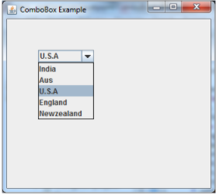

# **Java JTable**

The JTable class is used to display data in tabular form. It is composed of rows and columns.

1. **import** javax.swing.*;
2. **public** **class** TableExample {
3. JFrame f;
4. TableExample(){
5. f=**new** JFrame();
6. String data[][]={ {"101","Amit","670000"},
7. {"102","Jai","780000"},
8. {"101","Sachin","700000"}};
9. String column[]={"ID","NAME","SALARY"};
10. JTable jt=**new** JTable(data,column);
11. jt.setBounds(30,40,200,300);
12. JScrollPane sp=**new** JScrollPane(jt);
13. f.add(sp);
14. f.setSize(300,400);
15. f.setVisible(**true**);
16. }
17. **public** **static** **void** main(String[] args) {
18. **new** TableExample();
19. }
20. }

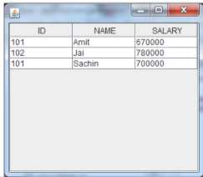

# **Java JList**

The object of JList class represents a list of text items. The list of text items can be set up so that the user can choose either one item or multiple items. It inherits JComponent class.

1. **import** javax.swing.*;
2. **public** **class** ListExample
3. {
4. ListExample(){
5. JFrame f= **new** JFrame();
6. DefaultListModel<String> l1 = **new** DefaultListModel<>();
7. l1.addElement("Item1");
8. l1.addElement("Item2");
9. l1.addElement("Item3");
10. l1.addElement("Item4");
11. JList<String> list = **new** JList<>(l1);
12. list.setBounds(100,100, 75,75);
13. f.add(list);
14. f.setSize(400,400);
15. f.setLayout(**null**);
16. f.setVisible(**true**);
17. }
18. **public** **static** **void** main(String args[])
19. {
20. **new** ListExample();
21. }}

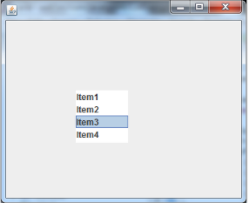

# **Java JOptionPane**

The JOptionPane class is used to provide standard dialog boxes such as message dialog box, confirm dialog box and input dialog box. These dialog boxes are used to display information or get input from the user. The JOptionPane class inherits JComponent class.

1. **import** javax.swing.*;
2. **public** **class** OptionPaneExample {
3. JFrame f;
4. OptionPaneExample(){
5. f=**new** JFrame();
6. JOptionPane.showMessageDialog(f,"Hello, Welcome to Javatpoint.");
7. }
8. **public** **static** **void** main(String[] args) {
9. **new** OptionPaneExample();
10. }
11. }

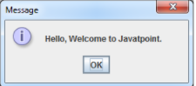

# **Java JScrollBar**

The object of JScrollbar class is used to add horizontal and vertical scrollbar. It is an implementation of a scrollbar. It inherits JComponent class.

1. **import** javax.swing.*;
2. **class** ScrollBarExample
3. {
4. ScrollBarExample(){
5. JFrame f= **new** JFrame("Scrollbar Example");
6. JScrollBar s=**new** JScrollBar();
7. s.setBounds(100,100, 50,100);
8. f.add(s);
9. f.setSize(400,400);
10. f.setLayout(**null**);
11. f.setVisible(**true**);
12. }
13. **public** **static** **void** main(String args[])
14. {
15. **new** ScrollBarExample();
16. }}

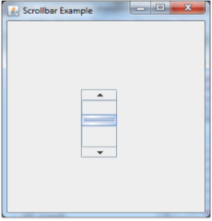

# **Java JMenuBar, JMenu and JMenuItem**

The JMenuBar class is used to display menubar on the window or frame. It may have several menus.

The object of JMenu class is a pull down menu component which is displayed from the menu bar. It inherits the JMenuItem class.

The object of JMenuItem class adds a simple labeled menu item. The items used in a menu must belong to the JMenuItem or any of its subclass.

1. **import** javax.swing.*;
2. **class** MenuExample
3. {
4. JMenu menu, submenu;
5. JMenuItem i1, i2, i3, i4, i5;
6. MenuExample(){
7. JFrame f= **new** JFrame("Menu and MenuItem Example");
8. JMenuBar mb=**new** JMenuBar();
9. menu=**new** JMenu("Menu");
10. submenu=**new** JMenu("Sub Menu");
11. i1=**new** JMenuItem("Item 1");
12. i2=**new** JMenuItem("Item 2");
13. i3=**new** JMenuItem("Item 3");
14. i4=**new** JMenuItem("Item 4");
15. i5=**new** JMenuItem("Item 5");
16. menu.add(i1); menu.add(i2); menu.add(i3);
17. submenu.add(i4); submenu.add(i5);
18. menu.add(submenu);
19. mb.add(menu);
20. f.setJMenuBar(mb);
21. f.setSize(400,400);
22. f.setLayout(**null**);
23. f.setVisible(**true**);
24. }
25. **public** **static** **void** main(String args[])
26. {
27. **new** MenuExample();
28. }}

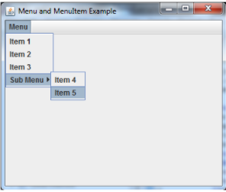

# **Java JSlider**

The Java JSlider class is used to create the slider. By using JSlider, a user can select a value from a specific range.

1. **import** javax.swing.*;
2. **public** **class** SliderExample1 **extends** JFrame{
3. **public** SliderExample1() {
4. JSlider slider = **new** JSlider(JSlider.HORIZONTAL, 0, 50, 25);
5. JPanel panel=**new** JPanel();
6. panel.add(slider);
7. add(panel);
8. }
10. **public** **static** **void** main(String s[]) {
11. SliderExample1 frame=**new** SliderExample1();
12. frame.pack();
13. frame.setVisible(**true**);
14. }
15. }



# **Java JSpinner**

The object of JSpinner class is a single line input field that allows the user to select a number or an object value from an ordered sequence.

1. **import** javax.swing.*;
2. **public** **class** SpinnerExample {
3. **public** **static** **void** main(String[] args) {
4. JFrame f=**new** JFrame("Spinner Example");
5. SpinnerModel value =
6. **new** SpinnerNumberModel(5, //initial value
7. 0, //minimum value
8. 10, //maximum value
9. 1); //step
10. JSpinner spinner = **new** JSpinner(value);
11. spinner.setBounds(100,100,50,30);
12. f.add(spinner);
13. f.setSize(300,300);
14. f.setLayout(**null**);
15. f.setVisible(**true**);
16. }
17. }

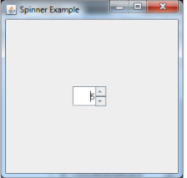

# **Java JDialog**

The JDialog control represents a top level window with a border and a title used to take some form of input from the user. It inherits the Dialog class.

Unlike JFrame, it doesn't have maximize and minimize buttons.

1. **import** javax.swing.*;
2. **import** java.awt.*;
3. **import** java.awt.event.*;
4. **public** **class** DialogExample {
5. **private** **static** JDialog d;
6. DialogExample() {
7. JFrame f= **new** JFrame();
8. d = **new** JDialog(f , "Dialog Example", **true**);
9. d.setLayout( **new** FlowLayout() );
10. JButton b = **new** JButton ("OK");
11. b.addActionListener ( **new** ActionListener()
12. {
13. **public** **void** actionPerformed( ActionEvent e )
14. {
15. DialogExample.d.setVisible(**false**);
16. }
17. });
18. d.add( **new** JLabel ("Click button to continue."));
19. d.add(b);
20. d.setSize(300,300);
21. d.setVisible(**true**);
22. }
23. **public** **static** **void** main(String args[])
24. {
25. **new** DialogExample();
26. }
27. }

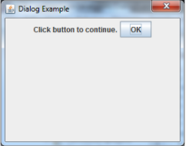

# **Java JPanel**

The JPanel is a simplest container class. It provides space in which an application can attach any other component. It inherits the JComponents class.

It doesn't have title bar.

1. **import** java.awt.*;
2. **import** javax.swing.*;
3. **public** **class** PanelExample {
4. PanelExample()
5. {
6. JFrame f= **new** JFrame("Panel Example");
7. JPanel panel=**new** JPanel();
8. panel.setBounds(40,80,200,200);
9. panel.setBackground(Color.gray);
10. JButton b1=**new** JButton("Button 1");
11. b1.setBounds(50,100,80,30);
12. b1.setBackground(Color.yellow);
13. JButton b2=**new** JButton("Button 2");
14. b2.setBounds(100,100,80,30);
15. b2.setBackground(Color.green);
16. panel.add(b1); panel.add(b2);
17. f.add(panel);
18. f.setSize(400,400);
19. f.setLayout(**null**);
20. f.setVisible(**true**);
21. }
22. **public** **static** **void** main(String args[])
23. {
24. **new** PanelExample();
25. }
26. }

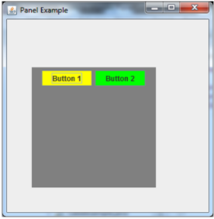

# **Java JFrame**

The javax.swing.JFrame class is a type of container which inherits the java.awt.Frame class. JFrame works like the main window where components like labels, buttons, textfields are added to create a GUI.

Unlike Frame, JFrame has the option to hide or close the window with the help of setDefaultCloseOperation(int) method.

1. **import** java.awt.FlowLayout;
2. **import** javax.swing.JButton;
3. **import** javax.swing.JFrame;
4. **import** javax.swing.JLabel;
5. **import** javax.swing.Jpanel;
6. **public** **class** JFrameExample {
7. **public** **static** **void** main(String s[]) {
8. JFrame frame = **new** JFrame("JFrame Example");
9. JPanel panel = **new** JPanel();
10. panel.setLayout(**new** FlowLayout());
11. JLabel label = **new** JLabel("JFrame By Example");
12. JButton button = **new** JButton();
13. button.setText("Button");
14. panel.add(label);
15. panel.add(button);
16. frame.add(panel);
17. frame.setSize(200, 300);
18. frame.setLocationRelativeTo(**null**);
19. frame.setDefaultCloseOperation(JFrame.EXIT_ON_CLOSE);
20. frame.setVisible(**true**);
21. }
22. }

