**Hospital management system**

**Introduction:**

Hospital management system: A unique cloud based hospital management system for both patients and hospital stuffs (Doctors, Management). The primary target of this design is to make hospital experience better than we currently have. Hospital is a place where no one willingly wants to visit but there are times when we need to. The old system of hospitals is not very user friendly. The first big stem is waiting in the queue for long hours. There are lots of other problems that makes your hospital experience bad. Our main focus is to make peoples life easier in the hour of need. We are working to design such a system that will reduce a lot of paperwork and save peoples time.

Hospital Information management system is designed for hospitals, which covers the wide range of hospital administration and management processes. It provides relevant information across the hospital to support effective decision making for patient care, scheduling and billing, in a seamless flow.

**Background History Analysis:**

Various management programs for management are present out there but there any not too many which provides the patients any functionality. The hospital system has been automated but the benefit is not for all. In such a situation I have figured out that there should be something for the patients. Some simple features for checking appointment, asking for appointment, prescription and test reports can reduce the hassle up to 70-80%. Because those are the sector where we face a lot of trouble and can find a way out. So this will allow us something that we were waiting for so long. The world is moving to internet so this is the right time to think about this. I have checked some hospital management system on internet and some local programs that the hospital stuffs are using near me. They are also very well designed and have rich features too but nothing for the patients to be happy about is there. If we compare the benefits and the satisfaction form every point of view then we cannot conclude things beneficial for all. If a system does not provide help for every user group then it cannot be perfect system. We came out a long way with maximizing benefit for all. Still there are a lot of things that can be added but at this point this is the most we can expect.

**Existing software:**

You will find hospital management system software in various hospitals in our country. They have great features to help the hospital but that does not allow the patients to manage their own data. This is what gave us the initial motivation to build a system where the system will work for all.

To overcome that limitation we are trying to build a social networking like site for hospitals that will help everyone working in the hospital and their patients.

Let’s discuss about the system in details and see how it will help us. There are no such things that come out without any limitations but we focused to overcome the best we could do. Our main focus was to determine the features for the patients. They are the large community of this system and they deserve to get the most out of this system. There is no doubt that our existing systems does not provide us the facility to check for our information related to our hospital documents and other important documents for example prescriptions and test reports. If these documents are close to us then we can at least be in some peace. We no longer have to worry about carrying those reports and of course it will help us the best in terms of losing those precious documents and get into trouble. The relief will be huge and so will be the benefit. Hopefully this will give us the benefit that we are expecting.

**Some existing software are:**

1/ **SoftClinic.**

## 2/ [Intelligent Medical Software](https://www.capterra.com/p/109350/Intelligent-Medical-Software/).

## 3/ [eHospital Systems](https://www.capterra.com/p/138518/eHospital-Systems/).

## 4/ [eVisit](https://www.capterra.com/p/136499/eVisit/).

## 5/ [Hospital Management Software](https://www.capterra.com/p/142145/Hospital-Management-Software/).

## Requirement:

**Functional:**

1. Patient information.

2 .Clinical laboratory, radiology, and patient monitoring.  
3. Patient census and billing.  
4. Staffing and scheduling.  
5. Outcomes assessment and quality control.  
6. Pharmacy ordering, prescription handling, and pharmacopoeia

Information.

7. Decision support.

8. Finance and accounting.

9. Supplies, inventory, maintenance, and orders management.

**Non-Functional:**

1. Access to information.  
2. Improvement in quality of documentation.  
3. Improving quality of patient care.  
4. Improvement in communications.  
5. Reduction in errors of omission.  
6. Reduction in medication errors.  
7. Reduction in hospital costs.  
8. Development of a common clinical database.  
9. Enhancing ability to track patient's record.

**Relational Model:**

There are three categories for users. The features will vary depending on your user type. You will be able to perform certain task in a category which may not be necessary for other categories.

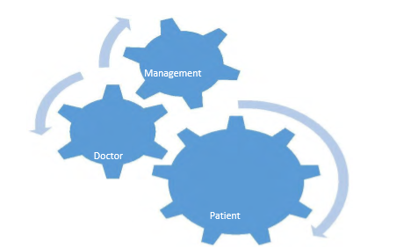

**1. Management:**

Management has the power to create user profile both for patients and doctors. They will be responsible for approving appointments and monitor through pending test reports. They will have the most important things to do. As many important things will depend on their action.

**2. Patient**:

Patients are normal users like us. We will be able to browse through available doctors and ask for appointments. We can also check our previous history. The patient’s functionality is limited based on their need. They will only be able to change their personal information and other things. Obviously they can look for their desired doctors to request an appointment.

**3. Doctor:**

Doctors can check appointments and also set appointment by their own. They can start prescribing their patients by clicking the appointment list. It will directly lean them for the prescription page. The prescription page has a lot of automated features for the doctor to set things and assign to their patients. Every field that is necessary for a doctor to make a perfect prescription is available. Which will obviously reduce the workload of doctors and they can give proper time to patients. There will be few clicks for them to make a proper prescriptions.

**E-R Diagram:**

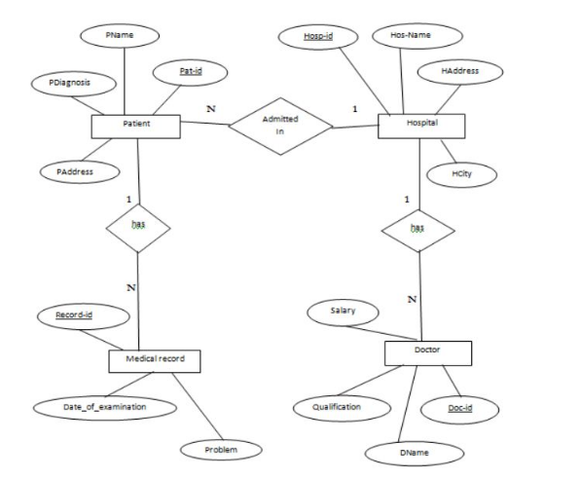

**Some snapshot with query and their outputs:**

**Left join:**

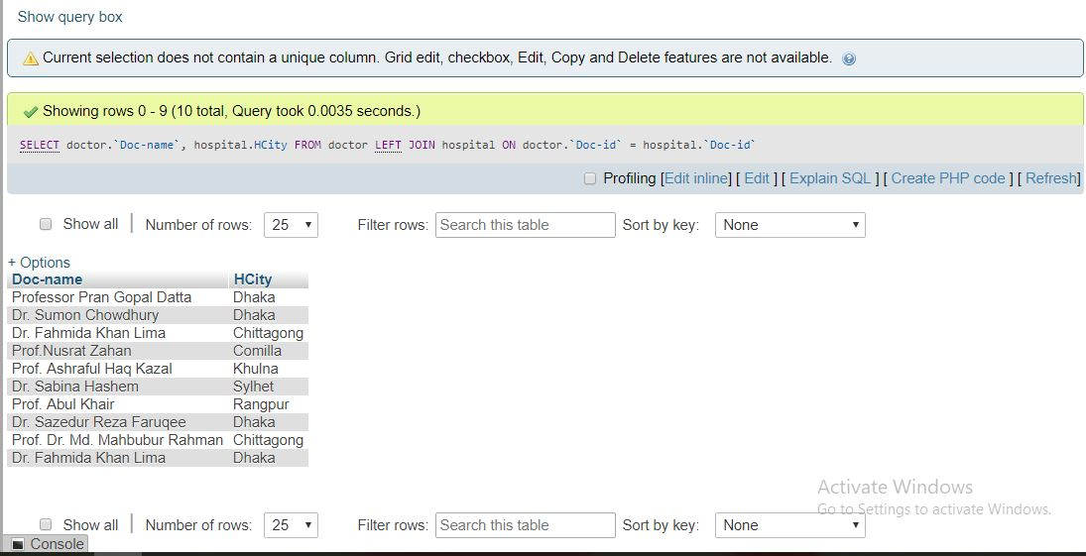

**Natural join:**

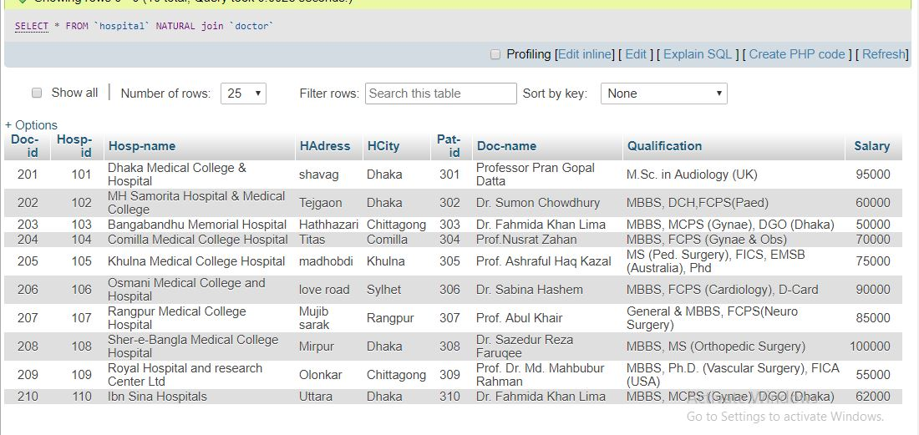

**Union:**

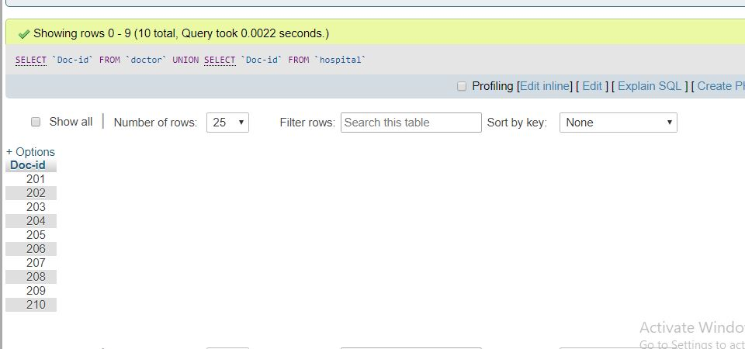

**Case:**

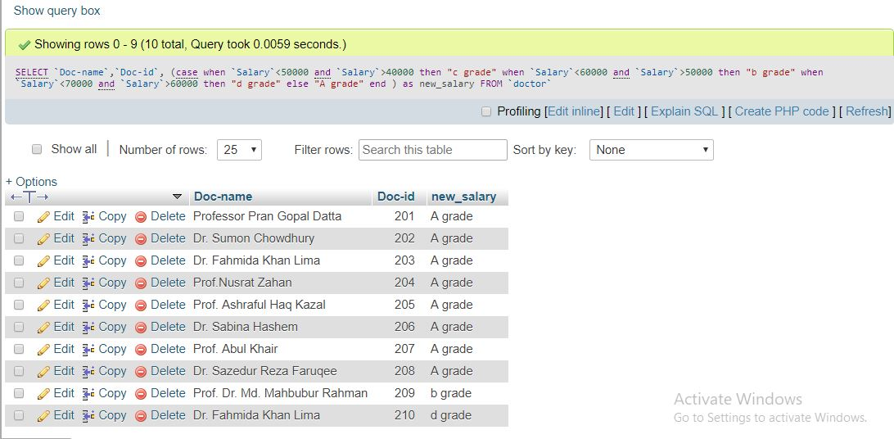

**Case with count:**

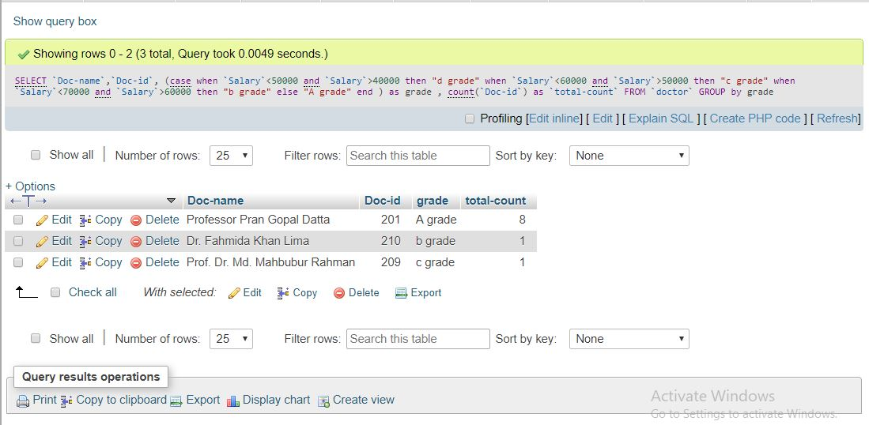

**Joining table:**

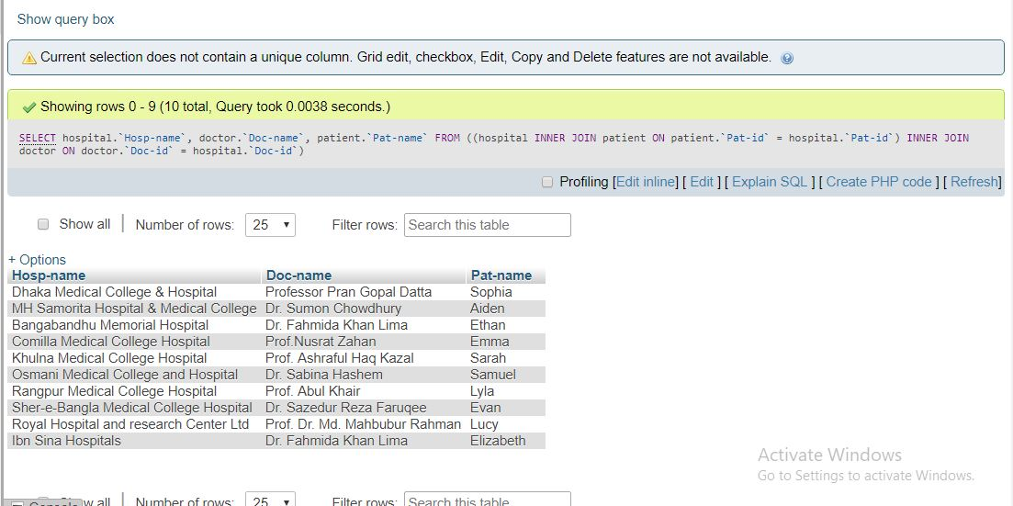

**Advantages:**

Hospital management requires a lot of decision making which is highly difficult if there is no strong management system in place. Since you need precise and accurate implementation at every stage, the automation system in the hospital has to be self-sufficient. Today, it is not possible to imagine a super-specialty hospital without it. A reliable, cost-effective, and efficient system becomes the backbone of the success of a medical center. There are several benefits of installing full-fledged software.

They will be able to check appointment any time and work accordingly. They will have long history of their patients.

Will not be dependent on patient for any information after the first visit.

The doctor patient relationship that we know is going to change dramatically with this simple step. People will not be able to chat with a doctor as they can with their friends with many web applications and platforms but the distance between the will certainly come much shorter.

* Access all data on a solitary stage and anticipate income spillage.
* Track ongoing measurements of your hospital and branches on a solitary tweaked dashboard.
* Ensure consistent correspondence between an individual doctor and his patients.
* Eliminate delays in patient release and streamline applications.
* Manage information viably through a safe and stable online stage.
* Improve quiet results with combined patient information by means of web dashboard.
* Implement AppsBazar Hospital Management System by simply introducing the app on your Smartphone and buy our membership according to your appropriateness.
* The required devices are a PC or a portable PC and Internet association. No requirement for costly equipment or extra assets.
* Save money and energy to the employees, improve service quality.
* Increase outpatient care, decrease surgeries need to hospitalization and inpatient days.

Disadvantage:

* Increase workload for employees and decrease job satisfaction.
* Lack the skills of Managers to contract with private sector and lack of powerful private sector caused outsourcing is failed.
* Impact on the quality was low but costs was reduced.
* Quality of service remains unchanged - increase workload and decrease in mental capacity of employees.
* Dysfunction and decreased well-being of hospital employees.
* May require additional hardware/software, which increases costs and logistics.

**Future Work:**

Modify as a web application targeting all doctors. A doctor will get 250mb initial space. They have to pay for additional cloud storage to save details of their patients (Example: Prescriptions, Test Reports). A mobile application to make things easy and bring them closer.

We used to say that everything is moving towards internet. The time has ended for such statement. I believe that we have moved to internet completely. Every major application has something to do with cloud and there are even special versions targeted only for cloud. Every new development has some part directly related to cloud. Cloud is nothing new for us and we have already started to enjoy the fruits of cloud. Clouds can hold major data for our future use and it does not matter which device you are on right now.

We’re entering a new world of patient-centric healthcare, one in which patients can be better informed, collect endless data related to their condition, and more fully participate in medical decision making. Patients are now receiving full access to their digital personal medical records which helps in medical patient education about their condition. As a result of these changes, it’s natural that patients will also want to use medical algorithms which until now had only been used by medical professionals. In any event, it will be almost impossible to exclude them from access.

• Directly getting the images for CT Scan or X-Rays from connected device

• Billing of patients.

• Blood Bank Information Management .

• Producing ECG using connected device .

• Video Conferencing facility for remote areas for treatments .

• Hangout for different doctors and patients at different locations.

**Conclusion:**

This was an excellent project to work on and I have learned a lot of things to complete this project. A lot of new idea and several problems that may happen to a system like this are quite clear for me now. I am not going to claim that this program offers you 100% functionality. It has mind blowing features but while working I have figured out how we can make this more beneficial for us. I have enjoyed this project and I want to keep working on it to give it a better shape. I believe that I can do make this different in a way that people will love the final output.

We build tools and machines to make our lives easy and more comfortable. Since then we have never stopped to build or design new things. We have been able to build things that have changed the entire thinking process of human civilization. We are now able to perform surgery that people could not even think about a decade ago. Researches are advancing to perform diagnosis and prescribe medicine for people without a doctor. Of course there are doctors for supervisions. We are building intelligent tools to take things at a new height.

This project is a tiny step towards the vast possibilities that science and computers can make to the medical sector. We have different approaches towards new things. This has been the case for human and it will continue. But new tools are coming every now and then. Science will keep on its journey and so will our human society. I am very proud to be a part of this work and very hopeful that someday this will be the reality of your hospital experience.