GLOBAL SYSTEM FOR MOBILE COMMUNICATIONS (GSM)

Introduction: Global system for mobile communication (GSM) is a global accepted standard for digital cellular communication. GSM is the name of a standardization group established in 1982 to create a common European mobile telephone standard that would formulate specification for a pan-European mobile cellular radio system operating at 900MHz. It is estimated that many countries outside of Europe will join the GSM partnership.

What is GSM?

If you are in Europe or Asia and using a mobile phone, then most probably you are using GSM

Technology in your mobile phone.

* GSM stands for Global System for Mobile Communication. It is a digital cellular technology used

For transmitting mobile voice and data services.

* The concept of GSM emerged from a cell-based mobile radio system at Bell Laboratories in the

early 1970s.

* GSM is the name of a standardization group established in 1982 to create a common European

mobile telephone standard.

* GSM is the most widely accepted standard in telecommunications and it is implemented

globally.

* GSM is a circuit-switched system that divides each 200 kHz channel into eight 25 kHz timeslots. GSM operates on the mobile communication bands 900 MHz and 1800 MHz in most parts of the world. In the US, GSM operates in the bands 850 MHz and 1900 MHz.
* GSM owns a market share of more than 70 percent of the world's digital cellular subscribers.
* GSM makes use of narrowband Time Division Multiple Access (TDMA) technique for

transmitting signals.

* GSM was developed using digital technology. It has an ability to carry 64 kbps to 120 Mbps of

data rates.

* Presently GSM supports more than one billion mobile subscribers in more than 210 countries

throughout the world.

* GSM provides basic to advanced voice and data services including roaming service. Roaming is

the ability to use your GSM phone number in another GSM network.

Why GSM?

Listed below are the features of GSM that account for its popularity and wide accepatance.

* Improved spectrum efficiency

• International roaming

• Low-cost mobile sets and base stations (BSs)

• High-quality speech

• Compatibility with Integrated Services Digital Network (ISDN) and other telephone company services

• Support for new services

GSM History:

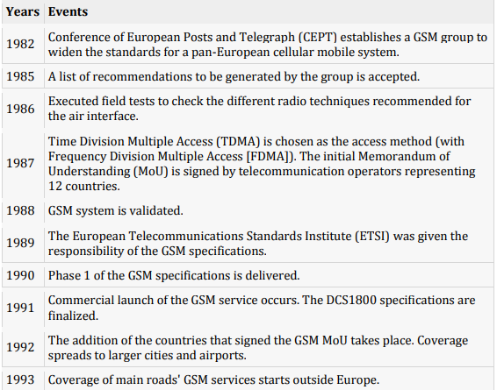

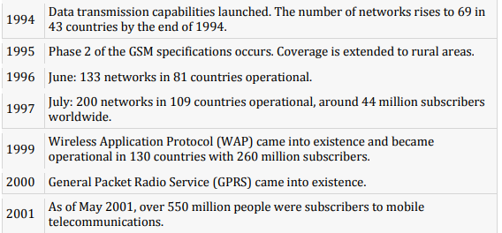

GSM Architecture:

A GSM network comprises of many functional units. These functions and interfaces are explained in this chapter. The GSM network can be broadly divided into:

• The Mobile Station (MS)

• The Base Station Subsystem (BSS)

• The Network Switching Subsystem (NSS)

• The Operation Support Subsystem (OSS)

Given below is a simple pictorial view of the GSM architecture.

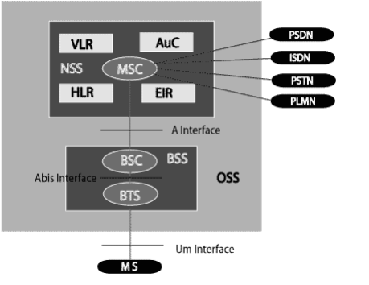

The additional components of the GSM architecture comprise of databases and messaging systems’ functions:

• Home Location Register (HLR)

• Visitor Location Register (VLR)

• Equipment Identity Register (EIR)

• Authentication Center (AuC)

• SMS Serving Center (SMS SC)

• Gateway MSC (GMSC)

• Chargeback Center (CBC)

• Transcoder and Adaptation Unit (TRAU)

The following diagram shows the GSM network along with the added elements:

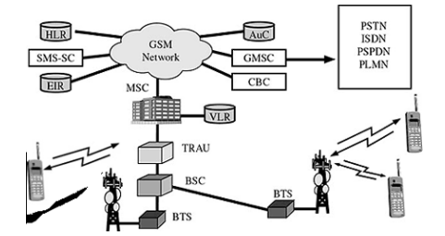

The MS and the BSS communicate across the Um interface. It is also known as the air interface or the radio link. The BSS communicates with the Network Service Switching (NSS) center across the A interface

GSM Network Areas:

In a GSM network, the following areas are defined:

• Cell: Cell is the basic service area; one BTS covers one cell. Each cell is given a Cell Global Identity (CGI), a number that uniquely identifies the cell.

• Location Area: A group of cells form a Location Area (LA). This is the area that is paged when a subscriber gets an incoming call. Each LA is assigned a Location Area Identity (LAI). Each LA is served by one or more BSCs.

• MSC/VLR Service Area: The area covered by one MSC is called the MSC/VLR service area.

• PLMN: The area covered by one network operator is called the Public Land Mobile Network (PLMN). A PLMN can contain one or more MSCs.

GSM Operations:

Mobile Phone to Public Switched Telephone Network (PSTN)

When a mobile subscriber makes a call to a PSTN telephone subscriber, the following sequence of events takes place:

1. The MSC/VLR receives the message of a call request.

2. The MSC/VLR checks if the mobile station is authorized to access the network. If so, the mobile station is activated. If the mobile station is not authorized, then the service will be denied.

3. MSC/VLR analyzes the number and initiates a call setup with the PSTN.

4. MSC/VLR asks the corresponding BSC to allocate a traffic channel (a radio channel and a timeslot).

5. The BSC allocates the traffic channel and passes the information to the mobile station.

6. The called party answers the call and the conversation takes place.

7. The mobile station keeps on taking measurements of the radio channels in the present cell and the neighboring cells and passes the information to the BSC. The BSC decides if a handover is required. If so, a new traffic channel is allocated to the mobile station and the handover takes place. If handover is not required, the mobile station continues to transmit in the same frequency.

GSM Specification:

The requirements for different Personal Communication Services (PCS) systems differ for each PCS network. Vital characteristics of the GSM specification are listed below:

Modulation:

Modulation is the process of transforming the input data into a suitable format for the transmission medium. The transmitted data is demodulated back to its original form at the receiving end. The GSM uses Gaussian Minimum Shift Keying (GMSK) modulation method.

Access Methods:

Radio spectrum being a limited resource that is consumed and divided among all the users, GSM devised a combination of TDMA/FDMA as the method to divide the bandwidth among the users. In this process, the FDMA part divides the frequency of the total 25 MHz bandwidth into 124 carrier frequencies of 200 kHz bandwidth.

Each BS is assigned with one or multiple frequencies, and each of this frequency is divided into eight timeslots using a TDMA scheme. Each of these slots are used for both transmission as well as reception of data. These slots are separated by time so that a mobile unit doesn’t transmit and receive data at the same time.

Transmission Rate:

The total symbol rate for GSM at 1 bit per symbol in GMSK produces 270.833 K symbols/second. The gross transmission rate of a timeslot is 22.8 Kbps.

GSM is a digital system with an over-the-air bit rate of 270 kbps.

Frequency Band:

The uplink frequency range specified for GSM is 933–960 MHz (basic 900 MHz band only). The downlink frequency band is 890–915 MHz (basic 900 MHz band only).

Channel Spacing:

Channel spacing indicates the spacing between adjacent carrier frequencies. For GSM, it is 200 kHz.

Speech Coding:

For speech coding or processing, GSM uses Linear Predictive Coding (LPC). This tool compresses the bit rate and gives an estimate of the speech parameters. When the audio signal passes through a filter, it mimics the vocal tract. Here, the speech is encoded at 13 kbps.

Duplex Distance:

Duplex distance is the space between the uplink and downlink frequencies. The duplex distance for GSM is 80 MHz, where each channel has two frequencies that are 80 MHz apart.

Miscellaneous:

• Frame duration: 4.615 mS

• Duplex Technique: Frequency Division Duplexing (FDD) access mode previously known as WCDMA.

• Speech channels per RF channel: 8.

GSM Addressing and Identifiers:

GSM treats the users and the equipment in different ways. Phone numbers, subscribers, and equipment identifiers are some of the known ones. There are many other identifiers that have been well-defined, which are required for the subscriber’s mobility management and for addressing the remaining network elements. Vital addresses and identifiers that are used in GSM are addressed below:

International Mobile Station Equipment Identity:

The International Mobile Station Equipment Identity (IMEI) looks more like a serial number which distinctively identifies a mobile station internationally. This is allocated by the equipment manufacturer and registered by the network operator, who stores it in the Entrepreneurs-inResidence (EIR). By means of IMEI, one recognizes obsolete, stolen, or non-functional equipment.

Following are the parts of IMEI:

• Type Approval Code (TAC): 6 decimal places, centrally assigned.

• Final Assembly Code (FAC): 6 decimal places, assigned by the manufacturer.

• Serial Number (SNR): 6 decimal places, assigned by the manufacturer.

• Spare (SP): 1 decimal place.

Thus, IMEI = TAC + FAC + SNR + SP. It uniquely characterizes a mobile station and gives clues about the manufacturer and the date of manufacturing.

International Mobile Subscriber Identity:

Every registered user has an original International Mobile Subscribter Identity (IMSI) with a valid IMEI stored in their Subscriber Identity Module (SIM).

IMSI comprises of the following parts:

• Mobile Country Code (MCC): 3 decimal places, internationally standardized.

• Mobile Network Code (MNC): 2 decimal places, for unique identification of a mobile network within the country.

• Mobile Subscriber Identification Number (MSIN): Maximum 10 decimal places, identification number of the subscriber in the home mobile network.

Mobile Subscriber ISDN Number:

The authentic telephone number of a mobile station is the Mobile Subscriber ISDN Number (MSISDN). Based on the SIM, a mobile station can have many MSISDNs, as each subscriber is assigned with a separate MSISDN to their SIM respectively.

Listed below is the structure followed by MSISDN categories, as they are defined based on international ISDN number plan:

• Country Code (CC) : Up to 3 decimal places.

• National Destination Code (NDC): Typically 2–3 decimal places.

• Subscriber Number (SN): Maximum 10 decimal places.

Mobile Station Roaming Number:

Mobile Station Roaming Number (MSRN) is an interim location dependent ISDN number, assigned to a mobile station by a regionally responsible Visitor Location Register (VLA). Using MSRN, the incoming calls are channeled to the MS.

The MSRN has the same structure as the MSISDN.

• Country Code (CC): of the visited network.

• National Destination Code (NDC): of the visited network.

• Subscriber Number (SN): in the current mobile network.

Location Area Identity:

Within a PLMN, a Location Area identifies its own authentic Location Area Identity (LAI). The LAI hierarchy is based on international standard and structured in a unique format as mentioned below:

• Country Code (CC): 3 decimal places.

• Mobile Network Code (MNC): 2 decimal places.

• Location Area Code (LAC): maximum 5 decimal places or maximum twice 8 bits coded in hexadecimal (LAC < FFFF).

Temporary Mobile Subscriber Identity:

Temporary Mobile Subscriber Identity (TMSI) can be assigned by the VLR, which is responsible for the current location of a subscriber. The TMSI needs to have only local significance in the area handled by the VLR. This is stored on the network side only in the VLR and is not passed to the Home Location Register (HLR).

Together with the current location area, the TMSI identifies a subscriber uniquely. It can contain up to 4 × 8 bits.

Local Mobile Subscriber Identity:

Each mobile station can be assigned with a Local Mobile Subscriber Identity (LMSI), which is an original key, by the VLR. This key can be used as the auxiliary searching key for each mobile station within its region. It can also help accelerate the database access. An LMSI is assigned if the mobile station is registered with the VLR and sent to the HLR. LMSI comprises of four octets (4x8 bits).

Cell Identifier:

Using a Cell Identifier (CI) (maximum 2 × 8) bits, the individual cells that are within an LA can be recognized. When the Global Cell Identity (LAI + CI) calls are combined, then it is uniquely defined.

Supplementary Services:

Supplementary services are additional services that are provided in addition to teleservices and bearer services. These services include caller identification, call forwarding, call waiting, multiparty conversations, and barring of outgoing (international) calls, among others. A brief description of supplementary services is given here:

Conferencing: It allows a mobile subscriber to establish a multiparty conversation, i.e., a simultaneous conversation between three or more subscribers to setup a conference call. This service is only applicable to normal telephony.

Call Waiting: This service notifies a mobile subscriber of an incoming call during a conversation. The subscriber can answer, reject, or ignore the incoming call.

Call Hold: This service allows a subscriber to put an incoming call on hold and resume after awhile. The call hold service is applicable to normal telephony.

Call Forwarding: Call Forwarding is used to divert calls from the original recipient to another number. It is normally set up by the subscriber himself. It can be used by the subscriber to divert calls from the Mobile Station when the subscriber is not available, and so to ensure that calls are not lost.

Call Barring: Call Barring is useful to restrict certain types of outgoing calls such as ISD or stop incoming calls from undesired numbers. Call barring is a flexible service that enables the subscriber to conditionally bar calls.

Number Identification:

There are following supplementary services related to number identification:

Calling Line Identification Presentation:

This service displays the telephone number of the calling party on your screen.

Calling Line Identification Restriction: A person not wishing their number to be presented to others subscribes to this service.

Connected Line Identification Presentation: This service is provided to give the calling party the telephone number of the person to whom they are connected. This service is useful in situations such as forwarding where the number connected is not the number dialed.

Connected Line Identification Restriction: There are times when the person called does not wish to have their numbers presented and so they would subscribe to this person. Normally, this overrides the presentation service. Malicious Call Identification: The malicious call identification service was provided to combat the spread of obscene or annoying calls. The victim should subscribe to this service, and then they could cause known malicious calls to be identified in the GSM network, using a simple command.

GSM Mobile Phones:

1/ Apple phones 2/ Asus phones 3/ Bird phones 4/ BlackBerry phones 5/ Gigabyte phones

6/ Haier phones 7/ HP phones 8/ HTC phones 9/ Motorola phones 10/Nokia phones 11/ Samsung phones 12/ Sony phones 13/ Toshiba phones GSM Enabled.

Future Scope:

* It can be used for high security in banks and other organizations.
* Using real time clock, the appliances which need response in real time can also be controlled through the wireless link.
* Connecting More Devices.
* Provision to Store Several Mobile Numbers.
* Video Recording once Alarm Gets.
* GSM based home security system, GSM based robot control, GSM based DC motor Controller, GSM based stepper motor controller, GSM based voting machine control.

### CONCLUSION:

The communication development and the increase of living standard of people are directly related to the more use of cellular mobile. Cellular mobile radio-the high end sophisticated technology that enables everyone to communicate anywhere with anybody. The mobile telephony industry rapidly growing and that has become backbone for business success and efficiency and a part of modern lifestyles all over the world.  
  
In this thesis work we have tried to give and over view of the GSM system. We hope that we gave the general flavor of GSM and the philosophy behind its design. The GSM is standard that insures interoperability without stifling competition and innovation among the suppliers to the benefit of the public both in terms of cost and service quality.  
  
The features and benefits expected in the GSM systems are superior speech quality, low terminal, operational and service costs, a high level security, providing international roaming support of low power hand portable terminals and variety of new services and network facilities. In near forth coming days, the third generation mobile telephony becomes available whole over the world, which will give the facility of videoconference in mobile telephone.