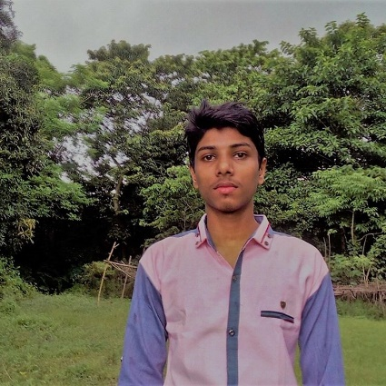

# Experience working in html, css, php, mysqli, wordpress, laravel, javaScript, reactJS.  
# Hard worker, quick learner & ability to assume responsibility.  
# Work well under pressure as part of a team.  
# Talented in problem solving,

# Having good experience in Microsoft Excel & Word.



**+88-01989419776**

My career objective is to build my career with software enginner as a web developer.  I am a dedicated and hard-working person who believes in honesty and good working relation.

**SPECIAL QUALIFICATION:**

****

zulkarnine43@gmail.com

****

93/A,Bashiruddin-Road, kolabagan,Dhaka

**CONTACT:**

**CAREER OBJECTIVE:**

CURICULUM VITAE

**ZULKAR NINE**

|  |  |  |
| --- | --- | --- |
| Father's Name | : | Abdur Rahman |
| Mother's Name | : | Asma Akter |
| Date of Birth | : | September 25, 1997 |
| Gender | : | Male |
| Marital Status | : | Unmarried |
| Nationality | : | Bangladeshi |
| National Id No. | : | 4202873024 |
| Religion | : | Islam |
| Permanent Address | : | Village -Elamdi, Post -Araihazar, Thana - Araihazar, District -Narayangonj. |
| Current Location | : | Dhaka |

Here, I declared that the above information in my CV is correctly described which are true and updated to the best of my knowledge and belief.

Sincerely,

Zulkar Nine

**PERSONAL DETAILS:**

* **Bachelor of Computer Science & engineer (BCSE)**

City University

Major/Group: **Engineering**

CGPA: 3.23 Out Of 4.00

Passing Year: 2017-2020

* **Higher Secondary Certificate (HSC)**

Govt. Safar Ali College Major/Group: **Science**

CGPA :**3.58** Out Of 5.00

Passing Year: 2016

Board: Dhaka

* **Secondary School Certificate (SSC)**

Sultanshadi High School & College

Major/Group: **Science**

CGPA: **4.75** Out Of 5.00

Passing Year: 2014

Board: Dhaka

**ACADEMIC QUALIFICATION:**