SQL JOIN

A JOIN clause is used to combine rows from two or more tables, based on a related column between them.

Let's look at a selection from the "Orders" table:

Orders(OrderID, CustomerID, OrderDate)

Customers(CustomerID, CustomerName, ContactName, Country)

Notice that the "CustomerID" column in the "Orders" table refers to the "CustomerID" in the "Customers" table. The relationship between the two tables above is the "CustomerID" column.

Then, we can create the following SQL statement (that contains an INNER JOIN), that selects records that have matching values in both tables:

### Example

SELECT Orders.OrderID, Customers.CustomerName, Orders.OrderDate  
FROM Orders  
INNER JOIN Customers ON Orders.CustomerID=Customers.CustomerID;

## Different Types of SQL JOINs

Here are the different types of the JOINs in SQL:

* **(INNER) JOIN**: Returns records that have matching values in both tables
* **LEFT (OUTER) JOIN**: Return all records from the left table, and the matched records from the right table
* **RIGHT (OUTER) JOIN**: Return all records from the right table, and the matched records from the left table
* **FULL (OUTER) JOIN**: Return all records when there is a match in either left or right table

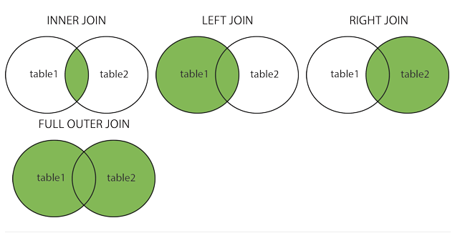

## SQL INNER JOIN Keyword

The INNER JOIN keyword selects records that have matching values in both tables.

### INNER JOIN Syntax

### SELECT column_name(s) FROM table1 INNER JOIN table2ON table1.column_name=table2.column_name;

### Example

SELECT Orders.OrderID, Customers.CustomerName  
FROM Orders  
INNER JOIN Customers ON Orders.CustomerID = Customers.CustomerID;

## JOIN Three Tables

The following SQL statement selects all orders with customer and shipper information:

### Example

SELECT Orders.OrderID, Customers.CustomerName, Shippers.ShipperName  
FROM ((Orders  
INNER JOIN Customers ON Orders.CustomerID = Customers.CustomerID)  
INNER JOIN Shippers ON Orders.ShipperID = Shippers.ShipperID);

## SQL LEFT JOIN Keyword

The LEFT JOIN keyword returns all records from the left table (table1), and the matched records from the right table (table2). The result is NULL from the right side, if there is no match.

### LEFT JOIN Syntax

SELECT column_name(s)  
FROM table1  
LEFT JOIN table2ON table1.column_name=table2.column_name;

## SQL LEFT JOIN Example

The following SQL statement will select all customers, and any orders they might have:

### Example

SELECT Customers.CustomerName, Orders.OrderID  
FROM Customers  
right JOIN Orders ON Customers.CustomerID = Orders.CustomerID  
ORDER BY Customers.CustomerName;